**ASSIGNMENT 24.3**

Create database and table: 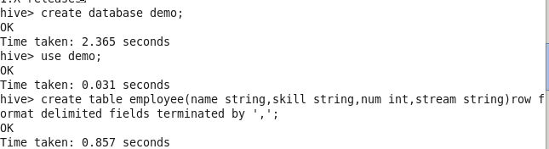

Load data:

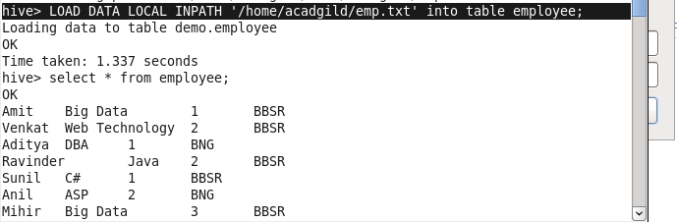

Display skill and corresponding count:

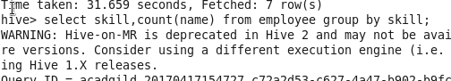

Output:

