**ASSIGNMENT 25.2**

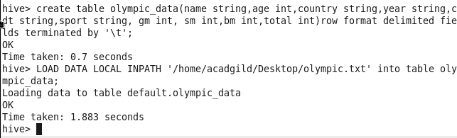

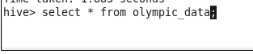

**DATASET:**

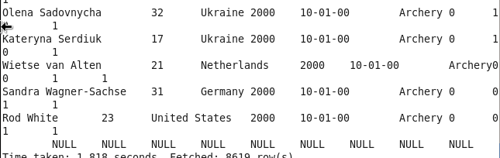

1. **Write a Hive Program to find the total number of medals each country won**

COUNT OF TOTAL MEDALS ACCORDING TO COUNTRY:

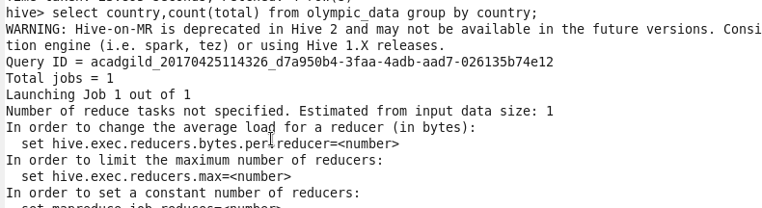

OUTPUT:

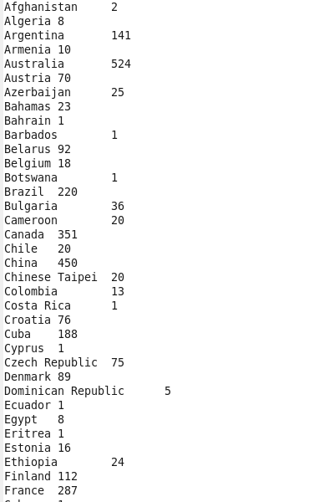

**2) : Write a Hive program to find the number of gold medals each country won**

COUNT OF GOLD MEDALS ACCORDING TO COUNTRY:

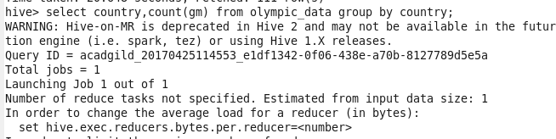

OUTPUT:

