ASSIGNMENT25.3

Problem Statement:

Get a list of employees who receive a salary less than 100, compared to their immediate employee with higher salary in the same unit

As we were supposed to get the list of employee who receive a salary less than 100, compared to their immediate employee with higher salary in the same unit for this to be achieved we have used a lag function in a select system where the previous salary is lagged by one and order by salary in desc as we want to compare immediate higher salary In the same unit we have partition by dep

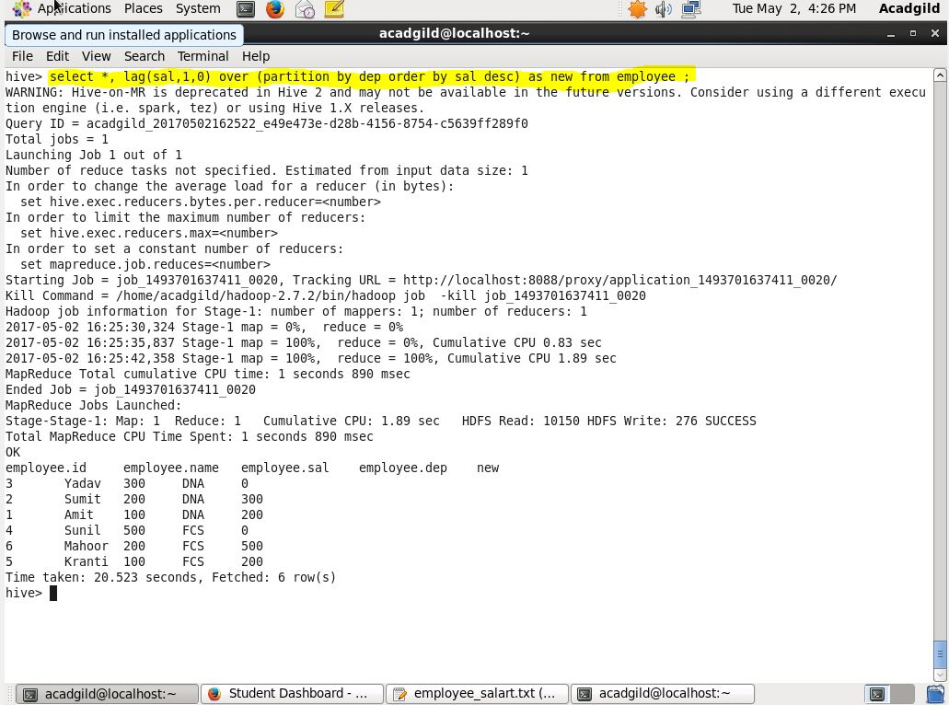

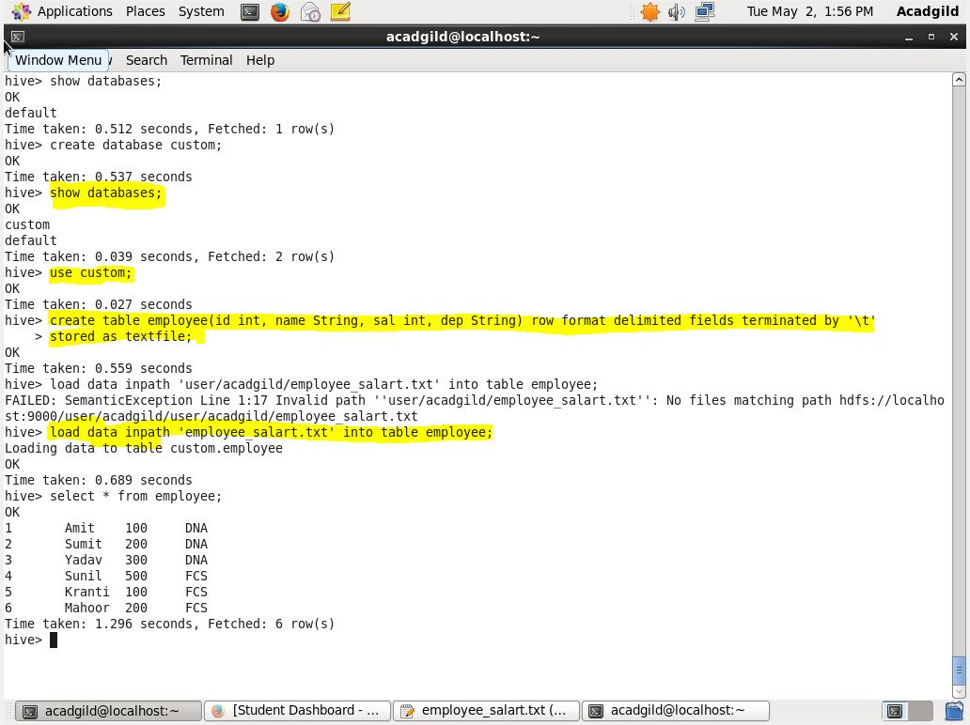

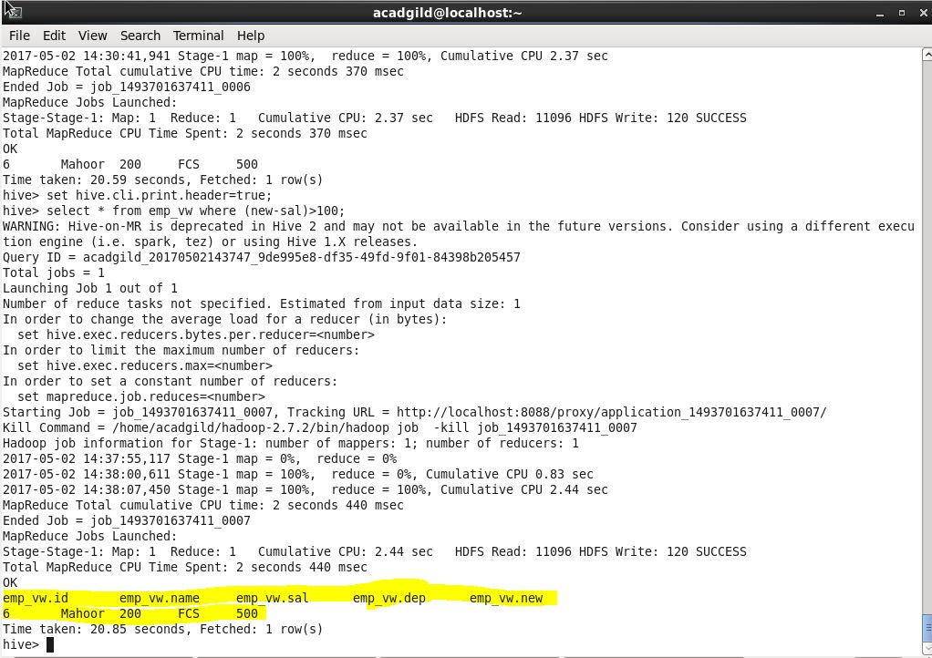

Problem Statement:

List of all employees who draw higher salary than the average salary of that department

We have implemented the view to get the average and the department, then we have joined this view and the employee table then we have executed the select query with where clause to get the employees who draw higher salary than the average salary of that department. For the same department we have grouped by dep.

