**Perform word count in Hive for above given dataset.**

**Input file**

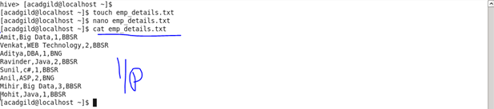

**Creating table and loading data**

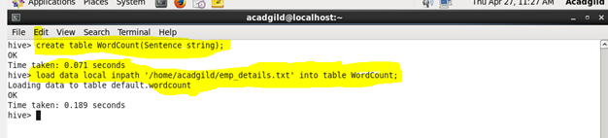

**Split command**

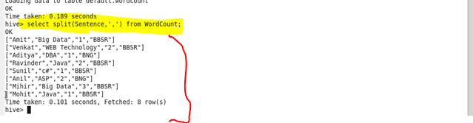

**Explode command**

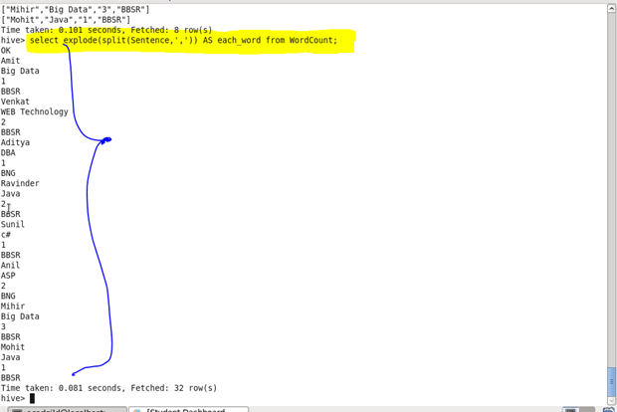

**Counting each word**

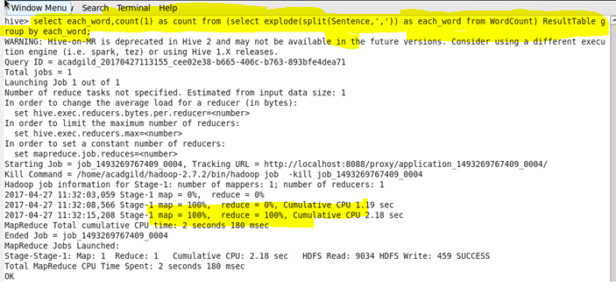

**Output**

