**ASSIGNMENT26.3**

**Create table RealEstate in Hive database, with all the columns present in dataset.**

**Using create command we will create table realestate -**

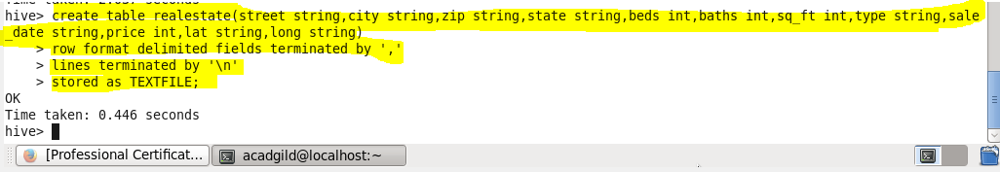

**Using Describe table command we can check the columns and their datatypes-**

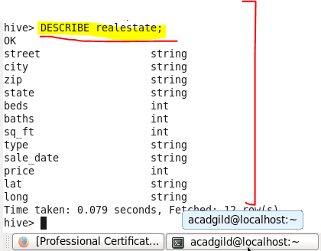

* Load dataset into table realEstate.

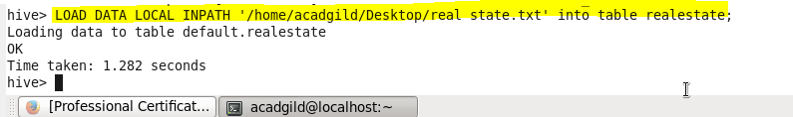

* Using Dynamic partition get separate lists of residential apartments with more than 2 beds and include columns in following order City,Baths,Sq_feet,Price,flat_type,Beds respectively.
* **Creating Partitioned Table**

**Here a partitioned table Separate is created where partition is made based on type,Beds as Shown**



**Using Dynamic partition get separate lists of residential apartments with more than 2 beds and include columns in following order City,Baths,Sq_feet,Price,flat_type,Beds respectively**

**In dynamic Partitioning we want to enter the bedrooms greater than 2,so we load data into the partitioned table by using select statement from realEstate Table where Beds>2 and type as residential**

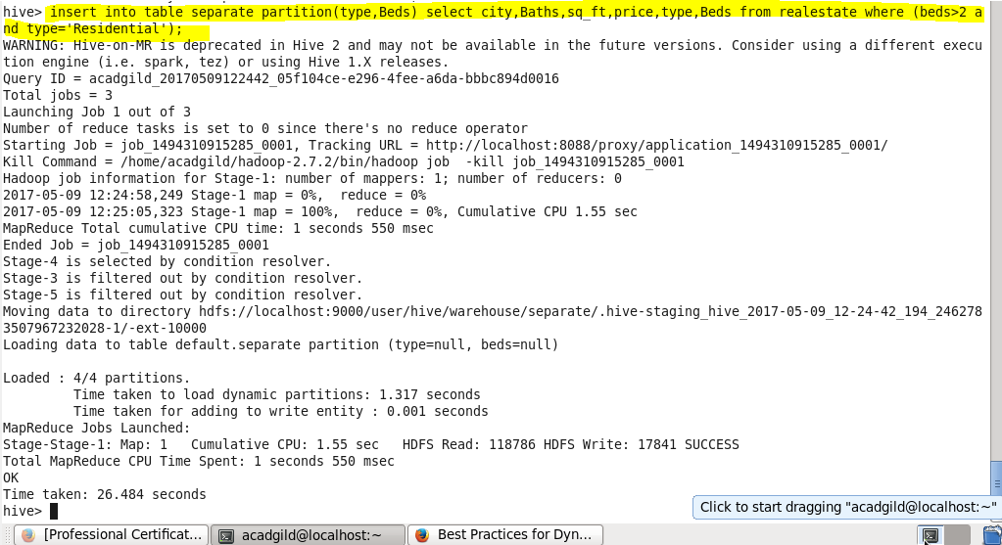

**Output:**

**In hive warehouse separate directories will be created for each beds count greater than 2 dynamically by hive**

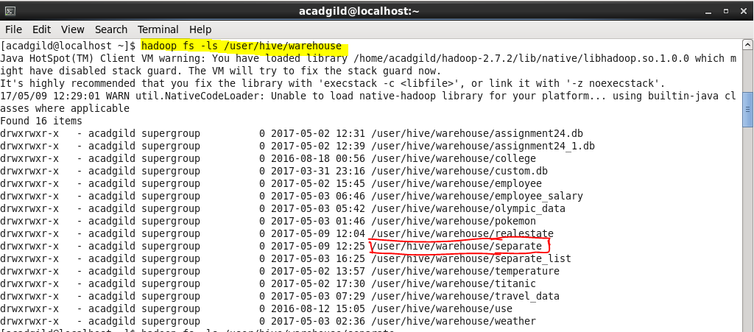

**Going inside we can check for our partition directory for type =Residential as we have partitioned by type**

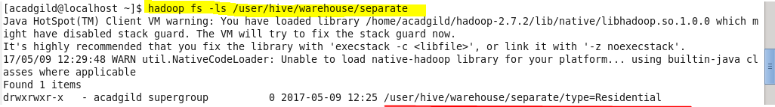

**Going inside we can check all separate list for beds >2 and type =Residential as we have partitioned by type and beds >2**

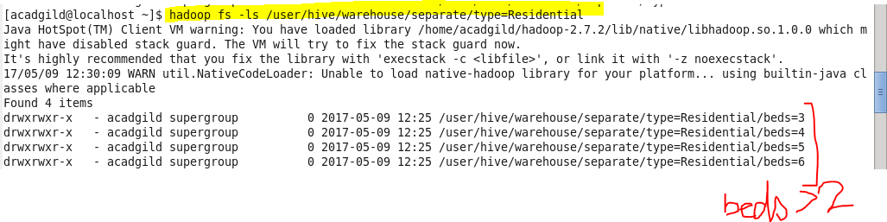

**So our separate list for bed =3 will be under this directory as showing**

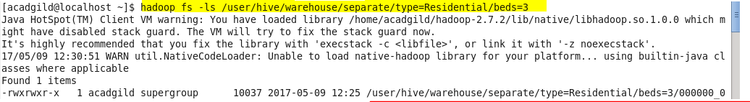

**Now we can check for the result using cat command in HDFS.**

**Sample Output for bed =3**

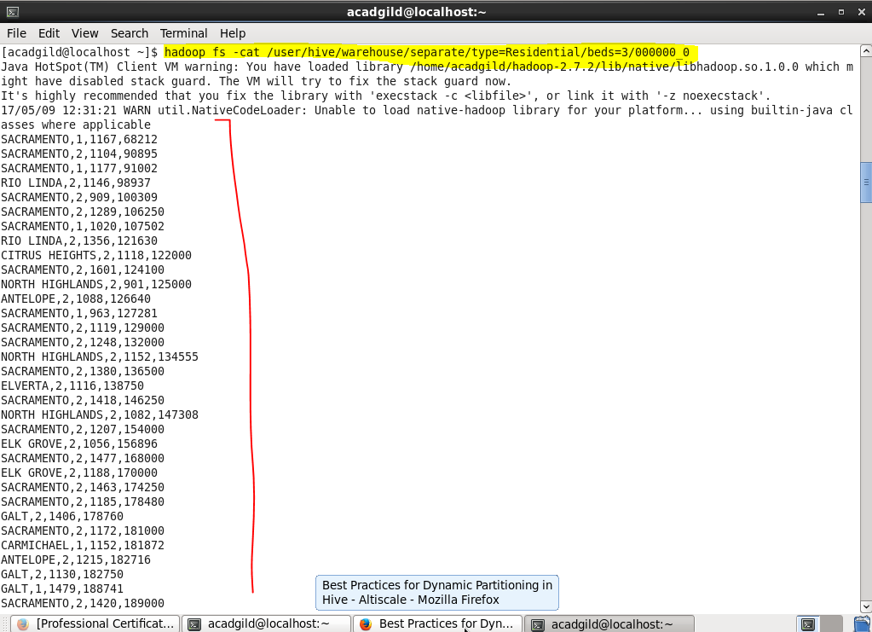

**Complete output data is attached in separate list - bed=3 file**

**Sample Output for bed =4**

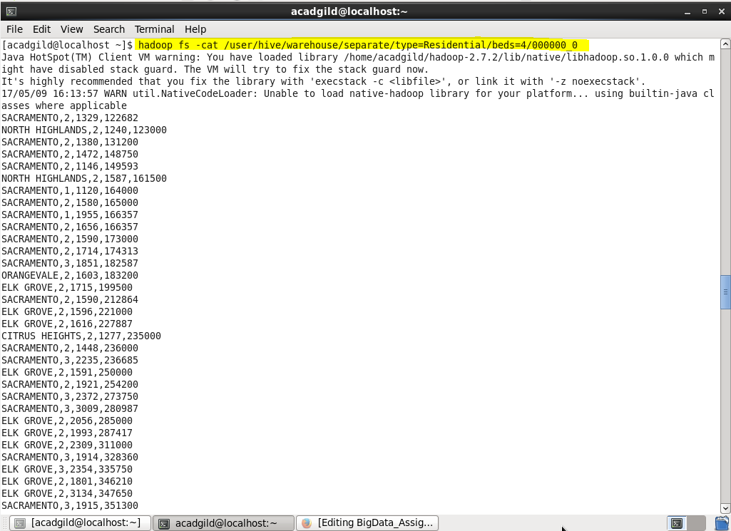

**Complete output data is attached in separate list - bed=4 file**

**Sample Output for bed = 5**



**Complete output data is attached in separate list - bed=5 file**

**Sample Output for bed = 6**

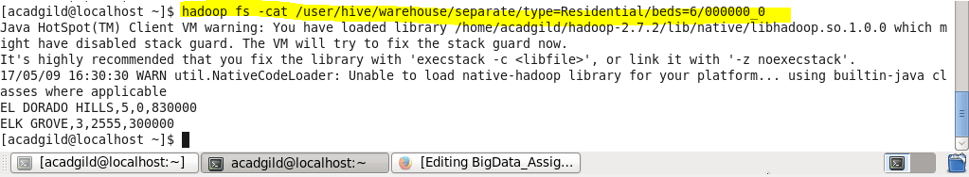

**DATASET:**

|  |
| --- |
| hadoop fs -cat /user/hive/warehouse/sep_list/type=Residential/beds=4/000000_0 |
|  |  |
|  |  |
|  | SACRAMENTO,2,1329,122682 |
|  | NORTH HIGHLANDS,2,1240,123000 |
|  | SACRAMENTO,2,1380,131200 |
|  | SACRAMENTO,2,1472,148750 |
|  | SACRAMENTO,2,1146,149593 |
|  | NORTH HIGHLANDS,2,1587,161500 |
|  | SACRAMENTO,1,1120,164000 |
|  | SACRAMENTO,2,1580,165000 |
|  | SACRAMENTO,1,1955,166357 |
|  | SACRAMENTO,2,1656,166357 |
|  | SACRAMENTO,2,1590,173000 |
|  | SACRAMENTO,2,1714,174313 |
|  | SACRAMENTO,3,1851,182587 |
|  | ORANGEVALE,2,1603,183200 |
|  | ELK GROVE,2,1715,199500 |
|  | SACRAMENTO,2,1590,212864 |
|  | ELK GROVE,2,1596,221000 |
|  | ELK GROVE,2,1616,227887 |
|  | CITRUS HEIGHTS,2,1277,235000 |
|  | SACRAMENTO,2,1448,236000 |
|  | SACRAMENTO,3,2235,236685 |
|  | ELK GROVE,2,1591,250000 |
|  | SACRAMENTO,2,1921,254200 |
|  | SACRAMENTO,3,2372,273750 |
|  | SACRAMENTO,3,3009,280987 |
|  | ELK GROVE,2,2056,285000 |
|  | ELK GROVE,2,1993,287417 |
|  | ELK GROVE,2,2309,311000 |
|  | SACRAMENTO,3,1914,328360 |
|  | ELK GROVE,3,2354,335750 |
|  | ELK GROVE,2,1801,346210 |
|  | ELK GROVE,2,3134,347650 |
|  | SACRAMENTO,3,1915,351300 |
|  | RANCHO MURIETA,3,2734,370500 |
|  | SACRAMENTO,2,2054,381942 |
|  | ANTELOPE,2,1830,387731 |
|  | ELK GROVE,3,3440,394470 |
|  | ELK GROVE,3,2359,400186 |
|  | ELK GROVE,3,2724,461000 |
|  | ELK GROVE,3,3440,489332 |
|  | FOLSOM,2,2462,539000 |
|  | EL DORADO HILLS,3,0,600000 |
|  | EL DORADO HILLS,3,0,606238 |
|  | SACRAMENTO,2,1099,70000 |
|  | SACRAMENTO,2,1316,89000 |
|  | SACRAMENTO,2,1448,145000 |
|  | NORTH HIGHLANDS,2,1183,146000 |
|  | SACRAMENTO,2,1310,150000 |
|  | ELK GROVE,2,1685,182000 |
|  | RANCHO CORDOVA,2,1829,184500 |
|  | CARMICHAEL,2,1120,189000 |
|  | LINCOLN,2,0,202500 |
|  | SACRAMENTO,2,1799,205000 |
|  | SACRAMENTO,3,1953,205000 |
|  | CITRUS HEIGHTS,2,1578,215000 |
|  | SACRAMENTO,2,1751,225000 |
|  | SACRAMENTO,2,1605,228000 |
|  | RIO LINDA,2,1475,229665 |
|  | SACRAMENTO,3,2491,245000 |
|  | ORANGEVALE,2,1456,250000 |
|  | ELK GROVE,2,1595,260000 |
|  | LINCOLN,2,0,261800 |
|  | SACRAMENTO,2,1253,264469 |
|  | ANTELOPE,3,1768,265000 |
|  | SACRAMENTO,3,2030,270000 |
|  | ELK GROVE,3,1653,275000 |
|  | ELK GROVE,2,2056,275000 |
|  | ELK GROVE,3,2494,280000 |
|  | SACRAMENTO,2,2169,292000 |
|  | LINCOLN,4,0,297500 |
|  | GALT,3,2307,300000 |
|  | SACRAMENTO,2,1910,300500 |
|  | SACRAMENTO,2,2205,319789 |
|  | RANCHO CORDOVA,3,2208,336000 |
|  | FOLSOM,2,1595,339000 |
|  | GALT,2,2159,345000 |
|  | PLACERVILLE,3,2295,350000 |
|  | SACRAMENTO,2,1900,361745 |
|  | SACRAMENTO,2,1718,361948 |
|  | ROCKLIN,2,0,380000 |
|  | ROCKLIN,2,2607,402000 |
|  | ELK GROVE,3,2724,406026 |
|  | RANCHO MURIETA,2,3192,425000 |
|  | LINCOLN,3,0,436746 |
|  | FOLSOM,2,2581,450000 |
|  | ELK GROVE,3,3992,460000 |
|  | SACRAMENTO,4,3397,465000 |
|  | PLACERVILLE,3,1929,485000 |
|  | ELK GROVE,3,3070,495000 |
|  | CARMICHAEL,2,2222,582000 |
|  | ROSEVILLE,3,3838,613401 |
|  | ROSEVILLE,2,0,614000 |
|  | LOOMIS,4,1624,839000 |
|  | SACRAMENTO,2,1120,102750 |
|  | SACRAMENTO,2,1448,114000 |
|  | SACRAMENTO,2,1390,125573 |
|  | ELVERTA,2,1354,126714 |
|  | SACRAMENTO,2,1587,127500 |
|  | SACRAMENTO,2,1590,147000 |
|  | CITRUS HEIGHTS,2,1351,158000 |
|  | CITRUS HEIGHTS,2,1280,167293 |
|  | CITRUS HEIGHTS,2,1280,167293 |
|  | SACRAMENTO,2,1917,170000 |
|  | SACRAMENTO,2,1638,180000 |
|  | SACRAMENTO,2,1766,207000 |
|  | SACRAMENTO,3,1940,208000 |
|  | ELK GROVE,2,1776,210000 |
|  | SACRAMENTO,2,1872,213675 |
|  | SACRAMENTO,2,1856,215000 |
|  | SACRAMENTO,3,1939,215000 |
|  | ELK GROVE,3,1739,221000 |
|  | GALT,2,1555,225500 |
|  | SACRAMENTO,2,1871,230000 |
|  | ANTELOPE,3,2026,231200 |
|  | SACRAMENTO,3,1936,235000 |
|  | GALT,2,1798,238861 |
|  | ANTELOPE,3,2652,239700 |
|  | SACRAMENTO,2,1816,240000 |
|  | ELK GROVE,2,1844,241000 |
|  | SACRAMENTO,3,2447,246000 |
|  | SACRAMENTO,2,1176,247234 |
|  | RIO LINDA,2,1182,247480 |
|  | ORANGEVALE,2,1574,252155 |
|  | ELK GROVE,2,1724,258000 |
|  | SACRAMENTO,3,2175,261000 |
|  | SACRAMENTO,2,1904,261000 |
|  | EL DORADO HILLS,2,1808,262500 |
|  | RANCHO CORDOVA,2,2711,266000 |
|  | ELK GROVE,3,2724,274425 |
|  | SACRAMENTO,3,2550,277980 |
|  | GALT,2,1928,280000 |
|  | CARMICHAEL,2,1559,285000 |
|  | ELK GROVE,2,2109,296000 |
|  | RANCHO CORDOVA,2,1524,296056 |
|  | SACRAMENTO,2,1876,299940 |
|  | RANCHO CORDOVA,3,1851,305000 |
|  | SACRAMENTO,2,2218,311328 |
|  | SACRAMENTO,2,1659,328578 |
|  | SACRAMENTO,2,2155,340000 |
|  | ELK GROVE,2,2789,351000 |
|  | GALT,2,1606,353767 |
|  | SACRAMENTO,2,2166,356035 |
|  | SACRAMENTO,2,1871,360552 |
|  | PLACERVILLE,2,0,371086 |
|  | ANTELOPE,3,2085,408431 |
|  | EL DORADO HILLS,3,0,420000 |
|  | FOLSOM,3,1939,423000 |
|  | CAMERON PARK,2,0,423000 |
|  | ELK GROVE,2,2002,445000 |
|  | ELK GROVE,4,4303,450000 |
|  | EL DORADO HILLS,3,0,471000 |
|  | ORANGEVALE,4,3056,475000 |
|  | GOLD RIVER,2,3037,528000 |
|  | FOLSOM,3,2660,636000 |
|  | CARMICHAEL,3,3357,668365 |
|  | LINCOLN,2,0,4897 |
|  | SACRAMENTO,2,1292,105000 |
|  | SACRAMENTO,2,1064,109000 |
|  | SACRAMENTO,2,1341,123000 |
|  | SACRAMENTO,2,1127,124000 |
|  | SACRAMENTO,2,1253,125000 |
|  | SACRAMENTO,3,1890,137721 |
|  | SACRAMENTO,2,1628,151000 |
|  | SACRAMENTO,2,1358,158000 |
|  | SACRAMENTO,2,1483,161600 |
|  | SACRAMENTO,2,1549,165000 |
|  | SACRAMENTO,2,1580,168000 |
|  | SACRAMENTO,2,1695,179000 |
|  | SACRAMENTO,2,1436,185074 |
|  | SACRAMENTO,2,1139,186785 |
|  | SACRAMENTO,2,1578,190000 |
|  | SACRAMENTO,2,1578,195000 |
|  | CITRUS HEIGHTS,3,1736,195000 |
|  | ELK GROVE,2,2306,204918 |
|  | SACRAMENTO,2,1800,207000 |
|  | ANTELOPE,2,1953,207744 |
|  | ELK GROVE,2,2329,213750 |
|  | ROSEVILLE,1,1376,215000 |
|  | SACRAMENTO,2,1566,220000 |
|  | CITRUS HEIGHTS,2,1419,220000 |
|  | SACRAMENTO,2,1991,225000 |
|  | SACRAMENTO,3,2126,228750 |
|  | ELK GROVE,2,2111,233500 |
|  | ANTELOPE,3,1915,240000 |
|  | ELK GROVE,2,2367,240000 |
|  | SACRAMENTO,2,1876,243500 |
|  | ANTELOPE,2,2504,246750 |
|  | ELK GROVE,3,1899,249000 |
|  | SACRAMENTO,2,1438,252000 |
|  | SACRAMENTO,2,2605,257200 |
|  | LINCOLN,2,0,267750 |
|  | EL DORADO HILLS,2,0,272700 |
|  | GALT,3,2214,278000 |
|  | CITRUS HEIGHTS,2,1582,280000 |
|  | ELK GROVE,3,2096,289000 |
|  | ANTELOPE,2,2160,290000 |
|  | SACRAMENTO,2,1382,293996 |
|  | ELK GROVE,2,1721,294173 |
|  | LOOMIS,2,1328,295000 |
|  | ELK GROVE,2,1982,298000 |
|  | LINCOLN,2,0,306000 |
|  | ROSEVILLE,3,1800,310000 |
|  | SACRAMENTO,2,2169,311518 |
|  | ORANGEVALE,2,2004,315000 |
|  | ROSEVILLE,3,2212,315000 |
|  | ROCKLIN,2,0,315000 |
|  | SACRAMENTO,3,2962,322000 |
|  | ROCKLIN,2,1888,325000 |
|  | RANCHO CORDOVA,3,2109,330000 |
|  | SACRAMENTO,2,2484,331200 |
|  | SACRAMENTO,3,2258,332000 |
|  | SACRAMENTO,2,2372,341000 |
|  | ROSEVILLE,2,2295,360000 |
|  | ROSEVILLE,3,2577,367463 |
|  | EL DORADO HILLS,2,2199,400000 |
|  | ROSEVILLE,3,0,412500 |
|  | AUBURN,3,2278,420454 |
|  | FOLSOM,3,3261,446000 |
|  | SACRAMENTO,2,2053,450000 |
|  | ROSEVILLE,3,2379,455000 |
|  | EL DORADO HILLS,2,0,493000 |
|  | EL DORADO HILLS,3,0,533000 |
|  | AUBURN,3,0,560000 |
|  | FOLSOM,3,3229,575000 |
|  | ROCKLIN,3,0,600000 |
|  | GRANITE BAY,3,2356,600000 |
|  | EL DORADO HILLS,3,0,879000 |
|  | WILTON,3,4400,884790 |
|  | SACRAMENTO,2,1512,56950 |
|  | SACRAMENTO,2,1158,80000 |
|  | SACRAMENTO,2,1462,121500 |
|  | SACRAMENTO,2,1570,126854 |
|  | SACRAMENTO,2,1309,131750 |
|  | SACRAMENTO,2,1392,150000 |
|  | CITRUS HEIGHTS,2,1381,161250 |
|  | SACRAMENTO,2,1608,165750 |
|  | ELK GROVE,2,1477,176850 |
|  | SACRAMENTO,2,1497,179500 |
|  | CITRUS HEIGHTS,3,1892,189836 |
|  | SACRAMENTO,2,1887,190000 |
|  | ELK GROVE,2,1609,204750 |
|  | SACRAMENTO,3,1968,205000 |
|  | ELK GROVE,2,1740,211500 |
|  | CARMICHAEL,2,1319,220000 |
|  | GALT,2,1770,220000 |
|  | SACRAMENTO,2,1627,223000 |
|  | SACRAMENTO,2,1329,229500 |
|  | SACRAMENTO,2,1715,230000 |
|  | SACRAMENTO,3,2280,232425 |
|  | ELK GROVE,2,1685,235301 |
|  |  |
|  | SACRAMENTO,2,2605,257200 |
|  | LINCOLN,2,0,267750 |
|  | EL DORADO HILLS,2,0,272700 |
|  | GALT,3,2214,278000 |
|  | CITRUS HEIGHTS,2,1582,280000 |
|  | ELK GROVE,3,2096,289000 |
|  | ANTELOPE,2,2160,290000 |
|  | SACRAMENTO,2,1382,293996 |
|  | ELK GROVE,2,1721,294173 |
|  | LOOMIS,2,1328,295000 |
|  | ELK GROVE,2,1982,298000 |
|  | LINCOLN,2,0,306000 |
|  | ROSEVILLE,3,1800,310000 |
|  | SACRAMENTO,2,2169,311518 |
|  | ORANGEVALE,2,2004,315000 |
|  | ROSEVILLE,3,2212,315000 |
|  | ROCKLIN,2,0,315000 |
|  | SACRAMENTO,3,2962,322000 |
|  | ROCKLIN,2,1888,325000 |
|  | RANCHO CORDOVA,3,2109,330000 |
|  | SACRAMENTO,2,2484,331200 |
|  | SACRAMENTO,3,2258,332000 |
|  | SACRAMENTO,2,2372,341000 |
|  | ROSEVILLE,2,2295,360000 |
|  | ROSEVILLE,3,2577,367463 |
|  | EL DORADO HILLS,2,2199,400000 |
|  | ROSEVILLE,3,0,412500 |
|  | AUBURN,3,2278,420454 |
|  | FOLSOM,3,3261,446000 |
|  | SACRAMENTO,2,2053,450000 |
|  | ROSEVILLE,3,2379,455000 |
|  | EL DORADO HILLS,2,0,493000 |
|  | EL DORADO HILLS,3,0,533000 |
|  | AUBURN,3,0,560000 |
|  | FOLSOM,3,3229,575000 |
|  | ROCKLIN,3,0,600000 |
|  | GRANITE BAY,3,2356,600000 |
|  | EL DORADO HILLS,3,0,879000 |
|  | WILTON,3,4400,884790 |
|  | SACRAMENTO,2,1512,56950 |
|  | SACRAMENTO,2,1158,80000 |
|  | SACRAMENTO,2,1462,121500 |
|  | SACRAMENTO,2,1570,126854 |
|  | SACRAMENTO,2,1309,131750 |
|  | SACRAMENTO,2,1392,150000 |
|  | CITRUS HEIGHTS,2,1381,161250 |
|  | SACRAMENTO,2,1608,165750 |
|  | ELK GROVE,2,1477,176850 |
|  | SACRAMENTO,2,1497,179500 |
|  | CITRUS HEIGHTS,3,1892,189836 |
|  | SACRAMENTO,2,1887,190000 |
|  | ELK GROVE,2,1609,204750 |
|  | SACRAMENTO,3,1968,205000 |
|  | ELK GROVE,2,1740,211500 |
|  | CARMICHAEL,2,1319,220000 |
|  | GALT,2,1770,220000 |
|  | SACRAMENTO,2,1627,223000 |
|  | SACRAMENTO,2,1329,229500 |
|  | SACRAMENTO,2,1715,230000 |
|  | SACRAMENTO,3,2280,232425 |
|  | ELK GROVE,2,1685,235301 |

|  |
| --- |
| hadoop fs -cat /user/hive/warehouse/sep_list/type=Residential/beds=6/000000_0 |
|  |  |
|  |  |
|  | EL DORADO HILLS,5,0,830000 |
|  | ELK GROVE,3,2555,300000 |

|  |
| --- |
| hadoop fs -cat /user/hive/warehouse/sep_list/type=Residential/beds=5/000000_0 |
|  |  |
|  |  |
|  | ELK GROVE,3,2136,223058 |
|  | ELK GROVE,3,2508,245918 |
|  | ELK GROVE,3,2790,258000 |
|  | ELK GROVE,3,2494,297000 |
|  | SACRAMENTO,3,2800,304037 |
|  | SACRAMENTO,3,2367,315537 |
|  | RANCHO CORDOVA,4,3516,320000 |
|  | ELK GROVE,3,3164,375000 |
|  | SACRAMENTO,3,3599,381300 |
|  | ELK GROVE,3,3433,425000 |
|  | RANCHO CORDOVA,3,3615,430000 |
|  | FOLSOM,3,2687,460000 |
|  | ELK GROVE,4,3508,510000 |
|  | LINCOLN,3,0,315000 |
|  | ELK GROVE,3,3389,370000 |
|  | ELK GROVE,4,3260,385000 |
|  | GALT,4,3746,420000 |
|  | EL DORADO HILLS,3,0,438700 |
|  | SACRAMENTO,3,3881,471750 |
|  | ROCKLIN,3,0,480000 |
|  | SACRAMENTO,3,3984,572500 |
|  | FAIR OAKS,5,2846,680000 |
|  | SACRAMENTO,2,2484,699000 |
|  | SACRAMENTO,2,1516,150000 |
|  | SACRAMENTO,3,3076,240000 |
|  | SACRAMENTO,3,2992,295000 |
|  | LINCOLN,3,0,304000 |
|  | ELK GROVE,3,3468,320000 |
|  | ANTELOPE,3,2346,320000 |
|  | ANTELOPE,3,2347,325000 |
|  | RANCHO CORDOVA,3,3281,395100 |
|  | SACRAMENTO,3,4246,452000 |
|  | EL DORADO HILLS,3,0,487500 |
|  | ROSEVILLE,3,0,520000 |
|  | WILTON,2,3741,579093 |
|  | GRANITE BAY,3,2896,676200 |
|  | WILTON,3,3788,691659 |
|  | GRANITE BAY,3,3670,760000 |
|  | SACRAMENTO,2,1712,168000 |
|  | ELK GROVE,2,2254,222750 |
|  | SACRAMENTO,3,2258,232500 |
|  | SACRAMENTO,3,2494,276000 |
|  | SACRAMENTO,3,2280,279000 |
|  | ELK GROVE,3,2592,303000 |
|  | LINCOLN,3,2457,312000 |
|  | ANTELOPE,3,3134,315000 |
|  | ROCKLIN,3,2606,346375 |
|  | ROSEVILLE,3,0,347225 |
|  | ELK GROVE,3,2877,349000 |
|  | ELK GROVE,3,2875,397000 |
|  | ROSEVILLE,3,0,438000 |
|  | FOLSOM,3,2787,441000 |
|  | SACRAMENTO,3,2824,445000 |
|  | EL DORADO HILLS,4,0,508000 |
|  | SACRAMENTO,4,3863,598695 |
|  | ROSEVILLE,3,0,600000 |
|  | ROSEVILLE,3,3579,610000 |

|  |
| --- |
| separate list output of of residential apartments with more than 2 beds - |
|  |  |
|  | using following command- |
|  |  |
|  | $hadoop fs -cat /user/hive/warehouse/separate/type=Residential/beds=3/000000_0 |
|  |  |
|  | SACRAMENTO,1,1167,68212 |
|  | SACRAMENTO,2,1104,90895 |
|  | SACRAMENTO,1,1177,91002 |
|  | RIO LINDA,2,1146,98937 |
|  | SACRAMENTO,2,909,100309 |
|  | SACRAMENTO,2,1289,106250 |
|  | SACRAMENTO,1,1020,107502 |
|  | RIO LINDA,2,1356,121630 |
|  | CITRUS HEIGHTS,2,1118,122000 |
|  | SACRAMENTO,2,1601,124100 |
|  | NORTH HIGHLANDS,2,901,125000 |
|  | ANTELOPE,2,1088,126640 |
|  | SACRAMENTO,1,963,127281 |
|  | SACRAMENTO,2,1119,129000 |
|  | SACRAMENTO,2,1248,132000 |
|  | NORTH HIGHLANDS,2,1152,134555 |
|  | SACRAMENTO,2,1380,136500 |
|  | ELVERTA,2,1116,138750 |
|  | SACRAMENTO,2,1418,146250 |
|  | NORTH HIGHLANDS,2,1082,147308 |
|  | SACRAMENTO,2,1207,154000 |
|  | ELK GROVE,2,1056,156896 |
|  | SACRAMENTO,2,1477,168000 |
|  | ELK GROVE,2,1188,170000 |
|  | SACRAMENTO,2,1463,174250 |
|  | SACRAMENTO,2,1185,178480 |
|  | GALT,2,1406,178760 |
|  | SACRAMENTO,2,1172,181000 |
|  | CARMICHAEL,1,1152,181872 |
|  | ANTELOPE,2,1215,182716 |
|  | GALT,2,1130,182750 |
|  | GALT,1,1479,188741 |
|  | SACRAMENTO,2,1420,189000 |
|  | SACRAMENTO,2,1280,192067 |
|  | ELK GROVE,2,1586,194000 |
|  | ANTELOPE,2,1362,194818 |
|  | SACRAMENTO,2,1266,198000 |
|  | FOLSOM,2,1820,200000 |
|  | CARMICHAEL,1,936,200000 |
|  | SACRAMENTO,2,1511,208000 |
|  | SACRAMENTO,2,1478,231477 |
|  | RANCHO CORDOVA,2,1287,234697 |
|  | MATHER,2,2093,237800 |
|  | RIO LINDA,2,1193,240122 |
|  | ELK GROVE,2,2163,242638 |
|  | SACRAMENTO,2,1269,244000 |
|  | SACRAMENTO,1,958,244960 |
|  | CITRUS HEIGHTS,2,1305,250000 |
|  | ELK GROVE,2,1843,254200 |
|  | SACRAMENTO,2,1541,260000 |
|  | SACRAMENTO,1,1018,260014 |
|  | POLLOCK PINES,2,1380,265000 |
|  | SACRAMENTO,1,975,271742 |
|  | SACRAMENTO,2,1446,275086 |
|  | ELK GROVE,2,1857,291000 |
|  | ELK GROVE,2,1843,298000 |
|  | ELK GROVE,3,2725,335750 |
|  | FOLSOM,2,2185,344250 |
|  | SACRAMENTO,3,1961,347029 |
|  | EL DORADO HILLS,2,0,352000 |
|  | WILTON,2,2110,372000 |
|  | SACRAMENTO,3,1627,391000 |
|  | GREENWOOD,2,2846,395000 |
|  | SACRAMENTO,3,2052,415000 |
|  | SACRAMENTO,3,2325,660000 |
|  | SACRAMENTO,1,1067,80000 |
|  | SACRAMENTO,1,1337,90000 |
|  | SACRAMENTO,1,924,92000 |
|  | SACRAMENTO,1,1643,99000 |
|  | GALT,1,1080,106716 |
|  | SACRAMENTO,1,1039,111000 |
|  | NORTH HIGHLANDS,1,1051,111000 |
|  | RANCHO CORDOVA,1,1098,120108 |
|  | SACRAMENTO,1,1050,123225 |
|  | SACRAMENTO,2,1110,123750 |
|  | NORTH HIGHLANDS,1,888,125000 |
|  | SACRAMENTO,2,1120,125000 |
|  | ELVERTA,2,1080,126000 |
|  | NORTH HIGHLANDS,1,957,129000 |
|  | SACRAMENTO,2,1211,135000 |
|  | SACRAMENTO,2,1264,135500 |
|  | SACRAMENTO,1,1080,140000 |
|  | GALT,2,1266,140000 |
|  | SACRAMENTO,2,1202,143500 |
|  | SACRAMENTO,2,1188,145000 |
|  | SACRAMENTO,1,1320,148500 |
|  | SACRAMENTO,2,1117,149000 |
|  | SACRAMENTO,2,1364,150000 |
|  | CITRUS HEIGHTS,2,1104,156000 |
|  | CITRUS HEIGHTS,2,1156,161653 |
|  | ANTELOPE,2,1392,165000 |
|  | SACRAMENTO,2,1439,168000 |
|  | SACRAMENTO,2,1159,169000 |
|  | RANCHO CORDOVA,2,1671,175000 |
|  | SACRAMENTO,2,1740,176250 |
|  | SACRAMENTO,2,1265,179000 |
|  | ELK GROVE,2,1716,180400 |
|  | ELK GROVE,2,1555,185000 |
|  | CITRUS HEIGHTS,2,1137,194000 |
|  | SACRAMENTO,1,1174,195000 |
|  | ANTELOPE,2,1393,200000 |
|  | CAMERON PARK,1,0,201000 |
|  | SACRAMENTO,2,1289,205000 |
|  | PLACERVILLE,2,0,205000 |
|  | CITRUS HEIGHTS,2,1317,215000 |
|  | SACRAMENTO,1,1360,222381 |
|  | SACRAMENTO,2,1522,225000 |
|  | ELK GROVE,2,1465,225000 |
|  | MEADOW VISTA,1,1216,230000 |
|  | ELK GROVE,2,1567,230000 |
|  | SACRAMENTO,2,1776,234000 |
|  | SACRAMENTO,2,2187,235000 |
|  | SACRAMENTO,1,1291,236250 |
|  | SACRAMENTO,2,1503,245000 |
|  | ORANGEVALE,2,1176,250000 |
|  | ROSEVILLE,2,1498,250000 |
|  | ANTELOPE,2,1574,255000 |
|  | SACRAMENTO,2,2170,257729 |
|  | ANTELOPE,2,1567,261000 |
|  | SACRAMENTO,2,1531,270000 |
|  | FAIR OAKS,2,1450,286013 |
|  | ROSEVILLE,2,1440,292000 |
|  | FAIR OAKS,2,1527,293993 |
|  | ROSEVILLE,2,1401,294000 |
|  | SACRAMENTO,2,1411,296769 |
|  | RIO LINDA,1,1284,300000 |
|  | PLACERVILLE,2,1329,300000 |
|  | GOLD RIVER,2,1981,305000 |
|  | FOLSOM,2,1258,330000 |
|  | ELK GROVE,2,2575,331000 |
|  | SACRAMENTO,1,1108,339000 |
|  | ROSEVILLE,2,1838,356000 |
|  | CAMERON PARK,2,2016,399000 |
|  | SACRAMENTO,1,2068,460000 |
|  | EL DORADO HILLS,2,0,460000 |
|  | AUBURN,3,0,504000 |
|  | SACRAMENTO,1,970,61500 |
|  | SACRAMENTO,1,1250,84000 |
|  | SACRAMENTO,1,1013,85000 |
|  | SACRAMENTO,1,1012,90000 |
|  | SACRAMENTO,1,1082,95000 |
|  | NORTH HIGHLANDS,1,1331,112500 |
|  | SACRAMENTO,1,1014,113000 |
|  | SACRAMENTO,1,966,114000 |
|  | SACRAMENTO,1,1174,116100 |
|  | NORTH HIGHLANDS,2,1207,119250 |
|  | SACRAMENTO,2,1366,120108 |
|  | SACRAMENTO,1,696,121725 |
|  | GALT,2,1080,122000 |
|  | SACRAMENTO,2,1104,123000 |
|  | NORTH HIGHLANDS,2,1209,130000 |
|  | ELVERTA,2,1416,140000 |
|  | SACRAMENTO,2,1300,140800 |
|  | SACRAMENTO,2,1120,145000 |
|  | SACRAMENTO,2,1407,149600 |
|  | SACRAMENTO,2,1646,150000 |
|  | SACRAMENTO,2,1676,155000 |
|  | SACRAMENTO,2,1370,155435 |
|  | SACRAMENTO,2,1370,155500 |
|  | NORTH HIGHLANDS,2,1152,158000 |
|  | SACRAMENTO,2,1452,160000 |
|  | RIO LINDA,2,1182,164000 |
|  | GALT,2,1100,167000 |
|  | SACRAMENTO,1,1039,168000 |
|  | SACRAMENTO,2,1159,170000 |
|  | SACRAMENTO,2,1520,170000 |
|  | GALT,2,1204,174000 |
|  | SACRAMENTO,2,1120,178000 |
|  | SACRAMENTO,2,1436,180000 |
|  | SACRAMENTO,2,1451,180000 |
|  | ROSEVILLE,1,1152,188325 |
|  | ROSEVILLE,2,1154,191500 |
|  | SACRAMENTO,2,1353,192000 |
|  | CITRUS HEIGHTS,2,1329,192700 |
|  | SACRAMENTO,1,1356,195000 |
|  | SACRAMENTO,2,1505,197654 |
|  | SACRAMENTO,1,1009,198000 |
|  | SACRAMENTO,2,1144,200345 |
|  | CITRUS HEIGHTS,1,1258,212000 |
|  | ROSEVILLE,1,998,215100 |
|  | ROSEVILLE,2,1758,217500 |
|  | SACRAMENTO,2,2142,218000 |
|  | ELK GROVE,2,1516,222900 |
|  | ANTELOPE,1,988,223139 |
|  | SACRAMENTO,2,1212,228327 |
|  | SACRAMENTO,2,1302,230000 |
|  | SACRAMENTO,2,1375,232000 |
|  | SACRAMENTO,1,1058,233641 |
|  | ANTELOPE,2,1187,234000 |
|  | FOLSOM,2,1427,236073 |
|  | SACRAMENTO,2,1306,245000 |
|  | RIO LINDA,1,1160,249862 |
|  | SACRAMENTO,2,1424,251000 |
|  | ANTELOPE,2,1830,254172 |
|  | CARMICHAEL,1,1713,266000 |
|  | ELK GROVE,2,1457,270000 |
|  | SACRAMENTO,2,1468,275336 |
|  | SACRAMENTO,3,1922,284686 |
|  | CITRUS HEIGHTS,2,1343,284893 |
|  | ROCKLIN,2,1510,285000 |
|  | EL DORADO,2,1624,289000 |
|  | SACRAMENTO,2,1248,297359 |
|  | SACRAMENTO,2,1394,313138 |
|  | SACRAMENTO,2,1410,316630 |
|  | ELK GROVE,3,2442,331000 |
|  | SACRAMENTO,2,1810,345746 |
|  | SACRAMENTO,2,1800,362305 |
|  | SACRAMENTO,1,1683,365000 |
|  | ROSEVILLE,2,0,367554 |
|  | ELK GROVE,2,1179,378000 |
|  | SACRAMENTO,1,1639,388000 |
|  | SACRAMENTO,2,1697,400000 |
|  | EL DORADO HILLS,2,0,400000 |
|  | ROCKLIN,2,1691,430922 |
|  | ROSEVILLE,2,2274,470000 |
|  | ELK GROVE,3,2503,484500 |
|  | ROCKLIN,3,0,488750 |
|  | FOLSOM,2,1905,500000 |
|  | PENRYN,2,1320,506688 |
|  | PLACERVILLE,2,2025,677048 |
|  | LINCOLN,2,0,4897 |
|  | LINCOLN,2,0,4897 |
|  | CITRUS HEIGHTS,2,1166,30000 |
|  | SACRAMENTO,2,1089,95625 |
|  | SACRAMENTO,2,1320,115500 |
|  | SACRAMENTO,2,1410,115620 |
|  | RANCHO CORDOVA,2,1115,116000 |
|  | SACRAMENTO,2,1169,122000 |
|  | SACRAMENTO,2,1164,122500 |
|  | SACRAMENTO,2,1219,124000 |
|  | NORTH HIGHLANDS,2,1272,124413 |
|  | SACRAMENTO,2,1120,130000 |
|  | SACRAMENTO,2,1260,137760 |
|  | SACRAMENTO,2,1400,138000 |
|  | SACRAMENTO,1,1264,140000 |
|  | SACRAMENTO,1,1060,145000 |
|  | SACRAMENTO,2,1466,150000 |
|  | SACRAMENTO,2,1092,150000 |
|  | SACRAMENTO,2,960,155000 |
|  | CITRUS HEIGHTS,2,1075,155800 |
|  | SACRAMENTO,2,1428,156142 |
|  | CITRUS HEIGHTS,2,1410,160000 |
|  | ANTELOPE,2,1711,161500 |
|  | GALT,2,1140,162000 |
|  | SACRAMENTO,2,1410,165000 |
|  | ELK GROVE,2,1240,167293 |
|  | ANTELOPE,2,1669,168750 |
|  | SACRAMENTO,1,1029,168750 |
|  | CITRUS HEIGHTS,1,1103,170000 |
|  | SACRAMENTO,2,2161,170250 |
|  | SACRAMENTO,2,1650,173000 |
|  | POLLOCK PINES,1,1320,175000 |
|  | SACRAMENTO,2,1200,176095 |
|  | SACRAMENTO,2,1170,176250 |
|  | CITRUS HEIGHTS,2,1199,178000 |
|  | RANCHO CORDOVA,2,1157,180000 |
|  | SACRAMENTO,2,1410,180000 |
|  | ROSEVILLE,2,1174,180000 |
|  | SACRAMENTO,2,1593,181000 |
|  | RIO LINDA,2,1093,182000 |
|  | ROSEVILLE,2,1770,182587 |
|  | SACRAMENTO,2,1124,185833 |
|  | SACRAMENTO,2,1638,187000 |
|  | SACRAMENTO,2,1328,188335 |
|  | ELK GROVE,2,1273,190000 |
|  | SACRAMENTO,1,1082,190000 |
|  | SACRAMENTO,2,1386,191250 |
|  | RANCHO CORDOVA,2,1452,193000 |
|  | SACRAMENTO,2,1513,193500 |
|  | SACRAMENTO,1,1473,195000 |
|  | SACRAMENTO,1,1150,198000 |
|  | SACRAMENTO,2,1127,199900 |
|  | FAIR OAKS,1,1144,200000 |
|  | CARMICHAEL,1,972,201000 |
|  | ANTELOPE,2,1479,205000 |
|  | SACRAMENTO,2,1430,205878 |
|  | SACRAMENTO,2,1120,209000 |
|  | SACRAMENTO,2,1232,210000 |
|  | ELK GROVE,2,1351,215000 |
|  | DIAMOND SPRINGS,2,1300,216033 |
|  | ELK GROVE,2,1261,220000 |
|  | ELK GROVE,2,1338,222000 |
|  | SACRAMENTO,2,1441,225000 |
|  | ELK GROVE,2,1094,229000 |
|  | ROCKLIN,2,1462,230095 |
|  | RANCHO CORDOVA,2,1074,233000 |
|  | SACRAMENTO,2,1686,239000 |
|  | SACRAMENTO,2,1962,240971 |
|  | SACRAMENTO,2,1789,243450 |
|  | ANTELOPE,2,1235,246544 |
|  | CARMICHAEL,2,1676,247000 |
|  | CITRUS HEIGHTS,2,1367,249000 |
|  | ELK GROVE,2,1636,250000 |
|  | SACRAMENTO,2,1828,250000 |
|  | ELK GROVE,2,1451,255000 |
|  | SACRAMENTO,1,1520,255000 |
|  | ROSEVILLE,2,1506,255000 |
|  | ORANGEVALE,2,1196,260000 |
|  | LINCOLN,2,1621,260000 |
|  | SACRAMENTO,2,1811,263500 |
|  | ELK GROVE,2,1540,266510 |
|  | ELK GROVE,2,1543,275000 |
|  | LINCOLN,2,1650,276500 |
|  | CARMICHAEL,2,1443,280000 |
|  | ELK GROVE,2,1857,285000 |
|  | ELK GROVE,2,1735,288000 |
|  | SACRAMENTO,2,1720,290000 |
|  | PLACERVILLE,2,0,294000 |
|  | COOL,2,1457,300000 |
|  | ROCKLIN,2,1577,300567 |
|  | CITRUS HEIGHTS,2,1401,305000 |
|  | CARMICHAEL,2,1502,310000 |
|  | FOLSOM,2,1327,310000 |
|  | SACRAMENTO,2,1360,315000 |
|  | SACRAMENTO,2,1276,320000 |
|  | ROSEVILLE,2,0,326951 |
|  | GALT,2,1548,328370 |
|  | SACRAMENTO,3,2212,334000 |
|  | ORANGEVALE,2,1616,335000 |
|  | ANTELOPE,2,2960,350000 |
|  | ROSEVILLE,2,2172,350000 |
|  | SACRAMENTO,2,1795,351000 |
|  | EL DORADO HILLS,2,0,356200 |
|  | WALNUT GROVE,1,1727,380000 |
|  | ELK GROVE,2,1485,380578 |
|  | CARMICHAEL,2,1655,386222 |
|  | ROSEVILLE,2,2049,395500 |
|  | CARMICHAEL,2,2334,415000 |
|  | SACRAMENTO,1,1493,425000 |
|  | CAMERON PARK,2,0,425000 |
|  | EL DORADO HILLS,2,0,460000 |
|  | PLACERVILLE,2,0,475000 |
|  | GARDEN VALLEY,2,0,490000 |
|  | FAIR OAKS,2,3173,525000 |
|  | SACRAMENTO,1,1348,545000 |
|  | LINCOLN,3,0,1551 |
|  | SLOUGHHOUSE,4,5822,2000 |
|  | SACRAMENTO,2,1092,85500 |
|  | SACRAMENTO,1,1058,95000 |
|  | SACRAMENTO,2,1040,97750 |
|  | SACRAMENTO,2,1354,104000 |
|  | NORTH HIGHLANDS,1,1051,105000 |
|  | SACRAMENTO,1,1161,109000 |
|  | SACRAMENTO,1,1004,110000 |
|  | NORTH HIGHLANDS,1,1229,110000 |
|  | SACRAMENTO,2,1249,112500 |
|  | SACRAMENTO,2,1161,114800 |
|  | SACRAMENTO,1,1010,116000 |
|  | SACRAMENTO,2,1269,122000 |
|  | SACRAMENTO,2,1093,127059 |
|  | SACRAMENTO,1,962,128687 |
|  | SACRAMENTO,2,1089,129500 |
|  | SACRAMENTO,2,1127,130000 |
|  | SACRAMENTO,2,1144,134000 |
|  | RANCHO CORDOVA,1,1000,134000 |
|  | ANTELOPE,2,1206,142000 |
|  | SACRAMENTO,1,1285,143012 |
|  | SACRAMENTO,2,1543,145846 |
|  | SACRAMENTO,1,1019,148750 |
|  | SACRAMENTO,2,1217,151087 |
|  | ANTELOPE,2,1670,157296 |
|  | SACRAMENTO,2,1302,157500 |
|  | SACRAMENTO,2,1488,160000 |
|  | NORTH HIGHLANDS,2,1373,160000 |
|  | SACRAMENTO,2,1265,164000 |
|  | CITRUS HEIGHTS,1,1344,166000 |
|  | SACRAMENTO,2,1202,169000 |
|  | LINCOLN,2,1104,170000 |
|  | SACRAMENTO,2,1232,170000 |
|  | SACRAMENTO,1,1638,170725 |
|  | SACRAMENTO,2,1582,172000 |
|  | ELK GROVE,2,1340,174000 |
|  | SACRAMENTO,2,1204,174250 |
|  | FAIR OAKS,1,960,185000 |
|  | SACRAMENTO,2,1428,188700 |
|  | SACRAMENTO,1,1039,189000 |
|  | FAIR OAKS,1,1529,189000 |
|  | ORANGEVALE,2,1294,191250 |
|  | SACRAMENTO,2,1638,191675 |
|  | SACRAMENTO,2,1677,195500 |
|  | CITRUS HEIGHTS,1,1073,198000 |
|  | SACRAMENTO,2,1231,200000 |
|  | ELK GROVE,2,1175,200000 |
|  | ELK GROVE,2,1416,200000 |
|  | SACRAMENTO,2,1358,201528 |
|  | CARMICHAEL,2,1296,205900 |
|  | ROSEVILLE,2,1371,208250 |
|  | NORTH HIGHLANDS,1,1310,208318 |
|  | GALT,2,1262,209347 |
|  | ANTELOPE,2,1517,212000 |
|  | SACRAMENTO,2,1450,213000 |
|  | ELK GROVE,2,1416,216000 |
|  | SACRAMENTO,1,888,216021 |
|  | CITRUS HEIGHTS,2,1882,219000 |
|  | ELK GROVE,2,1302,219794 |
|  | ELK GROVE,2,1418,220000 |
|  | SACRAMENTO,1,1040,224000 |
|  | NORTH HIGHLANDS,1,960,224252 |
|  | CAMERON PARK,2,0,224500 |
|  | ORANGEVALE,1,1456,225000 |
|  | ELK GROVE,2,1450,228000 |
|  | LINCOLN,2,1358,229027 |
|  | ELK GROVE,2,1262,230000 |
|  | SACRAMENTO,2,1477,234000 |
|  | CITRUS HEIGHTS,2,1216,235000 |
|  | EL DORADO HILLS,2,1362,235738 |