Problem Statement:

● Create a employee table in Mysql and columns as Emp_id, Emp_name, Dept_name(Hadoop Developer), Emp_sal.

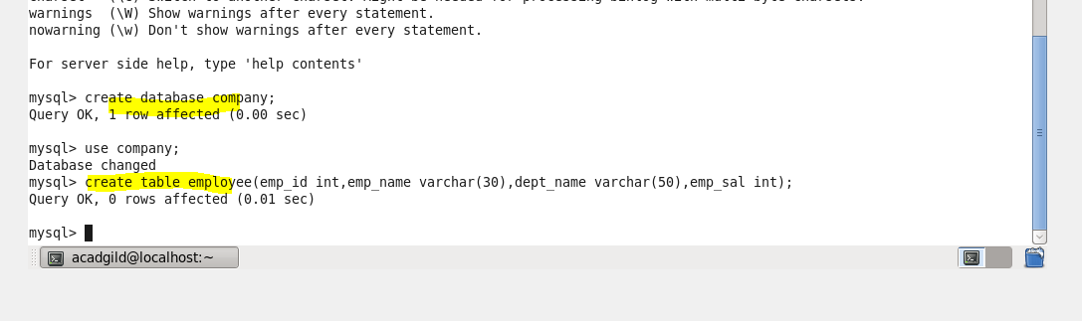

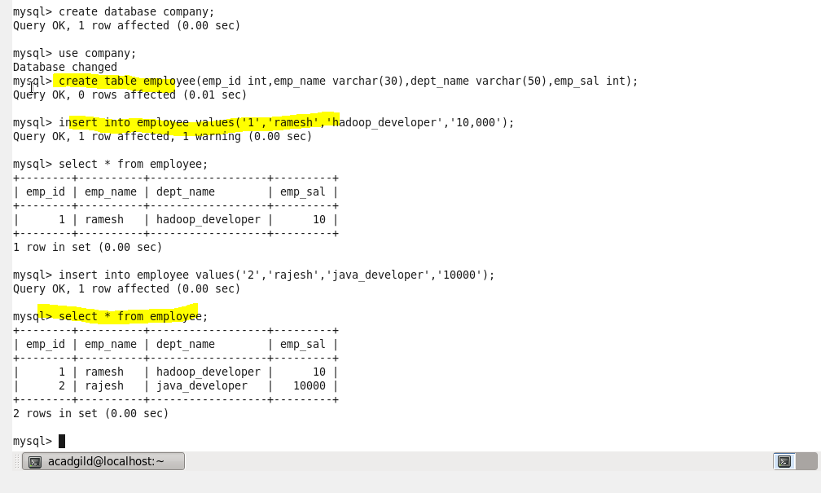

● Import the employee table contents into the HDFS directory using Sqoop

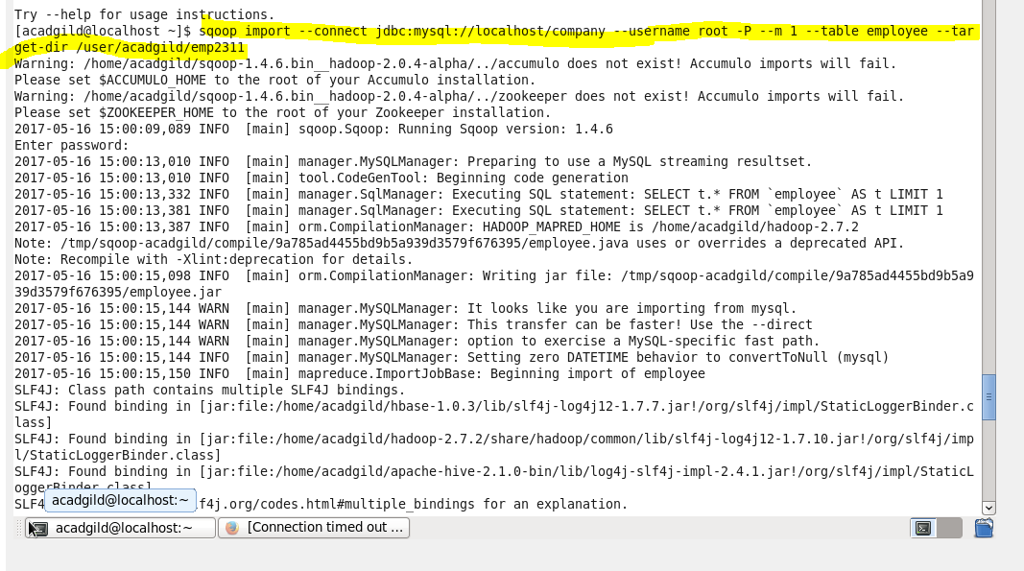

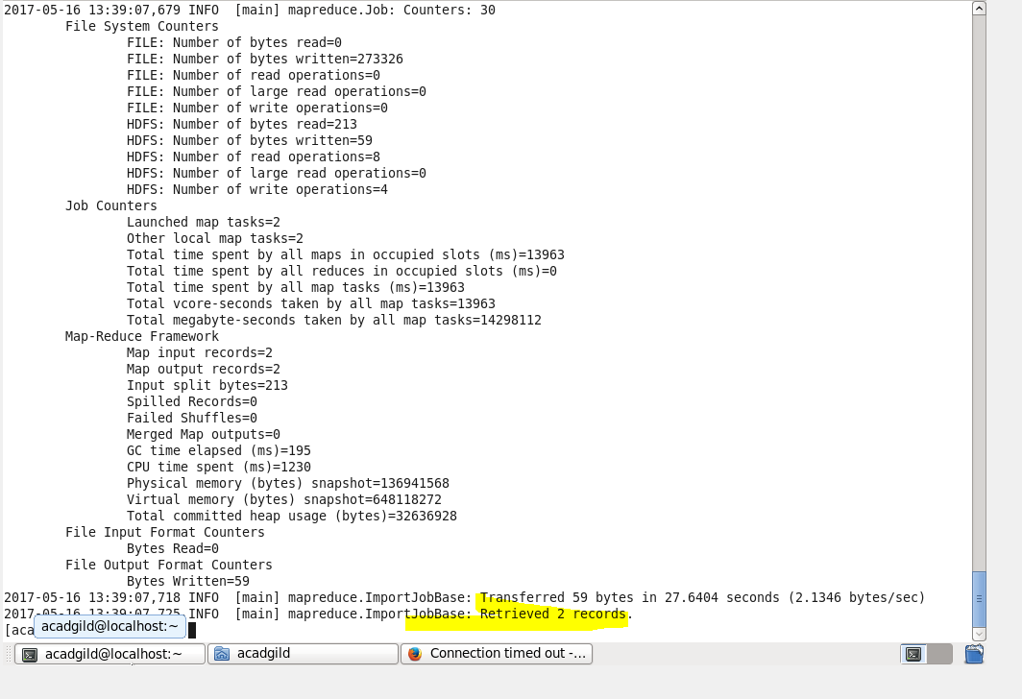

****records viewed from HDFS.

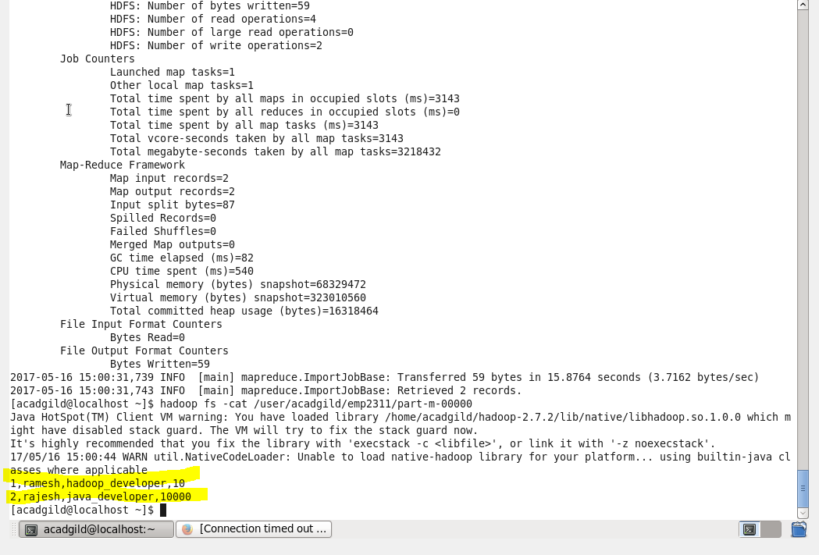

● Create a employee2 table in Mysql and Export employee details file from HDFS directory to Mysql table employee2 using Sqoop.

