**ASSIGNMENT 35.3**

* **Explain and perform Importing table contents from Mysql to Hive using Sqoop.**

sqoop import --connect jdbc:mysql://localhost:3306/company

--username root

-P

--m 1

--table customer

--target-dir /user/acadgild/hadoop/employee

--hive-import

--create-hive-table

--hive-table company_workspace.employee

here’s what the individual Sqoop command options mean:

* **connect –** provide JDBC string
* **username** – database username
* **-P**  – ask the password in the console. Alternatively, you can use **–password**, but this is not a good practice, as it's visible in your job execution logs and asking for trouble. One way to deal with this is to store the DB password in a file in HDFS and provide at runtime.
* **table –**tell which table you want to import from MySQL – here it's customer.
* m 1-1 mapper
* **target-dir** – HDFS destination dir.
* **hive-import** – Import table into the hive (uses Hive’s default delimiters if none are set).
* **create-hive-table** – If set, job will fail if Hive table already exists. It works in this case.
* **hive-table** – specify <db_name>.<table_name>. Here it's company_workspace.employee where company_workspace is my database and employee is the table name.

**IMPORT FROM MYSQL TO HIVE:**



**HIVE IMPORT COMPLETE:**

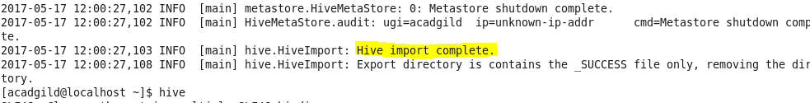

**OUTPUT ON HIVE:**

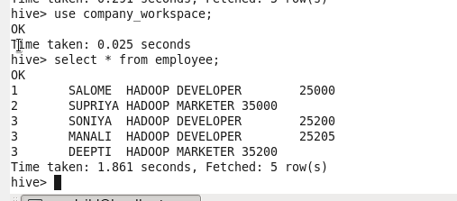

* **Explain and perform Importing table contents from Mysql to HBase using Sqoop.**

**Create Table Employee:**

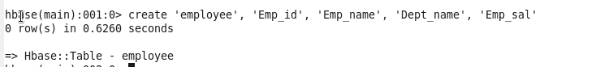**l**

**Sqoop Import Command:**



**Output:**

