**Problem Statement**

We have a dataset of travel data analysis

Column Name: Column 1: City pair (Combination of from and to): String Column 2: From location: String Column 3: To Location: String Column 4: Product type: Integer (1=Air, 2=Car, 3 =Air+Car, 4 =Hotel, 5=Air+Hotel, 6=Hotel +Car, 7 =Air+Hotel+Car) Column 5: Adults traveling: Integer Column 6: Seniors traveling: Integer Column 7: Children traveling: Integer Column 8: Youth traveling: Integer Column 9: Infant traveling: Integer Column 10: Date of travel: String Column 11: Time of travel: String Column 12: Date of Return: String Column 13: Time of Return: String Column 14: Price of booking: Float Column 15: Hotel name: String

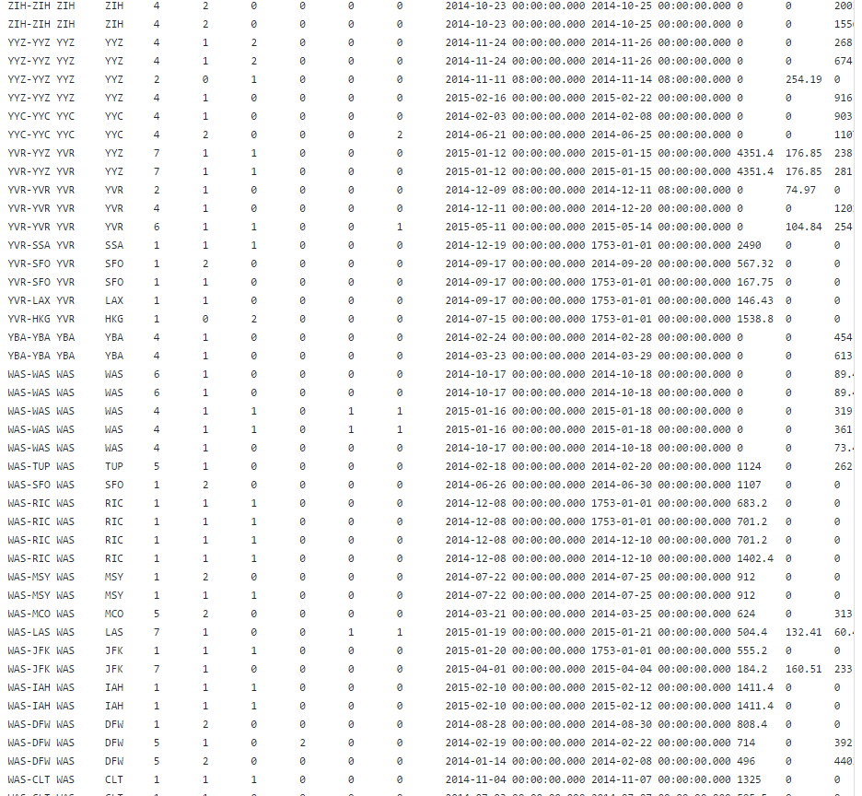

****************************************************************

The text output format separator is used in the driver class, so the output key and value is separated with comma.

****************************************************************

Find out how many people has chosen their destination as MIA and MCO

Driver:

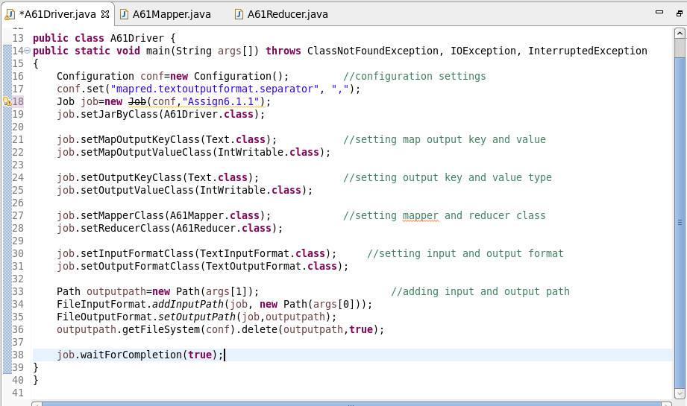

Mapper:

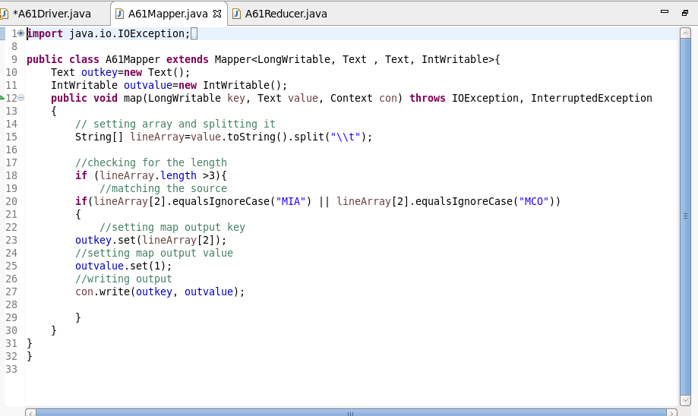

Reducer:

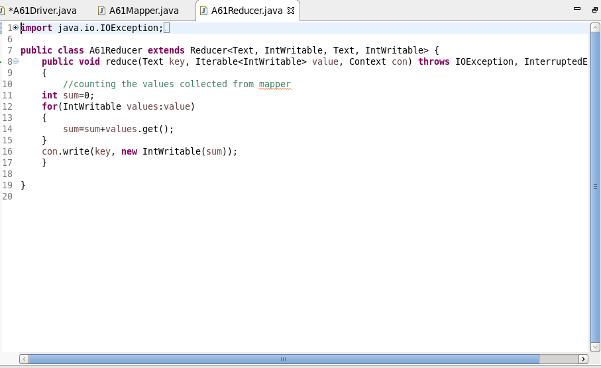

Result:

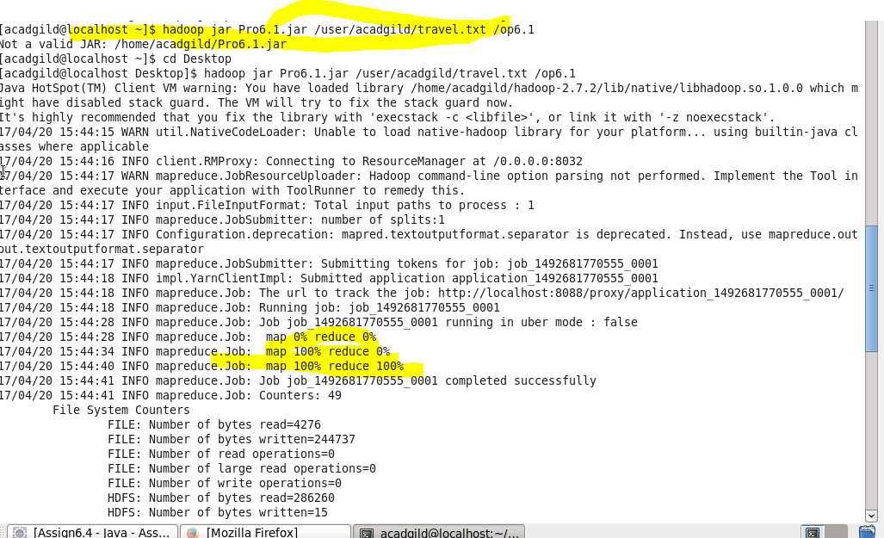



Find out the number of people undertaken the trips from the places MIA and HOU

Driver:

Driver is the same.



Mapper:

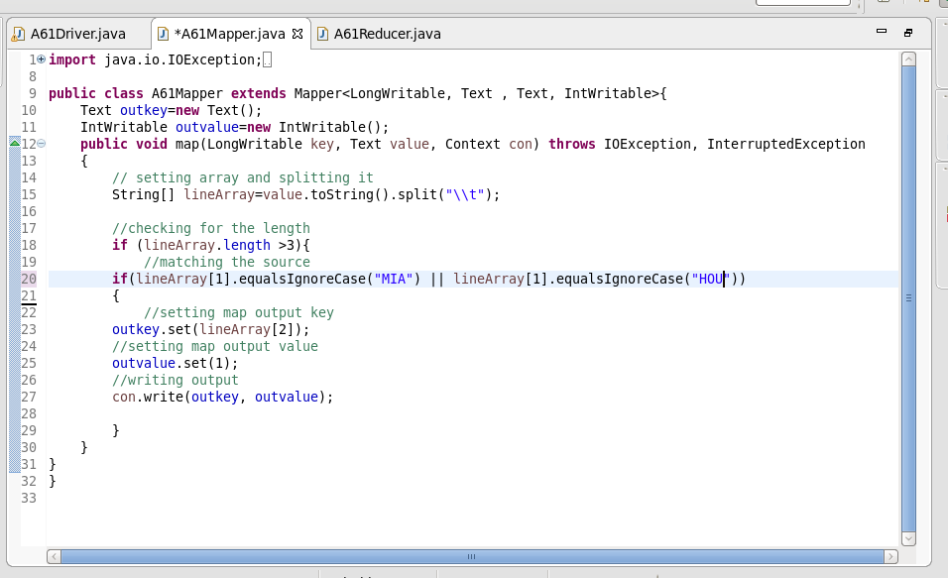

Reducer:

Remains the same.



Result:

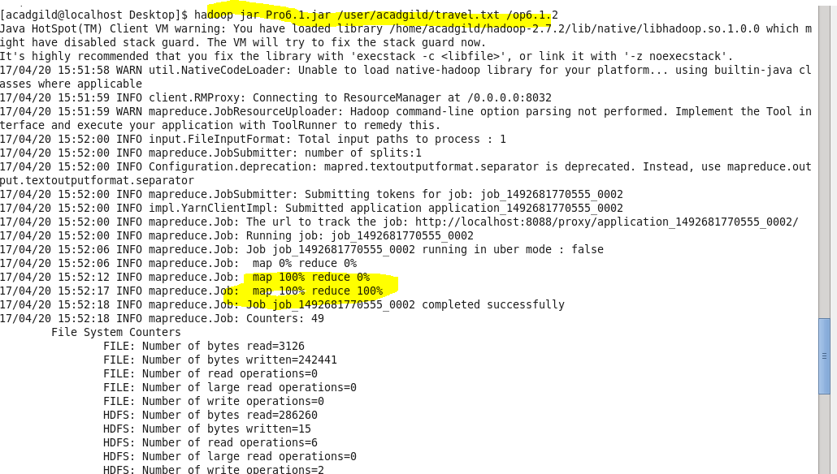

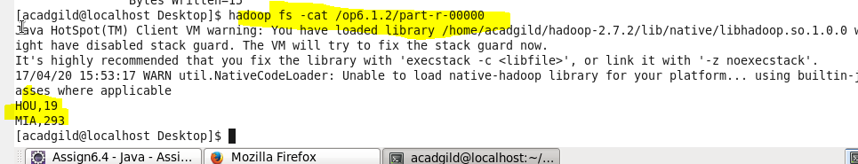

Find out how many people has chosen airline mode of travel for the places LAS and LAX

Driver:

Mapper:

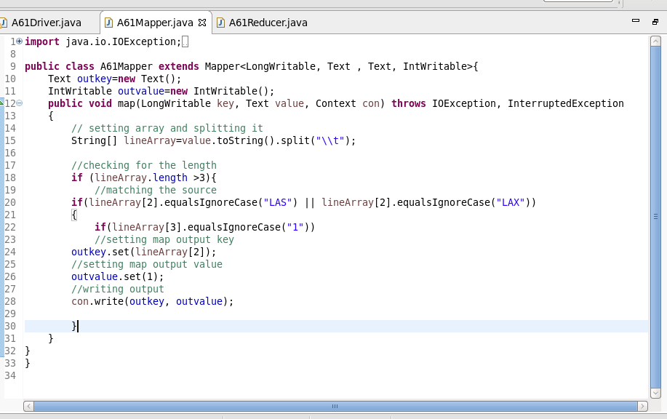

Reducer:

Remains same.

Result:

