Use key value output format to save the output of Session 6 – Assignment 1(Travel Data analysis) and save the output as comma (,) separated instead of tab(\t) separated.

Input file:

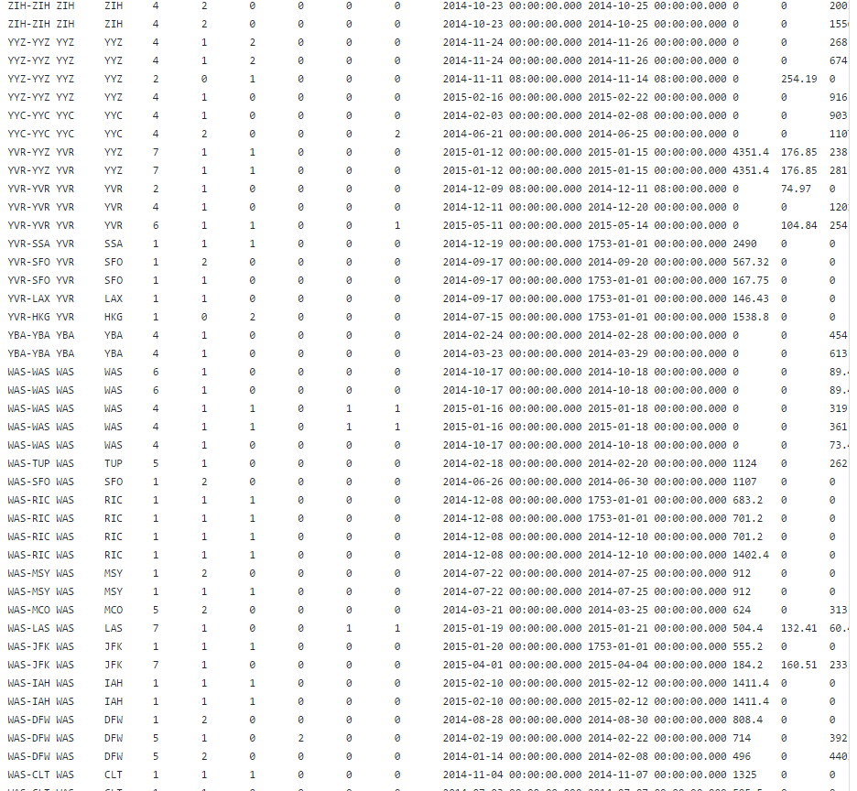

Driver:

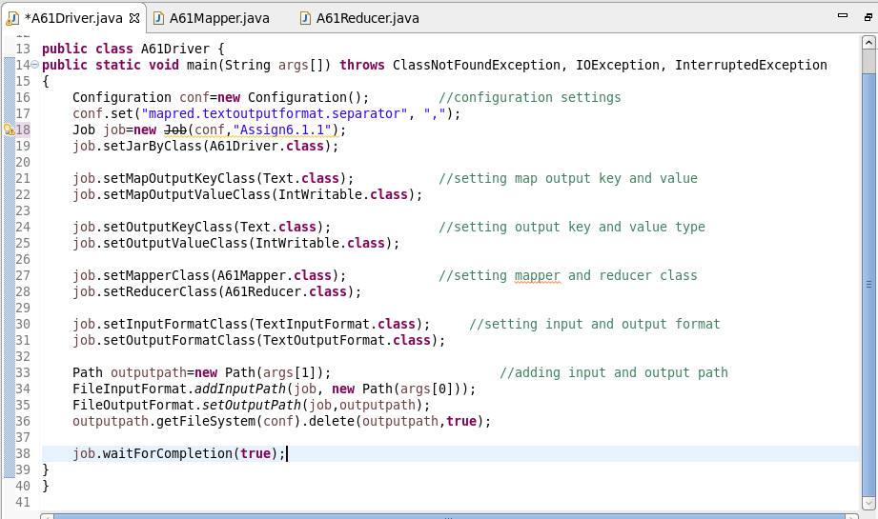

Mapper:

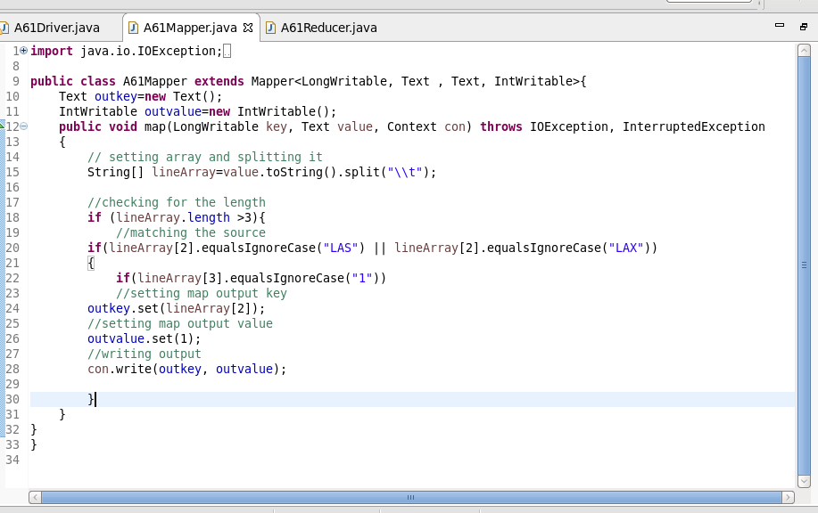

Reducer:

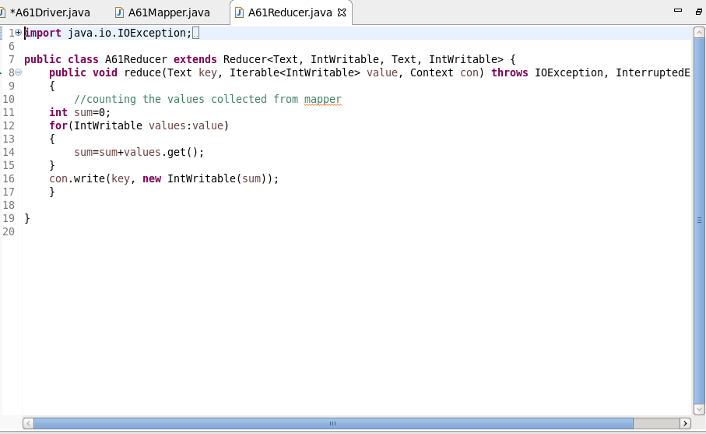

Result:

