ASSIGNMENT 6.3

**DATASET:**

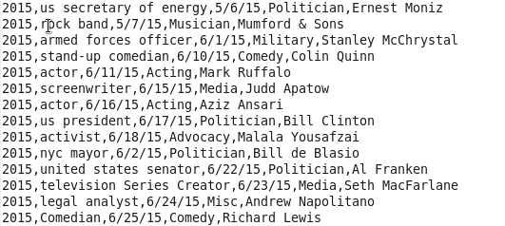

**DRIVER:**

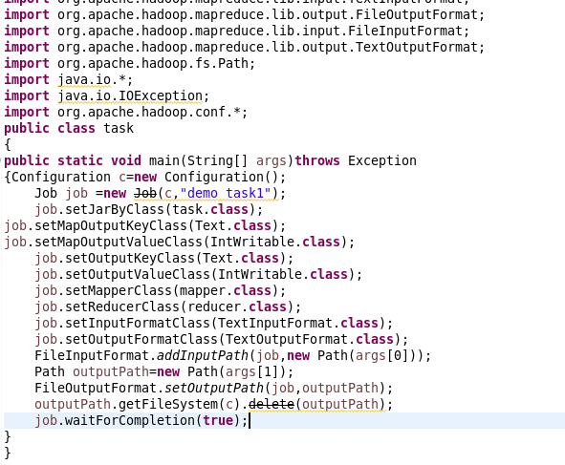

**REDUCER:**

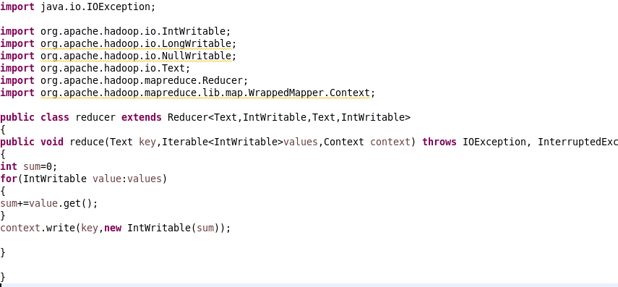

1. **Find the number of GoogleKnowledge occupation types in each group, who have been guests on the show**

**MAPPER:** 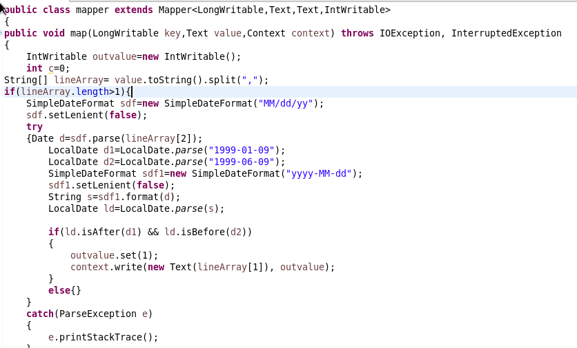

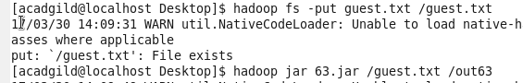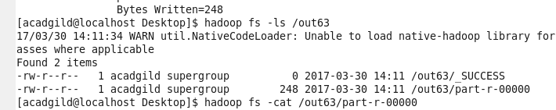

**OUTPUT:**

