**ASSIGNMENT 6.5**

**DATASET:** 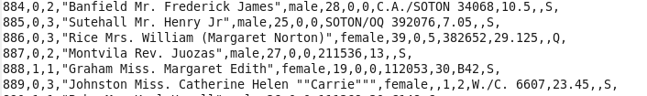

**DRIVER:**

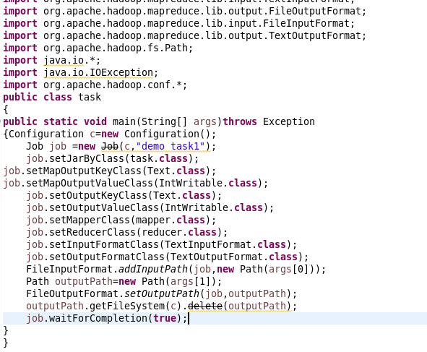

**REDUCER:**

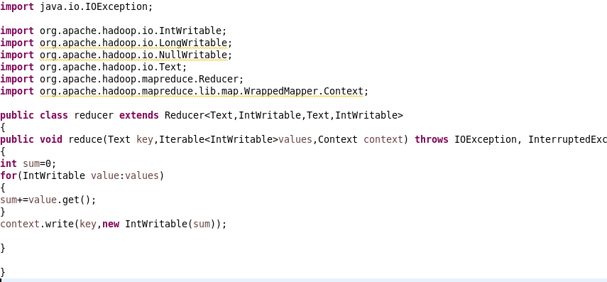

1. **Write a mapreduce code to find out number of males and females survived in the titanic tragedy and save the output in sequence file output format.**

**MAPPER: 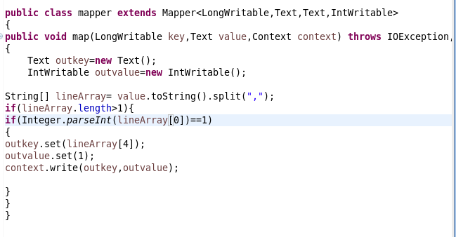OUTPUT:**

**C:\Users\612909\AppData\Local\Microsoft\Windows\Temporary Internet Files\Content.Outlook\DTK6JHGE\65out.PNG**