ASSIGNMENT8.1

Problem Statement:

1. Write a mapreduce program to find the total amount of petrol in volume sold by every distributor.

Solution:

Driver Class:

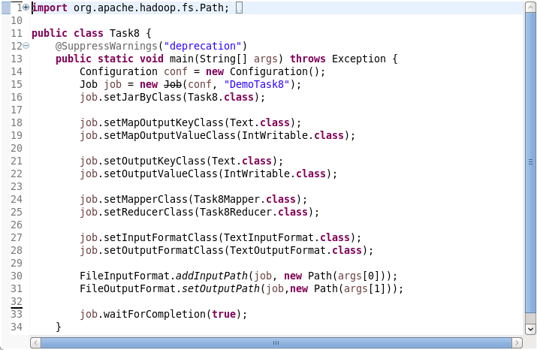

Mapper Class:

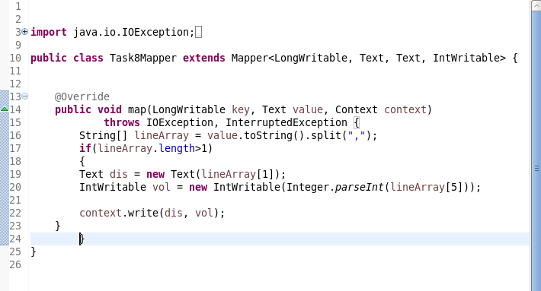

Reducer Class:

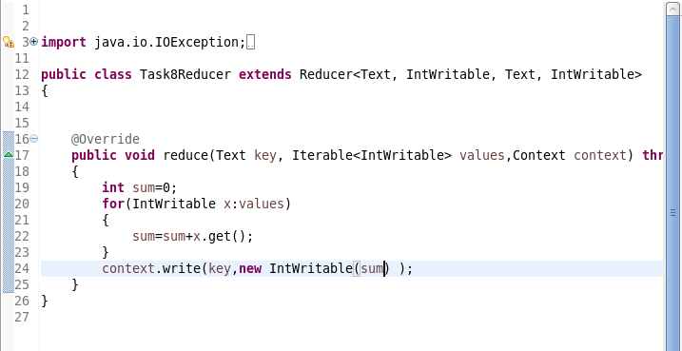

Execution Command:

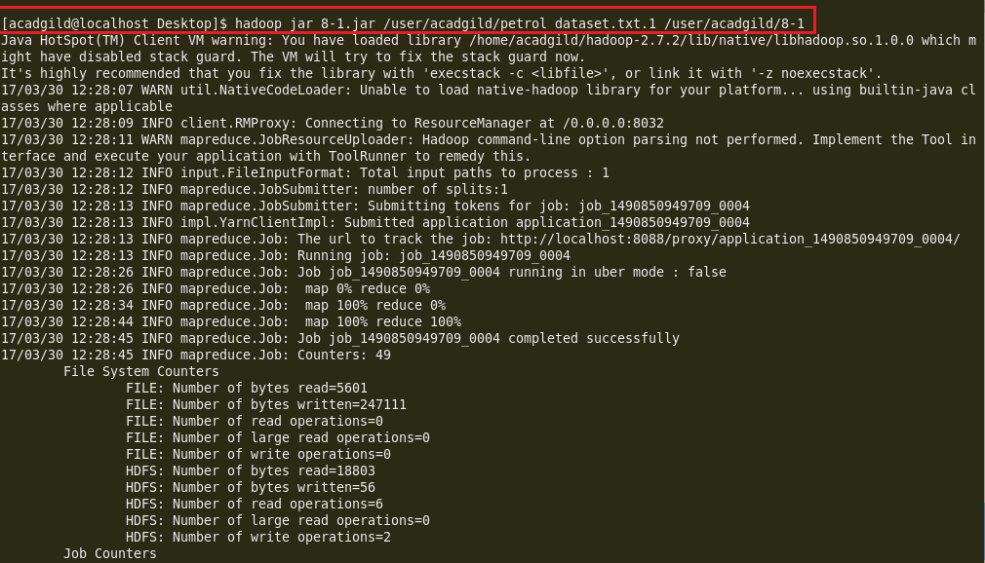

Output:

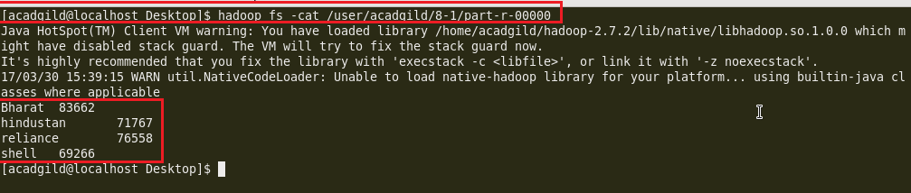

1. Write a mapreduce program to find which are the top 10 distributors ID's for selling petrol and also display the amount of petrol sold in volume.

Solution:

Driver Class:

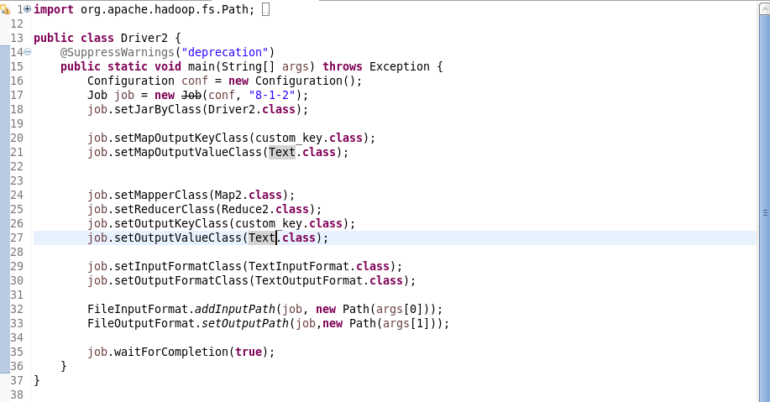

Mapper Class:

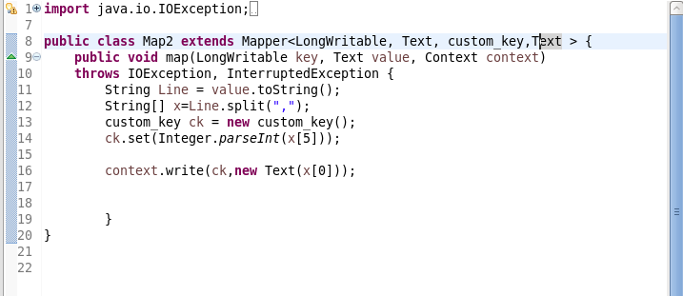

Reducer Class:

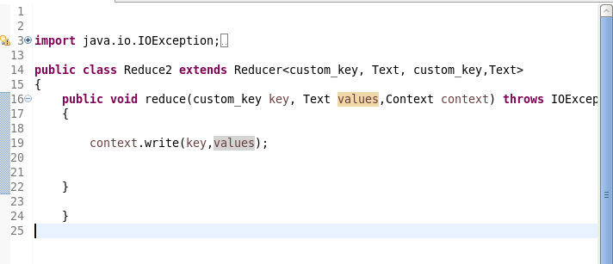

Custom key Class:

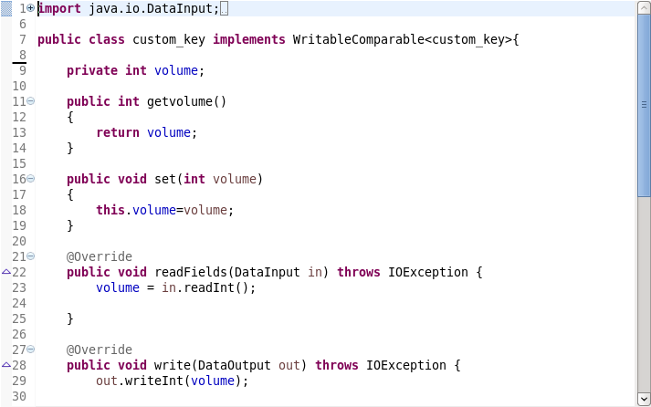

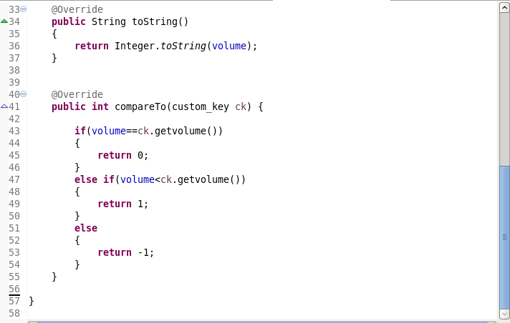

Execution Command:

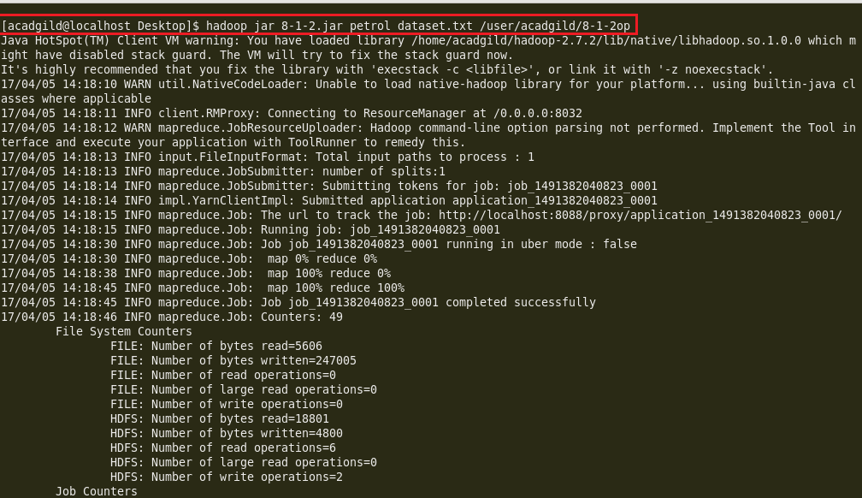

Output:

