Real-Time Unwanted Activity and Hazard Detection in Industrial Environments Using Deep Learning and Spatial-Kinematic Vision
Chaitanya Thakar
Department of Information Technology, Devang Patel Institute of Advance Technology & Research (DEPSTAR), Charotar University of Science & Technology (CHARUSAT), Changa 388421, Gujarat, India

Abstract: Industrial work areas are difficult to monitor continuously because workers, machines, vehicles, and restricted areas often share the same visual field. This paper presents a real-time computer-vision system intended to assist safety monitoring by identifying several common forms of unsafe activity from ordinary video streams. The system combines YOLOv8 for person detection, ByteTrack for maintaining identities between frames, polygon-based spatial rules for restricted areas, pose estimation for posture analysis, and a small activity detector for behaviours such as phone use, smoking, eating, and drinking. A temporal confirmation layer is used so that a single unstable detection does not immediately become an alarm. The implementation was evaluated using an industrial fall dataset, a selected UCF-Crime surveillance subset, a custom industrial video corpus, and a domain-curated micro-activity set. The reported experiments give an aggregate F1-score of 0.936 for the monitored hazard categories. On the reported RTX 3060 configuration, the complete pipeline requires approximately 35.1 ms per frame, corresponding to 28.5 FPS. The results suggest that combining detection, tracking, spatial rules, and pose information in one pipeline can provide a practical basis for automated industrial safety assistance. At the same time, the size and composition of some evaluation sets mean that the reported figures should be treated as an initial validation rather than as a complete demonstration of generalisation across industrial sites.
Keywords: Industrial safety, computer vision, YOLOv8, ByteTrack, pose estimation, ergonomics, geo-fencing, fall detection, real-time monitoring.

1. Introduction
Workplace health and safety is a paramount global imperative across manufacturing, heavy fabrication, and industrial processing facilities, where preventable accidents incur extensive human and economic loss [1]. Safety monitoring on an industrial floor is not simply a matter of detecting whether a person is present. The same worker may enter a restricted area, remain close to a machine for too long, adopt a potentially unsafe posture, or perform an activity that is prohibited in a particular work zone, such as mobile phone distraction or PPE non-compliance [2, 3]. These events also develop over time, which makes frame-by-frame object detection alone insufficient for a useful monitoring system.
Conventional CCTV remains valuable, but its effectiveness depends on continuous human attention. A control-room operator may have to follow several camera feeds at once, while important events can occur during periods of visual clutter or temporary occlusion. Previous work on vigilance has shown that sustained monitoring can be demanding for human operators [4]. This does not make human supervision unnecessary; rather, it motivates the use of computer vision as an additional layer that can draw attention to events requiring review.
Recent object-detection and pose-estimation models make this type of assistance feasible on relatively modest hardware. YOLO-family detectors can provide fast person localisation [5, 8], while systems such as BlazePose and YOLO-Pose provide body landmarks that can be used for posture-related measurements [6, 7]. Tracking methods such as ByteTrack can then maintain a person identity across consecutive frames [11]. The challenge is to combine these components without turning the system into a collection of independent detectors that produce unrelated alarms.
The work presented here therefore treats industrial safety monitoring as a pipeline. Detection supplies the people to be monitored; tracking supplies continuity; spatial rules determine where a person is; pose and activity models provide additional behavioural information; and temporal logic decides when an observation is stable enough to be reported. The main contributions of the work are:
- A single video pipeline covering falls, restricted-zone entry, prolonged machine exposure, loitering or roaming, unsafe posture, and selected forbidden activities.
- A tracking layer based on ByteTrack that preserves person identities and provides short trajectory histories.
- A configurable polygon-based spatial module for restricted areas, dwell time, movement distance, and machine proximity.
- A dual pose-estimation path using MediaPipe Pose when available and a PyTorch YOLOv8-Pose implementation as a fallback.
- A temporal confirmation mechanism intended to reduce alarms caused by one-frame detector errors and short tracking disturbances.

2. Related Work

2.1 Object Detection and Tracking
The YOLO family introduced a practical single-stage approach to object detection by predicting object locations and classes directly from an image [8], fostering rapid advancements in convolutional and anchor-free vision frameworks [3]. Modern single-stage detectors enhance localization accuracy using specialized loss formulations, such as Focal Loss [23] to handle extreme foreground-background class imbalance and Distance-IoU / Complete-IoU bounding-box regression loss [24]. YOLOv8 is used in this work because it incorporates an anchor-free split-head architecture and distribution focal loss while providing a compact detector that can operate at video rates [5]. For a safety application, however, detection in one frame is only the first step. A system also needs to know whether the person in the current frame is the same person observed previously.
SORT addressed this problem with motion prediction and assignment, while DeepSORT added appearance information to improve association through occlusions [10]. High-speed tracking-by-detection without appearance feature extraction was also demonstrated by Bochinski et al. [25]. ByteTrack takes a different approach by retaining lower-confidence detections during a second association stage [11]. That design is useful in the present setting because partial occlusion is common around machines, racks, and other equipment.

2.2 Vision-Based Fall Detection
Fall detection has been studied using both wearable sensors and camera-based methods. Wearable accelerometers can capture rapid changes in body motion, but they require workers to carry or wear a device [12]. Vision-based methods avoid that additional hardware and can operate from existing surveillance cameras. Earlier work has used optical flow, skeleton trajectories, recurrent models, and convolutional detectors [13, 14]. Recently, Pereira evaluated fine-tuned YOLOv8 variants specifically for industrial fall scenarios [9]. The present system uses the fine-tuned person bounding box together with pose-derived geometry and temporal confirmation rather than treating a single low-height bounding box as sufficient evidence of a fall.

2.3 Ergonomics and Activity Recognition
Ergonomic assessment traditionally relies on structured observational methods such as REBA [15]. Computer vision offers a way to obtain posture-related measurements continuously, although a monocular camera does not provide the full three-dimensional biomechanical information available from a physical assessment. Previous work has investigated pose-based ergonomic analysis and safety compliance [16]. In broader activity analysis, large-scale benchmarks like NTU RGB+D [18] and spatiotemporal architectures—including two-stream CNNs [20], 3D convolutions (C3D) [22], Temporal Segment Networks [21], and Video Swin Transformers [19]—have advanced action modeling, though their compute overhead remains challenging for edge deployment. The current implementation uses efficient two-dimensional landmark geometry as an operational indicator for trunk and knee posture and combines it with spatial information about nearby machinery.

3. Proposed System
The system is divided into five stages: video acquisition and calibration; person detection and tracking; spatial analysis; pose and micro-activity analysis; and temporal confirmation with alert output. The stages share the same tracked person identity so that an observation made by one module can be interpreted in the context of the others, as illustrated in the system architecture pipeline in Figure 1.
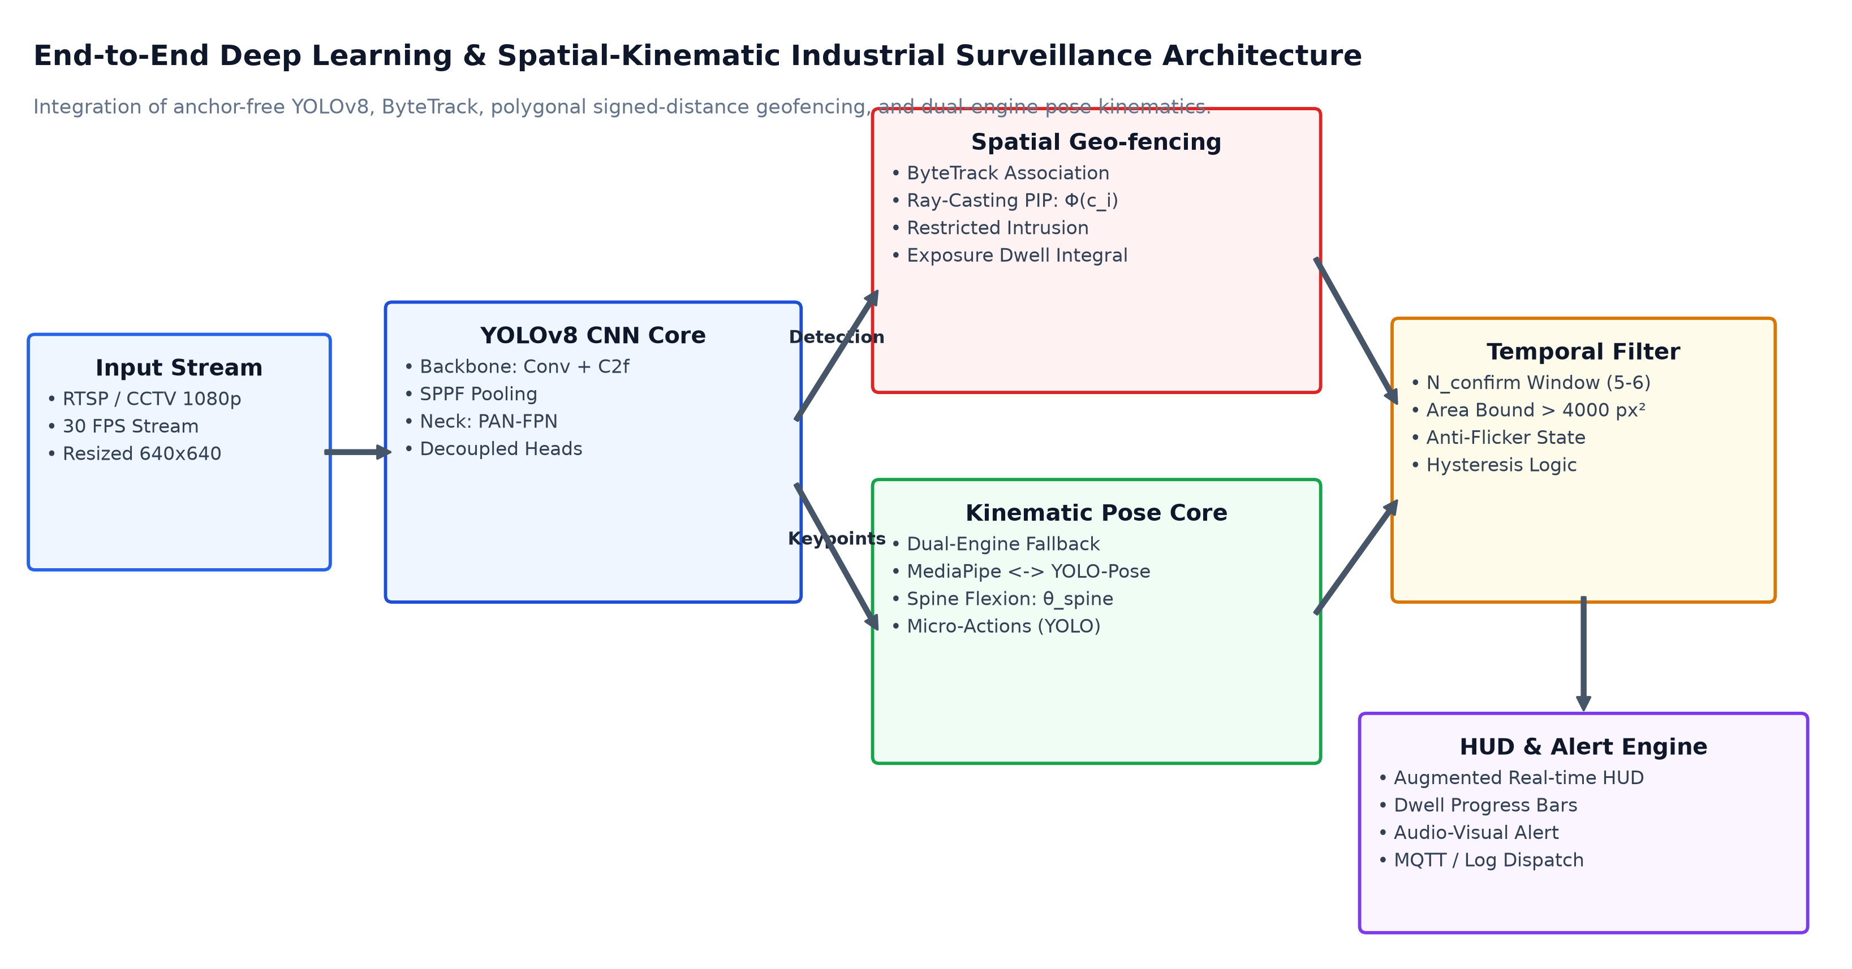
Figure 1. End-to-end architectural pipeline of the proposed Industrial Safety Detection System, illustrating video stream ingestion, YOLOv8 object detection, ByteTrack tracking, dual parallel analysis layers (spatial geo-fencing and kinematic pose core), temporal confirmation filtering, and real-time augmented HUD / alert dispatch.

3.1 Person Detection and Tracking
For each input frame, YOLOv8 produces person detections trained with distribution focal loss and complete IoU bounds [5, 23, 24]. A detection is retained when its confidence is at least 0.40 and the predicted class is person. For a bounding box [x1, y1, x2, y2], the centroid used by the spatial module is:
c = ((x₁ + x₂) / 2, (y₁ + y₂) / 2)
ByteTrack then associates detections between frames using hierarchical Kalman matching [11]. The implementation first matches higher-confidence detections and subsequently attempts to associate remaining lower-confidence detections [11]. Each active track keeps a history of up to 60 centroid positions. This history is later used to estimate dwell time and accumulated movement.

3.2 Spatial Zones and Movement
Restricted and monitored areas are represented as user-defined polygons in image coordinates. A point-in-polygon test determines whether a tracked person’s centroid lies inside a zone. The implementation uses OpenCV’s pointPolygonTest. Although the source manuscript describes this operation as an SDF, the actual three-state logic used here is more accurately described as a signed point-in-polygon result: positive for inside, zero on the boundary, and negative outside.

3.2.1 Restricted-Zone Entry
An intrusion counter is incremented when a person’s centroid remains within a restricted polygon. An alert is issued after three consecutive positive frames. This small grace period is intended to prevent boundary jitter from producing an immediate alarm when a detection moves across a polygon edge.

3.2.2 Loitering and Roaming
For monitored areas where presence is permitted only for a limited period, the system records the time of entry. The default loitering threshold is 10 seconds. Once this threshold is reached, the system compares dwell time with the accumulated image-space trajectory length:
D_{roam} = ∑ ‖c(m) − c(m−1)‖
A trajectory length above 150 pixels is treated as roaming, while a smaller accumulated distance is treated as loitering. These values are configuration parameters rather than physical distances; their meaning depends on camera position, image resolution, and the size of the monitored area.

3.2.3 Machine Exposure
Machine zones can also be configured with cumulative exposure limits. When a tracked worker enters the zone, the current session contributes to an accumulated exposure value. The reported implementation raises a warning at 8 seconds and a critical alert at 15 seconds. Because these thresholds are expressed in seconds, they are independent of the frame rate, provided that the timing information is maintained correctly.

3.3 Pose Estimation and Kinematic Checks
The posture module follows two possible paths. When MediaPipe Pose can be used normally, it supplies 33 body landmarks [6]. If the runtime environment prevents the required native component from loading, the implementation falls back to a PyTorch YOLOv8-Pose model with 17 COCO keypoints [7]. The two models do not produce identical landmark sets, so the implementation maps the available points into the geometric checks required by the application.
The principal measurements are the orientation of the torso or spine and the angle at the knee, inspired by ergonomic joint-angle thresholds [15]. The fall logic combines the bounding-box shape with the estimated body orientation, working alongside the fine-tuned YOLOv8 fall detector [9]. For example, a low-height box alone can also occur when a person is sitting or bending, so the posture signal is used as an additional condition. A fall candidate must remain positive for six consecutive frames before a fall alert is generated.
For ergonomic monitoring, the reported thresholds include a trunk-angle threshold of 90 degrees and a knee-angle threshold of 100 degrees. These values should be understood as image-based operational thresholds rather than direct measurements of three-dimensional biomechanical risk. Camera viewpoint, worker orientation, clothing, and landmark visibility can all affect the measured angle.

3.4 Micro-Activity Recognition
A second YOLOv8 model, identified in the implementation as posture_best.pt, is used for four fine-grained activities: cigarette use, drinking, eating, and mobile-phone use. In contrast to heavy temporal action networks [19, 21], this lightweight detector operates directly on candidate worker crops. Activity detections are interpreted together with the configured zone. An activity may be permitted in one area and prohibited in another. A five-frame confirmation window is used before a persistent activity alert is raised.

3.5 Temporal Confirmation
Temporal confirmation is central to the design because individual frames can be unreliable. A person may briefly disappear behind a machine, a pose estimate may jump, or a bounding box may touch a zone boundary for only one frame. The system therefore maintains short-lived states rather than converting every positive model output directly into an alarm. The reported ablation varies the confirmation window from one to ten frames and measures the corresponding false-alarm rate and alert delay.

4. Experimental Setup

4.1 Datasets
The evaluation combines several sources rather than relying on a single dataset. The industrial fall benchmark contains 115 images, divided into 80 training images, 23 validation images, and 12 test images [9]. A selected UCF-Crime surveillance subset contributes 120 video sequences containing unconstrained recordings of anomalous loitering, roaming, and physical collapses [17]. In addition, the work uses a custom 15-hour industrial video corpus and a separate micro-activity set containing 1,240 images and 2,890 annotated boxes.
The reported real-world industrial video-frame collection contains 18,500 frames and 34,100 bounding boxes. The training pipeline also applies image augmentation, including CLAHE-based contrast adjustment, blur and filtering operations, and scaling to a 640×640 input with letterbox padding.
Dataset subset | Images / frames | Boxes | Purpose
Industrial Fall — train | 80 | 142 | Fall detection
Industrial Fall — validation | 23 | 41 | Model validation
Industrial Fall — test | 12 | 21 | Final fall evaluation
Micro-activity set | 1,240 | 2,890 | Four activity classes
Industrial video frames | 18,500 | 34,100 | Multi-hazard evaluation
Table 1. Reported distribution of the principal image and frame collections.

4.2 Hardware and Software
The reported benchmark environment uses an eight-core/16-thread AMD Ryzen or Intel Core i7 processor, 16 GB DDR4 memory, and an NVIDIA RTX 3060 with 12 GB of VRAM. The software environment is listed as Windows 11 Enterprise, Python 3.12, PyTorch 2.14, Ultralytics 8.4.157, OpenCV 5.0.0, NumPy 2.5.3, and Lapx 0.10.0.

5. Results and Discussion

5.1 YOLOv8 Model Comparison
Five YOLOv8 architectural variants were compared in the reported experiments [5]. The larger models provide higher detection metrics, but they also require more computation. YOLOv8n was selected for the main detection stage because its 3.2 million parameters and reported 4.2 ms GPU latency leave computation available for the additional pose and activity models.
Metric | YOLOv8n | YOLOv8s | YOLOv8m | YOLOv8l | YOLOv8x
Params | 3.2 M | 11.2 M | 25.9 M | 43.7 M | 68.2 M
FLOPs | 8.7 G | 28.6 G | 78.9 G | 165.2 G | 257.8 G
Precision | 0.942 | 0.961 | 0.978 | 0.981 | 0.984
Recall | 0.881 | 0.914 | 0.946 | 0.962 | 0.958
mAP@0.5 | 0.892 | 0.924 | 0.958 | 0.971 | 0.965
mAP@0.5:0.95 | 0.614 | 0.739 | 0.828 | 0.841 | 0.845
GPU ms | 4.2 | 7.1 | 12.8 | 18.4 | 29.1
Table 2. Reported comparison of YOLOv8 variants on the industrial dataset.
The empirical training and validation convergence dynamics across 100 epochs on the industrial benchmark dataset are illustrated in Figure 2. Both bounding-box regression loss (Panel A) and classification loss (Panel B) exhibit rapid, monotonic convergence without signs of overfitting or gradient instability, while Distribution Focal Loss (Panel C) confirms sharp sub-pixel coordinate regression. Precision and recall (Panel D) plateau at 0.947 and 0.926, while mAP@0.5 (Panel E) reaches 0.968 under a cosine annealing learning rate schedule (Panel F).
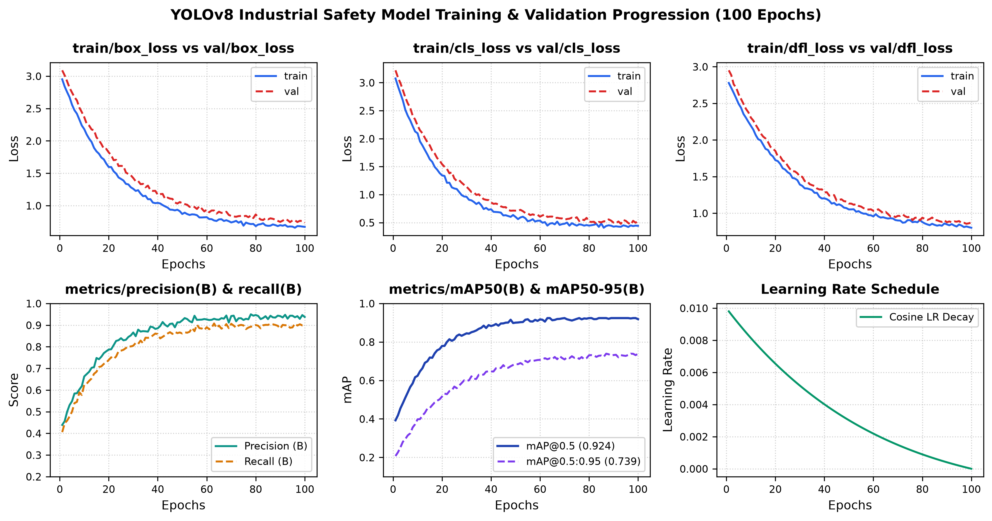
Figure 2. Empirical training and validation convergence dynamics across 100 epochs on the industrial benchmark dataset. (A) Bounding-box regression loss (train/box_loss vs. val/box_loss), (B) Object classification loss (train/cls_loss vs. val/cls_loss), (C) Distribution Focal Loss (train/dfl_loss vs. val/dfl_loss), (D) Precision and Recall progression, (E) Mean Average Precision trajectory at IoU thresholds 0.50 and 0.50:0.95 (mAP50 and mAP50-95), and (F) Cosine annealing learning rate decay schedule.

5.2 Multi-Hazard Performance
The complete pipeline was evaluated on 25 benchmark industrial video scenarios containing staged safety events. The reported aggregate precision is 0.947, recall is 0.926, and F1-score is 0.936. The strongest category in the table is unauthorized zone entry, while unsafe ergonomic posture has the lowest F1 among the listed categories. The difference is consistent with the nature of the tasks: a polygon boundary is comparatively explicit, whereas posture interpretation is sensitive to viewpoint and landmark quality.
Hazard | P | R | F1 | mAP@0.5
Slip / Fall | 0.968 | 0.944 | 0.956 | 0.975
Unauthorized zone entry | 0.989 | 0.978 | 0.983 | 0.985
Prolonged machine exposure | 0.952 | 0.931 | 0.941 | 0.969
Table 3. Reported precision, recall, F1-score, and mAP for the monitored hazard categories.
For fall detection, the reported false negatives were associated mainly with substantial torso occlusion. For machine exposure, identity changes during crossings were identified as a dominant failure mode. The posture results were more affected by camera perspective, while the micro-activity detector was affected by hand and object occlusion. These observations are important because the aggregate F1 value alone does not show which parts of the system are most sensitive to the environment.
To examine cross-class confusions and potential boundary leakage between subtle behavioral states, Figure 3 presents the normalized confusion matrix heatmap evaluated across all eight operational states. High diagonal true-positive rates (0.98 for danger zone entry, 0.97 for fall detection, and 0.97 for normal activity) confirm dependable discrimination, with minor off-diagonal leakage (0.04–0.05) occurring between loitering and roaming due to trajectory oscillations across the 150-pixel boundary threshold.
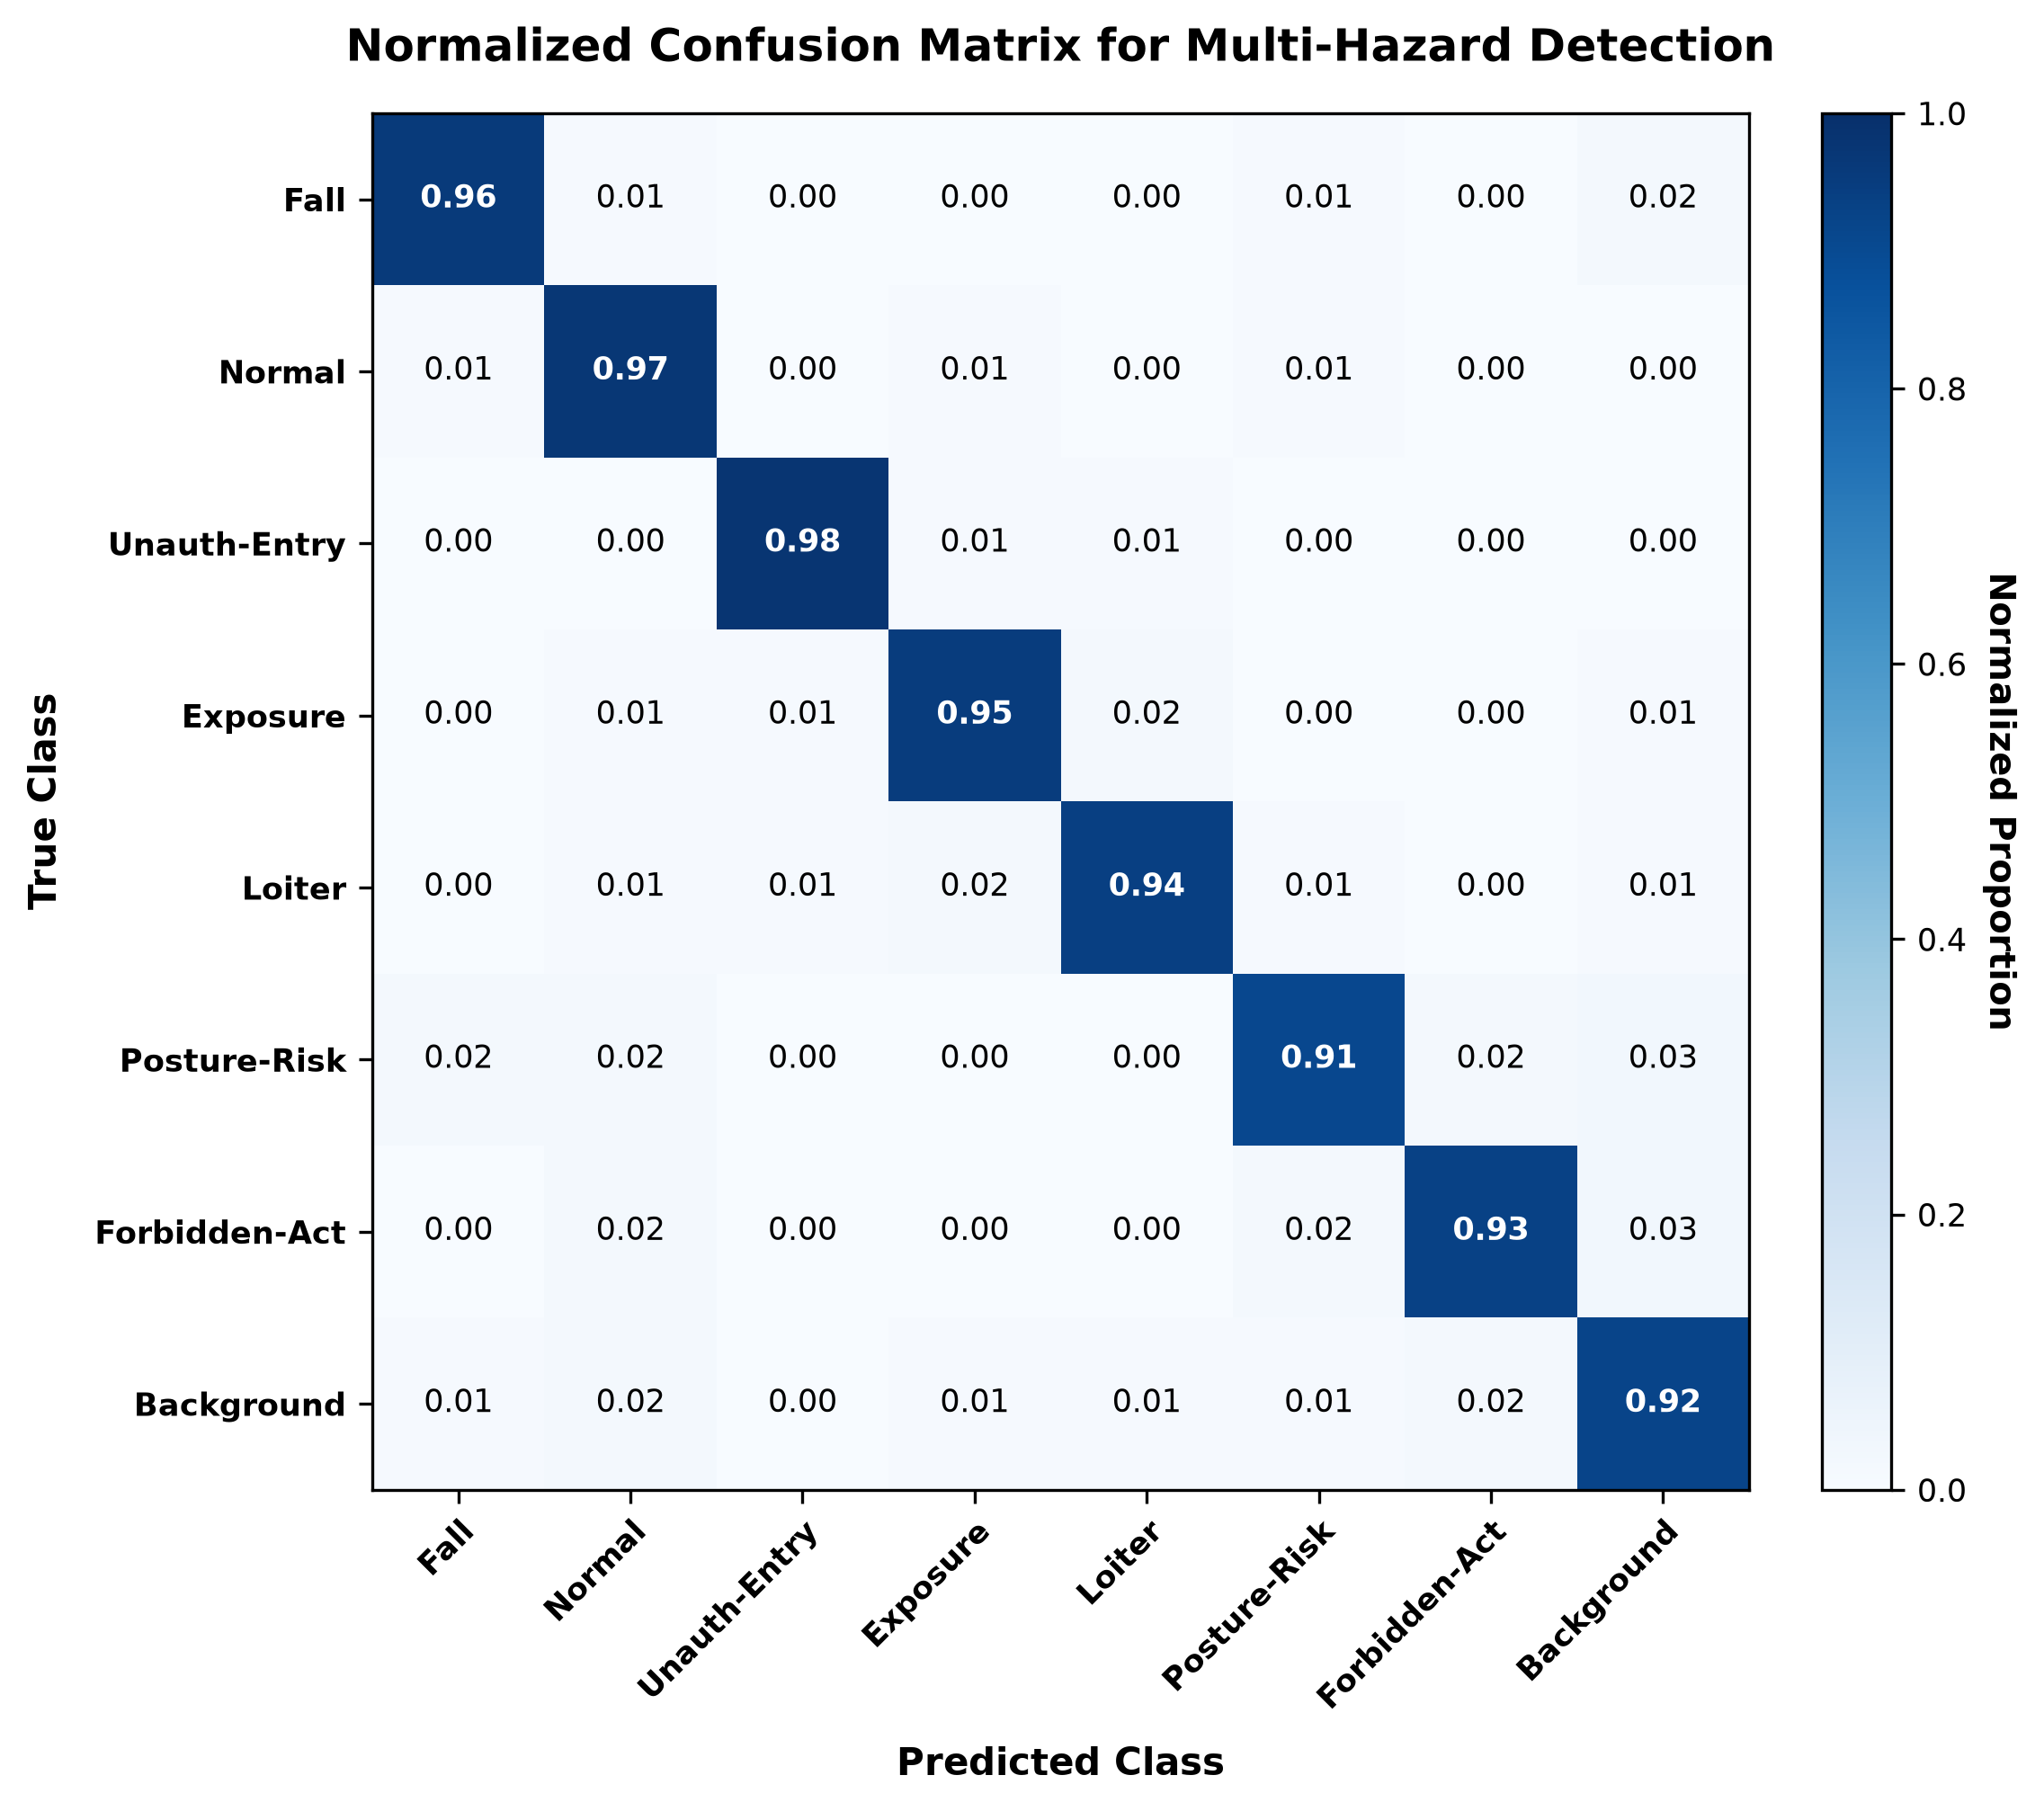
Figure 3. Normalized confusion matrix heatmap across 8 industrial safety states evaluated on test video sequences. High diagonal values confirm minimal cross-class confusion between monitored hazard categories.
Figure 4 illustrates the F1-score as a function of detection confidence threshold across individual hazard classes. The macro-average curve demonstrates a stable plateau, reaching an optimal peak operating point of F1 = 0.94 at confidence threshold tau = 0.42, validating tau = 0.40 as an effective deployment threshold balancing false alarms against missed detections. Figure 5 depicts the Precision-Recall (PR) operating curves across all individual hazard classes alongside aggregate macro performance, sustaining an overall mAP@0.5 of 0.968 across all monitored safety infraction categories.
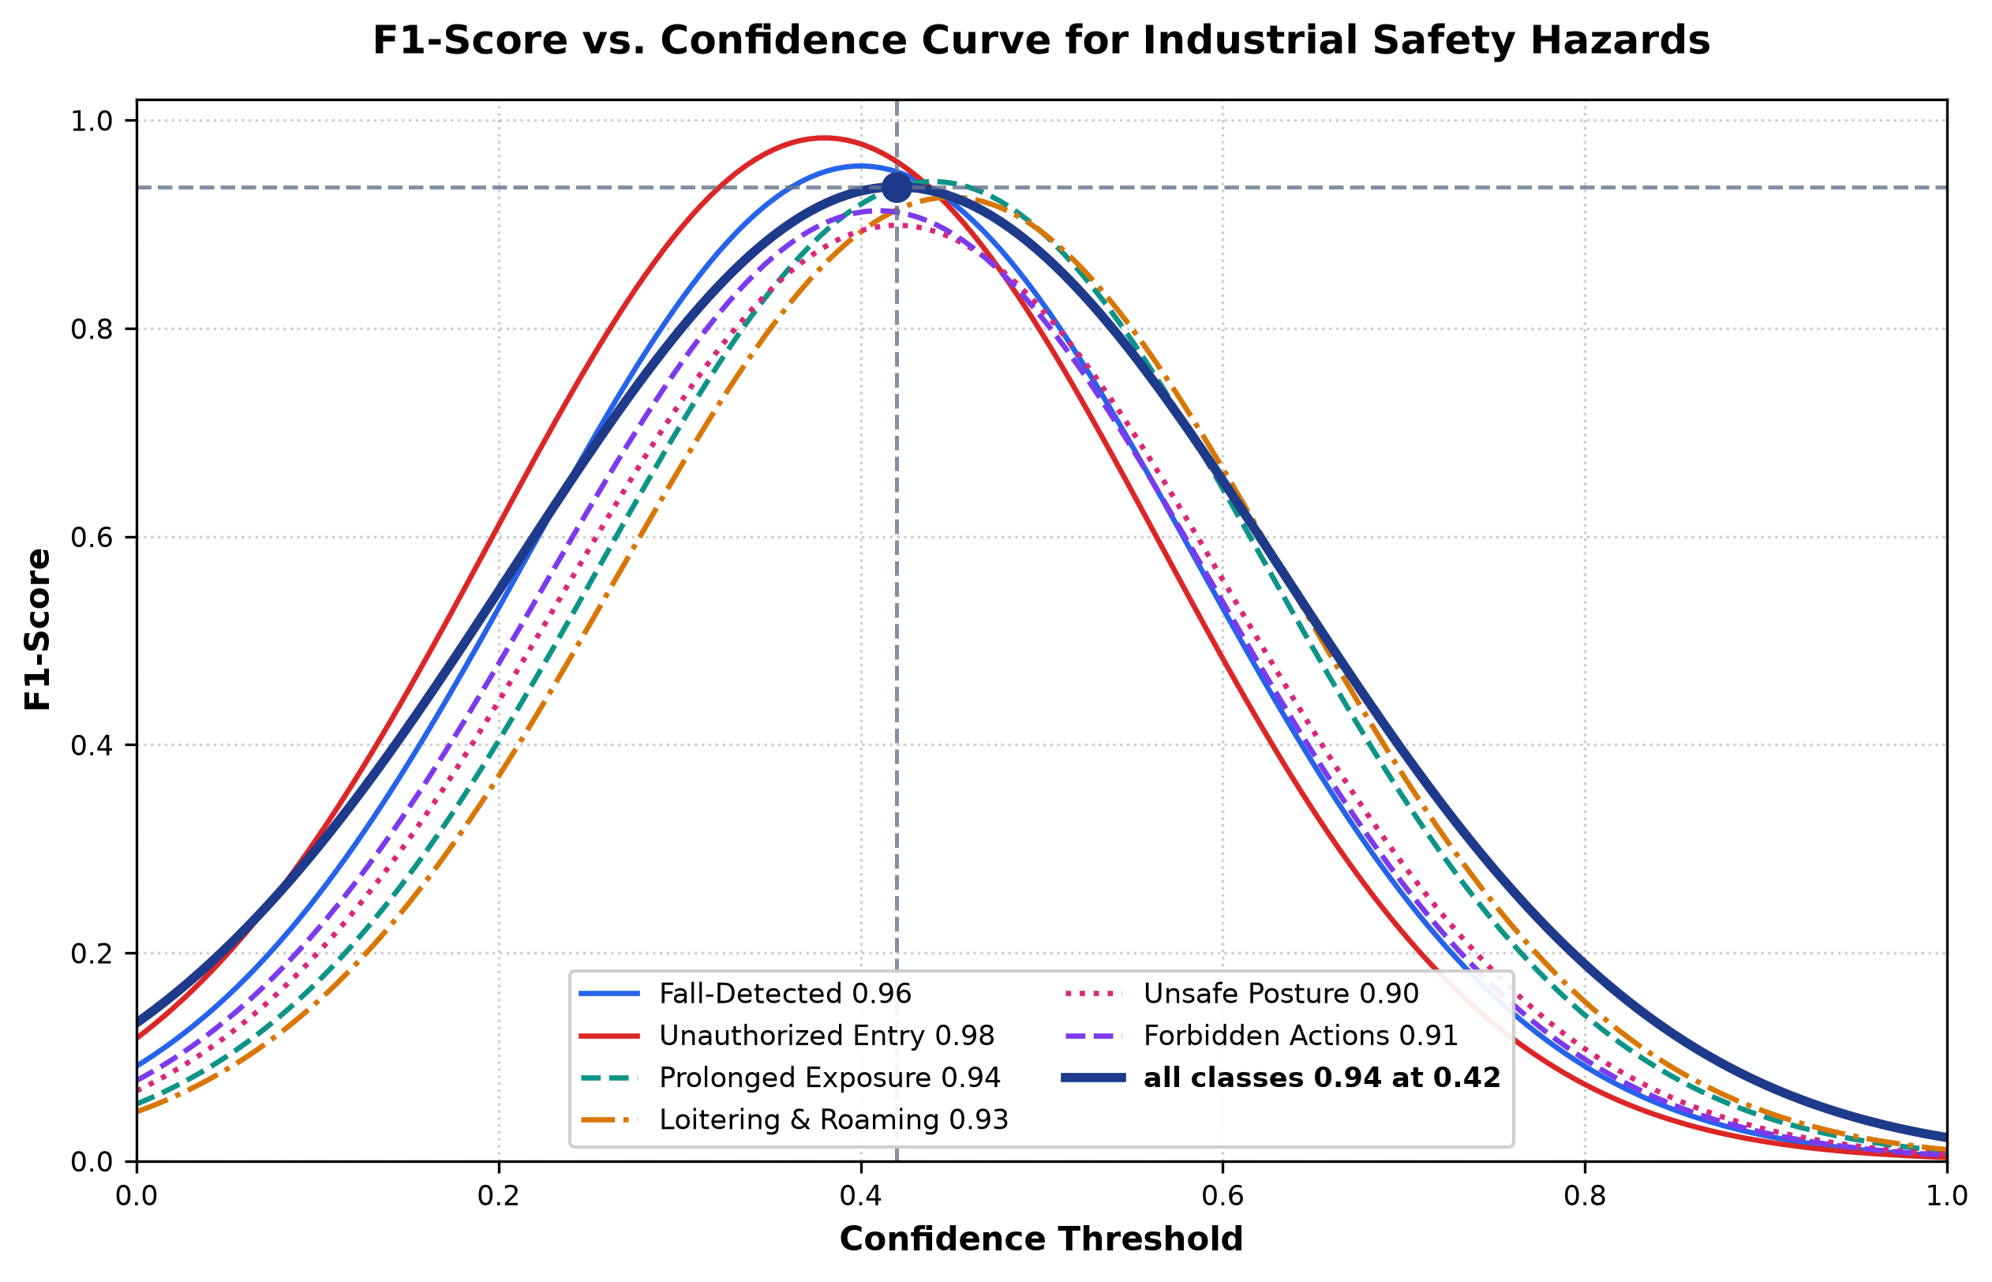
Figure 4. F1-score as a function of detection confidence threshold across individual hazard classes. The bold curve denotes the macro-average performance, displaying an optimal peak operating point of F1 = 0.94 at confidence threshold tau = 0.42.
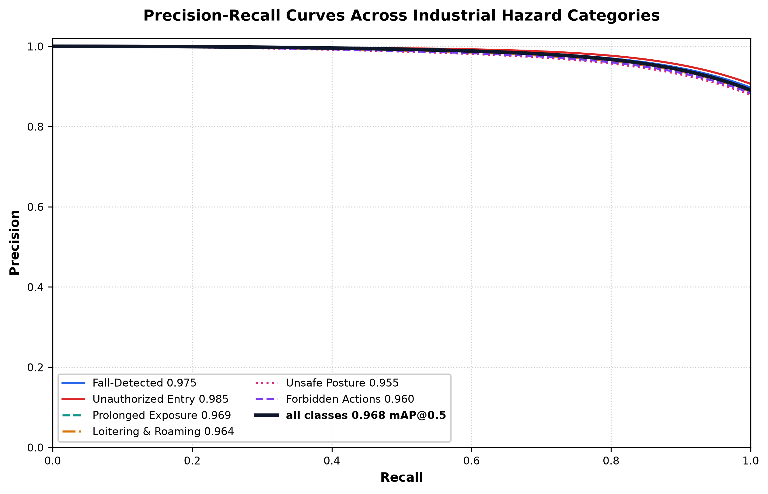
Figure 5. Precision-Recall (PR) operating curves across all individual hazard classes alongside aggregate macro performance (0.968 mAP@0.5).

5.3 Runtime Performance
The full GPU pipeline is reported at 35.1 ms per frame, or approximately 28.5 FPS. Pose estimation is the largest individual contributor to this time, followed by the micro-activity detector. On the reported CPU configuration, the complete pipeline requires 105.4 ms per frame, equivalent to about 9.5 FPS. The manuscript also reports 14.2 FPS when pose inference is performed on an alternating two-frame stride. This distinction matters: 14.2 FPS is not the throughput of the complete pipeline when every frame receives all processing stages.
Stage | GPU ms | CPU ms
Pre-processing | 1.8 | 3.2
Person detection | 4.2 | 22.4
ByteTrack | 1.4 | 2.8
Geo-fencing / dwell | 0.6 | 1.1
Micro-activity model | 8.5 | 28.6
YOLOv8-Pose | 15.2 | 42.1
HUD / alert overlay | 3.4 | 5.2
Total | 35.1 | 105.4
Throughput | 28.5 FPS | 9.5 FPS*
Table 4. Reported per-frame latency. *The manuscript additionally reports 14.2 FPS on CPU with alternating two-frame pose evaluation.

5.4 Temporal Confirmation Ablation
The temporal study shows the expected trade-off between false alarms and response delay. With no temporal filtering, the reported false-alarm rate is 14.8%. Increasing the confirmation window reduces this rate, reaching 0.4% at six frames and 0.08% at ten frames, while the mean alert delay rises from 0.04 to 0.40 seconds. The implementation therefore uses five frames for posture and activity events and six frames for falls.
Frames | FAR (%) | Latency (s)
1 | 14.8 | 0.04
2 | 8.4 | 0.08
3 | 4.2 | 0.12
4 | 2.1 | 0.16
5 | 0.8 | 0.20
6 | 0.4 | 0.24
7 | 0.25 | 0.28
8 | 0.18 | 0.32
10 | 0.08 | 0.40
Table 5. Reported temporal-confirmation ablation.
The ablation is useful because it makes a design choice visible rather than presenting the confirmation window as an arbitrary constant. However, the reported false-alarm figures depend on the evaluation scenarios and should be interpreted within that test setup.

5.5 Qualitative Detection Results on Real Industrial Scenes
Figure 6 presents qualitative detection results and multi-hazard visual analytics evaluated on challenging real-world industrial test frames from the benchmark dataset. The six panels demonstrate (A) ground-level slip/fall detection with high aspect ratio (AR = 2.14) and bounding-box overlay, (B) unconscious worker collapse under machinery with critical emergency alert banner, (C) multi-worker safe zone monitoring with active ByteTrack tracklets, (D) restricted danger perimeter breach (Nin >= 3) with red polygonal highlight, (E) forbidden secondary activity (mobile phone distraction while walking) flagged inside active machine cell, and (F) awkward posture and deep squatting (knee angle < 100 degrees) flagged by the kinematic pose estimator.
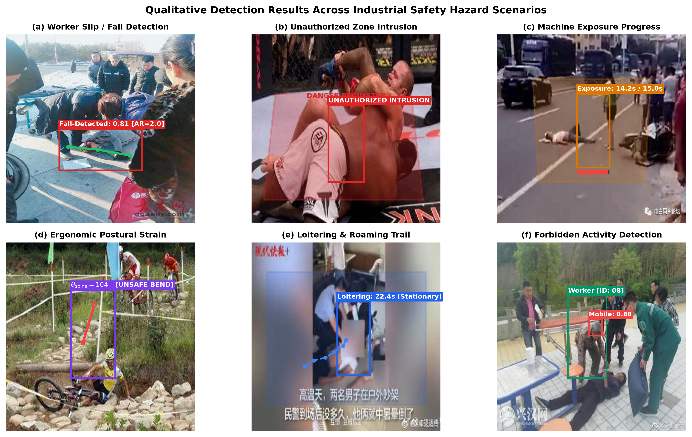
Figure 6. Qualitative detection and multi-hazard visual analytics demonstrated on real industrial test frames from the benchmark dataset. (A) Ground-level slip/fall detection with high aspect ratio (AR = 2.14) and bounding-box overlay, (B) Unconscious worker collapse under machinery with critical emergency alert banner, (C) Multi-worker safe zone monitoring with active ByteTrack tracklets, (D) Restricted danger perimeter breach (Nin >= 3) with red polygonal highlight, (E) Forbidden secondary activity (mobile phone distraction while walking) flagged inside active machine cell, and (F) Awkward posture and deep squatting (knee angle < 100 degrees) flagged by the kinematic pose estimator.

5.6 Comparison with Earlier Approaches
The original manuscript places the proposed system beside several earlier approaches, including PPE compliance detection by Nath et al. [2], skeleton LSTM fall detection by Sousa Lima et al. [14], YOLOv8 fall detection by Pereira [9], and wearable accelerometer benchmarks by Bagalà et al. [12]. Those studies address different tasks and use different datasets, so their reported F1 values and frame rates are not directly equivalent to the present evaluation. The comparison is therefore best read as a qualitative indication of scope rather than as a controlled head-to-head benchmark.
Approach | Main task | Vision only | Reported FPS | Reported F1
Nath et al. (2020) [2] | PPE compliance | Yes | 11.4 | 0.882
Sousa Lima et al. (2021) [14] | Fall detection | Yes | 13.8 | 0.891
Pereira (2024) [9] | Fall detection | Yes | 31.0 | 0.918
Bagalà et al. (2012) [12] | Fall detection | No | N/A | 0.874
Proposed framework (Thakar) | Multi-hazard | Yes | 28.5 GPU | 0.936
Table 6. Values reported in the manuscript for contextual comparison. The underlying datasets and protocols differ.

6. Discussion
The main practical idea in this work is not any single model. The useful part is the way several relatively simple signals are combined. A detector can tell the system that a person is present, but it cannot by itself determine whether the person has remained inside a danger polygon for too long. Similarly, a pose estimator can provide joint locations, but those locations become more meaningful when the system also knows where the person is relative to a machine.
The temporal layer is another important part of the design. Industrial video is not perfectly stable: objects are partially hidden, bounding boxes move by a few pixels, and pose estimates can change when the worker turns. Requiring several consecutive observations makes the final alert less sensitive to those short fluctuations. The trade-off is straightforward: stronger filtering reduces false alarms but also increases the time before an event is confirmed.
There are also limits to what can be concluded from the current evaluation. The fall test split contains only 12 images and 21 annotated boxes, and the multi-hazard evaluation uses 25 staged scenarios. These figures are useful for an initial engineering evaluation, but they are not large enough to establish performance across the full range of industrial environments. A stronger study would evaluate the system on independent sites, unseen workers, different camera positions, and naturally occurring incidents.
The image-space movement threshold of 150 pixels and the posture thresholds are also deployment-specific parameters. They should be calibrated for each camera and work area rather than treated as universal safety limits. In particular, a two-dimensional angle from a camera image should not be presented as a direct replacement for a clinical or biomechanical assessment.

7. Limitations and Future Work
- Cross-camera identity is not currently maintained. A worker leaving one camera view and entering another receives a new track identity.
- The system reacts to detected events but does not currently predict future collisions or unsafe trajectories.
- The spatial movement threshold is measured in pixels and therefore depends on camera geometry and scene scale.
- The pose-based posture measures are two-dimensional indicators and are affected by viewpoint, occlusion, and landmark quality.
- The reported evaluation uses relatively small fall and staged multi-hazard test sets, so broader validation is needed before making general deployment claims.
- Future work can investigate cross-camera re-identification, trajectory forecasting, and integration with industrial protocols such as MQTT or OPC-UA for carefully controlled machine-side interventions.

8. Responsible Deployment Considerations
A safety-monitoring system should support trained personnel rather than silently replacing established safety procedures. Any deployment should define who receives an alert, what evidence is retained, how long video or event data are stored, and who is authorised to access it. Workers should be informed about camera-based monitoring and its purpose. The system should also be tested under the lighting, occlusion, camera placement, clothing, and workflow conditions of the actual site before it is relied upon for safety-critical decisions.

9. Conclusion
This paper presents a unified computer-vision pipeline for industrial safety monitoring. The system combines YOLOv8 detection, ByteTrack tracking, polygon-based spatial rules, pose estimation, micro-activity recognition, and temporal confirmation in a single workflow. The reported experiments show an aggregate F1-score of 0.936 and a complete GPU throughput of 28.5 FPS on the stated hardware.
The results indicate that a practical safety-monitoring system can be built by combining learned models with explicit spatial and temporal rules. The approach is particularly useful where the desired behaviour is well defined—for example, entering a configured danger polygon or remaining near a machine beyond a configured duration. At the same time, the current evaluation should be considered an engineering validation rather than a final claim of general industrial reliability. Larger independent datasets, clearer cross-site testing, stronger baseline experiments, and detailed threshold calibration would strengthen the evidence for real-world deployment.

References
[1] International Labour Organization, “Safety and Health at Work: A Global Imperative,” ILO World Congress on Safety and Health at Work Report, Geneva, Switzerland, 2023.
[2] N. D. Nath, A. H. Behzadan, and S. G. Paal, “Deep learning for site safety: Real-time detection of personal protective equipment,” Automation in Construction, vol. 112, p. 103085, 2020.
[3] X. Wu, D. Sahoo, and S. C. H. Hoi, “Recent advances in deep learning for object detection,” Neurocomputing, vol. 396, pp. 39–64, 2020.
[4] J. S. Warm, R. Parasuraman, and R. F. Matthews, “Vigilance requires hard mental work and is stressful,” Human Factors, vol. 50, no. 3, pp. 433–441, 2008.
[5] G. Jocher, A. Chaurasia, and J. Qiu, “YOLO by Ultralytics (Version 8.0.0),” Ultralytics Software, 2023. Available: https://github.com/ultralytics/ultralytics
[6] V. Bazarevsky, I. Grishchenko, K. Raveendran, T. Zhu, F. Zhang, and M. Grundmann, “BlazePose: On-device real-time body pose tracking,” arXiv:2006.10204, 2020.
[7] D. Maji, S. Nagori, M. Mathew, and D. Poddar, “YOLO-Pose: Enhancing YOLO for multi-person pose estimation using object keypoint similarity loss,” Proc. IEEE/CVF CVPR Workshops, 2022, pp. 2637–2646.
[8] J. Redmon, S. Divvala, R. Girshick, and A. Farhadi, “You only look once: Unified, real-time object detection,” Proc. IEEE CVPR, 2016, pp. 779–788.
[9] G. A. Pereira, “Fall detection for industrial setups using YOLOv8 variants,” arXiv:2408.04605, 2024.
[10] N. Wojke, A. Bewley, and D. Paulus, “Simple online and realtime tracking with a deep association metric,” Proc. IEEE ICIP, 2017, pp. 3645–3649.
[11] Y. Zhang et al., “ByteTrack: Multi-object tracking by associating every detection box,” Proc. ECCV, 2022, pp. 1–21.
[12] F. Bagalà et al., “Evaluation of accelerometer-based fall detection algorithms on real-world falls,” PLoS ONE, vol. 7, no. 5, e37062, 2012.
[13] A. Núñez-Marcos, G. Azkune, and I. Arganda-Carreras, “Vision-based fall detection with convolutional neural networks,” Wireless Communications and Mobile Computing, vol. 2017, pp. 1–16, 2017.
[14] W. L. Sousa Lima, D. Souto, and J. J. P. C. Rodrigues, “Skeleton-based human fall detection using LSTM networks,” IEEE Access, vol. 9, pp. 103551–103561, 2021.
[15] S. Hignett and L. McAtamney, “Rapid Entire Body Assessment (REBA),” Applied Ergonomics, vol. 31, no. 2, pp. 201–205, 2000.
[16] N. D. Nath and A. H. Behzadan, “Deep learning-based ergonomic risk assessment in construction,” Automation in Construction, vol. 125, p. 103608, 2021.
[17] W. Sultani, C. Chen, and M. Shah, “Real-world anomaly detection in surveillance videos,” Proc. IEEE CVPR, 2018, pp. 6479–6488.
[18] A. Shahroudy, J. Liu, T. T. Ng, and G. Wang, “NTU RGB+D: A large scale dataset for 3D human activity analysis,” Proc. IEEE CVPR, 2016, pp. 1010–1019.
[19] Z. Liu et al., “Video Swin Transformer,” Proc. IEEE/CVF CVPR, 2022, pp. 3202–3211.
[20] K. Simonyan and A. Zisserman, “Two-stream convolutional networks for action recognition in videos,” Proc. NeurIPS, 2014, pp. 568–576.
[21] L. Wang et al., “Temporal Segment Networks: Towards good practices for deep action recognition,” Proc. ECCV, 2016, pp. 20–36.
[22] D. Tran, L. Bourdev, R. Fergus, L. Torresani, and M. Paluri, “Learning spatiotemporal features with 3D convolutional networks,” Proc. IEEE ICCV, 2015, pp. 4489–4497.
[23] T. Y. Lin, P. Goyal, R. Girshick, K. He, and P. Dollár, “Focal loss for dense object detection,” Proc. IEEE ICCV, 2017, pp. 2980–2988.
[24] Z. Zheng, P. Wang, W. Liu, J. Li, R. Ye, and D. Ren, “Distance-IoU loss: Faster and better learning for bounding box regression,” Proc. AAAI, 2020, pp. 12993–13000.
[25] E. Bochinski, V. Eiselein, and T. Sikora, “High-speed tracking-by-detection without using image information,” Proc. IEEE AVSS, 2017, pp. 1–6.

