DDL COMMANDS:
● Create
● Alter
● Drop
● Truncate

CREATE:
syntax:
CREATE TABLE table_name (column1 data_type, column2 data_type, ...);
Command:
create table student_table(name varchar(20),rollno int(10),branch varchar(10),age int(5),marks int(5));

OUTPUT:
Query OK, 0 rows affected, 3 warnings (0.05 sec)

ALTER:
Syntax:
ALTER TABLE table_name ADD COLUMN column_name data_type;
Command:
alter table student_table add fee varchar(20);

OUTPUT:
mysql> alter table student_table add fee varchar(20);
Query OK, 0 rows affected (0.03 sec)
Records: 0 Duplicates: 0 Warnings: 0

mysql> select * from student_table;
+------------+--------+--------+------+-------+------+
| name | rollno | branch | age | marks | fee |
+------------+--------+--------+------+-------+------+
| chaitanya| 3 | cse | 18 | 50 | NULL |
+------------+--------+--------+------+-------+------+
1 row in set (0.00 sec)

RENAME:
Syntax:
RENAME TABLE old_table_name TO new_table_name;
Command:
rename table student_table To student_table_1;

OUTPUT:
mysql> rename table student_table To student_table_1;
Query OK, 0 rows affected (0.08 sec)

TRUNCATE:
Syntax:
TRUNCATE TABLE table_name;
Command:
TRUNCATE TABLE student_table_1;

OUTPUT:
mysql> TRUNCATE TABLE student_table_1;
Query OK, 0 rows affected (0.11 sec)

mysql> select * from student_table_1;
Empty set (0.00 sec)

DROP:
Syntax:
DROP TABLE table_name;
Command:
drop table student_table_1;

OUTPUT:
mysql> drop table student_table_1;
Query OK, 0 rows affected (0.03 sec)

mysql> select * from student_table_1;
ERROR 1146 (42S02): Table '225h3.student_table_1' doesn't exist

DML COMMANDS:

● insert
● update
● delete

INSERT:
Syntax:
INSERT INTO table_name (column1, column2, ...) VALUES (value1, value2, ...);
Command:
insert into student_info (name,rollno,age,marks) values('Jessie',100,19,75);
insert into student_info values('Nitya',101,20,75);

OUTPUT:
mysql> insert into student_info values('Nitya',101,20,75);
Query OK, 1 row affected (0.06 sec)

mysql> select * from student_info;
+---------+--------+------+-------+
| name | rollno | age | marks |
+---------+--------+------+-------+
| Jessie | 100 | 19 | 75 |
| Nitya| 101 | 20 | 75 |
+---------+--------+------+-------+
2 rows in set (0.00 sec)

UPDATE:

Syntax:
UPDATE table_name SET column1 = value1, column2 = value2 WHERE condition;
Command:
update student_info set name='bindhu' where rolln0=100;

OUTPUT:
mysql> update student_info set name='varun' where rollno=100;
Query OK, 1 row affected (0.01 sec)
Rows matched: 1 Changed: 1 Warnings: 0
mysql> select * from student_info;
+---------+--------+------+-------+
| name | rollno | age | marks |
+---------+--------+------+-------+
| varun | 100 | 19 | 75 |
| Nitya | 101 | 20 | 75 |
+---------+--------+------+-------+
2 rows in set (0.00 sec)

DELETE:

Syntax:
DELETE FROM table_name WHERE condition;
Command:
delete from student_info where rollno=101;

OUTPUT:
mysql> delete from student_info where rollno=101;
Query OK, 1 row affected (0.07 sec)

mysql> select * from student_info;
+--------+--------+------+-------+
| name | rollno | age | marks |
+--------+--------+------+-------+
| varun| 100 | 19 | 75 |
+--------+--------+------+-------+
1 row in set (0.00 sec)

DQL COMMANDS
● select

SELECT:
syntax:
SELECT column1, column2, ...FROM table_name<br>WHERE condition;

Command:
select * from student_info;

OUTPUT:
mysql> select * from student_info;
+---------+--------+------+-------+
| name | rollno | age | marks |
+---------+--------+------+-------+
| varun | 100 | 19 | 75 |
| Nitya| 101 | 20 | 75 |
| Jessie | 102 | 19 | 95 |
| Karthik | 103 | 19 | 100 |
+---------+--------+------+-------+
4 rows in set (0.00 sec)

Command:
select name,age from student_info where rollno=103;

OUTPUT:
mysql> select name,age from student_info where rollno=103;
+------+------+
| name | age |
+------+------+
| Karthik | 19 |
+------+------+
1 row in set (0.00 sec)

Command:
select name,age from student_info where rollno=103 and marks=100;

OUTPUT:
mysql> select name,age from student_info where rollno=103 and marks=100;
+------+------+
| name | age |
+------+------+
| karthik | 19 |
+------+------+

Command:
select name,age from student_info where rollno=103 or marks=95;

OUTPUT:
+------+------+
| name | age |
| Jessie | 102|
+------+------+
| Karthik | 19 |
+------+------+

AGGREGATE COMMANDS:
● count()
● sum()
● Avg()
●Min()
● Max()

COUNT:

Syntax:

SELECT COUNT(column_name)
FROM table_name
WHERE condition;

Command:
select count(*) AS TOTAL_STUDENS from STUDENT_INFORMATION;

OUTPUT:
mysql> select count(*) AS TOTAL_STUDENS from STUDENT_INFORMATION;
+---------------+
| TOTAL_STUDENS |
+---------------+
| 10 |
+---------------+
1 row in set (0.05 sec)

SUM:

Syntax:
SELECT SUM(column_name)
FROM table_name
WHERE condition;

Command:
select sum(Marks) AS TOTAL_MARKS from STUDENT_INFORMATION;

OUTPUT:
mysql> select sum(Marks) AS TOTAL_MARKS from STUDENT_INFORMATION;
+-------------+
| TOTAL_MARKS |
+-------------+
| 869 |
+-------------+
1 row in set (0.00 sec)

AVERAGE:

Syntax:
SELECT AVG(column_name)
FROM table_name
WHERE condition;

Command:
select avg(Marks) AS TOTAL_AVG_MARKS from STUDENT_INFORMATION;

OUTPUT:
mysql> select avg(Marks) AS TOTAL_AVG_MARKS from STUDENT_INFORMATION;
+-----------------+
| TOTAL_AVG_MARKS |
+-----------------+
| 86.9000 |
+-----------------+
1 row in set (0.00 sec)

MAX:

Syntax:
SELECT MAX(column_name)

FROM table_name

WHERE condition;

Command:
select MAX(Marks) AS Maximum_Marks from STUDENT_INFORMATION;

OUTPUT:
mysql> select MAX(Marks) AS Maximum_Marks from STUDENT_INFORMATION;
+---------------+
| Maximum_Marks |
+---------------+
| 100 |
+---------------+
1 row in set (0.00 sec)

MIN:

Syntax:
SELECT MIN(column_name)

FROM table_name

WHERE condition;

Command:
select MIN(Marks) AS Minimum_Marks from STUDENT_INFORMATION;

OUTPUT:
mysql> select MIN(Marks) AS Minimum_Marks from STUDENT_INFORMATION;
+---------------+
| Minimum_Marks |
+---------------+
| 40 |
+---------------+
1 row in set (0.01 sec)

Entity-Relationship Diagram
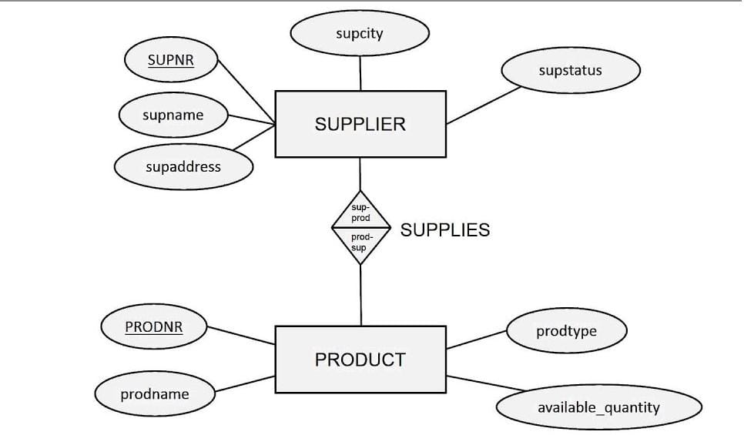

Creating an Entity-Relationship Diagram (ERD) for the relation between supplier , and products involves identifying the main entities and their relationships.
Entities and Attributes:
1.Supplier

Supplier is the main head which contains attributes like supno, supname,supcity ,supstatus supaddress

Supnr is the primary key
Which is unique where only unique supnr can be given to a supplier

2.product

Product represents to an item where it's has same attributes like Prodnr,prodname,prodtype, availability of product

