

**DEPARTMENT OF COMPUTER SCIENCE AND ENGNEERING**

**B. M. S. COLLEGE OF ENGINEERING**

**(AUTONOMOUS COLLEGE UNDER VTU, BELGAUM)** **BANGALORE – 560019**

# 2023-24

# OOJ LAB REPORT

**OBJECT ORIENTED JAVA PROGRAMMING (23CSEPCOOJ)**

**Submitted by**

Chaitanya N

1BM22CS076

**Submitted to**

## Shravya AR

Assistant Professor

Dept. of CSE, BMSCE

|  |  |
| --- | --- |
| **Lab Program** | **Program Details** |
| 1 | Develop a Java program that prints all real solutions to the quadratic equation ax2+bx+c = 0. Read in a, b, c and use the quadratic formula. If the discriminate b2 - 4ac is negative, display a message stating that there are no real solutions. |
| 2 | Develop a Java program to create a class Student with members usn, name, an array credits and an array marks. Include methods to accept and display details and a method to calculate SGPA of a student. |
| 3 | Create a class Book which contains four members: name, author, price, num_pages. Include a constructor to set the values for the members. Include methods to set and get the details of the objects. Include a toString( ) method that could display the complete details of the book. Develop a Java program to create n book objects. |
| 4 | Develop a Java program to create an abstract class named Shape that contains two integers and an empty method named printArea( ). Provide three classes named Rectangle, Triangle and Circle such that each one of the classes extends the class Shape. Each one of the classes contain only the method printArea( ) that prints the area of the given shape. |
| 5 | Develop a Java program to create a class Bank that maintains two kinds of account for its customers, one called savings account and the other current account. The savings account provides compound interest and withdrawal facilities but no cheque book facility. The current account provides cheque book facility but no interest. Current account holders should also maintain a minimum balance and if the balance falls below this level, a service charge is imposed. Create a class Account that stores customer name, account number and type of account. From this derive the classes Cur-acct and Sav-acct to make them more specific to their requirements. Include the necessary methods in order to achieve the following tasks: a) Accept deposit from customer and update the balance. b) Display the balance. c) Compute and deposit interest d) Permit withdrawal and update the balance Check for the minimum balance, impose penalty if necessary and update the balance. |
| 6 | Create a package CIE which has two classes- Student and Internals. The class Personal has members like usn, name, sem. The class internals has an array that stores the internal marks scored in five courses of the current semester of the student. Create another package SEE which has the class External which is a derived class of Student. This class has an array that stores the SEE marks scored in five courses of the current semester of the student. Import the two packages in a file that declares the final marks of n students in all five courses. |
| 7 | Write a program that demonstrates handling of exceptions in inheritance tree. Create a base class called “Father” and derived class called “Son” which extends the base class. In Father class, implement a constructor which takes the age and throws the exception WrongAge( ) when the input age=father’s age. |
| 8 | Write a program which creates two threads, one thread displaying “BMS College of Engineering” once every ten seconds and another displaying “CSE” once every two seconds |

**OOJ LAB PROGRAMS**

**LAB PROGRAM 1**

Develop a Java program that prints all real solutions to the quadratic equation ax2+bx+c = 0. Read in a, b, c and use the quadratic formula. If the discriminate b2 - 4ac is negative, display a message stating that there are no real solutions.

**CODE :**

import java.util.Scanner;

class Quad{

int a,b,c;

double d,r1,r2;

void input(){

Scanner sc=new Scanner(System.in);

System.out.println("Enter coefficients");

a=sc.nextInt();

b=sc.nextInt();

c=sc.nextInt();

}

void calc(){

double d=(b*b)-(4*a*c);

if(a==0||b==0||c==0){

System.out.println("invalid inputs");

}

else if(d>0){

System.out.println("roots are real and distinct");

r1=(-b+(Math.sqrt(d))/(2*a));

r2=(-b-(Math.sqrt(d))/(2*a));

System.out.println("r1="+r1);

System.out.println("r2="+r2);

}

else if(d==0){

    System.out.println("Roots are real and equal");

r1=r2=-b/(2*a);

System.out.println("r1="+r1);

System.out.println("r2="+r2);

}

else{

System.out.println("Roots are imaginary");

r1=-b/(2*a);

r2=Math.sqrt(-d)/(2*a);

System.out.println("r1="+r1+"+i"+r2);

System.out.println("r2="+r1+"-i"+r2);

}

}

}

class QuadMain{

public static void main(String args[]){

System.out.println("Chaitanya N");

System.out.println("1BM22CS076");

Quad q=new Quad();

System.out.println();

q.input();

q.calc();

}

}

**OUTPUT :**

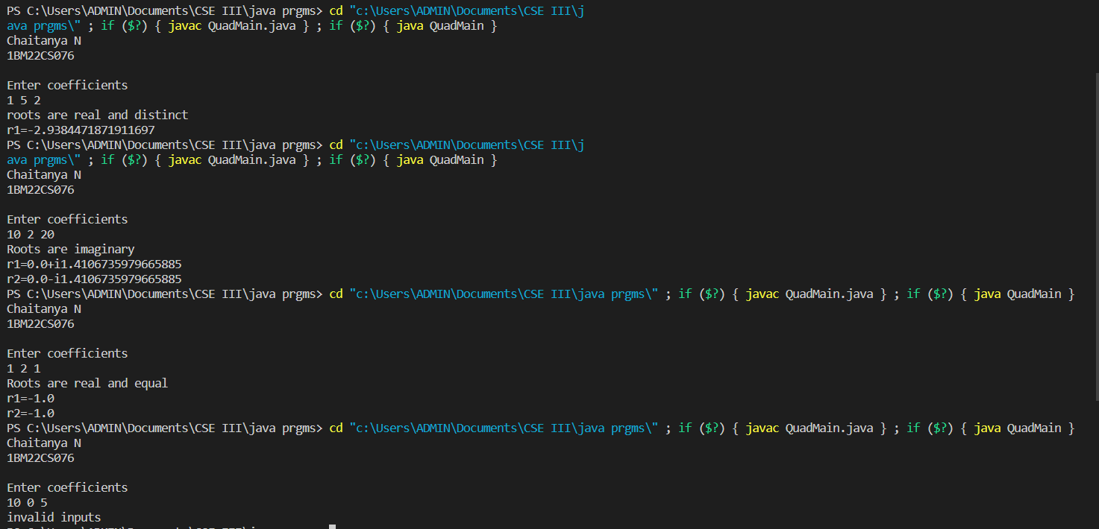

**LAB PROGRAM 2**

Develop a Java program to create a class Student with members usn, name, an array credits and an array marks. Include methods to accept and display details and a method to calculate SGPA of a student.

**CODE:**

import java.util.Scanner;

class Student {

    String USN, name;

    int marks[] = new int[6];

    int credits[]= new int[6];

    double percentage;

    double sgpa;

    void acceptDetails() {

        Scanner sc = new Scanner(System.in);

        System.out.print("Enter USN: ");

        USN = sc.nextLine();

        System.out.print("Enter name: ");

        name = sc.nextLine();

        System.out.println("Enter marks for 6 subjects:");

        for (int i = 0; i < 6; i++) {

            marks[i] = sc.nextInt();

        }

        System.out.println("Enter credits of 6 subjects:");

        for (int i = 0; i < 6; i++) {

            credits[i] = sc.nextInt();

        }

    }

    void calculatePercentage() {

        int totalMarks = 0;

        for (int mark : marks) {

            totalMarks += mark;

        }

        percentage = (double) totalMarks / 600 * 100;

    }

    void calculateSgpa(){

        double totalCredits = 0;

        double totalGradePoints = 0;

        for (int i = 0; i < 6; i++) {

            totalCredits += credits[i];

            totalGradePoints += calculateGradePoint(marks[i]) * credits[i];

        }

sgpa = totalGradePoints / totalCredits;

    }

    public static double calculateGradePoint(double marks) {

        if (marks >= 90) {

            return 10;

        } else if (marks >= 80) {

            return 9;

        } else if (marks >= 70) {

            return 8;

        } else if (marks >= 60) {

            return 7;

        } else if (marks >= 50) {

            return 6;

        } else if (marks >= 40) {

            return 5;

        } else {

            return 0;

        }

    }

    void displayDetails() {

        System.out.println("USN: " + USN);

        System.out.println("Name: " + name);

        System.out.println("Marks: " + marks[0] + ", " + marks[1] + ", " + marks[2] + ", " + marks[3] + ", " + marks[4] + ", " + marks[5]);

        System.out.println("Percentage: " + percentage + "%");

        System.out.println("SGPA : " + sgpa );

    }

}

public class StudentMain {

    public static void main(String[] args) {

        int numStudents;

        Scanner sc = new Scanner(System.in);

        System.out.println("Chaitanya N");

        System.out.println("1BM22CS076");

        System.out.println();

        System.out.print("Enter the number of students: ");

        numStudents = sc.nextInt();

        Student[] students = new Student[numStudents];

        // Accept details for each student

        for (int i = 0; i < numStudents; i++) {

            students[i] = new Student();

            students[i].acceptDetails();

            students[i].calculatePercentage();

            students[i].calculateSgpa();

        }

        // Display details of all students

        System.out.println("\nStudent Details:");

        for (Student student : students) {

            student.displayDetails();

            System.out.println();

        }

    }

}

**OUTPUT :**

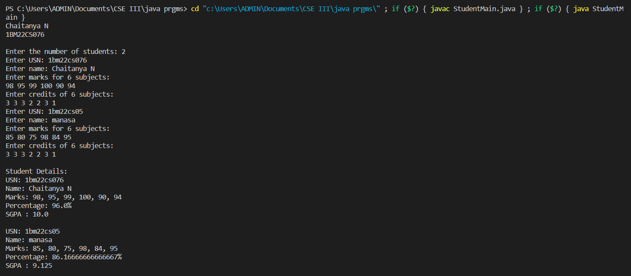

**LAB PROGRAM 3**

Create a class Book which contains four members: name, author, price, num_pages. Include a constructor to set the values for the members. Include methods to set and get the details of the objects. Include a toString( ) method that could display the complete details of the book. Develop a Java program to create n book objects.

**CODE:**

import java.util.Scanner;

class Book{

    private String name;

    private String author;

    private double price;

    private int num_pages;

    Book(String name,String author,double price,int num_pages){

        this.name=name;

        this.author=author;

        this.price=price;

        this.num_pages=num_pages;

    }

    public void setName(String name){

        this.name=name;

    }

    public void setAuthor(String author){

        this.author=author;

    }

    public void srtPrice(double price){

        this.price=price;

    }

    public void setNum_Pages(int num_pages){

        this.num_pages=num_pages;

    }

    public String getName(){

        return name;

    }

    public String getAuthor(){

        return author;

    }

    public double getPrice(){

        return price;

    }

    public int getNum_Pages(){

        return num_pages;

    }

    @Override

    public String toString(){

        return "Book Details:\n" +

        "Name: " + name + "\n" +

        "Author: " + author + "\n" +

        "Price: " + price + "\n" +

        "Number Of pages: "+ num_pages;

    }

}

public class BookDetails {

    public static void main( String argra[]){

        int n;

        Scanner sc=new Scanner(System.in);

        System.out.println("Chaitanya N");

        System.out.println("1BM22CS076");

        System.out.println();

        System.out.println("Enter number of books:");

        n=sc.nextInt();

        Book [] books=new Book[n];

        for(int i=0;i<n;i++){

            System.out.println("Enter details of book "+(i+1) +":");

            System.out.println("Name:");

            sc.nextLine();

            String name=sc.nextLine();

            System.out.println("Author:");

            sc.nextLine();

            String author=sc.nextLine();

            System.out.println("Price:");

            double price=sc.nextDouble();

            System.out.println("Number of pages:");

            int num_pages=sc.nextInt();

            books[i]=new Book(name,author,price,num_pages);

            System.out.println();

        }

        for(Book b:books){

            System.out.println(b);  //  System.out.println(b.toString);

        }

    }

}

**OUTPUT :**

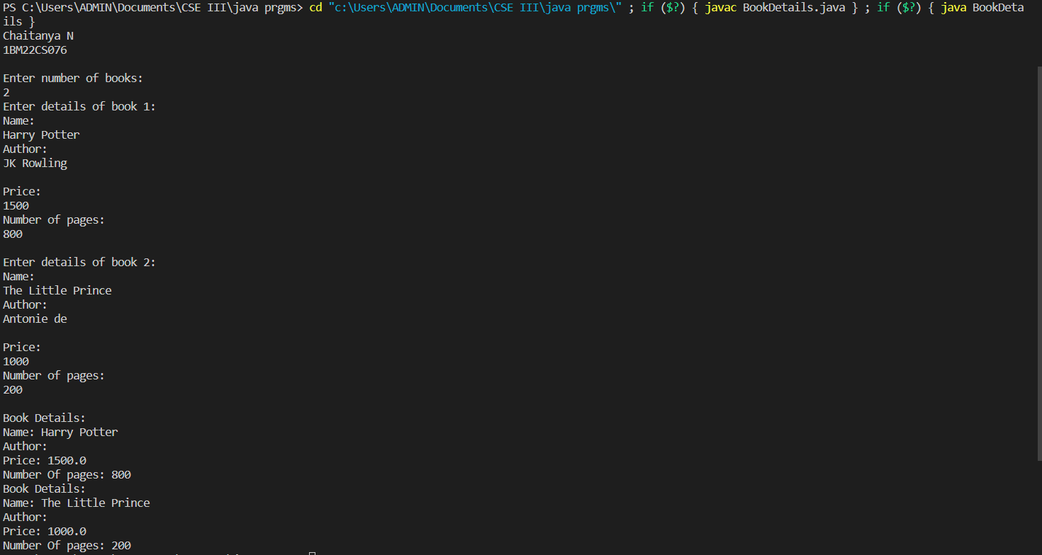

**LAB PROGRAM 4**

Develop a Java program to create an abstract class named Shape that contains two integers and an empty method named printArea( ). Provide three classes named Rectangle, Triangle and Circle such that each one of the classes extends the class Shape. Each one of the classes contain only the method printArea( ) that prints the area of the given shape.

**CODE:**

import java.util.Scanner;

abstract class Shape{

    int a,b;

    Shape(int a,int b){

        this.a=a;

        this.b=b;

    }

    public abstract void printArea();

}

    class Rectangle extends Shape{

        Rectangle(int length,int breadth){

            super(length,breadth);

        }

        public void printArea(){

            System.out.println("Area of Rectangle = "+(a*b));

        }

    }

    class Triangle extends Shape{

        Triangle(int base,int height){

            super(base,height);

        }

        public void printArea(){

            System.out.println("Area of Triangle = "+(0.5*a*b));

        }

    }

    class Circle extends Shape{

        Circle(int radius){

            super(radius,0);

        }

        public void printArea(){

            System.out.println("Area of Circle = "+(Math.PI*a*a));

        }

    }

public class Area {

    public static void main(String[] args) {

        Scanner sc= new Scanner(System.in);

        System.out.println("Chaitaya N");

        System.out.println("1BM22CS076");

        System.out.println();

        System.out.println("Enter length and breadth of Rectangle");

        int length=sc.nextInt();

        int breadth=sc.nextInt();

        System.out.println();

        System.out.println("Enter base and height of Triangle");

        int base=sc.nextInt();

        int height=sc.nextInt();

        System.out.println();

        System.out.println("Enter radius of a Circle");

        int radiius=sc.nextInt();

        Rectangle rectangle=new Rectangle(length, breadth);

        Triangle triangle=new Triangle(base, height);

        Circle circle=new Circle(radiius);

        rectangle.printArea();

        triangle.printArea();

        circle.printArea();

    }

}

**OUTPUT :**

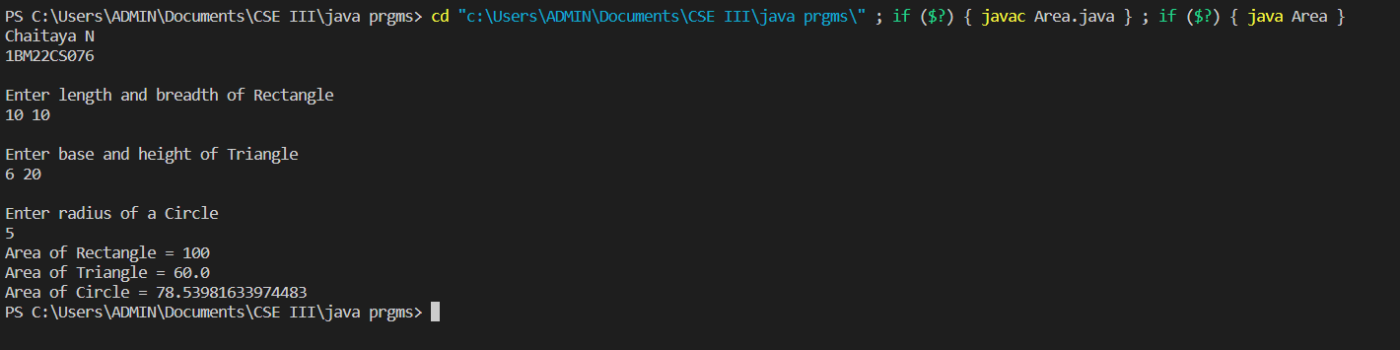

**LAB PROGRAM 5**

Develop a Java program to create a class Bank that maintains two kinds of account for its customers, one called savings account and the other current account. The savings account provides compound interest and withdrawal facilities but no cheque book facility. The current account provides cheque book facility but no interest. Current account holders should also maintain a minimum balance and if the balance falls below this level, a service charge is imposed. Create a class Account that stores customer name, account number and type of account. From this derive the classes Cur-acct and Sav-acct to make them more specific to their requirements. Include the necessary methods in order to achieve the following tasks: a) Accept deposit from customer and update the balance. b) Display the balance. c) Compute and deposit interest d) Permit withdrawal and update the balance Check for the minimum balance, impose penalty if necessary and update the balance.

**CODE :**

import java.util.Scanner;

class Account {

    protected String name;

    protected int accno;

    protected double balance;

    public void get_info() {

        Scanner sc = new Scanner(System.in);

        System.out.print("Enter Name: ");

        name = sc.nextLine();

        System.out.print("Enter Account Number: ");

        accno = sc.nextInt();

    }

    public void deposit(double amount) {

        balance += amount;

        System.out.println("Amount deposited successfully.");

    }

    public void display() {

        System.out.println("Name: " + name);

        System.out.println("Account Number: " + accno);

        System.out.println("Balance: " + balance);

    }

}

class Cur_acct extends Account {

    private final double min_balance = 500;

    private final double penalty = 100;

    public void withdraw(double amount) {

        if (balance - amount >= min_balance) {

            balance -= amount;

            System.out.println("Amount withdrawn successfully.");

        } else {

            System.out.println("Insufficient balance for withdrawal.");

        }

        check_min_balance();

    }

    private void check_min_balance() {

        if (balance < min_balance) {

            balance -= penalty;

            System.out.println("Penalty imposed for falling below minimum balance.");

        }

    }

}

class Sav_acct extends Account {

    private final double interest_rate = 0.04;

    public void compute_interest() {

        double interest = balance * interest_rate;

        balance += interest;

        System.out.println("Interest credited successfully.");

    }

}

class Bank {

    public static void main(String[] args) {

        Scanner sc = new Scanner(System.in);

        System.out.println("Chaitanya N");

        System.out.println("1BM22CS076");

        System.out.println();

        System.out.println("Enter 1 for Current Account or 2 for Savings Account: ");

        int choice = sc.nextInt();

        Account acc;

        if (choice == 1) {

            acc = new Cur_acct();

        } else {

            acc = new Sav_acct();

        }

        acc.get_info();

        while (true) {

            System.out.println("\nMenu:");

            System.out.println("1. Deposit");

            System.out.println("2. Withdraw");

            System.out.println("3. Display Balance");

            System.out.println("4. Compute Interest (Savings Account only)");

            System.out.println("5. Exit");

            System.out.print("Enter your choice: ");

            int choice2 = sc.nextInt();

            switch (choice2) {

                case 1:

                    System.out.print("Enter amount to deposit: ");

                    double amount = sc.nextDouble();

                    acc.deposit(amount);

                    break;

                case 2:

                    if (acc instanceof Sav_acct) {

                        System.out.println("Withdrawal not allowed for Savings Account.");

                    } else {

                        System.out.print("Enter amount to withdraw: ");

                        amount = sc.nextDouble();

                        ((Cur_acct) acc).withdraw(amount);

                    }

                    break;

                case 3:

                    acc.display();

                    break;

                case 4:

                    if (acc instanceof Sav_acct) {

                        ((Sav_acct) acc).compute_interest();

                    } else {

                        System.out.println("Interest computation not applicable for Current Account.");

                    }

                    break;

                case 5:

                    System.exit(0);

                default:

                    System.out.println("Invalid choice.");

            }

        }

}

**OUTPUT :**

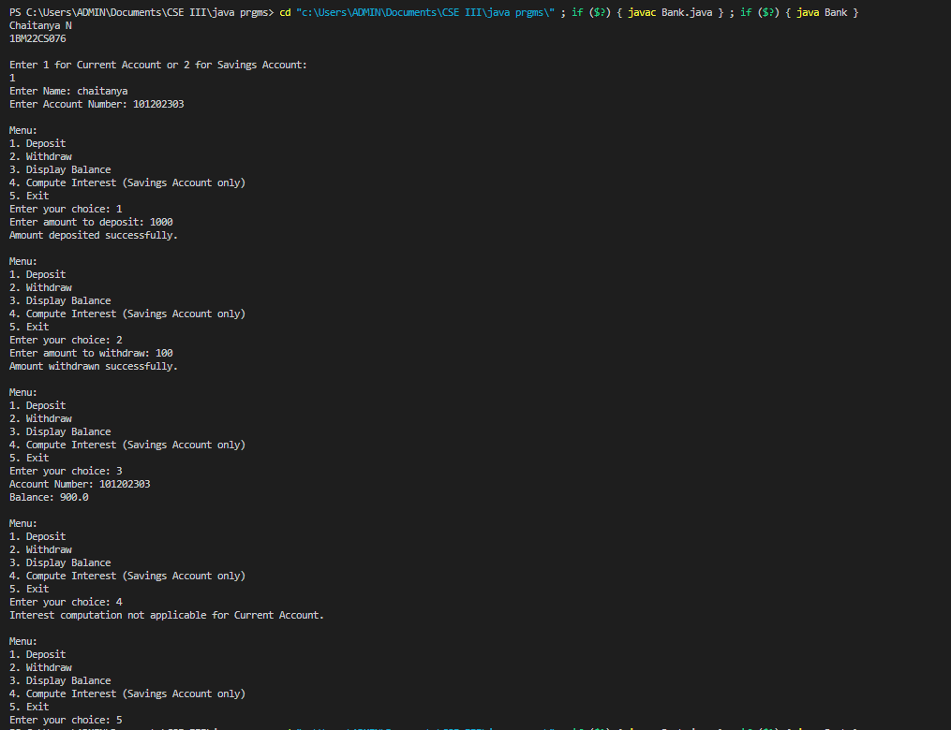

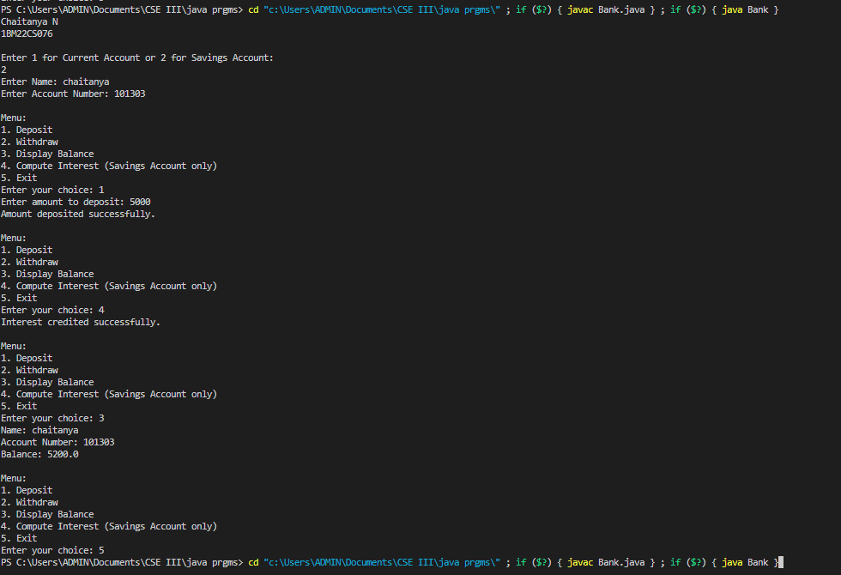



**LAB PROGRAM 6**

Create a package CIE which has two classes- Student and Internals. The class Personal has members like usn, name, sem. The class internals has an array that stores the internal marks scored in five courses of the current semester of the student. Create another package SEE which has the class External which is a derived class of Student. This class has an array that stores the SEE marks scored in five courses of the current semester of the student. Import the two packages in a file that declares the final marks of n students in all five courses.

**CODE :**

package CIE;

public class Student {

    public String usn;

    public String name;

    public int sem;

public Student(){}

public Student(String usn,String name,int sem){

        this.usn=usn;

        this.name=name;

        this.sem=sem;

    }

public void displayDetails(){

    System.out.println("USN:"+usn);

    System.out.println("Name:"+ name);

    System.out.println("Sem:"+sem);

}

}

package CIE;

import java.util.Scanner;

public class Internals extends Student {

    public Internals(){}

public int imarks[]=new int[5];

Scanner sc=new Scanner(System.in);

public void setImarks(){

    for(int i=0;i<5;i++){

        imarks[i]=sc.nextInt();

    }

}

public void displayImarks(){

    for(int i=0;i<5;i++){

        System.out.println("Subject"+" " +(i+1)+ ": "+imarks[i]);

    }

}

}

package SEE;

import java.util.Scanner;

public class External extends CIE.Student{

    public External() {

    }

    public int emarks[]=new int[5];

    Scanner sc=new Scanner(System.in);

    public void setEmarks(){

        for(int i=0;i<5;i++){

             emarks[i]=sc.nextInt();

        }

    }

    public void displayEmarks(){

        for(int i=0;i<5;i++){

            System.out.println("Subject"+" "+(i+1)+": "+emarks[i]);

        }

    }

}

import CIE.Student;

import CIE.Internals;

import SEE.External;

import java.util.Scanner;

public class Main {

    public static void main (String args []){

        int n,sem;

        String name,usn;

        System.out.println("Chaitanya N");

        System.out.println("1BM22CS076");

        System.out.println("Enter number of students:");

        Scanner sc=new Scanner(System.in);

        n=sc.nextInt();

        Student stds[]=new Student[n];

        Internals i[]=new Internals[n];

        External e[]=new External[n];

        for(int j=0;j<n;j++){

            System.out.println("Enter Details of Student "+(j+1)+":");

            sc.nextLine();

            System.out.println("Name:");

            name=sc.nextLine();

            System.out.println("USN:");

            usn=sc.nextLine();

            System.out.println("Enter Semester");

            sem=sc.nextInt();

            stds[j]=new Student(usn,name,sem);

            i[j]=new Internals();

            System.out.println("Enter internal marks");

            i[j].setImarks();

            e[j]=new External();

            System.out.println("Enter external marks");

            e[j].setEmarks();

        }

        for(int j=0;j<n;j++){

            System.out.println();

            System.out.println("Student "+(j+1)+" details:");

            stds[j].displayDetails();

            System.out.println("Internal Marks:");

            i[j].displayImarks();

            System.out.println("External Marks:");

            e[j].displayEmarks();

            System.out.println("Total Marks :");

            for(int k=0;k<5;k++){

                System.out.println("Subject"+" "+ (k+1)+" : "+(i[j].imarks[k]+e[j].emarks[k]));

            }

        }

    }

}

**OUTPUT :**

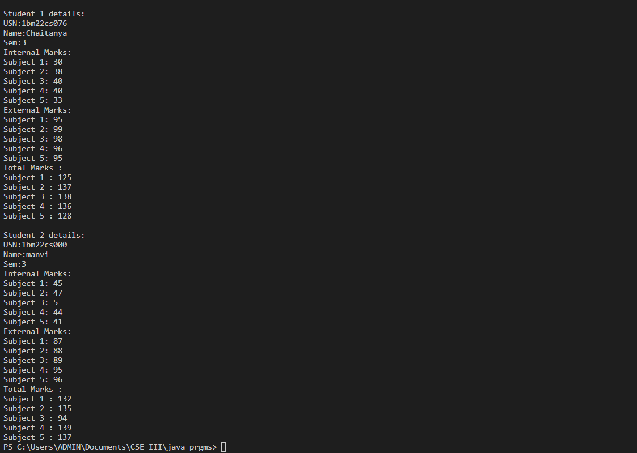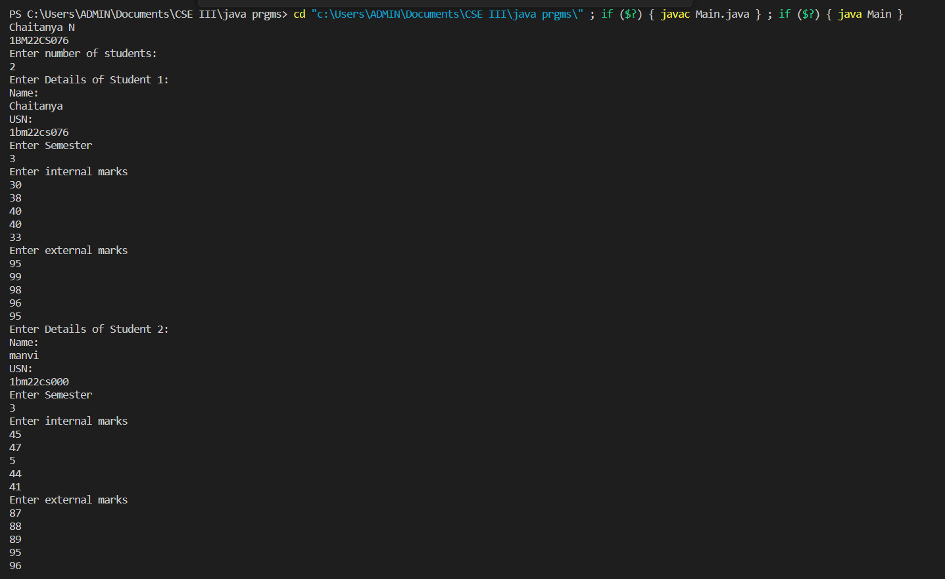

**LAB PROGRAM 7**

Write a program that demonstrates handling of exceptions in inheritance tree. Create a base class called “Father” and derived class called “Son” which extends the base class. In Father class, implement a constructor which takes the age and throws the exception WrongAge( ) when the input age=father’s age.

**CODE :**

import java.util.Scanner;

class WrongAge extends Exception {

    WrongAge(String msg) {

        super(msg);

    }

}

class Father {

    int age;

    Father(int age) throws WrongAge {

        if (age < 0) {

            throw new WrongAge("Age cannot be negative");

        }

        this.age = age;

    }

}

class Son extends Father {

    int sonAge;

    Son(int fatherAge, int sonAge) throws WrongAge {

        super(fatherAge);

        if (sonAge >= fatherAge) {

            throw new WrongAge("Son's age should be less than Father's age");

        }

        this.sonAge = sonAge;

    }

}

public class Exceps {

    public static void main(String[] args) {

        Scanner scanner = new Scanner(System.in);

        System.out.println("Chaitanya N");

        System.out.println("1BM22CS076");

        System.out.println();

        try {

            System.out.print("Enter father's age: ");

            int fatherAge = scanner.nextInt();

            System.out.print("Enter son's age: ");

            int sonAge = scanner.nextInt();

            Son son = new Son(fatherAge, sonAge);

            System.out.println("Father's age: " + fatherAge);

            System.out.println("Son's age: " + sonAge);

        } catch (WrongAge e) {

            System.out.println("Error: " + e.getMessage());

        } catch (Exception e) {

            System.out.println("Error: Invalid input");

        } finally {

            scanner.close();

        }

    }

}

**OUTPUT :**

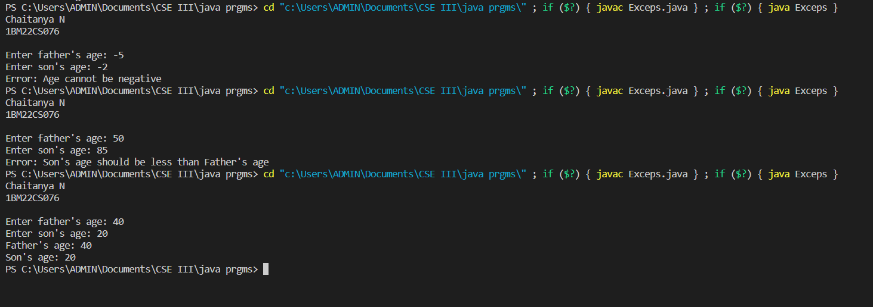

**LAB PROGRAM 8**

Write a program which creates two threads, one thread displaying “BMS College of Engineering” once every ten seconds and another displaying “CSE” once every two seconds.

**CODE :**

class DisplayMessage extends Thread{

    String msg;

    int interval;

    DisplayMessage(String msg,int interval){

        this.msg=msg;

        this.interval=interval;

    }

    public void run(){

        for(int i=0;i<10;i++){

            System.out.println(msg);

            try{

                Thread.sleep(interval*1000);

            }

            catch(InterruptedException e){

                System.out.println(e);

            }

        }

    }

}

public class Threadss {

    public static void main(String[] args) {

        System.out.println("Chaitanya N");

        System.out.println("1BM22CS076");

        DisplayMessage t1=new DisplayMessage("BMS COLLEGE OF ENGINEERING",10);

        DisplayMessage t2=new DisplayMessage("CSE",2);

        t1.start();

        t2.start();

    }

}

**OUTPUT :**

