COVID-19 Public Health Visualization Dashboard: A Web-Based System for Case and Vaccination Data Analysis

G. Chaitanya
Dept. of Computer Science and Engineering
[University Name]
[City], India
University ID: 2420030721
J. Vaman
Dept. of Computer Science and Engineering
[University Name]
[City], India
University ID: 2420030736
K. Mani Teja
Dept. of Computer Science and Engineering
[University Name]
[City], India
University ID: 2420030139

Abstract—The COVID-19 pandemic generated large volumes of data on confirmed cases, recoveries, deaths and vaccination, which are difficult to interpret in raw tabular form. This paper presents the COVID-19 Public Health Visualization Dashboard, a web-based data science system that converts stored COVID-19 records into interactive statistics, charts and reports. The system follows a three-tier architecture in which a browser interface built with HTML5, CSS3, Bootstrap 5 and JavaScript communicates with a Python Flask backend, a MySQL database stores member, place, case and vaccination records, and Chart.js renders pie, doughnut, bar and line charts. An authenticated administrator can manage member and place records, monitor affected and non-affected places, follow active, recovered and deceased cases, track vaccination status, filter information by state, district, place and date, and export filtered reports as PDF or Excel files. Sample data is used to demonstrate the summary cards and charts of the dashboard. The work shows that combining a relational database with interactive visualization gives administrators a clear, responsive and practical view of pandemic data. Directions for future work include real-time public data integration, trend forecasting, a mobile application and cloud deployment.
Keywords—COVID-19, data visualization, dashboard, public health, vaccination tracking, Flask, MySQL, Chart.js

Introduction
The COVID-19 pandemic produced data on an unprecedented scale. Health authorities recorded confirmed cases, active cases, recoveries, deaths, tests and vaccine doses from many different sources, and the figures changed every day. Web dashboards quickly became a main way of communicating this information to the public and to decision makers. The dashboard developed at Johns Hopkins University was one of the first widely used examples [1], and the World Health Organization publishes a global dashboard of cases, deaths and vaccination [2].
Raw records stored in tables or spreadsheets are hard to interpret. Rows of numbers do not show which regions are most affected, how cases change from day to day, or how vaccination coverage differs between groups. Data visualization addresses this problem by mapping data attributes to visual marks such as position, length and area, which people can compare quickly [3]. Dashboard design guidelines add that the most important information should be placed on a single screen so that it can be monitored at a glance [4].
Most public dashboards report aggregated figures. An administrator who is responsible for a set of places and members, however, needs a tool that works with the records themselves: adding members, assigning them to places, updating their COVID status and vaccination details, and immediately seeing the effect on the summary figures. This paper presents the COVID-19 Public Health Visualization Dashboard, a web-based system built for this purpose using Python Flask [5], a MySQL database [6] and Chart.js [7]. The main contributions are as follows.
- A three-tier architecture that connects a responsive browser interface, a Flask backend, a MySQL database and Chart.js visualization.
- A data model that links members to places and stores the COVID status and vaccination details of each member.
- A set of dashboard modules for summary statistics, charts, record management, filtering and PDF or Excel reports.
- A demonstration of the dashboard outputs using sample data.
The rest of this paper is organized as follows. Section II reviews related work, Section III states the problem and the objectives, Section IV describes the proposed system, Section V presents the dashboard modules, Section VI discusses the sample results and limitations, and Section VII concludes the paper and outlines future scope.

Related Work
Many public dashboards were created during the pandemic. The Johns Hopkins dashboard collected case data from several public sources and displayed it on an interactive map together with summary counts [1]. The World Health Organization dashboard presents global counts of cases, deaths and vaccination [2]. The Our World in Data project compiled a public global vaccination dataset that reports the doses administered and the population-adjusted coverage of each country [8]. Geographic information systems were also widely used to map and track the epidemic in near real time [9].
These systems are designed to inform the public and to support monitoring at national and global level, and they rely on aggregated, officially reported figures. The dashboard described in this paper is complementary. It is a lightweight administrative system that works with individual member and place records and lets an authenticated administrator edit them, filter them by state, district, place and date, and export the results as reports.

Problem Statement and Objectives

Problem Statement
Managing COVID-19 records manually becomes difficult as the number of members and places increases. It is time-consuming to find out which places are affected and which are not, and tracking active, recovered, deceased and vaccinated members requires well-organized records. Even when the records exist, raw data does not immediately show trends or comparisons between districts and dates. Administrators therefore need quick search, filtering and report generation to support routine data management. The proposed solution is a centralized dashboard that combines a database with interactive visualization.

Objectives
The system was designed to meet the following objectives.
- Authenticate administrators securely using a username and password.
- Display the total, affected and non-affected places.
- Display the total members together with the positive, active, recovered and deceased counts.
- Track vaccinated and non-vaccinated members along with their vaccination details.
- Provide create, read, update and delete (CRUD) operations for member and place records.
- Visualize the case distribution and daily trends using charts.
- Provide filters by state, district, place and date.
- Generate PDF and Excel reports for sharing and analysis.

Proposed System

System Architecture
The system follows the three-tier architecture shown in Fig. 1. The administrator works in a web browser, where the frontend, built with HTML5, CSS3, Bootstrap 5 and JavaScript, provides the login page, forms, tables and dashboard views. Requests from the browser are handled by the Python Flask backend, which implements the routes, authentication, CRUD operations and communication with the database. MySQL stores the member, place, COVID case, vaccination and user records. Flask processes the stored data, and Chart.js, running in the browser, converts the processed data into charts.
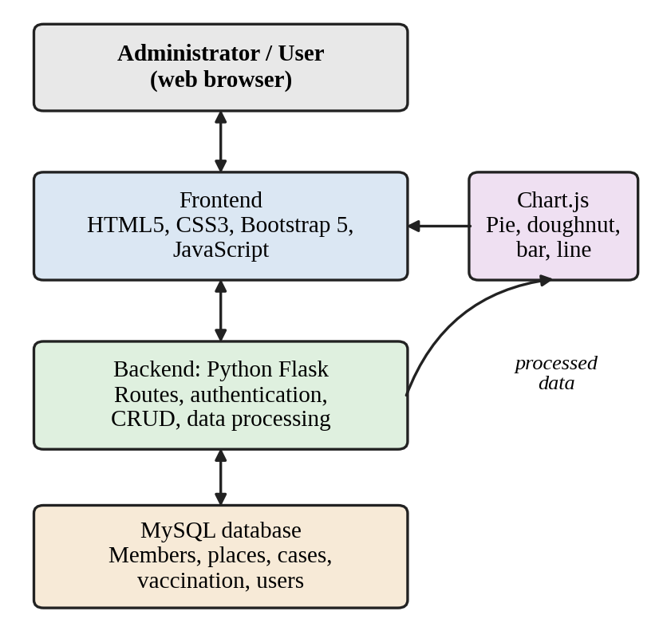
- System architecture of the COVID-19 Public Health Visualization Dashboard.

Technology Stack
Table I summarizes the technologies used and the role of each one. Bootstrap 5 [10] makes the interface responsive, so the dashboard can be used on both desktop and mobile screens.
- Technologies Used in the Dashboard
Technology | Role in the system
HTML5 | Structure of the login pages, dashboard pages, forms and tables
CSS3 | Styling, spacing, colors and layout
Bootstrap 5 | Responsive layout and ready-made interface components
JavaScript | Client-side interaction, validation, filters and dynamic updates
Chart.js | Pie, doughnut, bar and line charts
Python Flask | Backend routes, authentication, CRUD operations and database communication
MySQL | Storage of members, places, COVID cases, vaccination and user information

Data Model
The database holds three groups of data. A member record stores the member ID, name, age, gender, mobile number, address, the place to which the member belongs, the COVID status, the vaccination status, the vaccine name and the dose dates. A place record stores the place name, its location details and its classification as affected or non-affected. A user record stores the login information of the administrators and other users.
Every member is connected to a place, so one place can hold many members, and this link supports location-wise analysis. The COVID status of a member is one of positive, negative, active, recovered or deceased, and the vaccination status is either vaccinated or not vaccinated.

Authentication and Access Control
Access to the administrative pages is restricted to authenticated users. The user enters a username and password, the backend validates them, a session is created and the dashboard opens. Invalid credentials produce a clear error message, and logging out ends the session and returns the user to the login page. Role-based access can be used to separate the permissions of administrators and normal users.

Data Processing and Indicators
Records enter the system through forms whose fields are validated in the browser by JavaScript before they are sent to Flask and stored in MySQL. The summary values shown on the dashboard are not typed in by hand; they are calculated from the stored records, and the filters by state, district, place and date narrow the information that is shown. Let N be the total number of members, V the number of vaccinated members, P the total number of places, A the number of affected places, C the number of positive members, R the number of recovered members and D the number of deceased members. Four indicators can then be derived from these counts:
VC = (V / N) × 100 (1)
AR = (A / P) × 100 (2)
RR = (R / C) × 100 (3)
DR = (D / C) × 100 (4)
where VC is the vaccination coverage, AR is the affected-place ratio, RR is the recovery rate and DR is the death rate, all expressed as percentages.

Dashboard Modules

Main Dashboard
After login, the main dashboard summarizes the complete dataset in statistic cards. The place cards show the total, affected and non-affected places. The member cards show the total members, positive members, active cases, recovered members and death cases, and the vaccination cards show the vaccinated and non-vaccinated members. All values are calculated from the stored records.

Data Visualization
Charts help users identify proportions, comparisons and trends without reading every row of data. A pie chart shows affected versus non-affected places, a doughnut chart shows vaccinated versus non-vaccinated members, and bar and line charts show district-wise cases and daily trends. Fig. 2 shows the first two chart types drawn with the sample data described in Section VI.
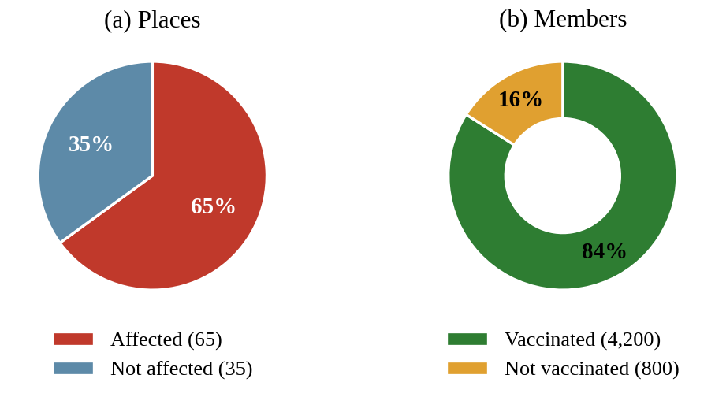
- Sample charts of the dashboard: (a) affected versus non-affected places and (b) vaccinated versus non-vaccinated members. The values are sample data.

Member and Place Management
Administrators can add, view, edit and delete member records and place records. The member module stores the fields listed in Section IV-C and supports search, filtering and pagination. The place module supports search and filtering, the affected or non-affected classification, and the connection of members to their place, which is useful for location-wise analysis.

COVID and Vaccination Records
COVID records can be summarized by district, place and date. The vaccination records identify vaccinated and non-vaccinated members and store the vaccine name and the dose dates. The dashboard filters narrow the information by state, district, place and date, so the administrator can examine a specific region, period or category.

Reports and Administration
Selected information can be exported as PDF or Excel reports, including filtered reports, for documentation and sharing. Profile management, password change, notifications and settings further improve the usability of the system for administrators. Because the interface is built with Bootstrap, the pages adapt to desktop and mobile screens.

Results and Discussion

Sample Data Demonstration
To demonstrate the dashboard, a sample dataset of 100 places and 5,000 members was used. These values are sample presentation data and not measurements from a real population, so the results below illustrate what the dashboard displays and should not be read as epidemiological findings. Table II lists the summary values with their shares, and Fig. 2 shows the corresponding charts.
- Summary Values from the Sample Dataset
Indicator | Count | Share (%) | Base
Affected places | 65 | 65.0 | Places
Non-affected places | 35 | 35.0 | Places
Positive members | 450 | 9.0 | Members
Active cases | 320 | 6.4 | Members
Death cases | 130 | 2.6 | Members
Vaccinated members | 4,200 | 84.0 | Members
Not vaccinated | 800 | 16.0 | Members
- Share is calculated with respect to 100 places or 5,000 members, as given in the Base column.
In the sample, 65 of the 100 places (65.0 %) are classified as affected and 35 as non-affected. Among the 5,000 members, 450 (9.0 %) are positive, 320 (6.4 %) are active cases and 130 (2.6 %) are recorded as deaths. The vaccination coverage given by (1) is 84.0 %, which leaves 800 members (16.0 %) not vaccinated. Figures of this kind let an administrator see at once where attention is needed, for example the members who are still unvaccinated.

Discussion
Compared with a plain table of records, the dashboard offers three practical advantages. First, the summary cards and charts present the state of all places and members on one screen, so proportions and comparisons are visible without reading individual rows. Second, CRUD operations, search and filters keep the underlying records organized and allow the administrator to move from the overall picture to a specific place, date or category. Third, exported PDF and Excel reports make it easy to share selected information for documentation. These advantages are qualitative.

Limitations
The results reported here are limited to sample data and a qualitative discussion. The dashboard is not yet connected to a live public data source, it does not include forecasting or other advanced analytics, and a formal usability, performance and security evaluation with real records remains future work.

Conclusion and Future Scope
This paper presented the COVID-19 Public Health Visualization Dashboard, a web-based system that combines a MySQL database, a Flask backend and Chart.js visualization to give administrators a centralized, visual and responsive view of COVID-19 cases, affected places and vaccination information. Authentication, CRUD operations, filters, charts and reports make the system practical for daily data management, and the sample demonstration shows how stored records are turned into summary figures and charts.
Several extensions are possible. The system can be connected to real-time or regularly updated public datasets, a dedicated mobile application can be developed, advanced analytics and trend forecasting can be added, and the application can be deployed on cloud infrastructure for scalable access.

Acknowledgment
The authors thank their project guide, Dr. N. Sunanda, and the Department of Computer Science and Engineering for their guidance and support during the Data Science course project (24AD3107).

References
- E. Dong, H. Du, and L. Gardner, “An interactive web-based dashboard to track COVID-19 in real time,” Lancet Infect. Dis., vol. 20, no. 5, pp. 533–534, May 2020.
- World Health Organization, “WHO coronavirus (COVID-19) dashboard.” [Online]. Available: https://covid19.who.int
- T. Munzner, Visualization Analysis and Design. Boca Raton, FL, USA: CRC Press, 2014.
- S. Few, Information Dashboard Design: The Effective Visual Communication of Data. Sebastopol, CA, USA: O’Reilly Media, 2006.
- Pallets Projects, “Flask documentation.” [Online]. Available: https://flask.palletsprojects.com
- Oracle Corporation, “MySQL reference manual.” [Online]. Available: https://dev.mysql.com/doc/
- Chart.js Contributors, “Chart.js documentation.” [Online]. Available: https://www.chartjs.org/docs/
- E. Mathieu et al., “A global database of COVID-19 vaccinations,” Nature Hum. Behav., vol. 5, pp. 947–953, 2021.
- M. N. K. Boulos and E. M. Geraghty, “Geographical tracking and mapping of coronavirus disease COVID-19/SARS-CoV-2 epidemic and associated events around the world: How 21st century GIS technologies are supporting the global fight against outbreaks and epidemics,” Int. J. Health Geogr., vol. 19, art. no. 8, 2020.
- Bootstrap Team, “Bootstrap documentation.” [Online]. Available: https://getbootstrap.com/docs/

