Devops Final Assesment Chaitanya Mahaprabhu

Section 1: Multiple-Choice Questions (MCQs)

1. What does WSL stand for in the context of Windows?
   1. Windows Software Locator
   2. Windows System Locator
   3. Windows Subsystem for Linux
   4. Windows Shell Language

# ANS c. Windows Subsystem for Linux

1. What is the primary goal of continuous integration (CI) in DevOps?
   1. Automating manual testing
   2. Frequent integration of code changes
   3. Managing cloud infrastructure
   4. Monitoring server performance

# ANS b. Frequent integration of code changes

3 In the Linux command line, what does the **cd** command do?

1. Copy files and directories
2. Change the working directory
3. Create a new directory
4. Calculate directory size

# ANS b. Change the working directory

1. Which of the following is not a Linux distribution?
   1. Ubuntu
   2. CentOS
   3. Docker
   4. Debian

# ANS a. Ubuntu

1. What is Docker primarily used for in DevOps and containerization?
   1. Managing cloud infrastructure
   2. Running virtual machines
   3. Packaging and deploying applications in containers
   4. Managing network security

# ANS c. Packaging and deploying applications in containers

1. What is the primary purpose of Azure DevOps?
   1. Infrastructure management
   2. Software development and delivery
   3. Network security
   4. Virtualization

# ANS b. Software development and delivery

1. Which components are part of Azure DevOps?
   1. Azure App Service and Azure Functions
   2. Azure Monitor and Azure Security Center
   3. Azure Boards and Azure Pipelines
   4. Azure Virtual Machines and Azure SQL Database

# ANS c. Azure Boards and Azure Pipelines

1. How does Azure DevOps support version control in software development?
   1. It provides automated database backups.
   2. It tracks changes in source code and manages versions.
   3. It monitors server performance.
   4. It optimizes network configurations.

# ANS b. It tracks changes in source code and manages versions.

1. In Linux, what is the primary role of the root user?
   1. Managing user accounts
   2. Running GUI applications
   3. Administrative tasks with superuser privileges
   4. Monitoring network traffic

# ANS c. Administrative tasks with superuser privileges

1. In Azure DevOps, which component is used to define, build, test, and deploy applications?
2. Azure Boards
3. Azure Repos
4. Azure Pipelines
5. Azure Artifacts

# ANS c. Azure Pipelines

Section 2: Labs

**Lab 1: File and Directory Management**

1. open the ubuntu command prompt
2. Open the home folder by using the below command root@Chaitanya:/# cd home
3. creating the dictionary with name lab1 root@Chaitanya:/home# mkdir lab1
4. creating the text file in lab1 root@Chaitanya:/home/lab1# nano sample.txt
5. root@Chaitanya:/home/lab1# cp sample.txt sample_copy.txt root@Chaitanya:/home/lab1# ls

sample.txt sample_copy.txt

1. List the files in the lab1 directory to confirm their names sample.txt sample_copy.txt

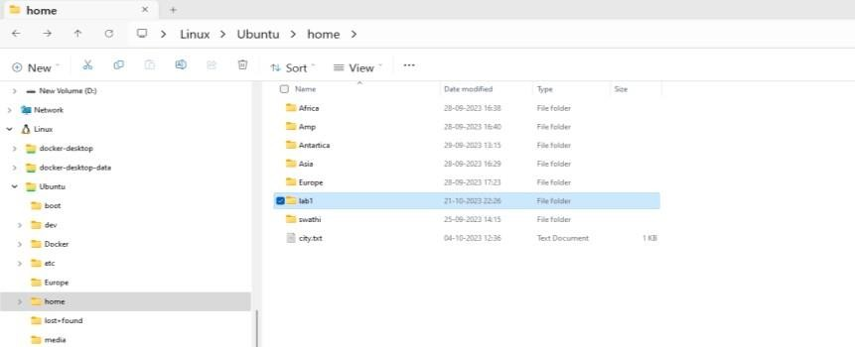

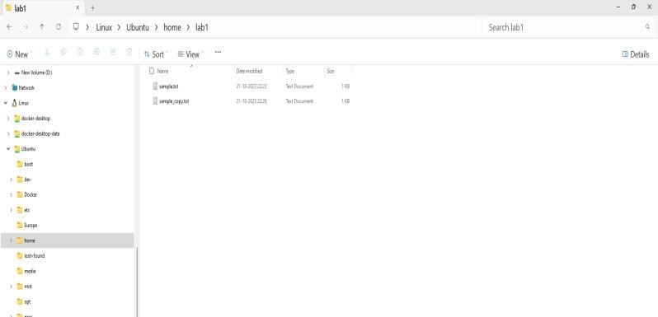

**Lab2 Permissions and Ownership** 1.Create the folder with name lab2 root@Chaitanya:/home# mkdir lab2 root@Chaitanya:/home# ls

folders present in home folder

Africa Amp Antartica Asia Europe city.txt lab1 **lab2** Chaitanya root@Chaitanya:/home/lab2# ls

2.create the text file root@Chaitanya:/home/lab2 touch secret.txt 3.To give permission

chmod 600 secret.txt 4chownChaitanya secret.txt

root@Chaitanya:/home# ls -l lab2/secret.txt

-rw 1Chaitanya root 0 Oct 23 05:39 lab2/secret.txt

5.root@Chaitanya:/home# ls -n lab2/secret.txt

-rw 1 1000 0 0 Oct 23 05:39 lab2/secret.txt

**Lab 3: Text Processing with Command Line Tools**

1. Create the folder with name lab3 root@Chaitanya:/home/lab3# ls random.txt
2. use echo command to write text in the file hello this isChaitanya from batch 4
3. to search for specific word

root@Chaitanya:/home# grep "Chaitanya" lab3/random.txt hello this isChaitanya from batch 4

1. replacing the wordChaitanya with the word replcaemnt root@Chaitanya:/home# sed -i 's/Chaitanya/replacement/g' lab3/random.txt hello this is replacement from batch 4
2. to count lines and numbers root@Chaitanya:/home# wc lab3/random.txt

0 7 38 lab3/random.txt 7 words

38 characters

**Lab 4 Working with Lists in YAML**

1. Creating the config.yaml in vs code C:\Users\CHAITANYA\Documents\config.yaml

1.Define key-value pairs in YAML for a fictitious application, including name, version, and description.

name: YamlFile1 version: 2.1.0 description: |

this is just a random text to practice yaml file.

1. 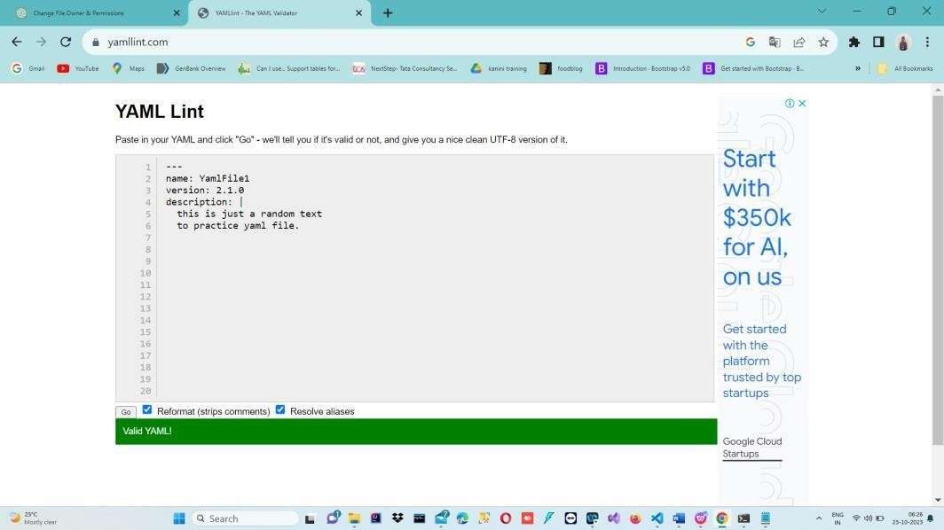Save the file

3.Validate that the YAML file is correctly formatted.

**Lab 5: Working with Lists in YAML**

1. Create the fruits.yaml file C:\Users\CHAITANYA\Documents\fruits.yaml

favorite_fruits:

* Banana
* Orange
* Mango
* Grapes

1. Adding items to the file

favorite_fruits:

* Banana
* Orange
* Mango
* Grapes
* watermelon
* Muskmelon
* Tomato

1. Validating the file

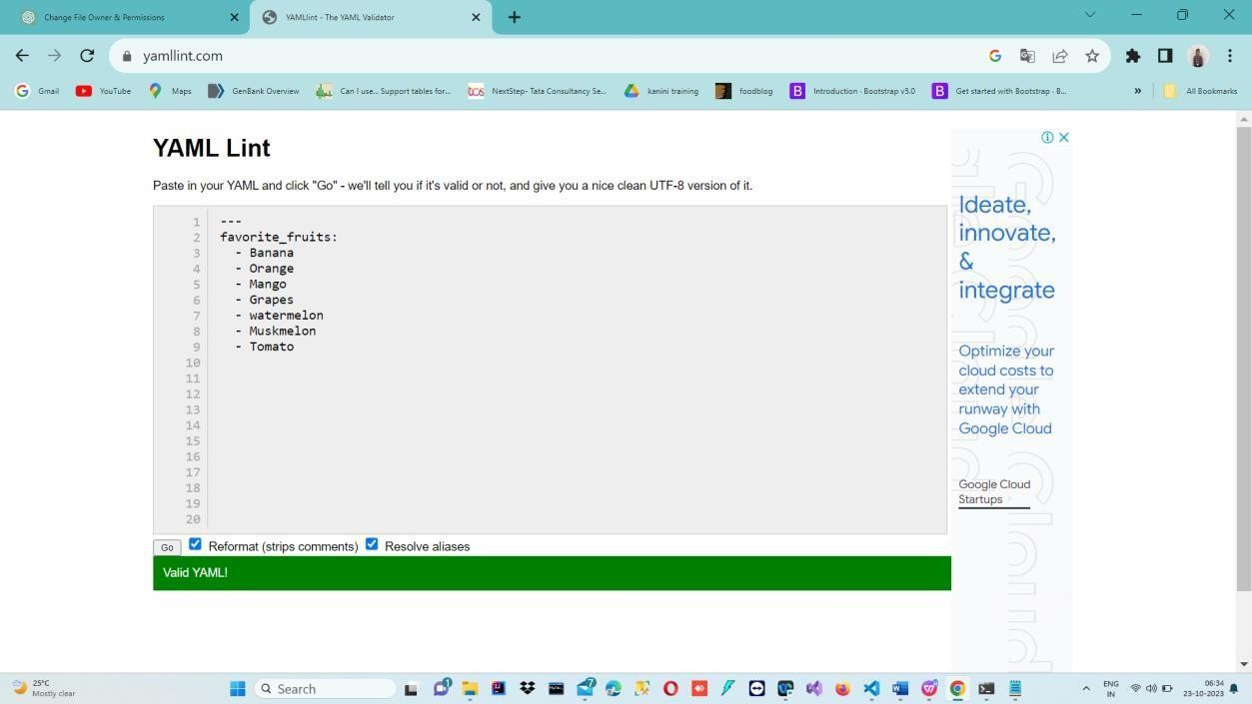

**Lab 6: Nested Structures in YAML**

1. Create the data.yaml file

C:\Users\CHAITANYA\Documents\data.yaml

Define a nested structure representing a fictitious organization with departments and employees.

organization: name: XYZ departments:

* name: Marketing employees:
  + name: Suresh

position: Marketing Director

* + name: Prabhu

position: Marketing Specialist

* name: Development employees:
  + name: Tom

position: Development Manager

* + name:sandarsh

position: Software Engineer

* name: Data employees:
  + name: Jerry position: Team lead
  + name: Thrupthi

position: Data Analist

1. Adding new member to the data

* name: Data

employees:

* + name: Jerry position: Team lead
  + name: Thrupthi

position: Data Analyst

- name: Bob Johnson

position: Sales Representative

1. removing tom from the development list

organization: name: XYZ departments:

* name: Marketing employees:
  + name: Suresh

position: Marketing Director

* + name: Prabhu

position: Marketing Specialist

* name: Development employees:
  + name:sandarsh

position: Software Engineer

* name: Data employees:
  + name: Jerry position: Team lead
  + name: Thrupthi position: Data Analyst
  + name: Bob Johnson

position: Sales Representative

1. updated data.yaml file

organization: name: XYZ departments:

- name: Marketing

employees:

* name: Suresh

position: Marketing Director

* name: Prabhu

position: Marketing Specialist

* name: Development employees:
  + name:sandarsh

position: Software Engineer

* name: Data employees:
  + name: Jerry position: Team lead
  + name: Thrupthi position: Data Analyst
  + name: Bob Johnson

position: Sales Representative

1. validating the data.yaml file

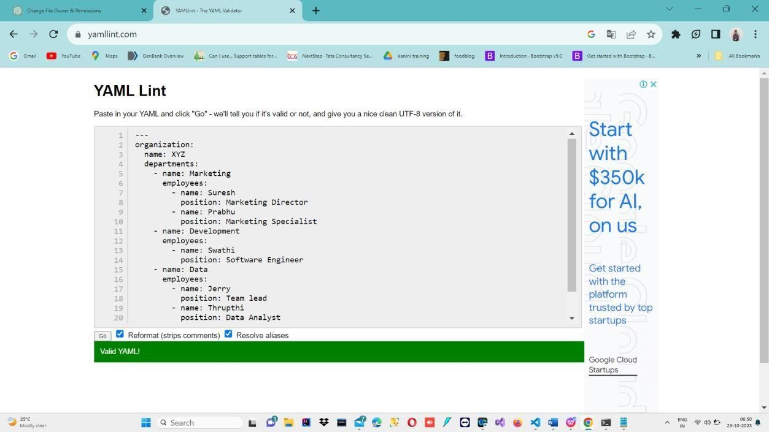

**Lab 7: Create Classic Azure CI Pipeline for Angular Application**

1. Create the new angular project

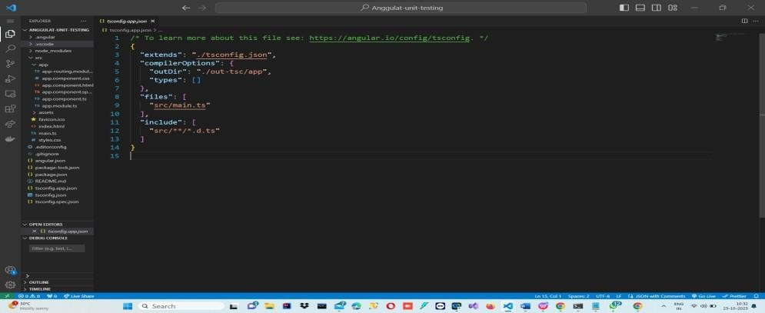

1. run the sample test cases

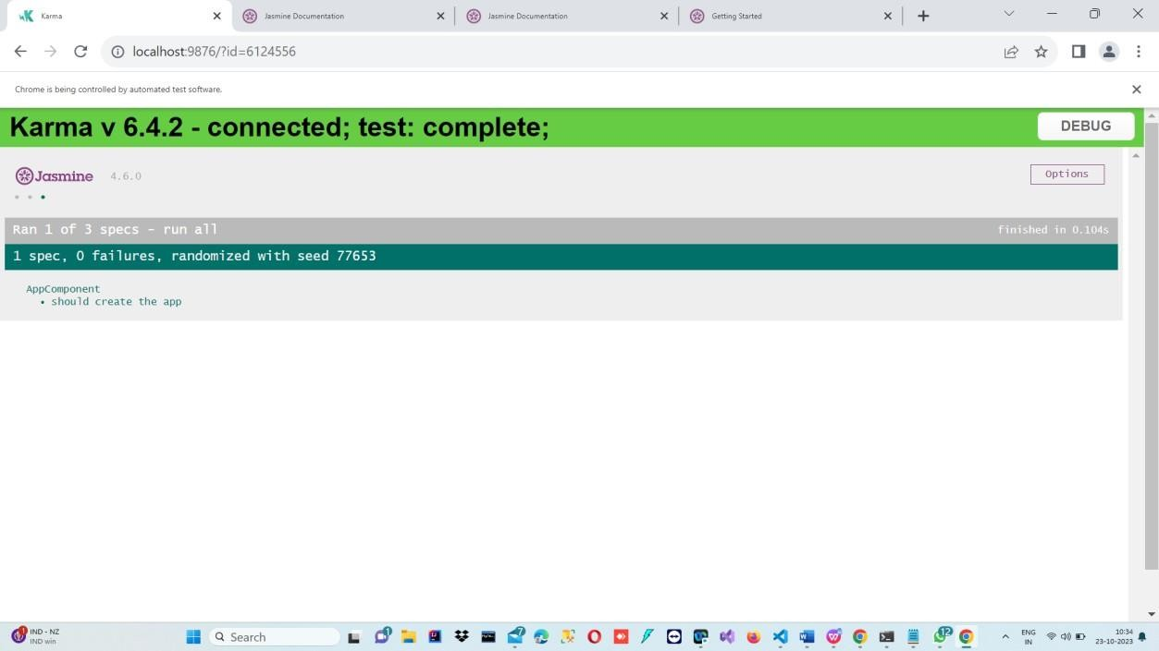

Upload to the Azure Devops Repository by using the below commands

PS C:\Users\CHAITANYA\Angular-test-project\Anggulat-unit-testing> git init

PS C:\Users\CHAITANYA\Angular-test-project\Anggulat-unit-testing> git remote add origin [https://Chaitanyakanini@dev.azure.com/Chaitanyakanini/Angular_Assessment1/_git/Angular_](https://sandarshkanini@dev.azure.com/sandarshkanini/Angular_Assessment1/_git/Angular_) Assessment1

PS C:\Users\CHAITANYA\Angular-test-project\Anggulat-unit-testing> git add .

PS C:\Users\CHAITANYA\Angular-test-project\Anggulat-unit-testing> git commit -m "files added"

PS C:\Users\CHAITANYA\Angular-test-project\Anggulat-unit-testing> git push -u origin –all 3.Files are uploaded in the Azure Devops Repository

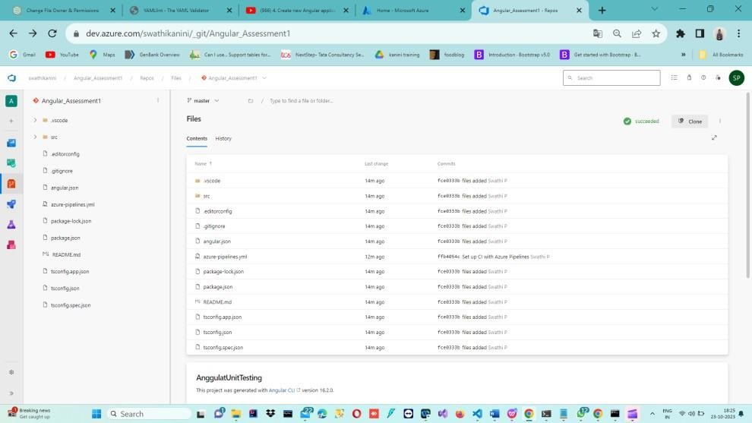

1. Create the pipeline

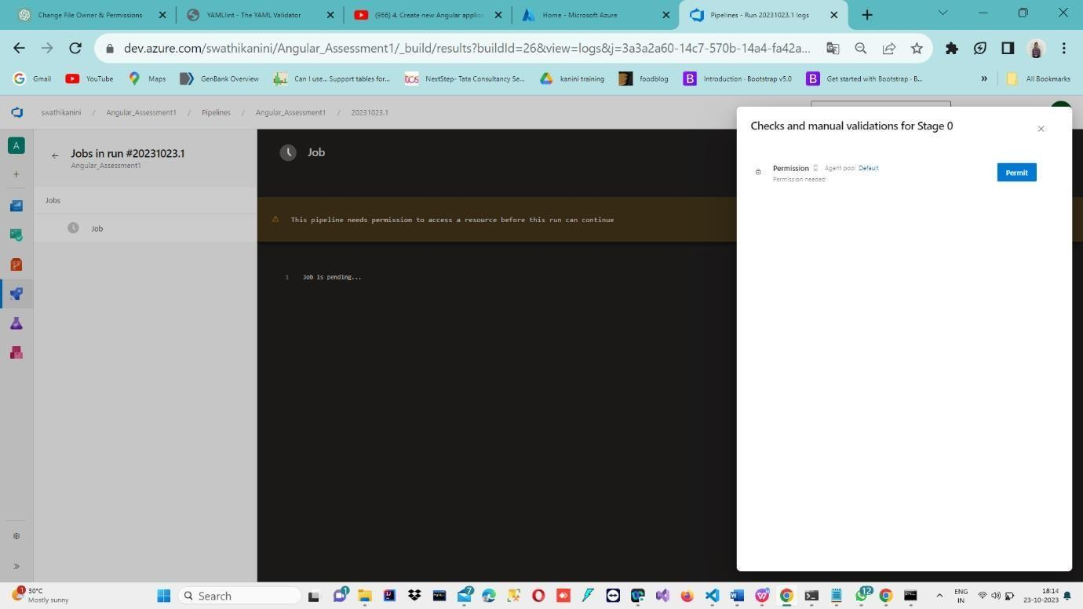

1. After creating the successful pipeline

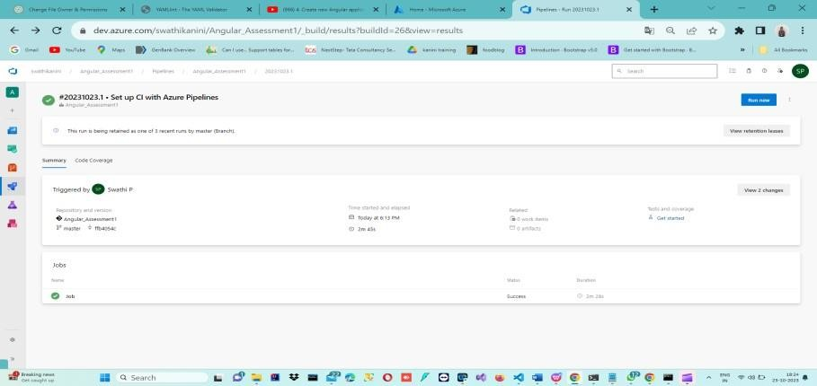

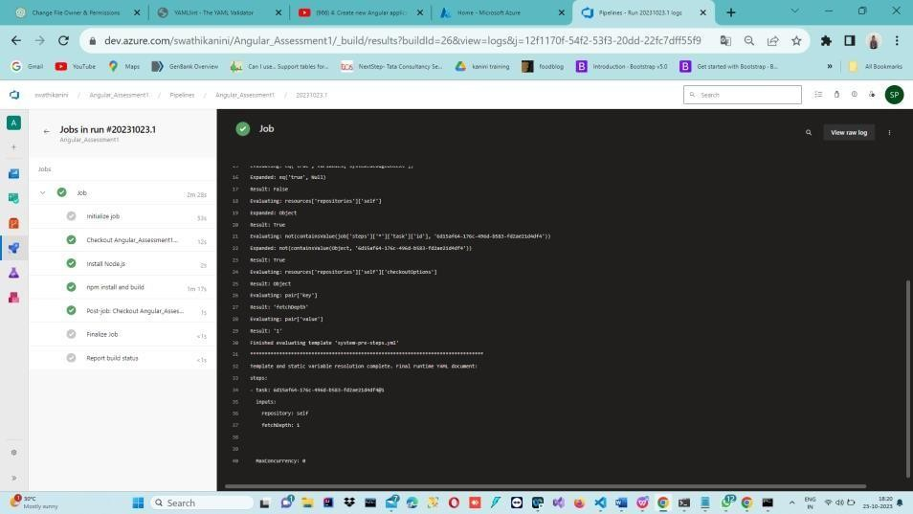

**Lab 8: Create YAML Azure CI Pipeline for React Application**

Objective: Create a YAML-based Azure CI pipeline to build a simple React application with unit testing using Enzyme and Jest.

Tasks:

1. Create an Azure DevOps project.
2. Create a YAML-based CI pipeline to build a React application.
3. Configure the pipeline to use Enzyme and Jest for unit testing.
4. Trigger the pipeline and verify the test results.

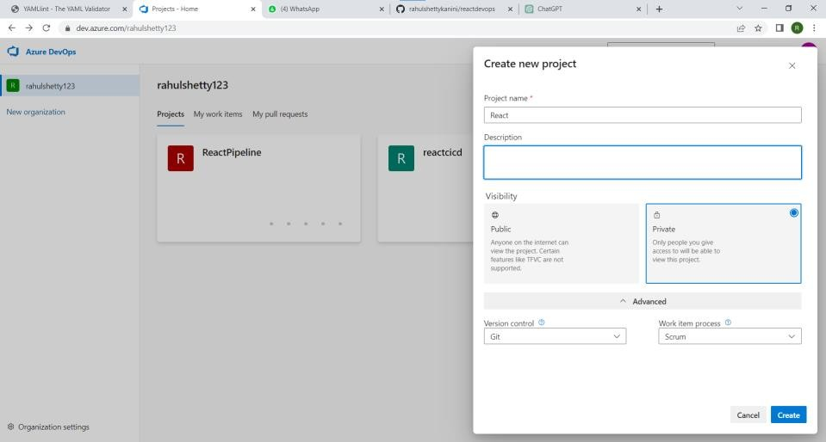

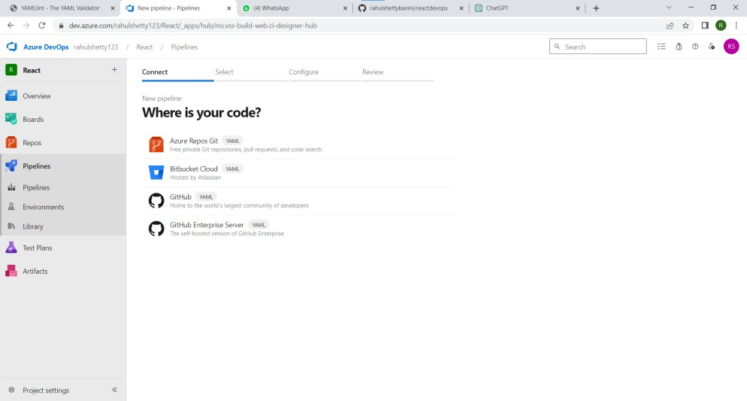

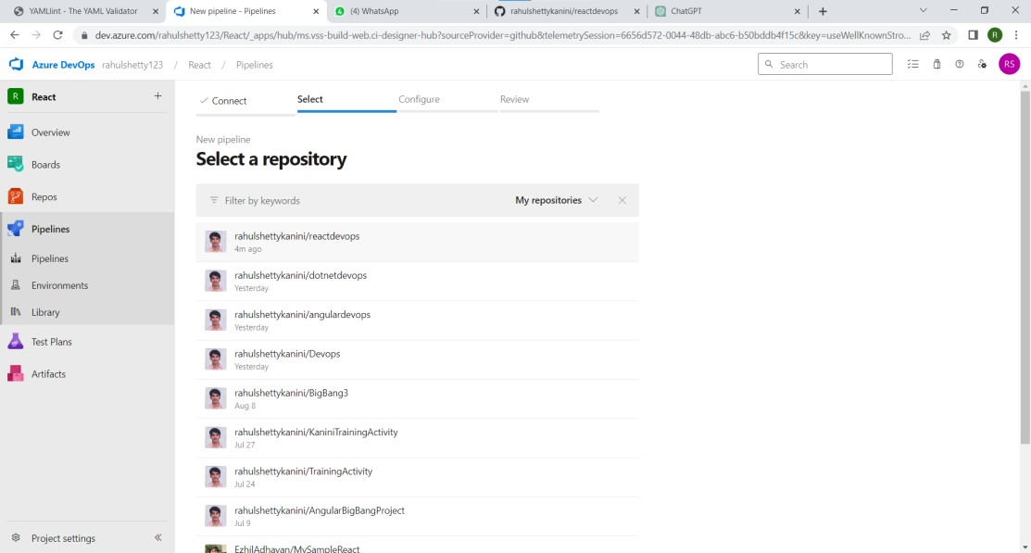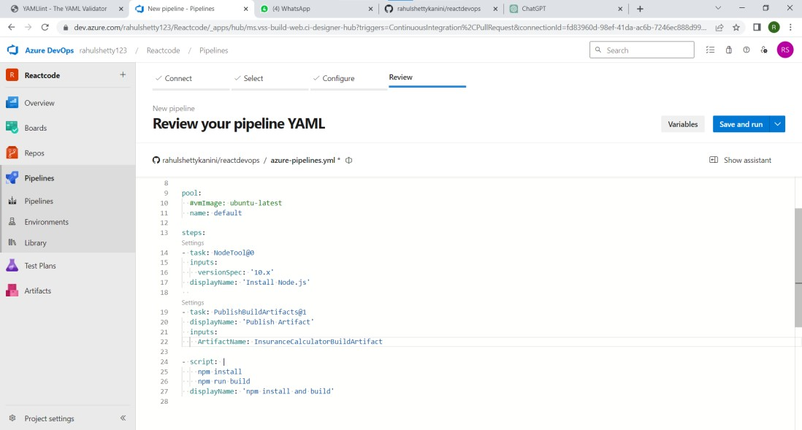

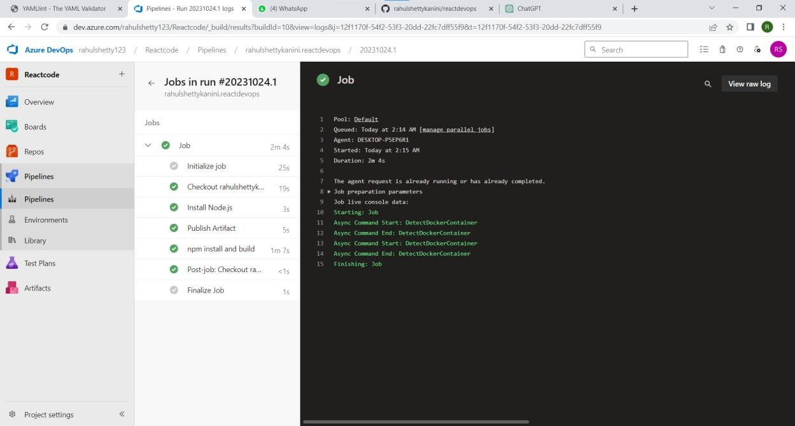

Lab 9: Create CI Pipeline for .NET Core Application with MS Unit Test Objective: Create a CI pipeline, either classic or YAML, to build a .NET Core application and run MS Unit tests.

Tasks:

1. Set up a new Azure DevOps project.
2. Create a CI/CD pipeline for a .NET Core application.
3. Configure the pipeline to use MS Unit tests.
4. Trigger the pipeline and validate the test results.

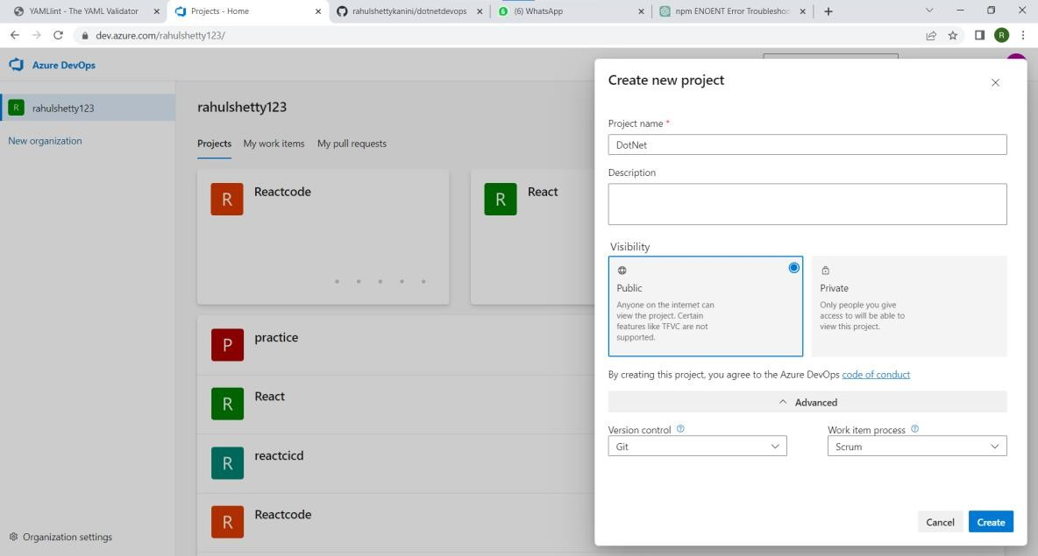

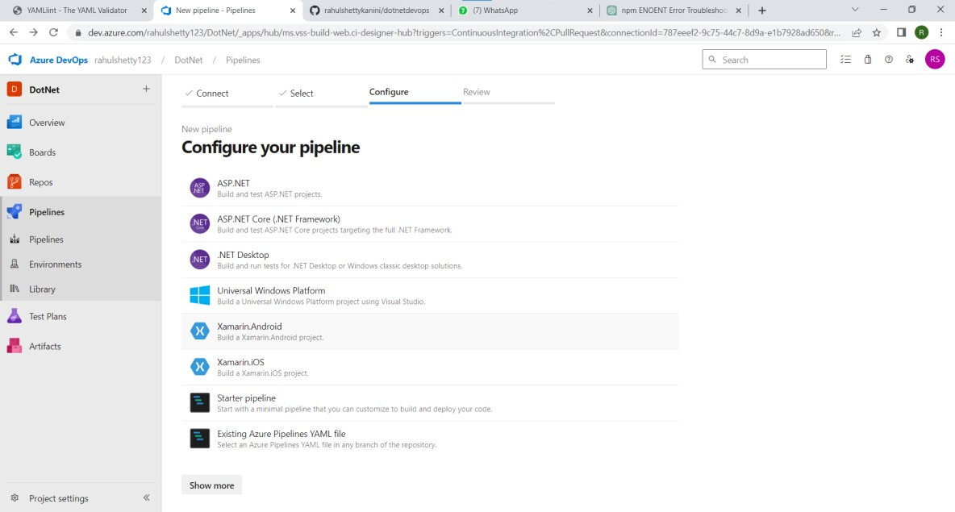

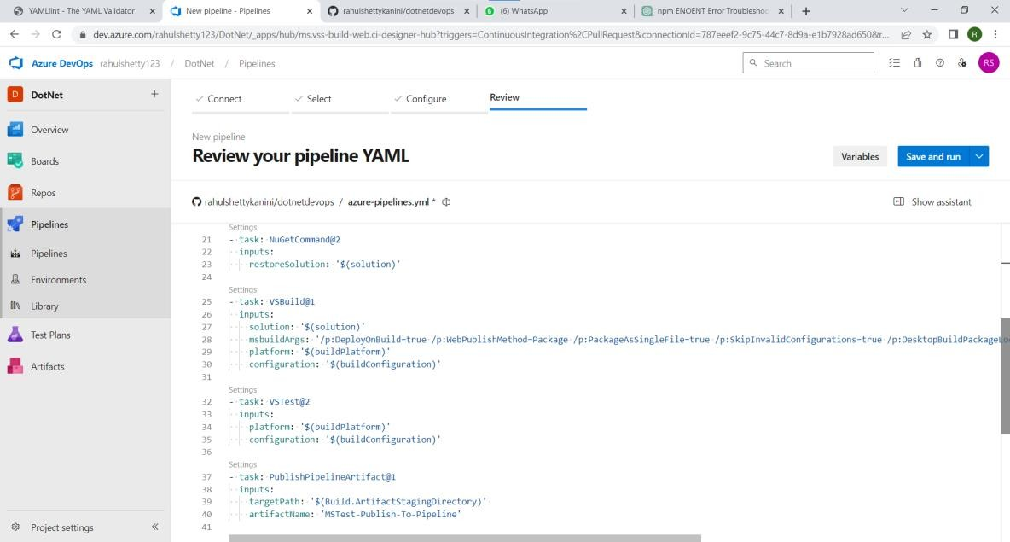

Lab 10: Creating a Docker Image for a .NET Core Web API and Running it in Rancher Desktop

Objective: In this lab, you will create a Docker image for a sample .NET Core Web API application and then run the Web API container in Rancher Desktop.

Prerequisites:

Rancher Desktop installed and running.

.NET Core SDK installed on your machine. Tasks

Step 1: Create a .NET Core Web API Project Step 2: Build the .NET Core Web API Project Step 3: Dockerize the .NET Core Web API

Step 4: Build the Docker Image

Step 5: Run the Docker Container in Rancher Desktop Step 6: Test the .NET Core Web API via swagger.

