**GIT Commit Hash:** **be17d122e086b7632a7e504a60806543ffe756c2**

**GIT HTTPS** URL**:** <https://github.uc.edu/mittapsa/Hadoop-Final.git>

**GIT SSH URL**: [git@github.uc.edu:mittapsa/Hadoop-Final.git](mailto:git@github.uc.edu:mittapsa/Hadoop-Final.git)

**Commands Used to Execute:**

Books.Jar has been placed in following directory: /home/mittapsa/

Navigate to /home/mittapsa/ and execute the Following command

**hadoop jar Books.jar com.booksset.BookSet /data/openlibrary/ol_dump_works_latest-20161202.txt output_final**

**Command to check Output:**

**hdfs dfs -cat output_final/part-r-00000 | tail -50**

5.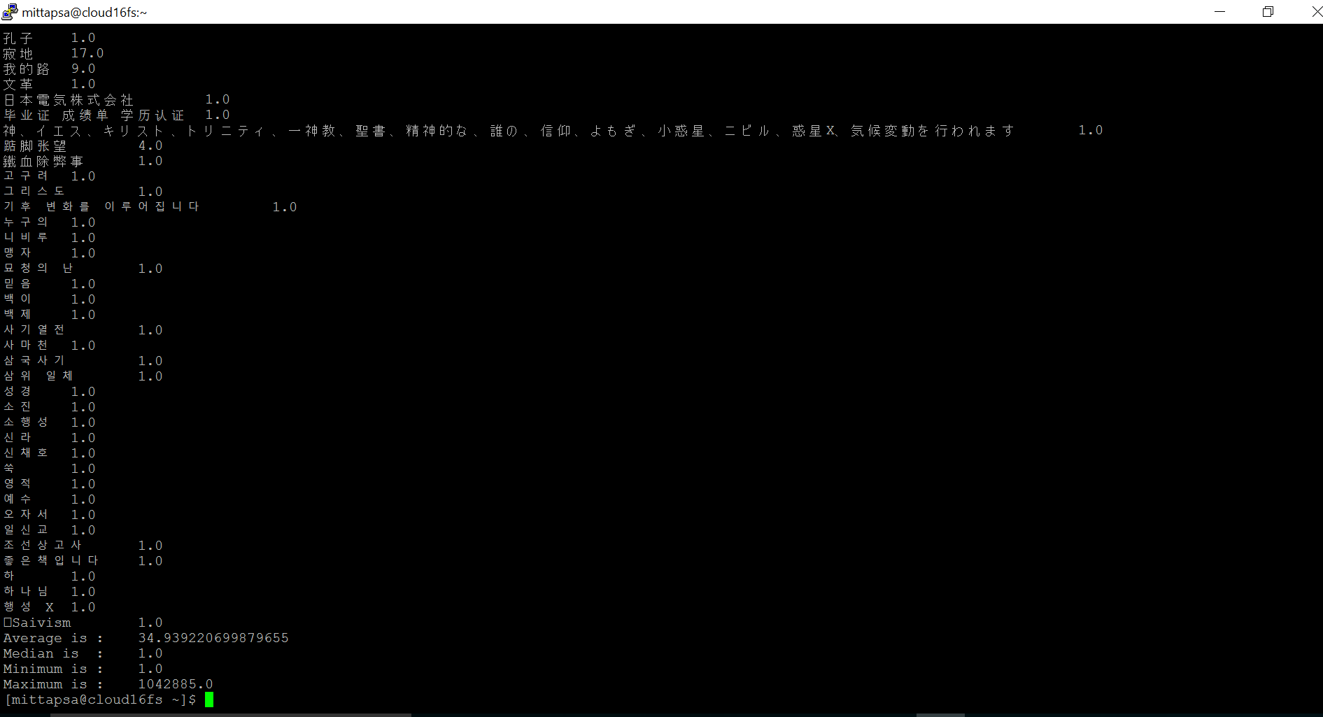

**Average of the Data Provided: 34.939**

**Median of the Data Provided: 1.0**

**Minimum of the Data Provided: 1.0**

**Maximum of the Data Provided: 1042885.0**