**1) 5 most frequent visitors**

**GIT Commit Hash:** 39913655df1d637f64ebf6b26a7b7e90332f4efa

**GIT HTTPS** URL**:** <https://github.uc.edu/mittapsa/WebServerLog-Analysis.git>

**GIT SSH URL**: git@github.uc.edu:mittapsa/WebServerLog-Analysis.git

**Commands Used to Execute:**

webserver.jar has been placed in /home/mittapsa/

Navigate to /home/mittapsa/ and execute the Following command

**hadoop jar webserver.jar com.logs.topVisitors /data/nasa/NASA_access_log_Aug95.log output_hw07_1**

**command to check Output:**

**hdfs dfs -cat output_hw07_1/part-r-00000**

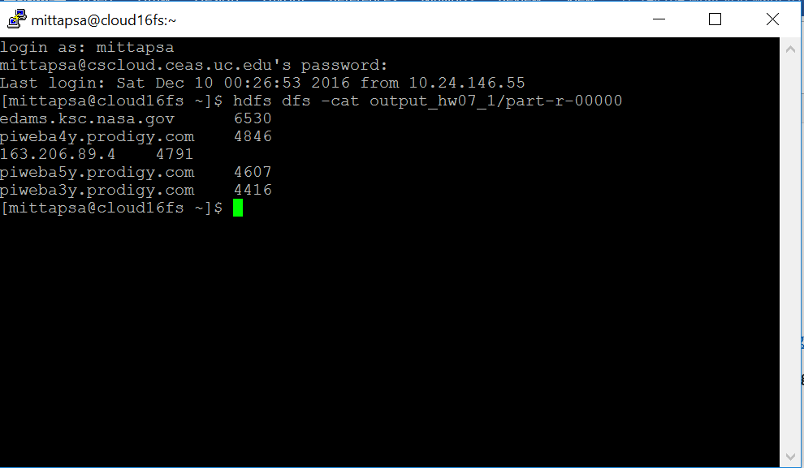

Output File part-r-00000_1 has been attached in the git repository

2) **5 most frequently requested web pages**

**GIT Commit Hash:** 39913655df1d637f64ebf6b26a7b7e90332f4efa

**GIT HTTPS** URL**:** <https://github.uc.edu/mittapsa/WebServerLog-Analysis.git>

**GIT SSH URL**: git@github.uc.edu:mittapsa/WebServerLog-Analysis.git

**Commands Used to Execute:**

webserver.jar has been placed in /home/mittapsa/

Navigate to /home/mittapsa/ and execute the Following command

**hadoop jar webserver.jar com.logs.topURLS /data/nasa/NASA_access_log_Aug95.log output_hw07_2**

**command to check Output:**

**hdfs dfs -cat output_hw07_2/part-r-00000**

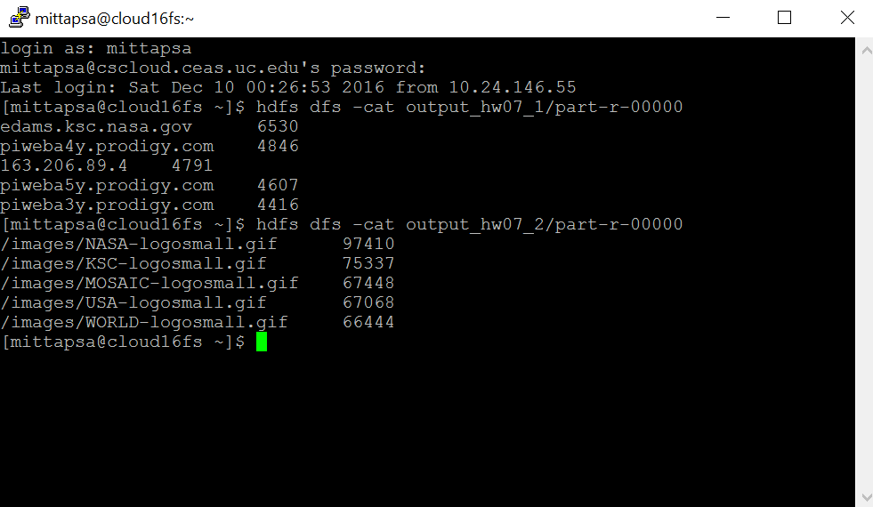

Output File part-r-00000_2 has been attached in the git repository

3) **Total count of bytes sent to all clients over the interval**

**GIT Commit Hash:** 39913655df1d637f64ebf6b26a7b7e90332f4efa

**GIT HTTPS** URL**:** <https://github.uc.edu/mittapsa/WebServerLog-Analysis.git>

**GIT SSH URL**: git@github.uc.edu:mittapsa/WebServerLog-Analysis.git

**Commands Used to Execute:**

webserver.jar has been placed in /home/mittapsa/

Navigate to /home/mittapsa/ and execute the Following command

**hadoop jar webserver.jar com.logs.topBytes /data/nasa/NASA_access_log_Aug95.log output_hw07_3**

**command to check Output:**

**hdfs dfs -cat output_hw07_3/part-r-00000**

Output File part-r-00000_3 has been attached in the git repository

