ASSESSMENT TOOL 1 – APPLICATION BASED QUESTIONS
Course Code: | DSA03 | Course Title: | Natural Language Processing
CO Assessed: | CO1 – Imitation (L1) | Assessment: | Assessment Tool 1 – Application Based Questions
Weightage: | 40% of CIA
CO1 Statement: | Analyse NLP models, regular expression patterns, finite state automata, morphological processing techniques and to interpret language processing. (BL-3)
Student Name: |  | Reg. No.:
Section / Batch: |  | Date:

Code of Conduct
I N.CHAITANYA RAM(192472172) (Name / Reg No) certify that this submission is my original work and that I have adhered to the guidelines specified for this assessment. I understand that any violation of academic integrity rules will result in disciplinary action.
Signature of the Student: CHAITANYA

Instructions
• Develop a modular and efficient Python program that satisfies all the functional requirements specified in the problem statement.
• Demonstrate the correctness of the implementation using suitable test cases and justify the output obtained.
• Follow good programming practices, including meaningful variable names, proper code indentation, comments, and error handling wherever applicable.
• Duration: 30 minutes.

Section / Topic | Focus | Q Nos
Information Extraction | Regex-Based Information Extraction | 1
Pattern Matching | Regex Pattern Matching | 2
Regular Expression Patterns | Regex-Based Input Validation | 3

Annexure A – Application Based Questions
Section 1: Regular Expressions – Resume Information Extraction
1. A multinational recruitment company receives thousands of resumes every day in text format. The HR department requires an automated system to extract candidate information for shortlisting.
Design and implement a Python-based resume information extraction system using Regular Expressions that performs the following tasks:
Extract the candidate's name.
Identify email addresses.
Extract mobile numbers.
Detect technical skills (Python, Java, SQL, Machine Learning, NLP).
Extract years of experience.
Generate a structured summary of the candidate's profile.
Display candidates who satisfy the minimum eligibility criteria (minimum 2 years of experience and Python skill).
ANSWER

CODE:

import re

def extract_resume(text):
# Extract candidate name
name_match = re.search(r"Name\s*:\s*(.+)", text, re.I)
name = name_match.group(1).strip() if name_match else "Not found"

# Extract email
emails = re.findall(
r"\b[A-Za-z0-9._%+-]+@[A-Za-z0-9.-]+\.[A-Za-z]{2,}\b",
text
)

# Extract mobile number
mobiles = re.findall(
r"(?<!\d)(?:\+91[- ]?)?[6-9]\d{9}(?!\d)",
text
)

# Detect technical skills
skill_pattern = (
r"\bPython\b|\bJava\b|\bSQL\b|"
r"\bMachine Learning\b|\bNLP\b"
)
skills = re.findall(skill_pattern, text, re.I)
skills = sorted(set(skill.title() for skill in skills))

# Extract years of experience
exp_match = re.search(
r"(\d+(?:\.\d+)?)\s*\+?\s*years?\s+of\s+experience",
text, re.I
)
experience = float(exp_match.group(1)) if exp_match else 0

# Generate structured profile
profile = {
"Name": name,
"Email": emails,
"Mobile": mobiles,
"Skills": skills,
"Experience": experience
}

return profile

resume = """
Name: Arun Kumar
Email: arun@gmail.com
Mobile: 9876543210
Skills: Python, Java, SQL, Machine Learning, NLP
Experience: 3 years of experience
"""

profile = extract_resume(resume)

print("CANDIDATE PROFILE")
for key, value in profile.items():
print(key, ":", value)

# Eligibility check
if profile["Experience"] >= 2 and any(
skill.lower() == "python" for skill in profile["Skills"]
):
print("Eligibility: Eligible for shortlisting")
else:
print("Eligibility: Not eligible for shortlisting")

OUTPUT
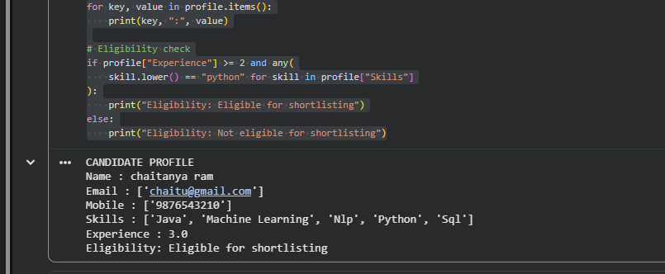

Section 2: Regular Expressions – Product Search System
2. An e-commerce company plans to enhance its product search engine to improve customer experience through flexible keyword matching.
Design and implement a Python-based product search system using Regular Expressions that performs the following tasks:
Search products using an exact keyword.
Perform prefix-based searches.
Perform suffix-based searches.
Search using partial keywords.
Perform case-insensitive searches.
Display all matching product names.
Generate a report showing the total number of matching products for each search.
ANSWER

CODE:
import re

products = [
"Python Programming Book",
"Java Programming Book",
"Python Laptop",
"SQL Database Guide",
"Machine Learning Course",
"Python Keyboard"
]

def search_products(keyword, mode):
matches = []

for product in products:
if mode == "exact":
pattern = r"^" + re.escape(keyword) + r"$"
elif mode == "prefix":
pattern = r"^" + re.escape(keyword)
elif mode == "suffix":
pattern = re.escape(keyword) + r"$"
elif mode == "partial":
pattern = re.escape(keyword)
else:
print("Invalid search mode")
return []

if re.search(pattern, product, re.I):
matches.append(product)

print("\nSearch mode:", mode)
print("Keyword:", keyword)
print("Matching products:")

if matches:
for product in matches:
print("-", product)
else:
print("No products found")

print("Total matching products:", len(matches))
return matches

# Demonstrate all search operations
search_products("Python Programming Book", "exact")
search_products("Python", "prefix")
search_products("Book", "suffix")
search_products("Program", "partial")
search_products("python", "partial")

OUTPUT
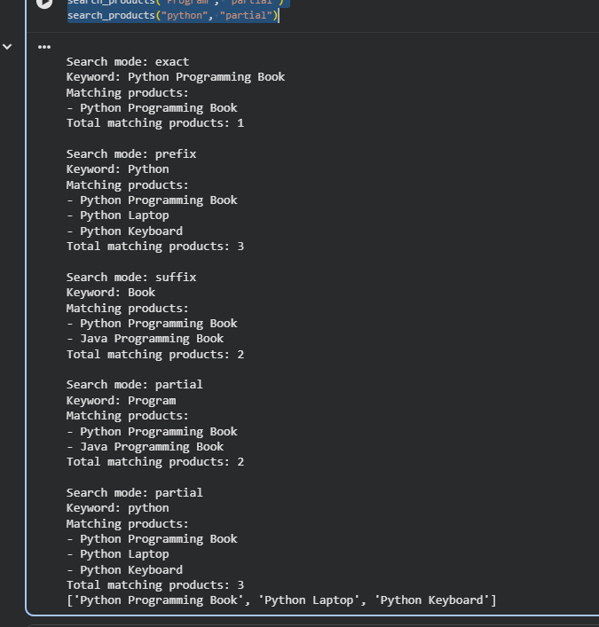

Section 3: Regular Expressions – University Registration System
A university is developing an automated online registration portal to verify student information before course enrollment.
Design and implement a Python-based validation system using Regular Expressions that performs the following tasks:
Validate the student register number.
Validate the institutional email address.
Validate the course code.
Validate the semester information.
Validate the student's mobile number.
Display appropriate validation messages for each field.
Generate a final registration status report indicating whether the registration is successful.
ANSWER

CODE:
import re

def validate(pattern, value):
return bool(re.fullmatch(pattern, value))

# Example validation formats
patterns = {
"Register Number": r"[A-Z]{2,4}\d{2,4}",
"Institutional Email": r"[A-Za-z0-9._%+-]+@simats\.edu\.in",
"Course Code": r"[A-Z]{2,5}\d{2,4}",
"Semester": r"(I|II|III|IV|V|VI|VII|VIII|1|2|3|4|5|6|7|8)",
"Mobile Number": r"[6-9]\d{9}"
}

# Student information
student = {
"Register Number": "AIDS1234",
"Institutional Email": "arun@simats.edu.in",
"Course Code": "DSA03",
"Semester": "III",
"Mobile Number": "9876543210"
}

all_valid = True

print("UNIVERSITY REGISTRATION REPORT")

for field, pattern in patterns.items():
value = student[field]

if validate(pattern, value):
print(field + ": Valid")
else:
print(field + ": Invalid")
all_valid = False

print("\nFINAL REGISTRATION STATUS")

if all_valid:
print("Registration Successful")
else:
print("Registration Failed - Check Invalid Fields")

OUTPUT
