European Cross-Commodity Risk Pack

Daily Desk Note — 2026-04-01
Theme: Gas + Carbon → European Power Curve Implications | Markets: TTF Gas | EUA Carbon | DE Day-Ahead Power
Name: Chaitanya Rawal
Email: chaitanya.rawal0804@gmail.com

1. Daily Monitor Metrics
Metric | Value | Unit | Trading Relevance
TTF Front Month | 11.19 | $/MMBtu | Prompt gas price benchmark
TTF (EUR equivalent) | 35.13 | €/MWh | Gas cost input to power stack
EUA Front Dec Price | 55.85 | €/tCO2 | Carbon cost input
EUA 30-Day Momentum | -7.39 | % | Policy/supply signal
EU Gas Storage | 38.4 | % full | Structural gas buffer
Storage vs 5yr Avg | -26.6 | pp | Relative tightness signal
DE Day-Ahead Power | 147.01 | €/MWh | Realised power benchmark
Clean Dark Spread | 49.95 | €/MWh | Gas→power profitability
Power-Carbon Correlation (30d) | -0.25 | r | Cross-commodity regime

2. Risk Narrative
# MORNING DESK NOTE – ENERGY MARKETS | 01-APR-2026
**GAS TIGHTNESS: Structural Deficit Persists Despite Seasonal Softening**
TTF front-month is trading at €35.13/MWh (USD 11.19/MMBtu), within normal seasonal ranges but masking an uncomfortable structural position. European storage sits at 38.4% full—a concerning 26.6% below the five-year average for this date. While spring demand typically eases, the storage deficit means we carry elevated marginal supply costs into summer. The price level suggests traders are pricing incremental LNG at the margin, but absent aggressive injections over the next 60 days, we risk a tighter H2 2026 than current forward curves reflect. **Momentum is flat-to-slightly-bid into April, but the summer premium is real.** Watch weekly storage builds; anything below 15 TWh/week signals that TTF re-rating higher is likely within six weeks.
**CARBON SIGNAL: Policy Headwind Undermining Power Support**
EUA prices have deteriorated 7.39% over the past month and now sit at €55.85/t—a meaningful break that suggests either demand destruction in industrial sectors or increased Phase 4 allowance supply expectations. At this level, carbon is providing *negative* signal for European power prices. The -0.25 correlation between power and carbon over 30 days confirms this: carbon weakness is not being offset by power strength, implying the selloff is driven by macro headwinds rather than supply-side tightness. For traders, this means EU power does **not** have carbon support on rallies—any upside in the curve is vulnerable to further EUA slides if economic data soften or if Fit-for-55 implementation debates resurface.
**POWER CURVE RISK: Dangerous Compression Below Q2 Spike**
The Clean Dark Spread sits at €49.95/MWh on the back of Day-Ahead power at €147.01/MWh. This is a *tight* margin—CDS implies gas-fired generation is barely covering variable costs plus carbon at spot. The asymmetry lies in the curve: **Day-Ahead is overpriced relative to Q2-Q3 forwards because storage deficit risk is being priced incrementally into summer, not frontloaded.** If cold weather extends into April or if any major supply disruption surfaces (LNG delays, Russian transit reductions), we see a violent spike in prompt curve that crushes the CDS spread further. Conversely, if storage builds aggressively, Q3 power could crater 15–20% with no corresponding Day-Ahead collapse, leaving us short the cheap hedge.
---
**KEY RISK STATEMENT:** *The combination of below-average storage, weak carbon, and razor-thin CDS creates a one-way bet: European power curve is vulnerable to a violent re-steepening if supply tightens, but lacks carbon support on the downside if demand softens. Position length cautiously; the risk/reward is asymmetric against shorts.*

3. Market Charts
Chart 1: TTF Gas vs EUA Carbon — 90 Day View
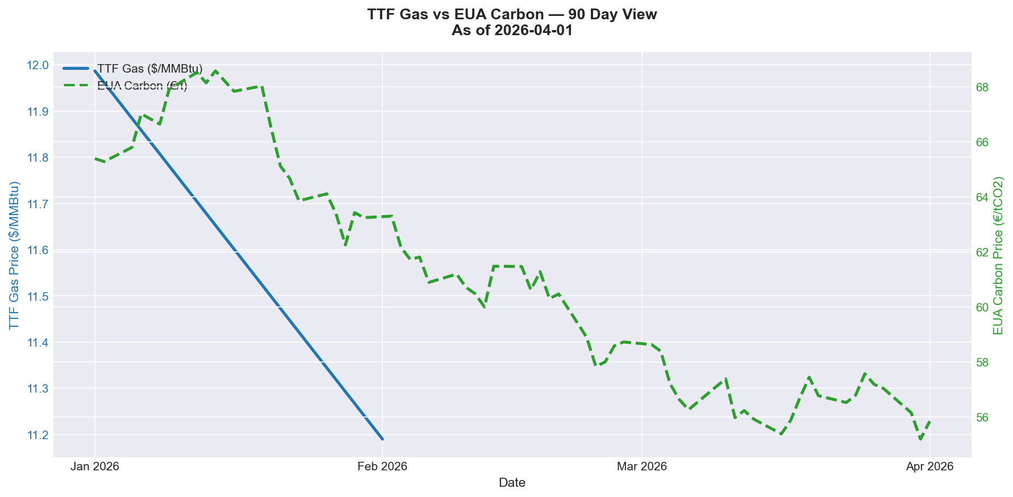

Chart 2: DE Day-Ahead Power & Clean Dark Spread
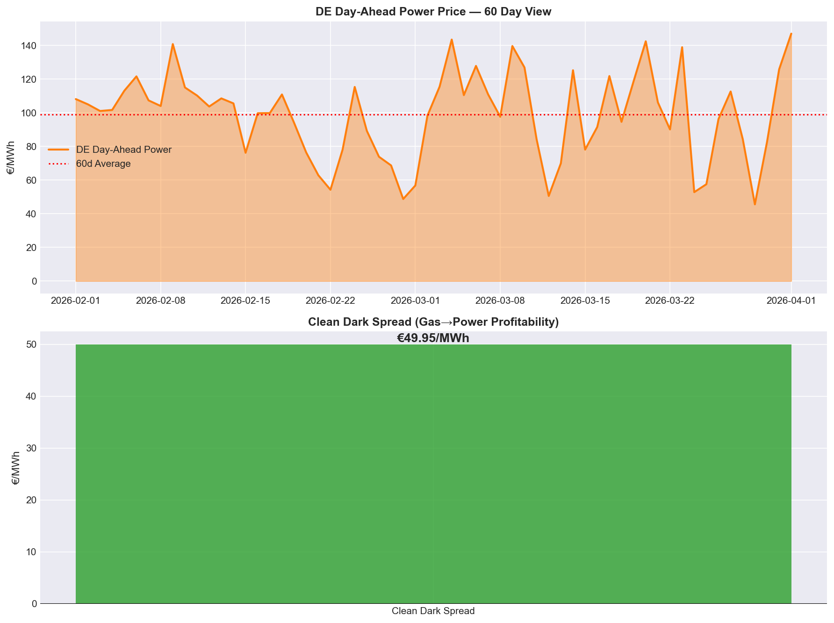

Generated automatically by EU Risk Pack Monitor | 2026-04-01 05:19 | Data: FRED, Stooq, GIE AGSI+, Energy-Charts.info | AI: Claude Haiku

