**Table of contents**

1. User Manual
2. Use Cases
3. Brief Use cases
4. Fully dressed use cases
5. UML Diagrams
6. Use Case diagram
7. Class diagram
8. Sequence diagram
9. Activity diagram
10. GUI Screenshots

User Manual

|  |  |
| --- | --- |
| Getting Started | |
|  | **Description**  This project is built to reflect what a dental clinic appointments management system would be like.  **Project Structure**  This project is a Windows Presentation Foundation Application. WPF application has a reference project (console application) where hosts business logic classes.  **Scenario**  The clinic has two doctors, a General Dentist & a Pediatric Dentist. Both have their separate calendars. Our clinic has only one dental chair. So, appointments should be booked in a systematic way via WPF application. The clinic has an admissions clerk (secretary), responsible for managing the appointments and filling the patients' information. |
| Appointment Slot | Choose one of the available time slots from the combo box. |
| Age | Enter age of the patient. Valid ages are [2-99] |
| Gender | Select gender from the drop-down list. |
| Medical Conditions | Select if patient has any medical conditions mentioned in the list. |
| CT-XRAY | Select yes if you patient has his CT-XRAY. |
| Treatment | Choose one of the services which patient requests for. |
| Credit card | Make a payment for the appointment by taking 16-digit credit card number. |
| Register | Create temporary patient and shows in Data Grid |
| Save | To book an appointment, save the appointment |
| Display | View the details of the patient. |
| Search | A screenshot of a cell phone  Description automatically generatedSearch details of the patient by age |

**Use cases**

Register: Admissions clerk selects appointment time, age, gender, medical conditions, CT- XRAY, treatment and credit card number.

Display: Clerk views the details entered.

Save: Clerk saves all the details entered.

Search: Clerk views all the details by priority.

**Fully Dressed use cases**

**Use case 1**

Use case Name: Save Appointment

Scope: Booking an appointment online

Primary actor: Admissions clerk

Stake holder and Interests:

User wants to book a dental appointment.

Clerks takes the details of the patient and books an appointment.

Preconditions:

Clerk enters the details in the respective fields.

Success guarantee (Post conditions):

Appointment is successfully booked.

Main success scenario:

1. Clerk inputs all the valid details.
2. Clerk books an appointment for the patient.

Extensions:

Clerk enters the age which is out of range.

1. Age field box will become red in color.

Clerk enters the credit card number in invalid format.

1. Credit card field turns red in color.

**Use case 2**

Use Case Name: Display details

Scope: Booking appointment online

Primary actor: Clerk

Stake holder and Interests:

Clerk wants to view the details accurately with out any errors.

Preconditions:

Clerk must register and an appointment save before displaying any details.

Success guarantee (Post conditions):

Details are displayed successfully in the data grid with out any errors.

Main success scenario:

1. User registers an appointment
2. User views the entered details.

Extensions:

Clerk clicks display button before registering or saving an appointment.

1. No data is displayed on the screen.

**UML Diagrams**

Use Case Diagram

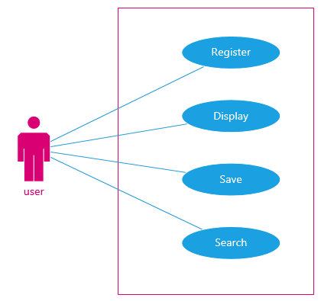

Class Diagram

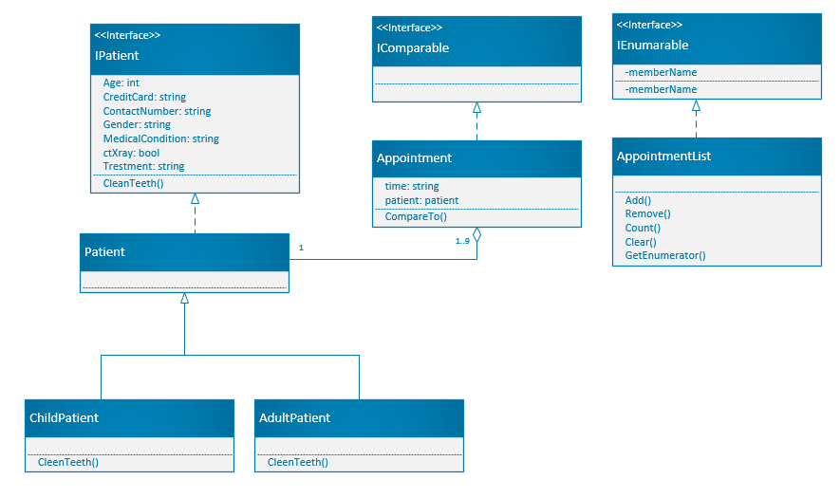

System Sequence diagram

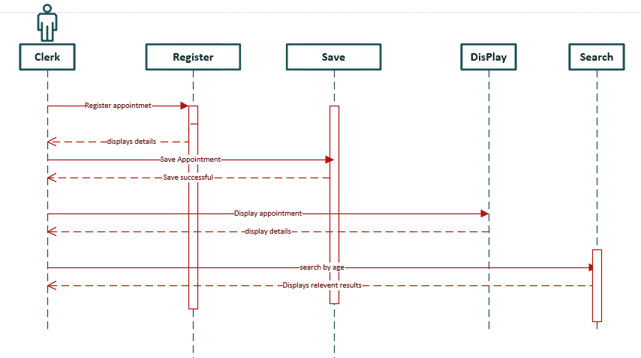

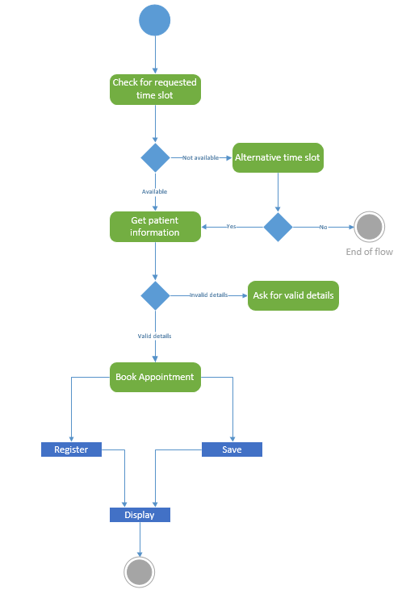**Activity Diagram**

**User Interaction and design**

This project is built to reflect what a dental clinic's appointments and patient’s management system would be like.

GUI Screenshots

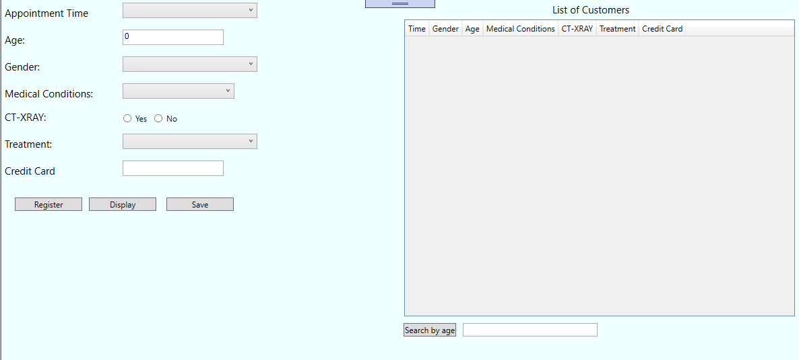

Error is handled when the data is invalid.

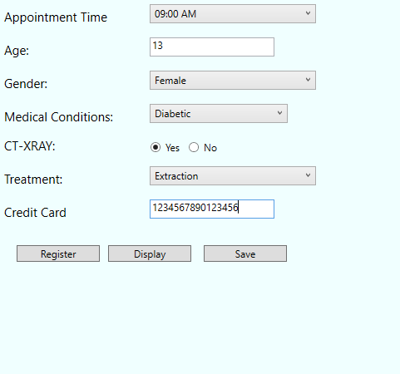 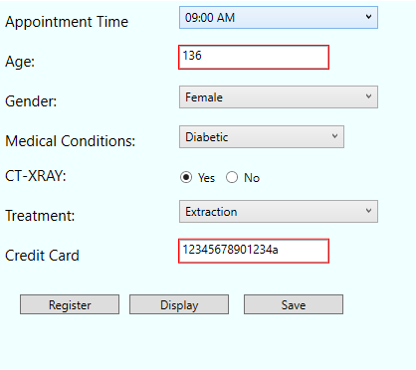

If the patient’s age is 15 and above will be considered as Adult patient and age less than 15 is considered as a child patient.

Details of child patient is displayed in green whereas adult patient details are displayed in yellow color.

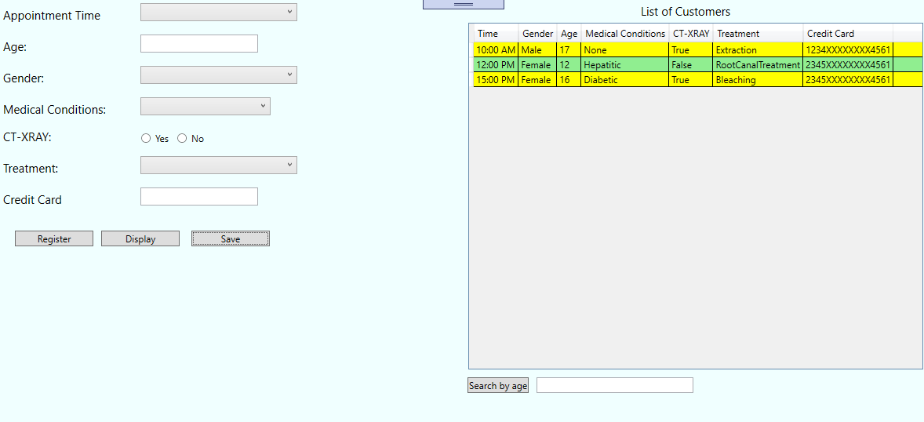

When clerk saves an appointment with out any errors, it will be saved successfully.

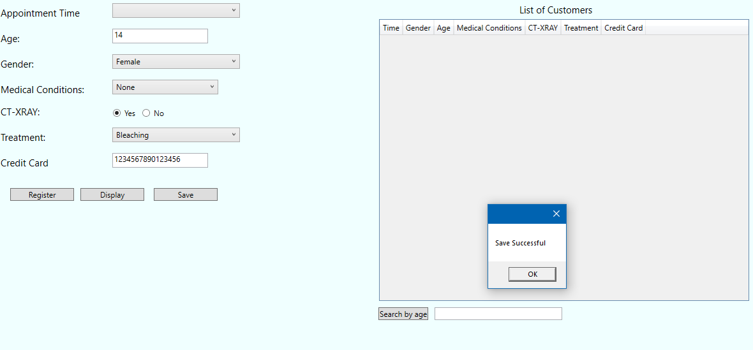

Error has been handled by displaying a message to the clerk.

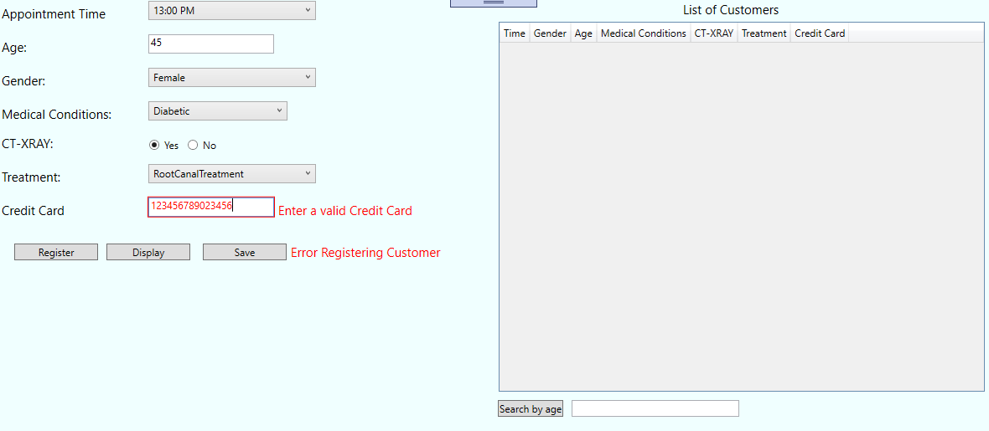

Filter appointments by age

