Setup and Installation Guide
Change-Aware Multi-Signal Anomaly Correlation for Kubernetes
M.Tech Project: Observability Testbed, Failure Injection and Evaluation
This guide explains, step by step, how to install and run the complete project on a new computer, from a fresh operating system to a working Kubernetes cluster with Prometheus, Loki, Grafana, the CI/CD pipeline collector, the failure-injection experiments and the CAMSAC evaluation.
Source code: https://github.com/chaitanya0807/devopsproject
Author: Chaitanya · Version 1.0 · November 2026

Contents
1. What you will build
2. System requirements
3. Install the required software
4. Download the project
5. Start the Kubernetes cluster
6. Deploy everything with one command
7. Verify the installation
8. Open the web interfaces
9. Configure the CI/CD pipeline collector
10. Run the failure-injection experiments (Mid-sem)
11. Evidence and screenshots
12. Daily use: stop and start
13. Troubleshooting
14. Remove everything

Note: Quick start for experienced users: install Docker, kubectl, minikube and Helm (Section 3), then run git clone, minikube start, ./scripts/setup.sh and ./scripts/verify.sh (Sections 4–7).

1. What you will build
The project has two parts that run on the same computer:
- Kubernetes cluster (minikube) runs the workload: the sample-app order service (2 replicas), its payments dependency, a load generator, and the in-cluster collectors (cAdvisor, kube-state-metrics, Promtail).
- Docker Compose stack runs storage and visualisation: Prometheus, Loki, Grafana, Node Exporter and the Python GitLab pipeline collector.

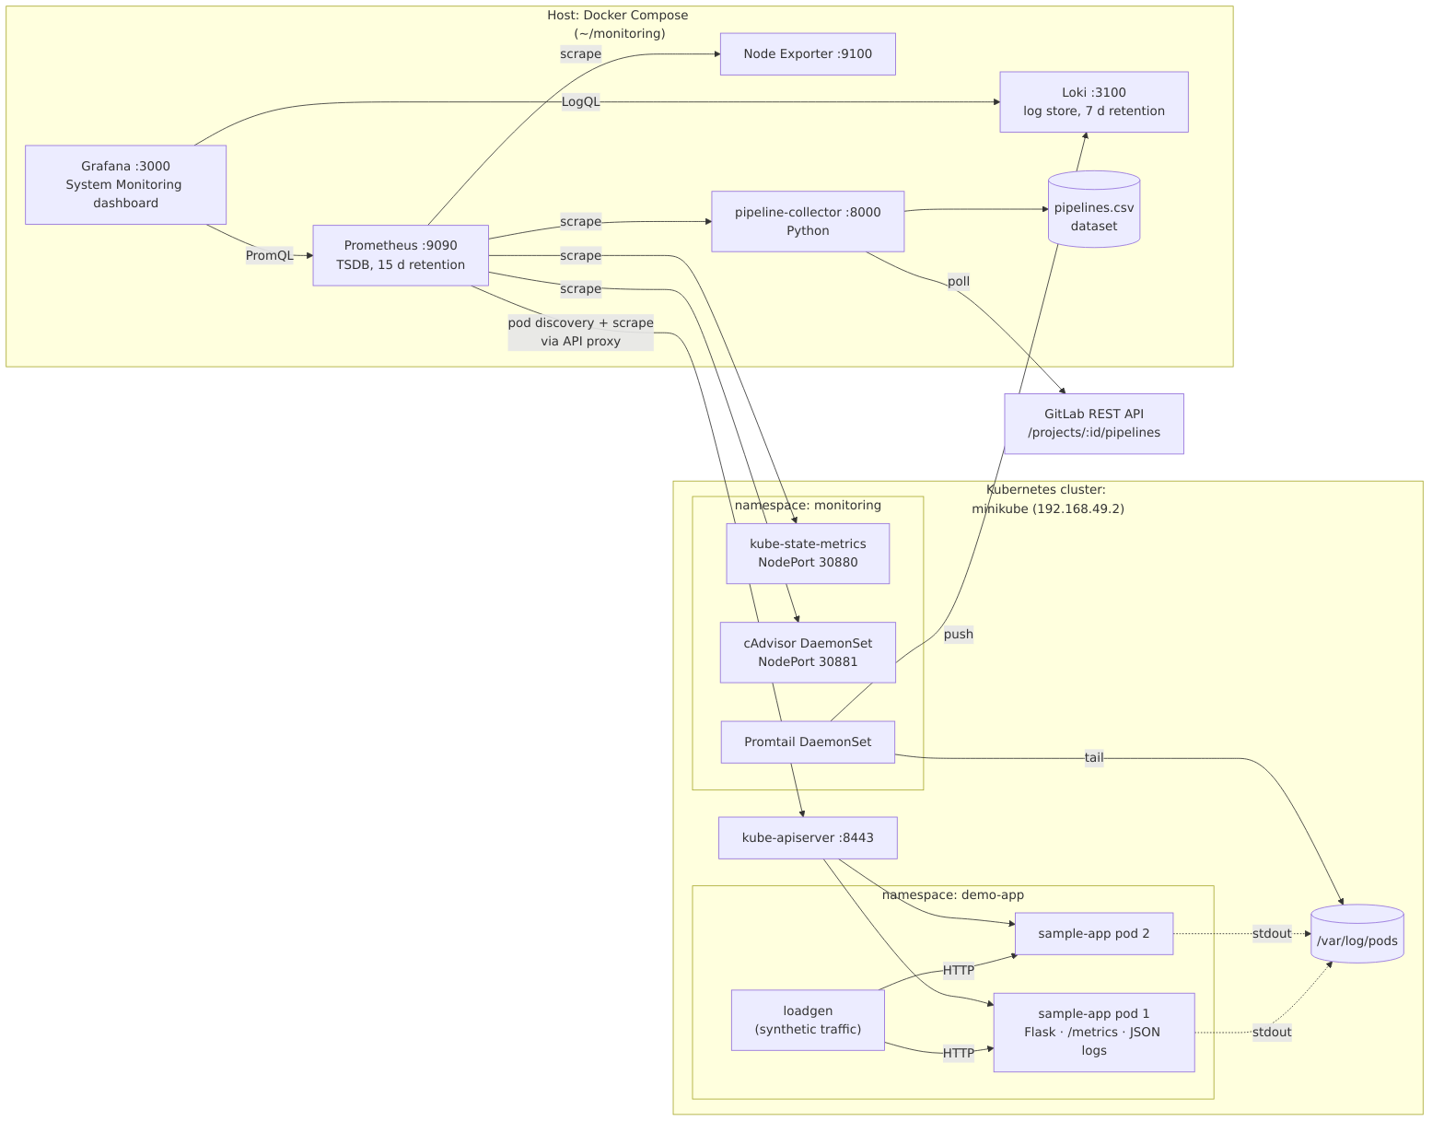
Figure 1: System architecture
Component | Where it runs | Purpose
sample-app, payments, loadgen | minikube, namespace demo-app | Monitored workload with fault-injection hooks
cAdvisor, kube-state-metrics, Promtail | minikube, namespace monitoring | Pod metrics, Kubernetes object state, log shipping
Prometheus | Docker Compose (port 9090) | Metrics storage and the B1 threshold alert rules
Loki | Docker Compose (port 3100) | Log storage
Grafana | Docker Compose (port 3000) | Dashboards
Node Exporter | Docker Compose (port 9100) | Host metrics
pipeline-collector | Docker Compose (port 8000) | GitLab CI/CD pipeline data
experiments/* | Host + analysis container | Fault injection, CAMSAC, baselines, evaluation

2. System requirements
Item | Minimum | Recommended
Operating system | Ubuntu 22.04 / 24.04 (64-bit) | Ubuntu 24.04 or newer
CPU | 4 cores | 8+ cores
RAM | 6 GB | 8 GB or more
Free disk | 25 GB | 40 GB
Internet | Required for installation and image downloads
Account | A user with sudo rights

Note: The project was developed and tested on Ubuntu 26.04 with 12 CPU cores and 5 GB RAM. With less than 6 GB of RAM, close the browser tabs you don't need while the cluster is running.
Windows users: install WSL2 with Ubuntu 24.04 (wsl --install -d Ubuntu-24.04 in an administrator PowerShell) and follow this guide inside the Ubuntu terminal. Install Docker Engine inside WSL as shown in Step 3 (not Docker Desktop), so that the minikube network is reachable exactly as on Linux.
macOS users: Docker Desktop works, but the minikube IP is not reachable from the Mac itself. Everything inside Docker (Prometheus scraping minikube) still works; to open the sample app in a browser use minikube service sample-app -n demo-app.

3. Install the required software
Open a terminal and run the following commands in order. Each step ends with a check command; compare its output before moving on.

Step 3.1: Basic tools
sudo apt update
sudo apt install -y git curl ca-certificates python3
Check: git --version and python3 --version print version numbers.

Step 3.2: Docker Engine
curl -fsSL https://get.docker.com -o get-docker.sh
sudo sh get-docker.sh
sudo usermod -aG docker $USER
Important: Log out and log back in (or restart the computer) after the last command, so that your user can run Docker without sudo.
Check (after logging in again):
docker run --rm hello-world
docker compose version
You should see “Hello from Docker!” and a Compose version (v2.x).

Step 3.3: kubectl (Kubernetes command-line tool)
curl -LO "https://dl.k8s.io/release/$(curl -Ls https://dl.k8s.io/release/stable.txt)/bin/linux/amd64/kubectl"
sudo install -m 0755 kubectl /usr/local/bin/kubectl
rm kubectl
Check: kubectl version --client

Step 3.4: minikube (local Kubernetes)
curl -LO https://storage.googleapis.com/minikube/releases/latest/minikube-linux-amd64
sudo install minikube-linux-amd64 /usr/local/bin/minikube
rm minikube-linux-amd64
Check: minikube version

Step 3.5: Helm (Kubernetes package manager)
curl -fsSL https://raw.githubusercontent.com/helm/helm/main/scripts/get-helm-3 | bash
Check: helm version --short
Note: Python libraries (Flask, pandas, scikit-learn, Drain3 …) are not installed on the host. They are installed automatically inside Docker images, so no pip is needed.

4. Download the project
cd ~
git clone https://github.com/chaitanya0807/devopsproject.git monitoring
cd ~/monitoring
All later commands are run from the ~/monitoring folder. The most important folders are:
Folder / file | Contents
docker-compose.yml | Prometheus, Loki, Grafana, Node Exporter, pipeline-collector
k8s/app/ | Sample application code (app.py), Dockerfile, Kubernetes manifests
k8s/monitoring/ | cAdvisor, Prometheus access (RBAC), Helm values
prometheus/ | Scrape configuration and rules/baseline.yml (B1 alerts)
grafana/provisioning/ | Datasources and the System Monitoring dashboard
pipeline-collector/ | Python GitLab pipeline collector
experiments/ | Fault injection, CAMSAC, baselines, evaluation
scripts/ | setup.sh, verify.sh, teardown.sh
docs/ | Architecture, testing, research proposal, Mid-sem report

5. Start the Kubernetes cluster
minikube start --driver=docker --memory=2500 --cpus=2
kubectl get nodes
The first start downloads about 1 GB and takes 3–5 minutes. The check should show one node named minikube with STATUS Ready.
Note: If your computer has 8 GB or more RAM you may use --memory=4096. Do not go below 2200 MB.

6. Deploy everything with one command
cd ~/monitoring
chmod +x scripts/*.sh experiments/*.sh
./scripts/setup.sh
The script is safe to run again at any time. It performs these steps automatically:
- Checks that docker, kubectl, minikube and helm are installed.
- Starts minikube if it is not running and enables metrics-server.
- Builds the sample-app:1.1 image inside minikube.
- Deploys the sample app, payments service and load generator (namespace demo-app).
- Deploys cAdvisor and the read-only Prometheus service account; installs kube-state-metrics and Promtail with Helm (namespace monitoring).
- Exports the service-account token and cluster CA into prometheus/k8s/ (this folder is git-ignored; never commit it).
- Writes the current minikube IP into prometheus/prometheus.yml.
- Waits for all pods, then starts the Docker Compose stack (docker compose up -d --build).
The first run takes 5–10 minutes (image downloads). It ends with a list of URLs.

7. Verify the installation
./scripts/verify.sh
Wait about 2 minutes after setup before running it, so that Prometheus and Loki have collected data. The expected last line is:
Result: 15 passed, 0 failed
Test | What it checks
T01–T04 | Node Ready, all pods running, sample app reachable
T05 | All Prometheus scrape targets are UP
T06–T10 | Data from Node Exporter, kube-state-metrics, cAdvisor, sample-app, CI collector
T11–T12 | Loki is ready and contains sample-app logs
T13–T15 | Grafana healthy, collector endpoint works, pipeline CSV written

The output is also saved to evidence/verify-output.txt.

8. Open the web interfaces
Service | Address | Login
Grafana | http://localhost:3000 | admin / admin (you are asked to set a new password)
Prometheus targets | http://localhost:9090/targets | none
Prometheus alerts (B1) | http://localhost:9090/alerts | none
Loki readiness | http://localhost:3100/ready | none
Pipeline collector | http://localhost:8000/metrics | none
Sample app | http://<minikube ip>:30080/api/orders | none (minikube ip prints the IP)

Find the dashboard
- Log in to Grafana.
- Open Dashboards → M.Tech Project → System Monitoring.
- The six rows are: Host, Kubernetes cluster, Containers/pods, Sample application, CI/CD pipelines, Logs.

Forgot the Grafana password?
docker exec grafana grafana cli admin reset-admin-password NewPassword123

9. Configure the CI/CD pipeline collector
By default the collector reads the public GitLab project gitlab-org/gitlab-runner, which needs no token. To use your own GitLab project, create a file .env in ~/monitoring:
GITLAB_URL=https://gitlab.com
GITLAB_PROJECT_ID=your-group/your-project
GITLAB_TOKEN=glpat-xxxxxxxxxxxxxxxx
POLL_INTERVAL=300
The token needs the read_api scope (GitLab → Preferences → Access Tokens). Then restart the collector and print a summary:
docker compose up -d pipeline-collector
docker compose run --rm pipeline-collector python collector.py --once
Important: .env is git-ignored. Never commit access tokens to GitHub.

10. Run the failure-injection experiments (Mid-sem)
This part produces the labelled dataset and the comparison of CAMSAC against Prometheus threshold alerts and the other baselines.

Step 10.1: Build the analysis image
cd ~/monitoring/experiments
docker build -t mtech-analysis:1.0 .

Step 10.2: Run the experiment campaign
Each run takes about 55 minutes: an 8-minute warm-up, then 8 faults (2 minutes each) in a random order with 3.5-minute cool-downs, plus 2 benign deployments. To run 5 runs (about 4.5 hours) in the background:
cd ~/monitoring/experiments
setsid nohup ./campaign.sh 1 5 > data/campaign.log 2>&1 < /dev/null &
tail -f data/campaign.log # Ctrl+C stops watching, not the campaign
Important: Keep the computer switched on and prevent sleep/suspend while the campaign runs. A run that is interrupted must be deleted (rm -rf data/runNN) and started again.
Each finished run creates experiments/data/runNN/ with labels.csv (ground truth), changes.jsonl (CD change feed), metrics.csv, alerts.csv and logs.jsonl.

Step 10.3: Evaluate
cd ~/monitoring/experiments
docker run --rm --network host -u $(id -u):$(id -g) -e MPLCONFIGDIR=/tmp \
-v $PWD:/work mtech-analysis:1.0 \
python -W ignore evaluate.py data/run0* --out results
Results are written to experiments/results/:
- summary.md: comparison table (precision, recall, F1, false alarms per hour, window FPR, MTTD, modelled MTTR, root-cause top-1/top-3) and the Wilcoxon test.
- per_fault.csv: one row per fault and method.
- timeline_runNN.png: signal scores, change events, CAMSAC probability and B1 alerts over time.
- weights.json: the learned CAMSAC fusion weights and thresholds.

Step 10.4: Try a single fault manually (demo)
kubectl -n demo-app set env deploy/sample-app ERROR_RATE=0.5 # error spike
kubectl -n demo-app set env deploy/sample-app ERROR_RATE=0.02 # back to normal
Watch the Error rate panel in Grafana and the HighErrorRate alert at http://localhost:9090/alerts.

11. Evidence and screenshots
Save screenshots in evidence/screenshots/ with these names:
File | What to capture
01-kubectl-pods.png | kubectl get pods -A, all Running
02-prometheus-targets.png | http://localhost:9090/targets, all UP
03-grafana-host-cluster.png | Dashboard: Host and Kubernetes rows
04-grafana-pods-app.png | Dashboard: Containers and Sample application rows
05-grafana-cicd-logs.png | Dashboard: CI/CD and Logs rows
06-loki-explore.png | Explore → Loki → {namespace="demo-app"} |= "error"
07-collector-output.png | collector.py --once output
08-verify-script.png | ./scripts/verify.sh with 15/15 passed
09-error-injection.png | Error-rate panel during the Step 10.4 demo
10-helm-compose.png | helm list -A and docker compose ps

Then upload them to GitHub:
cd ~/monitoring
git add evidence/screenshots
git commit -m "Add screenshots"
git push

12. Daily use: stop and start
Task | Command
Stop everything (data is kept) | ./scripts/teardown.sh
Start again | ./scripts/setup.sh
Health check | ./scripts/verify.sh
See all pods | kubectl get pods -A
See host containers | docker compose ps
Logs of one service | docker logs prometheus / kubectl -n demo-app logs deploy/sample-app
Free memory | kubectl -n demo-app scale deploy/sample-app --replicas=1

13. Troubleshooting
Problem | Cause | Fix
permission denied ... docker.sock | User not in docker group yet | Log out and back in after Step 3.2
minikube start fails: insufficient memory | Too little free RAM | Close programs, or use --memory=2200
Prometheus target sample-app is DOWN | minikube was re-created (new IP or token) | Run ./scripts/setup.sh again
Target cadvisor or kube-state-metrics DOWN | Pods still starting | kubectl get pods -n monitoring; wait 1–2 min
No logs in Grafana (Loki) | Promtail cannot reach Loki | kubectl -n monitoring logs ds/promtail; check docker ps shows loki
Grafana: “Datasource provisioning error” | Old Grafana volume with a different datasource | docker compose restart grafana; if it persists: docker volume rm monitoring_grafana_data
Port 3000/9090 already in use | Another program uses the port | Stop that program, or change the left-hand port in docker-compose.yml
ErrImageNeverPull for sample-app | Image not built inside minikube | minikube image build -t sample-app:1.1 k8s/app
Experiment run stopped halfway | Computer slept or terminal closed | rm -rf experiments/data/runNN and start campaign.sh again

14. Remove everything
cd ~/monitoring
docker compose down -v # removes containers and stored data
minikube delete # removes the cluster

