Day 05 – Linux Troubleshooting Drill: CPU, Memory, and Logs
1.Environment basics:
*uname -a :
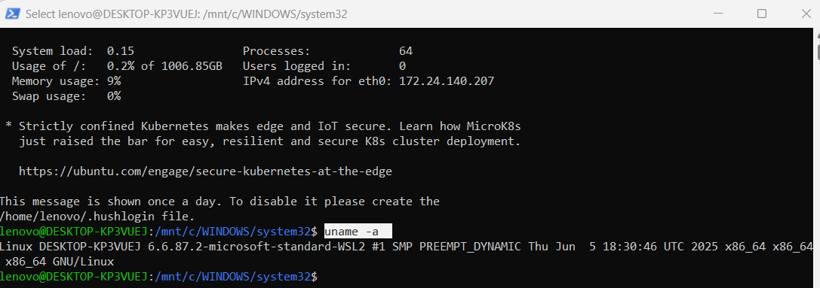
Output :
Linux DESKTOP-KP3VUEJ 6.6.87.2-microsoft-standard-WSL2 SMP PREEMPT_DYNAMIC
Linux: Operating System Kernel
DESKTOP-KP3VUEJ: machine/hostname
6.6.87.2: Linux Kernel Version
microsoft-standard-WSL2: running windows subsystem for linux version 2
SMP: Supports multiple CPU’s
PREEMPT_DYNAMIC: kernel supports dynamic scheduling
*cat /etc/os-release - displays detailed operating system information from a system file.
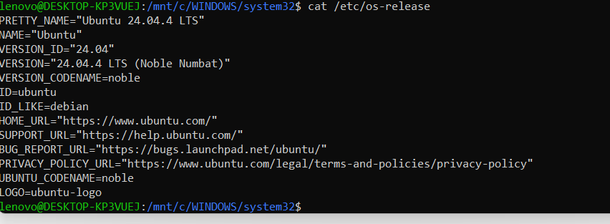

2. Filesystem sanity:
create a throwaway folder and file, e.g., mkdir /tmp/runbook-demo && ls -l /tmp/runbook-demo
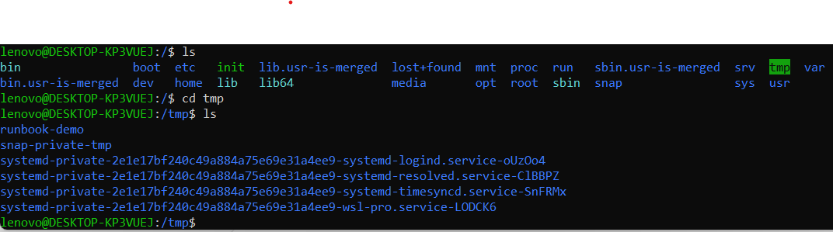
cp /etc/hosts /tmp/runbook-demo/hosts-copy && ls -l /tmp/runbook-demo
This command does two operations using &&.
Step 1 — Copy a file
cp /etc/hosts /tmp/runbook-demo/hosts-copy

cp – Copy Command
Source File : cp /etc/hosts
Destination File : tmp/runbook-demo/hosts-copy
Create a copy of the hosts file and save it as hosts-copy.
Step 2 –
Run the next command only if the previous command was successful.
ls- la will print
• permissions
• owner
• size
• date
• filename

Copy /etc/hosts into /tmp/runbook-demo/hosts-copy, and if the copy succeeds, show the detailed contents of /tmp/runbook-demo.
CPU / Memory (2): top/htop/ps -o pid,pcpu,pmem,comm -p <pid>, free -h, vm_stat (mac)
top:
It shows:
- CPU usage
- Memory usage
- Running processes
- Process IDs (PID)
- User running the process
- System uptime
- Load average

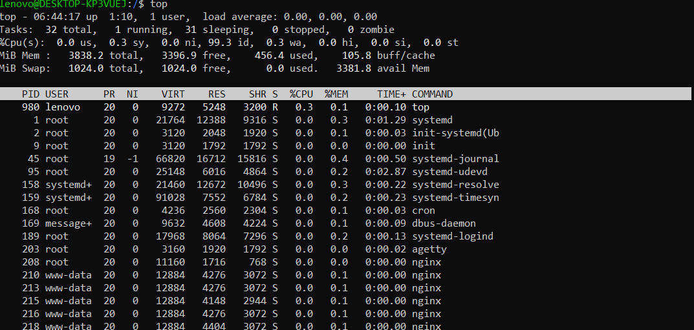

htop
htop is an improved and interactive version of the top command in Linux.
It provides:
- Colored output
- Easier process management
- CPU & RAM graphs
- Mouse support
- Scrolling process list
- Simple sorting/filtering
ps -o pid
ps : Shows currently running processes.
-o : custom output format
Pid : Tells ps to display only the Process ID column.
PID = Process Identifier
Every running process in Linux gets a unique number.
ps -o pcpu
• PID → Process ID
• %CPU / pcpu → CPU usage percentage
• CMD → Process command
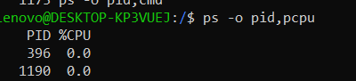
ps -o pid,pmem
shows:
- pid → Process ID
- pmem → Percentage of memory (RAM) used by the process

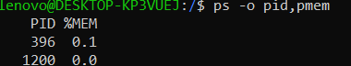
ps -o pid, comm
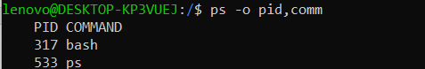
Disk / IO
df -h : df -h is a Linux command used to check disk space usage in a human-readable format.
