Customer Order & Revenue Analysis

- Project Overview
This project analyzes transactional order data generated from a custom-built Next.js e-commerce platform. The dataset captures customer demographics, product details, pricing, discounts, payment methods, and order status.
The objective of the project is to prepare raw application data using Python (Pandas) and perform structured analysis using PostgreSQL to derive insights into revenue, product performance, and customer behavior.
- Dataset Summary
Rows: 200
Columns: 16
Key Attributes:
- Customer demographics: Age, Gender, City, State
- Order details: Order Date, Order Status, Payment Method
- Product information: Product Name, Product Category
- Pricing fields: Quantity, Price, Discount, Revenue
Initial Data Observations:
- Missing values present in the Age column
- Revenue not provided in raw data and required calculation
- Inconsistent text formatting across categorical columns

- Exploratory Data Analysis using Python
Data exploration and cleaning were performed using Python (Pandas) across two Jupyter notebooks.
Data Loading & Initial Inspection:
- The dataset was imported using pandas.read_csv(). Dataset structure and data types were examined using df.head(), df.shape, and df.info(). Missing values were identified using df.isnull().sum().
- 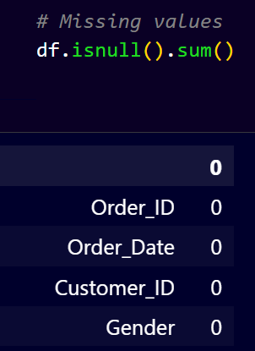

Age Group Feature Engineering:
- A custom function was used to group customer ages into categories: 0–18, 19–30, 31–45, 46–60, and 60+. A new column age_group was created.
- 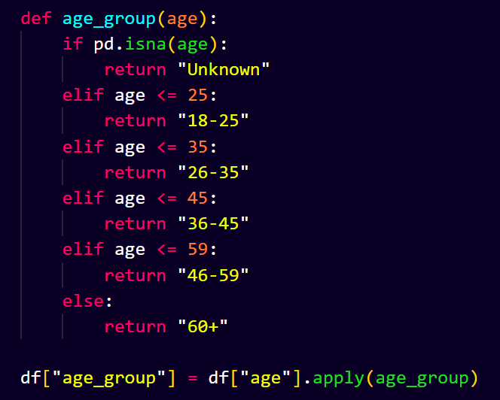
Categorical Data Standardization:
- Text-based columns were cleaned by stripping extra whitespace and standardizing capitalization.
- 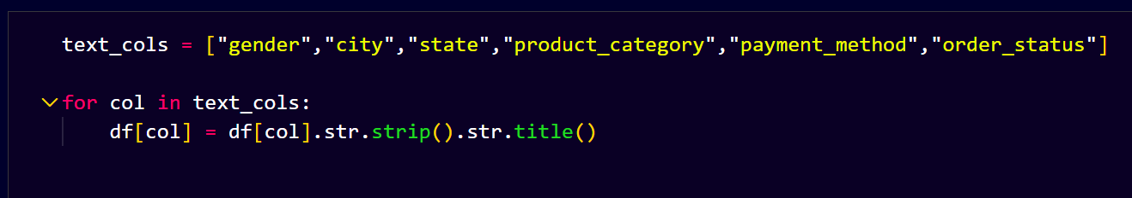
Revenue Calculation:
- Revenue = Quantity × Price × (1 − Discount)
- 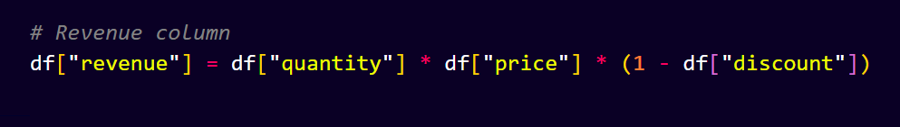
Final Output:
- The cleaned dataset was exported as cleaned_orders.csv.

- Data Analysis using SQL
Revenue analysis, demographic analysis, product performance, discount impact, order status distribution, payment methods, city-level orders, high-value orders, and customer ordering behavior were analyzed using PostgreSQL.

- Sales & Revenue Analysis
Q1. What is the total revenue generated by the company?
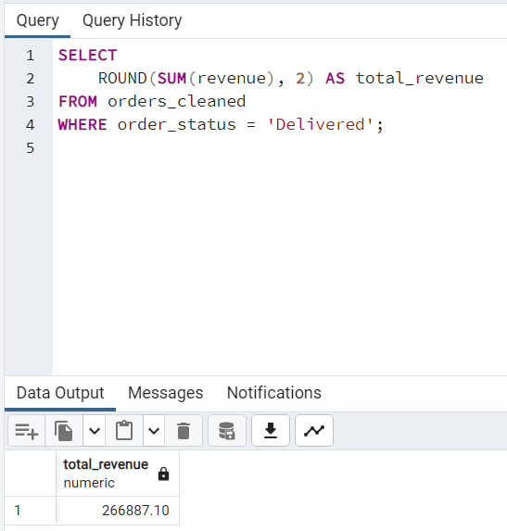
Q2. Which products are generating the lowest revenue (low-performing products)?
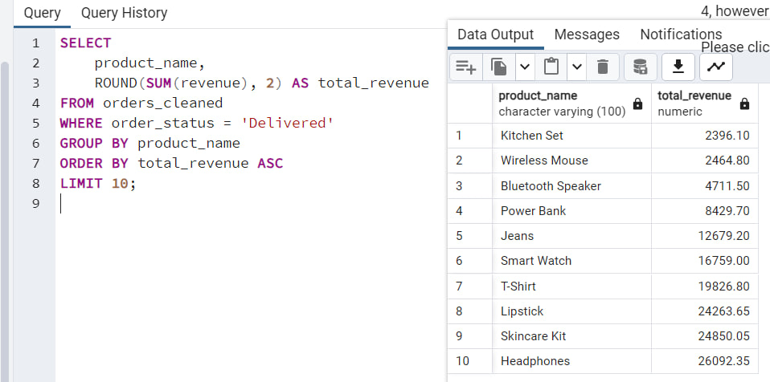
- Product Performance Analysis
Q3. Which products are sold the most by quantity?
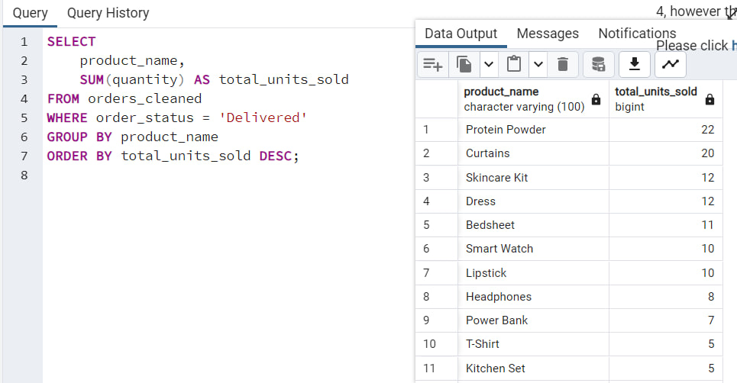

Q4. Are certain products associated with higher return rates?
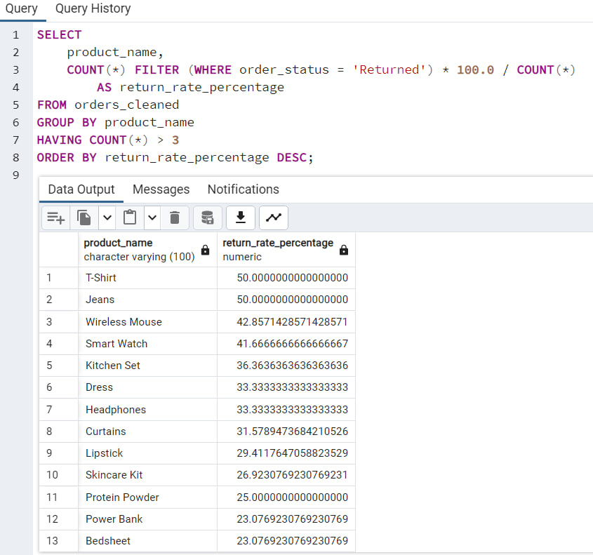
- Customer Demographics Analysis
Q5. How are orders distributed across age groups?
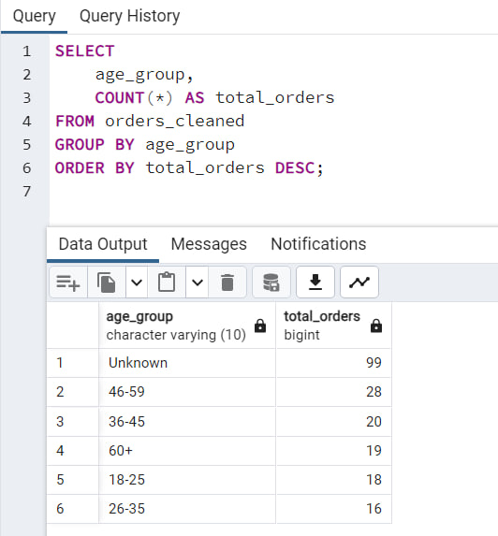

Q6. Are there differences in purchasing behavior by gender in terms of revenue?
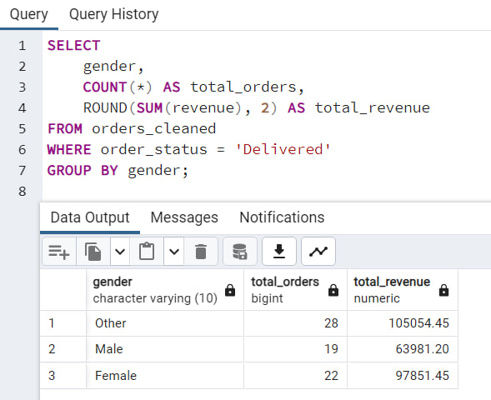
- Dashboard / Visualization Layer
The cleaned and analyzed dataset was visualized using an interactive dashboard to present insights in an intuitive and business-friendly manner. The dashboard is divided into three analytical sections: Sales & Revenue, Product Performance, and Customer Demographics.
- Sales & Revenue Analysis
This section analyzes overall business performance by measuring total orders, delivered revenue, and successful deliveries. It identifies key revenue-contributing states and product categories, helping understand geographical demand and high-earning segments.
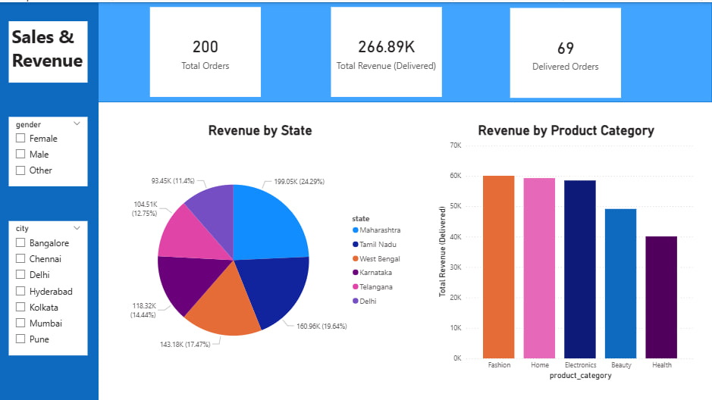

- Product Performance Analysis
This analysis evaluates product categories based on revenue, quantity sold, and return rates. It helps identify top-performing products as well as low-performing categories that generate sales volume but contribute less to revenue or have higher returns.
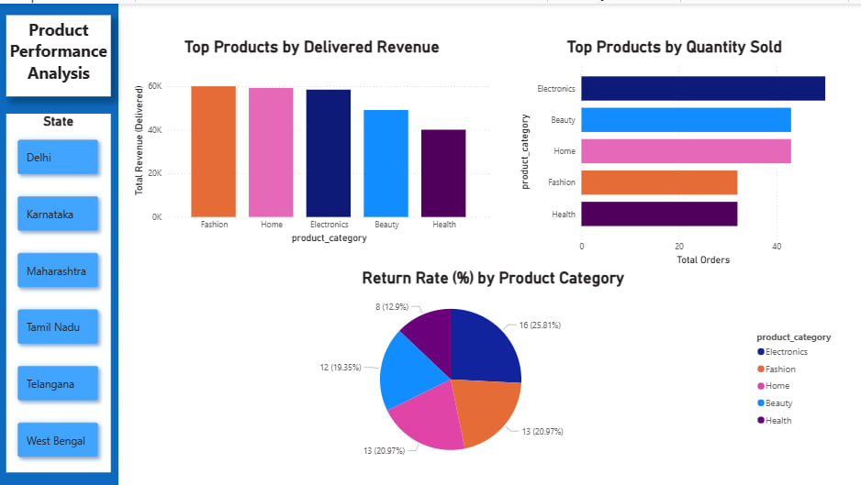

- Customer Demographic Analysis
This section studies customer purchasing behavior across cities, gender, and age groups. It highlights major customer locations and demographic segments contributing to revenue, supporting targeted marketing and customer segmentation strategies.
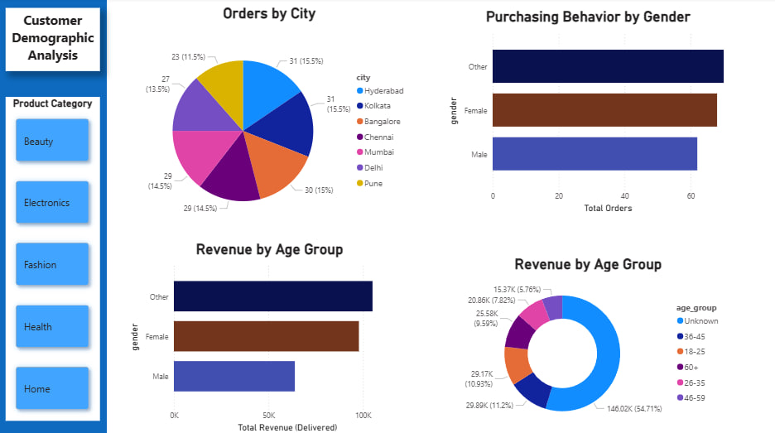

- Business Recommendations
- Revenue is concentrated, not widespread
Out of 200 total orders, only 69 delivered orders generate the full ₹266.9K revenue.
👉 This indicates significant leakage due to cancellations and returns, which directly impacts profitability.
- Top revenue-driving categories
  - Fashion, Home, and Electronics together contribute the major share of revenue.
  - Health generates the lowest revenue, making it a potential low-performing category.
- Geographic concentration of orders
Cities like Hyderabad, Kolkata, and Bangalore show the highest order volumes, indicating:
  - Strong demand in metro and tier-1 cities
  - Opportunity for regional marketing and faster delivery optimization
- Gender-based purchasing differences
Female category contribute slightly more revenue than male category.
👉 Suggests potential for:
Gender-targeted promotions
Category-specific campaigns
- City-level demand is evenly distributed
No single city dominates orders completely.
👉 Indicates a stable multi-city customer base, reducing overdependence on one region.

