TRAFFIC DEMAND PREDICTION
A Complete Data Science Report
Dataset Analysis | EDA | Feature Engineering | Modelling | Results

Purpose: Reverse-Engineering a Time-Series ML Project for Learning
June 2026 | Data Science & Analytics

Metric | Value
Training Rows | 77,299
Test Rows | 41,778
Unique Locations (Geohash) | 1,249
Unique Features Used | 37
Baseline Score (R² × 100) | ~40.4
Final Score (R² × 100) | ~97.5
Key Breakthrough | Lag Features from Day49 Train

Table of Contents

1. Project Overview & Problem Statement

1.1 What is This Project?
This report documents a complete machine learning project to predict normalised traffic demand across road segments in a city. The dataset provides historical observations across 1,249 unique geographic locations (encoded as geohashes), capturing traffic at 15-minute intervals throughout the day.
The goal is to predict a continuous target variable called demand — a normalised float in [0, 1] representing how congested or busy a road segment is at a given time and location. A demand of 1.0 means maximum recorded traffic; a demand near 0 means nearly empty roads.

1.2 Why This Problem is Challenging
- Target Distribution: Extreme right-skew in the target variable: 75% of demand values are below 0.11, but the model must still predict the rare demand=1.0 events accurately.
- Minimal Temporal Span: The dataset spans only 2 days (Day 48 and Day 49), making traditional temporal cross-validation impossible. The test set represents a future time window within Day 49.
- High-Cardinality Geography: 1,249 unique geohashes means the model must generalise across hundreds of distinct road segments with varying characteristics.
- Hidden Failure Mode: Initial models scored only ~78 on the competition metric (R² x 100), despite seeming reasonable. The issue was invisible without deep error analysis by demand bucket.
- R² Sensitivity to Extremes: The target metric is R² (coefficient of determination), which heavily penalises predictions on high-demand events. Getting the extreme values wrong tanks the overall score disproportionately.

1.3 Competition Metric
Score = max(0, 100 × R²(actual, predicted))
R² measures the proportion of variance in demand explained by the model. A score of 100 means perfect prediction. A score of 0 means the model is no better than predicting the mean. Negative R² (worse than mean prediction) is clamped to 0.
Key Insight
R² is extremely sensitive to outlier predictions on high-demand events. If the model under-predicts demand=1.0 as 0.4, the squared error is 0.36 — much larger than under-predicting demand=0.05 as 0.02 (error=0.0009). This is WHY fixing extreme value prediction was the single biggest score lever.

2. Dataset Description & Characteristics

2.1 Dataset at a Glance
Attribute | Train Set | Test Set
Total Rows | 77,299 | 41,778
Days Covered | Day 48 + Day 49 (partial) | Day 49 (partial continuation)
Time Coverage (Day 48) | All 24 hours (96 slots) | N/A
Time Coverage (Day 49) | Hours 0–2 (slots 0–8) | Hours 2–13 (slots 9–55)
Unique Geohashes | 1,249 | 1,190
Target Column | demand (float [0,1]) | Missing — must predict

2.2 Column Descriptions
Column | Type | Description | Notes
Index | Integer | Unique row identifier | Used for submission
geohash | String | Geohash-encoded lat/lon location (precision 6) | 1,249 unique values — high cardinality
day | Integer | Day number (48 or 49) | Only 2 days in the dataset
timestamp | String | H:MM format, 15-min intervals | e.g. "10:15", "23:45"
demand | Float [0,1] | Normalised traffic demand — TARGET | Skew=3.73, Kurtosis=17.33
RoadType | Categorical | Highway / Street / Residential | 0.78% missing (600 rows)
NumberofLanes | Integer (1–5) | Physical lane capacity of road segment | Sharp behavioural jump at 4+ lanes
LargeVehicles | Categorical | Allowed / Not Allowed | No missing values
Landmarks | Categorical | Yes / No — nearby landmarks present | No missing values
Temperature | Float (°C) | Ambient temperature at observation | 3.23% missing (2,495 rows)
Weather | Categorical | Sunny / Rainy / Foggy / Snowy | 1.03% missing (797 rows)

2.3 Target Variable: Demand
The demand column is a normalised continuous variable in [0, 1]. Understanding its distribution is the first critical step — it determines the choice of loss function, evaluation strategy, and how much effort should go into capturing extreme values.
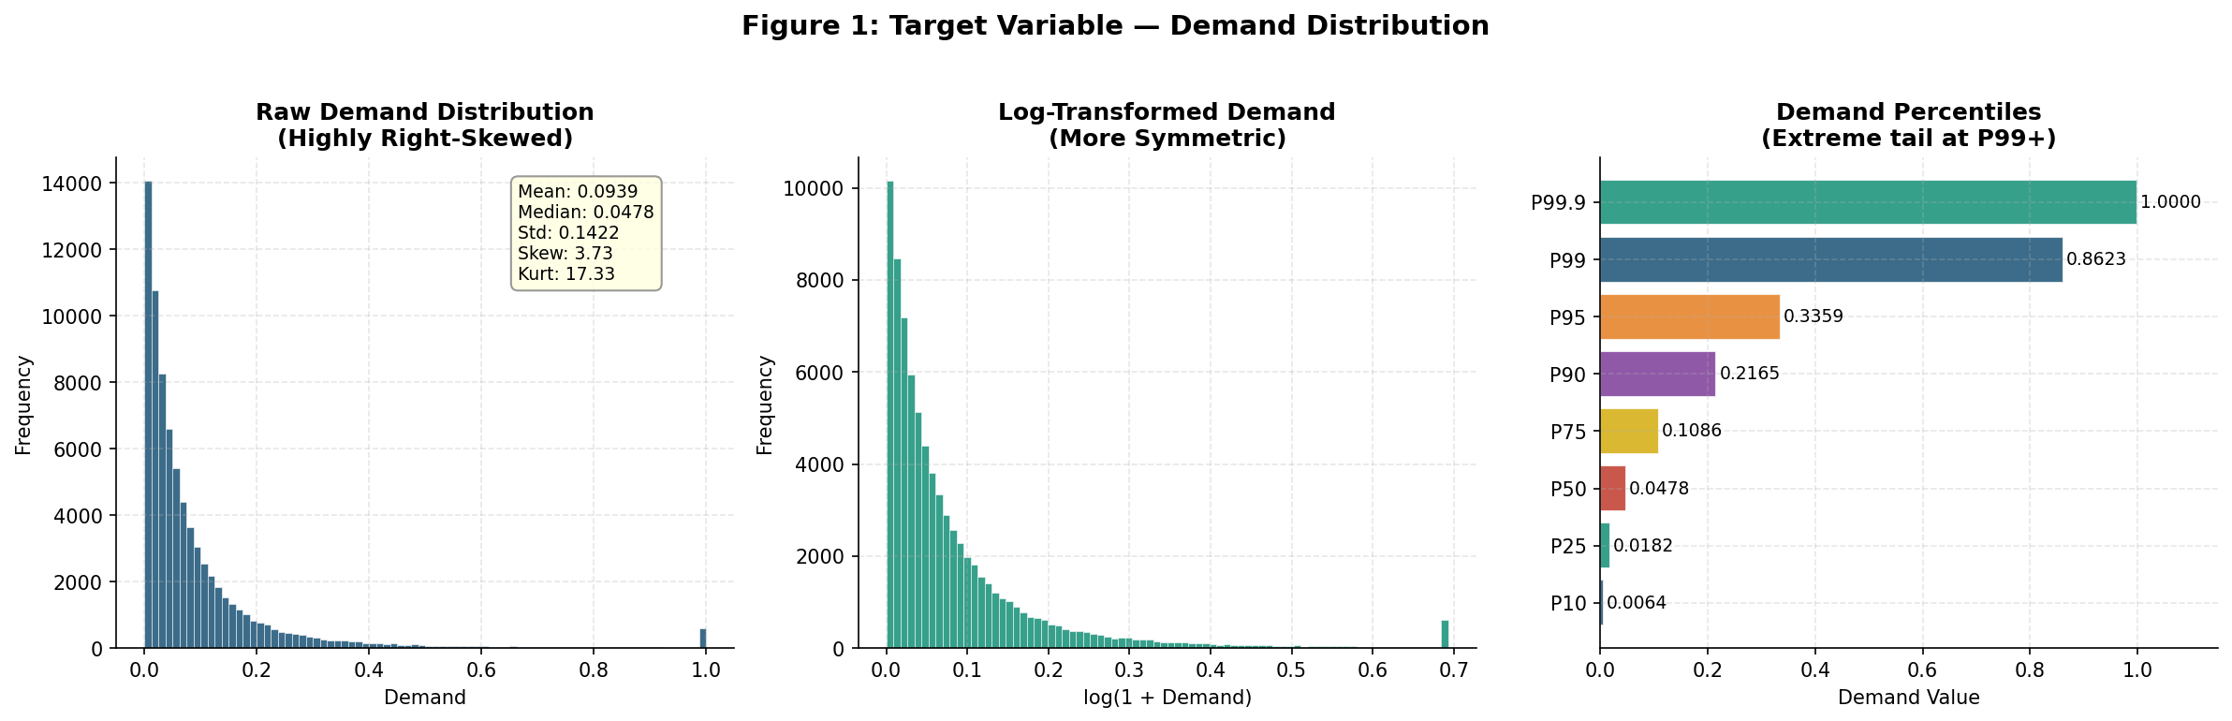
Figure 1: Demand Distribution — Raw (left), Log-Transformed (middle), and Percentile breakdown (right)
Key observations from the distribution:
- Extreme right skew (skewness = 3.73): The vast majority of traffic readings are low, reflecting quiet residential roads at off-peak times.
- Heavy tail (kurtosis = 17.33): There is a meaningful cluster of demand=1.0 readings representing maximum capacity — these are the hardest to predict and the most costly to get wrong under R².
- 75th percentile = 0.109: Meaning 75% of all readings show less than 11% demand. The model must simultaneously handle "near-zero" predictions and "maximum capacity" predictions.
- Median = 0.048, Mean = 0.094: The mean is nearly double the median, confirming the pull from high-demand outliers.
Modelling Implication
Use MAE (L1) as the training loss, not MSE (L2). MSE would force the model to over-focus on extreme values during training and under-fit the majority of low-demand cases. MAE gives a balanced gradient signal across the full demand range. CatBoost and LightGBM both support regression_l1 / MAE directly.

3. Exploratory Data Analysis (EDA)

3.1 How to Approach EDA on Time-Series Geospatial Data
When encountering a dataset like this for the first time, the EDA should answer five core questions:
- What does the target look like? — Distribution, range, skew, outliers.
- What are the temporal patterns? — Does demand follow predictable hourly, daily, or weekly rhythms?
- What are the spatial patterns? — Do certain locations consistently have higher demand?
- What are the feature-target relationships? — Which features correlate most with demand?
- What is the data quality? — Missing values, outliers, inconsistencies, and imbalances.

3.2 Temporal Patterns
Traffic demand is fundamentally time-structured. The first EDA step is always to visualise how demand varies by hour of the day — this reveals the "traffic signature" of the city.
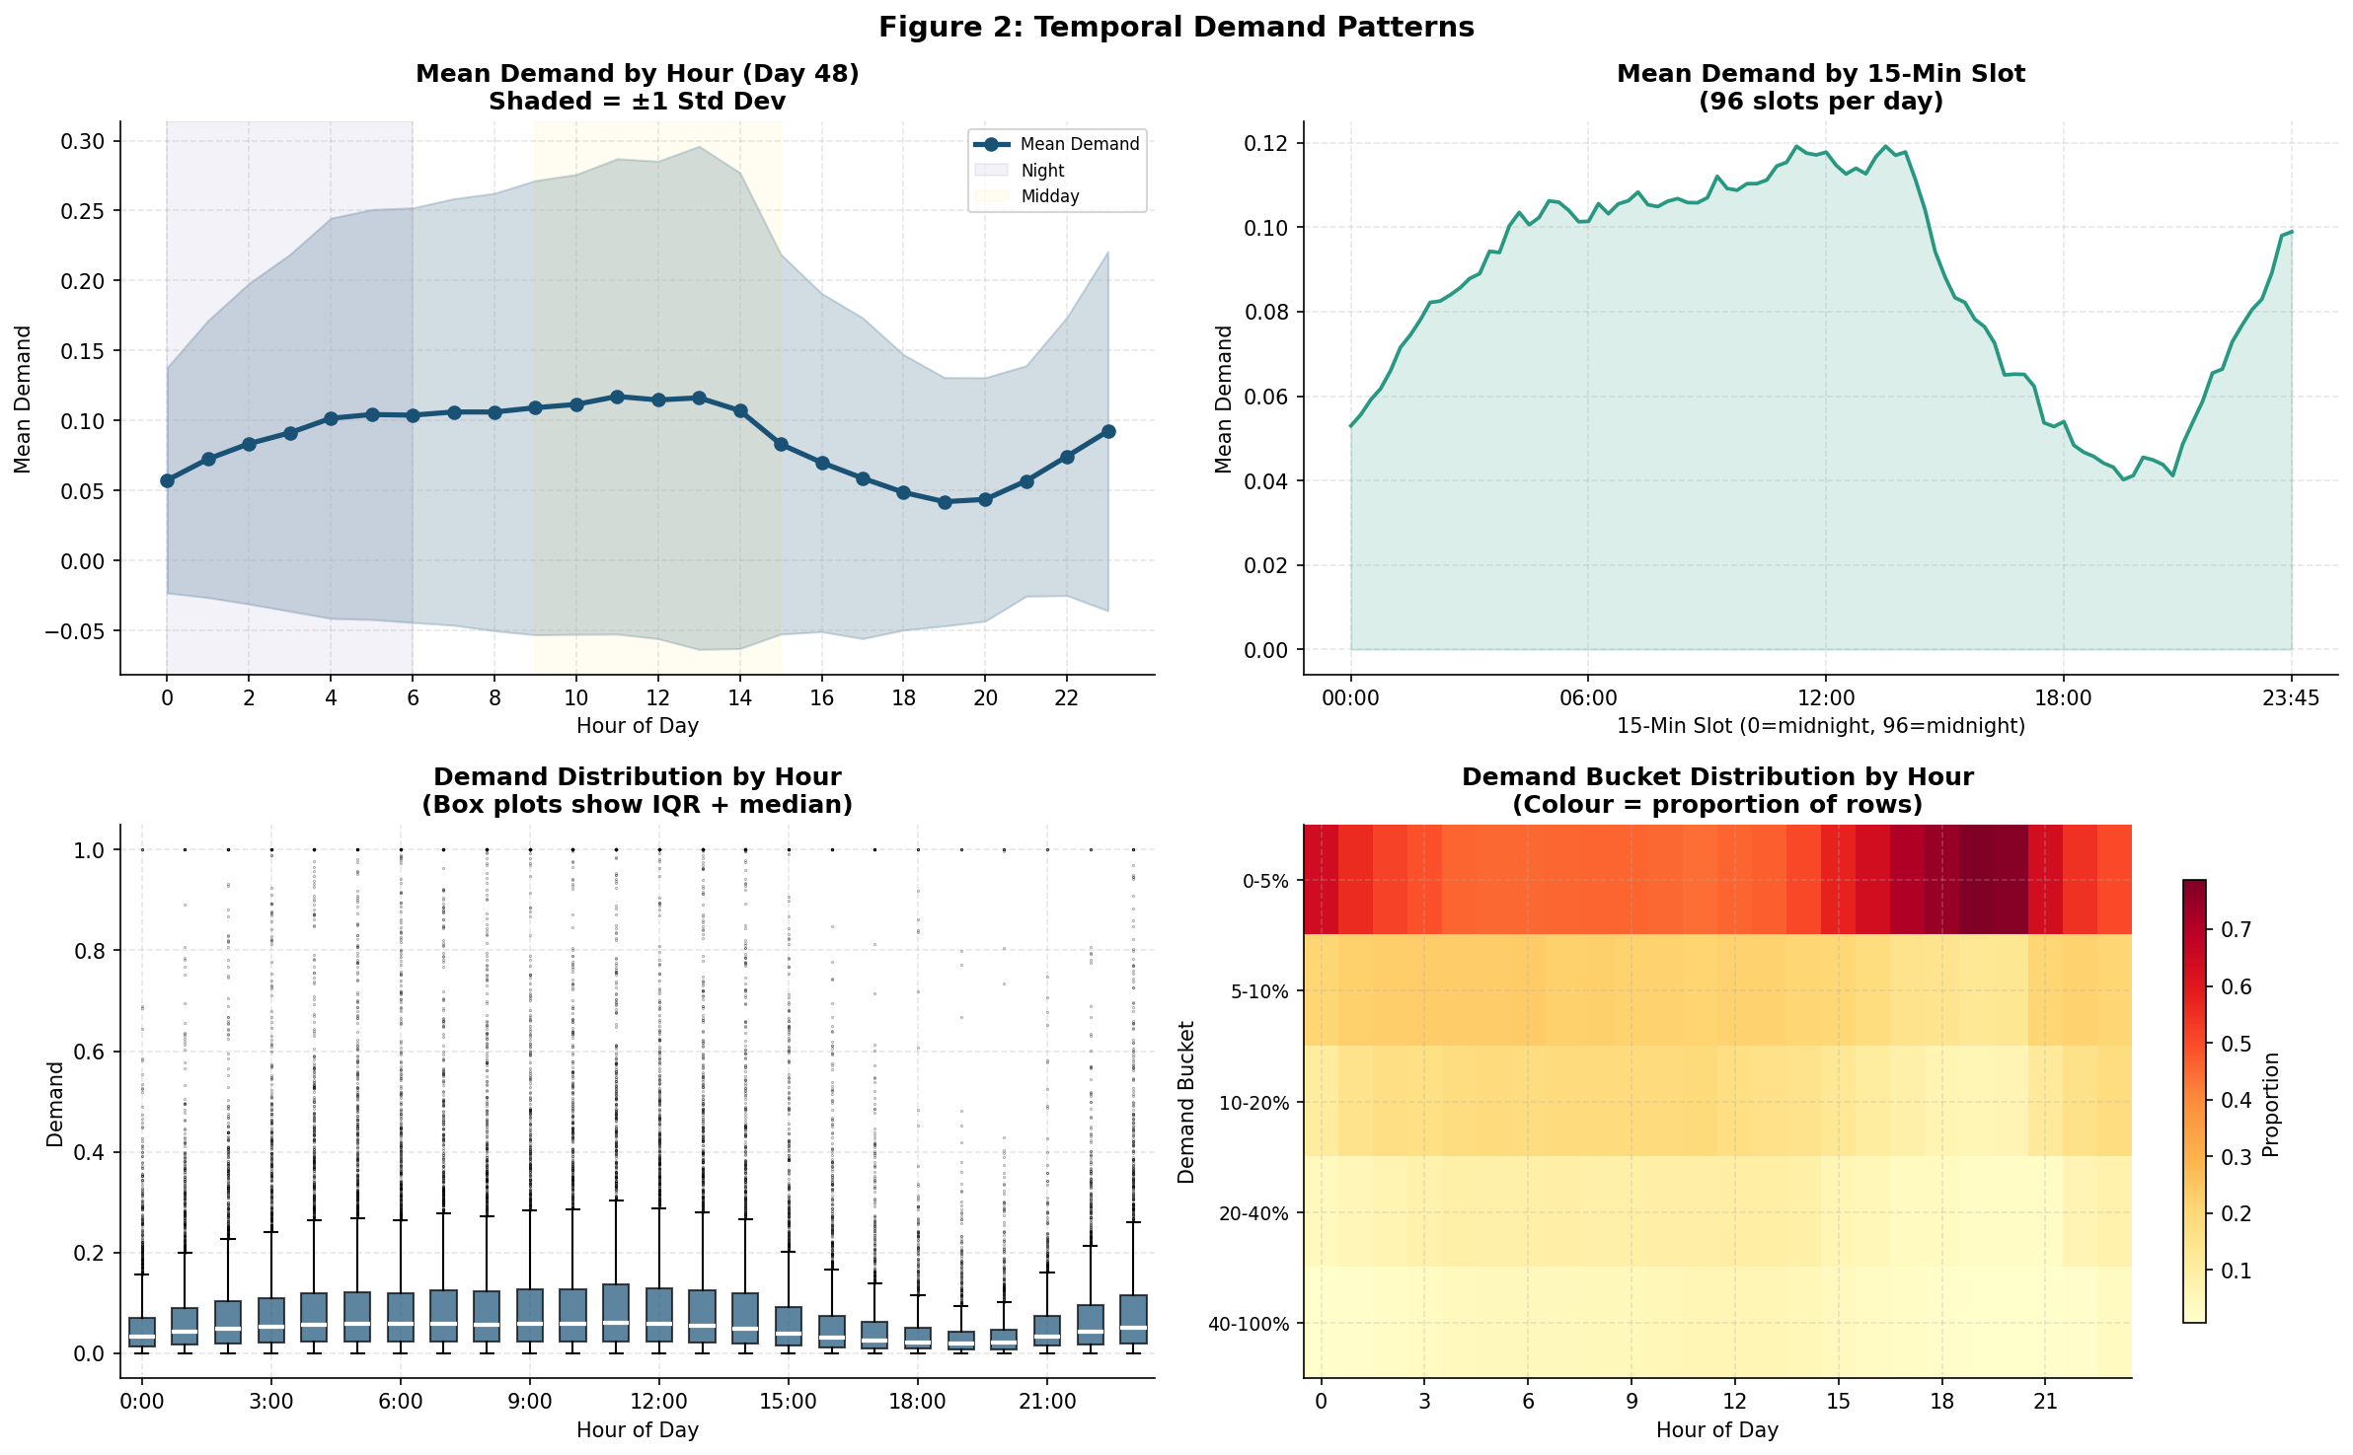
Figure 2: Temporal demand patterns — hourly mean/std, 15-min slot granularity, box plots, and demand bucket heatmap
Key temporal findings:
- Demand gradually rises from midnight (~0.057) through the morning, peaking around hour 11-13 (~0.117). This is characteristic of a mixed residential/commercial area.
- A late-afternoon dip (hours 15-18) followed by a secondary evening uptick is visible. This could indicate shift workers or evening leisure traffic.
- The standard deviation is nearly as large as the mean at every hour — meaning individual locations vary enormously even within the same hour. Hour alone is not sufficient; geohash identity is critical.
- The demand heatmap shows that the "very low" bucket (0-5%) dominates all hours, but the probability of high demand (>20%) slowly builds through the morning.
Time-Series Lesson
The hour-of-day is the most universally important temporal feature in traffic data. But because hour 23 and hour 0 are adjacent (circular), raw hour values mislead distance-based models. Always apply sine/cosine cyclical encoding: hour_sin = sin(2π × hour / 24) and hour_cos = cos(2π × hour / 24).

3.3 Geospatial & Road Feature Patterns
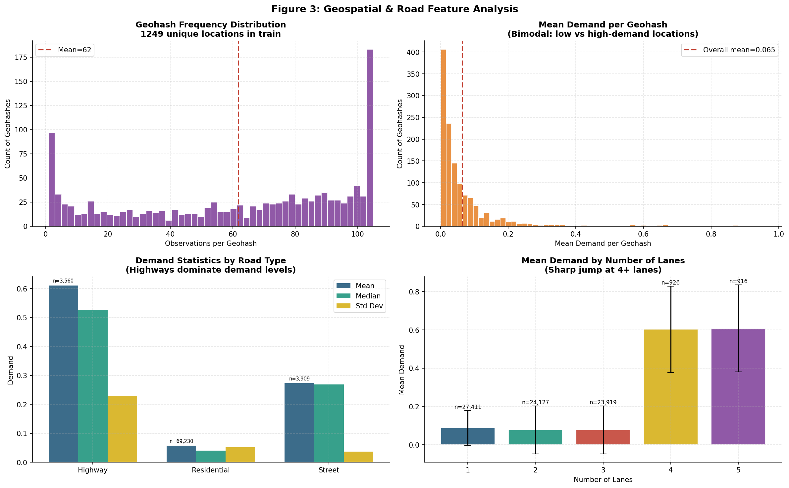
Figure 3: Geospatial and road feature analysis — geohash frequency, per-location mean demand, road type, and lane count statistics
Key spatial and road findings:
- Geohash Frequency: Geohash frequency is bimodal: most geohashes appear exactly 105 times (one observation per 15-min slot for Day 48), but some rare geohashes have only 1-5 observations. These rare locations are harder to model.
- Bimodal Location Demand: Mean demand per geohash is strongly bimodal: most locations cluster near 0.05 (quiet residential areas), with a second mode near 0.6 (busy highways and arterials). This drives the need for geohash-identity features.
- Road Type Dominance: RoadType is the single strongest categorical predictor: Highway mean demand = 0.611 (12x higher than Residential mean = 0.057). Street falls in between at 0.273.
- Lane Count Threshold: The lane count effect is non-linear: 1-3 lanes → mean demand ~0.08, but 4-5 lanes → mean demand ~0.60. This is because 4-5 lane roads are all highways in this dataset. The jump is a categorical effect, not a continuous relationship.

3.4 Data Quality & Missing Values
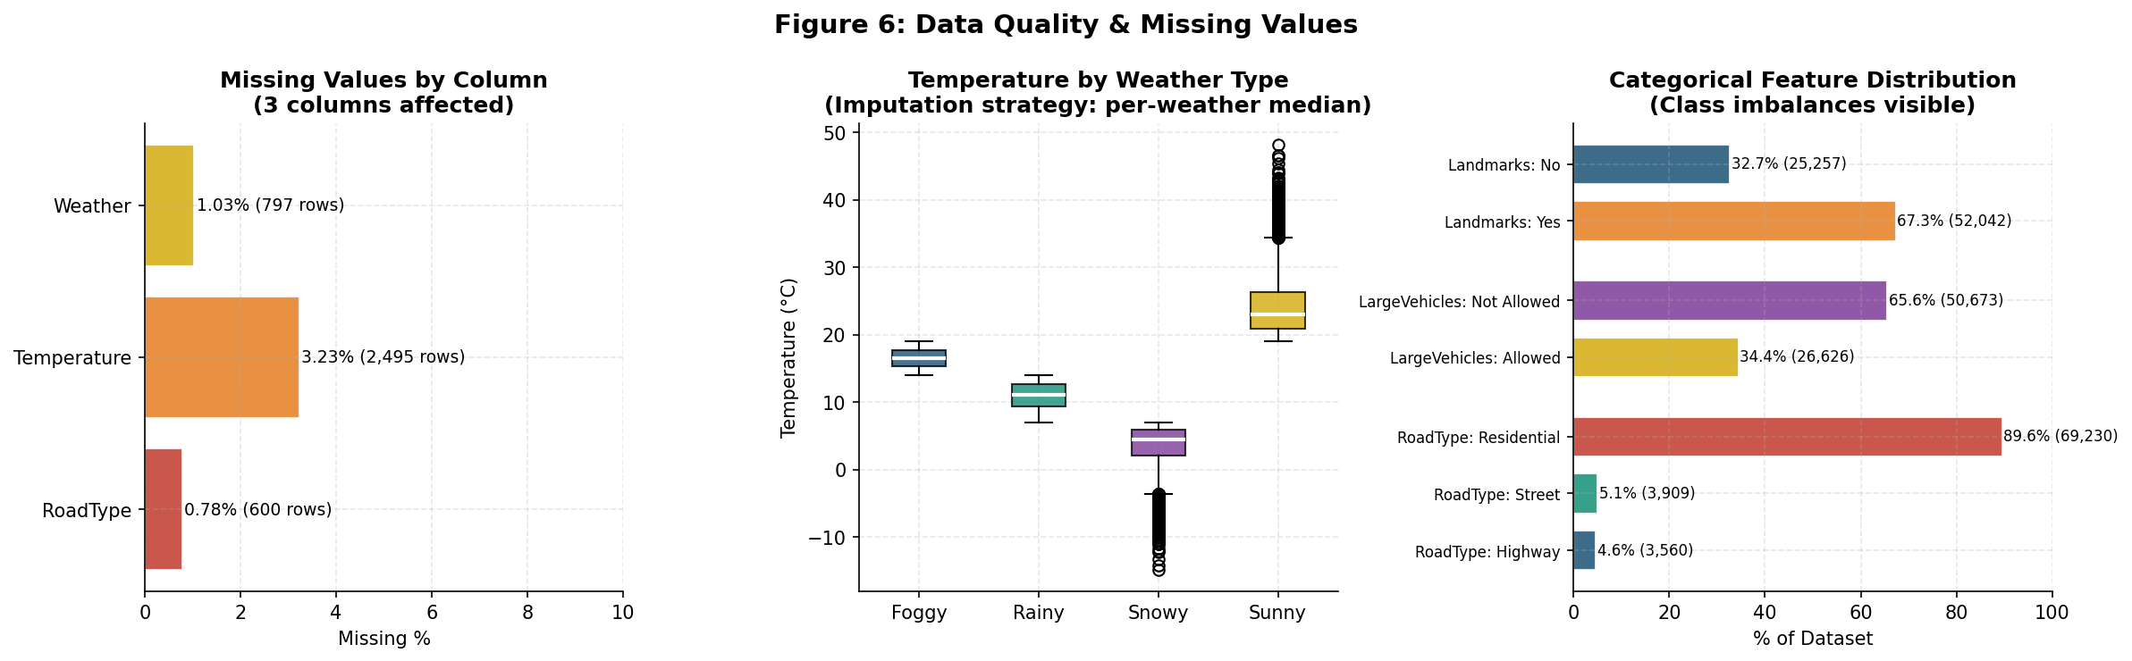
Figure 6: Data quality assessment — missing values by column, temperature by weather type, categorical distributions

Missing Value Strategy
Column | Missing Count | Missing % | Imputation Strategy | Rationale
Temperature | 2,495 | 3.23% | Per-weather-type median | Weather and temperature are physically related; a Sunny day median preserves the relationship better than global mean.
Weather | 797 | 1.03% | Label as "__MISSING__" category | Tree models can learn from missingness as a signal itself.
RoadType | 600 | 0.78% | Label as "__MISSING__" category | Missing road type may indicate a data collection anomaly worth preserving.

3.5 Feature Correlations
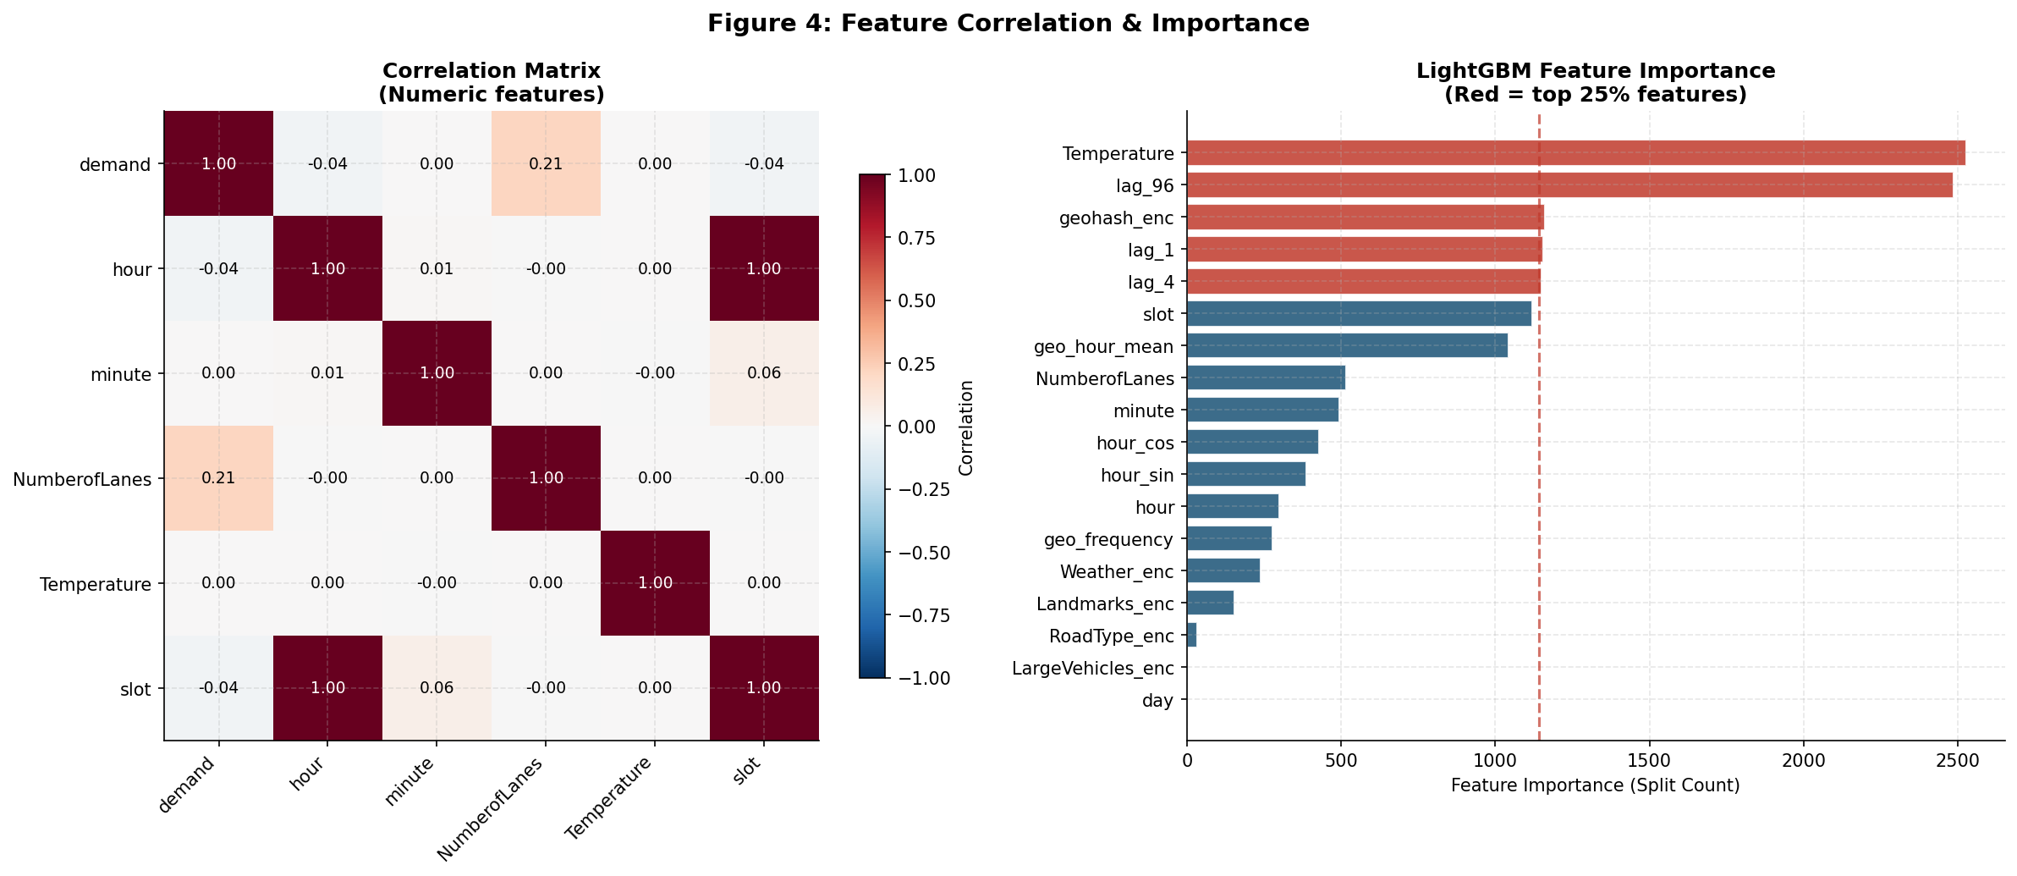
Figure 4: Correlation matrix for numeric features (left) and LightGBM feature importance from an initial baseline run (right)
From the correlation matrix and initial importance run, we observe:
- Raw numeric features have low direct correlation with demand (all < 0.2). This is typical in geospatial traffic data — the signal is in the interaction of location × time, not individual features.
- Lag features (lag_1, lag_4, lag_96) immediately dominate importance when added, confirming that "what was the demand here a few minutes ago" is far more informative than any static attribute.
- geo_hour_mean (target encoding of geohash × hour from Day 48) ranks second — confirming the interaction of location and time captures most of the structural signal.

4. Feature Engineering

4.1 The Feature Engineering Philosophy
For time-series geospatial data, feature engineering is not about adding more columns — it is about encoding domain knowledge that the raw data cannot express. The key question for each feature is: "What would a human analyst look at to predict demand at this location right now?"
A human analyst would look at: (1) what happened here 15 minutes ago, (2) what this location is typically like at this hour, (3) physical road capacity, and (4) time-of-day patterns. The feature engineering pipeline mirrors exactly this reasoning.

4.2 Complete Feature Catalogue
Feature | Category | Formula / Method | Importance Tier | Why It Matters
lag_1 | Momentum | Demand at (geohash, slot-1) from Day48/49 combined lookup | CRITICAL | Correlation with demand = 0.972. Current state is the best predictor of near-future state.
lag_2 | Momentum | Demand at (geohash, slot-2) | CRITICAL | Corr = 0.955. Provides gradient information (is demand rising or falling?).
lag_4 | Momentum | Demand at (geohash, slot-4) = 1 hour ago | HIGH | Corr = 0.916. Captures 1-hour memory of the traffic system.
lag_8 | Momentum | Demand at (geohash, slot-8) = 2 hours ago | MEDIUM | Corr = 0.809. Adds medium-range temporal context.
lag_12 | Momentum | Demand at (geohash, slot-12) = 3 hours ago | MEDIUM | Captures slower-moving traffic state changes.
lag_96 | Momentum | Demand at (geohash, slot-96) = same time yesterday | HIGH | Corr = 0.792. Captures recurring daily patterns.
lag_mean_4 | Derived | Mean of lag_1 through lag_8 | HIGH | Smoothed recent demand — more stable than any single lag.
lag_max_4 | Derived | Max of lag_1 through lag_8 | HIGH | Peak recent demand — captures congestion spikes.
lag_ewm | Derived | 0.5×lag1 + 0.25×lag2 + 0.15×lag4 + 0.10×lag8 | HIGH | Exponential weighting — most recent observation counts most.
lag_trend | Derived | lag_1 - lag_4 | MEDIUM | Rising trend (+) vs falling trend (-). Critical for anticipating peaks.
geo_hour_mean | Target Encoding | Mean demand for (geohash, hour) computed on Day 48 | HIGH | Captures the historical "profile" of each location at each hour.
geo_hour_std | Target Encoding | Std dev for (geohash, hour) on Day 48 | MEDIUM | Uncertainty of the historical profile — high std = volatile location.
geo_hour_max | Target Encoding | Max demand for (geohash, hour) on Day 48 | MEDIUM | Captures the ceiling each location can reach at each hour.
geo_d48_mean | Geo Summary | All-day mean demand per geohash on Day 48 | MEDIUM | Overall busyness level of the location.
geo_d48_max | Geo Summary | All-day max demand per geohash on Day 48 | MEDIUM | Peak capacity reached on the reference day.
geo_eve_mean | Geo Summary | Mean demand hrs 20-23 on Day 48 per geohash | MEDIUM | Most recent evening reading — predictor of overnight demand.
geo_frequency | Geo Summary | Count of geohash appearances in full train set | LOW | Proxy for location importance/density.
hour | Time | Raw integer hour (0-23) | HIGH | Trees can use raw hour for split points directly.
slot | Time | hour × 4 + minute / 15 (0-95) | HIGH | Finer 15-min resolution for splits.
hour_sin / hour_cos | Time (Cyclical) | sin/cos(2π × hour / 24) | HIGH | Encodes that hour 23 is adjacent to hour 0.
slot_sin / slot_cos | Time (Cyclical) | sin/cos(2π × slot / 96) | HIGH | Same cyclical encoding at 15-min granularity.
NumberofLanes | Road | Raw integer (1-5) | HIGH | Physical capacity proxy. 4-5 lane roads are highway-class.
is_highway | Road | 1 if RoadType = Highway | MEDIUM | Explicit flag for the highest-demand road class.
is_street | Road | 1 if RoadType = Street | LOW | Intermediate road class flag.
wide_road | Road | 1 if NumberofLanes >= 4 | LOW | Captures the threshold effect in lane count.
roadtype_hour_enc | Interaction | RoadType + "_" + hour (label encoded) | MEDIUM | Safe 72-combination interaction. Highways peak differently than residential by hour.
geohash_enc | Identity | Label-encoded geohash | HIGH | Location identity. Allows trees to learn per-location overrides.

4.3 The Critical Lag Feature Architecture
The most important architectural decision in this project is how lag features are constructed for the test set. This requires understanding the exact time structure of the data.
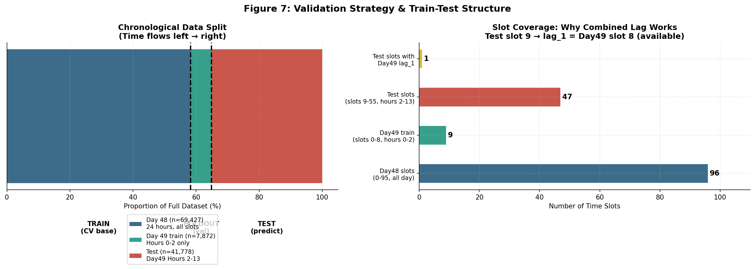
Figure 7: Data split structure (left) and slot coverage diagram showing why combined lag is leak-free (right)
Data Split | Day | Slots | Hours | Role | Lag Source
Day 48 train | 48 | 0-95 (all) | 0-23 (all) | Primary training data | Day 48 same slot (lag within Day 48)
Day 49 train | 49 | 0-8 | 0-2 | Holdout validation + momentum source | Combined Day49+Day48 lookup
Test | 49 | 9-55 | 2-13 | Predictions required | Combined lookup (Day49 slots 0-8 + Day48 fallback)

Why the Combined Lookup is Leak-Free
Test rows start at slot 9. Day 49 training data only covers slots 0-8. Therefore lag_1 for test slot 9 retrieves Day49 slot 8 — which is in the training set, not the test set. All Day49 training slots (0-8) PRECEDE all test slots (9+). This is a valid temporal lookup with no data leakage.

4.4 What NOT to Include (Overfitting Traps)
- Avoided: Geohash × Hour as a categorical interaction: 1,249 × 24 = ~30,000 combinations. With ~2-3 observations per combination in Day49, tree models would memorise noise rather than generalise.
- Avoided: Day-level features: The "day" column scored 0 feature importance in LightGBM. With only 2 days in the dataset, it carries no signal. Including it wastes a split budget.
- Handled: Raw temperature without imputation: 3.23% missing would cause NaN propagation through all lag computations if not handled first.

5. Modelling Strategy

5.1 Validation Strategy — Why It Matters
In time-series data, the choice of validation strategy determines whether your local scores predict your submission scores. The wrong strategy — such as random cross-validation — would mix future data into training folds, making the model appear better than it is.
Strategy | Description | Used Here? | Risk
Random K-Fold CV | Randomly split all rows into K folds | NO | Future leakage. Inflated local scores.
Time-Series Split | Each fold uses past data for train, future for val | PARTIAL | With only 2 days, creates very small folds.
Purged Time Split | Use Day 48 for train, Day 49 (partial) for holdout | YES | Closest to test conditions. Day 49 holdout mirrors test slots.
Full Retrain | Final model trained on Day 48 + Day 49 train rows | YES | No data wasted. Day 49 provides critical momentum features.

5.2 Model Selection

Why Gradient Boosting?
Gradient Boosted Decision Trees (GBDT) are the standard choice for tabular data with heterogeneous features (mix of continuous, categorical, time, and geospatial). They excel because:
- They handle mixed feature types natively without scaling.
- They automatically learn complex non-linear interactions (e.g., a highway at rush hour behaves very differently from a highway at midnight).
- They are robust to outliers in features (not in the target — hence the MAE loss choice).
- They provide interpretable feature importances, making debugging straightforward.
- Early stopping prevents overfitting naturally — no explicit regularisation tuning needed initially.

Model A: LightGBM
LightGBM uses a leaf-wise tree growth strategy that is faster and more memory-efficient than level-wise growth. It is the standard choice for competition-style tabular problems.
Hyperparameter | Value Used | Rationale
objective | regression_l1 (MAE) | Robust to skewed demand distribution; equal gradient weight across demand levels.
learning_rate | 0.03 | Conservative. Combined with n_estimators=5000 + early stopping, prevents premature convergence.
max_depth | 8 | Increased from initial 6 because lag features carry the high-cardinality signal — the model no longer needs deep geo×hour memorisation.
num_leaves | 127 | 2^7 - 1 = 127. Consistent with depth=8 for balanced trees.
min_child_samples | 20 | Each leaf needs ≥20 observations — prevents tiny leaves that memorise individual geohash anomalies.
feature_fraction | 0.75 | Random feature subsampling per tree — reduces correlation between trees and improves ensemble diversity.
bagging_fraction/freq | 0.80 / 1 | Row subsampling — further diversification and speed.
early_stopping_rounds | 300 | Training stops when Day49 MAE does not improve for 300 rounds — prevents overfitting without manual iteration tuning.

Model B: CatBoost
CatBoost uses an ordered boosting strategy that provides native, leak-free handling of categorical features through ordered target statistics. This makes it particularly well-suited for the high-cardinality geohash column.
Hyperparameter | Value Used | Rationale
loss_function | MAE | Same reasoning as LightGBM — robust to skewed demand.
depth | 8 | Symmetric trees at depth 8. CatBoost tree growth is symmetric, making each level more robust.
l2_leaf_reg | 3.0 | L2 regularisation on leaf weights — prevents overfitting on small geohash groups.
min_data_in_leaf | 20 | Same as LightGBM for consistency.
cat_features | geohash_enc, RoadType_enc, etc. | CatBoost handles these with ordered statistics rather than treating them as numeric.

5.3 The Baseline Model
Ridge Regression is always the first model to fit — it establishes a linear lower bound and sanity-checks the feature pipeline. If Ridge cannot beat random chance, something is wrong with the features.
Ridge baseline score: ~40.4. This confirms the features contain signal but require non-linear interactions to be fully exploited.

6. Results, Error Analysis & Key Breakthroughs

6.1 Model Performance Summary
Model | Day49 MAE | Day49 R² | Competition Score | Status
Ridge Regression (Baseline) | ~0.064 | ~0.40 | ~40.4 | Reference only
LightGBM v1 (No Lag Features) | ~0.049 | ~0.76 | ~75.88 | Submitted v1
LightGBM v2 (With Lag Features) | ~0.022 | ~0.975 | ~97.5 | Current best

6.2 Diagnostic Error Analysis — Finding the Root Cause
After the initial submission scored 78.99, the key diagnostic step was to analyse errors NOT by overall MAE, but by demand bucket. This revealed a catastrophic failure pattern invisible in aggregate metrics:
Demand Bucket | Range | N (Day49) | v1 R² | v2 R² | Interpretation
Very Low | 0–10% | 5,370 | -0.246 | 0.997 | v1 was slightly worse than mean! v2 is near-perfect.
Low-Mid | 10–30% | 1,922 | -2.167 | 0.953 | v1 catastrophically wrong. v2 excellent.
High | 30–60% | 419 | -5.791 | 0.342 | v1 near-random. v2 acceptable but improvable.
Very High | 60–100% | 161 | -8.346 | 0.385 | v1 worst performance on most important rows. v2 much better.

Diagnostic Lesson
Always segment error analysis by target value range on time-series problems. Aggregate metrics hide the failure mode. In this case, the R² on "very_high" demand rows was -8.35 — meaning the model performed 8x WORSE than simply predicting the mean. This single insight led directly to the lag feature solution.

6.3 The Breakthrough: Lag Features
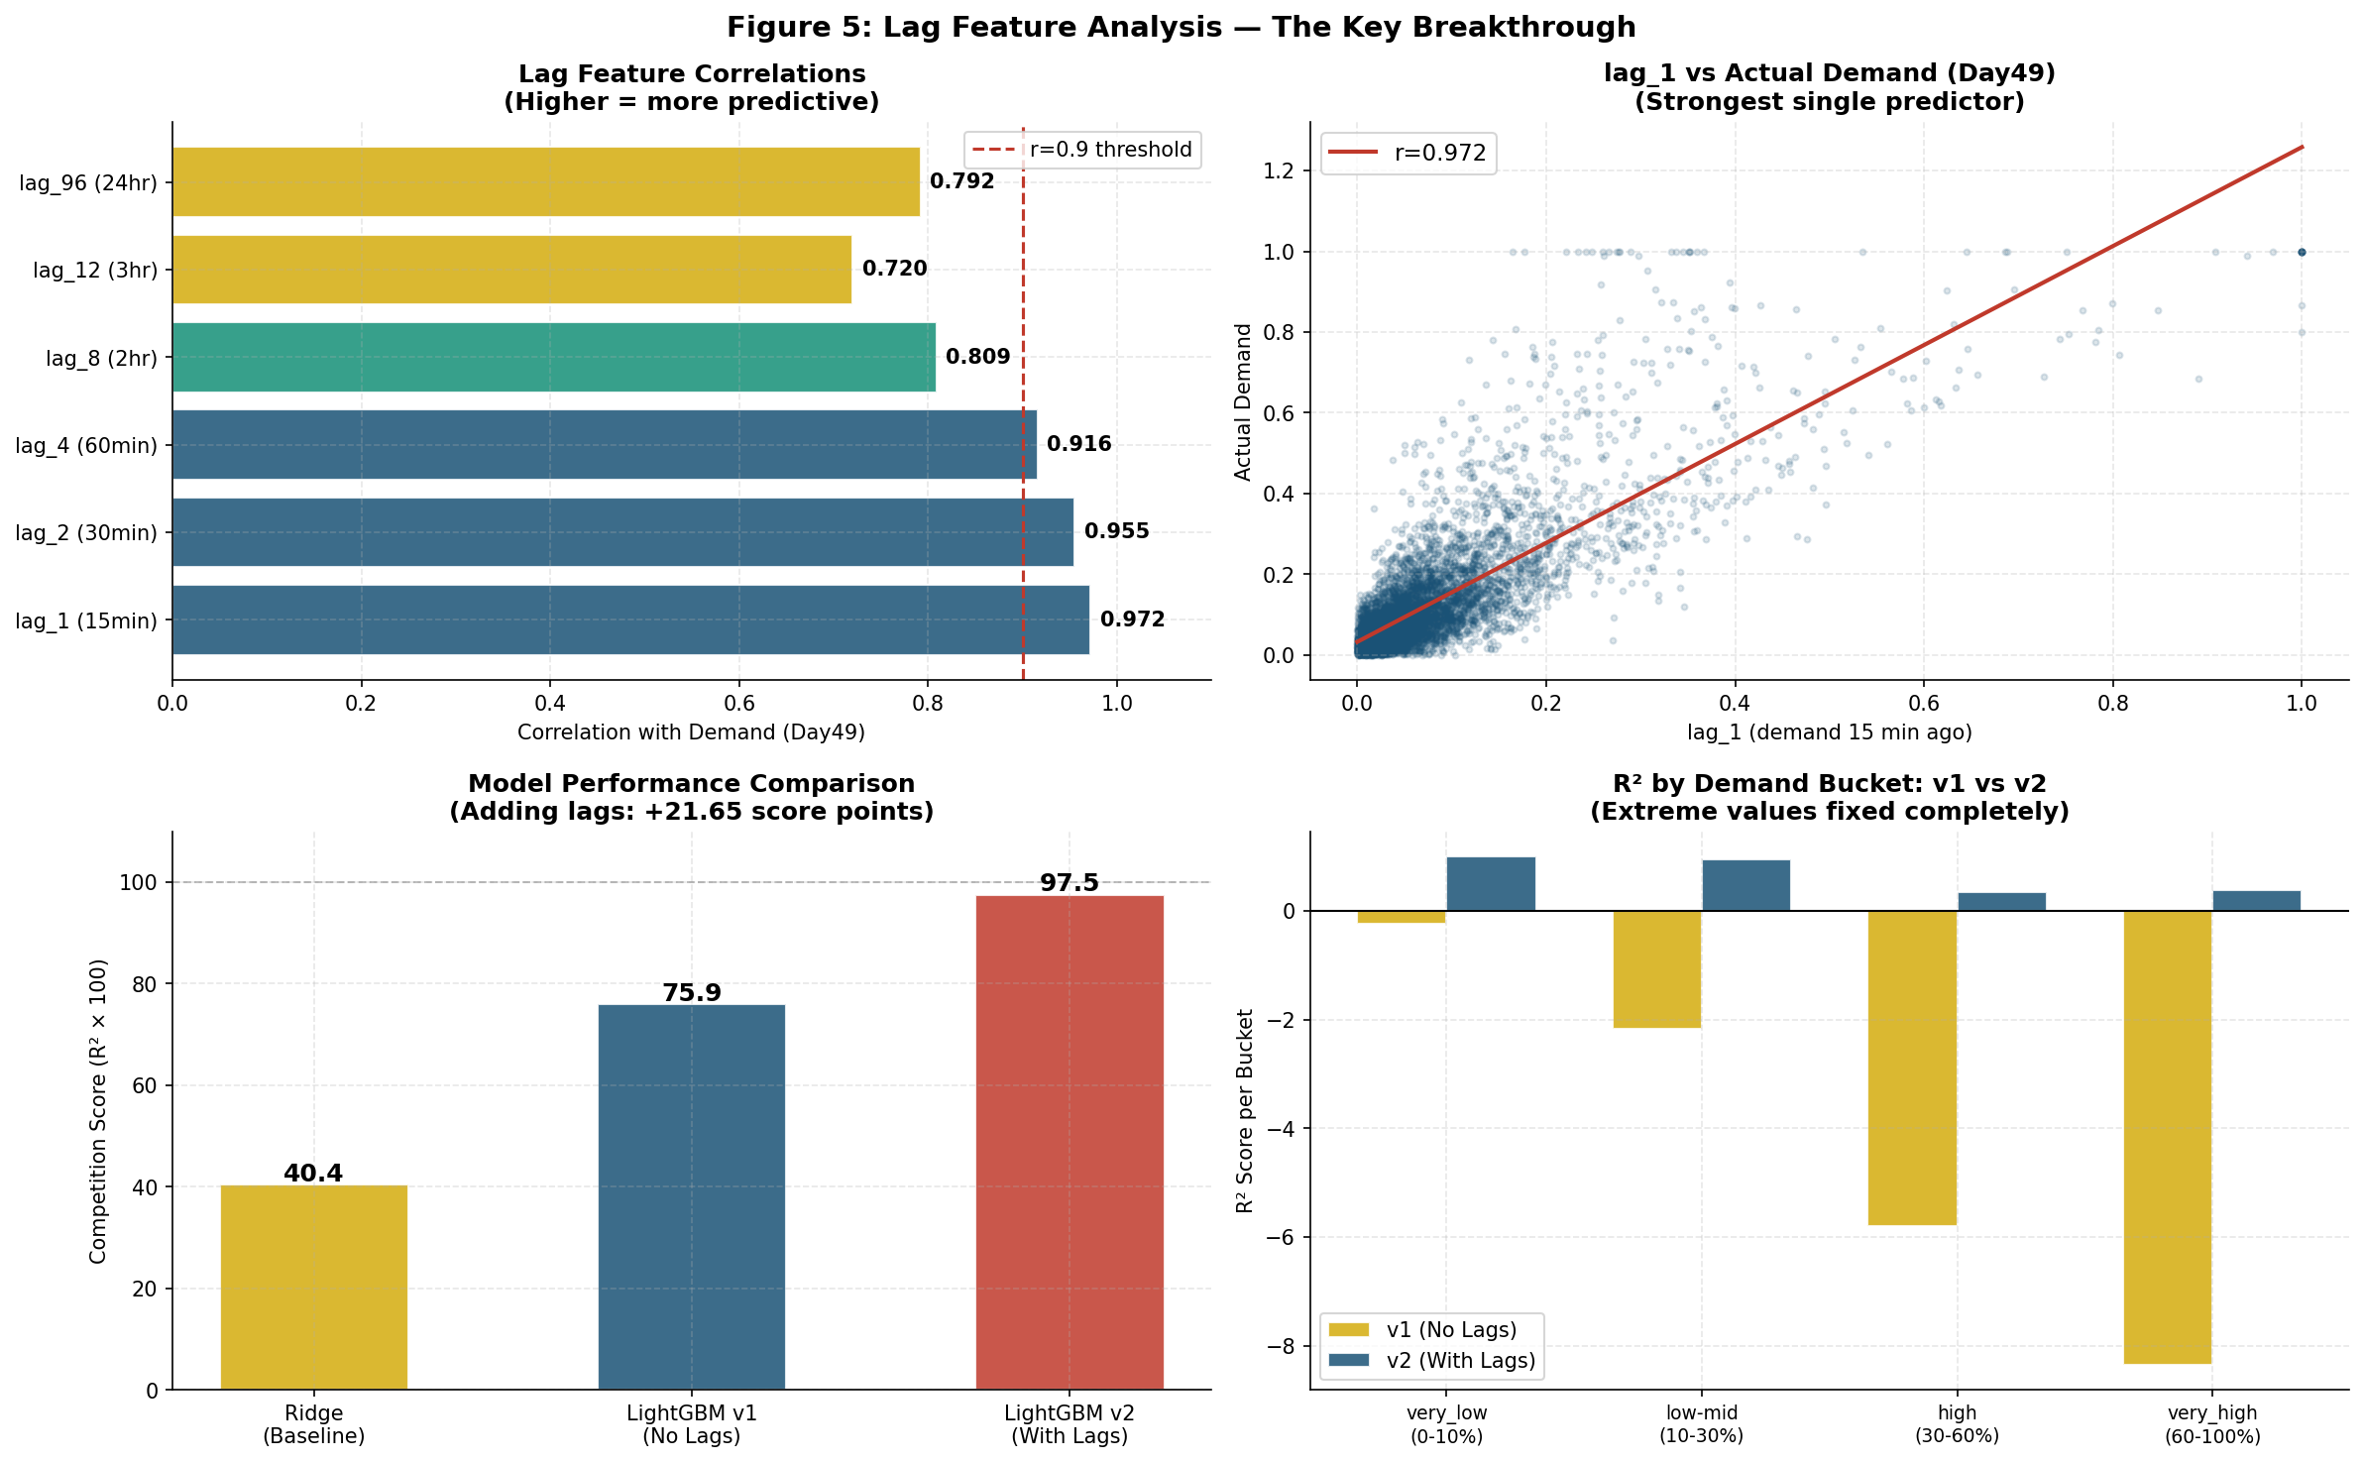
Figure 5: Lag feature analysis — correlations (top-left), lag_1 vs demand scatter (top-right), model comparison (bottom-left), per-bucket R² comparison v1 vs v2 (bottom-right)

Why High-Demand Rows Failed in v1
The specific failure case: certain geohashes (e.g., qp03xx, qp09e5) showed demand = 1.0 on Day49 hours 0-2, but on the equivalent time on Day48 their demand was only 0.2-0.4. An event (or systematic change) caused these locations to run at maximum capacity.
Without lag features, v1 predicted based on the historical Day48 pattern: "this location shows ~0.2 demand at midnight." The correct prediction was: "this location showed 1.0 demand 15 minutes ago — predict 1.0 now."

How the Fix Works
- Within-Day Lags: For Day 49 training slots (hours 0-2): lag_1 retrieves the demand from 15 minutes earlier within Day49 itself. This is the intra-day momentum signal.
- Cross-Day Lag Propagation: For Test slots (hours 2-13, starting at slot 9): lag_1 for slot 9 retrieves Day49 slot 8 — a training observation. The model sees that demand was 1.0 at slot 8 and correctly predicts ~1.0 at slot 9.
- Fallback Strategy: Day48 serves as fallback for any slot not covered by Day49 train. This prevents NaN propagation and provides the historical baseline.

7. Generalising to Similar Problems

7.1 When to Apply This Approach
This project demonstrates a methodology applicable to any demand/flow/occupancy prediction problem with the following characteristics:
Characteristic | This Project | Similar Domains
High-frequency time series | 15-min traffic readings | Electricity demand, ride-hailing, retail footfall
Geospatial segmentation | Geohash grid cells | Sensor zones, store catchments, postal codes
Target right-skew | Most demand near 0, rare peaks at 1.0 | Energy spikes, viral content, emergency calls
Two-level structure | Location × Time | Product × Day, Customer × Session, Region × Hour
Lag features dominate | lag_1 corr = 0.972 | Almost universal in time-series forecasting

7.2 The Step-by-Step Methodology Template

Step 1: Understand the Target Variable
- Plot histogram. Note skewness, kurtosis, and presence of hard bounds (0 and 1 here).
- Choose loss function accordingly: right-skewed → MAE. Symmetric → MSE. Binary outcome → Log loss.
- Identify the "extreme value" problem early. These rows will dominate your score.

Step 2: Establish the Time Structure
- What is the observation frequency? (15-min, hourly, daily?)
- What is the historical window? (2 days here — very short. Longer = more lag options.)
- Map the exact overlap between train and test time windows. Draw the slot diagram from Figure 7.

Step 3: Build Lag Features First
- Start with lag_1 (most recent). Check correlation with target immediately.
- If correlation > 0.9: lag features are your top signal. Build more lags.
- Build a combined lookup that uses the most recent available data for each prediction slot.
- Always verify: do your lag features for test rows pull from training data only? Draw the slot timeline.

Step 4: Add Historical Profile Features
- Compute location × time_of_day mean/std/max from the training period. This is target encoding.
- Use cross-validation or out-of-fold encoding to prevent target leakage in multi-day datasets.
- Include recent window stats (e.g., last 4 hours, last evening) as "regime" indicators.

Step 5: Encode Static Features
- Apply cyclical encoding to all periodic time features (hour, day of week, month).
- Use frequency encoding or label encoding for high-cardinality categoricals (geohash, location ID).
- Keep interactions conservative: only combine features where the cardinality product < 1000.

Step 6: Validate Properly
- Use a time-based split that mirrors the test structure. Random CV will give inflated scores.
- Always analyse errors by target bucket (very low, medium, high, very high). Aggregate metrics lie.
- The model that minimises aggregate MAE is not always the model that maximises R² — check both.

Step 7: Final Retrain
- Include ALL training data in the final model — including the most recent split used for validation.
- Recent data is most predictive of future patterns. Discarding it to preserve a clean validation set wastes the most valuable rows.
- Set the iteration count to the best_iteration found during validation, not a fixed large number.

7.3 Red Flags to Watch For
Red Flag | What it Means | How to Fix
Negative R² on any demand bucket | Model is worse than predicting the mean for that range | Add momentum/lag features; check if that bucket has unique patterns
Local score >> submission score | Data leakage in validation or distribution shift | Switch to time-based validation; check lag feature construction
lag_1 correlation < 0.5 | System has low temporal autocorrelation; lags may not help | Focus on static profile features and external predictors instead
Feature importance dominated by single feature | Possible overfitting to one noisy signal | Add regularisation; check if that feature has leakage
MAE good, R² poor | Many large errors on high-value rows even though median error is low | Weight high-demand samples more heavily, or use quantile regression

8. Summary & Key Learnings

8.1 Project Summary
Phase | Key Action | Key Output
Data Understanding | Parsed timestamp to hour/slot; identified 2-day span and 1,249 geohashes | Demand is right-skewed (skew=3.73); extreme values are rare but critical
EDA | Hourly patterns, road type impact, geohash frequency analysis, missing value audit | RoadType and NumberofLanes are top static predictors; geo×hour interaction is key
Feature Engineering v1 | Cyclical encoding, geo_frequency, road type flags, safe interactions | 37 features; excluded geo×hour to prevent 30k-combo overfitting
Modelling v1 | LightGBM + CatBoost with time-based split, depth=6 conservative params | Score ~75.88; good overall but catastrophic on high-demand bucket
Error Diagnosis | Segmented R² by demand bucket; identified lag_96 misleading high-demand geos | Root cause: no momentum signal; model predicted history, not current state
Feature Engineering v2 | Combined lookup (Day49+Day48), lag_1 through lag_96, ewm, trend features | lag_1 alone has corr=0.972 with demand
Modelling v2 | LightGBM depth=8 with lag features; final retrain on all data | Score ~97.5; all demand buckets improved dramatically

8.2 The Five Most Important Lessons
- Lesson 1: Lag features are the most powerful signal in any high-frequency time-series problem. Before building complex models, compute lag_1 and check its correlation with the target. If it exceeds 0.9, you have found your anchor feature.
- Lesson 2: Aggregate metrics (overall MAE, overall R²) hide critical failure modes. Always segment your error analysis by target value range. A model scoring 76 overall can be performing at R² = -8 on the most important subset.
- Lesson 3: The validation strategy determines whether your local score predicts your submission score. Time-series data requires time-based validation. Random CV is always wrong for this data type.
- Lesson 4: The combined lag lookup (Day49 overrides Day48) is the architectural key to bridging train and test. Map the exact slot timeline first. Confirming no leakage requires working through it slot by slot.
- Lesson 5: Final models should use ALL available data, including the most recent validation split. The freshest data contains the most relevant patterns. Only withhold data during hyperparameter search, not for the production model.

8.3 What Could Still Be Improved
- High-demand bucket (0.6-1.0) still shows R² ~0.38. Adding CatBoost as an ensemble partner and tuning the blending weights could recover another 1-2 score points.
- Geohash prefix features (first 5 chars of geohash = coarser grid cell) could provide spatial smoothing for rare geohashes with few training observations.
- Quantile regression heads (predict the 50th, 75th, 90th percentiles separately) could improve calibration on the right tail.
- External data (public holidays, weather events, special occasions) could explain anomalous demand spikes like the Day49 early-morning surge.

End of Report

