**TRAFFIC CONTROL USING IMAGE PROCESSING**

Department of Electronics and Communication Engineering,  **Shri Vishnu Engineering College for Women**, Vishnupur, Bhimavaram.

Esparx id:31384.

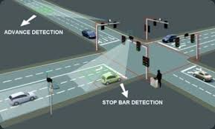

Submitted by:

K.Kumudavalli.

K.Gaana Sruthi.

IInd ECE.

Abstract

1. **INTRODUCTION:**

As the problem of urban traffic congestion spreads, there is a pressing need for the introduction of advanced technology and equipment to improve the state-of-the-art of traffic control. Traffic problems nowadays are increasing because of the growing number of vehicles and the limited resources provided by current infrastructures. The simplest way for controlling a traffic light uses timer for each phase. Another way is to use electronic sensors in order to detect vehicles, and produce signal that cycles. We propose a system for controlling the traffic light by image processing. The system will detect vehicles through images instead of using electronic sensors embedded in the pavement. A camera will be installed alongside the traffic light. It will capture image sequences. Setting image of an empty road as reference image, the captured images are sequentially matched using image matching.

**1.1** **Standard Traffic Control Systems:**

1.1.1 Manual Controlling

Manual controlling the name instance it require man power to control the traffic. Depending on the countries and states the traffic polices are allotted for a required area or city to control traffic. The traffic polices will carrysign board, sign light and whistle to control the traffic. They will be instructed to wear specific uniforms in order to control the traffic.

1.1.2 Automatic Controlling

Automatic traffic light is controlled by timers and electrical sensors. In traffic light each phase a constant numerical value loaded in the timer. The lights are automatically getting ON and OFF depending on the timer value changes. While using electrical sensors it will capture the availability of the vehicle and signals on each phase, depending on the signal the lights automatically switch ON and OFF.

**1.2** **Drawbacks in using manual control**

In the manual controlling system we need more man power. As we have poor strength of traffic police we cannot control traffic manually in all area of a city or town. So we need a better solution to control the traffic. On the other side, automatic traffic controlling a traffic light uses timer for every phase. Using electronic sensors is another way in order to detect vehicles, and produce signal that to this method the time is being wasted by a green light on an empty road. Traffic congestion also occurred while using the electronic sensors for controlling the traffic.

**1.3Need for Image Processing in Traffic Light Control**

We propose a system for controlling the traffic light by image processing. The vehicles are detected by the system through images instead of using electronic sensors embedded in the pavement. A camera will be placed alongside the traffic light. It will

capture image sequences. Image processing is a better technique to control the state change of the traffic light. It shows that it

can decrease the traffic congestion and avoids the time being wasted by a green light on an empty road. It is also more reliable in estimating vehicle presence because it uses actual traffic images. It visualizes the practicality, so it functions much better than those systems that rely on the detection of the vehicles metal content.

**2.** **Introduction to Image Processing:**

**Image processing** is a method to convert an image into digital form and perform some operations on it, in order to get an enhanced image or to extract some useful information from it. It is a type of signal dispensation in which input is image, like video frame or photograph and output may be image or characteristics associated with that image. Usually **Image Processing** system includes treating images as two dimensional signals while applying already set signal processing methods to them.

**2.1 Image Acquistion:**

Image acquisition in image processing can be broadly defined as the action of retrieving an image from some source, usually a hardware-based source, so it can be passed through whatever processes need to occur afterward. Performing image acquisition in image processing is always the first step in the workflow sequence because, without an image, no processing is possible. The image that is acquired is completely unprocessed and is the result of whatever hardware was used to generate it, which can be very important in some fields to have a consistent baseline from which to work. One of the ultimate goals of this process is to have a source of input that operates within such controlled and measured guidelines that the same image can, if necessary, be nearly perfectly reproduced under the same conditions so anomalous factors are easier to locate and eliminate.

**Input Image:**

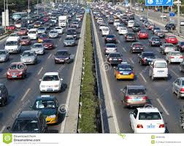

The figure is the captured by a sensor. Here photo diode sensor is used. The sensor is constructed with silicon material. The output voltage waveform of sensor is proportional to light. We can also use filter to improve selectivity. We can also make a output which has one strong color than remaining visible colors using filter. We can generate a 2-D image using single sensor with a displacement in both directions of plane. The arrangement used here is for high precision scanning where film negative is mounted on to a drum which produce mechanical rotation. This mechanical rotation provides displacement in one direction. A sensor mounted on a lead screw is used as it provides motion in perpendicular direction. Using this we can control mechanical motion effectively and images are obtained with high resolution. The sensors a arranged as strips to provide imaging in both direction. The strip provides image in one direction while motion takes care about perpendicular direction. This method is effectively used in airborne imaging. The arrangement is attached to aircrafts during their flights. One dimensional imaging

sensor strips that respond to various bands of electromagnetic spectrum are mounted perpendicular to provide perpendicular image so as form a 2-D image.

**2.2 Image preprocessing:**

Pre-processing is a common name for operation with images at the lowest level of abstraction both input and output are intensity images. The aim of pre-processing is an improvement of the image data that suppresses unwanted distortions or enhances some image features important for further processing. Image pre-processing methods use the considerable redundancy in images. Neighboring pixels corresponding to one object in real images have essentially the same or similar brightness value.

2.2.1 Image scaling:

In computer graphics, **image scaling** is the process of resizing a digital image. Scaling is a non-trivial process that involves a trade-off between efficiency ,smoothness and sharpness.

2.2.2 RGB to GRAY Conversion:

When converting an RGB image to gray scale, we have to consider the RGB values for each pixel and make as output a single value reflecting the brightness of that pixel. One of the approaches is to take the average of the contribution from each channel: (R+B+C)/3. However, since the perceived brightness is often dominated by the green component, a different, more "human-oriented", method is to consider a weighted average, e.g.: 0.3R + 0.59G + 0.11B.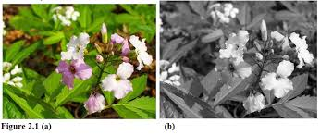

**2.3 EDGE DETECTION**

Edge Detection is an image processing technique for finding the boundaries of objects within images. It works by detecting discontinues in brightness. Edge detection is used for image segmentation and data extraction in areas such as image processing, computer vision, and machine vision.

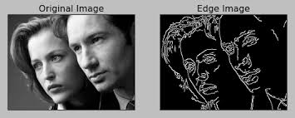

**Edge Detection Techniques:**

2.3.1 CANNY EDGE DETECTION:

The canny edge detector is a edge detection operator that uses a multi-stage algorithm to detect a wide range of edges in images. It was developed by John.F.Canny in 1986. He also produced a computational theory of edge detection explaining why the detection works.



**2.4 MATCHING:**

It is the mathematical discipline of graph theory, a matching or independent edge set in a graph is a set of edges without common vertices. It may also be an entire graph consisting of edges without common vertices. Bipartite matching is a special case of network flow problem. A vertex is matched if it is an endpoint of one of the edges in the matching. Otherwise the vertex is unmatched.

**3.IMPLEMENTATION**

As mentioned earlier the components required for this system are classified by two different modules and mentioned. They are explained below.

* Hardware and interfacing
* Software Module

The software module has been finished with the reference and captured images. Remaining the hardware module and interfacing the software module with hardware module has to be done in future. MATLAB version 7.8 as image processing software comprising of specialized modules that perform specific tasks has been used.

**3.1 BLOCK DIAGRAM:**

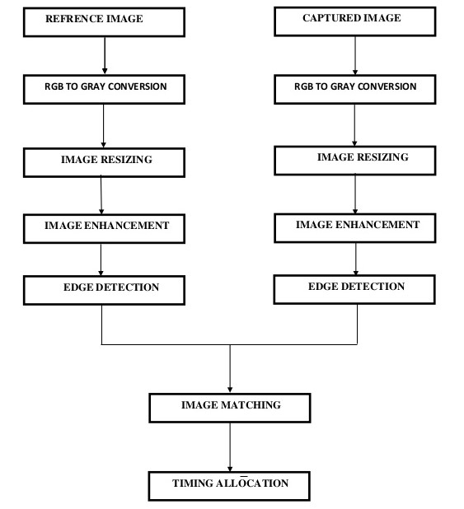

**3.2 MATLAB**

Matlab is a high-performance language for technical computing. It integrates computation, visualization, and programming in an easy-to-use environment where problems and solutions are expressed in familiar mathematical notation. Typical uses include: Math and computation.

**3.3 GUI:**

It stands for Graphic User Interface.

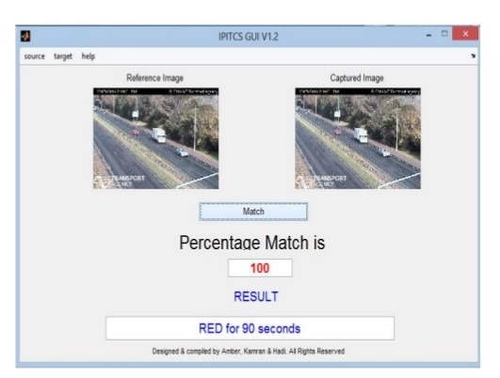

**RESULTS:**

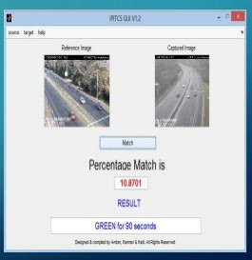

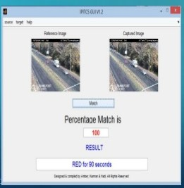

**CONCLUSION:**

Past researches have showed a promising result for including image processing in traffic light control. Earlier in automatic traffic control use of timer had a drawback that the time is being wasted by green light on the empty. This technique avoids this problem. we have successfully implemented an algorithm for a real -time image processing based traffic controller. Upon comparison of various edge detection algorithms, it was inferred that Canny Edge Detector technique is the most efficient one. Analysis of various contour tracing and object counting methods revealed the Moore neighbourhood technique to be more robust when compared to the others. The paper demonstrates that image processing is a far more efficient method of traffic control as compared to traditional techniques. We have also implemented a system for emergency vehicle detection based on image processing techniques. The use of our algorithm removes the need for extra hardware such as sound sensors or RFID tags. The increased response time for these vehicles is crucial for prevention of loss of life.

**References:**

[1] Ahmed S. Salama, Bahaa K. Saleh, Mohamad M. Eassa, ”Intelligent Cross Road Traffic Management System (ICRTMS),” 2nd Int. Conf. on Computer Technology and Development,

Cairo, Nov 2010, pp. 27-31.

[2] B. Fazenda, H. Atmoko, F. Gu, L.Guan1 and A. Ball, ”Acoustic Based Safety Emergency Vehicle

Detection for Intelligent Transport Systems ISSN (Print): 2278-8948, Volume-2, Issue-5, 2013102 ICCAS-SICE, Fukuoka, Aug 2009, pp.4250-4255.

[3] Y. Wu, F. Lian, and T. Chang, “Traffic monitoring and vehicle tracking using roadside camera,” IEEE Int. Conf. on Robotics and Automation, Taipei, Oct 2006, pp. 4631–4636.

[4] Z. Jinglei, L. Zhengguang, and T.Univ, “A vision-based road surveillance system using improved background subtraction and region

growing approach,” Eighth ACIS Int. Conf. on Software Engineering, Artificial Intelligence,

Networking, and Parallel/Distributed Computing, Qingdao, August 2007, pp. 819-822.

[5]M.Siyal,and J.Ahmed,“A novel

morphological edge detection and window based approach for real-

time road data control and management,” Fifth IEEE Int. Conf.

on Information, Communications

and Signal Processing, Bangkok, July 2005, pp.324-328.

[6] K. Wang, Z. Li, Q. Yao, W. Huang, and F. Wang, “Anautomated vehicle counting system for traffic surveillance,” IEEE Int.Conf. on Vehicular Electronics and Safety, Japan, Dec-2007.