**Esparx-Reg-61805**

**Antennas and Microwave Engineering**

**WIRELESS CHARGING OF MOBILE PHONES USING MICROWAVES**

P.S.GAYATHRI S.V.PADMAJA  
13B01A04C3 13B01A04D6  
III-ECE III-ECE  
[*gayatripammi@gmail.com*](mailto:gayatripammi@gmail.com)[*padmajasv13@gmail.com*](mailto:padmajasv13@gmail.com)

**ABSTRACT:**

It is a hectic task to carry everywhere the charger of mobile phones or any electronic gadget while travelling or it is very cruel when your mobile phone getting off by the time you urgently need it. It is the major problem in today’s electronic gadgets. Though the world is leading with the developments in technology, but this technology is still incomplete because of certain limitations. Today’s world requires the complete technology and for this purpose we are proposing ‘Wireless Charging of Mobile Phones Using Microwaves’.

**INTRODUCTION:**

Microwaves are radio waves (a form of electromagnetic radiation) with wavelengths ranging from as long as one meter to as short as one millimeter. The prefix "micro-" in "microwave" is not meant to suggest a wavelength in the micrometer range. It indicates that microwaves are "small" compared to waves used in typical radio broadcasting, in that they have shorter wavelengths.

Microwave technology is extensively used for point-to-point telecommunications (i.e., non-broadcast uses). Microwaves are especially suitable for this use since they are more easily focused into narrow beams than radio waves, allowing frequency reuse; their comparatively higher frequencies allow broad bandwidth and high data transmission rates, and antenna sizes are smaller than at lower frequencies because antenna size is inversely proportional to transmitted frequency.

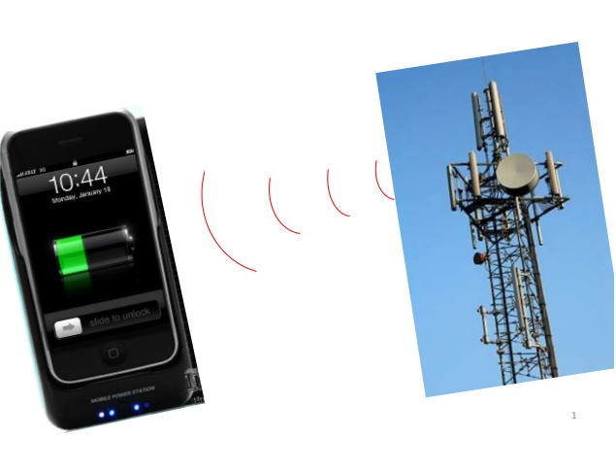

Microwaves are used in spacecraft communication, and much of the world's data, TV, and telephone communications are transmitted long distances by microwaves between ground stations and communications satellites. Microwaves are also employed in microwave ovens and in radar technology. With mobile phones becoming a basic part of life, the recharging of mobile phone batteries has always been a problem. The mobile phones vary in their talk time and battery standby according to their manufacturer and batteries. All these phones irrespective of their manufacturer and batteries have to be put to recharge after the battery has drained out. The main objective of this current proposal is to make the recharging of the mobile phones independent of their manufacturer and battery make. In this paper a new proposal has been made so as to make the recharging of the mobile phones is done automatically as you talk in your mobile phone! This is done by use of microwaves. The microwave signal is transmitted from the transmitter along with the message signal using special kind of antennas called slotted wave guide antenna at a frequency is 2.45 GHz.

**ELECTRO MAGNETIC SPECTRUM:**

The electromagnetic spectrum is the [range](https://en.wikipedia.org/wiki/Spectrum) of all possible frequencies of [electromagnetic radiation](https://en.wikipedia.org/wiki/Electromagnetic_radiation). The "electromagnetic spectrum" *of an object* has a different meaning, and is instead the characteristic distribution of electromagnetic radiation emitted or absorbed by that particular object.

The electromagnetic spectrum extends from below the low frequencies used for modern [radio](https://en.wikipedia.org/wiki/Radio) communication to [gamma radiation](https://en.wikipedia.org/wiki/Gamma_radiation) at the short-[wavelength](https://en.wikipedia.org/wiki/Wavelength) (high-frequency) end, thereby covering wavelengths from thousands of [kilometers](https://en.wikipedia.org/wiki/Kilometer) down to a [fraction](https://en.wikipedia.org/wiki/Fraction_(mathematics)) of the size of an [atom](https://en.wikipedia.org/wiki/Atom). The limit for long wavelengths is the size of the [universe](https://en.wikipedia.org/wiki/Universe) itself, while it is thought that the short wavelength limit is in the vicinity of the [Planck length](https://en.wikipedia.org/wiki/Planck_length). Until the middle of the 20th century it was believed by most physicists that this spectrum was [infinite](https://en.wikipedia.org/wiki/Infinity) and [continuous](https://en.wikipedia.org/wiki/Continuum_(theory)).

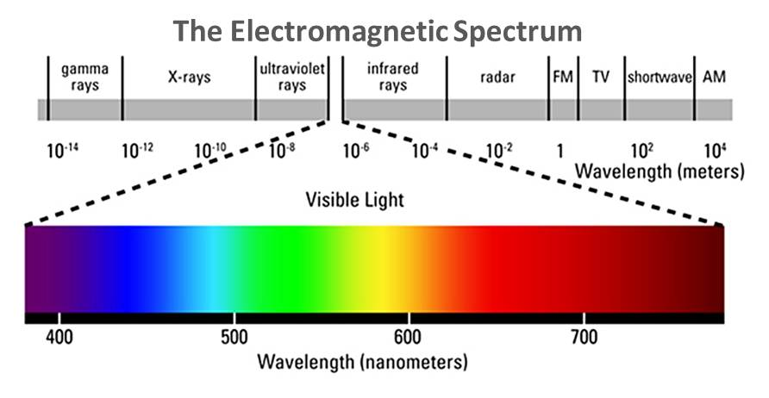

The types of electromagnetic radiation are broadly classified into the following classes.

1. Gamma radiation
2. X-ray radiation
3. Ultraviolet radiation
4. Visible radiation
5. Infrared radiation
6. Terahertz radiation
7. Microwave radiation
8. Radio waves

This classification goes in the increasing order of wavelength, which is characteristic of the type of radiation. While, in general, the classification scheme is accurate, in reality there is often some overlap between neighboring types of electromagnetic energy.

Microwaves are a form of [electromagnetic radiation](https://en.wikipedia.org/wiki/Electromagnetic_radiation) with [wavelengths](https://en.wikipedia.org/wiki/Wavelength) ranging from one meter to one millimeter; with [frequencies](https://en.wikipedia.org/wiki/Frequency) between 300 MHz (100 cm) and 300 GHz (0.1 cm). This broad definition includes both [UHF](https://en.wikipedia.org/wiki/Ultra_high_frequency) and [EHF](https://en.wikipedia.org/wiki/Extremely_high_frequency) ([millimeter waves](https://en.wikipedia.org/wiki/Millimeter_wave)), and various sources use different boundaries. In all cases, microwave includes the entire [SHF](https://en.wikipedia.org/wiki/Super_high_frequency) band (3 to 30 GHz, or 10 to 1 cm) at minimum, with [RF engineering](https://en.wikipedia.org/wiki/RF_engineering) often restricting the range between 1 and 100 GHz (300 and 3 mm).

The [prefix](https://en.wikipedia.org/wiki/Prefix) [*micro-*](https://en.wiktionary.org/wiki/micro-) in *microwave* is not meant to suggest a wavelength in the micrometer range. It indicates that microwaves are "small", compared to waves used in typical [radio broadcasting](https://en.wikipedia.org/wiki/Radio_broadcasting), in that they have shorter wavelengths. The boundaries between [far infrared](https://en.wikipedia.org/wiki/Far_infrared), [terahertz radiation](https://en.wikipedia.org/wiki/Terahertz_radiation), microwaves, and [ultra-high-frequency](https://en.wikipedia.org/wiki/Ultra-high-frequency) [radio](https://en.wikipedia.org/wiki/Radio) [waves](https://en.wikipedia.org/wiki/Wave) are fairly arbitrary and are used variously between different fields of study.

Microwave technology is extensively used for [point-to-point telecommunications](https://en.wikipedia.org/wiki/Point-to-point_(telecommunications)) (i.e. non-broadcast uses). Microwaves are especially suitable for this use since they are more easily focused into narrower beams than radio waves, allowing [frequency reuse](https://en.wikipedia.org/wiki/Frequency_reuse); their comparatively higher frequencies allow broad [bandwidth](https://en.wikipedia.org/wiki/Bandwidth_(signal_processing)) and high [data transmission rates](https://en.wikipedia.org/wiki/Data_transmission_rate), and antenna sizes are smaller than at lower frequencies because antenna size is inversely proportional to transmitted frequency. Microwaves are used in spacecraft communication, and much of the world's data, TV, and telephone communications are transmitted long distances by microwaves between ground stations and [communications satellites](https://en.wikipedia.org/wiki/Communications_satellite). Microwaves are also employed in [microwave ovens](https://en.wikipedia.org/wiki/Microwave_oven) and in [radar](https://en.wikipedia.org/wiki/Radar) technology.

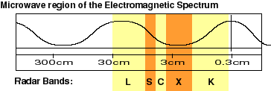

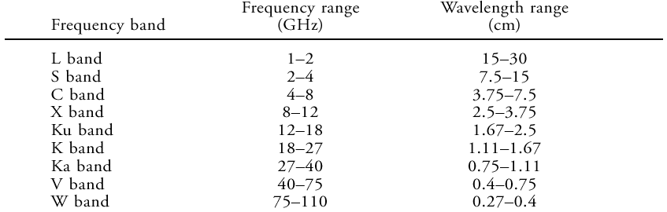

**TRANSMITTER DESIGN:**

The transmission section consists of two parts: 1.Magnetron 2.Slotted wave guide antenna.

**MAGNETRON:**

The magnetron is a self-contained microwave oscillator that operates differently from the linear-beam tubes, such as the TWT and the klystron. The below figure is a simplified drawing of the magnetron. Crossed -electron and magnetic fields are used in the magnetron to produce the high-power output required in radar and communications equipment.

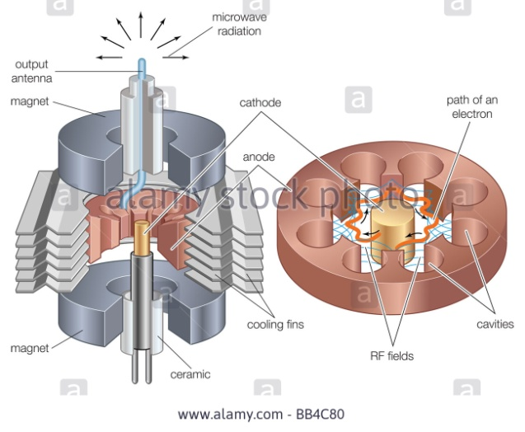

The magnetron is classed as a diode because it has no grid. A magnetic field located in the space between the plate (anode) and the cathode serves as a grid. The plate of a magnetron does not have the same physical appearance as the plate of an ordinary electron tube. Since conventional inductive-capacitive (LC) networks become impractical at microwave frequencies, the plate is fabricated into a cylindrical copper block containing resonant cavities that serve as tuned circuits. The magnetron base differs considerably from the conventional tube base. The magnetron base is short in length and has large diameter leads that are carefully sealed into the tube and shielded. The cathode and filament are at the center of the tube and are supported the filament leads. The filament leads are large and rigid enough to keep the cathode and filament structure fixed in position. The output leads is usually a probe or loop extending into one of the tuned cavities and coupled into a waveguide or coaxial line. The plate structure, is a solid block of copper. The cylindrical holes around its circumference are resonant cavities. A narrow slot runs from each cavity into the central portion of the tube dividing the inner structure into as many segments as there are cavities. Alternate segments are strapped together to put the cavities in parallel with regard to the output. The cavities control the output frequency. The straps are circular, metal bands that are placed across the top of the block at the entrance slots to the cavities.

Since the cathode must operate at high power, it must be fairly large and must also be able to withstand high operating temperatures. It must also have good emission characteristics, particularly under return bombardment by the electrons. This is because most of the output power is provided by the large number of electrons that are emitted when high-velocity electrons return to strike the cathode. The cathode is indirectly heated and is constructed of a high-emission material. The open space between the plate and the cathode is called the INTERACTION SPACE. In this space the electric and magnetic fields interact to exert force upon the electrons.

**SLOTTED WAVE GUIDE ANTENNA:**

A **slotted waveguide** is a [waveguide](https://en.wikipedia.org/wiki/Waveguide) that is used as an [antenna](https://en.wikipedia.org/wiki/Antenna_(electronics)) in microwave [radar](https://en.wikipedia.org/wiki/Radar) applications. Prior to its use in surface search radar, such systems used a [parabolic](https://en.wikipedia.org/wiki/Parabola) segment reflector.

For comparison, in the parabolic type of antenna a feed horn at the end of a [waveguide](https://en.wikipedia.org/wiki/Waveguide) directs a [conical](https://en.wikipedia.org/wiki/Cone_(geometry)) beam of output energy toward the reflector, whence it is focused into a narrow [collimated beam](https://en.wikipedia.org/wiki/Collimated_beam). Reflected energy from the environment follows the reverse path and is focused by the reflector onto the feed horn where it travels back to the receiver. The reflector must be built to a precision determined by the wavelength used. For a one centimeter wavelength, a reflector precision of one or two millimeters would be adequate.

A slotted waveguide has no reflector but emits directly through the slots. The spacing of the slots is critical and is a multiple of the wavelength used for transmission and reception. The effect of this geometry is to form a high gain antenna that is highly directional in the plane of the antenna. Without augmentation a slotted waveguide is not as efficient as a parabolic reflector, lacking an ability to focus in the vertical plane, but is much more durable and is less expensive to construct. The antenna's vertical focus is usually enhanced by the application of a [microwave lens](https://en.wikipedia.org/w/index.php?title=Microwave_lens&action=edit&redlink=1) attached to the front of the antenna. As this, like the companion slotted waveguide, is a one-dimensional device, it too may be made relatively cheaply as compared to a parabolic reflector and feed horn.

Usually a slotted waveguide antenna is protected by microwave transparent material, which may visually obscure the slots. Nevertheless, it is easily distinguished from a parabolic reflector by its flat or tube shape. The wave guide contains slits with size of about 1/4 wavelength, in a distance of 1/2 wavelength.

In a related application, so-called *leaky waveguides* are also used in the determination of railcar positions in certain rapid transit applications. They are used primarily to determine the precise position of the train when it is being brought to a halt at a station, so that the doorway positions will align correctly with queuing points on the platform or with a second set of safety doors should such be provided.

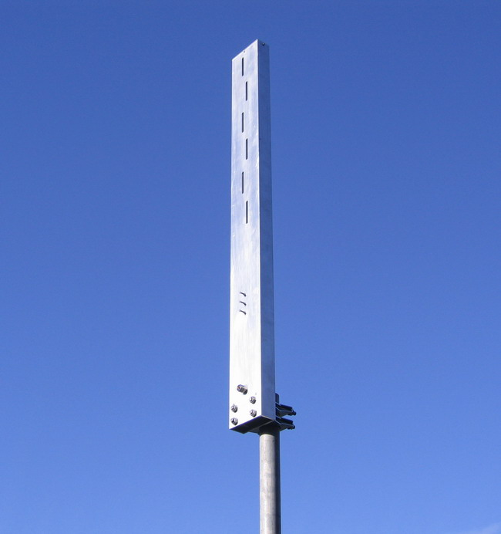

**RECIEVER DESIGN:**

The basic addition to the mobile phone is going to be the rectenna. A rectenna is a rectifying antenna, a special type of antenna that is used to directly convert microwave energy into DC electricity. Its elements are usually arranged in a mesh pattern, giving it a distinct appearance from most antennae. A simple rectenna can be constructed from a Schottky diode placed between antenna dipoles. The diode rectifies the current induced in the antenna by the microwaves. Rectenna are highly efficient at converting microwave energy to electricity. In laboratory environments, efficiencies above 90% have been observed with regularity. Some experimentation has been done with inverse rectenna, converting electricity into microwave energy, but efficiencies are much lower--only in the area of 1%. With the advent of nanotechnology and MEMS the size of these devices can be brought down to molecular level. A rectenna comprises of a mesh of dipoles and diodes for absorbing microwave energy from a transmitter and converting it into electric power. Its elements are usually arranged in a mesh pattern, giving it a distinct appearance from most antennae. A simple rectenna can be constructed from a Schottky diode placed between antenna dipoles as shown in Fig... The diode rectifies the current induced in the antenna by the microwaves. Rectenna are highly efficient at converting microwave energy to electricity.

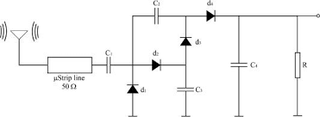

Fig: Block Diagram of a Rectenna

It has been theorized that similar devices, scaled down to the proportions used in nanotechnology, could be used to convert light into electricity at much greater efficiencies than what is currently possible with solar cells. This type of device is called an optical rectenna. Theoretically, high efficiencies can be maintained as the device shrinks, but experiments funded by the United States National Renewable energy Laboratory have so far only obtained roughly 1% efficiency while using infrared light. Another important part of our receiver circuitry is a simple sensor.

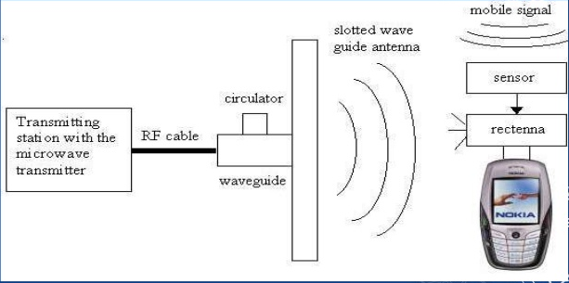

The sensor circuitry is a simple circuit, which detects if the mobile phone receives any message signal. This is required, as the phone has to be charged as long as the user is talking. Thus a simple F to V converter would serve our purpose. In India the operating frequency of the mobile phone operators is generally 900MHz or 1800MHz for the GSM system for mobile communication. Recentness will be used to generate large-scale power from microwave beams delivered from orbiting SPS satellites.

**SENSOR CIRCUITRY:**

The sensor circuitry is a simple circuit, which detects if the mobile phone receives any message signal. This is required, as the phone has to be charged as long as the user is talking. Thus a simple F to V converter would serve our purpose. In India the operating frequency of the mobile phone operators is generally 900MHz or 1800MHz for the GSM system for mobile communication. Thus the usage of simple F to V converters would act as switches to trigger the rectenna circuit to on. A simple yet powerful F to V converter is LM2907. Using LM2907 would greatly serve our purpose. It acts as a switch for triggering the rectenna circuitry.

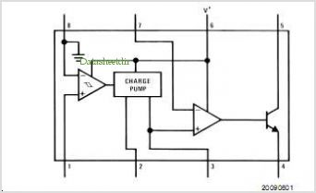

The general block diagram for the LM2907 is given below. Thus on the reception of the signal the sensor circuitry directs the rectenna circuit to ON and the mobile phone begins to charge using the microwave power.

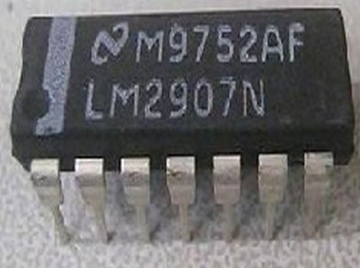

Thus on the reception of the signal the sensor circuitry directs the rectenna circuit to ON and the mobile phone begins to charge using the microwave power.

**RECTENNA:**

A rectenna is a rectifying antenna, a special type of antenna that is used to convert microwave energy into direct current electricity. A simple rectenna element consists of a dipole antenna with an RF diode connected across the dipole elements. The current included by the microwaves in the antenna is rectified by the diode. Which powers a load connected across the diode. Schottky diodes are used because they have low voltage drop and high speed so that they have low power loss.

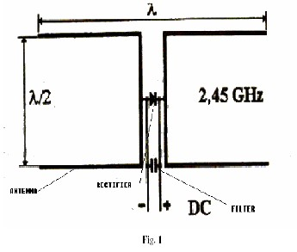

**PROCESS OF RECTIFICATION:**

Studies on various microwave power rectifier configurations show that a bridge configuration is better than a single diode one. But the dimensions and the cost of that kind of solution do not meet our objective. This study consists in designing and simulating a single diode power rectifier “in hybrid technology” with improved sensitivity at low power levels. We achieved good matching between simulation results and measurements thanks to the optimization of the packaging of the Schottky diode. Microwave energy transmitted from space to earth apparently has the potential to provide environmentally clean electric power on a very large scale. The key to improve transmission efficiency is the rectifying circuit. The aim of this study is to make a low cost power rectifier for low and high power levels at a frequency of 2.45 GHz with good efficiency of rectifying operation. The objective also is to increase the detection sensitivity at low levels of power. Different configurations can be used to convert the electromagnetic wave into DC signal, the study done in showed that the use of a bridge is better than a single diode, but the purpose of this study is to achieve a low cost microwave rectifier with single Schottky diode for low and high power levels that has a good performances. This study is divided on two kind of technologies the first is the hybrid technology and the second is the monolithic one. The goal of this investigation is the development of a hybrid microwave rectifier with single Schottky diode. The first study of this circuit is based on the optimization of the rectifier in order to have a good matching of the input impedance at the desired frequency 2.45GHz. Besides, the aim of the second study is the increasing of the detection sensitivity at low levels of power.

**SCHOTTY BARRIER DIODE:**

A Schottky barrier, named after [Walter H. Schottky](https://en.wikipedia.org/wiki/Walter_H._Schottky), is a [potential energy](https://en.wikipedia.org/wiki/Potential_energy) barrier for electrons formed at a [metal–semiconductor junction](https://en.wikipedia.org/wiki/Metal%E2%80%93semiconductor_junction). Schottky barriers have [rectifying](https://en.wikipedia.org/wiki/Rectifier) characteristics, suitable for use as a [diode](https://en.wikipedia.org/wiki/Diode). One of the primary characteristics of a Schottky barrier is the Schottky barrier height, denoted by ΦB . The value of ΦB depends on the combination of metal and semiconductor.

Not all metal–semiconductor junctions form a rectifying Schottky barrier; a metal–semiconductor junction that conducts current in both directions without rectification, perhaps due to its Schottky barrier being too low, is called an [ohmic contact](https://en.wikipedia.org/wiki/Ohmic_contact).

In a rectifying Schottky barrier, the barrier is high enough that there is a [depletion region](https://en.wikipedia.org/wiki/Depletion_region) in the semiconductor, near the interface. This gives the barrier a high resistance when small voltage biases are applied to it. Under large voltage bias, the [electric current](https://en.wikipedia.org/wiki/Electric_current) flowing through the barrier is essentially governed by the laws of [thermionic emission](https://en.wikipedia.org/wiki/Thermionic_emission), combined with the fact that the Schottky barrier is fixed relative to the metal's Fermi level.. .

Under forward bias, there are many thermally excited electrons in the semiconductor that are able to pass over the barrier. The passage of these electrons over the barrier (without any electrons coming back) corresponds to a current in the opposite direction. The current rises very rapidly with bias, however at high biases the series resistance of the semiconductor can start to limit the current.

Under reverse bias, there is a small leakage current as some thermally excited electrons in the metal have enough energy to surmount the barrier. To first approximation this current should be constant (as in the [Shockley diode equation](https://en.wikipedia.org/wiki/Shockley_diode_equation)); however, current rises gradually with reverse bias due to a weak barrier lowering (similar to the vacuum [Schottky effect](https://en.wikipedia.org/wiki/Schottky_effect)). At very high biases, the depletion region breaks down.

A [Schottky diode](https://en.wikipedia.org/wiki/Schottky_diode) is a single metal–semiconductor junction, used for its rectifying properties. Schottky diodes are often the most suitable kind of diode when a low forward [voltage drop](https://en.wikipedia.org/wiki/Voltage_drop) is desired, such as in a high efficiency DC [power supply](https://en.wikipedia.org/wiki/Power_supply). Also, because of their majority-carrier conduction mechanism, Schottky diodes can achieve greater switching speeds than p–n junction diodes, making them appropriate to rectify high-frequency signals.

A [bipolar junction transistor](https://en.wikipedia.org/wiki/Bipolar_junction_transistor) with a Schottky barrier between the base and the collector is known as a [Schottky transistor](https://en.wikipedia.org/wiki/Schottky_transistor). Because the junction voltage of the Schottky barrier is small, the transistor is prevented from saturating too deeply, which improves the speed when used as a switch. This is the basis for the Schottky and Advanced Schottky [TTL](https://en.wikipedia.org/wiki/Transistor-transistor_logic) families, as well as their low power variants.

A [MESFET](https://en.wikipedia.org/wiki/MESFET) or metal–semiconductor [FET](https://en.wikipedia.org/wiki/Field_effect_transistor) uses a reverse-biased Schottky barrier to provide a depletion region that pinches off a conducting channel buried inside the semiconductor (similar to the [JFET](https://en.wikipedia.org/wiki/JFET) where instead a [p–n junction](https://en.wikipedia.org/wiki/P%E2%80%93n_junction) provides the depletion region). A variant of this device is the [high-electron-mobility transistor](https://en.wikipedia.org/wiki/High-electron-mobility_transistor) (HEMT), which also utilizes a [heterojunction](https://en.wikipedia.org/wiki/Heterojunction) to provide a device with extremely high conductance.

A Schottky barrier [carbon nanotube FET](https://en.wikipedia.org/wiki/Carbon_nanotube_field-effect_transistor) uses the non-ideal contact between a metal and a carbon nanotube to form a Schottky barrier that can be used to make extremely small Schottky diodes, transistors, and similar electronic devices with unique mechanical and electronic properties.

**ADVANTAGES:**

1. Charging of mobile phone is done wirelessly.
2. We can save time in charging mobile phones
3. Wastage of power is less.
4. Mobiles get charged as we make call even during long journey.
5. Better than witricity as the distance the witricity can cover is about 20 meters, whereas in this technology we are using a base station for transmission that can cover more area.

**DISADVANTAGES:**

1. Radiation problem may occur.
2. Network problem may cause problems in charging
3. Charging depends on network coverage.
4. Rate of charging dependson minute range.

**REFERENCES:**

1. <http://hyperphysics.phy-astr.gsu.edu/hbase/waves/magnetron.html>
2. <https://en.wikipedia.org/wiki/Schottky_diode>
3. <http://www.antenna-theory.com/antennas/aperture/slottedwaveguide2.php>
4. http://www.ijesit.com/Volume%202/Issue%205/IJESIT201305_29.pdf

**CONCLUSION:**

In this modern era of Science and Technology, we do not have enough time to be constantly at one place and recharge our Mobile Phones, Laptops etc. Regardless of office, we work even when we are at home, then our Communicating media need sudden recharge without being interrupted. A novel use of the Rectenna and a sensor in a Mobile phone could provide a new dimension in the revolution of Mobile Phone. Covering these aspects, this new system of wireless recharging will certainly bring innovative Change in recharging Electronic Equipment and will upgrade our Lifestyle. Thus this paper successfully demonstrates a novel method of using the microwave’s power to charge the Mobile Phones.