** **

**NANO TECHNOLOGY**

P.PRASANNA

III ECE

Peddireddyprasanna@gmail.com

P.LOHARSHA VARDHINI

III ECE

Loharsha27may@gmail.com

SHRI VISHNU ENGINEERING COLLEGE for WOMEN, vishnupur, Bhimavaram, W.G.Dt

**Abstract:**

A basic definition of Nanotechnology is the study manipulation and manufacture of extremely minute machines or devices. These devices are so small to the point of manipulating the atoms themselves to form materials. By this Nanotechnology we can make computers billions of times more full than todays and new medical capabilities that will heal and cure in cases that are now viewed as utterly hopelessly. The properties of manufactured products depend on how those atoms are arranged. If we know about exactly how many do pant atoms are in a single transistor and exactly where each individual do pant atom is located and placed roughly the right number in roughly the right place, we can make a working transistor. Another

improvement in Nanotechnology is self replication. Self replication makes a effective route to truly low cost manufacturing. Our intuitions about self replicating systems learned from biological systems that surround us are likely to seriously mislead us about the properties and characteristics of artificial self replicating systems designed for manufacturing purposes. Artificial systems able to make a wide range of non-biological products like diamond under programmatic control are likely to be more brittle and less adaptable in their response to changes in their environment than biological systems. At the same time they should be simpler and easier to design. Thus the progress of technology around the world has already given us more

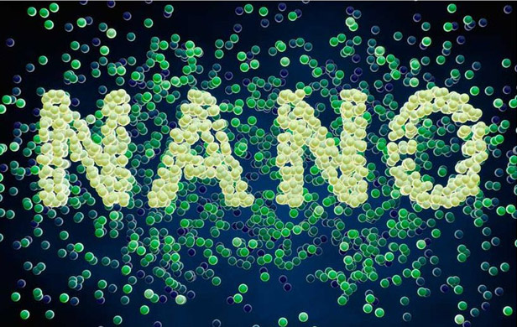

precise, less expensive manufacturing technologies that can make an unprecedented diversity of new products. Everything requires the computer is a major reason why people should research and develop Nanotechnology.

**1. INTRODUCTION**

A basic definition of Nanotechnology is the study, manipulation and manufacture of extremely minute machines/devices. In a few decades, this emerging manufacturing technology will let us inexpensively arrange atoms and molecules in most of the ways permitted by physical law**.**

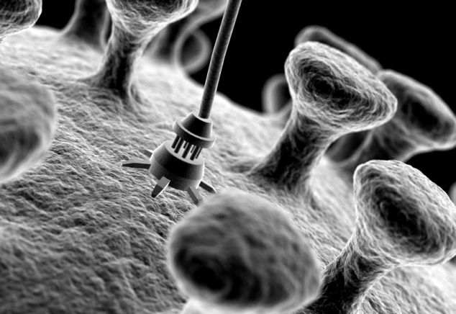

Nanotechnology could, in the future, be used to rapidly identify and block attacks. Distributed surveillance systems could quickly identify arms buildups and offensive weapons deployments, while lighter, stronger and smarter materials controlled by powerful molecular computers would let us make radically improved versions of existing weapons able to respond to such threads. Replicating manufacturing systems could rapidly churn out the needed defenses in huge quantities.

While Nanotechnology does propose to use replication, it does not propose to copy living systems. Living systems are wonderfully adaptable and can survive in a complex natural environment. Instead, Nanotechnology proposes to build molecular machine systems that are similar to small versions of what you might find in today’s modern factories. Robotic arms shrunk to submicron size should be able to pick up and assemble molecular parts like their large cousins in factories around the world pick up and assemble nuts and bolts. Unfortunately, our intuitions are about replicating systems can be led seriously astray by a simple fact: the only replicating systems most of us are familiar with are biological self-replicating systems.

**Why we use Nanotechnology**

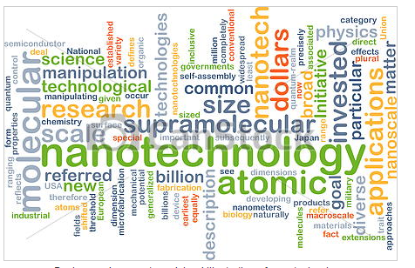

Firstly, the synthetic manufacture of materials is included under the science of nanotechnology. Once we learn enough to synthetically replicate and produce naturally occurring substances on earth, we will not relay on remaining stores currently on earth.

Secondly, similar to the fabrication of materials that we currently use, self-replication would be a major step to reducing manufacturing costs, time and problems. The only costs incurred would be the cost of the material required, and the cost of making one machine to start with. Also, the conductivity of certain materials could be vastly improved by Nanotechnology. Timber is not a good choice for a semiconductor. This is because electrons do not move very freely over its surface. On the other hand silicon and diamond are good choices for a semiconductor. If we could manipulate these materials down to each atom and molecule then we could make a transistor the width of few molecules across. The energy required to operate these super transistors would be greatly smaller than the requirements of today’s computer systems. The computer with these super transistors would run at around 60GHz, and be exceptionally more powerful than today’s most advanced computers.

**2. ABOUT THE TECHNOLOGY**

In the coming decades nanotechnology could make a super computer so small it could barely be seen in a light microscope. The coming revolution in manufacturing is a continuation of trends that date back decades and even centuries. Looking ahead we will be able to manufacture products with the ultimate in precision the finite features will be individual atoms and molecules.

Manufactured products are made from atoms. The property of those products depends on how those atoms are arranged. If we rearrange the atoms in coal we can make diamond. If we rearrange the atoms in sand we can make computer chips. Today’s manufacturing products are very crude at the molecular level.

There are two concepts mainly associated with nanotechnology-

1. POSITIONAL ASSEMBLY

2. SELF-REPLICATION

**1. POSITIONAL ASSEMBLY**

This positional assembly aims to place the right molecular parts in the right place. The need for positional assembly implies an interest in molecular robotics. e.g., robotic devices those are molecular both in their size and precision. These molecular scale positional devices are likely to resemble very small versions of their everyday macroscopic counterparts. Positional assembly is frequently used in normal macroscopic manufacturing today, and provides tremendous advantages. Imagine trying to build a bicycle with both hands tied behind your back! The idea of manipulating and positioning individual atoms and molecules is still new and takes some getting used to. however as Feynman said “The principles of physics, do not against the possibility of maneuvering things atom by atom.” We need to apply at the molecular scale the concept that was demonstrated its effectiveness at the macroscoping scale: making parts go where we want by putting them where we want!

**2. SELF REPLICA:**

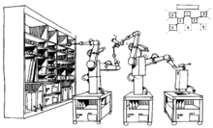

The remarkably low manufacturing cost comes from self replication. Molecular machines can make more molecular machines, which can make yet more molecular machines. While the research and development costs for such systems are likely to be quite high, incremental manufacturing costs of a system able to make systems like it can be very low.

Self replication is at the heart of many policy discussions. The only self replicating systems most of us are familiar with are biological. We automatically assume that nanotechnological self-replicating systems will be similar. The machines people make bear little resemblance to living systems and molecular manufacturing systems are likely to be just as dissimilar.

The artificial self replicating systems are being proposed for molecular manufacturing are inflexible and brittle. It is difficult enough to design a system able to self replicate in a controlled environment, let alone designing one that can approach the marvelous adaptability that hundreds of millions of years of evolution have given to living systems. Designing a system that uses a single source of energy is both much easier to do and produce a much more efficient system. Artificial self replicating systems will be both simpler and more efficient if most of this burden is offloaded: we can give them the odd compounds and unnatural molecular structures that they require in an artificial feedstock rather than forcing the device to make everything itself-a process that is both less efficient and more complex to design.

The mechanical designs proposed for Nanotechnology are more reminiscent of a factory than of a living system. Molecular scale robotic arms able to move and position molecular parts would assemble rather rigid molecular products using methods more familiar to a machine shop than the complex brew of chemicals found in a cell. Although we are inspired by living systems, the actual designs are likely to owe more to design constraints and human objectives than to living systems.

Self-replication is but one of many abilities that living systems exbhit. Copying that one ability in an artificial system will be challenge enough without attempting to emulate their many other remarkable abilities. The engineering effort required to design systems of such complexity will be significant, but should not be greater than the complexity involved in the design of such existing systems as computers, airplanes etc.

**3. NANOTECHNOLOGY APPROACH**

There are two types of approaches in nano technology. They are:

1. BOTTOM TO TOP APPROACH

2. TOP TO BOTTOM APPROACH

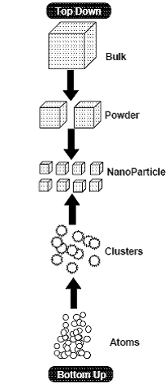

**3.1. BOTTOM-TO-TOP**

Nanotechnology promises an inexpensive "bottom up" alternative in which electronic or other devices will be assembled from simpler components such as molecules and other nano-structures. This approach is similar to the one nature uses to construct complex biological architectures. Nano-products will be smarter than the traditional devices as:

* Nano-devices operate at the most fundamental level.
* Work very fast, because it works at a very small scale.
* Have plummeting costs, as the technology is applied to itself.
* And eventually, be ubiquitous. Just as today's computers are showing up in more and more products, nano-computers and nano-defined materials will be able to improve just about any object we use, including our own bodies.

**3.2. TOP-TO-BOTTOM APPROACH**

Today, electronic devices, sensors, motors, and many other items are fabricated using a "top down" approach. Today's computer chips are made using photolithography, a process that uses light and chemicals to etch lines into silicon wafers. The process requires vacuum chambers, powerful lasers and hazardous chemicals, which is why state-of-the-art chip factories tend to be billion-dollar facilities. As device features have become finer, the number of devices that can be crammed onto a chip has been doubling every 18 to 24 months.

**4.APPLICATIONS:** 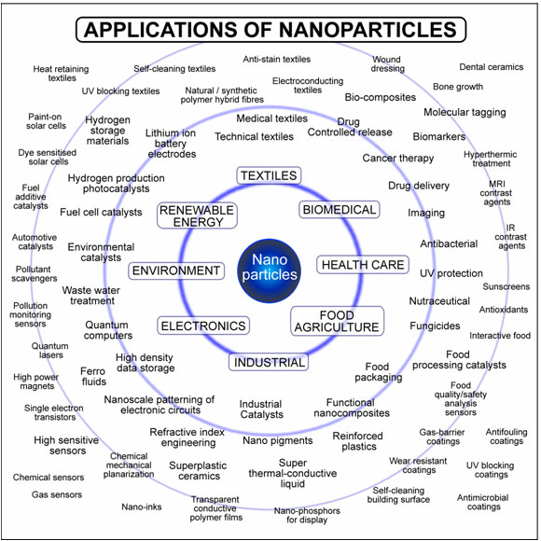

The improvement and advance in the computer industry alone is a major reason why people are and why people should research and develop Nanotechnology. Imagine the world being run by supercomputers rather than the relatively slow and cumbersome machines of today. Everything that requires computer would be improved dramatically and be better, faster and more efficient. Nanotechnology will let us make supercomputers that fit head of a pin and fleets of medical nanorobots smaller than human cell able to eliminate cancer, infections, clogged arteries and even old age.

**4.1. MOLECULAR ELECTRONICS**

Molecular Electronics is a revolutionary idea to attend maximum miniaturization, instead

of using transistor‘s ‗on ‘and ‗off’ states for

Implementing ones and zeros respectively, the characteristics of electrons maybe used for the same. Positive and negative spins can be used to implement one and zero respectively.

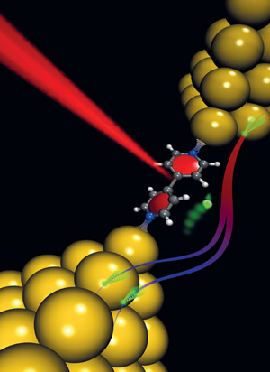

The idea is new and it will take time for its implementation. But this will be the ultimate destination in the quest for miniaturization.

Molecular Electronics is based on a new organic material that may lead to a biological or chemical computer. A new radical information processing systems is being thought where organic cells or the bacteria will act as basic components.

Living Organisms are made up of organic compounds. And as such, thinking functions can be easily realized in such a system. Due to biological level scale the high density circuits may be made.

One example of a natural molecular device is the bacterial photo reaction center. Analogous devices have been successfully made through the synthesis of single and complex molecules, which release charge on photo excitation.

**4.2. HIGH MEMORY STORAGE CAPACITY**

The first application that comes to mind is

a very high -density memory.

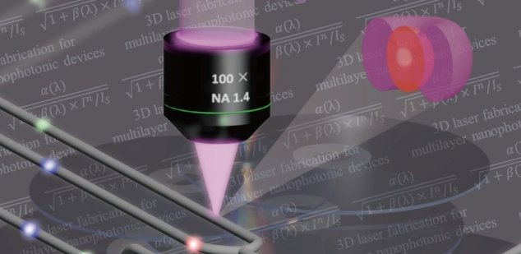

The minimum spot-size demonstrated in the new work is 10 angstroms, though a somewhat larger size might be required in practice. If we assume that a single bit can be read or written into a 10angstrom square, then one square centimeter surface can hold 10

14 bits. That's one hundred terabytes. The 100 nanosecond pulse time sets a 10-megabit/second maximum write rate, though this might be degraded for other reasons. At this rate, it would take several months to a year of constant writing to fill a one square centimeter memory. Access times will probably be limited by the time needed to move the needle--which might be a significant fraction of a second to travel one centimeter--giving access times similar to those on current disk drives. The manufacturing cost of such a system is unclear, but the basic components do not seem unduly expensive. It seems safe to predict that someone in the not-too-distant future is going to build a

low-cost very large capacity secondary storage device.

**4.3. MILITARY APPLICATIONS**

Today, "smart" weapons are fairly big -- we have the "smart bomb" but not the "smart bullet". In the future, even weapons as small as a single bullet cold pack more computer power than the largest supercomputer in existence today ,allowing them to perform real time image analysis of their surroundings and communicate with weapons tracking systems to acquire and navigate to targets with greater precision and control.

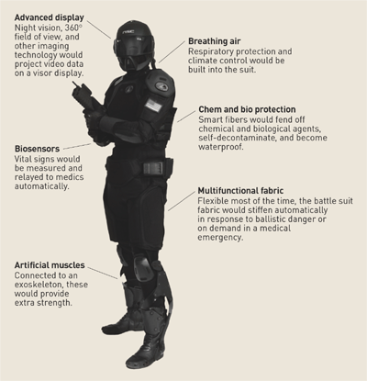

We'll also be able to build weapons both inexpensively and much more rapidly, at the same time taking full advantage of the remarkable materials properties of diamond. Rapid and inexpensive manufacture of great quantities of stronger more precise weapons guided by massively increased computational power will alter the way we fight wars. Changes of this magnitude could destabilize existing power structures in unpredictable ways. Military applications of nanotechnology raise a number of concerns that prudence suggests we begin to investigate before, rather than after, we develop this new technology.

**4.4. SMART FURNITURE**

Doctors warned against the way many people sit for hours together, and recommend a little bit of exercise. But what if the furniture itself changes its shape to accommodate us comfortably. The concepts of adaptive furniture have caught the fancy of many designers who value the aesthetic design and the ove

rall getup and feel of furniture. Smart furniture of the future could be fitted with microchips that help the furniture concerned to behave and changed accordingly depending upon the posture of the person. Nanotechnology would be the enabler of adaptive structures in furniture.

Today we have furniture that adapts to the human body, but it does so in an awkward and incomplete manner. A chair adapts because it is a hinge contraption that grudgingly bends and extends in a few places to suit the preferred position.

There are advertisements of the furniture giving a massage. But in fact it only vibrates. So what we get in reality is a momentarily relief and in long run a problem like lower back pain.

These limitations are due to the incompatibility in design. However with molecular manufacturing it will be easy to make furniture from smart materials that adapt to the changing position of the user.

**4.5. SOLAR ENERGY**

Nanotechnology will cut costs both of the solar cells and the equipment needed to deploy them, making solar power economical. In this application we need not make new or technically superior solar cells: making in expensively what we already know how to make expensively would move solar power into the mainstream.

**4.6. MEDICAL APPLICATIONS**

It is not modern medicine that does the healing, but the cells themselves: we are but onlookers. If we had surgical tools that were molecular both in their size and precision, we could develop a medical technology that for the first time would let us directly heal the injuries at the molecular and cellular level that are the root causes of disease and ill health. With the precision of drugs combined with the intelligent guidance of the surgeon's scalpel, we can expect quantum leap in our medical capabilities.

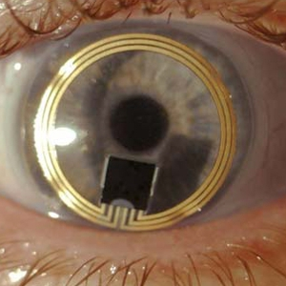

On the medical front, doctors claim that around the year 2020 there would be no unanticipated illness. Chronic sensor implants would monitor almost every major circulatory system in the human body and provide you with early warning of any minor change in the body system, such as common cold and even go to the extent of saving life by detecting the harmful cancerous cells/tumors and eradicating them completely. Nanotech visionaries have much more ambitious notion like designing a device that cruises the human blood stream seeks out cholesterol deposit on vessel walls and dissembles them. These nano bots could chip pluck from arteries, gang up on bacteria and virus, scour toxins from the blood stream, repair broken blood vessels and dozens of jobs doctors haven‘t dreamed of yet.

**5. FUTURE TRENDS**

Unprecedented opportunities are arising for re-engineering existing products. For example, cluster of atoms (nanodots, macromolecules), nanocrystalline structured materials (grain size less than 100 nm), fibers less than 100 nm in diameter (nanorods and nanotubes), films less than 100 nm in thickness provide a good base to develop further new nanocomponents and materials.

The buckyball (C60) has opened up a excellent field of chemistry and material science with many exciting applications because of its ability to accept electrons. Carbon nanotubes have shown a promising potential in the safe, effective and risk free storage of hydrogen gas in fuel cells, increasing the prospects of wide uses of fuel cells and replacement of internal combustion engine. The potential of nanotubes can be further exploited in oil and gas industry. The nanotube market is likely to hit 1.35 billion dollars in 2005. Nanotechnology offers a myriad of applications for production of new gas sensors, optical sensors, chemical sensors, and other energy conversion devices to bio implants.

**6. ADVANTAGES:**

* Suitability for low cost, high volume production.
* Reduced size, mass and power consumption.
* High functionality.
* Improved reliability and robustness.
* Can detect some diseases in early stages
* Can help cleaning up existing pollution in air.
* Can construct materials can reduce the amount of energy used in vehicles.

**7. DISADVANTAGES**

* More research and development should be done.
* Nano materials are not regulated by the government
* .Some nano particles are toxic to humans.

**8. CONCLUSION**

Adding programmed positional control; self replication to existing methods gives us greater control over the material world and improved our standards of living. Nanotechnology- the science is good, the engineering is feasible, the paths of approach are many, the consequences are revolutionary-times-revolutionary, and the schedule is: in our lifetimes.

**9. REFERENCES**

* https://en.wikipedia.org/wiki/**Nanotechnolog**
* https://www.foresight.org/nano/
* www.electronics for you
* **ieee**xplore.**ieee**.org/xpl/RecentIssue.jsp?punumber=7729
* www.eng**paper**.com /free-research-paper-**nanotechnology**.htm
* http://www.scribd.com/doc/.. ./**Seminar**-**Report-**on-**Nanotechnology**
* www.faadooengineers.com

Modular, Self-reconfigurable robots show the promise of great versatility, robustness and low cost. This paper presents examples and issues in realizing those promises. A modular reconfigurable robotic system consists of various link and joint units with standardized connecting interfaces that can be easily separated and reassembled into different configurations. Compared to a fixed configuration robot, which is usually a compromised design for a limited set of tasks, a modular robot can accomplish a large class of tasks through reconfiguration of a small inventory of modules. This thesis studies how to find an optimal module assembly configuration constructed from a given inventory of module components for a specific task.

**1. Introduction**

Modular robotic systems are those systems that are composed of modules that can be disconnected and reconnected in different arrangements to form a new system enabling new functionalities these include: manual reconfiguration, automatic reconfiguration, homogenous and heterogeneous modules. The systems are automatically reconfiguring, hardware systems that tend to be more homogenous than heterogeneous. The general

philosophy is to simplify the design and construction of components while

enhancing functionality and versatility through larger numbers of modules. Thus, the low heterogeneity of the system is a

design leverage point getting more functionality for a given amount of design. Modular self-reconfigurable robot systems can also reconfigure their own modules. These systems claim to have many desirable properties including versatility, robustness and low cost. While the number of modules has been large in simulation, the physical implementation of these systems has rarely had more than 10 modules. They can contain [electronics](https://en.wikipedia.org/wiki/Electronics) , sensors, processors, memory, and [power supplies](https://en.wikipedia.org/wiki/Power_supplies) contain[actuators](https://en.wikipedia.org/wiki/Actuator) that are used for manipulating their location in the environment.

**2. Three promises of reconfigurable robots**

Modular reconfigurable robotic systems that are composed of many modules have three promises. They promise to be versatile, robust, and low cost. However, there are important issues that are often neglected that need to be addressed before these promises are realized.

**Versatility**

The ability to reconﬁgure allows a robot to disassemble and/or reassemble itself to form morphologies that are well-suited for a variety of given tasks.

**Robustness**

Since the system is composed of many repeated parts which can be rearranged during operation, faulty parts can be discarded and replaced with anidenticalmoduleon-the-ﬂy,leadingtoself-repair.

**Low-cost**

MSR systems can lower module costs since mass production of identical unit modules has an economic advantage that scales favorably. Also, a range of complex machines can be made from a set of modules saving the cost versus having multiple single-function machines for doing diﬀerent tasks.

**3. Modular Self-Reconfigurable Robot Review**

CategoriesofMSRSystems

There are several ways of categorizing MSR robotic systems.Oneisbasedontheregularityoflocationsforattaching;latticevs.chainvs.mobile,andanotherisbasedonthe methodsofmovingbetweenthoselocations; stochastic vs. deterministic.

**Mobile**

The mobile class of reconﬁguration occurs with modules moving in the environment disconnected from other modules. When they attach, they can end up in chains or in a lattice. Examplesof mobile reconﬁguration devicesincludemultiplewheeledrobotsthatdrivearound and link together to form trains, modules which ﬂoat in aliquidorouterspaceanddockwithothermodules.

**Lattice**

A lattice based MSR system has modules arranged nominally in a 2D or 3D grid structure. For this category, there are discrete positions that a given module canoccupy. Incontrasttochain-basedarchitectureswhere modules are free to move in continuous space, the grid based structure of lattice systems generally simpliﬁes the reconﬁguration process. Kinematics and collision detection are comparatively simple for lattice systems. An exampleisshowninFig.1.

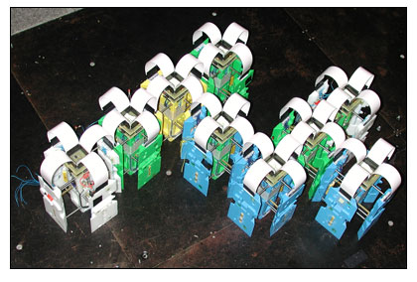

Fig:1 lattice reconfigurable robot

**Chain**

A chain based MSR system consists of modules arranged in groups of connected serial chains, forming treeandloopstructures.Sincethesemodulesaretypically arranged in an arbitrary point in space, the coordination ofareconﬁgurationiscomplex.In particular, forwardand inverse kinematics, motion planning, and collision detection are problems that do not scale well as the number of modulesincreases.An example isshowninFig.2

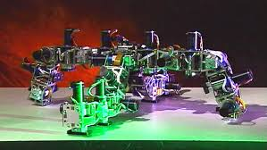

Fig:2 chain reconfigurable robots

**Stochastic**

Inastochasticsystem,modulesmoveina2D or 3D environment randomly and form structures by bonding to a substrate and/or other modules. Modules moveintheenvironmentinapassivestate.Onceamodulecontacts the substrate or another module, it makes a decision about whether it will bond to the structure or reject a bond. The time that it takesfor the system to reach a desired conﬁguration is probabilistically bounded. The reliance on environmental forces allows the mechanical actuationtobesimpliﬁedasonlybondingactuationisrequired internal to the module. An example is shown in Fig.3.

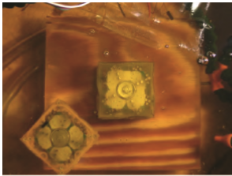3a

3b

Fig:3 Stochastic reconfigurable robots

**Deterministic**

In deterministic MSR systems, modules moveoraremanipulateddirectlyfromonepositiontoanother in the lattice or chain. The positions of each module in the system are known at all times. The amount of time it takes for a system to change from one conﬁgurationtoanotherisdetermined.A module’sreconﬁguration mechanism requires a control structure that allows it to coordinateandperformreconﬁgurationsequenceswithits neighbors. There are a growing number of existing physical systems that researchers are developing self-reconﬁgurable robots. One indication thatthisnumberis gettinglargeis the development of a robot whose name is YaMoR(Yet another Modular Robot). Table 1 lists many of the other instantiated modular robot systems. In addition to the name, class, and author, the table lists DOF. This describes the number of actuated degrees of freedom for modulemotion (e.g.notlatchdegreesoffreedom)aswell aswhetherthe systemmotionisplanar(2D) orcanmove outoftheplane(3D).Theyearistheestimatedﬁrstpublic disclosure.

4**. Applications**

Comparedwithﬁxed morphology robots,MSRrobotsare ﬂexible in that they can adapt to a wide range of tasks andenvironments.However,this ﬂexibility maycompromiseperformance orcost. Fixedmorphology systemscan be optimized for a particular known task, therefore, MSR roboticsystemsareparticularlywell-suitedfortaskswhere the operating conditions and ability requirementsare not known or not well speciﬁed a priori. The following sets of application examples illustratesomeareasthatwouldbeneﬁtfromthedevelopmentofarmatureMSRsystem.

**Space**

Theexplorationofspacepresentsnumerouschallenges, including an unpredictable environment and signiﬁcantlimitationsonthemassandvolumeofequipment usedto study thatenvironment.Since one setof modules can be reconﬁgured to perform many tasks, MSR robots can solve both the unexpected challenges while occupy little space and weight as compared to multiple devices Graceful degradationdue to failure is particularly importantforrobotsoperatinginspace–a componentmalfunctioncanpotentiallyleadtomissionfailure.Theredundant nature of MSR systems gives them the ability to discard failedmodules.Modulescanalsobepackagedinaconvenient way so as to meet the volume constraints of spacecraft. Once on site, modules can be used to build structures, navigate across terrain, perform scientiﬁc studies, etc. shown in fig:4

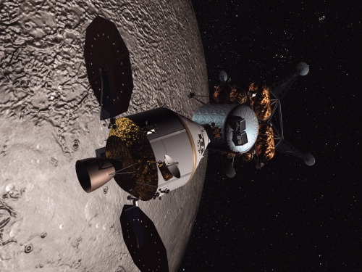

Fig: 4 Space applications

**Search and Rescue**

Disaster areas such as those around collapsed buildings or other structures present another type of highly unstructured unpredictable environment where the use of an MSR robot could be beneﬁcial. For example, the MSR system could take the form of a snake which can more easily squeeze through small void spaces toﬁndvictims.Oncefound,therobotcouldemitalocator beaconandtaketheformofasheltertoprotectthevictim untilrescued.

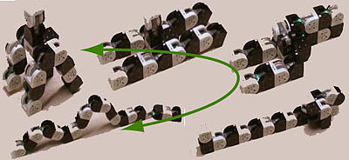

Fig: 5 Research and rescue

**Bucket of Stuﬀ**

The term “Bucket of Stuﬀ” is futuristic ideacoinedbyDavidDuﬀatthePaloAltoResearch Center. The system would be a consumer product comprisedofacontainerofreconﬁgurablemodulesthatwould reconﬁgure toaccomplish arbitraryhouseholdtasks.This application can be seen as the most generalpractical goal of MSR robotics: a system that can adapt to any task in realtime.AbucketofMSRmodulescouldbeusedtoform thedesiredconﬁgurationfortheendusersuchascleaning gutterstofoldinglaundry.

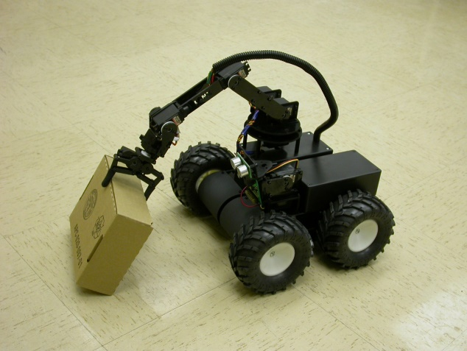

Fig: 6 Bucket of stuff

**5. FutureDirections**

The grand challenges for MSR robotic systems were the results of a workshop where a group of researchers in the MSR robot community gathered.Aproposed ultimategoalfor thesesystemswould be to one day use them in vast numbers for practical applicationswhereun-supervised,adaptiveself-organization is needed.Five grand challenges that, if overcome, would enableanext-generationofmodularrobotswithvastlysuperiorcapabilitiesaresummarizedhere:

**Self-repairingsystems**

Ademonstrationofaself-healing structure made up of many distributed, communicating partswouldrequirerethinkingalgorithmsforsensing and estimation of the global state, as well as truly robust hardware and algorithms for reconﬁguration that work from any initial condition. A concrete example would be havinga system blown up (randomly separated into many pieces) then self-assembling, or recoveringfromfailureofacertainpercentageoffaulty units.

**Self-replication and self-extension**

While simple robotic self-replication has been demonstrated using few high-level modules, a signiﬁcant challenge remains todemonstrateself-replicationfrom elementarycomponents and raw materials. The demonstration of a“seed”groupofmodularrobotsthatcanbuildcopies of themselves from raw materials would require advancing beyond a level of complexity that Von Neumann identiﬁed as the equivalent of breaking the soundbarrierforengineeredsystems.

**5. Conclusion**

Self-reconfiguring robots are able to adapt to the operating environment and required functionality by changing shape. They consist of a set of identical robotic modules that can autonomously and dynamically change their aggregate geometric structure to suit different locomotion, manipulation, and sensing tasks. However, creating robots with self-reconfiguration capabilities is a serious challenge now being met through new designs for reconfigurable systems and new ideas about algorithmic planning and control that confer autonomous re-configurability. We discussed planning issues and illustrated a hardware-specific distributed planner and a generic distributed planner that can be instantiated to many different designs. These results are encouraging first steps toward creating self-reconfiguring robotics applications. However, we have a way to go before we can engineer modular self-reconfiguring robot systems that can be embedded into the physical world and respond in real time to requests for self-assembly. Because these robot systems will constitute long-lived distributed systems, all the supporting hardware and software will have to be robust, long-lasting, fault-tolerant, scalable, and self-healing. The units will have to be networked with a reliable wireless ad-hoc communication infrastructure. And control will have to be highly parallel, scalable, and distributed.

**6. References**

* J.J. Craig, Introduction to Robotics, Addison- Wesley, Reading, MA, 1989.
* S. Murata, H. Kurokawa, E. Yoshida, K. Tomita. S. Kokaji, “A 3D Self-Reconfigurable Structure,” Proc. of the IEEE International Con$ on Robotics und Automati