Esparx Id : Esparx - Reg - 90156

**VLSI AND NANO TECHNOLOGY**

Para.Deepthi1, Mutyala. Sri Anantha Lakshmi2

II B.TECH - ELECTRONICS AND COMMUNICATION ENGINEERING

Shri Vishnu Engineering College For Women,Bhimavaram.

[paradeepu1997@gmail.com](mailto:paradeepu1997@gmail.com), <lakshmimutyala19@gmail.com>

Contact Details : 8008990515, 9550532977.

*Abstract :*

***VLSI:***

The relevance of VLSI in performance computing, telecommunications, and consumer electronics has been expanding progressively, and at a very hasty pace. Inorder to build complex digital logic circuits it is often essential to sub divide multi-million transistors design into manageable pieces. Circuit partitioning is a general approach used to solve problems that are too large and complex to be handled at once.In partitioning, the problem is divided into small and manageable parts recursively, until the required complexity level is reached.In the area of VLSI, circuit complexity is rapidly multiplying, together with the reducing chip sizes; the integrated chips being produced today are highly sophisticated. There are many diverse problems that occur during the development phase of an IC that can be solved by using circuit partitioning which aims at obtaining the sub circuits with minimum interconnections between them. This paper aims at circuit partitioning using clustering technique by applying two clustering algorithms NNA(Nearest Neighbour) and PAM (Partitioning around methods).These two algorithms were tested on a BCD to Seven segment code converter circuit consisting of 8 nodes and were implemented on VHDL.These tested results show that PAM yield better sub circuits than NNA.

**INTRODUCTION:**

Very-large-scale integration (VLSI) is the process of creating an integrated circuit (IC) by combining thousands of transistors into a single chip. VLSI began in the 1970s when complex semiconductor and communication technologies were being developed. The microprocessor is a VLSI device. Before the introduction of VLSI technology most ICs had a limited set of functions they could perform. An electronic circuit might consist of a CPU, ROM, RAM and other glue logic. VLSI lets IC designers add all of these into one chip.

**STRUCTURAL DESIGN:**

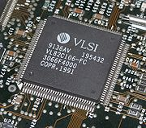

Structured VLSI design is a modular methodology originated by Carver Mead and Lynn Conway for saving microchip area by minimizing the interconnect fabrics area. This is obtained by repetitive arrangement of rectangular macro blocks which can be interconnected using wiring by abutment. An example is partitioning the layout of an adder into a row of equal bit slices cells.

As we have seen that VLSI is a technology by which 10000-1 Million Transistors can be fabricated on a single chip.

In olden days during the vacuum tube era, the size of Electronic Devices were huge, required more power, dissipated more amount of heat and were not so reliable. So there was certainly a need to reduce the size of these devices and their heat dissipation. After the invention of SSD's, the size and the heat produced by devices was undoubtedly reduced drastically, but as the days passed the requirement of additional features in Electronic Devices increased which again made the devices look bulky and complex. This gave birth to the invention of technology which can fabricate more number of components onto a single chip. As the need of additional features in Electronic Devices arised,the growth of VLSI Technology has improved.

**Top of Form**

**Advantages of VLSI:**

VLSI has many advantages:

1. Reduces the Size of Circuits.

2. Reduces the effective cost of the devices.

3. Increases the Operating speed of circuits

4. Requires less power than Discrete components.

5. Higher Reliability

6. Occupies a relatively smaller area.

**Uses of VLSI :**

In today's world VLSI chips are widely used in various branches of Engineering like:

* Voice and Data Communication networks
* Digital Signal Processing
* Computers
* Commercial Electronics
* Automobiles
* Medicine and many more.

**NANO TECHNOLOGY:**

Nanotechnology were first discussed in 1959 by renowned physicist Richard Feynman in his talk There's Plenty of Room at the Bottom, in which he described the possibility of synthesis via direct Comparison of Nanomaterials Sizes.

[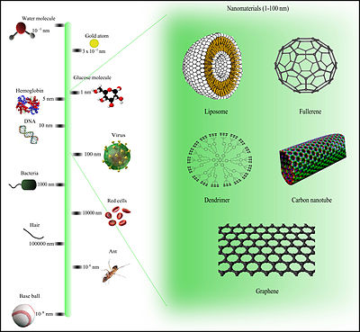](https://en.wikipedia.org/wiki/File:Comparison_of_nanomaterials_sizes.jpg)

Inspired by Feynman's concepts, K. Eric Drexler used the term "nanotechnology" in his 1986 book Engines of Creation: The Coming Era of Nanotechnology, which proposed the idea of a nanoscale "assembler" which would be able to build a copy of itself and of other items of arbitrary complexity with atomic control. Also in 1986, Drexler co-founded The Foresight Institute (with which he is no longer affiliated) to help increase public awareness and understanding of nanotechnology concepts and implications.

Thus, emergence of nanotechnology as a field in the 1980s occurred through convergence of Drexler's theoretical and public work, which developed and popularized a conceptual framework for nanotechnology, and high-visibility experimental advances that drew additional wide-scale attention to the prospects of atomic control of matter. In manipulation of atoms. The term "nano-technology" was first used by Norio Taniguchi in 1974, though it was not widely known.

First, the invention of the scanning tunneling microscope in 1981 which provided unprecedented visualization of individual atoms and bonds, and was successfully used to manipulate individual atoms in 1989. The microscope's developers Gerd Binnig and Heinrich Rohrer at IBM Zurich Research Laboratory received a Nobel Prize in Physics in 1986.[6][7] Binnig, Quate and Gerber also invented the analogous atomic force microscope that year.

[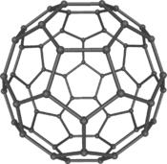](https://en.wikipedia.org/wiki/File:C60a.png)

Buckminsterfullerene C60, also known as the buckyball, is a representative member of the carbon structures known as fullerenes. Members of the fullerene family are a major subject of research falling under the nanotechnology umbrella.

Second, Fullerenes were discovered in 1985 by Harry Kroto, Richard Smalley, and Robert Curl, who together won the 1996 Nobel Prize in Chemistry.[8][9] C60 was not initially described as nanotechnology; the term was used regarding subsequent work with related graphene tubes (called carbon nanotubes and sometimes called Bucky tubes) which suggested potential applications for nanoscale electronics and devices.

**APPLICATIONS:**

* Medicine
* Food
* Electronics
* Fuel cells
* Solar cells
* batteries

**CONCLUSION:**

VLSI gives circuit designs with high computational speed and less power dissipiation and less circuit board area, with higher speeds and higher reliability at lower costs. VLSI has revolutionized and has a wide range of applications in this electronic industry.

Continued technological advancement, including on the nanoscale, will not automatically make the world any fairer or safer, but it will increase the resources available to those who want to ensure that it is.