**Lab – 3 Ginka Anusha P.no:19960524-2081**

**Procedure:**

* Identifying the required file to analyse, based on the Personal number. (Format YYYYMMDD)
* Clear the work space and load the required file of “.asc”
* Plotting the a with the given data.
* Extracting the parameters of the dataset.
* Plotting the Probability Density Function (PDF) using the extracted parameters from the file.
* Finding the parameters of the dataset.
* Plotting the Complementary Cumulative Distribution Function (CCDF) of the dataset from the extracted parameters.
* Plot the Empirical PDF (EPDF) of the dataset from the extracted parameters.
* Analyse the obtained graphs and identify the type of distribution.

1)For the Identification of the required file to analyse: (**199605024**) mod 3 + 1 = 1

• So, the file is “1.asc”.

**MATLAB Program**:

1. **Clear all the workspace and load the required file by using the following Program.**

clc;

clear all;

close all; a=load('1.asc');

1. **Plot the Probability Distribution Function of the given data.**

a=a/max(a);

x=0:0.001:1;

hist(a,x);

grid;

axis([0 1 0 1000]);

xlabel('Random Variables (x10)');

ylabel('Density (Probability of Occurrence)');

title('Normalized Probability Density

Function');

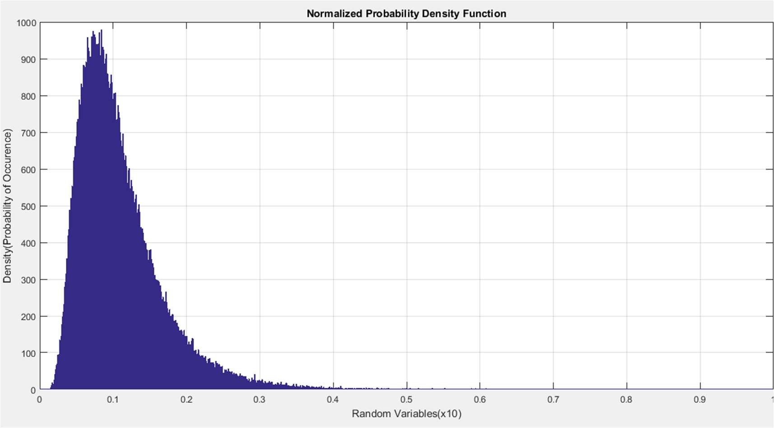

1. **Extraction of the Parameters of the data-set and Plot the PDF using the extracted Parameters**.

moments=lognfit(a);

pdflog=lognpdf(x,moments(1),moments(2));

figure,plot(pdflog),grid;

title('The PDF graph Random Variable Simulated with the parameters extracted

from the Distribution');

xlabel('Random Variable');

ylabel('Probability');

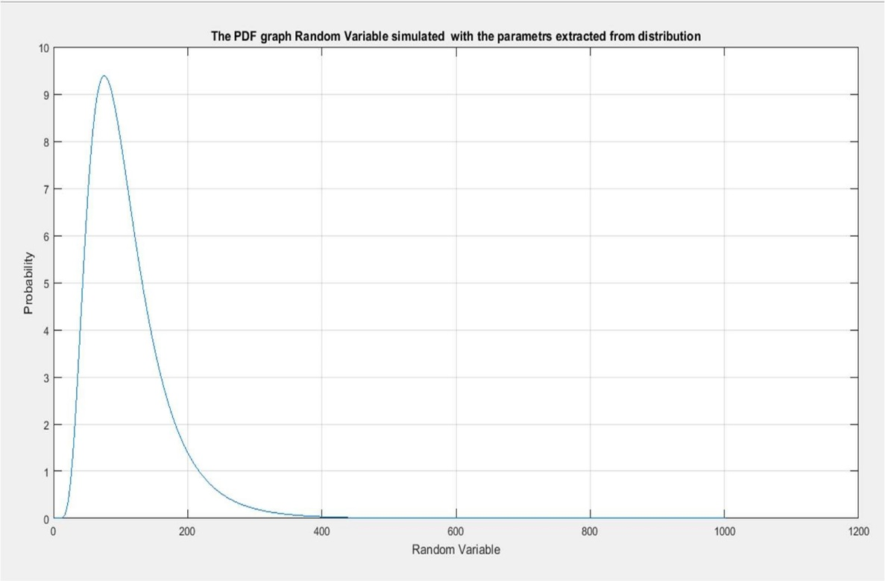

1. **Finding the parameters of the Data-Set**

fprintf('The Mean of the data-set is = %d\n',moments(1));

fprintf('The Standard Deviation of the data-set is = %d\n',moments(2));

**Result for the above:**

* + The Mean of the data-set is = -2.342696e+00
  + The Standard Deviation of the data-set is = 5.018774e-01

1. **Plotting the Cumulative CDF of the Data-set from the extracted parameters** ccdflog=1-logncdf(x,moments(1),moments(2));

figure,plot(ccdflog);

grid;

title('The CCDF graph of Random Variable Simulated with the parameters

extracted from the Distribution');

xlabel('Random Variable');

ylabel('Probability');

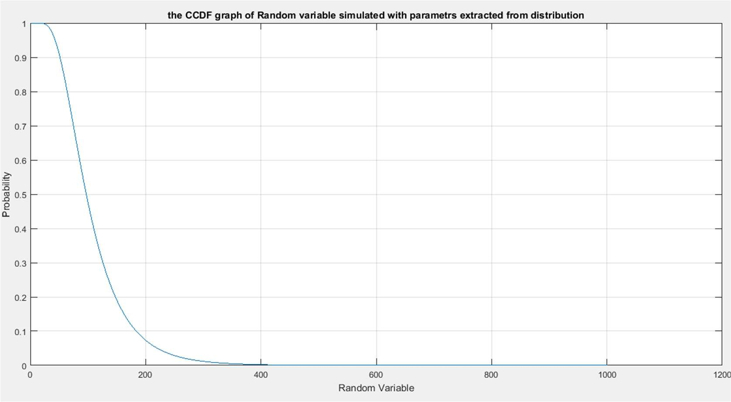

1. **Plotting the Empirical CDF of the Data-set from the extracted parameters.**

figure, ecdf(a);

grid;

title('The ECDF graph of Random Variable');

xlabel('Random Variable');

ylabel('Probability');

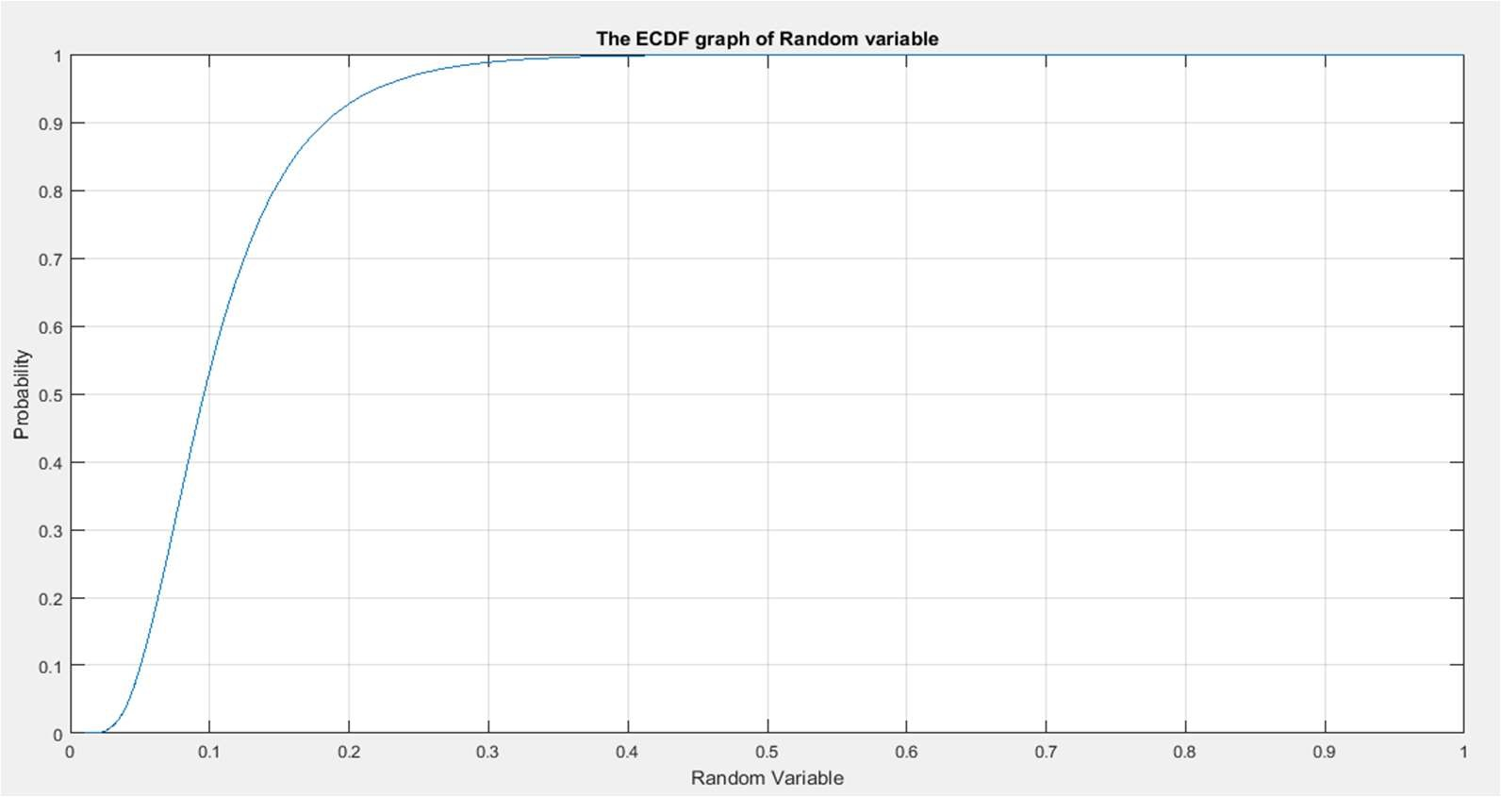

Conclusion drawn from above observations:

* The above given data set follows Log-Normal Distribution.