**Project: Data Wrangling of OpenStreetMap Data**

**By: Chaitanya Narayanavaram**

**Area Chosen: Houston, TX**

Reason: I chose this area because I have been living in Houston since 2 years and been going to school here.

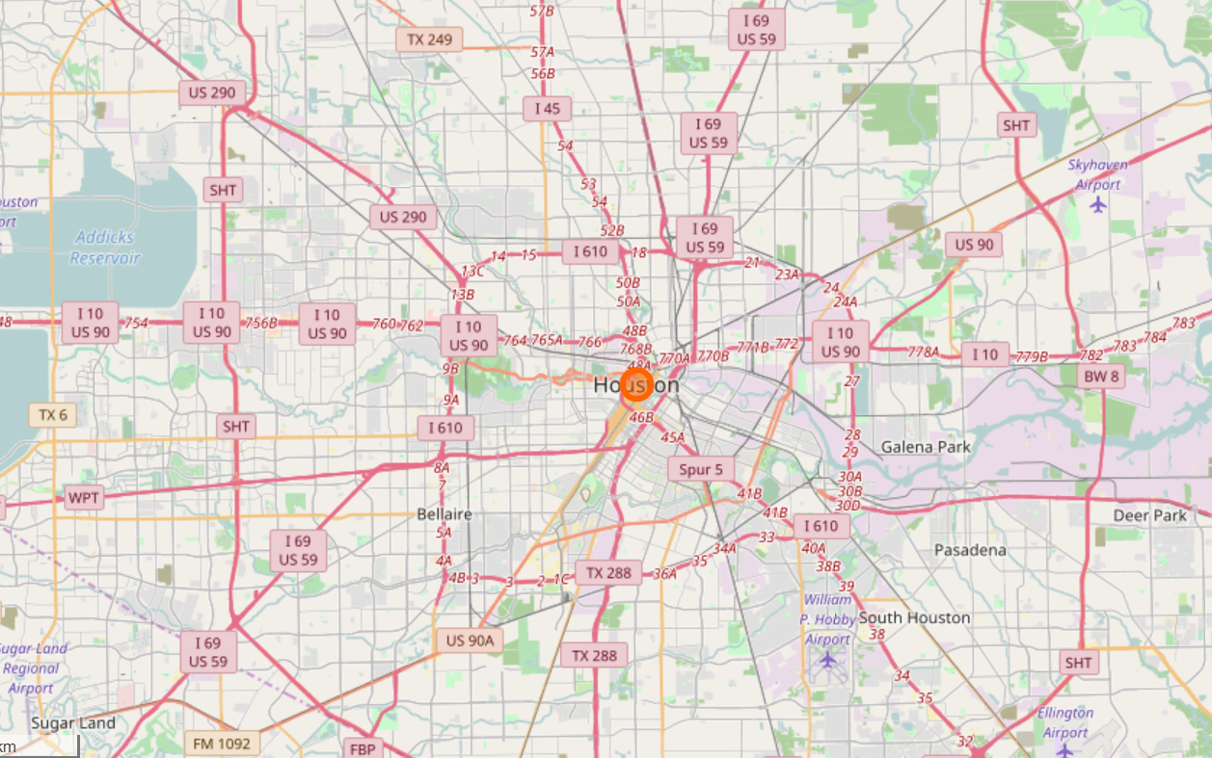

**Project Summary:**

In this project I audit, clean and load data of OpenstreetMap data (Houston, TX area) into MongoDB and then write queries to explore the data in the database.

**Analyzing the osm file**

First, I create a smaller sample of the original osm file in order to make it easier to iterate on my investigation.

**Analyzing the tags:**

{'bounds': 1,

'member': 27102,

'nd': 3621612,

'node': 3028397,

'osm': 1,

'relation': 2462,

'tag': 2087714,

'way': 367024}

These are the different tags and the number of times they occur in the osm file.

**Tag Patterns:**

Now I check the type of values present for the attribute ‘k’ in the tags. By type, I mean I categorize the values into 3 categories: lower case characters and are valid, lower case characters with colon in it, and problematic characters.

Tags Patterns are:

{'lower': 892280, 'lower_colon': 1141166, 'other': 54265, 'problemchars': 3}

**Analyzing the key values in the tags:**

Below we can see what are the keys that occur in tags and how many times each of them occur.

'addr:city': 4567,

'addr:country': 289,

'addr:full': 3,

'addr:housename': 29,

'addr:housenumber': 2935,

'addr:inclusion': 20,

'addr:interpolation': 20,

'addr:postcode': 2315,

'addr:state': 4220,

'addr:street': 2848,

'addr:street_1': 1,

'addr:unit': 3,

These are just a few entries from the result. I have shown only the ones that start with ‘addr’ as I am only interested in auditing them.

**Problems in Data**

**Street names:**

* Abbreviations in street names like Dr, Blvd, Pkwy, Fwy need to be corrected (Eg: Dr -> Drive, Blvd -> Boulevard)
* Abbreviations like E,W,N,S need to be cahnged to East, West, North, South respectively
* All upper and lower case names need to be changed to camel case to maintain consistency
* Names with Farm-to-Market Road needs to be changed to "FM" to maintain consistency

**City Names:**

* There are a few entries that have 'Tx'/'Texas' following the city name. This has to be corrected (we will only retain the city name)
* There is one entry 'Galveston Island' which has to be changes to 'Galveston' to maintain consistency.
* The first entry '77386' seems to be a pincode value which is erroneously present here. This needs to be removed.
* 'TEXAS CITY' should be changed to 'Texas City' to maintain consistency.
* 'West University' and 'West University Place' refer to the same area. So, 'West University' should be changed to 'West University Place' to maintain consistency.
* 'Sugarland' and 'Sugar Land, TX' should be changed to 'Sugar Land' to maintain consistency as they refer to the same place.
* 'clear lake shores' should be changed to 'Clear Lake Shores' to maintain consistency as they refer to the same place.

**Country Values:**

All the country names in the tags are correct and consistent. Thus, there is no need to audit this field further.

**House Numbers:**

Some of the house numbers have street names in them. These need to be corrected. For eg: "600 jefferson st" -> "600"

**Postcodes:**

* 73032 belongs to Dougherty, Oklahoma
* 74404 belongs to Montana
* 75057 belongs to Dallas, TX
* 88581 belongs to El Paso, TX

Also, the extensions like 'TX' need to be removed from postcode

**State names:**

{'TEXAS': 1,

'TX': 4051,

'TX - Texas': 1,

'Texas': 73,

'Tx': 79,

'Tx.': 7,

'texas': 3,

'tx': 5}

All of the values have to be changed to 'TX' (which is the most common) to maintain consistency

**Data Cleaning**

Next, I collect all the incorrect and inconsistent values of each field in respective dictionaries / lists and then clean the data programmatically.

Then, I write the cleaned data to a json file so that it can be imported into MongoDB using mongoimport.

**Data Overview**

**File Sizes:**

* OSM File: 656 MB

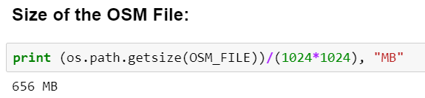

* Sample File: 66 MB

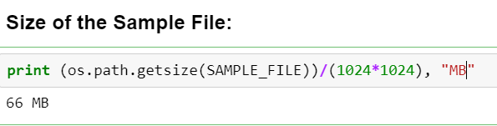

**Other Statistics:**

* Number of documents = 3395421

Number of nodes = 3028394

Number of ways = 367012

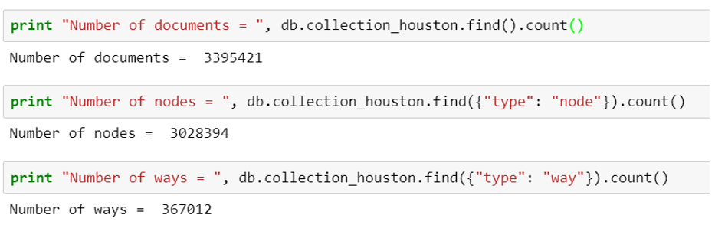

* Number of unique users = 1616

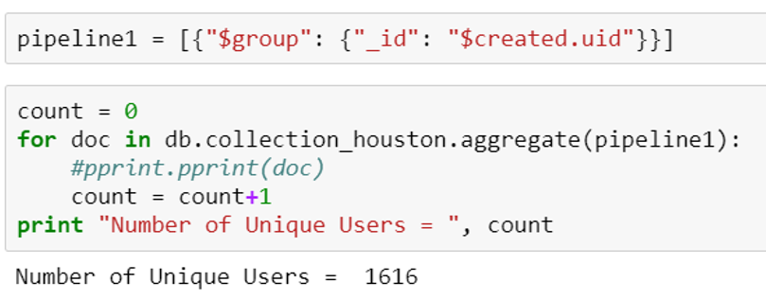

* Top 10 users with most contribution:

{u'_id': u'woodpeck_fixbot', u'number_of_contributions': 568993}

{u'_id': u'TexasNHD', u'number_of_contributions': 538422}

{u'_id': u'afdreher', u'number_of_contributions': 473598}

{u'_id': u'scottyc', u'number_of_contributions': 205104}

{u'_id': u'cammace', u'number_of_contributions': 192887}

{u'_id': u'claysmalley', u'number_of_contributions': 136355}

{u'_id': u'brianboru', u'number_of_contributions': 118529}

{u'_id': u'skquinn', u'number_of_contributions': 86265}

{u'_id': u'RoadGeek_MD99', u'number_of_contributions': 82072}

{u'_id': u'Memoire', u'number_of_contributions': 56661}

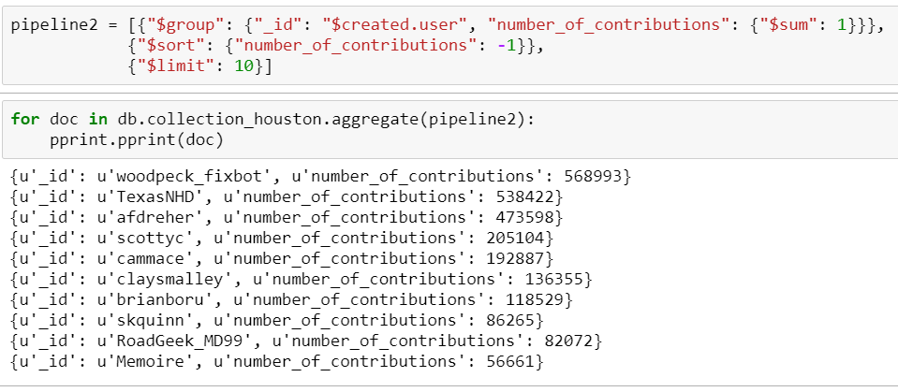

* Top 10 popular cuisines in Houston:

{u'_id': u'burger', u'freq': 383}

{u'_id': u'mexican', u'freq': 156}

{u'_id': u'sandwich', u'freq': 137}

{u'_id': u'chicken', u'freq': 114}

{u'_id': u'pizza', u'freq': 78}

{u'_id': u'american', u'freq': 67}

{u'_id': u'coffee_shop', u'freq': 54}

{u'_id': u'italian', u'freq': 42}

{u'_id': u'chinese', u'freq': 41}

{u'_id': u'seafood', u'freq': 29}

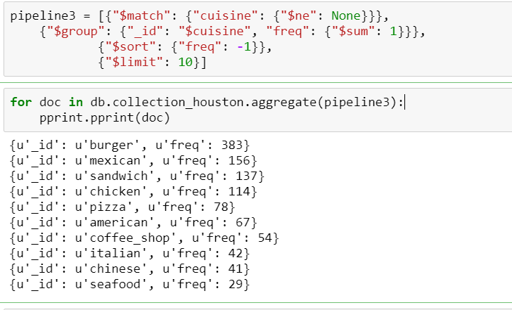

* Top 10 most popular amenities:

{u'_id': u'parking', u'freq': 3786}

{u'_id': u'place_of_worship', u'freq': 2483}

{u'_id': u'school', u'freq': 1726}

{u'_id': u'fast_food', u'freq': 960}

{u'_id': u'restaurant', u'freq': 953}

{u'_id': u'fountain', u'freq': 729}

{u'_id': u'fuel', u'freq': 560}

{u'_id': u'fire_station', u'freq': 401}

{u'_id': u'bank', u'freq': 287}

{u'_id': u'pharmacy', u'freq': 239}

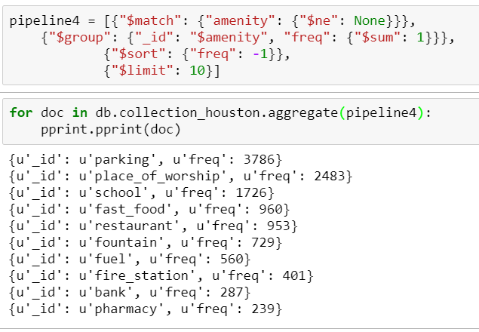

**Conclusion:**

In this project I have identified some errors and inconsistencies in a few fields in the data, especially in the address fields, which I have cleaned. But there are many more fields that need improvement for the data set to be clean.

Over the course of this project I have realized that data cleaning is a very important part and the most time consuming part of a data analyst’s job.

**Suggestions:**

A major problem according to me is lack of consistency. There is a lack of consistency in units, naming conventions and even in attributes.

For eg:

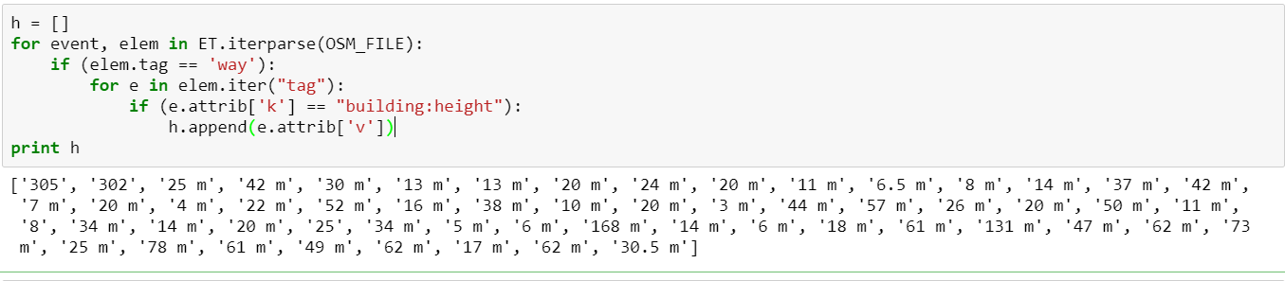

We can see above that ‘m’ is missing in a few entries for building:height. In this case we cant know for sure whether the value is in meters or any other unit.

A classic example of lack of standards in naming conventions is state names.

My suggestion is that there needs to be a gold standard for data entry. Also, the data entered has to be cross-referenced with other reliable data sources. This will lead to the data being highly reliable and ready to use.

Anticipated Problems:

The main problem in implementing this is that most of the users entering data might not like to follow such rigid instructions (gold standards).