**ECE 6370: ROM Homework**

**Chaitanya Narayanavaram**

**PSID: 1446728**

**Memory controller Verilog code:**

// ECE 6370

// Author: Chaitanya Narayanavaram, 6728.

`timescale 1ns/10ps

module ROMController(Data_In, Address, Data_Out, Clk, Rst);

input [3:0] Data_In;

output [5:0] Address;

reg [5:0] Address;

output [3:0] Data_Out;

reg [3:0] Data_Out;

input Clk, Rst;

always @(posedge Clk) // One-procedure

begin

if(Rst == 0)

begin

Address <= 0;

end

else

begin

case(Address)

0,1,2,3,4,5,6,7,8,9,10: begin

if(Data_In == 4'b1111) // 1111 (or) 15 is the ending word

begin

Address <= 12;

end

else

begin

Data_Out <= Data_In;

Address <= Address + 1'b1;

end

end

12: begin

Data_Out <= 0;

end

default: begin

Address <= 0;

end

endcase

end

end

endmodule

**Testbench Code:**

// ECE 6370

// Author: Chaitanya Narayanavaram, 6728.

`timescale 1ns/10ps

module MyROMTestbench();

wire [3:0] Data_s;

reg Clk_s, Rst_s;

MyRomTopModule DUT_MyRomTopModule(Clk_s, Rst_s, Data_s);

always

begin

Clk_s = 0;

#10;

Clk_s = 1;

#10;

end

initial

begin

#3 Rst_s <= 0;

@(posedge Clk_s);

#3 Rst_s <= 1;

@(posedge Clk_s);

@(posedge Clk_s);

@(posedge Clk_s);

@(posedge Clk_s);

@(posedge Clk_s);

@(posedge Clk_s);

@(posedge Clk_s);

@(posedge Clk_s);

@(posedge Clk_s);

@(posedge Clk_s);

@(posedge Clk_s);

@(posedge Clk_s);

@(posedge Clk_s);

@(posedge Clk_s);

@(posedge Clk_s);

@(posedge Clk_s);

@(posedge Clk_s);

@(posedge Clk_s);

@(posedge Clk_s);

@(posedge Clk_s);

@(posedge Clk_s);

@(posedge Clk_s);

@(posedge Clk_s);

@(posedge Clk_s);

@(posedge Clk_s);

end

endmodule

**ROM details:**

The ROM that I have chosen has 64 words and each word is 4-bits long.

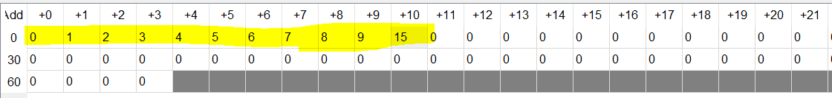

**Waveform:**

