SMART PLANT DISEASE DETECTION AND TREATMENT RECOMMMENDATION SYSTEM
Real Time Project Report
Submitted in partial fulfillment of the requirements for the award of the Degree of

Bachelor of Technology (B.Tech)
In
Department of CSE (Artificial Intelligence & Machine Learning)
By
Methuku Sri Krishna Chaitanya 24AG1A6641
Gadde Janaki Raam 23AG1A6623
Kolipaka Naga Sathwik 23AG1A6633

Under the Esteemed Guidance of
DR. ATUL KUMAR RAMOTRA
Associate Professor
Dept.of CSE(AI&ML)


ACE ENGINEERING COLLEGE
Department of CSE (Artificial Intelligence & Machine Learning)
An Autonomous Institution

(NBA ACCREDITED B.TECH COURSES: EEE, ECE & CSE, ACCORDED NAAC ‘A’ GRADE) Affiliated to Jawaharlal Nehru Technological University, Hyderabad, Telangana,
APRIL 2026

Ghatkesar, Hyderabad – 501 301

 ACE
Engineering College
An Autonomous Institution
(NBA ACCREDITED B.TECH COURSES: EEE, ECE & CSE, ACCORDED NAAC ‘A’ GRADE)
(Affiliated to Jawaharlal Nehru Technological University, Hyderabad, Telangana)
Ghatkesar, Hyderabad – 501 301
Website : www.aceec.ac.in E-mail: info@aceec.ac.in

CERTIFICATE
This is to certify that the Real Time Project work entitled Smart Plant Disease Detection and Treatment Detection is being submitted by Methuku Sri Krishna Chaitanya (23AG1A6641), Gadde Janaki Raam(23AG1A6623), Kolipaka Naga Sathwik (23AG1A6633) in partial fulfillment for the award of Degree of BACHELOR OF TECHNOLOGY in DEPARTMENT OF CSE (ARTIFICIAL INTELLIGENCE & MACHINE LEARNING) to the Jawaharlal Nehru Technological University, Hyderabad during the academic year 2025-26 is a record of bonafide work carried out by them under our guidance and supervision.
The results embodied in this report have not been submitted by the student to any other University or Institution for the award of any degree or diploma.

Internal Guide Head of the Department
DR. ATUL KUMAR RAMOTRA Dr. KAVITHA SOPPARI
Associate Professor Professor and
Dept. of CSE (AI & ML) Head Dept. of CSE (AI&ML)

ACKNOWLEDGEMENT
We would like to express our gratitude to all the people behind the screen who have helped us transform an idea into a real time application.
We would like to express our heart-felt gratitude to our parents without whom we would not have been privileged to achieve and fulfill our dreams.
A special thanks to our Secretary, Prof. Y.V. Gopal Krishna Murthy, for having founded such an esteemed institution. We are also grateful to our beloved principal, Dr. N. Sudhakar Reddy for permitting us to carry out this project.

We profoundly thank Dr. Atul Kumar Ramotra, Associate Professor of the Department of CSE (Artificial Intelligence & Machine Learning), who has been an excellent guide and also a great source of inspiration to our work.

We extremely thank, Dr. Atul Kumar Ramotra, Associate Professor, Real Time Project coordinator, who helped us in all the way in fulfilling of all aspects in completion of our Real Time Project.

We are very thankful to our Head of the Department Dr. Kavitha Soppari, Professor and Head of the Department of CSE (Artificial Intelligence & Machine Learning),who has been an excellent and also given continuous support for the completion of our Real Time Project work.

The satisfaction and euphoria that accompany the successful completion of the task would be great, but incomplete without the mention of the people who made it possible, whose constant guidance and encouragement crown all the efforts with success. In this context, we would like to thank all the other staff members, both teaching and non-teaching, who have extended their timely help and eased our task.

Methuku Sri Krishna Chaitanya (24AG1A6641)
Gadde Janaki Raam (24AG1A6623)
Kolipaka Naga Sathwik (24AG1A6633)

DECLARATION

This is to certify that the work reported in the present project titled “SMART PLANT DISEASE DETECTION AND TREATMENT RECOMMENDATION SYSTEM” is a record work done by us in the Department of CSE (Artificial Intelligence & Machine Learning), ACE Engineering College.

No part of the thesis is copied from books/journals/internet and whenever the portion is taken, the same has been duly referred in the text; the reported are based on the project work done entirely by us not copied from any other source.

Methuku Sri Krishna Chaitanya (24AG1A6641)
Gadde Janaki Raam (24AG1A6623)
Kolipaka Naga Sathwik (24AG1A6633)

ABSTRACT

Plant diseases significantly affect agricultural productivity and lead to major economic losses worldwide. Traditional disease detection methods rely on manual inspection by experts, which is time-consuming, labor-intensive, and often inaccessible to farmers.
This project aims to develop a Smart Plant Disease Detection and Treatment Recommendation System using machine learning techniques. The system processes plant leaf images through image processing methods to extract relevant features and employs a deep learning model for accurate disease classification.
After identifying the disease, the system provides suitable treatment recommendations
efficient, cost-effective, and user-friendly, enabling early disease detection and supporting farmers in making informed decisions. Ultimately, this system contributes to improving crop health, productivity, and the advancement of smart agriculture.

CONTENTS | PAGE NO
1. INTRODUCTION | 1
1.1. Leveraging Advanced Technologies | 2
1.2. Significance of Feedback Systems | 2
1.3. Challenges and Opportunities | 3
1.4. Existing System | 3
1.5. Proposed System | 4
2. LITERATURE-SURVEY | 5
2.1. About the Project | 5
2.2. Literature Review | 5
3. SYSTEM REQUIREMENTS | 10
3.1. Hardware Requirements | 10
3.2. Software Requirements | 10
4. SYSTEM ARCHITECTURE | 11
4.1. System Architecture  4.2. System Module | 11  12
5. SYSTEM DESIGN | 13
5.1. Introduction to UML | 13
5.2. UML Diagrams | 13
5.2.1 Class Diagram | 14
5.2.2 Use case Diagram | 15
5.2.3 Activity Diagram | 16
5.2.4 Sequence Diagram | 17
5.2.5 State Chart Diagram | 18
5.2.6 Object Diagram | 19
INDEX
5.2.7 Deployment Diagram | 20
5.2.8 Component Diagram | 21
5.2.9 Collaboration Diagram  5.3 Algorithm | 22  23
6. IMPLEMENTATION | 25
6.1 app.py | 25
6.2 history.ts | 34
6.3 plant_disease_model.h5 | 37
6.4 Dataset sample | 43
6.5 Final output | 46
7. TESTING | 48
7.1 Introduction to Testing | 48
7.2 Types of Testing | 48
7.2.1 Unit Testing | 48
7.2.2 Integration Testing | 49
7.2.3 System Testing | 49
7.2.4 Acceptance Testing | 49
7.2.5 Performance Testing | 50
7.3 Test Plan | 50
7.3.1 Objectives | 50
7.3.2 Scope | 51
7.3.3 Test Approach  7.4 Test Case | 51  51
8. FUTURE ENHANCEMENT AND CONCLUSION | 58
8.1 Future Enhancement | 58
8.2 Conclusion | 59
9. REFERENCES | 60

LIST OF FIGURES

Fig. No. | Figure Name | Page No.
4.1 | System Architecture Diagram | 11
4.2 | System Module | 12
5.1 | Class Diagram | 14
5.2 | Use Case Diagram | 15
5.3 | Activity Diagram | 16
5.4 | Sequence Diagram | 17
5.5 | State Chart Diagram | 18
5.6 | Object Diagram | 19
5.7 | Deployment Diagram | 20
5.8 | Component Diagram | 21
5.9 | Collaboration Diagram | 22
6.1 | Main Page | 44
6.2 | Uploaded Files | 44
6.3 | Result Page | 45
6.4 | History | 45
7.1 | Invalid Testcase1 | 49
7.2 | Invalid Testcase2 | 49
7.3 | Valid Testcase | 51

LIST OF TABLES

Table No | Table Name | Page No
1 | Test Cases | 54

CHAPTER 1

INTRODUTION

Plant diseases pose a serious threat to global agriculture, affecting crop productivity, food quality, and farmers’ livelihoods. Early detection and proper diagnosis of plant diseases are essential for preventing the spread of infections and ensuring healthy crop production. Traditionally, plant disease detection relies on manual inspection by farmers or agricultural experts who observe visible symptoms on plant leaves. However, this method can be time-consuming, requires expert knowledge, and may lead to inaccurate diagnosis due to human error, environmental conditions, or lack of experience.
To overcome these challenges, researchers and developers have started using Machine Learning (ML) and Deep Learning (DL) techniques to develop automated plant disease detection systems. These systems analyze plant leaf images using advanced algorithms to identify disease patterns such as discoloration, spots, or abnormal textures. By using Convolutional Neural Networks (CNNs), especially efficient architectures like MobileNetV2, the system can learn complex visual features and accurately classify plant diseases from images.
Automated plant disease detection systems provide several advantages such as faster diagnosis, improved accuracy, and scalability. Farmers can simply upload or capture an image of a plant leaf, and the system can instantly predict whether the plant is healthy or affected by diseases such as Early Blight or Late Blight. This allows farmers to take timely preventive actions and apply appropriate treatments, reducing crop damage and improving agricultural productivity.
Furthermore, integrating such systems into user-friendly web applications allows easy accessibility for farmers, researchers, and agricultural experts. The system can also maintain prediction history and provide information about the causes and treatments of detected diseases, enabling better understanding and effective disease management.
Despite the significant progress made in this area, challenges still remain. These include improving model accuracy, handling variations in lighting and image quality, ensuring robustness across different plant species, and providing reliable treatment recommendations. Researchers continue to explore advanced deep learning models, transfer learning techniques, and larger datasets to enhance the performance of plant disease detection systems.
The potential benefits of automated plant disease detection systems are significant, including:
- Improved accuracy and early detection: Deep learning models can identify disease patterns with high precision, helping farmers detect diseases at an early stage.
- Time and labor efficiency: Automated systems reduce the need for manual inspection and expert consultation.
- Better crop management: Farmers can take preventive measures and apply treatments quickly.
- Scalability and accessibility: Web-based systems allow easy access for users in different locations.
By utilizing modern deep learning techniques and image processing methods, plant disease detection systems can become a valuable tool in modern agriculture, helping farmers protect crops, increase productivity, and support sustainable farming practices.

1.1 Leveraging Advanced Technologies
This approach involves collecting plant leaf images, preprocessing the images, extracting visual features, and training deep learning models to classify plant diseases. By leveraging technologies such as Convolutional Neural Networks and transfer learning models like MobileNetV2, the system can effectively recognize patterns associated with specific diseases. The model is trained on labeled datasets containing images of healthy and diseased leaves to learn distinguishing characteristics.

These technologies enable efficient and accurate detection of plant diseases with minimal human intervention. The system can quickly analyze images and provide instant predictions along with possible causes and recommended treatments. This reduces manual effort and helps farmers make informed decisions about crop management. Additionally, integrating these technologies into a web-based application allows users to easily upload images and receive results in real time.
1.2 Significance of Feedback Systems
Feedback systems play an important role in automated plant disease detection applications. Providing information about the detected disease, along with its causes and possible treatments,helps users understand the condition of the plant and take appropriate action. This information enables farmers and gardeners to identify problems early and prevent further spread of the disease.
An effective feedback system also improves user experience by presenting results in a clear and structured format. By displaying causes and treatment recommendations, the system acts not only as a diagnostic tool but also as an educational resource. This helps users learn about common plant diseases and adopt better agricultural practices, ultimately improving crop health and productivity.
1.3 Challenges and Opportunities
Although automated plant disease detection systems provide many advantages, they also face several challenges. Variations in lighting conditions, image quality, and background noise can affect the accuracy of predictions. Additionally, different diseases may have similar visual symptoms, making classification more complex. Limited availability of high-quality labeled datasets can also impact model performance.
However, these challenges also create opportunities for further research and improvement. Advances in deep learning, transfer learning, and image processing techniques can help improve the accuracy and robustness of these systems. By expanding datasets and refining model architectures, it is possible to develop more reliable and efficient disease detection solutions.
The adoption of such technologies can significantly benefit agriculture by enabling faster disease diagnosis, improving crop management, and reducing financial losses for farmers. As these systems continue to evolve, they have the potential to transform agricultural practices and support sustainable farming methods.
1.4 EXISTING SYSTEM
Existing plant disease detection methods primarily rely on manual inspection by farmers or agricultural experts. In some cases, traditional image processing techniques and basic machine learning models are used to analyze plant leaf images. These methods often involve extracting features such as color, texture, and shape from images and using classifiers like Support Vector Machines (SVM) or decision trees for disease identification.
While these systems can detect certain diseases, they often struggle with complex visual patterns and variations in real-world conditions. Additionally, manual diagnosis requires expert knowledge and may not always be accessible to farmers in remote areas. Traditional systems also have limitations in scalability and accuracy compared to modern deep learning approaches.
1.5 PROPOSED SYSTEM
The proposed system aims to develop an automated plant disease detection application using deep learning techniques. The system uses a Convolutional Neural Network based on the MobileNetV2 architecture to analyze plant leaf images and classify them into categories such as Healthy, Early Blight, and Late Blight.Users can upload an image of a plant leaf through a web-based interface, and the system processes the image using the trained model to predict the disease. The application then displays the detected disease along with information about its causes and possible treatments. Additionally, the system stores prediction history, allowing users to review previous diagnoses.By leveraging deep learning and user-friendly interfaces, the proposed system provides a fast, accurate, and accessible solution for plant disease detection. This approach helps farmers and agricultural enthusiasts monitor plant health, take timely preventive measures, and improve overall crop productivity.

CHAPTER 2

LITERATURE SURVEY

2.1 ABOUT PROJECT

Plant Disease Detection using Deep Learning aims to develop a system that can accurately and efficiently identify diseases in plant leaves using image analysis. Plant diseases significantly affect crop yield and quality, making early detection and proper treatment essential for sustainable agriculture. Traditional methods of disease detection rely on manual inspection by farmers or agricultural experts, which can be time-consuming, inconsistent, and dependent on expert knowledge.By leveraging Machine Learning and Deep Learning techniques, the system analyzes images of plant leaves and identifies disease patterns such as spots, discoloration, or texture variations. The project involves collecting plant leaf image datasets, preprocessing the images, extracting meaningful features, training deep learning models, and evaluating their performance. The trained model can classify leaf images into categories such as Healthy, Early Blight, and Late Blight.The expected outcomes of the system include accurate disease detection, faster diagnosis, reduced dependency on agricultural experts, and improved crop management practices. The system also provides additional information such as the causes and treatments for detected diseases, helping farmers take preventive actions quickly.This automated approach improves agricultural productivity and reduces crop losses by enabling farmers to detect plant diseases at an early stage. By integrating the system into a user-friendly web interface, users can easily upload leaf images and obtain instant predictions. Overall, the project aims to support smart agriculture by providing an efficient, scalable, and accessible plant disease detection solution.

2.2 LITERATURE REVIEW
[1] Author : Mohanty S.P., Hughes D.P., Salathé M. (2016)
Title: Using Deep Learning for Image-Based Plant Disease Detection
This approach focuses on using deep learning techniques to identify plant diseases from leaf images. The system utilizes Convolutional Neural Networks (CNNs) to automatically learn visual features from plant leaf images without requiring manual feature extraction. The dataset consists of thousands of labeled images of healthy and diseased plant leaves collected from different crops.
During preprocessing, images are resized, normalized, and augmented using techniques such as rotation, flipping, and scaling to increase the diversity of the dataset and improve model generalization. The CNN model is then trained to recognize patterns such as spots, color changes, and irregular textures associated with specific plant diseases.
The trained model can classify plant diseases with high accuracy and can be used to develop automated disease detection applications. This deep learning approach significantly improves the efficiency and reliability of plant disease diagnosis compared to traditional manual inspection methods. It also enables early detection, which helps farmers take timely preventive actions.
[2] Author: Ferentinos K.P. (2018)

Title: Deep Learning Models for Plant Disease Detection and Diagnosis
This study presents the use of deep learning models for detecting and diagnosing plant diseases using leaf images. The system employs various convolutional neural network architectures such as AlexNet, VGGNet, and GoogleNet to classify plant diseases across multiple crop species.
The process begins with collecting a large dataset of plant leaf images, followed by preprocessing steps such as image resizing, noise reduction, and normalization. The CNN models automatically extract important features such as color patterns, edges, and shapes that distinguish healthy leaves from infected ones.
After training, the models are evaluated using performance metrics such as accuracy, precision, and recall. The results demonstrate that deep learning models can achieve very high classification accuracy in plant disease detection tasks.
This approach highlights the potential of deep learning techniques in developing reliable agricultural decision-support systems that help farmers detect diseases early and manage crops effectively.

[3] Author: Too E.C., Yujian L., Njuki S., Yingchun L. (2019)
Title: A Comparative Study of Fine-Tuning Deep Learning Models for Plant Disease Identification
This research explores the use of transfer learning for plant disease detection. Instead of training a model from scratch, pretrained deep learning models such as ResNet, MobileNet, and Inception are fine-tuned using plant leaf datasets.
Transfer learning significantly reduces the training time and computational requirements while maintaining high accuracy. The pretrained models already contain knowledge about general image features, which can be adapted to identify plant disease patterns.
The study demonstrates that lightweight architectures such as MobileNet perform well in real-time applications and mobile environments. These models are particularly suitable for developing agricultural tools that farmers can use through smartphones or web applications.
The research shows that transfer learning can greatly enhance the performance of plant disease detection systems while reducing the need for large training datasets

[4] Author: Brahimi M., Boukhalfa K., Moussaoui A. (2017).
Title: Deep Learning for Tomato Diseases Detection and ClassificationThis approach focuses specifically on detecting diseases in tomato plants using deep learning techniques. The system uses convolutional neural networks to analyze images of tomato leaves and classify them into healthy or diseased categories.The model is trained on a labeled dataset containing images of tomato leaves affected by different diseases. Image preprocessing techniques such as cropping, scaling, and normalization are applied before training. The CNN learns to identify distinctive visual patterns that indicate disease presence.Once trained, the system can automatically classify new images and provide predictions about the disease type. The system demonstrates high accuracy and can assist farmers in detecting diseases such as Early Blight and Late Blight.This research highlights the effectiveness of deep learning techniques in agricultural disease detection and supports the development of automated plant health monitoring systems.

[5] Author: Sladojevic S., Arsenovic M., Anderla A., Culibrk D., Stefanovic D. (2016)

Title: Deep Neural Networks Based Recognition of Plant Diseases by Leaf Image Classification
This research proposes an automated plant disease recognition system using deep neural networks. The system processes plant leaf images and classifies them into different disease categories using CNN architectures.The process involves several stages including image acquisition, preprocessing, feature extraction, and classification. The deep neural network automatically learns relevant features such as leaf color variations, spot patterns, and texture differences that indicate plant diseases.The trained model is capable of recognizing multiple plant diseases with high accuracy and can be integrated into real-time agricultural applications. This approach demonstrates the effectiveness of deep learning models in improving plant disease diagnosis and supporting precision agriculture.The study concludes that automated disease detection systems can significantly reduce the workload of farmers and agricultural experts while providing accurate and timely information about plant health.

CHAPTER 3

SYSTEM REQUIREMENTS

3.1 HARDWARE REQUIREMENTS
- Processor: Intel Core i5 or above
- RAM: 8 GB or higher
- Storage: 500 GB

3.2 SOFTWARE REQUIREMENTS
- Operating System: 64-bit Windows 10 / Windows 11 or Linux (Ubuntu)
- Languages: Python 3.x
- Libraries: TensorFlow ,OpenCV
- Tools: Visual Studio Code, Jupyter Notebook or Eclipse

CHAPTER 4
SYSTEM ARCHITECTURE

4.1 System Architecture

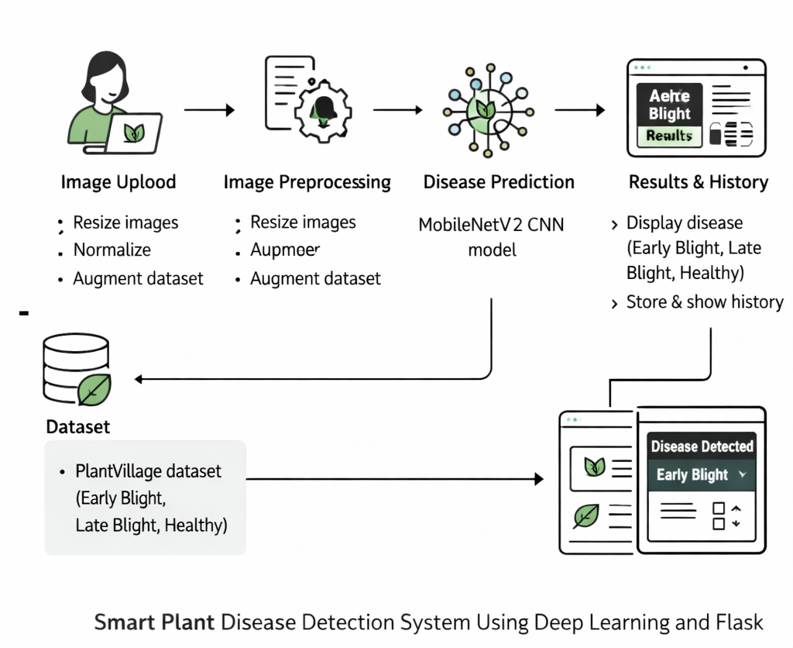

Fig 4.1: System Architecture

The architectural schematic illustrates a comprehensive system for detecting plant leaf diseases using deep learning techniques. The process begins with the User Interface Module, where users upload images of plant leaves through the application. These images are then forwarded to the Image Processing Module, where preprocessing operations such as resizing, normalization, and formatting are performed to prepare the images for analysis. The processed images are then passed to the Deep Learning Model Module, which uses a trained Convolutional Neural Network (CNN) based on the MobileNetV2 architecture to analyze visual patterns and identify potential diseases.
After analysis, the output is sent to the Prediction Module, which classifies the leaf image into categories such as Healthy, Early Blight, or Late Blight. The prediction results are then forwarded to the Result Display Module, where the detected disease, along with its causes and treatment suggestions, is presented to the user in a clear and structured format. Additionally, the system interacts with a Disease Information Database, which stores detailed descriptions, causes, and treatment methods for each disease category.
Finally, the detected results are saved in the History Module, allowing users to review previously analyzed images and predictions. This architecture ensures efficient image processing, accurate disease detection, and user-friendly result presentation, enabling farmers and researchers to quickly identify plant diseases and take appropriate corrective measures. The system ultimately supports better crop health management and contributes to improved agricultural productivity.
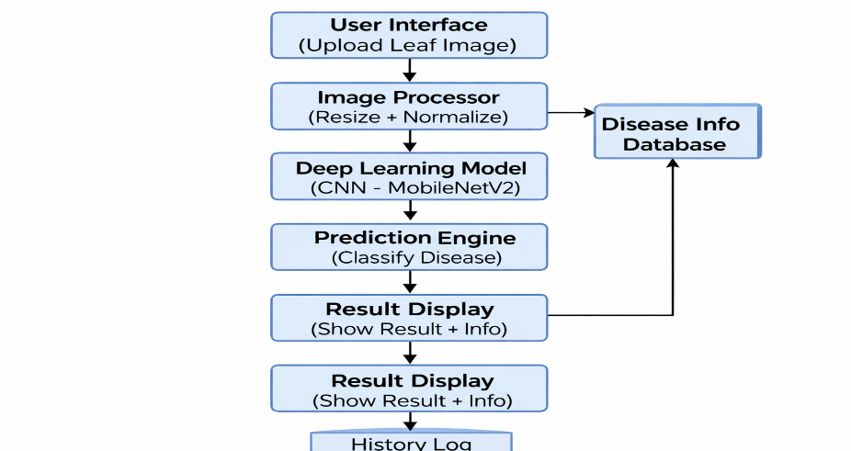
Fig:4.2 System module
An architectural model in software is a detailed and structured diagram that follows established standards, primarily focused on representing a set of trade-offs within the design and structure of a system or ecosystem. Software architects use these models to effectively communicate their design decisions and gather feedback from peers and stakeholders. The architectural model acts as a representation of a viewpoint within the software architecture.

CHAPTER 5
UML DIAGRAMS

5.1 INTRODUCTION TO UML
The Unified Modelling Language (UML) offers software engineers a standardized approach to visually represent an analysis model, governed by a set of rules that ensure proper syntax, semantics, and practicality. A UML system is visualized through unique views, each highlighting a different aspect of the system. These views are outlined as follows:

User Model View
• Focuses on the system from the user's standpoint.
• Describes usage scenarios to showcase how end-users interact with the system.

Structural Model View
• Highlights the static framework of the system.
• Represents internal data and functionality, emphasizing relationships and dependencies among components such as classes and objects.

Behavioural Model View
• Depicts the dynamic nature of the system.
• Illustrates interactions between structural elements, combining insights from the User and Structural Model Views to showcase workflows, object communications, and state changes.

Implementation Model View
• Represents the system's structural and behavioural aspects as they are meant to be implemented.
• Serves as a guide for developers, outlining how the system's components will be constructed.
5.2 UML DIAGRAMS

5.2.1 CLASS DIAGRAM

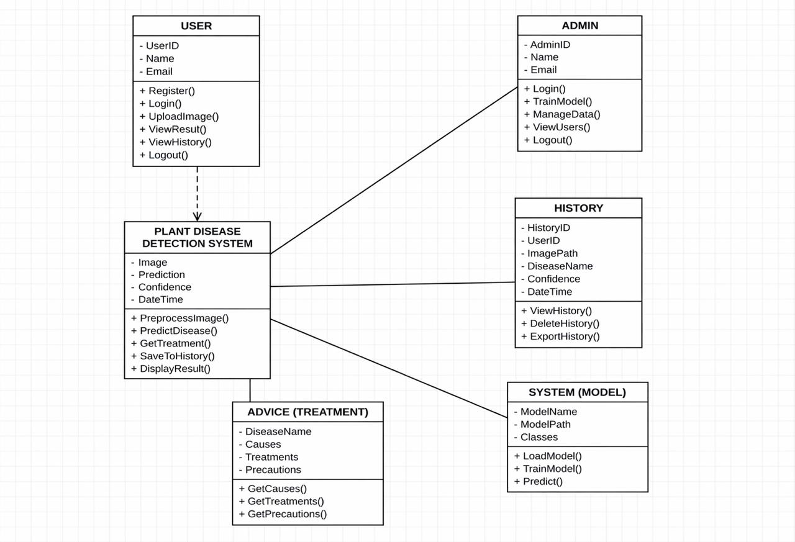
Fig 5.1: Class Diagram

Class diagrams are used to represent the static structure of a system by showing its classes, attributes, operations, and the relationships between objects. These diagrams are essential for understanding how a system is organized and how the different components or classes interact with each other. Class diagrams are foundational in object-oriented modeling and help in both the design and implementation phases.
The key purposes of class diagrams can be outlined as:
• Represent the static structure of the system, detailing the classes and their relationships.
• Illustrate the attributes and operations of each class, helping to define the behavior and data associated with them.

5.2.2 USE CASE DIAGRAM:
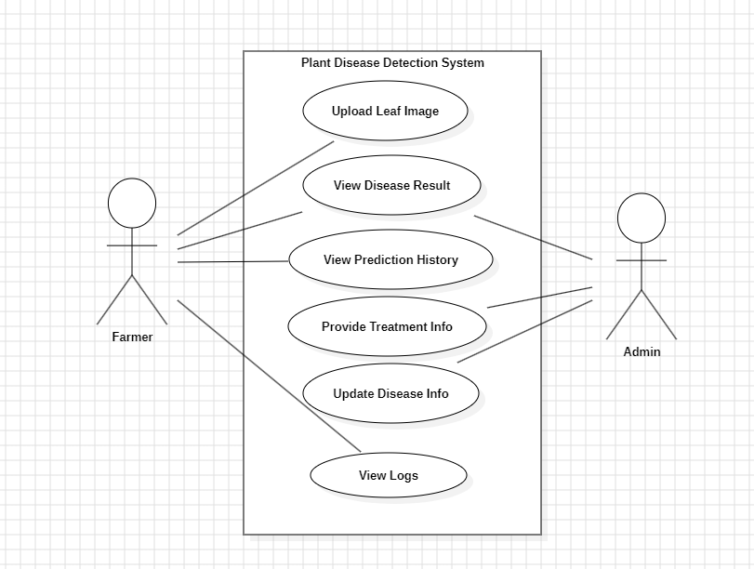

Fig 5.2: Use Case Diagram
When modeling a system, it is crucial to focuson capturing its dynamic behaviour which refers to how the system behaves when it is running or actively functioning. To elaborate, dynamic behavior refers to the system's activities, interactions, and state changes during operation. Use case diagrams play a key role in eliciting requirements for a system, including both internal and external factors that influence the system. These requirements are typically related to thedesign phase of the system. When analysing a system to determine its functionalities, use cases are created, and actors both internal and external are identified.
To summarize, the main purposes of use case diagrams can be described as:
a. To gather the functional requirements of a system.
b. To obtain an external perspective of how the system interacts with its environment.
c. Use case diagrams identify external and internal elements affecting system behavior to clarify interactions and requirements.

5.2.3 ACTIVITY DIAGRAM
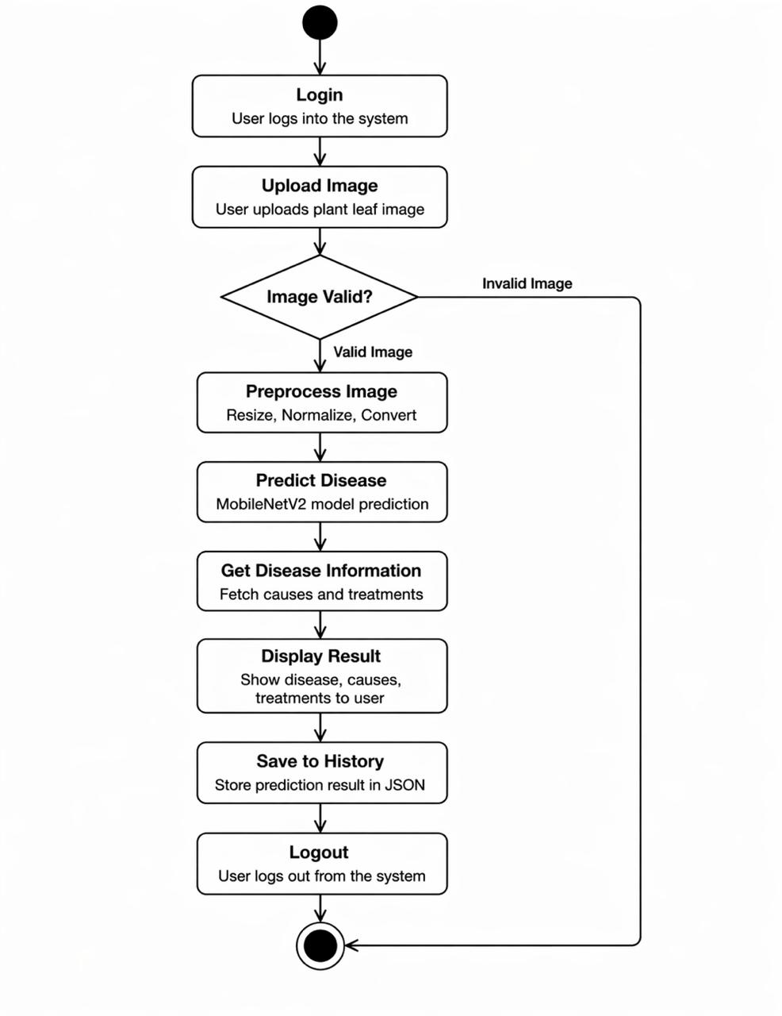
Fig 5.3: Activity Diagram

The activity diagram is another essential diagram in UML used to represent the dynamic behavior of a system. Essentially, the activity diagram functions as a flowchart, illustrating how the system transitions from one activity to another. An activity in this context refers to an operation or task that the system performs.
The key purposes of an activity diagram can be outlined as:
      - Represent the flow of activities within the system.
      - Depict the sequence in which activities occur, from one step to the next.
      - Illustrate parallel, conditional, and concurrent flows, showing how different activities can happen simultaneously or branch off based on conditions.

5.2.4 SEQUENCE DIAGRAM

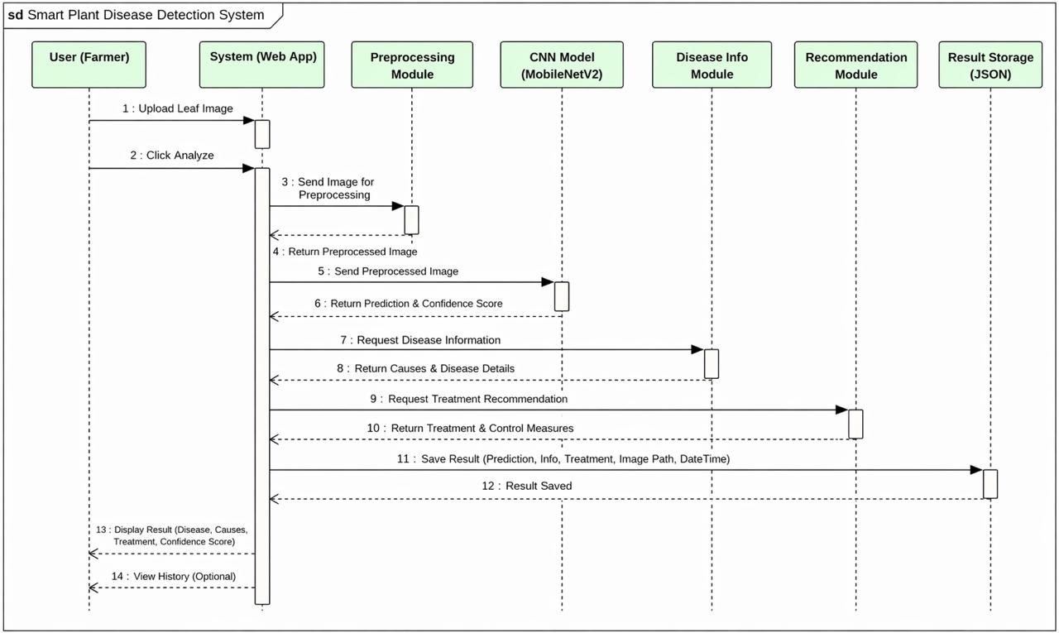
Fig 5.4: Sequence Diagram
Sequence diagrams are used to represent interactions between classes or objects in terms of message exchanges over time. Often referred to as event diagrams, sequence diagrams are highly effective in visualizing and validating various runtime scenarios. They help in understanding how the system will behave during execution and can be instrumental in uncovering the responsibilities that a class should assume when designing a new system.
The primary purposes of sequence diagrams can be summarized as:
- Visualize the interaction flow between objects or classes over time.
- Validate different runtime scenarios, illustrating how the system components collaborate in real-time.
- Assign clear responsibilities to each class or object to fulfill system behavior.

5.2.5 STATE CHART DIAGRAM
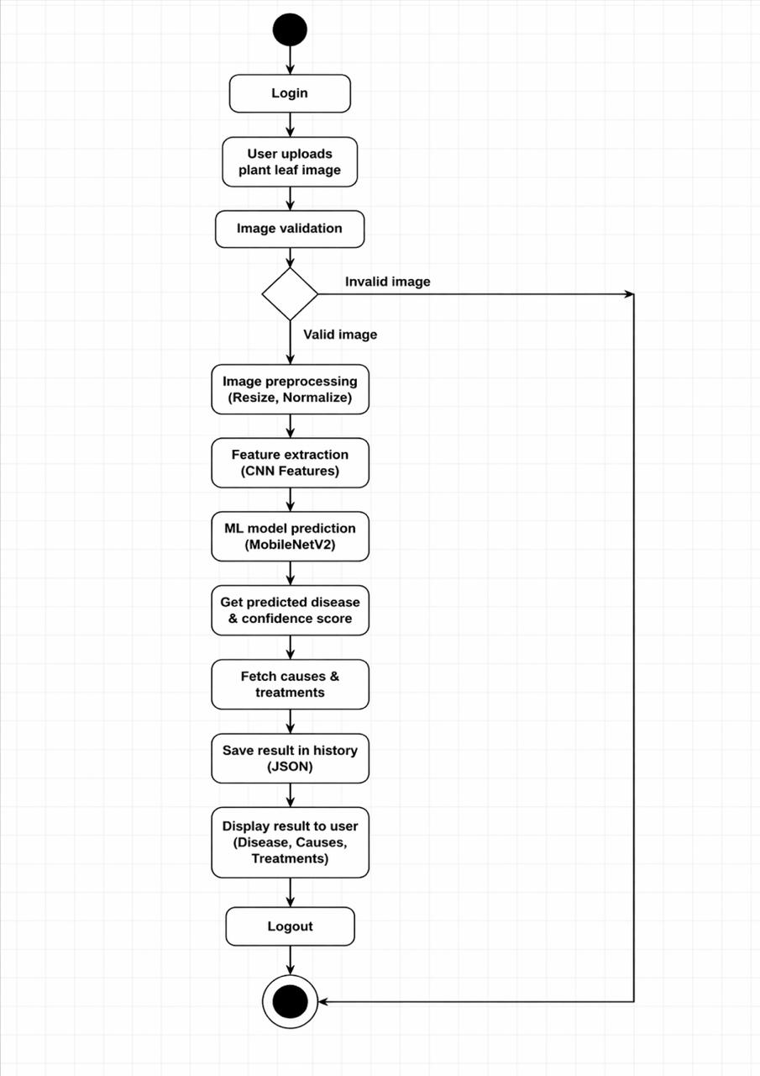
Fig 5.5: State Chart Diagram
Statechart diagrams, also known as state machine diagrams, are used to describe the dynamic behavior of an object in response to different events or stimuli. They show how an object transitions from one state to another based on internal or external events. These diagrams are particularly useful for modeling the lifecycle of an object or an entity, tracking its state changes and how it reacts to different conditions.
The key purposes of state chart diagrams can be summarized as:
- Model the lifecycle of an object, showing how it transitions through various states.
- State transitions represent how an object responds to events by changing its state.

5.2.6 OBJECT DIAGRAM
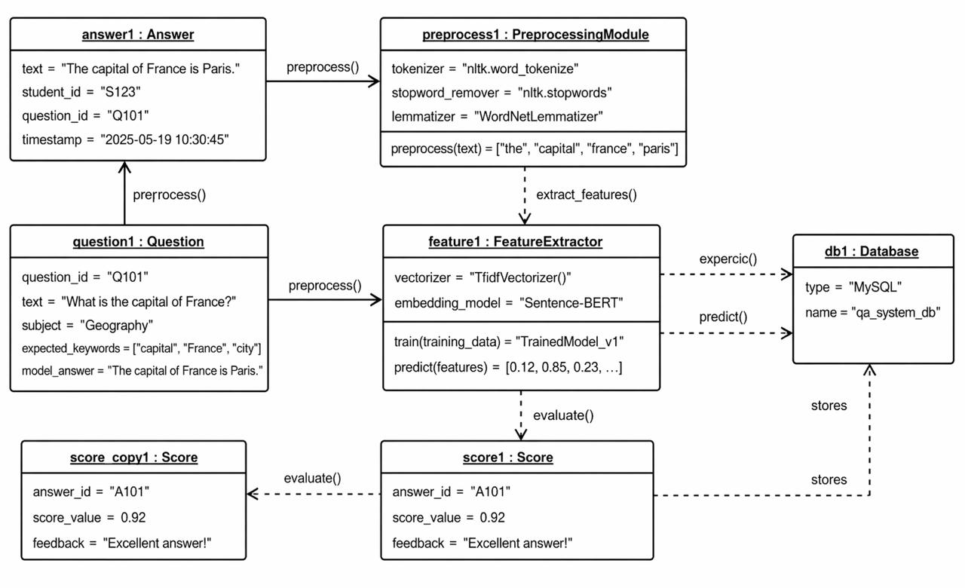
Fig 5.6: Object diagram
An Object Diagram can be referred to as a screenshot of the instances in a system and the relationship that exists between them. Object diagrams are a crucial aspect of UML, providing a snapshot of the instances in a system at a particular moment. They help in visualizing the relationships between objects. An object diagram in UML is useful because it provides a clear and visual representation of specific instances of classes and their relationships at a particular point in time, aiding in understanding and communicating the structure and interactions within a system. In other words, “An object diagram in the Unified Modeling Language (UML), is a diagram that shows a complete or partial view of the structure of a modeled system at a specific time. The use of object diagrams is limited, mainly to show examples of data structures. During the analysis phase of a project, you might create a class diagram to describe the structure of a system and then create a set of object diagrams as test cases to verify the accuracy and completeness of the class diagram.recognition, image classifications which appears to be the complex method.

5.2.7 DEPLOYMENT DIAGRAM
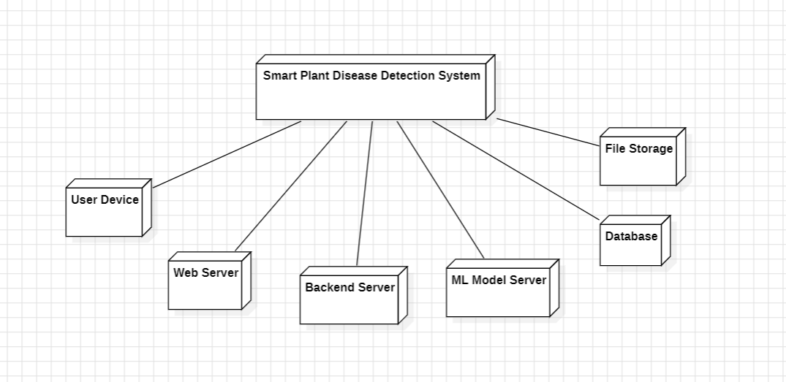
Fig 5.7: Deployment diagram
A UML deployment diagram is a diagram that shows the configuration of run time processing nodes and the components that live on them. Deployment diagrams is a kind of structure diagram used in modeling the physical aspects of an object-oriented system. They are often be used to model the static deployment view of a system (topology of the hardware).
• They show the structure of the run-time system
• They capture the hardware that will be used to implement the system and the links between
different items of hardware.
• They model physical hardware elements and the communication paths between them
• They can be used to plan the architecture of a system.
• They are also useful for Document the deployment of software components or nodes.

5.2.8 COMPONENT DIAGRAM

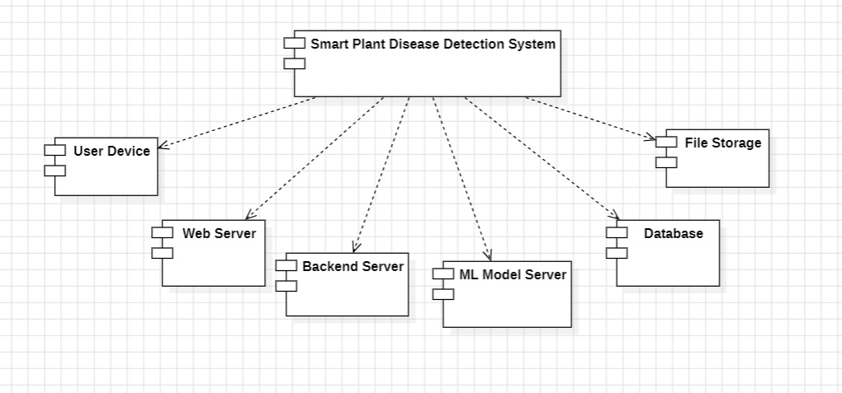
Fig 5.7: Component Diagram
UML Component diagrams are used in modeling the physical aspects of object-oriented systems that are used for visualizing, specifying, and documenting component-based systems and also for constructing executable systems through forward and reverse engineering. Component diagrams are essentially class diagrams that focus on a system's components that often used to model the static implementation view of a system.
• It portrays the components of a system at the runtime.
• It is helpful in testing a system.
• It envisions the links between several connections.

5.2.9 COLLABORATION DIAGRAM
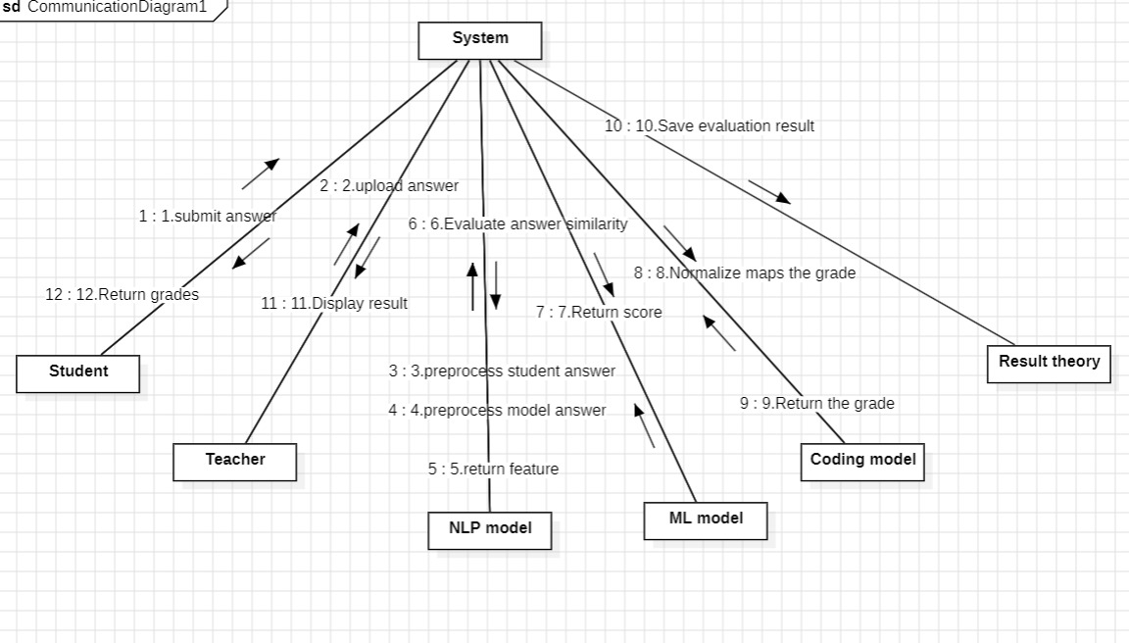
Fig 5.9: Collaboration diagram
Collaboration diagrams (known as Communication Diagram in UML 2.x) are used to show how objects interact to perform the behavior of a particular use case, or a part of a use case. Along with sequence diagrams, collaboration are used by designers to define and clarify the roles of the objects that perform a particular flow of events of a use case. They are the primary source of information used to determining class responsibilities and interfaces.
It mainly puts emphasis on the structural aspect of an interaction diagram, i.e., how lifelines are connected.
• The syntax of a collaboration diagram is similar to the sequence diagram; just the difference is that the lifeline does not consist of tails.
• The messages transmitted over sequencing is represented by numbering each individual message.
• The collaboration diagram is semantically weak in comparison to the sequence diagram.

  - ALGORITHM
1. Technologies Used
- Frontend
- Streanmlit(Python web framework for UI)
- HTML/CSS
- Backend
- Python
- Machine Learning
- TensorFlow (for training and loading deep learning model)
- MobileNetV2 (CNN architecture for image classification)
- Keras (high-level API for building neural networks)
- NumPy (for numerical operations)
- Image Processing Libraries
- JSON – used to store prediction history
- Other Python Libraries
2. How Everything Connects
1.Frontend(Streamlit)
- User opens the web application in their browser.
- User opens the web application in their browser.
- User navigates to the image upload section.
- User selects a plant leaf image to upload.
- User clicks the Analyze button.
- The frontend sends the uploaded image to the backend for processing.
2. Backend (Python + Deep Learning Model)
- The backend receives the uploaded plant leaf image from the frontend.
- The system preprocesses the image by resizing it and converting it into a format suitable for the model.
- The processed image is passed to the trained MobileNetV2 deep learning model.
- The model analyzes the image and identifies patterns related to plant diseases.
- The model predicts the class label such as Healthy, Early Blight, or Late Blight.
- The backend retrieves additional information like causes and treatments related to the detected disease.
- The prediction result is saved in the history file for future reference.
- The backend sends the prediction results back to the frontend.
3. Frontend (Streamlit)
- The frontend receives the prediction results from the backend.
- The system displays the detected disease to the user.
- The system also shows the causes and treatments for the detected disease.
- The user can view previous results through the history section of the application.

CHAPTER 6
CODE IMPLEMENTATION

6.1 app.py
import streamlit as st
import tensorflow as tf
import numpy as np
from PIL import Image
import json
import os
import cv2
# -------- PAGE CONFIGURATION --------
st.set_page_config(page_title="Plant Disease Detector 🌿", layout="wide")
# -------- LOAD MODEL --------
model = tf.keras.models.load_model("model/plant_disease_model.h5")
classes = ["Early Blight","Healthy","Late Blight"]
# -------- HISTORY FILE --------
history_file = "history.json"
if not os.path.exists(history_file):
with open(history_file,"w") as f:
json.dump([], f)
def save_history(result):
with open(history_file,"r") as f:
data = json.load(f)
data.append(result)
with open(history_file,"w") as f:
json.dump(data,f)
def load_history():
with open(history_file,"r") as f:
return json.load(f)
# -------- BLUR DETECTION --------
def is_blurry(image):
img = np.array(image.convert("RGB"))
gray = cv2.cvtColor(img, cv2.COLOR_RGB2GRAY)
variance = cv2.Laplacian(gray, cv2.CV_64F).var()
return variance < 100
# -------- DISEASE INFO --------
disease_info = {
"Early Blight":{
"causes":[
"Fungal infection by Alternaria solani",
"Warm humid weather",
"Overwatering",
"Poor air circulation"
],
"treatment":[
"Remove infected leaves",
"Apply fungicide",
"Improve plant spacing",
"Avoid wet leaves"
]
},
"Late Blight":{
"causes":[
"Phytophthora infestans fungus",
"Cool wet climate",
"High humidity",
"Infected nearby plants"
],
"treatment":[
"Remove infected plants",
"Use fungicide spray",
"Improve drainage",
"Water at soil level"
]
},
"Healthy":{
"causes":[
"No disease symptoms",
"Proper watering",
"Good sunlight",
"Healthy soil nutrients"
],
"treatment":[
"Continue normal care",
"Monitor plant regularly",
"Maintain watering schedule",
"Keep garden clean"
]
}
}
# -------- STYLE (YOUR ORIGINAL BACKGROUND KEPT) --------
st.markdown("""
<style>
.stApp{
background:linear-gradient(
rgba(0,0,0,0.6),
rgba(0,0,0,0.6)
),
url("https://images.unsplash.com/photo-1501004318641-b39e6451bec6");
background-size:cover;
background-position:center;
}
.upload-box{
background:white;
padding:40px;
border-radius:15px;
text-align:center;
}
.result-box{
background:white;
padding:25px;
border-radius:15px;
text-align:center;
margin-top:20px;
}
.info-box{
background:white;
padding:15px;
border-radius:10px;
text-align:center;
margin-top:20px;
}
.box-heading{
color:black;
font-weight:bold;
font-size:22px;
}
.disease-text{
color:black;
font-size:28px;
font-weight:bold;
}
.points{
color:white;
font-size:18px;
margin-left:20px;
}
.history-card{
background:white;
padding:15px;
border-radius:10px;
margin-bottom:10px;
color:black;
font-weight:bold;
}
</style>
""", unsafe_allow_html=True)
# -------- PAGE STATE --------
if "page" not in st.session_state:
st.session_state.page = "home"
# -------- NAVIGATION --------
col1,col2,col3 = st.columns([8,1,1])
with col1:
st.markdown("<h2 style='color:white'>🌿 Plant Disease Detector</h2>", unsafe_allow_html=True)
with col2:
if st.button("🏠 Home"):
st.session_state.page="home"
with col3:
if st.button("📜 History"):
st.session_state.page="history"
# -------- PREDICTION --------
def predict(image):
image = image.resize((224,224))
image = np.array(image)/255.0
image = np.expand_dims(image,axis=0)
prediction = model.predict(image)
confidence = np.max(prediction)
if confidence < 0.7:
return "Invalid Image"

return classes[np.argmax(prediction)]
# -------- HOME PAGE --------
if st.session_state.page=="home":
st.markdown("<h1 style='color:white'>Detect Plant Diseases Instantly 🌱</h1>", unsafe_allow_html=True)
center = st.columns([2,4,2])[1]
with center:
st.markdown('<div class="upload-box">', unsafe_allow_html=True)
file = st.file_uploader("Upload Leaf Image", type=["jpg","png","jpeg"])
if file:
image = Image.open(file)
st.image(image, width=350)
# -------- BLUR CHECK --------
if is_blurry(image):
st.warning("⚠️ Image is too blurry. Please upload a clearer leaf image.")
else:
if st.button("Analyze 🌿"):
result = predict(image)
if result == "Invalid Image":
st.warning("⚠️ Please upload plant leaf image.")
else:
save_history(result)
st.session_state.result = result
st.session_state.page = "result"
st.rerun()
st.markdown('</div>', unsafe_allow_html=True)
# -------- RESULT PAGE --------
elif st.session_state.page=="result":
result = st.session_state.result
st.markdown(f"""
<div class="result-box">
<div class="box-heading">Disease Detected</div>
<div class="disease-text">{result}</div>
</div>
""", unsafe_allow_html=True)
col1,col2 = st.columns(2)
with col1:
st.markdown("<divclass='info-box'><divclass='box-heading'>Causes</div></div>", unsafe_allow_html=True)
for c in disease_info[result]["causes"]:
st.markdown(f"<div class='points'>• {c}</div>", unsafe_allow_html=True)
with col2:
st.markdown("<div class='info-box'><div class='box-heading'>Treatment</div></div>", unsafe_allow_html=True)
for t in disease_info[result]["treatment"]:
st.markdown(f"<div class='points'>• {t}</div>", unsafe_allow_html=True)
# -------- HISTORY PAGE --------
elif st.session_state.page=="history":
st.markdown("<h1 style='color:white'>Prediction History</h1>", unsafe_allow_html=True)
history = load_history()
if len(history)==0:
st.info("No predictions yet")
else:
for item in reversed(history):
st.markdown(f"""
<div class="history-card">
🌿 {item}
</div>
""", unsafe_allow_html=True)
6.2 history.json
This file is used to store the prediction history of the plant disease detection system.
Each time a user uploads a leaf image and the model predicts the disease, the predicted
result is saved in this file. The data is stored in JSON format as a list of disease
names. The Streamlit application reads this file to display the previous predictions
in the History section of the application. This allows users to review earlier analysis
results without re-uploading images.

6.3 plant_disease_model.h5
import tensorflow as tf
from tensorflow.keras.preprocessing.image import ImageDataGenerator
from tensorflow.keras.applications import MobileNetV2
from tensorflow.keras.layers import Dense, GlobalAveragePooling2D
from tensorflow.keras.models import Model
from tensorflow.keras.optimizers import Adam
dataset_path = "dataset"
IMG_SIZE = 224
BATCH_SIZE = 32
datagen = ImageDataGenerator(
rescale=1./255,
validation_split=0.2
)
train_data = datagen.flow_from_directory(
dataset_path,
target_size=(IMG_SIZE, IMG_SIZE),
batch_size=BATCH_SIZE,
class_mode='categorical',
subset='training'
)
val_data = datagen.flow_from_directory(
dataset_path,
target_size=(IMG_SIZE, IMG_SIZE),
batch_size=BATCH_SIZE,
class_mode='categorical',
subset='validation'
)
base_model = MobileNetV2(
input_shape=(IMG_SIZE, IMG_SIZE, 3),
include_top=False,
weights='imagenet'
)
base_model.trainable = False
x = base_model.output
x = GlobalAveragePooling2D()(x)
x = Dense(128, activation='relu')(x)
predictions = Dense(3, activation='softmax')(x)
model = Model(inputs=base_model.input, outputs=predictions)
model.compile(
optimizer=Adam(),
loss='categorical_crossentropy',
metrics=['accuracy']
)
model.fit(
train_data,
validation_data=val_data,
epochs=10
)
model.save("plant_disease_model.h5")
print("Model saved successfully!")

6.4 Dataset Sample
A custom dataset was created for the Plant Disease Detection System using machine learning and image processing techniques. The dataset contains images of plant leaves categorized into three classes: Early Blight, Healthy, and Late Blight. Each image represents a plant leaf sample used to train the model to identify disease patterns.
The images are preprocessed before training by resizing them to a standard size, normalizing pixel values, and organizing them into labeled folders. This preprocessing step helps the model learn important visual features effectively.
A Convolutional Neural Network (CNN) based on the MobileNetV2 architecture is used to extract features from the leaf images and classify them into the appropriate disease category. The model learns patterns such as leaf spots, discoloration, and texture variations associated with plant diseases.
After training, the model generates predictions for new images uploaded by users. The prediction results are displayed through the application interface along with possible causes and recommended treatments for the detected disease.
The prediction history is stored in a JSON file so users can review previous analyses. This system helps in early detection of plant diseases, assisting farmers and gardeners in taking preventive measures and improving crop health.

6.5 Final Output
The user uploads a plant leaf image using the upload option provided in the interface.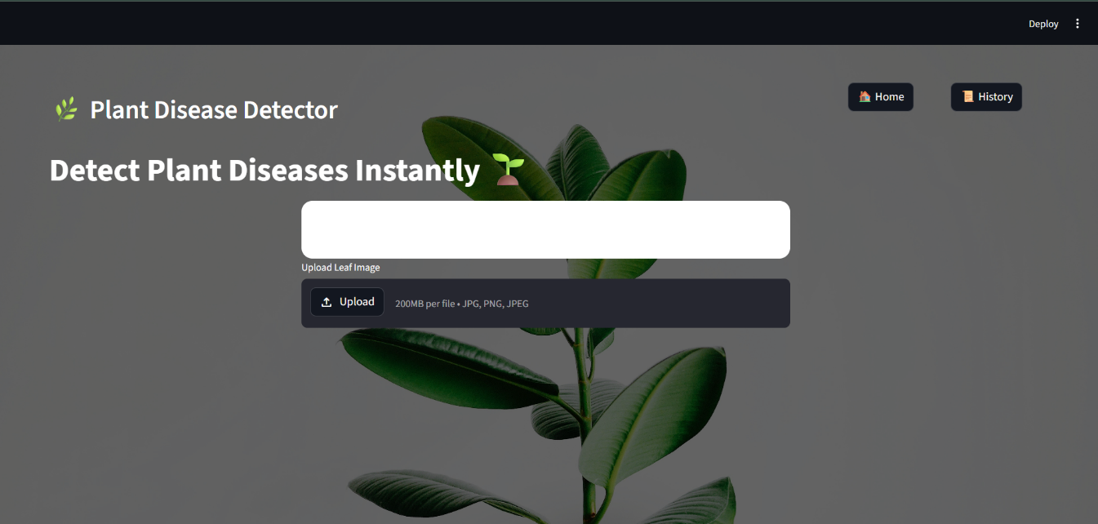

Fig : 6.1 Main page

The user uploads a plant leaf image using the upload option provided in the interface.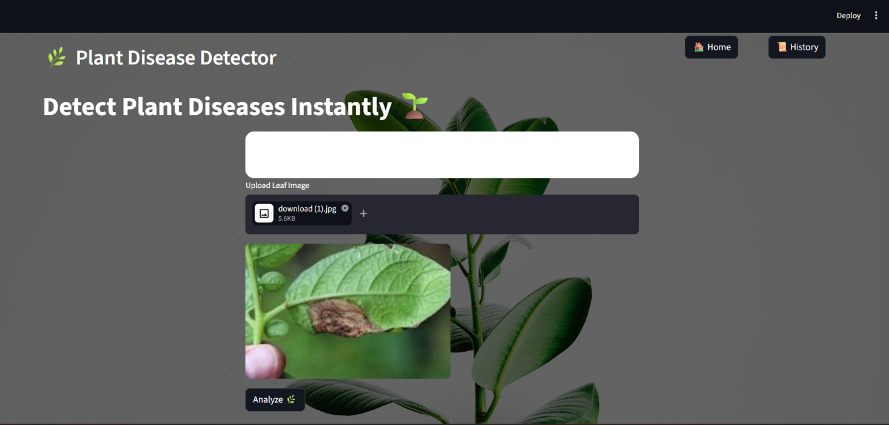
Fig: 6.2 Uploaded files

The system predicts the disease and displays the result along with causes and treatment suggestions.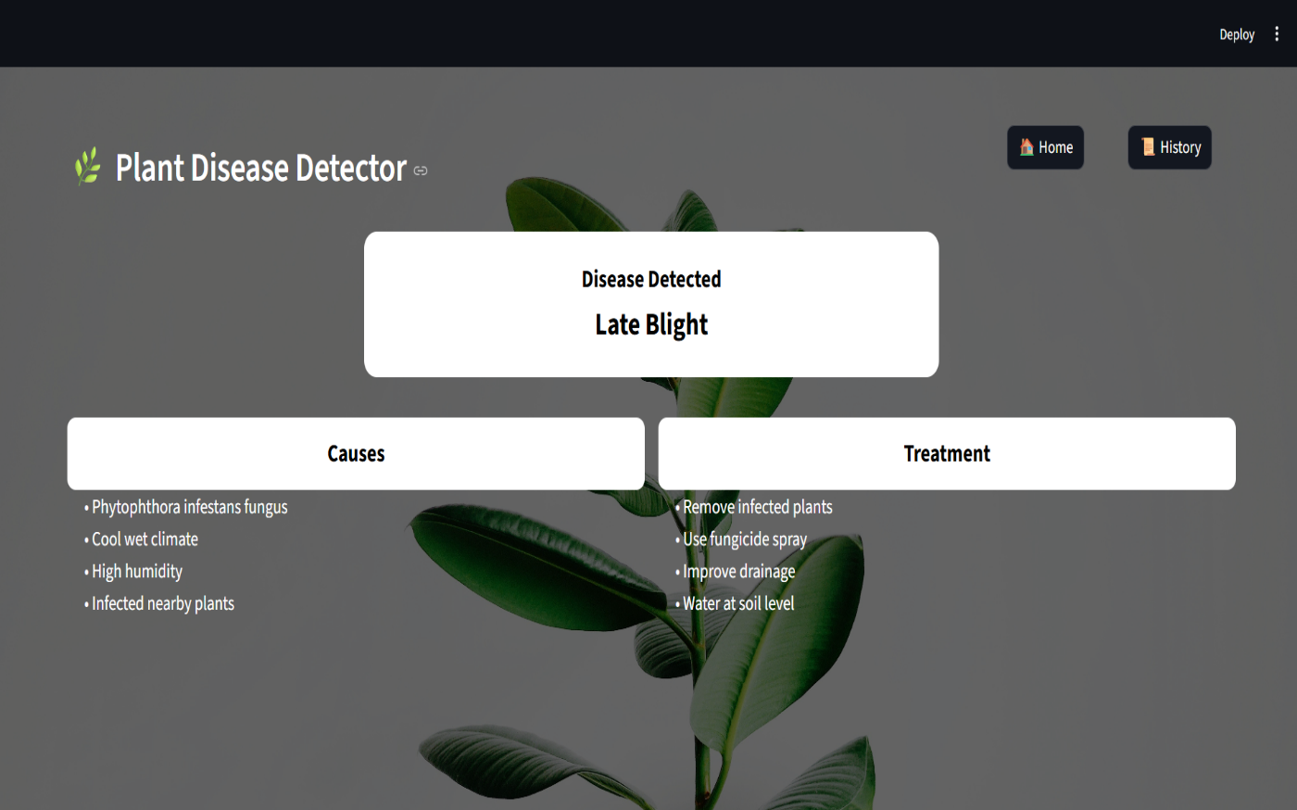
Fig 6.3 Result page

The prediction result is stored in the history section, allowing the user to view previous disease detection results.

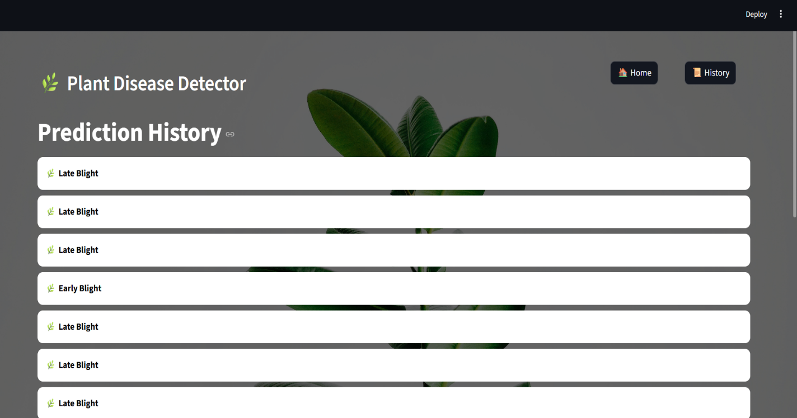
Fig: 6.4 History

CHAPTER 7
TESTING

7.1 Introduction to Testing
Testing aiming to ensure the software meets the specified requirements, performs as expected, and delivers a high-quality user experience. It involves a systematic process of evaluating the software to identify defects, such as bugs, errors, and inconsistencies. Through various testing methods, including unit testing, integration testing, system testing, and acceptance testing, developers and testers can validate the software's functionality, performance, security, and usability. By identifying and addressing issues early in the development lifecycle, testing helps reduce development costs, improve software quality, and increase customer satisfaction. Effective testing strategies involve a combination of manual and automated testing techniques, utilizing appropriate tools and leveraging clear test plans and documentation.
7.2 Types of Testing
7.2.1 Unit Testing
Unit testing is a method of testing individual units or components of a software application. It is typically done by developers as they write the code and is used to ensure that the individual units of the software are working as intended. Unit tests are usually automated and are designed to test specific parts of the code, such as a particular function or method. By isolating individual components, unit tests help developers quickly identify and fix bugs early in the development process. This can significantly reduce the cost and time required to debug and fix issues later in the development cycle.Additionally, unit tests serve as valuable documentation for the code, as they demonstrate how each unit is intended to be used and provide examples of how to call and use the code correctly. A well-written suite of unit tests can also make it easier to refactor code later on, as the tests can be used to verify that the refactored code still behaves as expected
- Tests individual components like image preprocessing and prediction function.
Ensures each small module works correctly on its own
7.2.2 Integration Testing
Integration testing is a crucial stage in software development that focuses on verifying the interactions between different modules or components of an application. It aims to ensure that these units, which have been individually tested during unit testing, work together seamlessly and as expected when combined. This involves testing the interfaces and data exchange between modules, ensuring that they communicate and collaborate correctly to achieve the desired system behavior. Integration testing helps identify and resolve issues that may arise due to unexpected interactions, data inconsistencies, or timing problems between different components. By conducting integration testing, developers can gain confidence that the system as a whole functions reliably and meets the specified requirements.
- Checks if different modules like upload, model, and UI work together.Ensures smooth data flow from image upload to disease result display.

7.2.3 System Testing
System testing is a critical phase in the software development lifecycle where the entire integrated software system is evaluated as a whole to ensure it meets the specified requirements and performs as expected. This stage follows integration testing and precedes acceptance testing. System testing involves a comprehensive set of tests, including functional testing, performance testing, security testing, usability testing, and compatibility testing. It aims to identify and resolve any issues that may arise when the different components of the system interact and operate together. By thoroughly testing the system at this stage, developers can ensure its stability, reliability, and suitability for delivery to end-users.
- Tests the complete application as a full working system.Ensures the plant disease detector works in real real-world conditions.
7.2.4 Acceptance testing
Acceptance testing is a crucial phase in the software development lifecycle where the primary goal is to determine if the software meets the needs and expectations of the end-users. It involves a series of tests conducted by end-users or authorized representatives to evaluate the system's functionality, usability, and overall suitability for deployment. This user-centric approach helps identify issues that may not be apparent to developers, such as usability problems, integration
issues with existing systems, and performance bottlenecks. By involving end-users in the testing process, acceptance testing builds confidence, improves communication, and ultimately ensures that the delivered software meets the business requirements and provides a positive user experience.
- Checks whether the plant disease detection system meets the client’s or user’s requirements.
Ensures the final application is ready for real-world use with correct predictions and smooth UI.

7.2.5 Performance Testing
Performance testing is a crucial aspect of software testing that evaluates the system's behavior under different workloads and conditions. It aims to determine how the system responds to varying levels of stress, such as high traffic, large data volumes, and concurrent user activity. Techniques like load testing, stress testing, and volume testing are employed to simulate real-world scenarios and identify performance bottlenecks, such as slow response times, high resource utilization, and error rates. By conducting performance testing, developers can ensure that the system delivers a satisfactory user experience, can handle expected and unexpected workloads, and maintains stability and reliability under various conditions.
- Checks system speed and response time during image prediction.Ensures fast and efficient processing even with large images.

7.3 Test Plan

7.3.1 Objectives
The primary objective of the testing process is to ensure that the TechLearn Pulse feedback analysis system meets the specified functional and non-functional requirements. It should provide accurate data analysis, secure user data, and deliver insights effectively via visual representations.

7.3.2 Scope
The testing scope includes:
- Functional testing of the feedback collection, analysis, and report generation modules.
- Non-functional testing focusing on performance, usability, and security.
- Compatibility testing across browsers and devices to ensure accessibility.

7.3.3 Test Approach
- Manual and automated testing techniques will be used.
- Tests will cover unit, integration, system, and acceptance testing phases.
7.4 Test Case
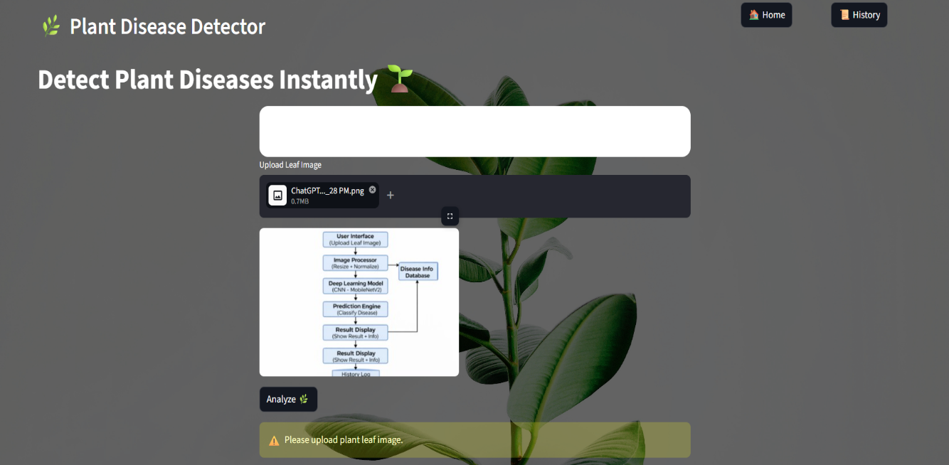
Fig 7.1 Invalid Testcase1
This test case verifies the system’s behavior when no plant leaf image is uploaded in the application. The interface should clearly prompt the user with a message such as “Please upload a clear plant leaf image for disease detection.”

Fig:7.2 Invalid Testcase2
This test verifies the system’s behavior when a user uploads a blurry or out-of-focus plant leaf image. The application should detect low image quality (if supported) or proceed with a warning such as “Image quality is low. Prediction may be inaccurate.”
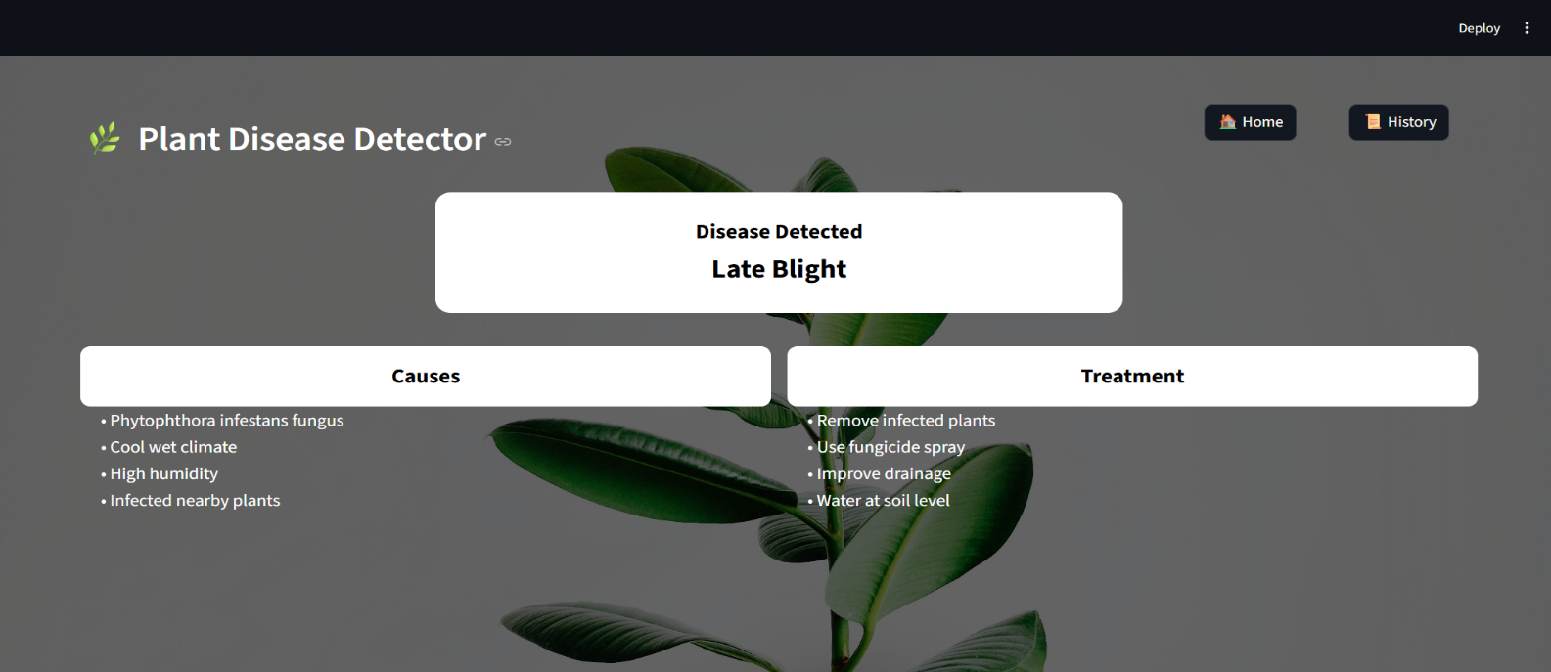
Fig:7.3 Valid Testcase

This test verifies the system’s ability to correctly process a clear and valid plant leaf image for disease detection. The user uploads a well-focused image of a plant leaf in supported formats such as JPG or PNG. The image is successfully processed by the model without triggering blur detection or invalid image warnings. The system should display the predicted result (Early Blight, Late Blight, or Healthy) along with the corresponding causes and treatment information.

Test Id | Objective / Description | Input Data | Expected Output | Actual Output | Status
1 | Ensure system accepts valid plant leaf images for analysis | Upload image of plant leaf (jpg/png) | Image accepted and displayed in application | Image uploaded and displayed correctly | Pass
2 | Verify image preprocessing works correctly | Uploaded plant leaf image | Image resized to required dimensions and normalized | Image processed successfully before prediction | Pass
3 | Check if system predicts plant disease correctly | Image of Early Blight infected leaf | Prediction result: Early Blight | System predicted Early Blight | Pass
4 | Ensure system detects healthy leaves | Image of healthy plant leaf | Prediction result: Healthy | System predicted Healthy correctly | Pass
5 | Verify detection of Late Blight disease | Image of Late Blight infected leaf | Prediction result: Late Blight | System predicted Late Blight | Pass
6 | Ensure system displays causes of detected disease | Predicted disease result | Causes related to detected disease displayed | Causes shown correctly in result page | Pass
7 | Verify treatment suggestions are displayed | Predicted disease result | Treatment recommendations shown | Treatment details displayed correctly | Pass
8 | Check system response for unsupported file format | Upload unsupported file (txt/pdf) | Error message asking for valid image format | Error message displayed correctly | Pass
9 | Ensure prediction history is stored | Perform multiple predictions | Prediction results saved in history | History stored in history.json file | Pass
10 | Verify history page displays previous predictions | Open history page after predictions | List of previous detected diseases displayed | History displayed correctly | Pass
11 | Check system stability with multiple image uploads | Upload several images sequentially | System processes images without crashing | Images processed successfully | Pass
12 | Validate system interface navigation | Navigate between Home, Result, and History pages | Pages load correctly without errors | Navigation worked properly | Pass

CHAPTER 8
FUTURE ENHANCEMENT AND CONCLUSION

8.1 FUTURE ENHANCEMENT
Future enhancements of the Plant Disease Detection System will focus on improving accuracy, usability, and real-world applicability. One important improvement is expanding the dataset to include a wider variety of plant species and additional plant diseases. A larger and more diverse dataset will allow the machine learning model to recognize more disease patterns and improve prediction accuracy.
Another enhancement involves integrating more advanced deep learning models and improving image processing techniques to better detect disease symptoms such as leaf spots, discoloration, and texture variations. This will help the system provide more reliable results even when images are captured under different lighting conditions or from different angles.
The system can also be enhanced by developing a mobile application, allowing farmers and gardeners to easily capture leaf images directly from their smartphones and receive instant disease diagnosis. Integration with cloud-based services could further improve processing speed and enable real-time disease detection.
Additional features such as automatic disease prevention tips, pesticide recommendations, and crop management suggestions can be included to help users take immediate action after detecting a plant disease. The system could also store more detailed analysis history and provide statistical insights about frequently detected diseases.
Future versions may also integrate IoT sensors and environmental monitoring systems to analyze factors such as temperature, humidity, and soil conditions. This would enable early disease prediction and preventive measures before the disease spreads. These enhancements will make the system more intelligent, practical, and beneficial for modern agriculture.

8.2 CONCLUSION
The Plant Disease Detection System using Machine Learning provides an efficient and intelligent solution for identifying plant diseases from leaf images. By utilizing deep learning techniques, the system can automatically analyze plant leaf patterns and classify them into different disease categories such as Early Blight, Healthy, and Late Blight.This approach helps reduce the time and effort required for manual plant disease identification while providing quick and reliable results. The system also provides useful information about the causes and treatments of detected diseases, enabling users to take appropriate preventive actions.The developed application demonstrates how machine learning and image processing can be effectively applied in the agricultural field to support farmers and gardeners in maintaining healthy crops. With further improvements and larger datasets, such systems have the potential to play a significant role in improving crop management and reducing agricultural losses.Overall, the Plant Disease Detection System contributes to smarter and more technology-driven farming practices, helping users detect plant diseases early and maintain better plant health.

CHAPTER 9
REFERENCES
[1] Alex Krizhevsky, Ilya Sutskever, and Geoffrey Hinton (2012). ImageNet Classification with Deep Convolutional Neural Networks. Advances in Neural Information Processing Systems (NIPS).
[2] Mark Sandler, Andrew Howard, Menglong Zhu, and Liang-Chieh Chen (2018). MobileNetV2: Inverted Residuals and Linear Bottlenecks. Proceedings of the IEEE Conference on Computer Vision and Pattern Recognition (CVPR).
[3] Karen Simonyan and Andrew Zisserman (2015). Very Deep Convolutional Networks for Large-Scale Image Recognition. International Conference on Learning Representations (ICLR).
[4] Kaiming He, Xiangyu Zhang, Shaoqing Ren, and Jian Sun (2016). Deep Residual Learning for Image Recognition. IEEE Conference on Computer Vision and Pattern Recognition (CVPR).
[5] Sergey Ioffe and Christian Szegedy (2015). Batch Normalization: Accelerating Deep Network Training by Reducing Internal Covariate Shift. International Conference on Machine Learning (ICML).

