## SYSTEMDESIGN

#### TABLE DESIGN

VARIOUS TABELS TO MAINTAIN INFORMATION

**Doctor Collection From Storage Database:**

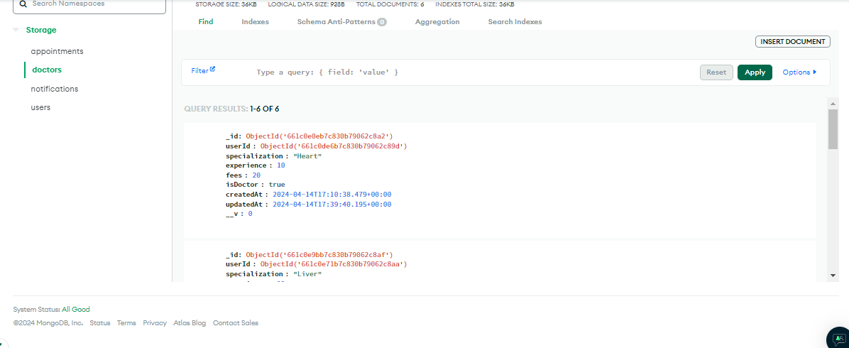

**Notification Collection from Database:**

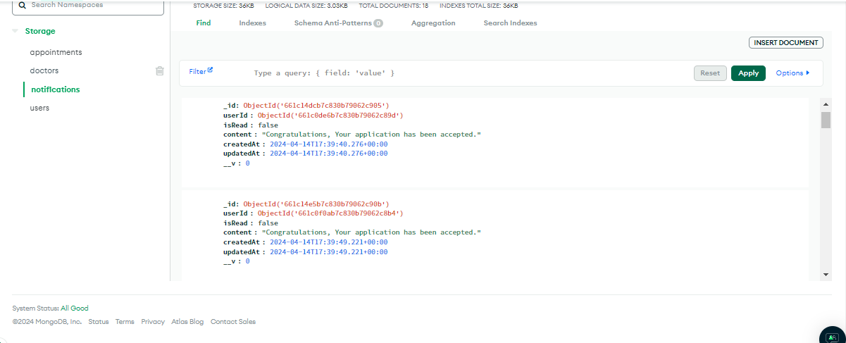

**Users Collection from Database:**

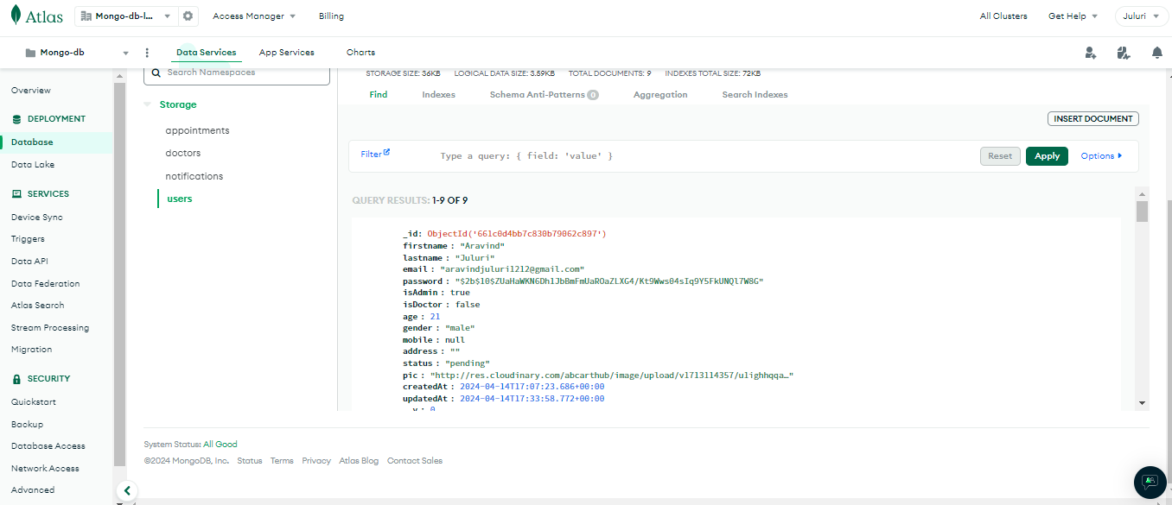

**Doctor Schedule Table from Database**



**3.2 DATA FLOW DIAGRAMS**

**DATA FLOW DIAGRAM FOR ADMIN LOGIN**

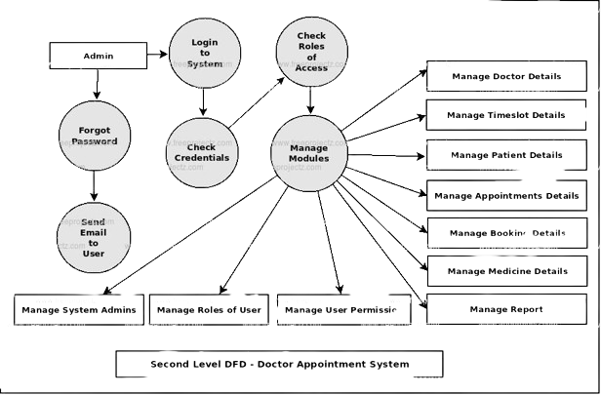

After entering to the home page of the website, Admin can choose the Admin Login option where they are asked to enter username &password

, and if he/she is a valid user then at each user login page will be displayed.

**USECAESE DIAGRAM FOR USER**

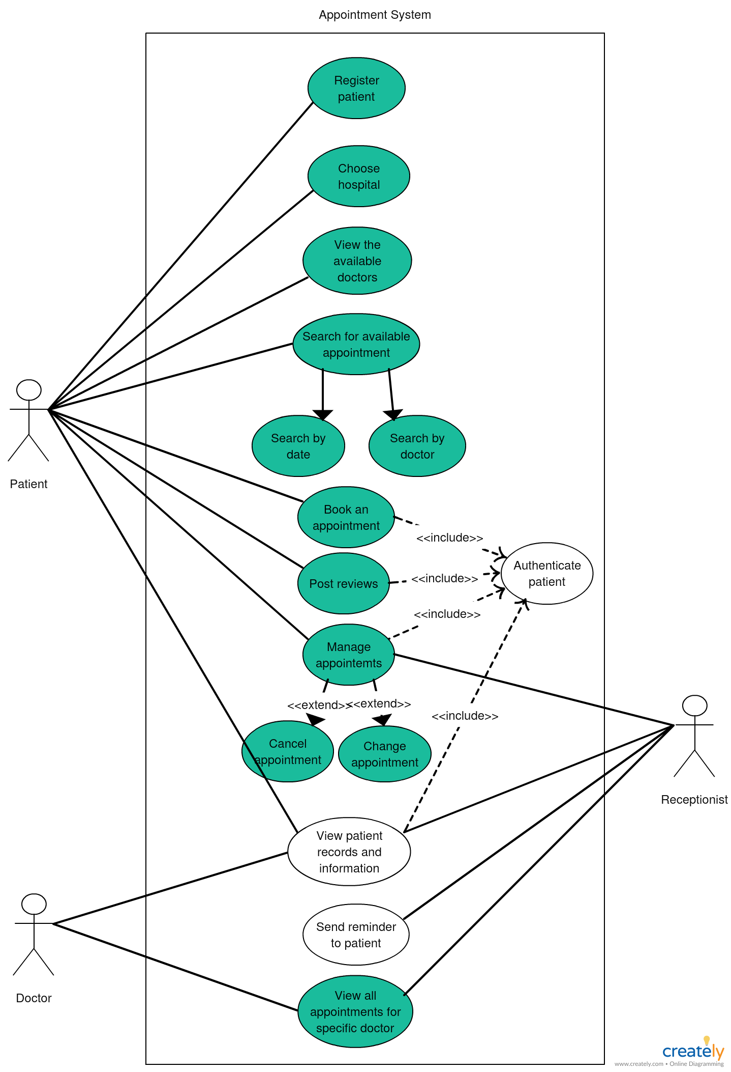

After entering to the homepage of the website, user can choose the USER LOGIN option where they are asked to enter username & password, and if he/she is a valid user then a student login page will be displayed.

**DATAFLOW DIAGRAM FOR USER**

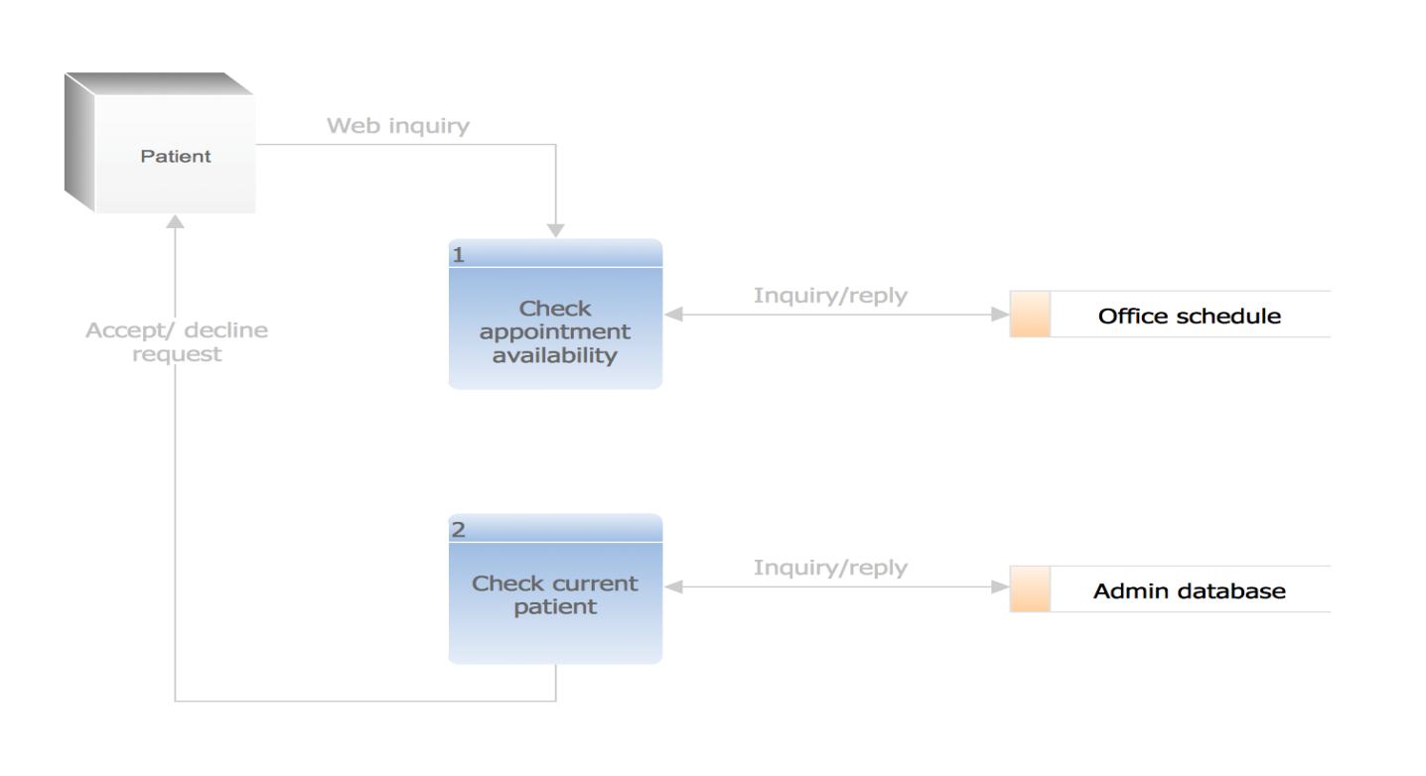

**USE CASE DIAGRAM FOR ADMIN**

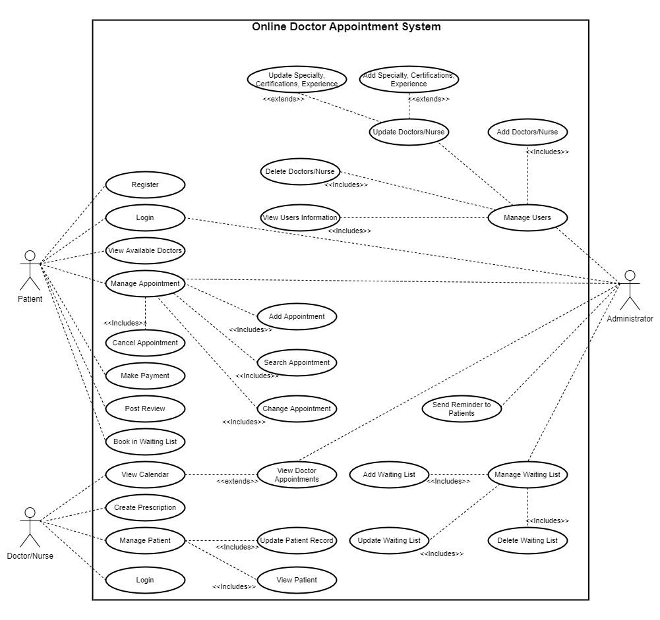

**SEQUENCE DIAGRAM**

