**1st Hands On Exercise**

App.js

import *logo* from './logo.svg';  
import './App.css';  
  
function App() {  
return <h1>Welcome to the first session of React</h1>  
}  
  
export default App;

App.css

h1 {  
text-align: center;  
}

Output



**2nd Hands On Exercise**

App.js

import './App.css';  
import { Home } from "./components/Home";  
import { About } from "./components/About";  
import { Contact } from "./components/Contact";  
  
function App() {  
return (  
<>  
<div className="container">  
<Home/>  
<About/>  
<Contact/>  
</div>  
</>  
)  
}  
  
export default App;

Home.js

import { Component } from "react";  
  
export class Home extends Component {  
 render() {  
return (  
<div>  
<h3>Welcome to the Home page of Student Management Portal</h3>  
</div>  
)  
 }  
}

About.js

import { Component } from "react";  
  
export class About extends Component {  
render() {  
return (  
<div>  
<h3>Welcome to the About page of Student Management Portal</h3>  
</div>  
)  
 }  
}

Contact.js

import { Component } from "react";  
  
export class Contact extends Component {  
 render() {  
return (  
<div>  
<h3>Welcome to the Contact page of Student Management Portal</h3>  
</div>  
)  
 }

}

App.css

.container {  
display: flex;  
flex-direction: column;  
align-items: center;  
  
}

Output



**Q3) Hands On Exercise**

App.js

import './App.css';  
import { CalculateScore } from "./components/CalculateScore";  
  
function App() {  
return (  
<CalculateScore  
Name={"Steeve"}  
 School={"DNV Public School"}  
 total={284}  
 goal={3}  
/>  
)  
}  
  
export default App;

CalculateScore.js

import '../Stylesheets/mystyle.css'  
  
constpercentToDecimal= (decimal) => {  
return (decimal.toFixed(2) + '%')  
}  
constcalcScore= (total, goal) => {  
return percentToDecimal(total / goal)  
}  
  
export constCalculateScore= ({Name, School, total, goal}) => (  
<div className="formatstyle">  
<h1><font color="Brown">Student Details:</font></h1>  
<div className="Name">  
<b><span>Name: </span></b>  
<span>(Name)</span>  
</div>  
<div className="School">  
<b><span>School: </span></b>  
<span>{School}</span>  
</div>  
<div className="Total">  
<b><span>Total:</span></b>  
<span>{total}</span>  
<span>Marks</span>  
</div>  
<div className="Score">  
<b>Score:</b>  
<span>  
{calcScore(total, goal)}  
</span>  
</div>  
</div>  
)

myStyle.css

.Name {  
font-weight: 300;  
color: blue;  
}  
  
.School {  
color: crimson;  
}  
  
.Total {  
color: darkmagenta;  
}  
  
.formatstyle{  
text-align: center;  
font-size: large;  
}  
  
.Score {  
color: forestgreen;  
}

Output –



**Q4) Hands On Exercise**

App.js

import './App.css';  
import { Posts } from "./components/Posts";  
  
function App() {  
return (  
<Posts />  
)  
}  
  
export default App;

Posts.js

import { Component } from "react";  
  
export class Posts extends Component {  
constructor(props) {  
super(props);  
this.state= {  
posts: [],  
 }  
 }  
  
loadPosts() {  
fetch("https://jsonplaceholder.typicode.com/posts")  
 .then(res =>res.json())  
 .then(res => {  
*console*.log("Posts loaded", res);  
this.setState({posts: res});  
 })  
 }  
  
componentDidMount() {  
this.loadPosts()  
 }  
  
componentDidCatch(error, errorInfo) {  
*console*.log("Error", error);  
 }  
  
render() {  
return <>{this.state.posts.map(post =><p key={post.id} >{post.body}</p>)}</>  
}  
  
}

Post.js

export class Post {  
constructor(id, title, body) {  
this.id = id;  
this.title= title;  
this.body= body;  
 }  
}

Output –

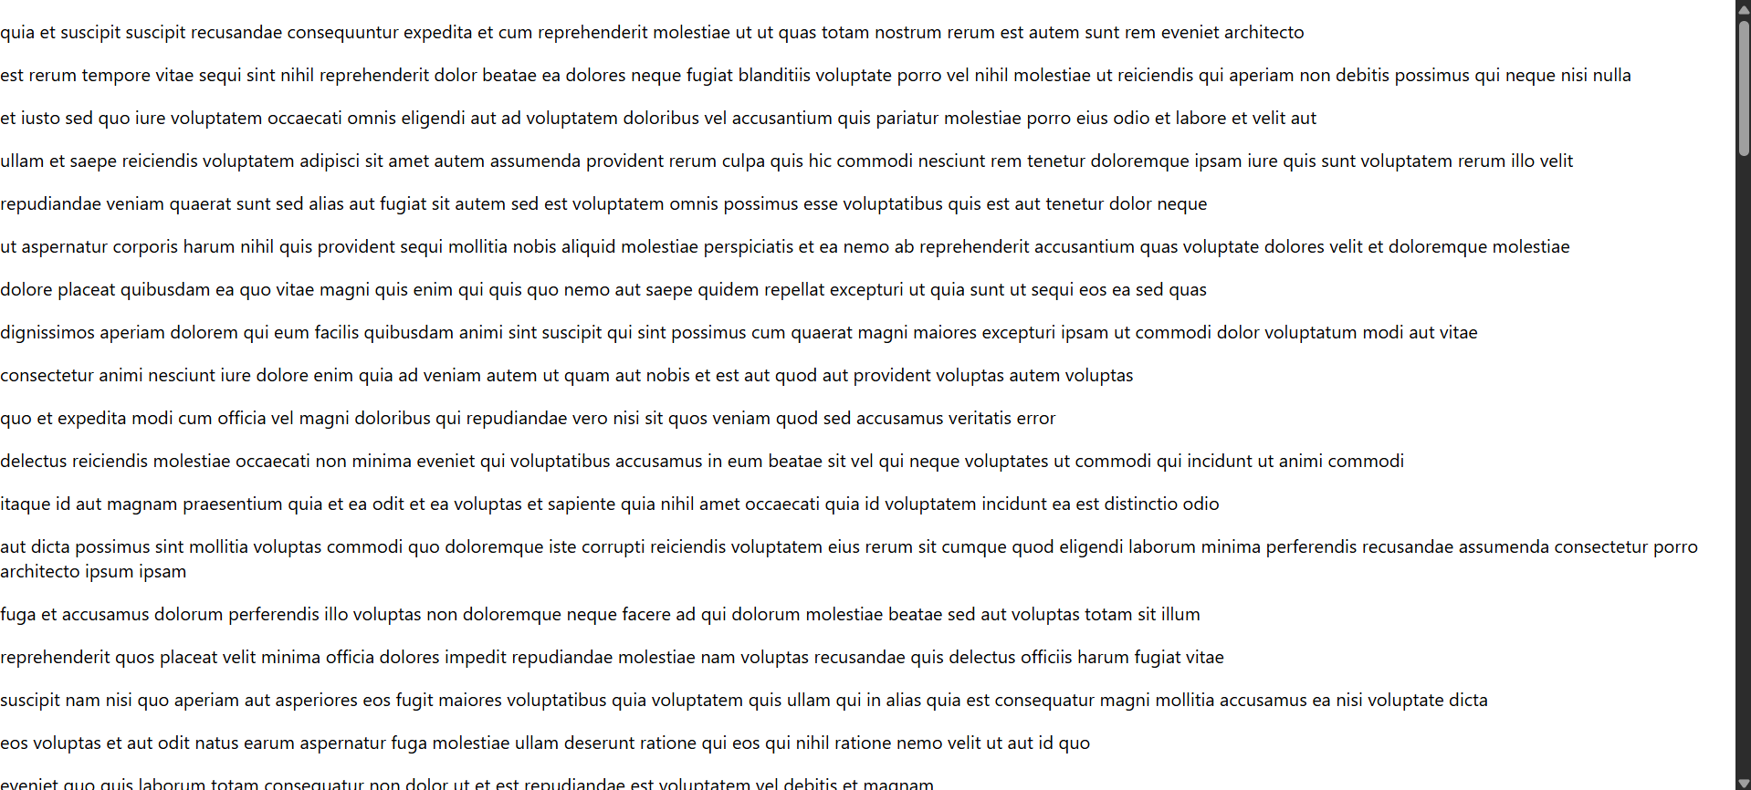

**Q5) Hands On Exercise**

CohortDetails.module.css

.box {  
width: 300px;  
display: inline-block;  
margin: 10px;  
padding: 10px 20px;  
border: 1px solid black;  
border-radius: 10px;  
}  
  
dt {  
font-weight: 500;  
}

CohortDetails.js

import React from "react";  
import styles from "./CohortDetails.module.css";  
  
constCohortDetails = ({ name, status }) => {  
constheadingColor = status === "ongoing" ? "green" : "blue";  
  
return (  
<div className={styles.box}>  
<h3 style={{ color: headingColor }}>{name}</h3>  
<dl>  
<dt>Status:</dt>  
<dd>{status}</dd>  
</dl>  
</div>  
);  
};  
  
export default CohortDetails;

App.js

import React from "react";  
import CohortDetails from "./CohortDetails";  
  
function App() {  
return (  
<div>  
<CohortDetailsname="React Bootcamp" status="ongoing" />  
<CohortDetailsname="Spring Boot Camp" status="completed" />  
</div>  
);  
}  
  
export default App;

Output –

