**Q9) React hands on exercise**

**App.js**

import ListofPlayers from "./components/ListofPlayers";

import { EvenPlayers, OddPlayers } from "./components/OddPlayers";

import ListOfPlayersMerged from "./components/ListOfPlayersMerged";

function App() {

const showListOfPlayers = false;

const T20Players = ["Player A", "Player B", "Player C"];

const RanjiTrophyPlayers = ["Player D", "Player E", "Player F"];

const IndianPlayers = [...T20Players, ...RanjiTrophyPlayers];

if (showListOfPlayers) {

return <ListofPlayers />;

}

return (

<>

<h1>Indian team odd players</h1>

<OddPlayers arr={IndianPlayers} />

<h1>Indian team even players</h1>

<EvenPlayers arr={IndianPlayers} />

<h1>List of players merged</h1>

<ListOfPlayersMerged arr={IndianPlayers} />

</>

);

}

export default App;

**ListOfPlayersMerged.js**

import React from "react";

function ListOfPlayersMerged({ arr }) {

return (

<ul>

{arr.map((item, index) => (

<li key={index}>{item}</li>

))}

</ul>

);

}

export default ListOfPlayersMerged;

**ListofPlayers.js**

import React from "react";

function ListofPlayers() {

const players = [

{ name: "Virat", score: 90 },

{ name: "Rohit", score: 65 },

{ name: "Gill", score: 72 },

{ name: "Rahul", score: 68 },

{ name: "Surya", score: 88 },

{ name: "Pant", score: 45 },

{ name: "Hardik", score: 81 },

{ name: "Jadeja", score: 67 },

{ name: "Ashwin", score: 30 },

{ name: "Bumrah", score: 10 },

{ name: "Shami", score: 25 },

];

const lowScorers = players.filter(player => player.score < 70);

return (

<div>

<h2>All Players</h2>

<ul>

{players.map((player, i) => (

<li key={i}>Mr. {player.name} {player.score}</li>

))}

</ul>

<h2>Players with Score &lt; 70</h2>

<ul>

{lowScorers.map((player, idx) => (

<li key={idx}>{player.name} - {player.score}</li>

))}

</ul>

</div>

);

}

export default ListofPlayers;

**OddPlayers.js**

import React from "react";

export function OddPlayers({ arr }) {

const [first, , third, , fifth] = arr;

return (

<ul>

<li>First: {first}</li>

<li>Third: {third}</li>

<li>Fifth: {fifth}</li>

</ul>

);

}

export function EvenPlayers({ arr }) {

const [, second, , fourth, , sixth] = arr;

return (

<ul>

<li>Second: {second}</li>

<li>Fourth: {fourth}</li>

<li>Sixth: {sixth}</li>

</ul>

);

}

**Output**

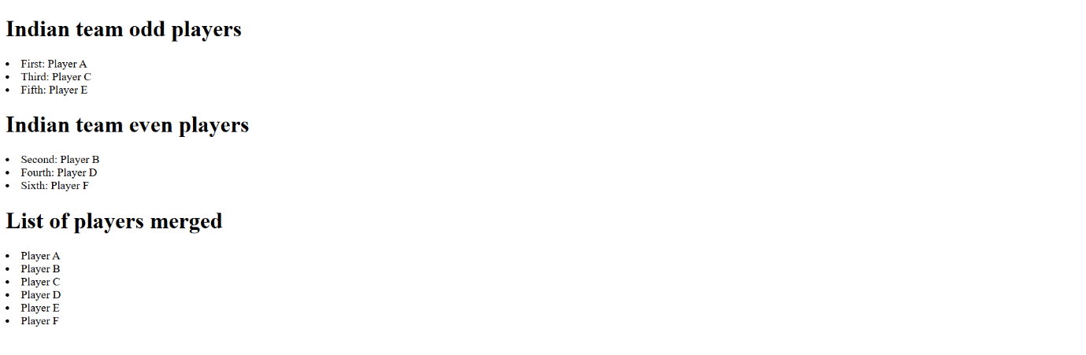

**Q10) React hands on exercise**

function App() {

const element = "Office Space "

const src = "https://assets.executivecentre.com/assets/Banner-Product-PrivateOffice.jpg"

const itemName = {name: "DBS", rent: 50000, address: "Chennai"}  
return (  
 <>

<h1>{element}, at Affordable Range</h1>

<img src={src} alt={"Office Space"} width="25%" height="25%" />

<h1>Name: {itemName.name}</h1>

<h1 style={{color: itemName.rent < 60000 ? "red" : "green"}} >Rent: {itemName.rent}</h1>

<h1>Address: {itemName.address}</h1>

</>

)

}

export default App;

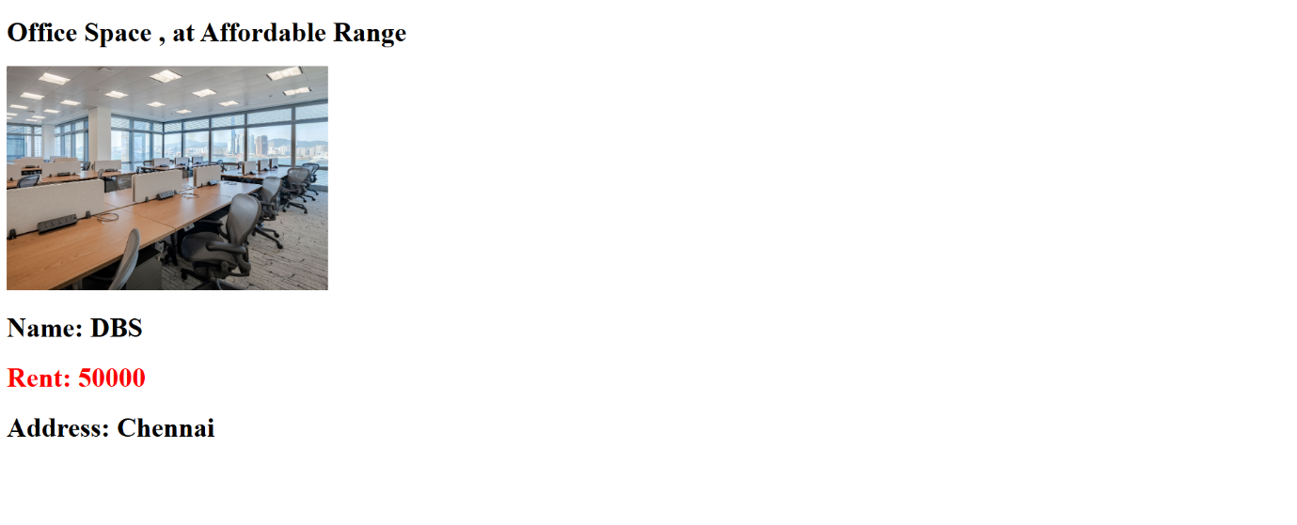

**Q11) React hands on exercise**

import { useState } from "react";

function App() {

const [number, setNumber] = useState(0);

const [currency, setCurrency] = useState(0);

const staticMessage = "John"

function welcome() {

alert(`Hello ${staticMessage}!`);

}

function increment() {

setNumber(prev => prev + 1);

welcome();

}

function decrement() {

setNumber(prev => prev - 1);

welcome()

}

function clickEventHandler() {

alert("button was clicked!");

}

function convert() {

alert(currency * 80);

}

return (

<>

<h1>{number}</h1>

<button onClick={increment}>increment</button> <br />

<button onClick={decrement}>decrement</button> <br />

<button>Say Welcome</button> <br />

<button onClick={clickEventHandler} >Click on me</button> <br />

<h1 style={{color: "red"}} >Currency Convertor</h1>

<input onChange={e => setCurrency(Number(e.target.value))} />

<br />

<textarea value={"Euro"} />

<br />

<button onClick={convert} >Convert</button>

</>

)

}

export default App;

**output**

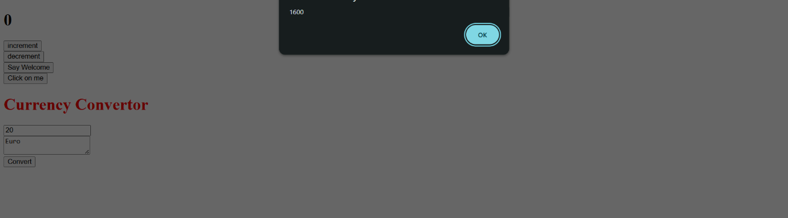

**Q12) React hands on exercise**

import { Greeting } from "./components/Greeting";

function App() {

return <Greeting isLoggedIn={false} />

}

export default App;

import React, { useState } from "react"

import { UserGreeting } from "./UserGreeting";

import { GuestGreeting } from "./GuestGreeting";

export function Greeting(props) {

const [isLoggedIn, setLoggedIn] = useState(props.isLoggedIn)

function onClick() {

setLoggedIn(prev => !prev)

}

if( isLoggedIn ) {

return <UserGreeting onClick={onClick} />

}

return <GuestGreeting onClick={onClick} />

}

import React from "react";

export function UserGreeting({onClick}) {

return (

<>

<h1>Welcome back</h1>

<button onClick={onClick} >Logout</button>

</>

)

}

import React from "react";

export function GuestGreeting({onClick}) {

return (

<>

<h1>Please Sign Up</h1>

<button onClick={onClick} >Login</button>

</>

)

}

**output**

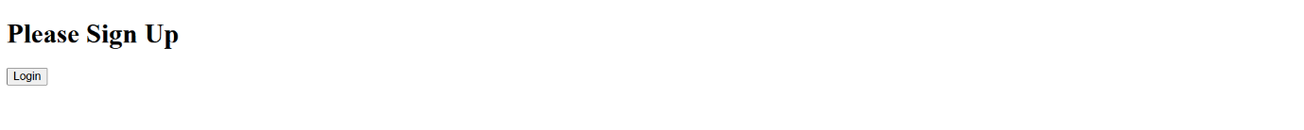

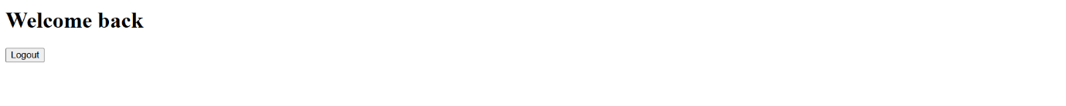

**Q13) React hands on exercise**

import React from 'react';

import './App.css';

const books = [

    { id: 101, bname: 'Master React', price: 670 },

    { id: 102, bname: 'Deep Dive into Angular 11', price: 800 },

    { id: 103, bname: 'Mongo Essentials', price: 450 },

];

const BookDetails = (props) => (

    <ul>

        {props.books.map((book) => (

            <div key={book.id}>

                <h3>{book.bname}</h3>

                <h4>{book.price}</h4>

            </div>

        ))}

    </ul>

);

function App() {

    return (

        <div className="container">

            <div className="section">

                <h2>Course Details</h2>

                <div>

                    <strong>Angular</strong>

                    <p>4/5/2021</p>

                </div>

                <div>

                    <strong>React</strong>

                    <p>6/3/20201</p>

                </div>

            </div>

            <div className="section">

                <h2>Book Details</h2>

                <BookDetails books={books} />

            </div>

            <div className="section">

                <h2>Blog Details</h2>

                <div>

                    <strong>React Learning</strong>

                    <p><b>Stephen Biz</b></p>

                    <p>Welcome to learning React!</p>

                </div>

                <div>

                    <strong>Installation</strong>

                    <p><b>Schwezdenier</b></p>

                    <p>You can install React from npm.</p>

                </div>

            </div>

        </div>

    );

}

export default App;

.container {

    display: flex;

    justify-content: space-around;

    padding: 20px;

}

.section {

    padding: 10px;

    border-left: 3px solid green;

}

.section h2 {

    font-weight: bold;

    margin-bottom: 10px;

}

.section div {

    margin-bottom: 20px;

}

**output**

