Cycle | Last Shortage | New Requirement | Total RS | Production | QC Accepted | Scrap/Reject | Dispatch | Expected Next Last Shortage
1 | 0 | 10000 | 10000 | 10000 | 10000 | 0 | 10000 | 0
2 | 0 | 10000 | 10000 | 8000 | 8000 | 0 | 8000 | 2000
3 | 2000 | 10000 | 12000 | 8000 | 7000 | 1000 scrap | 7000 | 5000
4 | 5000 | 5000 | 10000 | 10000 | 9000 | 1000 scrap | 9000 | 1000
5 | 1000 | 4000 | 5000 | 5000 | 4000 | 1000 rework pending | 4000 | Wait / not final
5A | 1000 | 4000 | 5000 | — | +800 rework accepted | 200 final scrap | 4800 total | 200
6 | 200 | 3000 | 3200 | 3200 | 3000 | 200 scrap | 3000 | 0
7 | 0 | 5000 | 5000 | 5000 | 4500 | 500 hold pending | 4500 | Wait / not final
7A | 0 | 5000 | 5000 | — | hold approved +500 | 0 | 5000 total | 0
8 | 0 | 6000 | 6000 | 6000 | 6000 | 0 | 4000 | 0
9 | 0 | 5000 | 3000 | 3000 | 2800 | 200 Rework pending | 2800

Cycle | New Requirement | Last Shortage Expected | Usable Deduction | Total to Produce Expected | QC Accepted | Scrap/Reject | Dispatch | Next Last Shortage Expected
1 | 10,000 | 0 | 0 | 10,000 | 8,000 | 2,000 | 8,000 | 2,000
2 | 5,000 | 2,000 | 0 | 7,000 | 4,000 | 3,000 | 4,000 | 3,000
3 | 6,000 | 3,000 | 0 | 9,000 | 9,000 | 0 | 9,000 | 0
4 | 5,000 | 0 | 0 | 5,000 | 4,500 | 500 | 4,500 | 500
5 | 5,000 | 500 | 0 | 5,500 | 5,500 | 0 | 5,500 | 0

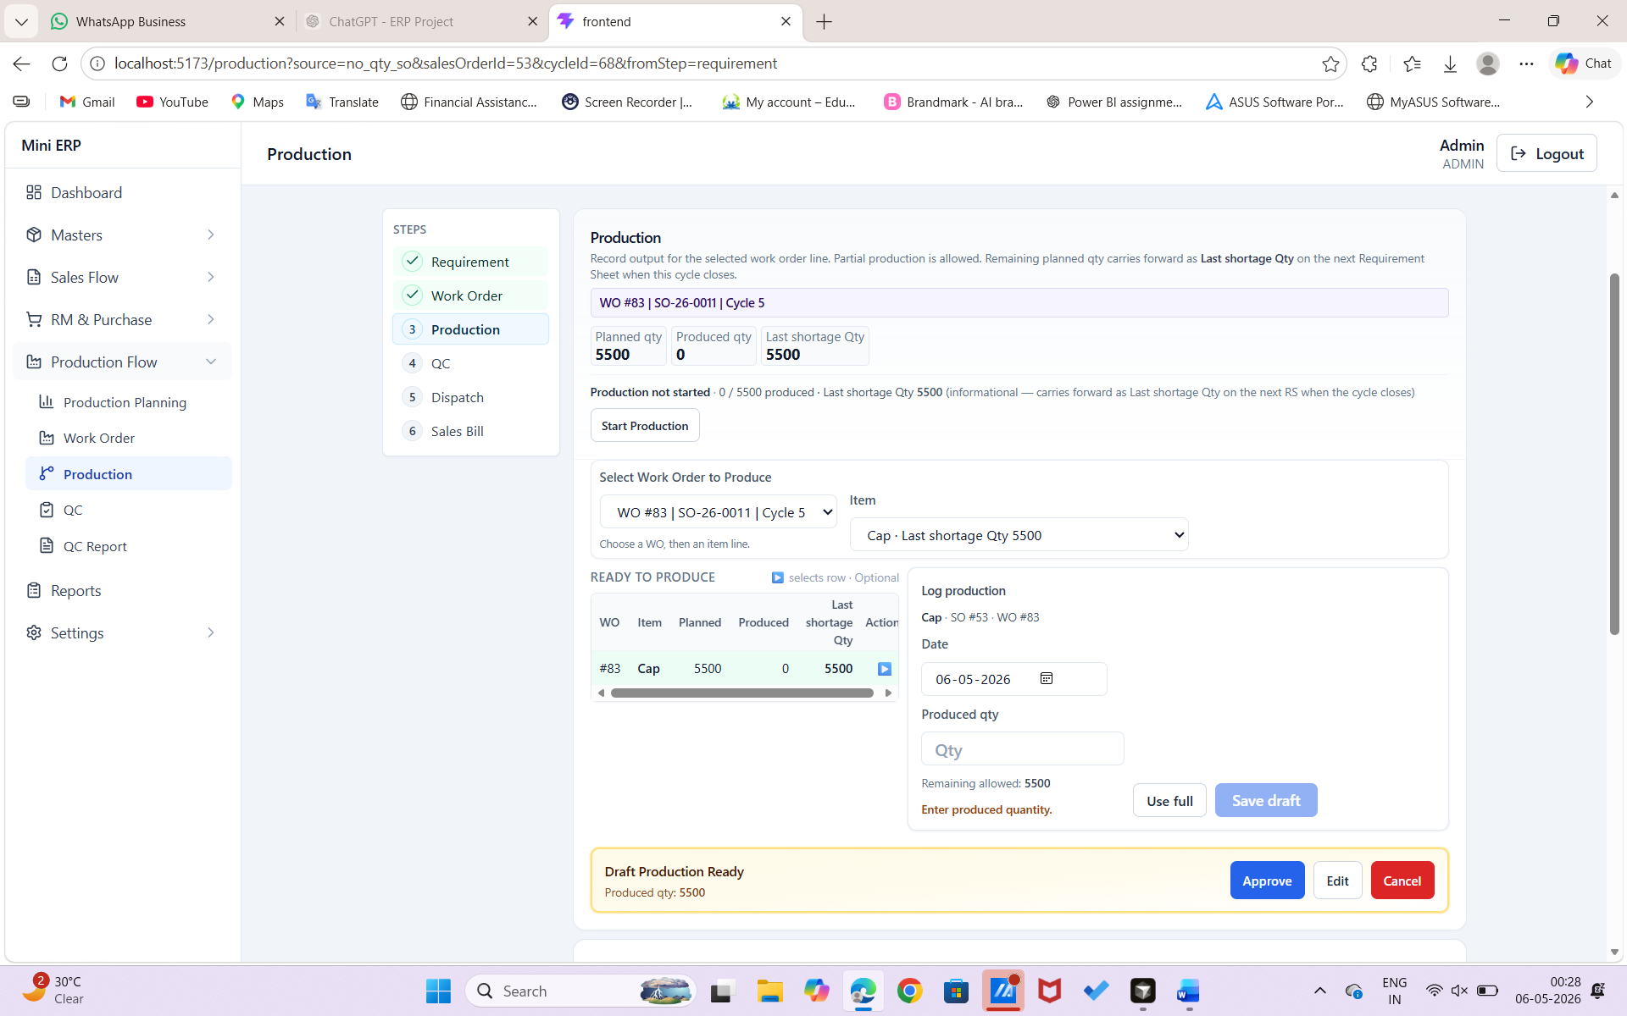
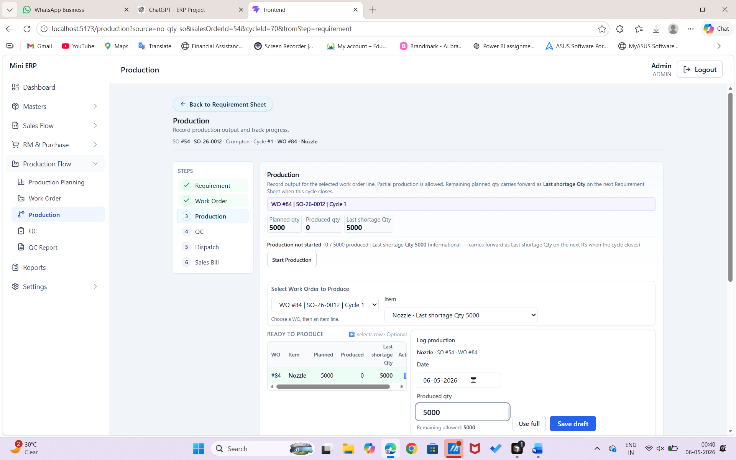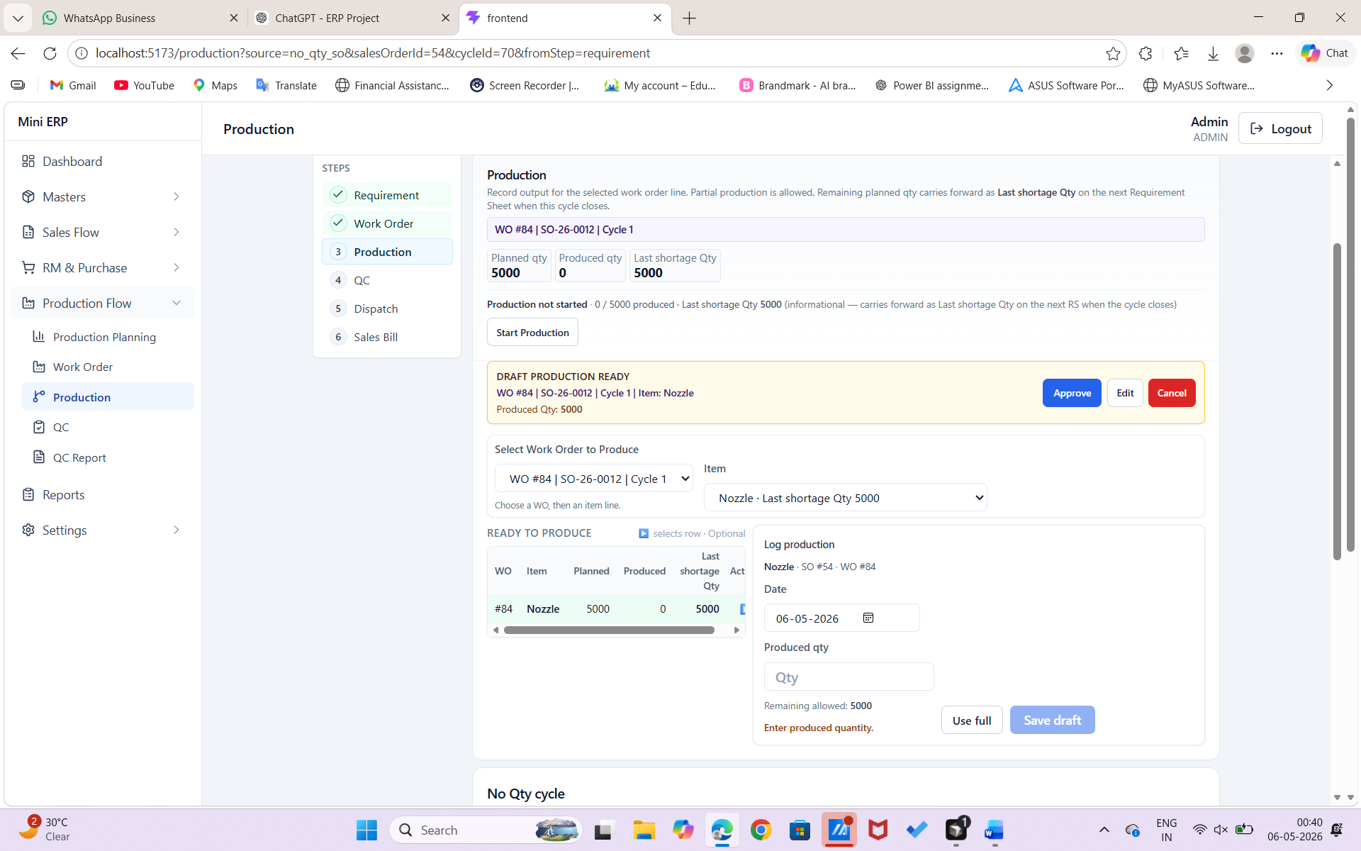

Cycle | Last Shortage | New Requirement | Total RS Demand | Production | QC Accepted / Final Usable | Scrap / Pending | Dispatch | Expected Next Last Shortage | Status
1 | 0 | 10000 | 10000 | 10000 | 10000 | 0 | 10000 | 0 | Final
2 | 0 | 10000 | 10000 | 8000 | 8000 | 0 | 8000 | 2000 | Final
3 | 2000 | 10000 | 12000 | 8000 | 7000 | 1000 Scrap | 7000 | 5000 | Final
4 | 5000 | 5000 | 10000 | 10000 | 9000 | 1000 Scrap | 9000 | 1000 | Final
5 | 1000 | 4000 | 5000 | 5000 | 4000 | 1000 Rework Pending | 4000 | Wait / Not Final | Pending Rework
5A | 1000 | 4000 | 5000 | 4000 | +800 Rework Accepted | 200 Final Scrap | 4800 Total | 200 | Final
6 | 200 | 3000 | 3200 | 3200 | 3000 | 200 Scrap | 3000 | 200 | Final
7 | 200 | 5000 | 5200 | 5000 | 4500 | 500 Hold Pending | 4500 | Wait / Not Final | Pending Hold
7A | 200 | 5000 | 5200 | — | +500 Hold Approved | 0 | 5000 Total | 200 | Final
8 | 200 | 6000 | 6200 | 6000 | 6000 | 0 | 4000 | 200 | Partial Dispatch
9 | 200 | 5000 | 5200 | 3000 | 2800 | 200 Rework Pending | 2800 | Wait / Not Final | Pending Rework

