eBilling and Invoice System

OBJECTIVE 1
Project Scope 2
Customer, Products, Billing Generation 2
Report Generation System 2
Out of Scope 3
Goal 3
Solution Concept 3
User Profiles 5
Usage Summary 6
Requirements Summary 7
Business Requirements 7
User Requirements 7
Operational Requirements 8
System Requirements 9
Success Criteria 9
Sales Automation 9
Design Goals and Constraints 10
Performance 10
Availability 10
Reliability 10
Scalability 10
Security 10
Interoperability 10
Location 10
Setup/Installation 10
Features/Functionality 10
Software and Hardware Requirement 13
General Requirement for Server/Client: 13
Development Tools and Technologies 13
Development Tools and Technologies 14
Front End 14
Back End 14
Development Environment 15
Use Case Summary 16
Manage Orders 16
Description 16
Business Need 16
Priority 16
Manage Products 16
Description 16
Business Need 16
Priority 16
Manage Contacts 16
Description 16
Business Need 16
Priority 17
Analyze Customers 17
Description 17
Business Need 17
Priority 17
Forecast Sales 17
Description 17
Business Need 17
Priority 17
Establish Sales Goals 17
Description 17
Business Need 17
Priority 17
Usage Scenarios 18
Use Case ID: UC 4.7.1 Retrieve Customer Data 18
Intent 18
Scenario Narrative 18
Assumptions/Preconditions 18
Actors 18
Basic Course 18
Alternate Course 18
Uses/Extends 18
User Implementation Requests 18
Frequency 18
Authority 18
Associated Specifications 19
Issues 19
Decision Points 19
Future Requirements 19
Modification 19
Use Case Model: Retrieve Customer Data 20
Use Case ID: UC 04.7.2 Manage Products 21
Intent 21
Scenario Narrative 21
Assumptions/Preconditions 21
Actors 21
Basic Course: 21
Alternate Course: 21
Uses/Extends 21
User Implementation Requests 21
Frequency 21
Authority 21
Associated Specifications 21
Issues 22
Decision Points 22
Future Requirements 22
Modification 22
Use Case: Manage Products 23
Use Case ID: UC 04.7.3 Manage Orders 24
Intent 24
Scenario Narrative 24
Assumptions/Preconditions 24
Actors 24
Basic Course: 24
Uses/Extends 24
User Implementation Requests 24
Frequency 24
Authority 24
Associated Specifications 25
Issues 25
Decision Points 25
Future Requirements 25
Modification 25
Use Case ID: UC 04.7.3 Manage Contacts 27
Intent 27
Scenario Narrative 27
Assumptions/Preconditions 27
Actors 27
Basic Course: 27
Uses/Extends 27
User Implementation Requests 27
Frequency 27
Authority 27
Associated Specifications 27
Issues 28
Decision Points 28
Future Requirements 28
Modification 28
Solution Architecture 30
Infrastructure 30
Visual Design 30
Conceptual Design 30
Logical Design 32
Physical Design 34
eBilling and Invoice System Data Dictionary 35
eBilling and Invoice System Data Dictionary 36
Table : product_master 36
Table : bill 36
Table : bill_details 37
Table : Company_master 37
Table : user_master 38
eBilling and Invoice System – Data Schema ER Diagram 39
eBilling and Invoice System DFD (Data Flow Diagram) 40
Form Design and Coding 41
FrmSplash 41
FrmLogin 43
FrmMain 46
FrmProducts 48
FrmBill 54
FrmReports 71
FrmPrintBill 73
ProductSummary Report 75
FrmBillSummary 76
FrmExportData 78
FrmUtlity 84
FrmCompactAndRepairDatabase 86
FrmBackupDatabase 88
FrmCompanyInfo 91
FrmClientInfo 96
FrmChangePassword 101
ModGen 103
ModBrowse 105
ModRsToWord 107
eBilling and Invoice System Test Plan 111
Introduction 111
Test Scope 111
Test Strategy 111
Preconditions 112
Test Priorities 112
Test Techniques 112
Test Organization 113
Roles and Responsibilities 113
Deliverables 113
Test Environment 113
Hardware and Software 113
Testing Automation Software 114
Application Configuration 114
Test Management 114
Testing Schedules 114
Threats to Testing 115
Conclusion and future enhancement 116
Bibliography 117
Websites 117
Books 117

OBJECTIVE

This project is made for one of the big decorator services in Mumbai, they supply decorating item to film industry for movie shooting. Presently they issue their client handwritten invoice and they enter details in manual register. And maintain MS Excel file for product rate. They want computerization of their manual invoice and bill generation process.

The client uses MS Excel, and maintains their product list, customer list, and prints the invoice, however it is not possible them to share the data from multiple system in multi user environment, there is lot of duplicate work, and chance of mistake. When the product price are changed they need to update each and every excel file. There is no option to find and print previous saved invoice.

There is no security; any body can access any report and sensitive data, also no reports to find out the sales volume, stock list, and summary report. This eBilling and invoicing system is used to overcome the entire problem which they are facing currently, and making complete atomization of manual billing and invoicing system

High Level Solution Architecture

User Profiles
The following user types are expected for the eBilling and Invoicing System:

User | Brief Description of Use Actions
Sales Representative | Downloads and uploads customer and order information, which affects accounting, inventory and product data. View customer and product data as described in metrics, track orders and deliveries.
Manager | All sales representative use actions, and management reports, quota establishment, reporting and adjustment.
Accountant | View and print stocks, track orders. Update product details like price.
MIS Executive | Generate reports, view and print inventory reports, view and print stock reports.

Usage Summary
eBilling and Invoicing System Version 1.0 will address the following use cases. The complete usage scenarios will be completed during the information-gathering process. Use cases will be created and prioritized. Selected use cases will be expanded into usage scenarios and features that are derived from both use cases and the usage scenarios, as represented in the following diagram:

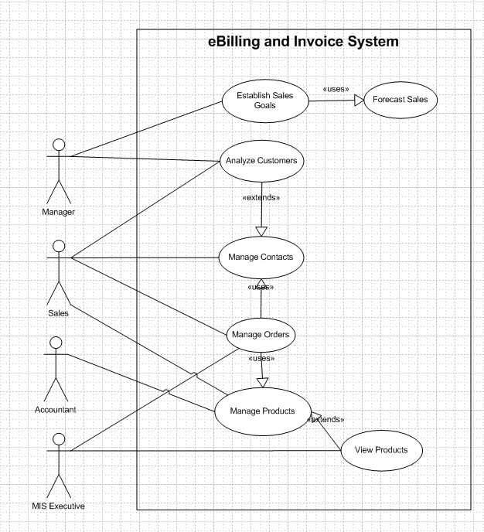

Usage summary use case

Requirements Summary
The following preliminary lists are based on initial interviews

Business Requirements
The business goal for the application is to support an increase the productivity and complete automation of existing manual bill and invoice generation process. Business requirements are discussed in the Scope section, with the following additional detail:

- Sales representatives need a method to store and access sales opportunity data, and when a sale is generated, convert some or all of the information into a sales order without re-entering information.
- Each sales representative should receive customer and sales data pertinent only to them.
- The accountant should be able to enter or update product information in one interface only, with all necessary product information being received by sales staff.
- Manager must receive his or her customer and appointment data plus detailed and rollup information for each sales representative on his or her team.
- The application should support the capability to use multi user environment.
- The MIS Executive should able to generate all type of reports as and when required by the management.

The sales staff wants to improve their current ability to analyze their customers. In particular, they want to focus on identifying their best customers and building long-term relationships within that base. To enable them to accomplish this goal, they want to extract meaningful data that easily answers the following questions:

- What are the early warning signs of problems?
- Who are my best customers across product lines?
- With whom do I focus my efforts for building a long-term relationship?
- What are my customers' issues as groups?
- Geographically, where are my best customers?
- What products are my customers buying and at what rate?

User Requirements
User requirements are categorized by user type.

Sales Staff (Representatives and Managers)

- View the data in various ways, for example:
  - Customers who are the top buyers of specific items
  - Best customers based on criteria to be determined
  - Best customers based on geographical analysis
  - Drops in a customer's sales
- Store multilingual and multiregional information in the database rather than relying on the sales staff to translate the information
- Identify which product prices have been modified, especially on current orders in progress
- Use opportunity rules, which are statements that help the sales representative convert an opportunity into a sale
- Add third-party data sources and financial evaluation tools
- Identify where promotions and programs would be the most beneficial
- Apply discounts to customer orders:
  - Sales representatives can offer discounts up to 15 percent, or up to 20 percent with authorization.
  - Sales managers can offer discounts up to 20 percent
- Enable capture, analysis, and sharing of data about a customer across the company
- Use forecasts to establish sales goals
- Allow all staff to view all contacts, but allow each contact to be assigned to a sales representative

Accountant

- Update product details, including price, photo, and description
- Add, delete, and update product specifications
- Generate stock reports and check the availability, order the item as and when needed.

MIS Executive

- Generate Reports as per requirement.
- Share the data, and convert reports to different format like Text, CSV.

Operational Requirements
The following requirements provide a high-level view of how the system will run:

- Processor usage should not exceed 80 percent during concurrent uses.
- Backups will occur incrementally throughout the day.
- A full weekly backup is required to WORM drives.
- Ensure that information is easy to access either, and meaningful for the sales representative and the company.
- Minimize the technical knowledge that sales and marketing staff need to access the data, generate ad hoc queries, track promotions, and view customer segmentation information.
- Any change to information must be reflected immediately, and the changes must be propagated to the search engine so that employees that perform searches see this new information.
- The application should work with the existing communications and networking infrastructure.
- The application should deploy with a minimum of additional operational processes, manual or otherwise.

System Requirements
These are additional constraints from a system perspective:

- Previous data of customer, product details must be imported in the new system.
- The administrator must be able to monitor everything from the IT department.
- The information must be accessible by everyone in the company as per the rights specify.

Success Criteria
To determine the success of this project, the following metrics can be quantified and used to analyze success factors.

Sales Automation
- Problem customer identification. Ability to identify top 10 developing problem customers by sales representative.
- Identification of best customers across product lines and regions. All customers can be sorted by the factors (to be determined) that rank them qualitatively. Variable sorts and rankings can be chosen by the sales representative.
- Identification of issues across groups. All customers can be sorted by the issues (to be determined) within group categories that can be updated. Variable sorts and rankings can be chosen by the sales representative or other user.
- Analysis of quantities and rates of products. Products can be sorted by the quantity and dates sold. Variable sorts and rankings can be chosen by the user.

Design Goals and Constraints

Performance
No more than a 5-percent degradation in average query response is allowed while all concurrent user are using the system.
Processor utilization should not exceed 80 percent during all concurrent users are using the system.

Availability
Because the system is accessed by sales representative to book the order and print the invoice, and their should not be any single point of failure.

Reliability
Because of the need no single point failure, automatic failover will be required. In addition, existing disaster recovery and backup plans and procedures must be revised to incorporate the eBilling and Invoicing System.

Scalability
eBilling and Invoice System an average load of 50 concurrent users after the system is fully operational, and expects that to grow by 5 percent each year for the next five years.

Security
For the sensitive customer and order data, all users will need to log on the system with their user id and password.

Every resource in the system are defined by the role and privileged. System administrator assigned user role and privileged for their access rights.

Interoperability
In Version 1.0 of the eBilling and Invoice System, there are no requirements for interoperability with other systems.

Location
The eBilling and Invoice System are used in the company office only.

Setup/Installation
Setup and installation must not interrupt the sales staff’s daily tasks and work flow.

Use Case Summary

Manage Orders

Description
This function will enable sales representative to place orders for eBilling and Invoice System products, track submitted orders, and view completed orders and print the invoice.

Business Need
This function will enable sales representative to interact with eBilling and Invoice System catalog directly without the intervention of any other employees.

Priority
High

Manage Products

Description
This function allows user of eBilling and Invoice System to create, maintain, and delete information about products in the product database that can then be viewed and ordered by customers, and accessed and updated by the sales staff.

Business Need
This function will support the sales staff with accurate and relevant information, and will also support the Manage Orders function by ensuring up-to-date product information.

Priority
High

Manage Contacts

Description
This function enables the sales staff to create and manage contacts as well as share contact information with the rest of the company.

Business Need
This function enables user of eBilling and Invoice System to have accurate and up-to-date contact information when working with customers.

Priority
Medium

Analyze Customers

Description
This function allows management to analyze the customer database and find out information, such as the identities of the best customers, the top buyers, and the most popular products.

Business Need
This function will allow management to determine the most (and least) profitable customers and product lines, enabling better decision making in the running of the business.

Priority
Medium

Forecast Sales

Description
This function allows management to plan and track production costs, track sales results, and plan sales staffing needs.

Business Need
This function will allow management to manage the revenue streams of the organizations and control costs.

Priority
Medium

Establish Sales Goals

Description
This function allows management to view current sales trends and employee performance and to determine sales goals for the sales staff within the organization.

Business Need
This function will allow management to set goals for staff, review the performance of staff members, and track employee performance.

Priority
Medium

Usage Scenarios
Usage scenarios that describe how users will use the solution within the context of the business, See following usage scenarios.

Use Case ID: UC 4.7.1 Retrieve Customer Data
Title: UC 04.7.1 Retrieve Customer Data
Abbreviated Title: Retrieve Customer Data
Requirement ID: 21

Intent
Return the selected information about one or more customers.

Scenario Narrative
A sales representative may want to search for and retrieve information about one or more customers for use in analysis and forecasting activities.

Assumptions/Preconditions
- Sales representative has access rights to view customer data.

Actors
- Sales Representative

Basic Course
- Use case begins when the sales representative decides to retrieve customer information.
- System prompts for the type of customer information that is required.
- Sales representative selects the type of customer information to be retrieved.
- System presents the appropriate customer information to the sales representative.
- Use case ends when the selected information is passed to a method of delivery.

Alternate Course
- If no appropriate customer information can be found, system reports this fact.
- Use case restarts to enable sales representative to update the type of customer information.

Uses/Extends
- None

User Implementation Requests
- None

Frequency
Quite frequent

Authority
- Not applicable

Associated Specifications
Number | Name | Category | Type

Issues
- None identified

Decision Points
- None

Future Requirements
- The sales representative may want to apply filters to the retrieved data.
- The sales representative may want to sort the data. For example, the sales representative may want to list the names of customers in chronological order based on the sale date.

Modification
Date | Author | Description

Use Case Model: Retrieve Customer Data

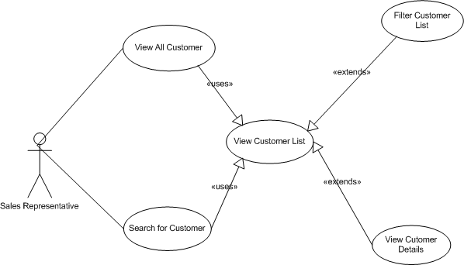

Use Case: Manage Orders

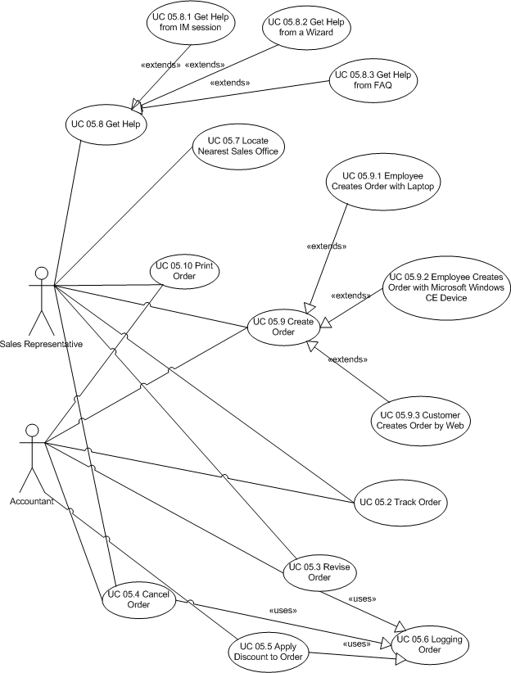

Use Case ID: UC 04.7.3 Manage Contacts
Title: UC 04.7.2 Manage Contacts
Abbreviated Title: Manage Contacts
Requirement ID: 19

Intent
Enable actor to create, view, modify of the information about customer contacts.

Scenario Narrative
An actor wants to create view, modify, and delete the customer contacts.

Assumptions/Preconditions
- The actor has rights to access to the eBilling and Invoice System, and having rights to view, ads, edit and delete the customer contacts.

Actors
- Sales Representative
- Manager
- Accountant

Basic Course:
- Use case begins when actor decides to search customer.
- Actor searches the customer.
- System displays the customer details.
- Actor view the customer contact details:
- Actor add, modify the contact details.

Uses/Extends
- None

User Implementation Requests
1. None

Frequency
Frequent

Authority
- Not applicable

Associated Specifications
Number | Name | Category | Type

Issues
- None

Decision Points
- None

Future Requirements
- None

Modification
Date | Author | Description

Solution Architecture

Infrastructure
New servers must be dual processor 1.26 GHz computers, with 1 GB of RAM. The operating system software will be Microsoft® Windows® 2000 with the latest service pack, although use of Windows Server 2003 will be considered when it is available.

These servers will be installed on existing network.

To help provide security of the application, both an internal and external firewall will be installed.

Visual Design
See later on the visual interface design..

Conceptual Design
For information about the conceptual design see the use case of previous chapters of the eBilling and Invoice System,

Business Rule Catalog of eBilling and Invoice System

BR ID | Business Rule Title | Description | Authority | Current Process
1 | Timely Product Information Adjustments | The product information, price in the system must be current 100% of the time. Adjustments to this information must be made at any time. | Mr. Ajay Kumar, Accountant. Interview dated May 6, 2008 | 1. Product is identified by Manager  2. Current information is reviewed and modifications are identified.  3. Accountant notes changes to information and obtains approval from Manager.  4. Accountant makes the changes to the product information.  5. After approval is given by all owners, Accountant saves the changes.
2 | Reactivating Deleted Products | A product can be "deleted," meaning that it is no longer sold by eBilling and Invoice System. However, the product information should be available in case the product is reactivated at a future time. | Mr. Ajay Kumar, Accountant. Interview dated May 6, 2008 | 1. Product is identified by Manager.  2. Accountant is notified that the product should be removed from the catalog. Notification comes from Manager.  3. Accountant archives product information and saves the information in text and graphics files on an internal business server.  4. If a product is reactivated, the Accountant receives notification from Manager.  5. Accountant creates a new product record in the database and copies the information from the files on the internal business server to the database record.  6. Accountant notifies product information "owners" in Manager to review the new product record.  7. After approval is given by all owners, Accountant makes the product record available to the catalog.
3 | Authorization for Catalog Changes | No change to product information can be made publicly available without the approval from the information "owners," usually Manager. | Mr. Ajay Kumar, Accountant. Interview dated May 6, 2008 | Derived from BR1
4 | Delivery of Daily Pricing Updates to Sales | The Sales force needs to use the most up-to-date information about product pricing and related information, such as availability. Otherwise, sales representatives miss receiving changes that do affect them. This results in the sales representatives having to redo orders and recalculate pricing. | Mr. Ajay Kumar, Accountant. Interview dated May 6, 2008 | Every morning of every day:  1. Accountant Update the pricing from the vendor.
5 | Authorization for Information Access | Certain roles have access to certain information types and functions. Current roles include Sales Representative, Sales Manager, Accountant, MIS Executive | Mr. Joydeep Das, IT Manager. Interview dated May 12, 2008 | 1. A suitable authority is requested for creation of a role.  2. The role is created and authorized by the authorization authority.

Logical Design

EBilling and Invoice System Service Matrix
Business Objects | Services | Actors (Roles) | Responsibilities | Collaborations | Use Case Reference
Products | Manage Products | - Sales representative | - Set filtering information  - Get price modifications | - Select a catalog item from catalog item | Use Case : Manage Product
Products | Manage Products | - Sales representative | - Select a catalog item  - Get details of catalog item  - Get product specs | - None | Use Case : Manage Product
Products | Manage Products | - Sales representative | - Set address details  - Get address list  - Validate address  - Confirm delivery | - Set delivery address from order | Use Case : Manage Product
Products | Manage Products | - Sales representative | - Print product specs | - None | Use Case : Manage Product
Products | Manage Products | - Sales representative | - View product specs | - None | Use Case : Manage Product
Products | Manage Products | - Customer  - Sales representative | - View summary information | - None | Use Case : Manage Product
Products | Manage Products | - Sales representative | - View detailed information | - None | Use Case : Manage Product
Products | Edit Products | - Accountant | - Add item to catalog | - Browse catalog items  - Set item details from catalog item | Use Case : Edit Product
Products | Edit Products | - Accountant | - Get editable items  - Set item details  - Validate item details  - Save item details | - Get details of catalog item from catalog item | Use Case : Edit Product
Products | Search Products | - Sales representative  - Accountant  - Sales manager | - List categories  - Browse to category  - List catalog items | - View summary information from catalog item | Use Case : Manage Product
Products | Search Products | - Sales representative  - Accountant  - Sales manager | - Set search criteria  - Search catalog | - None | Use Case : Manage Product
Order | Manage an order | - Sales representative | - Set dispatch mechanism  - Enter dispatch details  - Validate dispatch details | - Get details of catalog item from catalog item | Use Case : Manage Orders
Order | Manage an order | - Sales representative | - Set delivery address | - None | Use Case : Manage Orders
Order | Manage an order | - Sales representative | - Search for an order  - Get order details  - Set order details | - Get order details from order | Use Case : Manage Orders
Order | Manage an order | - Sales representative | - Search for an order  - Get order details  - Cancel order | - Get order details from order | Use Case : Manage Orders
Order | Manage an order | - Sales representative | - Create Order  - Set order details  - Add catalog item to order  - Set delivery address  - Set payment details  - Confirm order  - Synchronize order with CE device | - Browse catalog items | Use Case : Manage Orders
Order | Manage an order | - Sales representative | - Synchronize order with laptop  - Set customer signature | - Browse catalog items | Use Case : Manage Orders
Order | Manage an order | - Sales representative  - Sales manager | - Apply a discount | - None | Use Case : Manage Orders
Order | Track an order | - Sales representative | - Get order status | - None | Use Case : Manage Orders
Order | Track an order | - Sales representative | - Search for an order  - Get order details  - Set discount amount  - Validate discount amount  - Set order details | - Get details of catalog item from catalog item | Use Case : Manage Orders
Customer | Track a customer | - Sales representative | - Get customer details  - Search for a customer | - None | Use Case : Retrieve Customer Data

Physical Design

eBilling and Invoice System Physical Object Model

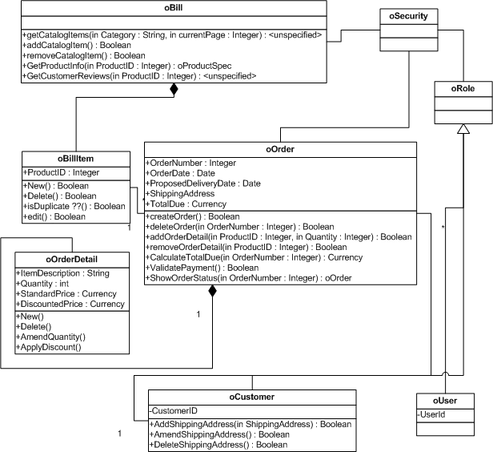
Add new product to product master sequence diagram

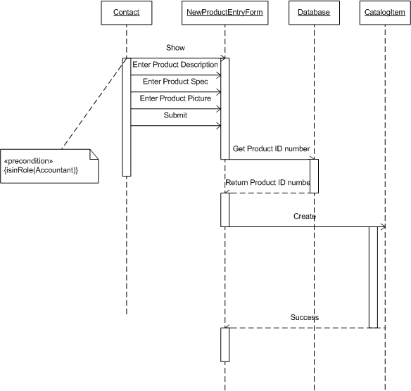

eBilling and Invoice System Data Dictionary

Table : product_master
Owner: dbo
Destination DB name: ebill
Number of columns: 5
Number of indexes: 2
Number of foreign keys: 0
Extended attributes:
OnFileGroup PRIMARY
Clustered PK Yes

Columns | Data type | Allow NULLs | Value/range
Sno | int | Not allowed
ProdType | nvarchar(60) | Not allowed
ProdSubType | nvarchar(60) | Not allowed
Rate | int | Not allowed
isactive | nvarchar(30) | Not allowed

Indexes | Type | Columns
PK_ProductMaster_sno | clustered, unique, primary key located on PRIMARY | sno

Table : bill
Owner: dbo
Destination DB name: ebill
Number of columns: 15
Number of indexes: 3
Number of foreign keys: 0
Extended attributes:
OnFileGroup PRIMARY
Clustered PK Yes

Columns | Data type | Allow NULLs | Value/range
sno | int | Not allowed
invoiceno | nvarchar(60) | Not allowed
canme | nvarchar(60) | Not allowed
Invoice_date | datetime | Not allowed
location | nvarchar(60) | Not allowed
chalan_no | int | Not allowed
customer_name | nvarchar(100) | Not allowed
Customer_address1 | nvarchar(100) | Not allowed
Customer_address2 | nvarchar(100) | Allowed
Total_amt | int | Not allowed
discount | int | Not allowed
Amt_words | nvarchar(100) | Not allowed
Paid_type | nvarchar(60) | Not allowed
Cheque_no | nvarchar(60) | Allowed
Entry_date | datetime | Not allowed

Indexes | Type | Columns
PK_Bill_SNO | clustered, unique, primary key located on PRIMARY | sno
IX_bill_cname | nonclustered located on PRIMARY | cname
IX_bill_invoiceno | nonclustered, unique located on PRIMARY | invoiceno

Table : bill_details
Owner: dbo
Destination DB name: ebill
Number of columns: 6
Number of indexes: 3
Number of foreign keys: 2
Extended attributes:
OnFileGroup PRIMARY
Clustered PK Yes

Columns | Data type | Allow NULLs | Value/range
sno | int | Not allowed
Bill_sno | int | Not allowed
Prod_sno | nvarchar(60) | Not allowed
qty | datetime | Not allowed
rate | nvarchar(60) | Not allowed
amt | int | Not allowed

Indexes | Type | Columns
PK_Bill_details_SNO | clustered, unique, primary key located on PRIMARY | sno
IX_bill_details_bill_sno | nonclustered located on PRIMARY | Bill_sno
IX_bill_deatils_prod_sno | nonclustered, unique located on PRIMARY | Prod_sno

Table : Company_master
Owner: dbo
Destination DB name: ebill
Number of columns: 7
Number of indexes: 2
Number of foreign keys: 0
Extended attributes:
OnFileGroup PRIMARY
Clustered PK Yes

Columns | Data type | Allow NULLs | Value/range
Company_name | nvarchar(60) | Not allowed
Address1 | nvarchar(100) | Not allowed
Address2 | nvarchar(100) | Allowed
city | nvarchar(60) | Not allowed
pin | int | Not allowed
telephone | nvarchar(60) | Not allowed
vatno | nvarchar(60) | Not allowed

Indexes | Type | Columns
PK_comapny_master_company_name | clustered, unique, primary key located on PRIMARY | Comapnay_name
IX_ comapny_master_pin | nonclustered located on PRIMARY | pin

Table : user_master
Owner: dbo
Destination DB name: ebill
Number of columns: 3
Number of indexes: 2
Number of foreign keys: 0
Extended attributes:
OnFileGroup PRIMARY
Clustered PK Yes

Columns | Data type | Allow NULLs | Value/range
user_name | nvarchar(60) | Not allowed
User_password | nvarchar(60) | Not allowed
User_type | nvarchar(60) | Allowed

Indexes | Type | Columns
PK_user_master_user_name | clustered, unique, primary key located on PRIMARY | user_name
IX_ user_master_user_type | nonclustered located on PRIMARY | User_type

eBilling and Invoice System – Data Schema ER Diagram

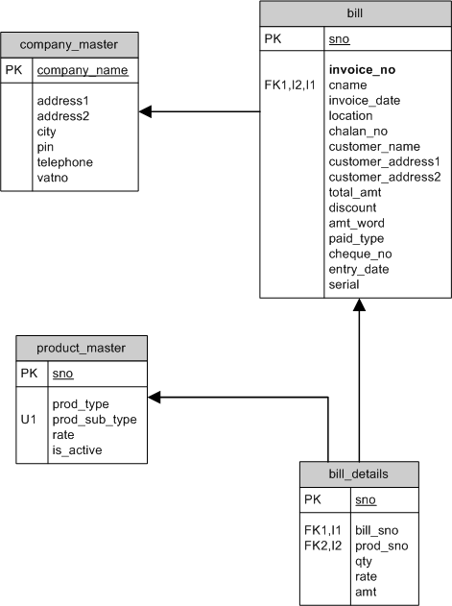

eBilling and Invoice System DFD (Data Flow Diagram)

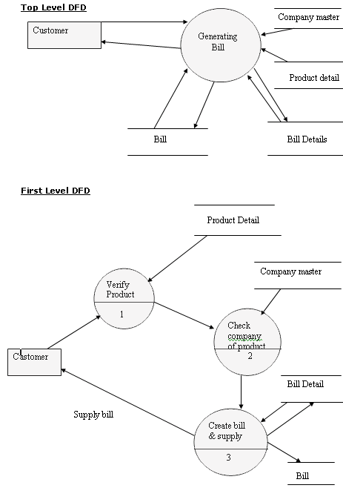

Form Design and Coding

FrmSplash
(Module to show startup screen)

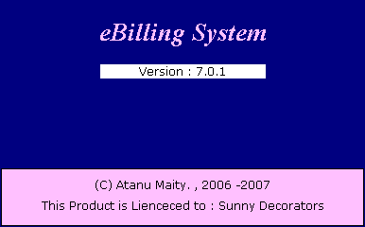

'*************************************
' eBilling System
' Version 1.0.0
' Created by Mr. Atanu Maity
' Date : 21-Aug-2006
'*************************************
' Splash Screen
' Used Table : NA
'Module to show startup screen
'*************************************

Option Explicit

Dim r As Integer
Dim i As Integer
Private Sub Form_Load()
'>>> center the form
Me.Left = (Screen.Height - Me.Height) / 2
Me.Top = (Screen.Width - Me.Width) / 2

'>>> get a random value to decide how many seconds
'>>> startup screen should be displayed
r = Rnd * 5 + 1
End Sub

Private Sub Form_Unload(ByVal Cancel As Integer)

'>>> release all the references
FrmSplash = Nothing
End Sub

Private Sub Timer1_Timer()
'>>> check the ellapsed time
'>>> if the ellapsed time greater then random value
'>>> stored in form load, stop the timer
'>>> show main from and close the startup screen
i = i + 1
If r >= i Then
i = 0
Timer1.Interval = 0
Unload(Me)

Load(FrmMain)
FrmMain.Show()
End If
End Sub

FrmLogin
(Module to Authenticate User)

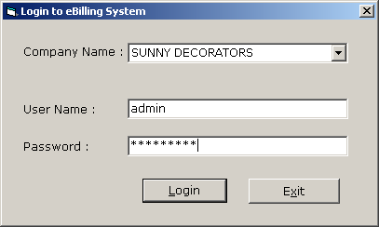

'*************************************
' eBilling System
' Version 1.0.0
' Created by Mr. Atanu Maity
' Date : 21-Aug-2006
'*************************************
' Login Module
' Used Table : user_master
'Module to check user login and load
'user rights as per user type.
'*************************************

Option Explicit
Dim Rs As New ADODB.Recordset
Private Sub Command1_Click()
'>>> check wheather user name and password are blank
'>>> if its is blan warn user to enter
If TxtUserName.Text = "" Or TxtPassword.Text = "" Then
MsgBox("Enter user name and password ...", vbExclamation)
TxtUserName.SetFocus()
Exit Sub
End If

'>>> check for entered company
'>>> query to database and if no record found warn user to select company from the list.
If Rs.State = adStateOpen Then Rs.Close()
Rs.Open("select * from company_master where company_name='" & CmbCompanyName.Text & "'", Cn, adOpenStatic, adLockReadOnly)
If Rs.RecordCount > 0 Then
CompanyName = CmbCompanyName.Text
Else
MsgBox("Select company name from the list", vbExclamation)
CmbCompanyName.SetFocus()
Exit Sub
End If

'>>> check for username and password
'>>> query to user_master with user_name and password
'>>> if no record found check warn user for enter valid user namne and password
'>>> if record found store user_nmae, user_type in global variable for future use.
If Rs.State = adStateOpen Then Rs.Close()
Rs.Open("select * from user_master where USER_name ='" & TxtUserName.Text & "' and user_password ='" & TxtPassword & "'", Cn, adOpenStatic, adLockReadOnly)
If Rs.RecordCount > 0 Then
CheckLogin = True
UserName = IIf(IsNull(Rs("USER_name").Value) = True, "NA", Rs("USER_name").Value)
UserType = IIf(IsNull(Rs("user_type").Value) = True, "NA", Rs("user_type").Value)

Unload(Me)

Else
MsgBox("Invalid User Name and Password ... ", vbExclamation, "Login Error ")
TxtPassword.Text = ""
TxtUserName.SetFocus()
Exit Sub
End If

End Sub

Private Sub Command2_Click()
'>>> close the application
End
FrmLogin = Nothing
End Sub

Private Sub Form_Load()
'>>> open the global connection
If Cn.State = 1 Then Cn.Close()
OpenCon()
'>>> center the form
Me.Move (Screen.Width - Width) / 2, (Screen.Height - Height) / 2

'>>> fill the combo box with all company_name from company master
If Rs.State = adStateOpen Then Rs.Close()
Rs.Open("select * from company_master ", Cn, adOpenStatic, adLockReadOnly)
CmbCompanyName.Clear()
If Rs.RecordCount > 0 Then
While Rs.EOF = False
CmbCompanyName.AddItem(Rs("company_name"))
Rs.MoveNext()
End While
End If
If Rs.State = adStateOpen Then Rs.Close()
End Sub

Private Sub Form_QueryUnload(ByVal Cancel As Integer, ByVal UnloadMode As Integer)
'>>> release all the object variable used by form
FrmLogin = Nothing
End Sub

FrmMain
(Give user access to different module)

'*************************************
' eBilling System
' Version 1.0.0
' Created by Mr. Atanu Maity
' Date : 21-Aug-2006
'*************************************
' Main Screen
' Used Table : NA
'Module to show diffrent options
'*************************************

Option Explicit

Private Sub MDIForm_Activate()
'>>> show the login form as modulas for first time
'>>> when main form activate first time
If CheckLogin = False Then
FrmLogin.Show(1)
End If
LblCompanyName = CompanyName
End Sub

Private Sub MDIForm_Resize()
'>>> reposition the picturebox as per form size
'>>> to display the selected company name
Picture1.Left = Me.Width - Picture1.Width - 400
End Sub

Private Sub Toolbar1_ButtonClick(ByVal Button As MSComctlLib.Button)
'>>> load appropriate form as per user click on toolbar buttons
'>>> in design time we set key value for each toolbar button
If Button.Key = "exit" Then
End
ElseIf Button.Key = "product_master" Then
FrmProducts.Show(1)
ElseIf Button.Key = "bill" Then
FrmBill.Show(1)
ElseIf Button.Key = "utility" Then
FrmUtility.Show(1)
ElseIf Button.Key = "reports" Then
FrmReports.Show(1)
ElseIf Button.Key = "company" Then
FrmChangeCompany.Show(1)
End If

End Sub

FrmProducts
(Maintain Product master)

'*************************************
' eBilling System
' Version 1.0.0
' Created by Mr. Atanu Maity
' Date : 21-Aug-2006
'*************************************
' Maintain Product Master
' Used Table : product_master
'
'Module to allow user to select product
'add/modify product details
'*************************************

Option Explicit
'>> decalre form level valriable
Dim Rs As New ADODB.Recordset
Dim AddEdit As String

Private Sub CmbProductType_Change()
'>>> as per product type fill the product list
Dim QrStr As String
If CmbProductType.Text = "ALL" Then
QrStr = "select prod_sub_type from product_master order by prod_sub_type"
Else
QrStr = "select prod_sub_type from product_master where prod_type='" & CmbProductType.Text & "' order by prod_sub_type"
End If
LstProductSubType.Clear()
If Rs.State = adStateOpen Then Rs.Close()
Rs.Open(QrStr, Cn, adOpenStatic, adLockReadOnly)
While Rs.EOF = False
LstProductSubType.AddItem(Rs("prod_sub_type"))
Rs.MoveNext()
End While
'>>> select the first product
If LstProductSubType.ListCount > 0 Then
LstProductSubType.ListIndex = 0
DisplayRecord()
End If
End Sub

Private Sub CmbProductType_Click()
'>>> call change event
CmbProductType_Change()
End Sub

Private Sub CmdCancel_Click()
'>>> cancel update
ED(False, True)
DisplayRecord()
End Sub

Private Sub CmdClose_Click()
'>>> close the fron
Unload(Me)
End Sub

Private Sub CmdEdit_Click()
'>>> set flag to edit
ED(True, False)
AddEdit = "EDIT"
End Sub

Private Sub CmdNew_Click()
'>>> set the flag to add
'>>> claer text box
LblSr.Caption = 0
CmbType.Text = ""
TxtName.Text = ""
TxtRate.Text = 0
ChkActive.Value = 1

ED(True, False)

AddEdit = "ADD"
End Sub

Private Sub CmdSave_Click()
'>>> validate the entry
If Trim(CmbType.Text) = "" Then
MsgBox("Select or Enter product type.", vbExclamation)
CmbType.SetFocus()
Exit Sub
End If
If Trim(TxtName.Text) = "" Then
MsgBox("Enter product name.", vbExclamation)
TxtName.SetFocus()
Exit Sub
End If
If InStr(1, TxtName.Text, Chr(34)) > 0 Then
MsgBox("Don't use double qoute in product name.", vbExclamation)
TxtName.SetFocus()
Exit Sub
End If
If IsNumeric(TxtRate.Text) = False Then
MsgBox("Enter rate, numeric only", vbExclamation)
TxtRate.SetFocus()
Exit Sub
End If
'>>> check the flag from add/edit
If AddEdit = "ADD" Then
If Rs.State = adStateOpen Then Rs.Close()
Rs.Open("select max(sno) +1 from product_master ", Cn, adOpenStatic, adLockReadOnly)
Dim sno As Integer
sno = Rs(0)
If Rs.State = adStateOpen Then Rs.Close()
Rs.Open("select * from product_master where 1=2", Cn, adOpenDynamic, adLockOptimistic)
Rs.AddNew()
Rs("sno") = sno
Rs("prod_type") = CmbType.Text
Rs("prod_sub_type") = TxtName.Text
Rs("rate") = Val(TxtRate.Text)
Rs("is_active") = Val(ChkActive.Value)
Rs.Update()
Rs.Close()
Else
If Rs.State = adStateOpen Then Rs.Close()
Rs.Open("select * from product_master where sno=" & Val(LblSr.Caption), Cn, adOpenDynamic, adLockOptimistic)
Rs("prod_type") = CmbType.Text
Rs("prod_sub_type") = TxtName.Text
Rs("rate") = Val(TxtRate.Text)
Rs("is_active") = Val(ChkActive.Value)
Rs.Update()
Rs.Close()
End If

'>>> dispaly and update lists
Dim OldPType As String
OldPType = CmbType.Text
Dim OldPName As String
OldPName = TxtName.Text

CmbType.Clear()
CmbProductType.Clear()
CmbProductType.AddItem("ALL")
CmbProductType.Text = OldPType
If Rs.State = adStateOpen Then Rs.Close()
Rs.Open("select distinct prod_type from product_master order by prod_type", Cn, adOpenStatic, adLockReadOnly)
While Rs.EOF = False
CmbProductType.AddItem(Rs("prod_type"))
CmbType.AddItem(Rs("prod_type"))
Rs.MoveNext()
End While
'>>> fill the product list again with updated/inserted records
Dim QrStr As String
If CmbProductType.Text = "ALL" Then
QrStr = "select prod_sub_type from product_master order by prod_sub_type"
Else
QrStr = "select prod_sub_type from product_master where prod_type='" & CmbProductType.Text & "' order by prod_sub_type"
End If
LstProductSubType.Clear()
If Rs.State = adStateOpen Then Rs.Close()
Rs.Open(QrStr, Cn, adOpenStatic, adLockReadOnly)
While Rs.EOF = False
LstProductSubType.AddItem(Rs("prod_sub_type"))
Rs.MoveNext()
End While
'>>> show the first record
If LstProductSubType.ListCount > 0 Then
LstProductSubType.Text = OldPName
DisplayRecord()
End If

'>>> enable/diable button
ED(False, True)

End Sub

Private Sub Form_Load()
'>>> center the form
Me.Move (Screen.Width - Width) / 2, (Screen.Height - Height) / 2
'>>> reset connection
OpenCon()

ED(False, True)
CmbType.Clear()

'>>> fill the product type
CmbProductType.Clear()
CmbProductType.AddItem("ALL")
CmbProductType.Text = "ALL"
If Rs.State = adStateOpen Then Rs.Close()
Rs.Open("select distinct prod_type from product_master order by prod_type", Cn, adOpenStatic, adLockReadOnly)
While Rs.EOF = False
CmbProductType.AddItem(Rs("prod_type"))
CmbType.AddItem(Rs("prod_type"))
Rs.MoveNext()
End While

'>>> fill the product sub type
Dim QrStr As String
If CmbProductType.Text = "ALL" Then
QrStr = "select prod_sub_type from product_master order by prod_sub_type"
Else
QrStr = "select prod_sub_type from product_master where prod_type='" & CmbProductType.Text & "' order by prod_sub_type"
End If
LstProductSubType.Clear()
If Rs.State = adStateOpen Then Rs.Close()
Rs.Open(QrStr, Cn, adOpenStatic, adLockReadOnly)
While Rs.EOF = False
LstProductSubType.AddItem(Rs("prod_sub_type"))
Rs.MoveNext()
End While
'>>> select the first record
If LstProductSubType.ListCount > 0 Then
LstProductSubType.ListIndex = 0
DisplayRecord()
End If
End Sub
Private Sub DisplayRecord()
'>>> display record as per selected product name
If Rs.State = adStateOpen Then Rs.Close()
Rs.Open("select * from product_master where prod_sub_type=" & Chr(34) & LstProductSubType.Text & Chr(34), Cn, adOpenStatic, adLockReadOnly)
If Rs.RecordCount > 0 Then
LblSr.Caption = Rs("sno")
CmbType.Text = Rs("prod_type")
TxtName.Text = Rs("prod_sub_type")
TxtRate.Text = Rs("rate")
ChkActive.Value = Rs("is_active")
Else
LblSr.Caption = ""
CmbType.Text = ""
TxtName.Text = ""
TxtRate.Text = ""
ChkActive.Value = 1

End If
End Sub
Private Sub ED(ByVal T1 As Boolean, ByVal T2 As Boolean)
'>>> enable/disable button
CmdSave.Visible = T1
CmdCancel.Visible = T1

CmdFind.Visible = T2
CmdNew.Visible = T2
CmdEdit.Visible = T2
CmdClose.Visible = T2

CmbType.Locked = T2
TxtName.Locked = T2
TxtRate.Locked = T2
ChkActive.Enabled = T1
End Sub

Private Sub LstProductSubType_Click()
DisplayRecord()
End Sub

Private Sub TxtName_KeyDown(ByVal KeyCode As Integer, ByVal Shift As Integer)
'>>> SELECT FROM LIST
If CmbProductType.Text <> "ALL" Then
CmbProductType.Text = "ALL"
End If
If KeyCode = vbKeyDown Then
If LstProductSubType.ListIndex < LstProductSubType.ListCount - 1 Then
LstProductSubType.ListIndex = LstProductSubType.ListIndex + 1
End If
End If
If KeyCode = vbKeyUp Then
If LstProductSubType.ListIndex > 0 Then
LstProductSubType.ListIndex = LstProductSubType.ListIndex - 1
End If
End If
End Sub

FrmBill
(Create and modify bill and print the saved bill)

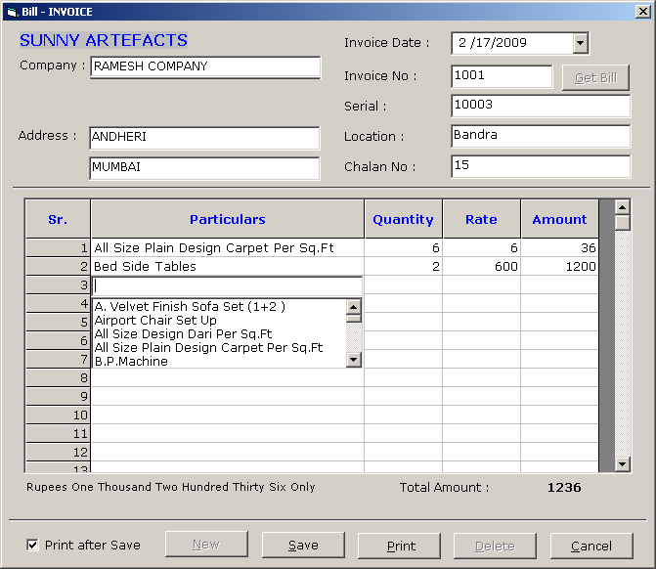

'*************************************
' eBilling System
' Version 1.0.0
' Created by Mr. Atanu Maity
' Date : 21-Aug-2006
'*************************************
' New/Modify Bill Module
' Used Table : Bill
' : Bill Details
' : Product
' : Company
'Module to make new or modify bill,
'Print bill after save the record
'also we make editable flexgrid with
'text box and combobox
'*************************************

Option Explicit
'>>> declare form global variable

Dim AddEdit As String
Dim Rs As New ADODB.Recordset
Dim sno As Integer
Dim SavePrint As String

Private Sub CmdClose_Click()
'>>> check the caption of the button
'>>> close the form or cancel the save
If CmdClose.Caption = "&Close" Then
Unload(Me)
Else
DE(True, False)
End If

End Sub

Private Sub CmdDelete_Click()
'>>> confirm for deletion of bill
'>>> if user select YES delete the record from bill and bill_details
'>>> clear the seleted data from the screen for deleted bill

If MsgBox("Record will delete permantley ?", vbYesNo + vbCritical) = vbYes Then
Cn.Execute("delete from bill_details where bill_sno =" & sno)
Cn.Execute("delete from bill where sno =" & sno)
AddEdit = ""

CmdGetBill.Caption = "&Find"
CmdDelete.Enabled = False
Call ClearField()
If TxtInvoiceNo.Enabled = True Then
TxtInvoiceNo.SetFocus()
End If
End If

End Sub

Private Sub CmdGetBill_Click()
'>>> find the bill details
'>>> find the bill by invoice no
AddEdit = ""
If CmdGetBill.Caption = "&Get Bill" Then
TxtInvoiceNo.Enabled = True

Call ClearField()
TxtInvoiceNo.BackColor = vbYellow
TxtInvoiceNo.SetFocus()
CmdGetBill.Caption = "&Find"

Else
Dim RS1 As New ADODB.Recordset
RS1.Open("select * from bill where invoice_no =" & Val(TxtInvoiceNo.Text) & " and cname='" & CompanyName & "'", Cn, adOpenStatic, adLockReadOnly)
If RS1.RecordCount > 0 Then
'>>> show details from bill table
DtDate.Value = RS1("invoice_date")
TxtLocation.Text = RS1("location")
TxtChalanNo.Text = RS1("chalan_no")
TxtCompany.Text = RS1("customer_name")
TxtAddress1.Text = RS1("customer_address1")
TxtAddress2.Text = RS1("customer_address2")
LblTotalAmount = RS1("total_amt")
LblRsWord.Caption = RS1("amt_word")
TxtSerial.Text = RS1("serial")

'>>> show data from bill_details
Dim Rs2 As New ADODB.Recordset
If Rs2.State = adStateOpen Then Rs2.Close()
Dim Rs3 As New ADODB.Recordset
Rs2.Open("select * from bill_details where bill_sno=" & RS1("sno") & " order by sno ", Cn, adOpenStatic, adLockReadOnly)
If Rs2.RecordCount > 0 Then
Dim i As Integer
Rs2.MoveFirst()
For i = 0 To Rs2.RecordCount - 1
If Rs3.State = adStateOpen Then Rs3.Close()
Rs3.Open("select * from product_master where sno =" & Rs2("prod_sno"), Cn, adOpenStatic, adLockReadOnly)
If Rs3.RecordCount > 0 Then
Mf1.TextMatrix(i + 1, 1) = Rs3("prod_sub_type")
End If
If Rs3.State = adStateOpen Then Rs3.Close()
Mf1.TextMatrix(i + 1, 2) = Rs2("qty")
Mf1.TextMatrix(i + 1, 3) = Rs2("rate")
Mf1.TextMatrix(i + 1, 4) = Rs2("amt")

Rs2.MoveNext()
Next
End If
If Rs2.State = adStateOpen Then Rs2.Close()

CmdGetBill.Caption = "&Get Bill"
CmdDelete.Enabled = True
cmbval.Visible = False
CmdPrint.Enabled = True
CmdSave.Enabled = True

'>>> locak the buttons
Mf1.Enabled = True
cmbval.Enabled = True
TXTVAL.Enabled = True
TxtCompany.Locked = False
TxtAddress1.Locked = False
TxtAddress2.Locked = False
DtDate.Enabled = True
TxtLocation.Locked = False
TxtChalanNo.Locked = False
Else
MsgBox("No Previous Details found for invoice..." & TxtInvoiceNo.Text, vbExclamation)
CmdGetBill.Caption = "&Find"
TxtInvoiceNo.Enabled = True
TxtInvoiceNo.SetFocus()
CmdDelete.Enabled = False
CmdPrint.Enabled = False
CmdSave.Enabled = False

Mf1.Enabled = False
cmbval.Enabled = False
TXTVAL.Enabled = False
TxtCompany.Locked = True
TxtAddress1.Locked = True
TxtAddress2.Locked = True
DtDate.Enabled = False
TxtLocation.Locked = True
TxtChalanNo.Locked = True

End If
If RS1.State = adStateOpen Then RS1.Close()
End If
End Sub

Private Sub CmdNew_Click()
'>>> claer the screen for entering data for new bill
'>>> enable/disable buttons
DE(False, True)

AddEdit = "ADD"

Call ClearField()

'>>> get the new system id from bill
If Rs.State = adStateOpen Then Rs.Close()
Rs.Open("select max(sno) from bill ", Cn, adOpenStatic, adLockReadOnly)
If Rs.RecordCount > 0 Then
sno = IIf(IsNull(Rs(0)) = True, 0, Rs(0)) + 1
End If
If Rs.State = adStateOpen Then Rs.Close()
TxtCompany.SetFocus()
End Sub

Private Sub CmdPrint_Click()
'NOTE : it is not the right solution to call crystal report by temp using temp table
'some time it is a good practice for complecated databse relation table
'This may not run properly in multi user environment
'Better approch is passing value by SelectionFormula in crystal report
'but anyway it is a working solution
'>>> find the bill sno from seleted invoice no
'>>> if record found
'>>> delete temp bill na dbill_details
'>>> insert from bill,bill_details to temp_bill, teemp_bill_details

Dim RS1 As New ADODB.Recordset
If RS1.State = 1 Then RS1.Close()
RS1.Open("select sno from bill where invoice_no=" & Val(TxtInvoiceNo.Text) & " and cname ='" & CompanyName & "'", Cn, adOpenStatic, adLockReadOnly)
If RS1.RecordCount > 0 Then
Cn.Execute("delete from temp_bill_details")
Cn.Execute("delete from temp_bill")
Cn.Execute("insert into temp_bill select * from bill where sno=" & RS1("sno"))
Cn.Execute("insert into temp_bill_details select * from bill_details where bill_sno=" & RS1("sno"))
Call OpenCon()

'>>> call crystal report
Cr1.WindowState = crptMaximized
Cr1.ReportFileName = App.Path & "\reports\bill.rpt"
Cr1.DataFiles(0) = App.Path & "\data.mdb"
Cr1.Action = 1
Else
MsgBox("No Bill found select/enter invoice no for print", vbExclamation)
Exit Sub
End If

End Sub

Private Sub CmdSave_Click()
'>>> validation
'>>> check the required field
If Trim(TxtCompany.Text) = "" Then
MsgBox("Enter Company Name...", vbExclamation)
TxtCompany.SetFocus()
Exit Sub
End If

If IsNumeric(TxtInvoiceNo.Text) = False Then
MsgBox("Enter only Numeric Invoice No...", vbExclamation)
TxtInvoiceNo.SetFocus()
Exit Sub
End If

If Trim(TxtLocation.Text) = "" Then
MsgBox("Enter Location...", vbExclamation)
TxtLocation.SetFocus()
Exit Sub
End If

If Trim(TxtChalanNo.Text) = "" Then
MsgBox("Enter Chalan No...", vbExclamation)
TxtChalanNo.SetFocus()
Exit Sub
End If
If IsNumeric(TxtChalanNo.Text) = False Then
MsgBox("Enter only Numeric Chalan No...", vbExclamation)
TxtChalanNo.SetFocus()
Exit Sub
End If

'>>> reset the transaction
Call OpenCon()

'>>> create transaction for insert bill and bil details
Cn.BeginTrans()
Dim RS1 As New ADODB.Recordset

'>>> check wheather we need to insert or edit the record
'>>> if it is edit, then delete the old bill and insert new record
If AddEdit <> "ADD" Then
If RS1.State = adStateOpen Then RS1.Close()
RS1.Open("select * from bill where invoice_no =" & Val(TxtInvoiceNo.Text) & " and cname='" & CompanyName & "'", Cn, adOpenStatic, adLockReadOnly)
If RS1.RecordCount > 0 Then
sno = RS1("sno")
End If
If RS1.State = adStateOpen Then RS1.Close()
Cn.Execute("delete from bill_details where bill_sno =" & sno)
Cn.Execute("delete from bill where sno =" & sno)
AddEdit = ""
End If

'>>> check for product master
'>>> check the grid
'>>> wheather there is a product or not
'>>> wheater they enter any quantity or not
'>>> wheatehr there is any price or not
'>>> if any thing goes wrong show message
Dim cc As Integer
Dim i As Integer
For i = 1 To Mf1.Rows - 1
Dim Ch As Boolean
Ch = False
If Trim(Mf1.TextMatrix(i, 1)) = "" Then
Ch = True
End If
If RS1.State = adStateOpen Then RS1.Close()
RS1.Open("select sno from product_master where prod_sub_type =" & Chr(34) & Mf1.TextMatrix(i, 1) & Chr(34), Cn, adOpenStatic, adLockReadOnly)
If RS1.RecordCount <= 0 Then

Ch = True
End If
If RS1.State = adStateOpen Then RS1.Close()
If Val(Mf1.TextMatrix(i, 2)) = 0 Then
Ch = True
End If
If Val(Mf1.TextMatrix(i, 3)) = 0 Then
Ch = True
End If
If Val(Mf1.TextMatrix(i, 4)) = 0 Then
Ch = True
End If
If Ch = False Then
cc = cc + 1
End If
Next
If cc = 0 Then
MsgBox("No Bill details found for save", vbExclamation)
Exit Sub
End If

'>>> check for duplicate invoice no
If Rs.State = adStateOpen Then Rs.Close()
Rs.Open("select * from bill where invoice_no=" & Val(TxtInvoiceNo.Text), Cn, adOpenStatic, adLockReadOnly)
If Rs.RecordCount > 0 Then
MsgBox("Invalid Invoice No cannot save..", vbExclamation)
TxtInvoiceNo.SetFocus()
Exit Sub
End If
If Rs.State = adStateOpen Then Rs.Close()

'>>> save record in bill table
RS1.Open("select * from bill where 1=2", Cn, adOpenDynamic, adLockOptimistic)
RS1.AddNew()
RS1("sno") = sno
RS1("invoice_no") = Val(TxtInvoiceNo.Text)
RS1("cname") = CompanyName
RS1("invoice_date") = Format(DtDate.Value, "dd-mmm-yy")
RS1("location") = Trim(TxtLocation.Text)
RS1("chalan_no") = Val(TxtChalanNo.Text)
RS1("customer_name") = Trim(TxtCompany.Text)
RS1("customer_address1") = Trim(TxtAddress1.Text)
RS1("customer_address2") = Trim(TxtAddress2.Text)
RS1("total_amt") = Val(LblTotalAmount.Caption)
RS1("discount") = 0
RS1("amt_word") = LblRsWord
RS1("paid_type") = "NA"
RS1("cheque_no") = "NA"
RS1("entry_date") = Now
RS1("serial") = TxtSerial.Text
RS1.Update()
If RS1.State = 1 Then RS1.Close()

'>>> vaildate each row before save in details
Dim LastSno As Integer
Dim ProdSno As Integer
Dim Rs2 As New ADODB.Recordset
If Rs2.State = 1 Then Rs2.Close()
Rs2.Open("select max(sno) from bill_details", Cn, adOpenStatic, adLockReadOnly)
If Rs2.RecordCount > 0 Then
LastSno = IIf(IsNull(Rs2(0)) = True, 0, Rs2(0)) + 1
End If
For i = 1 To Mf1.Rows - 1

Ch = False
If Trim(Mf1.TextMatrix(i, 1)) = "" Then
Ch = True
End If
If RS1.State = adStateOpen Then RS1.Close()
RS1.Open("select sno from product_master where prod_sub_type =" & Chr(34) & Mf1.TextMatrix(i, 1) & Chr(34), Cn, adOpenStatic, adLockReadOnly)
If RS1.RecordCount > 0 Then
ProdSno = RS1(0)
Else
Ch = True
End If
If RS1.State = adStateOpen Then RS1.Close()
If Val(Mf1.TextMatrix(i, 2)) = 0 Then
Ch = True
End If
If Val(Mf1.TextMatrix(i, 3)) = 0 Then
Ch = True
End If
If Val(Mf1.TextMatrix(i, 4)) = 0 Then
Ch = True
End If
If Ch = False Then

'>>> insert in bill details for each validated grid row
If Rs2.State = 1 Then Rs2.Close()
Rs2.Open("select * from bill_details where 1=2", Cn, adOpenDynamic, adLockOptimistic)
Rs2.AddNew()
Rs2("sno") = LastSno
Rs2("bill_sno") = sno
Rs2("prod_sno") = ProdSno
Rs2("qty") = Val(Mf1.TextMatrix(i, 2))
Rs2("rate") = Val(Mf1.TextMatrix(i, 3))
Rs2("amt") = Val(Mf1.TextMatrix(i, 4))
Rs2.Update()
If Rs2.State = 1 Then Rs2.Close()
LastSno = LastSno + 1
End If
Next

'>>> commit the transaction
Cn.CommitTrans()
MsgBox("Bill Saved", vbInformation)
If ChkPrint.Value = 1 Then
'>>> call the report for print of the saved bill
CmdPrint_Click()
End If
'>>> prepare for new bill entry
AddEdit = ""
Call ClearField()
Call CmdNew_Click()

End Sub

Private Sub DtDate_KeyDown(ByVal KeyCode As Integer, ByVal Shift As Integer)
'>>> move the cursor to new field
If KeyCode = 13 Then
SendKeys("{tab}")
End If
End Sub

Private Sub DtDate_KeyPress(ByVal KeyAscii As Integer)
'>>> move the cursor to new field
If KeyAscii = 13 Then
SendKeys("{tab}")
End If
End Sub

Private Sub Form_Load()
'>>> cnter the form
Me.Left = (Screen.Width - Me.Width) / 2
Me.Top = (Screen.Height - Me.Height) / 2

'>>> reset connection
Call OpenCon()
LblCompanyName.Caption = CompanyName
DtDate.Value = Now

'>>> clear the form for new bill entry
Call ClearField()

'>>> enable/diable buttons
DE(True, False)

'>>> load last status for bill print after saved
Dim ChkV As Integer
ChkV = Val(GetSetting("billsystem", "print", "checkprint", "1"))
ChkPrint.Value = ChkV

'>>> load clent name from the table
Rs.Open("select client_name from client_master where client_name is not null order by client_name", Cn, adOpenStatic, adLockReadOnly)

While Not Rs.EOF
TxtCompany.AddItem(Rs(0))
Rs.MoveNext()
End While

Picture1.Visible = True
End Sub
Private Sub DE(ByVal T1 As Boolean, ByVal T2 As Boolean)

'>>> enable/disable buttons
CmdGetBill.Enabled = T1
CmdNew.Enabled = T1
CmdSave.Enabled = T2
CmdPrint.Enabled = T2

TXTVAL.Enabled = T2
cmbval.Enabled = T2
Mf1.Enabled = T2
If T1 = True Then
CmdClose.Caption = "&Close"
Else
CmdClose.Caption = "&Cancel"
End If

TxtCompany.Locked = T1
TxtAddress1.Locked = T1
TxtAddress2.Locked = T1
DtDate.Enabled = T2
TxtLocation.Locked = T1
TxtChalanNo.Locked = T1
TxtInvoiceNo.BackColor = vbWhite
CmdDelete.Enabled = False
End Sub

Private Sub ClearField()
'>>> clear the fields
TxtCompany.Text = ""
TxtAddress1.Text = ""
TxtAddress2.Text = ""
TxtInvoiceNo.Text = ""
TxtLocation.Text = ""
LblRsWord.Caption = ""
LblTotalAmount.Caption = ""
TxtChalanNo.Text = ""
TxtSerial.Text = ""

'>>> for grid edit
Call set_heading()
Call move_textbox()
End Sub

Private Sub Form_QueryUnload(ByVal Cancel As Integer, ByVal UnloadMode As Integer)

'>>> save last status for bill print after saved in the registry

If ChkPrint.Value = 1 Then
SaveSetting("billsystem", "print", "checkprint", "1")
Else
SaveSetting("billsystem", "print", "checkprint", "0")
End If
End Sub

Private Sub TxtAddress1_KeyPress(ByVal KeyAscii As Integer)
'>>> move the focus to next control
If KeyAscii = 13 Then
SendKeys("{tab}")
End If
End Sub

Private Sub TxtAddress2_KeyPress(ByVal KeyAscii As Integer)
'>>> move the focus to next control
If KeyAscii = 13 Then
SendKeys("{tab}")
End If
End Sub

Private Sub TxtChalanNo_KeyPress(ByVal KeyAscii As Integer)
'>>> move the focus to next control

If KeyAscii = 13 Then
cmbval.SetFocus()
End If
End Sub

Private Sub TxtCompany_GotFocus()
'>>> make listbox as editable textbox
TxtCompany.Height = 1020
Picture1.Visible = False
End Sub

Private Sub TxtCompany_KeyDown(ByVal KeyCode As Integer, ByVal Shift As Integer)
'>>> show the address of the seleted company
Dim RS1 As New ADODB.Recordset
If RS1.State = adStateOpen Then RS1.Close()
RS1.Open("select * from client_master where client_name='" & TxtCompany.Text & "'", Cn)
If RS1.RecordCount > 0 Then
TxtAddress1.Text = IIf(IsNull(RS1("address1")) = True, "", RS1("address1"))
TxtAddress2.Text = IIf(IsNull(RS1("address2")) = True, "", RS1("address2"))
Else
TxtAddress1.Text = ""
TxtAddress2.Text = ""
End If
If RS1.State = adStateOpen Then RS1.Close()
End Sub

Private Sub TxtCompany_KeyPress(ByVal KeyAscii As Integer)
'>>> move the focus to next control

If KeyAscii = 13 Then
SendKeys("{tab}")
End If
End Sub

Private Sub TxtCompany_LostFocus()
'>>> move the focus to next control

TxtCompany.Height = 330
Picture1.Visible = True
End Sub

Private Sub TxtInvoiceNo_KeyDown(ByVal KeyCode As Integer, ByVal Shift As Integer)
'>>> call getbill by enter key in invoice no text box
If KeyCode = 13 And CmdGetBill.Caption = "&Find" Then
CmdGetBill_Click()
End If

End Sub

Private Sub TxtLocation_KeyPress(ByVal KeyAscii As Integer)
'>>> move the focus to next control
If KeyAscii = 13 Then
SendKeys("{tab}")
End If
End Sub

Private Sub TxtSerial_KeyPress(ByVal KeyAscii As Integer)
'>>> move the focus to next control
If KeyAscii = 13 Then
SendKeys("{tab}")
End If
End Sub

Private Sub TXTVAL_KeyPress(ByVal KeyAscii As Integer)
'>>> make flex gird editable move th textbox in gid cell for entering value
'>>> check wheathe we press enter key
'>>> if yes..move the control to next grod
Dim t As Integer

If KeyAscii = 13 And Mf1.Col = 2 Then
If IsNumeric(TXTVAL.Text) = False Then
KeyAscii = 0
Exit Sub
End If
Mf1.Text = TXTVAL.Text
'>>> show total
Mf1.TextMatrix(Mf1.Row, Mf1.Col + 2) = Val(Mf1.TextMatrix(Mf1.Row, Mf1.Col + 1)) * TXTVAL.Text
Dim x As Integer
Dim T1 As Double
For x = 1 To Mf1.Rows - 1
T1 = T1 + Val(Mf1.TextMatrix(x, 4))
Next
LblTotalAmount.Caption = T1
LblRsWord = RsWord(LblTotalAmount.Caption)

If Mf1.Col <> Mf1.Cols - 3 Then
Mf1.Col = Mf1.Col + 1

Else

If Mf1.Row <> Mf1.Rows - 2 Then
'>>> go to next row
Mf1.Row = Mf1.Row + 1
Else
'>>> add new rows
Mf1.Rows = Mf1.Rows + 1

'>>> set the current row
Mf1.Row = Mf1.Row + 1
'>>> set sr no
Mf1.TextMatrix(Mf1.Row, 0) = Val(Mf1.TextMatrix(Mf1.Row - 1, 0)) + 1
End If
Mf1.Col = 1
End If
move_textbox()
'>>> select the text in text box
TXTVAL.SelStart = 0
TXTVAL.SelLength = Len(TXTVAL.Text)
End If

End Sub

Private Sub cmbval_KeyPress(ByVal KeyAscii As Integer)
'>>> make flex gird editable move th combobox in gid cell for seleting value
'>>> check wheathe we press enter key
'>>> if yes..move the control to next grod

Dim t As Integer

If KeyAscii = 13 Then
'>>> find prod rate
Dim RS1 As New ADODB.Recordset
If RS1.State = adStateOpen Then RS1.Close()
RS1.Open("select * from product_master where prod_sub_type=" & Chr(34) & cmbval.Text & Chr(34), Cn, adOpenStatic, adLockReadOnly)
If RS1.RecordCount > 0 Then
Mf1.TextMatrix(Mf1.Row, Mf1.Col + 2) = RS1("rate")
Else
KeyAscii = 0
Exit Sub
End If

Mf1.Text = cmbval.Text

'>>> show total
Mf1.TextMatrix(Mf1.Row, 4) = Val(Mf1.TextMatrix(Mf1.Row, 2)) * Val(Mf1.TextMatrix(Mf1.Row, 3))
Dim x As Integer
Dim T1 As Double
For x = 1 To Mf1.Rows - 1
T1 = T1 + Val(Mf1.TextMatrix(x, 4))
Next
LblTotalAmount.Caption = T1
LblRsWord = RsWord(LblTotalAmount.Caption)

If Mf1.Col <> Mf1.Cols - 2 Then

Mf1.Col = Mf1.Col + 1
Else
If Mf1.Row <> Mf1.Rows - 1 Then
Mf1.Row = Mf1.Row + 1

Else
'>>> add new rows
Mf1.Rows = Mf1.Rows + 1

'>>> set the current row
Mf1.Row = Mf1.Row + 1

'>>> set sr no
Mf1.TextMatrix(Mf1.Row, 0) = Val(Mf1.TextMatrix(Mf1.Row - 1, 0)) + 1
End If
Mf1.Col = 1
End If
move_textbox()
cmbval.SelStart = 0
cmbval.SelLength = Len(cmbval.Text)
End If
End Sub

Public Sub set_heading()
'>>> creating for the grid

Dim K As Integer
Dim t As Integer
Mf1.Clear()
Mf1.Refresh()
Mf1.Rows = 30
Mf1.Cols = 5

Mf1.Row = 0
Mf1.RowHeight(0) = 600

Mf1.Col = 0
Mf1.ColWidth(0) = 1000
Mf1.CellForeColor = vbBlue
Mf1.CellFontBold = True
Mf1.CellAlignment = 4
Mf1.Text = "Sr."

Mf1.Col = 1
Mf1.ColWidth(1) = 4200
Mf1.CellForeColor = vbBlue
Mf1.CellFontBold = True
Mf1.CellAlignment = 4
Mf1.Text = "Particulars"

Mf1.Col = 2
Mf1.ColWidth(2) = 1200
Mf1.CellForeColor = vbBlue
Mf1.CellFontBold = True
Mf1.CellAlignment = 4
Mf1.Text = "Quantity"

Mf1.Col = 3
Mf1.ColWidth(3) = 1200
Mf1.CellForeColor = vbBlue
Mf1.CellFontBold = True
Mf1.CellAlignment = 4
Mf1.Text = "Rate"

Mf1.Col = 4
Mf1.ColWidth(4) = 1200
Mf1.CellForeColor = vbBlue
Mf1.CellFontBold = True
Mf1.CellAlignment = 4
Mf1.Text = "Amount"

Mf1.TextMatrix(1, 0) = "1"

Mf1.Row = 0
For K = 0 To Mf1.Cols - 1
Mf1.Col = K
Mf1.CellFontBold = True
Next

Mf1.Row = 1
Mf1.Col = 1

'>>> set serial from 1.2...
For K = 1 To Mf1.Rows - 1
Mf1.TextMatrix(K, 0) = K
Next
Mf1.Row = 1
End Sub

Private Sub MF1_EnterCell()
'>>> call appropriate control for edit the grid
If Mf1.Col = 1 Then
'>>> visble combo box for select product
cmbval.Visible = True
TXTVAL.Visible = False
If cmbval.Visible = True Then
If cmbval.Enabled = True Then
cmbval.SetFocus()
End If
End If

cmbval.Clear()
Dim Rs As New ADODB.Recordset
If Rs.State = 1 Then Rs.Close()

'>>>Fill item
If Mf1.Col = 1 Then
Rs.Open("select prod_sub_type from product_master order by prod_sub_type", Cn, adOpenStatic, adLockReadOnly)

While Not Rs.EOF
cmbval.AddItem(Rs(0))
Rs.MoveNext()
End While

ElseIf Mf1.Col = 3 Then
cmbval.AddItem("")
End If

Else
'>>> visble text box for entring quantity
cmbval.Visible = False
TXTVAL.Visible = True
If TXTVAL.Visible = True Then
If TXTVAL.Enabled = True Then
TXTVAL.SetFocus()
End If
End If

End If

Call move_textbox()
End Sub

Public Sub move_textbox()
'>>align textbox as per grid cell and set text
TXTVAL.Left = Mf1.CellLeft + Mf1.Left
TXTVAL.Top = Mf1.CellTop + Mf1.Top
TXTVAL.Width = Mf1.CellWidth
TXTVAL.Height = Mf1.CellHeight
TXTVAL.Text = Mf1.Text

'>>align combo box as per grid cell and set text
cmbval.Left = Mf1.CellLeft + Mf1.Left
cmbval.Top = Mf1.CellTop + Mf1.Top
cmbval.Width = Mf1.CellWidth
cmbval.Text = Mf1.Text
End Sub

(Print out of the bill)

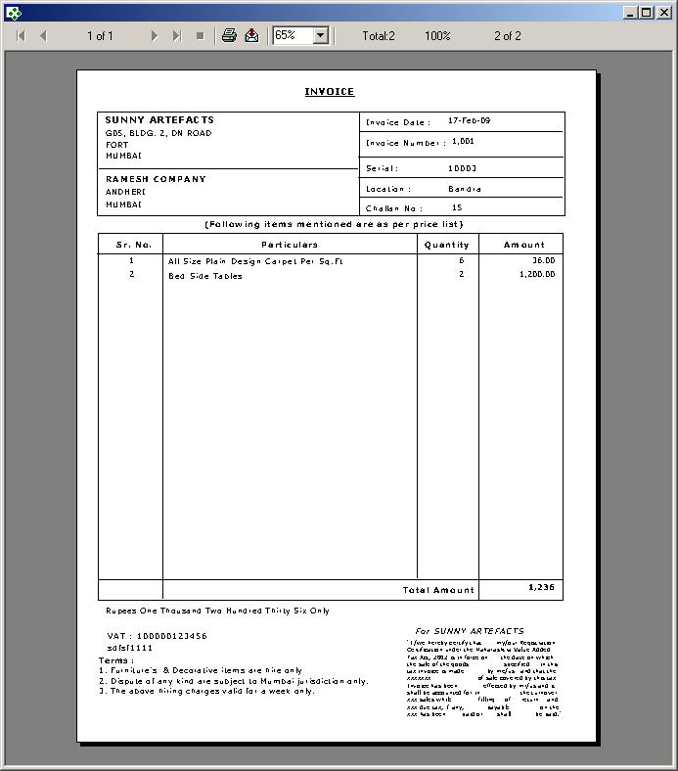

FrmReports
(Show Different Report Options)

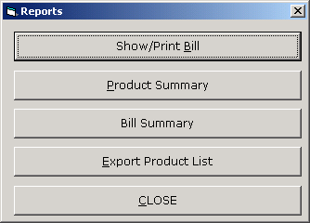

'*************************************
' eBilling System
' Version 1.0.0
' Created by Mr. Atanu Maity
' Date : 21-Aug-2006
'*************************************
' Show report options
'
'
'allow user to select diffrent report
'*************************************

Option Explicit

Private Sub CmdBillSummary_Click()
'>>> show bill summary
FrmBillSummary.Show(1)
End Sub

Private Sub CmdClose_Click()
'>>> cloase the form
Unload(Me)
End Sub

Private Sub CmdExport_Click()
'>>> show export product form
FrmExportData.Show(1)
End Sub

Private Sub CmdPrintBill_Click()
'>> show print bill
FrmPrintBill.Show(1)
End Sub

Private Sub CmdProductSummary_Click()
'>>> show all product list report
Cr1.WindowState = crptMaximized
Cr1.ReportFileName = App.Path & "\reports\products.rpt"
Cr1.DataFiles(0) = App.Path & "\data.mdb"
Cr1.Action = 1
End Sub

Private Sub Form_Load()
'>>> center the form
Me.Move (Screen.Width - Width) / 2, (Screen.Height - Height) / 2

End Sub

FrmPrintBill
(Print already saved bill)

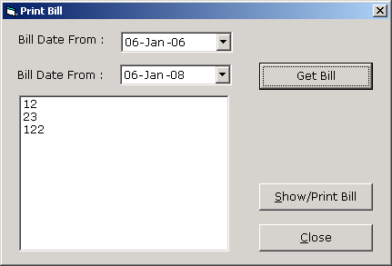

'*************************************
' eBilling System
' Version 1.0.0
' Created by Mr. Atanu Maity
' Date : 21-Aug-2006
'*************************************
' Print already saved bill
' Used Table : bill
' : bill_details
'Module to allow user to select the invoice
'no from seleted date range
'and open the bill by its invoice/bill no
'*************************************

Option Explicit
Dim Rs As New ADODB.Recordset

Private Sub CmdClose_Click()
'>>> close the bill
Unload(Me)
End Sub

Private Sub CmdGetBill_Click()
'>>> get bill no as per selected date range
'>>> fill the list box from record set
LstInvoiceNo.Clear()
If Rs.State = adStateOpen Then Rs.Close()
Rs.Open("select invoice_no from bill where invoice_date>=#" & Format(DTPicker1.Value, "dd-mmm-yy") & "# and invoice_date<=#" & Format(DTPicker2.Value, "dd-mmm-yy") & "# and cname='" & CompanyName & "' order by invoice_no", Cn, adOpenStatic, adLockReadOnly)
While Rs.EOF = False
LstInvoiceNo.AddItem(Rs(0))
Rs.MoveNext()
End While

End Sub

Private Sub CmdShowBill_Click()
'>>> get teh bill details from bill table as per selected bill no
If LstInvoiceNo.ListIndex < 0 Then Exit Sub
Dim RS1 As New ADODB.Recordset
If RS1.State = 1 Then RS1.Close()
RS1.Open("select sno from bill where invoice_no=" & Val(LstInvoiceNo.Text) & " and cname ='" & CompanyName & "'", Cn, adOpenStatic, adLockReadOnly)
If RS1.RecordCount > 0 Then
'>>> delete old data from temp table and insert from bill, bill_deatils table
Cn.Execute("delete from temp_bill_details")
Cn.Execute("delete from temp_bill")
Cn.Execute("insert into temp_bill select * from bill where sno=" & RS1("sno"))
Cn.Execute("insert into temp_bill_details select * from bill_details where bill_sno=" & RS1("sno"))
'>>> reset the connection
Call OpenCon()
'>>> open the crystal report
Cr1.DataFiles(0) = App.Path & "\data.mdb"
Cr1.WindowState = crptMaximized
Cr1.ReportFileName = App.Path & "\reports\bill.rpt"
Cr1.Action = 1
Else
MsgBox("No Bill found select/enter invoice no for print", vbExclamation)
Exit Sub
End If
End Sub

Private Sub Form_Load()

'>>> center form
Me.Move (Screen.Width - Width) / 2, (Screen.Height - Height) / 2

LstInvoiceNo.Clear()
'>>> set datepicker to current date
DTPicker1.Value = Date
DTPicker2.Value = Date
'>>> reset connection
Call OpenCon()
End Sub

ProductSummary Report
(Show Product Summary report in crystal report)

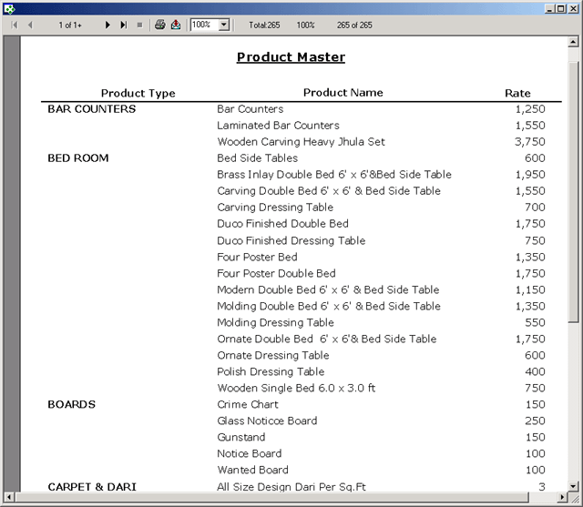

FrmBillSummary
(Show bill summary for particular date range)

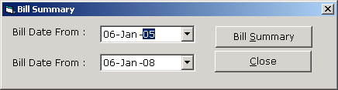

'*************************************
' eBilling System
' Version 1.0.0
' Created by Mr. Atanu Maity
' Date : 21-Aug-2006
'*************************************
' Show summery of bill
' Used Table : bill
' : bill_details
'show bill summary for seleted date
'range, show report in crystal report
'move data into temp table and show
'report from temp table
'*************************************
Option Explicit

Private Sub CmdClose_Click()
'>>> close the form
Unload(Me)
End Sub

Private Sub CmdGetBill_Click()
'NOTE : it is not the right solution to call crystal report by temp using temp table
'some time it is a good practice for complecated databse relation table
'This may not run properly in multi user environment
'Better approch is passing value by SelectionFormula in crystal report
'but anyway it is a working solution
'>>> find the bill sno from seleted invoice no
'>>> if record found
'>>> delete temp bill na dbill_details
'>>> insert from bill,bill_details to temp_bill, teemp_bill_details

Cn.Execute("delete from temp_bill_details")
Cn.Execute("delete from temp_bill")
Cn.Execute("insert into temp_bill select * from bill where invoice_date>=#" & Format(DTPicker1.Value, "dd-mmm-yy") & "# and invoice_date<=#" & Format(DTPicker2.Value, "dd-mmm-yy") & "# and cname='" & CompanyName & "' ")
Cn.Execute("insert into temp_bill_details select * from bill_details where bill_sno in ( select sno from bill where invoice_date >=#" & Format(DTPicker1.Value, "dd-mmm-yy") & "# and invoice_date<=#" & Format(DTPicker2.Value, "dd-mmm-yy") & "# and cname='" & CompanyName & "')")
Call OpenCon()

'>>> open crystal report
Cr1.DataFiles(0) = App.Path & "\data.mdb"
Cr1.WindowState = crptMaximized
Cr1.ReportFileName = App.Path & "\reports\billsummary.rpt"
Cr1.Action = 1

End Sub

Private Sub Form_Load()
'>>> cnter the form
Me.Left = (Screen.Width - Me.Width) / 2
Me.Top = (Screen.Height - Me.Height) / 2

'>>> show the current date
DTPicker1.Value = Date
DTPicker2.Value = Date
End Sub

Bill Summary Report

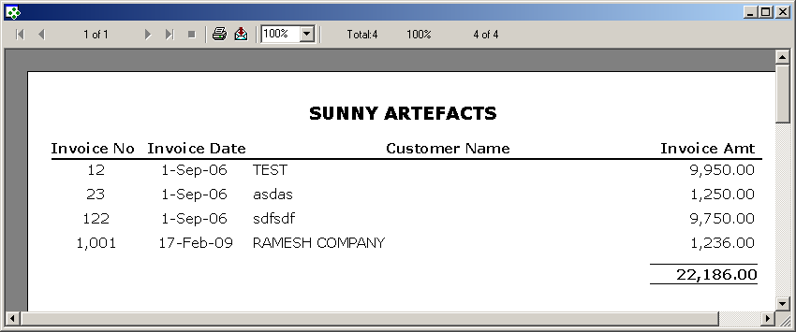

FrmExportData
(Export product Data in FlexGrid and MS-Excel with formatting)

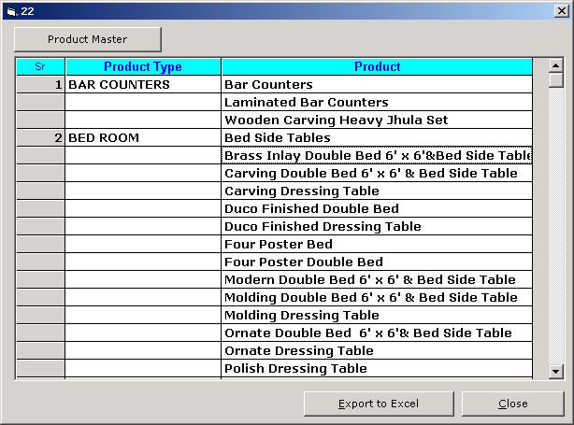

'*************************************
' eBilling System
' Version 1.0.0
' Created by Mr. Atanu Maity
' Date : 21-Aug-2006
'*************************************
' Export product_master in grid and ms-excel
' Used Table : product_master
'open the product_master in grid
'display record in flex grid with gropu by product type
'*************************************
Option Explicit

Private Sub CmdClose_Click()
'>>> close the form
Unload(Me)
End Sub

Private Sub CmdExcel_Click()
'>>>export data into ms excel from grid with formatting
'>>> check the grid
If Mf1.TextMatrix(0, 0) = "" Then
MsgBox("No Records Available for Exporting ... ", vbExclamation)
Exit Sub
End If
Label1.Caption = "WAIT ... Generate Excel "
Label1.Refresh()

'>>> creating excel object variable
Dim ex As New Excel.Application
Dim wb As New Workbook
Dim Es As New Worksheet
wb = ex.Workbooks.Add
Es = wb.Worksheets(1)
Dim i As Integer
Dim j As Integer
'>>> set excel columns width as per flex grid columns width
For i = 0 To Mf1.Cols - 1
Mf1.Row = 1
Mf1.Col = i
Es.Columns(ReturnAlphabet(i + 1) & ":" & ReturnAlphabet(i + 1)).ColumnWidth = Mf1.CellWidth / 110
Next
'>>> set data from grid to excel row, column wise
Dim K As Integer
For i = 0 To Mf1.Rows - 1
For j = 0 To Mf1.Cols - 1
ex.Cells(i + 1, j + 1) = Mf1.TextMatrix(i, j)
Next
Next

Dim R1 As String
Dim R2 As String
R2 = ReturnAlphabet(Mf1.Cols) & "1"

'>>> formatting excel
Dim x As Range
'>>>head
x = Es.Range("A1:" & R2)
x.Font.Bold = True
x.Font.ColorIndex = 40
x.Interior.ColorIndex = 9
x.Interior.Pattern = xlSolid
x.HorizontalAlignment = xlCenter
x.VerticalAlignment = xlBottom

'>>>border
R2 = ReturnAlphabet(Mf1.Cols) & Mf1.Rows - 1
x = Es.Range("A1:" & R2)

With x.Borders(xlEdgeLeft)
.LineStyle = xlContinuous
.Weight = xlThin
.ColorIndex = xlAutomatic
End With
With x.Borders(xlEdgeTop)
.LineStyle = xlContinuous
.Weight = xlThin
.ColorIndex = xlAutomatic
End With
With x.Borders(xlEdgeBottom)
.LineStyle = xlContinuous
.Weight = xlThin
.ColorIndex = xlAutomatic
End With
With x.Borders(xlEdgeRight)
.LineStyle = xlContinuous
.Weight = xlThin
.ColorIndex = xlAutomatic
End With
With x.Borders(xlInsideVertical)
.LineStyle = xlContinuous
.Weight = xlThin
.ColorIndex = xlAutomatic
End With
With x.Borders(xlInsideHorizontal)
.LineStyle = xlContinuous
.Weight = xlThin
.ColorIndex = xlAutomatic
End With
'>>> FILL DETAILS
x = Es.Range("A2:" & R2)
x.Interior.ColorIndex = 40

'>>TOTAL

R2 = ReturnAlphabet(Mf1.Cols) & Mf1.Rows
x = Es.Range("A" & Mf1.Rows & ":" & R2)
x.Font.Bold = True
x.Font.ColorIndex = 9
'
Es.Name = "Report"

ex.Visible = True

ex.Quit()
wb = Nothing
Es = Nothing
ex = Nothing

'>>> process complete

Label1.Caption = "Ready"
Label1.Refresh()

End Sub

Private Sub CmdProductMaster_Click()
'>>> reset the grid

Mf1.Rows = 2
Mf1.Cols = 3
Mf1.Clear()
Mf1.Refresh()

Mf1.Row = 0

Mf1.Col = 0
Mf1.ColWidth(0) = 800
Mf1.Text = "Sr"
Mf1.CellAlignment = 4
Mf1.CellFontName = "Arial"
Mf1.Font.Size = 10
Mf1.Font.Bold = True
Mf1.CellForeColor = vbBlue
Mf1.CellBackColor = vbCyan

Mf1.Col = 1
Mf1.ColWidth(1) = 2500
Mf1.Text = "Product Type"
Mf1.CellAlignment = 4
Mf1.CellFontName = "Arial"
Mf1.Font.Size = 10
Mf1.Font.Bold = True
Mf1.CellForeColor = vbBlue
Mf1.CellBackColor = vbCyan

Mf1.Col = 2
Mf1.ColWidth(2) = 5000
Mf1.Text = "Product"
Mf1.CellAlignment = 4
Mf1.CellFontName = "Arial"
Mf1.Font.Size = 10
Mf1.Font.Bold = True
Mf1.CellForeColor = vbBlue
Mf1.CellBackColor = vbCyan

'>>> find distinct product type from product master
'>>> loop all product type
Dim RS1 As New ADODB.Recordset
Dim Rs2 As New ADODB.Recordset
RS1.Open("select distinct prod_type from product_master", Cn, adOpenStatic, adLockReadOnly)
Dim i As Integer
Dim j As Integer
For i = 0 To RS1.RecordCount - 1
Me.Caption = i + 1
Mf1.Row = Mf1.Rows - 1
Mf1.Col = 0
Mf1.Text = i + 1

Mf1.Col = 1
Mf1.Text = RS1("prod_type")
'>>> query product master for each prod type from outer loop
If Rs2.State = adStateOpen Then Rs2.Close()
Rs2.Open("select prod_sub_type from product_master where prod_type ='" & RS1("prod_type") & "' order by prod_sub_type", Cn, adOpenStatic, adLockReadOnly)
For j = 0 To Rs2.RecordCount - 1
Mf1.Row = Mf1.Rows - 1
Mf1.Col = 2
Mf1.Text = Rs2(0)

Mf1.Rows = Mf1.Rows + 1
Rs2.MoveNext()
Next
RS1.MoveNext()
Next

End Sub

Private Sub Form_Load()
'>>> cnter the form
Me.Left = (Screen.Width - Me.Width)
Me.Top = (Screen.Height - Me.Height)

End Sub

Export product Data MS-Excel with formatting

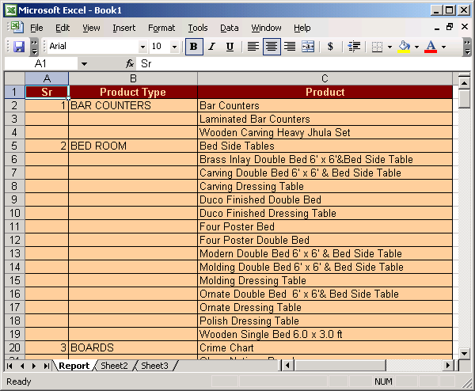

FrmUtlity
(To Access different utility program like compact, backup, change password etc.)

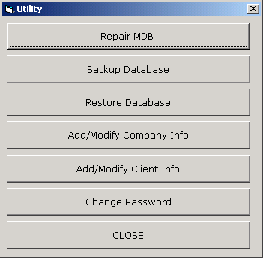

'*************************************
' eBilling System
' Version 1.0.0
' Created by Mr. Atanu Maity
' Date : 21-Aug-2006
'*************************************
' Show options for utilities
'
'
'allow user to select diffrent options
'*************************************
Option Explicit

Private Sub CmdAddModifyClient_Click()
FrmClientInfo.Show(1)
End Sub

Private Sub CmdAddModifyCompany_Click()
FrmCompanyInfo.Show(1)
End Sub

Private Sub CmdBackUp_Click()
FrmBackupDatabase.Show(1)
End Sub

Private Sub CmdChangePassword_Click()
FrmChangePassword.Show(1)
End Sub

Private Sub CmdClose_Click()
Unload(Me)
End Sub

Private Sub CmdRepair_Click()
FrmCompactAndRepairDatabase.Show(1)
End Sub

Private Sub Command1_Click()

End Sub

Private Sub Command2_Click()

End Sub

Private Sub Command4_Click()
Unload(Me)
End Sub

Private Sub CmdRestore_Click()
MsgBox("Copy last backup file, rename it to data.mdb and then paste it in application folder." & vbCrLf & vbCrLf & "Contact program vendor..it may cause lost of data, if backup is not current", vbCritical)

End Sub

Private Sub Form_Load()
'>>> center the form
Me.Move (Screen.Width - Width) / 2, (Screen.Height - Height) / 2

'>>> check user type and show diffrent options as per user rights
If LCase(UserType) <> "admin" Then
CmdRepair.Enabled = False
CmdBackUp.Enabled = False
CmdAddModifyCompany.Enabled = False
CmdRestore.Enabled = False
End If
End Sub

FrmCompactAndRepairDatabase
(To shrink and compact main database data.mdb.)

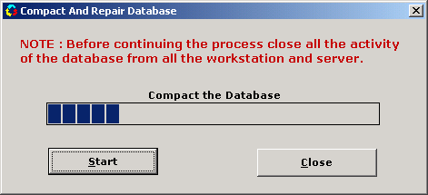

'*************************************
' eBilling System
' Version 1.0.0
' Created by Mr. Atanu Maity
' Date : 21-Aug-2006
'*************************************
' comapct/shrink the access database
' Used Table : NA
'check the repairdb.mdb file in application path
'if it is already their delete the file
'use DBENGINE CompactDatabase function to comapct the access database
'create new compacted tempdb.mdb from data.mdb.
'delete old data.mdb and rename tempdb.mdb to data.mdb
'*************************************

Option Explicit

Dim dbE As New DAO.DBEngine

Private Sub Command1_Click()
Unload(Me)
End Sub

Private Sub Command2_Click()
'>>> if any connection open close all the connection
If Cn.State = 1 Then Cn.Close()
Dim x As String
'>>> check allready file is there or not
x = Dir(App.Path & "\repairedDB.mdb")
'>>> if file present delete the file
If x <> "" Then Kill(App.Path & "\repairedDB.mdb")
Timer1.Enabled = True
'>>> compact teh database
dbE.CompactDatabase(App.Path & "\data.mdb", App.Path & "\RepairedDB")
'>>> delete old database
Kill(App.Path & "\data.mdb")
'>>> rename the new database to old database
Name App.Path & "\repairedDB.mdb" As App.Path & "\data.mdb"
'>>> open connection
Call OpenCon()
End Sub

Private Sub Form_Load()
'>>> center the form
Me.Move (Screen.Width - Width) / 2, (Screen.Height - Height) / 2
'>>> set the progress bar initial value
ProgressBar1.Min = 0
ProgressBar1.Max = 100
End Sub

Private Sub Timer1_Timer()
'>> show the progress of compact process
If ProgressBar1.Value < 100 Then
ProgressBar1.Value = ProgressBar1.Value + 10
Else
MsgBox("Process Complete Successfully ..", vbInformation)
ProgressBar1.Value = 0 'Reset the min value
Timer1.Enabled = False 'Disable the Timer
End If
End Sub

FrmBackupDatabase
(To take backup of main database data.mdb.)

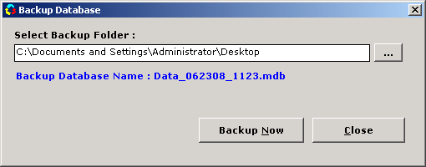

'*************************************
' eBilling System
' Version 1.0.0
' Created by Mr. Atanu Maity
' Date : 21-Aug-2006
'*************************************
' Backup the Database (data.mdb)
' Used Table : NA
'Module to take a copy of data.mdb in
'diffrent location with timestramp
'*************************************

Option Explicit
'>>> Declare File System variable
Dim Fs As New FileSystemObject
Dim NewFile As String

Private Sub Command1_Click()
'>>> open folder browser dialog
'>>> select the folder path
'>>> store the path in text box text1
Dim S As String
S = BrowseFolders(hWnd, "Select Folder for Creating Backup file ... ", BrowseForEverything, CSIDL_DESKTOP)
If S = "" Then
MsgBox("Select Valid Folder for Creating Dump File.", vbInformation, "Creating Dump")
Command1.SetFocus()
Exit Sub
Else
If Fs.FolderExists(S) = False Then
MsgBox("Invalid Folder,Select Valid Folder. ", vbInformation, "Creating Dump")
Command1.SetFocus()
Exit Sub
End If
Text1.Text = S
End If

End Sub

Private Sub Command2_Click()
On Error GoTo myer1
'>>> check the selected folder wheather
'>>> it is exist or not
If Fs.FolderExists(Text1) = False Then
MsgBox("Invalid Folder,Select Valid Folder. ", vbInformation, "Creating Dump")
Command1.SetFocus()
Exit Sub
End If

'>>> save the settings in registry
SaveSetting("BILLING_SOFTWARE", "BACKUP_DATABASE", "BACKUP_PATH", Text1)

'>>> copy the database file in selected folder for backup
Fs.CopyFile(App.Path & "\data.mdb", Text1.Text & "\" & NewFile, False)
MsgBox("Backup Process Complete.", vbInformation)
Exit Sub
myer1:
'>> check the folder if the file alreday exist warn for overwrite
If Err.Number = 58 Then
If MsgBox("File Allready exist in same name , do you want to overwrite the existing file ..", vbExclamation + vbYesNo + vbDefaultButton1) = vbYes Then
Fs.CopyFile(App.Path & "\data.mdb", Text1.Text & "\" & NewFile, True)
MsgBox("Backup Process Complete", vbInformation)
End If
Else
MsgBox("Can not complete backup following error occured : " & Err.Description, vbCritical)
End If

End Sub

Private Sub Command3_Click()
Unload(Me)
End Sub

Private Sub Form_Load()

'>>> center the form
Me.Move (Screen.Width - Width) / 2, (Screen.Height - Height) / 2

'>>> new backup file name like data_040108_1745.mdb
NewFile = "Data_" & Format(Now, "ddnnyy_hhnn") & ".mdb"
Label2.Caption = "Backup Database Name : " & NewFile

'>>> load the last saved settings from registry
Text1.Text = GetSetting("BILLING_SOFTWARE", "BACKUP_DATABASE", "BACKUP_PATH", "")
End Sub

FrmCompanyInfo
(Add/Modify Company Info)

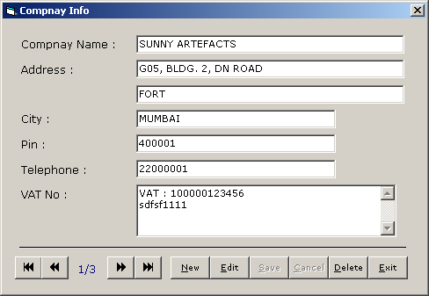

'*************************************
' eBilling System
' Version 1.0.0
' Created by Mr. Atanu Maity
' Date : 21-Aug-2006
'*************************************
' add/edit/delete company details
' Used Table : company_master
'open the company_master
'display first record in form load
'add edit save delete and navigation
'*************************************

Option Explicit
Dim RS1 As New ADODB.Recordset
Dim AddEdit As String

Private Sub Command1_Click()
'>>> close the form
Unload(Me)
End Sub

Private Sub Command11_Click()
'>>> delete the record
If RS1.State = adStateClosed Then Exit Sub
If RS1.RecordCount <= 0 Then Exit Sub

On Error GoTo myer1
'>>> confirm before delete
If MsgBox("Delete the Record ? ", vbCritical + vbYesNo) = vbYes Then
RS1.Delete()
Call ClearText()
Command4_Click()
End If
Exit Sub
myer1:
MsgBox("Error Occured : " & Err.Description, vbCritical)
End Sub

Private Sub Command2_Click()
'>>> move record ponter to first record
'>>> display first record
On Error Resume Next
If RS1.State = adStateClosed Then Exit Sub
If RS1.RecordCount <= 0 Then Exit Sub
RS1.MoveFirst()
Call DisplayRecord()
End Sub

Private Sub Command3_Click()
'>>> move back the record pointer and display current record
On Error Resume Next
If RS1.State = adStateClosed Then Exit Sub
If RS1.RecordCount <= 0 Then Exit Sub
If RS1.AbsolutePosition > 1 Then
RS1.MovePrevious()
Else
MsgBox("First Record ..", vbInformation)

RS1.MoveFirst()
End If
Call DisplayRecord()

End Sub

Private Sub Command4_Click()
'>>> move next the record pointer and display current record
On Error Resume Next
If RS1.State = adStateClosed Then Exit Sub
If RS1.RecordCount <= 0 Then Exit Sub
If RS1.AbsolutePosition < RS1.RecordCount Then
RS1.MoveNext()
Else
MsgBox("Last Record ..", vbInformation)

RS1.MoveLast()
End If
Call DisplayRecord()

End Sub

Private Sub Command5_Click()
'>>> move last the record pointer and display current record
On Error Resume Next
If RS1.State = adStateClosed Then Exit Sub
If RS1.RecordCount <= 0 Then Exit Sub
RS1.MoveLast()
Call DisplayRecord()

End Sub

Private Sub Command6_Click()
'>>> prepare for add record, clear all text box, set flag to ADD
If RS1.State = adStateClosed Then Exit Sub
If RS1.RecordCount <= 0 Then Exit Sub
AddEdit = "ADD"
Call ClearText()
DE(False, True)
TxtCompanyName.SetFocus()
End Sub

Private Sub Command7_Click()
'>>> prepare for edit record, set flag to EDIT
If RS1.State = adStateClosed Then Exit Sub
If RS1.RecordCount <= 0 Then Exit Sub

AddEdit = "EDIT"
DE(False, True)
TxtCompanyName.SetFocus()
End Sub

Private Sub Command8_Click()
'>>> save the record
'>>> check for validation
'>>> check the flag for ADD/Edit
If RS1.State = adStateClosed Then Exit Sub
If RS1.RecordCount <= 0 Then Exit Sub

On Error GoTo myer1
If Trim(TxtCompanyName.Text) = "" Then
MsgBox("Enter Company Name ", vbCritical)
TxtCompanyName.SetFocus()
Exit Sub
End If
If AddEdit = "ADD" Then
RS1.AddNew()
RS1("company_name") = TxtCompanyName.Text
RS1("Address1") = TxtAddress1.Text
RS1("Address2") = TxtAddress2.Text
RS1("city") = TxtCity.Text
RS1("pin") = TxtPin.Text
RS1("telephone") = TxtTelephone.Text
RS1("vatno") = TxtVatNo.Text

RS1.Update()
RS1.MoveLast()
Call DisplayRecord()
Else
RS1("Address1") = TxtAddress1.Text
RS1("Address2") = TxtAddress2.Text
RS1("city") = TxtCity.Text
RS1("pin") = TxtPin.Text
RS1("telephone") = TxtTelephone.Text
RS1("vatno") = TxtVatNo.Text
RS1.Update()

'>>> if it is edit after requery show the edited record

Dim p As Integer
p = RS1.AbsolutePosition
RS1.Requery()
RS1.MoveFirst()
RS1.Move(p - 1)
Call DisplayRecord()
End If
DE(True, False)
Exit Sub
myer1:
MsgBox("Error Occured : " & Err.Description, vbCritical)
End Sub

Private Sub Command9_Click()
'>>> cancel save
DE(True, False)
End Sub

Private Sub Form_Load()
'>>> center the form
Me.Move (Screen.Width - Width) / 2, (Screen.Height - Height) / 2
'>>> reset connection
'>>> clear all text
ClearText()
OpenCon()
'>>> load alreday saved clent data
'>>> and show the first record

If RS1.State = adStateOpen Then RS1.Close()
RS1.Open("select * from company_master order by company_name ", Cn, adOpenDynamic, adLockOptimistic)
If RS1.RecordCount > 0 Then
RS1.MoveFirst()
Call DisplayRecord()
End If
DE(True, False)
End Sub

Private Sub ClearText()
'>>> clear all text box in the form
Dim Ctl As Control
For Each Ctl In Me.Controls
If TypeOf Ctl Is TextBox Then
Ctl.Text = ""
End If
Next
End Sub

Private Sub DisplayRecord()
'>>> display current record
On Error Resume Next
Call ClearText()
TxtCompanyName.Text = IIf(IsNull(RS1("company_name")) = True, "", RS1("company_name"))
TxtAddress1.Text = IIf(IsNull(RS1("Address1")) = True, "", RS1("Address1"))
TxtAddress2.Text = IIf(IsNull(RS1("Address2")) = True, "", RS1("Address2"))
TxtCity.Text = IIf(IsNull(RS1("city")) = True, "", RS1("city"))
TxtPin.Text = IIf(IsNull(RS1("pin")) = True, "", RS1("pin"))
TxtTelephone.Text = IIf(IsNull(RS1("telephone")) = True, "", RS1("telephone"))
TxtVatNo.Text = IIf(IsNull(RS1("vatno")) = True, "", RS1("vatno"))

Label17.Caption = RS1.AbsolutePosition & "/" & RS1.RecordCount
End Sub

Private Sub DE(ByVal T1 As Boolean, ByVal T2 As Boolean)
'>>> enable disable buttons
Command2.Enabled = T1
Command3.Enabled = T1
Command4.Enabled = T1
Command5.Enabled = T1
Command6.Enabled = T1
Command7.Enabled = T1
Command11.Enabled = T1
Command8.Enabled = T2
Command9.Enabled = T2
End Sub

FrmClientInfo
(Add/Modify Client Info)

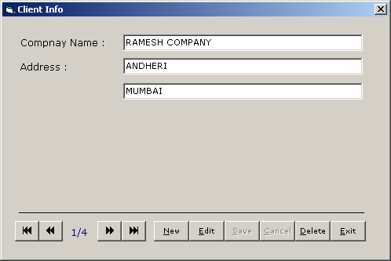

'*************************************
' eBilling System
' Version 1.0.0
' Created by Mr. Atanu Maity
' Date : 21-Aug-2006
'*************************************
' add/edit/delete client details
' Used Table : client_master
'open the client_master
'display first record in form load
'add edit save delete and navigation
'*************************************
Option Explicit
Dim RS1 As New ADODB.Recordset
Dim AddEdit As String

Private Sub Command1_Click()
'>>> close the form
Unload(Me)
End Sub

Private Sub Command11_Click()
'>>> delete the record
If RS1.State = adStateClosed Then Exit Sub
If RS1.RecordCount <= 0 Then Exit Sub

On Error GoTo myer1
'>>> confirm before delete
If MsgBox("Delete the Record ? ", vbCritical + vbYesNo) = vbYes Then
RS1.Delete()
Call ClearText()
Command4_Click()
End If
Exit Sub
myer1:
MsgBox("Error Occured : " & Err.Description, vbCritical)
End Sub

Private Sub Command2_Click()
'>>> move record ponter to first record
'>>> display first record
On Error Resume Next
If RS1.State = adStateClosed Then Exit Sub
If RS1.RecordCount <= 0 Then Exit Sub
RS1.MoveFirst()
Call DisplayRecord()
End Sub

Private Sub Command3_Click()
'>>> move back the record pointer and display current record
On Error Resume Next
If RS1.State = adStateClosed Then Exit Sub
If RS1.RecordCount <= 0 Then Exit Sub
If RS1.AbsolutePosition > 1 Then
RS1.MovePrevious()
Else
MsgBox("First Record ..", vbInformation)

RS1.MoveFirst()
End If
Call DisplayRecord()

End Sub

Private Sub Command4_Click()
'>>> move next the record pointer and display current record
On Error Resume Next
If RS1.State = adStateClosed Then Exit Sub
If RS1.RecordCount <= 0 Then Exit Sub
If RS1.AbsolutePosition < RS1.RecordCount Then
RS1.MoveNext()
Else
MsgBox("Last Record ..", vbInformation)

RS1.MoveLast()
End If
Call DisplayRecord()

End Sub

Private Sub Command5_Click()
'>>> move last the record pointer and display current record
On Error Resume Next
If RS1.State = adStateClosed Then Exit Sub
If RS1.RecordCount <= 0 Then Exit Sub
RS1.MoveLast()
Call DisplayRecord()

End Sub

Private Sub Command6_Click()
'>>> prepare for add record, clear all text box, set flag to ADD
If RS1.State = adStateClosed Then Exit Sub
If RS1.RecordCount <= 0 Then Exit Sub
AddEdit = "ADD"
Call ClearText()
DE(False, True)
TxtCompanyName.SetFocus()
End Sub

Private Sub Command7_Click()
'>>> prepare for edit record, set flag to EDIT

If RS1.State = adStateClosed Then Exit Sub
If RS1.RecordCount <= 0 Then Exit Sub

AddEdit = "EDIT"
DE(False, True)
TxtCompanyName.SetFocus()
End Sub

Private Sub Command8_Click()
'>>> save the record
'>>> check for validation
'>>> check the flag for ADD/Edit
If RS1.State = adStateClosed Then Exit Sub
If RS1.RecordCount <= 0 Then Exit Sub

On Error GoTo myer1
If Trim(TxtCompanyName.Text) = "" Then
MsgBox("Enter Company Name ", vbCritical)
TxtCompanyName.SetFocus()
Exit Sub
End If
If AddEdit = "ADD" Then
RS1.AddNew()
RS1("client_name") = TxtCompanyName.Text
RS1("Address1") = TxtAddress1.Text
RS1("Address2") = TxtAddress2.Text

RS1.Update()
RS1.MoveLast()
Call DisplayRecord()
Else
RS1("Address1") = TxtAddress1.Text
RS1("Address2") = TxtAddress2.Text

RS1.Update()
'>>> if it is edit after requery show the edited record
Dim p As Integer
p = RS1.AbsolutePosition
RS1.Requery()
RS1.MoveFirst()
RS1.Move(p - 1)
Call DisplayRecord()
End If
DE(True, False)
Exit Sub
myer1:
MsgBox("Error Occured : " & Err.Description, vbCritical)
End Sub

Private Sub Command9_Click()
'>>> cancel save
DE(True, False)
End Sub

Private Sub Form_Load()
'>>> center the form
Me.Move (Screen.Width - Width) / 2, (Screen.Height - Height) / 2
ClearText()
'>>> reset connection
OpenCon()
'>>> load alreday saved clent data
'>>> and show the first record
If RS1.State = adStateOpen Then RS1.Close()
RS1.Open("select * from client_master order by client_name ", Cn, adOpenDynamic, adLockOptimistic)
If RS1.RecordCount > 0 Then
RS1.MoveFirst()
Call DisplayRecord()
End If
DE(True, False)
End Sub

Private Sub ClearText()
'>>> clear all text box in the form
Dim Ctl As Control
For Each Ctl In Me.Controls
If TypeOf Ctl Is TextBox Then
Ctl.Text = ""
End If
Next
End Sub

Private Sub DisplayRecord()
'>>> display current record
Call ClearText()
TxtCompanyName.Text = IIf(IsNull(RS1("client_name")) = True, "", RS1("client_name"))
TxtAddress1.Text = IIf(IsNull(RS1("Address1")) = True, "", RS1("Address1"))
TxtAddress2.Text = IIf(IsNull(RS1("Address2")) = True, "", RS1("Address2"))

Label17.Caption = RS1.AbsolutePosition & "/" & RS1.RecordCount
End Sub

Private Sub DE(ByVal T1 As Boolean, ByVal T2 As Boolean)
'>>> enable disable buttons
Command2.Enabled = T1
Command3.Enabled = T1
Command4.Enabled = T1
Command5.Enabled = T1
Command6.Enabled = T1
Command7.Enabled = T1
Command11.Enabled = T1
Command8.Enabled = T2
Command9.Enabled = T2
End Sub

FrmChangePassword
(Change password for currently logged user)

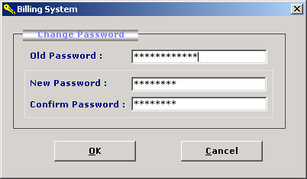

'*************************************
' eBilling System
' Version 1.0.0
' Created by Mr. Atanu Maity
' Date : 21-Aug-2006
'*************************************
' change the current company
' Used Table : company_master
'Module to allow user to change the
'current comopany from the list
'set company name to global variable
'*************************************

Option Explicit
Dim Rs As New ADODB.Recordset

Private Sub Command1_Click()
'>>> check the company nmae select by user
'>>> frm the comapny_master table
'>>> if record found set global variable
'>>> otherwise warn user to select from the list.
If Rs.State = adStateOpen Then Rs.Close()
Rs.Open("select * from company_master where company_name='" & CmbCompanyName.Text & "'", Cn, adOpenStatic, adLockReadOnly)
If Rs.RecordCount > 0 Then
CompanyName = CmbCompanyName.Text
FrmMain.LblCompanyName = CompanyName
Unload(Me)
Else
MsgBox("Select company name from the list", vbExclamation)
CmbCompanyName.SetFocus()
Exit Sub
End If
End Sub

Private Sub Command2_Click()
'>>> cloase the form
Unload(Me)
End Sub

Private Sub Form_Load()

'>>> reset the database connection
If Cn.State = 1 Then Cn.Close()
OpenCon()

'>>> center the form

Me.Move (Screen.Width - Width) / 2, (Screen.Height - Height) / 2

'>>> fill the combo box with company name from company_master
'>>> open record from company_master
'>>> loop throgh recordset and add each company_name into combo box
If Rs.State = adStateOpen Then Rs.Close()
Rs.Open("select * from company_master ", Cn, adOpenStatic, adLockReadOnly)
CmbCompanyName.Clear()
If Rs.RecordCount > 0 Then
While Rs.EOF = False
CmbCompanyName.AddItem(Rs("company_name"))
Rs.MoveNext()
End While
End If
If Rs.State = adStateOpen Then Rs.Close()
'>>> set the already selected company name from login form
CmbCompanyName.Text = CompanyName
End Sub

ModGen
(Module to store global variable and procedure)

'*************************************
' eBilling System
' Version 1.0.0
' Created by Mr. Atanu Maity
' Date : 21-Aug-2006
'*************************************
'
'declare global variable and procedure
'
'*************************************
Option Explicit

Public Cn As New ADODB.Connection
Public CheckLogin As Boolean
Public UserName As String
Public UserType As String
Public CompanyName As String
Public Sub OpenCon()
'>>> open connction
If Cn.State = 1 Then Cn.Close()
Cn.ConnectionString = "provider=microsoft.jet.oledb.4.0; data source= " & App.Path & "\data.mdb"
Cn.CursorLocation = adUseClient
Cn.Open()

End Sub

Public Function newsno(ByVal table As String) As Integer
'>>> find max sno for passing table
Dim Rs As New ADODB.Recordset
If Rs.State = 1 Then Rs.Close()
Rs.Open("select max(sno) from " & table, Cn, adOpenStatic, adLockReadOnly)
If IsNull(Rs(0)) = True Then
newsno = 1
Else
newsno = Val(Rs(0)) + 1
End If

End Function

Public Function ReturnAlphabet(ByVal n As Integer) As String
'>>> return alphabel as per supplied no
'>>> like 1 - A,2-B, 26-Z, 27-AA, 256-IV
'>>> this function is used to excel formatting to set column value in range
If n < 0 Or n > 256 Then
MsgBox("Invalid Invalid range is 1-256", vbQuestion)
Exit Function
End If

Dim i As Integer
Dim r As Integer
Dim S As String
Dim R1 As Integer
If n <= 26 Then
S = Chr(n + 64)
Else
r = n Mod 26
R1 = n / 26
S = Chr(R1 + 64) & Chr(r + 64)
End If
ReturnAlphabet = S
End Function

ModBrowse
(Show Folder Browser)

'*************************************
' eBilling System
' Version 1.0.0
' Created by Mr. Atanu Maity
' Date : 21-Aug-2006
'*************************************
'
'declare global variable and procedure
'it is used to show folder browser
'
'*************************************

Option Explicit

Private Type BrowseInfo
hWndOwner As Long
pIDLRoot As Long
pszDisplayName As Long
lpszTitle As Long
ulFlags As Long
lpfnCallback As Long
lParam As Long
iImage As Long
End Type

'>>> Browsing type.
Public Enum BrowseType
BrowseForFolders = &H1
BrowseForComputers = &H1000
BrowseForPrinters = &H2000
BrowseForEverything = &H4000
End Enum

'>>> Folder Type
Public Enum FolderType
CSIDL_BITBUCKET = 10
CSIDL_CONTROLS = 3
CSIDL_DESKTOP = 0
CSIDL_DRIVES = 17
CSIDL_FONTS = 20
CSIDL_NETHOOD = 18
CSIDL_NETWORK = 19
CSIDL_PERSONAL = 5
CSIDL_PRINTERS = 4
CSIDL_PROGRAMS = 2
CSIDL_RECENT = 8
CSIDL_SENDTO = 9
CSIDL_STARTMENU = 11
End Enum

Private Const MAX_PATH = 260
Private Declare Sub CoTaskMemFree Lib "ole32.dll" (ByVal hMem As Long)
Private Declare Function lstrcat Lib "kernel32.dll" Alias "lstrcatA" (ByVal lpString1 As String, ByVal lpString2 As String) As Long
Private Declare Function SHBrowseForFolder Lib "shell32.dll" (ByVal lpbi As BrowseInfo) As Long
Private Declare Function SHGetPathFromIDList Lib "shell32.dll" (ByVal pidList As Long, ByVal lpBuffer As String) As Long
Private Declare Function SHGetSpecialFolderLocation Lib "shell32.dll" (ByVal hWndOwner As Long, ByVal nFolder As Long, ByVal ListId As Long) As Long

'>>>> main function for broser
Public Function BrowseFolders(ByVal hWndOwner As Long, ByVal sMessage As String, ByVal Browse As BrowseType, ByVal RootFolder As FolderType) As String
Dim Nullpos As Integer
Dim lpIDList As Long
Dim res As Long
Dim sPath As String
Dim BInfo As BrowseInfo
Dim RootID As Long

SHGetSpecialFolderLocation(hWndOwner, RootFolder, RootID)
BInfo.hWndOwner = hWndOwner
BInfo.lpszTitle = lstrcat(sMessage, "")
BInfo.ulFlags = Browse
If RootID <> 0 Then BInfo.pIDLRoot = RootID
lpIDList = SHBrowseForFolder(BInfo)
If lpIDList <> 0 Then
sPath = String(MAX_PATH, 0)
res = SHGetPathFromIDList(lpIDList, sPath)
Call CoTaskMemFree(lpIDList)
Nullpos = InStr(sPath, vbNullChar)
If Nullpos <> 0 Then
sPath = Left(sPath, Nullpos - 1)
End If
End If
BrowseFolders = sPath
End Function

ModRsToWord
(Convert Rs to Word)
'*************************************
' eBilling System
' Version 1.0.0
' Created by Mr. Atanu Maity
' Date : 21-Aug-2006
'*************************************
'
'Module to convert Rs to Word
'123.50 = One Hundred Twent Three and Ffty Paise Only
'*************************************
Option Explicit

'display digit to words
'123 -- > One hundred and twentythree only.

Public Function RsWord(ByVal t As String) As String
On Error Resume Next

Dim la As Boolean
Dim th As Boolean
Dim l As Integer
Dim l1 As Integer
Dim i As String
Dim r As String
Dim p1 As String
Dim NL As Integer
Dim p As Boolean
Dim pl As Integer
Dim a As Integer
Dim b As Integer
Dim c As Integer
Dim z As Boolean

NL = InStr(t, ".")
p = True
pl = Len(t) - NL

If NL = 0 Then
NL = Len(t) : p = False
l = Len(t)
Else
l = NL - 1
End If
l1 = l

While l > 0
i = Mid(t, l1 - (l - 1), 1)

If l = 7 Then la = True
If l = 7 And i = "0" And Mid(t, l1 - (l - 2), 1) <> "0" Then
r = r & SingleDigit(Mid(t, l1 - (l - 2), 1)) & " Lackhs "
End If
If l = 7 And (i <> "0" And i <> "1") Then
r = r & Tenths(i) & " " & SingleDigit(Mid(t, l1 - (l - 2), 1)) & " Lackhs "
End If
If l = 7 And i = "1" Then
r = r & TwoDigit(Mid(t, l1 - (l - 2), 1)) & " Lackhs "
End If

If l = 6 And i <> "0" And la = False Then
r = r & SingleDigit(i) & " Lackhs "
End If

If l = 5 Then th = True
If l = 5 And i = "0" And Mid(t, l1 - (l - 2), 1) <> "0" Then

r = r & SingleDigit(Mid(t, l1 - (l - 2), 1)) & " Thousand "
End If
If l = 5 And (i <> "0" And i <> "1") Then
r = r & Tenths(i) & " " & SingleDigit(Mid(t, l1 - (l - 2), 1)) & " Thousand "
End If
If l = 5 And i = "1" Then
r = r & TwoDigit(Mid(t, l1 - (l - 2), 1)) & " Thousand "
End If
If l = 4 And i <> "0" And th = False Then
r = r & SingleDigit(i) & " Thousand "
End If

If l = 3 And i <> "0" Then
r = r & SingleDigit(i) & " Hundred "
End If
If l = 2 And (i <> "0" And i <> "1") Then
r = r & Tenths(i)
End If
If l = 2 And i = "1" Then
r = r & TwoDigit(Mid(t, l1 - (l - 1), 1)) & " "
End If
If l = 1 And Mid(t, l1 - (l - 2), 1) <> "1" Then
r = r & " " & SingleDigit(i)
End If
l = l - 1
End While

If p = True Then
l1 = NL + 1
While pl > 0
i = Mid(t, Len(t) - pl + 1, 1)
If pl = 2 And (i <> "0" And i <> "1") Then
p1 = p1 & Tenths(i)
End If
If pl = 2 And i = "1" Then
p1 = p1 & TwoDigit(Mid(t, Len(t) - pl + 2, 1)) & " "
End If
If pl = 1 And Mid(t, Len(t) - pl, 1) <> "1" Then
p1 = p1 & " " & SingleDigit(i)
End If
pl = pl - 1
End While
End If
If r <> "" And p1 <> "" Then
RsWord = "Rupees " & r & " and " & p1 & " Paise Only"
End If
If p1 = "" And r <> "" Then
RsWord = "Rupees " & r & " Only"
End If
If r = "" And p1 <> "" Then
RsWord = p1 & " Paise Only"
End If
If r = "" And p1 = "" Then
RsWord = "Nil"
End If
End Function
Private Function TwoDigit(ByVal d As String) As String
Dim S As String
If d = "1" Then S = "Eleven"
If d = "2" Then S = "Twelve"
If d = "3" Then S = "Thirteen"
If d = "4" Then S = "Forteen"
If d = "5" Then S = "Fifteen"
If d = "6" Then S = "Sixteen"
If d = "7" Then S = "Seventeen"
If d = "8" Then S = "Eighteen"
If d = "9" Then S = "Nineteen"
If d = "0" Then S = "Ten"
TwoDigit = S
End Function
Private Function Tenths(ByVal d As String) As String
Dim S As String
If d = "2" Then S = "Twenty"
If d = "3" Then S = "Thirty"
If d = "4" Then S = "Forty"
If d = "5" Then S = "Fifty"
If d = "6" Then S = "Sixty"
If d = "7" Then S = "Seventy"
If d = "8" Then S = "Eighty"
If d = "9" Then S = "Ninety"
Tenths = S
End Function

Private Function SingleDigit(ByVal d As String) As String
Dim S As String
If d = "1" Then S = "One"
If d = "2" Then S = "Two"
If d = "3" Then S = "Three"
If d = "4" Then S = "Four"
If d = "5" Then S = "Five"
If d = "6" Then S = "Six"
If d = "7" Then S = "Seven"
If d = "8" Then S = "Eight"
If d = "9" Then S = "Nine"
If d = "0" Then S = ""

SingleDigit = S
End Function

eBilling and Invoice System Test Plan

Introduction
This document describes the user acceptance test plan for the EBilling and Invoice System. The complete test strategy for the EBilling and Invoice System is to perform the following kinds of tests, in sequence:

- Component testing of each component that makes up the EBilling and Invoice System
- Integration testing of the EBilling and Invoice System, to ensure the correct interworking of its components
- Validation testing of the EBilling and Invoice System, to ensure that it works correctly in a pseudo-live environment
- User acceptance testing of the EBilling and Invoice System, to ensure that its function is acceptable to its users

Acceptance testing is the last set of tests to be performed before the application goes officially live.

Test Scope
The scope of the user acceptance testing covers:

- Version 1 of the EBilling and Invoice System
- User-facing functionality defined by a set of use cases
- Administrator-facing functionality defined by a set of use cases

The aim of the testing is to determine how well the application meets its functional requirements from the perspective of the user, and to identify any issues so they can be resolved. Also, the testing serves to compile a set of test data and results that can be used during subsequent test cycles, to test for non-regression of the software in later releases or after the application is in maintenance.

Working practices might vary from user to user and are considered outside the scope of the testing.

Test Strategy
The basis of user acceptance testing is that other tests were completed successfully, so the application and its required infrastructure are considered to be stable and reliable. Acceptance testing concentrates on the application from the user’s perspective, that is, how the application is used and whether it meets the necessary quality criteria.

Change requests will be sent to the development team as the actionable documentation. Change criteria will be determined by the Test team and the Development team prior to the beginning of testing. For instance, criteria may include impact to desired functionality, amount of code impacted by proposed change, and design required by proposed change. The tester will evaluate the criteria. The test lead will determine Change Required or not. Once a bug has been determined as Change Required, the bug report will be translated into a Change Request and passed on to development.

The customer of the acceptance testing is the System Users, Supervisor and Adminstratorfor EBilling and Invoice System. The progress of the acceptance testing will be reported to the customer, together with any issues that are discovered and their planned resolutions. Sign-off of the tests, and therefore the acceptance of the application, will be performed by the customer or a selected representative.

Preconditions
The following items are required before testing can take place:

- A complete and coherent functional specification of the EBilling and Invoice System expressed as use cases and usage scenarios
- A complete and validation-tested release of EBilling and Invoice System, delivered according to the delivery plan
- An agreed-upon procedure for dealing with any anomalies that are discovered during the testing process
- A set of test specifications describing how each functional area of the EBilling and Invoice System is to be acceptance tested
- An implemented test environment for the testing
- Sufficient, suitable resources to carry out the testing
- Available standards for the acceptance testing

Test Priorities
During testing of the EBilling and Invoice System, the following qualities will be tested in order of priority:
- Functionality—whether the required functions are available and working as expected
- Usability—how user-friendly and intuitive the EBilling and Invoice System is
- Security—how well-protected and guaranteed corporate and user data is
- Performance—whether the response times are within acceptable limits
- Customization—how straightforward it is to use the application in new, unpredicted ways

Test Techniques
The following techniques will be applied:
- Scripted tests—sequences of user interactions (based on the use case and usage scenarios) using predefined data sets against predicted results
- Unscripted tests—based on scripted tests, the tester tries to modify the scenarios to explore what-if possibilities
- Penetration tests—scripted tests to attempt unauthorized entry into the system
- Usability checklists—tests to determine the complexity of interactions
- Performance statistics—generation of performance information to check against desired performance criteria

Test Organization

Roles and Responsibilities
The following roles are defined:

- QA lead/test manager—responsible for planning and ensuring the smooth running of the test process
- Tester—carries out the tests according to the test plan, and then reports the results
- Product manager—ensures that the tests are carried out successfully from a user perspective
- Project sponsor/client—acts as main stakeholder, and ensures that the needs of the customer community as a whole are considered
- Test support—provides technical assistance, such as test environment configuration, and non-technical assistance, such as methodological support

Weekly team meetings will be held involving the test manager, testers, and product managers. At these meetings, the progress of the testing process will be reported, any issues will be discussed, and actions will be agreed upon.

Conclusion and future enhancement

This project was developed to fulfill user and business requirement; however there are lots of scope to improve the performance of the eBilling and Invoice System in the area of user interface, database performance, and query processing time. Etc.

So there are many things for future enhancement of this project. The future enhancements that are possible in the project are as follows.

- Linking and integration of any legacy system for accounting.
- Integration with travel agent through Web Services
- Connection to third-party OLAP applications
- Electronic Data Interchange (EDI) system between banks, other credit verification agency and their vendors
- In the area of data security and system security.
- Provide more online tips and help.
- To optimize the query which is embedded in the system.

Bibliography

Websites

- http://www.google.com
- http://www.microsoft.com
- http://www.programmer2programmer.net
- http://www.codeproject.com
- http://www.msdn.com.
- http://www.vb123.com
- http://www.vbcode.com
- http://www.sqltuner.com

Books

- Mastering Visual Basic 6 (Paperback)
- Mastering Visual Basic .NET (Paperback)
- Visual Basic Black Book (Paperback)
- SQL Bible, 2nd Edition (Paperback)
- Database Development in Visual Basic

