Project Synopsis

eBilling and Invoice System 1
Project Synopsis 1
Revision & Sign-off Sheet 2
Vision Statement 1
Opportunity Statement 1
Scope 1
Customer, Products, Billing Generation 1
Report Generation System 2
Out of Scope 2
Goal 3
Solution Concept 3
User Profiles 5
Usage Summary 5
Requirements Summary 7
Business Requirements 7
User Requirements 7
Operational Requirements 8
System Requirements 9
Success Criteria 9
Sales Automation 9
Features/Functionality 10
Use Cases Summary 12
Software and Hardware Requirement 13
General Requirement for Server/Client: 13
Development Tools and Technologies 13
Development Tools and Technologies 14
Front End 14
Back End 14
Development Environment 15
Visual Design 16
Conceptual Design 16
Logical Design 18
Physical Design 21
eBilling and Invoice System Data Dictionary 22
eBilling and Invoice System Data Dictionary 23
Table : product_master 23
Table : bill 23
Table : bill_details 24
Table : Company_master 24
Table : user_master 25
eBilling and Invoice System – Data Schema ER Diagram 26
eBilling and Invoice System DFD (Data Flow Diagram) 27

Introduction
The client uses MS Excel, and maintains their product list, customer list, and prints the invoice, however it is not possible them to share the data from multiple system in multi user environment, there is lot of duplicate work, and chance of mistake. When the product price are changed they need to update each and every excel file. There is no option to find and print previous saved invoice. There is no security; any body can access any report and sensitive data, also no reports to find out the sales volume, stock list, and summary report. This eBilling and invoicing system is used to overcome the entire problem which they are facing currently, and making complete atomization of manual billing and invoicing system

Objective
This section presents a conceptual overview of the solution, and then provides an introduction to its requirements.

Solution Concept
The eBilling and Invoice System consists of:

- Customer, Products, Billing Generation: Automate the current manual bill generation system and maintain the searchable customer, products database and product invoice, maintain the data security, user rights.
- Report Generation: A Report Generation system will be developed for the user and management of eBilling and Invoicing System. This MIS system will have both details and summary type reports for analysis the sales volume, sales trend, available stock

Part of the solution will involve converting data from Microsoft Excel to the Database, system can import existing customer, product data from predefined MS Excel, CSV format. It reduces the data entry work and quick implementation of the system.
The following diagram describes the proposed solution architecture at a high level.
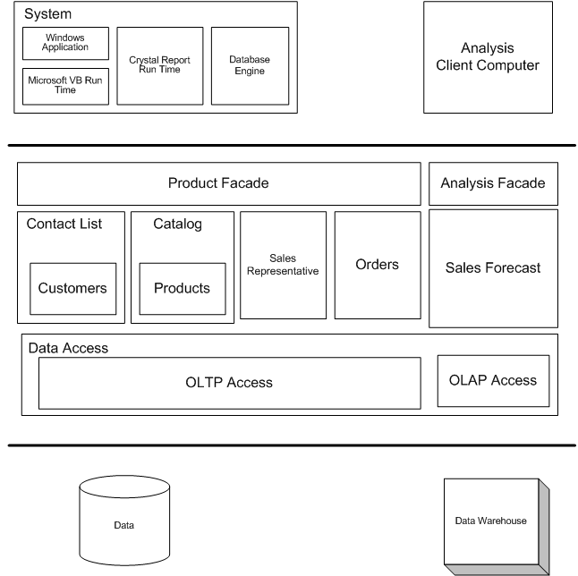

High Level Solution Architecture

User Profiles
The following user types are expected for the eBilling and Invoicing System:

User | Brief Description of Use Actions
Sales Representative | Downloads and uploads customer and order information, which affects accounting, inventory and product data. View customer and product data as described in metrics, track orders and deliveries.
Manager | All sales representative use actions, and management reports, quota establishment, reporting and adjustment.
Accountant | View and print stocks, track orders. Update product details like price.
MIS Executive | Generate reports, view and print inventory reports, view and print stock reports.

Usage Summary
eBilling and Invoicing System Version 1.0 will address the following use cases. The complete usage scenarios will be completed during the information-gathering process. Use cases will be created and prioritized. Selected use cases will be expanded into usage scenarios and features that are derived from both use cases and the usage scenarios, as represented in the following diagram:

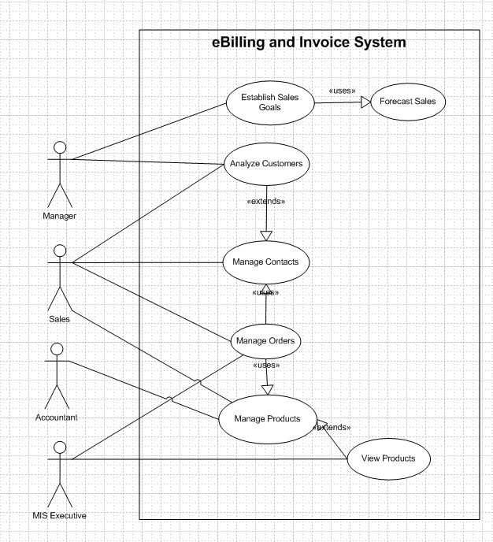

Usage summary use case

Features/Functionality

The following sections summarize features and functionality described by use case. Please see bellow eBilling and Invoice System – Requirements
Manage Customers - Analyze Customers
Must be able to analyze customer data
Must be able to sort customers
Must be able to sort customers by amount of sales
Must be able to sort customers by amount of sales of particular products
Must be able to identify sales trends
Must be able to identify drops in sales
Must be able to identify drops in a customer's sales
Manage Orders
Sales representatives must be able to offer discount in an order
Must be able to create, track, revise, and cancel orders
Must be able to create an order
Must be able to track an order
Must be able to revise an order
Must be able to cancel an order
Manage Products (Catalog, Categories)
Must be able to browse products
Must be able to browse products by category
Must be able to add a new product
Must be able to edit an existing product
Customers must be able to search the database
Customers must be able to search the database by product type
customers must be able to search the database by product
The system must have the capability to provide help
Manage Users
Must be able to record information about users
Must be able to search for employee information
Must be able to track information for each employee
Must be able to add/ modify user information
User can change his/ her password
Must be specify the user rights and privilege
Management Information System / MIS Reports
All users from all departments must be able to see reports from a central database as per their rights and privileges
All reports can be exported in different formats like Text, CSV, Ms Excel
System should store historical data.
System Should have automated backup procedure for disaster
Network Management
Must be able to monitor the network centrally
Must be able to monitor servers centrally
Must be able to monitor application server software centrally
Must be able to monitor databases centrally
CEO Requirements
To extend our product availability (Looks more like a business goal than a definable requirement.)
Providing a no single point failure application (Looks more like a business goal than a definable requirement.)
Reduce our costs by lowering customer handle time (Looks more like a business goal than a definable requirement.)
Need to improve our sales volume (Looks more like a business goal than a definable requirement.)

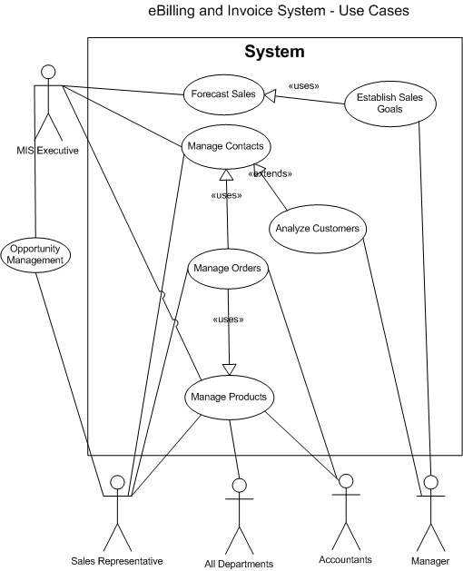
Use Cases Summary

Software and Hardware Requirement

General Requirement for Server/Client:

Type | Software | Hardware
Work Station/ Node | 1. Windows XP  2. VB Run time  3. MS Office | 1. P-4  2. RAM -256 MB
Database Server | 1.Win2000 Advance Server | 1.P-4  2.RAM- 2GB  3.Hard Disk-160GB  4.RAID
Application Server | 1.Win 2000 Advance Server | 1.P-4  2.RAM- 1GB  3.Hard Disk-40GB

Application Server
Data Base Server
Workstation 1
Workstation 2
Workstation 3
Workstation N

Development Tools and Technologies

Front End

- VB 6

Why VB6?

VB6 is built on the Windows Server System to take major advantage of the OS and which comes with a host of different servers which allows for building, deploying, managing and maintaining Windows Based solutions. The Windows Server System is designed with performance as priority and it provides scalability, reliability.

The advantage of VB.NET includes
- Rapid Application Development (RAD) Support.
- Powerful Windows-based Applications
- Simplified Deployment
- Powerful, Flexible, Simplified Data Access
- Improved Coding
- Direct Access to the OS Platform
- Object-Oriented Constructs
- COM Interoperability

Back End
- MS Access
Why MS Access?
MS Access is desktop RDMS support small application with all features like relational query, different data types, joins, and query. Includes
  - Easy to use and easy to deployment.
  - Integration with Windows OS
  - Scalability
  - Import and Export of data in all major database system.
  - Centralized Management
  - Reliability
  - Automating Tasks

Development Environment
- Visual Studio 6.0
eBilling and Invoice System Data Dictionary

Table : product_master
Owner: dbo
Destination DB name: ebill
Number of columns: 5
Number of indexes: 2
Number of foreign keys: 0
Extended attributes:
OnFileGroup PRIMARY
Clustered PK Yes

Columns | Data type | Allow NULLs | Value/range
Sno | int | Not allowed
ProdType | nvarchar(60) | Not allowed
ProdSubType | nvarchar(60) | Not allowed
Rate | int | Not allowed
isactive | nvarchar(30) | Not allowed

Indexes | Type | Columns
PK_ProductMaster_sno | clustered, unique, primary key located on PRIMARY | sno

Table : bill
Owner: dbo
Destination DB name: ebill
Number of columns: 15
Number of indexes: 3
Number of foreign keys: 0
Extended attributes:
OnFileGroup PRIMARY
Clustered PK Yes

Columns | Data type | Allow NULLs | Value/range
sno | int | Not allowed
invoiceno | nvarchar(60) | Not allowed
canme | nvarchar(60) | Not allowed
Invoice_date | datetime | Not allowed
location | nvarchar(60) | Not allowed
chalan_no | int | Not allowed
customer_name | nvarchar(100) | Not allowed
Customer_address1 | nvarchar(100) | Not allowed
Customer_address2 | nvarchar(100) | Allowed
Total_amt | int | Not allowed
discount | int | Not allowed
Amt_words | nvarchar(100) | Not allowed
Paid_type | nvarchar(60) | Not allowed
Cheque_no | nvarchar(60) | Allowed
Entry_date | datetime | Not allowed

Table : bill_details
Owner: dbo
Destination DB name: ebill
Number of columns: 6
Number of indexes: 3
Number of foreign keys: 2
Extended attributes:
OnFileGroup PRIMARY
Clustered PK Yes

Columns | Data type | Allow NULLs | Value/range
sno | int | Not allowed
Bill_sno | int | Not allowed
Prod_sno | nvarchar(60) | Not allowed
qty | datetime | Not allowed
rate | nvarchar(60) | Not allowed
amt | int | Not allowed

Table : Company_master
Owner: dbo
Destination DB name: ebill
Number of columns: 7
Number of indexes: 2
Number of foreign keys: 0
Extended attributes:
OnFileGroup PRIMARY
Clustered PK Yes

Columns | Data type | Allow NULLs | Value/range
Company_name | nvarchar(60) | Not allowed
Address1 | nvarchar(100) | Not allowed
Address2 | nvarchar(100) | Allowed
city | nvarchar(60) | Not allowed
pin | int | Not allowed
telephone | nvarchar(60) | Not allowed
vatno | nvarchar(60) | Not allowed

Table : user_master
Owner: dbo
Destination DB name: ebill
Number of columns: 3
Number of indexes: 2
Number of foreign keys: 0
Extended attributes:
OnFileGroup PRIMARY
Clustered PK Yes

Columns | Data type | Allow NULLs | Value/range
user_name | nvarchar(60) | Not allowed
User_password | nvarchar(60) | Not allowed
User_type | nvarchar(60) | Allowed

eBilling and Invoice System – Data Schema ER Diagram

