Report
Of
Fundraising Internship at NayePankh Foundation
Submitted
To
School of Computer Science and Engineering
IILM University, Greater Noida, U.P.
In partial fulfilment of the requirement of degree of
B.Tech CSE (AIML)


By,

Roll Number: 25SCS1003002192
Name: CHAITANYA DEV RAJPUT
Batch: 2026-27
2026-27

CANDIDATE'S DECLARATION

I, CHAITANYA DEV RAJPUT, do hereby declare that the internship report titled “Fundraising Internship at NayePankh Foundation” has been completed by me to fulfil the requirement for the award of the degree of Bachelor of Technology in Computer Science and Engineering (AIML). All the references have been quoted and I have not taken as such any material from any other source. I affirm that this report is my own and has not been submitted to any other institute for any degree/diploma requirement and further I shall be solely responsible for any kind of copyright violation in this regard.
Signature
Student Name: Chaitanya Dev Rajput
Roll No.: 25SCS1003002192

ACKNOWLEDGEMENT
I am using this opportunity to express my gratitude to everyone who supported me throughout the Internship Program. I am thankful for their aspiring guidance, invaluably constructive criticism and friendly advice during this work. I am sincerely grateful to them for sharing their truthful and illuminating views on a number of issues related to this work.
I would like to sincerely thank Mr. Prashant Shukla, Founder & President of NayePankh Foundation, and the entire team for the opportunity to intern as a Fundraising Intern and for their continuous guidance and support throughout the internship period.
I would also like to thank the School of Computer Science and Engineering, IILM University, Greater Noida, for providing me the opportunity to undertake this internship as a part of my academic curriculum.
I express my gratitude to my parents for their blessings.
Signature
Student Name: Chaitanya Dev Rajput
Roll No.: 25SCS1003002192

TABLE OF CONTENTS
Cover Page ----
1. Candidate's Declaration i
2. Acknowledgement ii
3. Internship Completion Certificate ----
4. Project Description 1
4.1 Introduction 1
4.2 Organization Profile 2
4.3 Problem Statement 3
4.4 Project Objectives 3
4.5 Scope of the Project 4
4.6 Technologies and Tools Used 4
4.7 System Architecture 5
4.8 Methodology 5
4.9 Expected Outcomes 6
4.10 Certificates and Communication Proof 7
5. Bibliography/References 8

INTERNSHIP COMPLETION CERTIFICATE
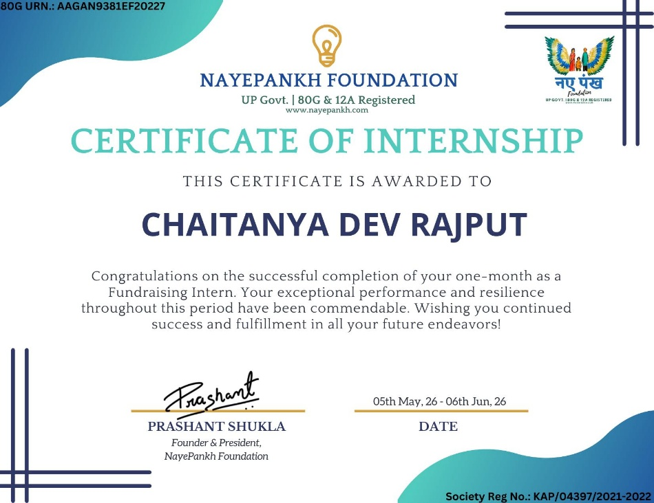

4. Project Description
4.1 Introduction
This report presents an account of the one-month internship undertaken by the author as a Fundraising Intern at NayePankh Foundation, a UP Government registered non-profit society (80G and 12A registered) working towards social welfare causes. The internship was carried out in online/remote mode from 05th May 2026 to 06th June 2026 and was undertaken as part of the academic curriculum for the degree of Bachelor of Technology in Computer Science and Engineering (AIML) at the School of Computer Science and Engineering, IILM University, Greater Noida.
Although the internship domain – fundraising for a non-profit organization – falls outside the core technical curriculum, it provided valuable exposure to digital outreach, campaign planning, donor communication, and the use of online/social media platforms to mobilize resources for a social cause. This exposure complements the analytical, communication, and project-execution skills expected of a computer science graduate.
4.2 Organization Profile
NayePankh Foundation (“naye pankh”, meaning “new wings”) is a registered non-profit society under the UP Government (Society Registration No. KAP/04397/2021-2022), holding both 80G and 12A registration status. The foundation is led by its Founder & President, Mr. Prashant Shukla, and works towards empowering underprivileged communities through various welfare initiatives, relying on donor contributions and fundraising drives to sustain its programs. Its 80G registration allows donors to claim tax exemption on their contributions, which is a key element leveraged during fundraising outreach.
4.3 Problem Statement
Non-profit organizations such as NayePankh Foundation depend heavily on continuous donor engagement to fund their welfare programs. However, limited visibility, low awareness among potential donors, and inconsistent outreach on digital platforms often restrict the funds an organization can mobilize. The core problem addressed during this internship was: how to effectively use online and social media channels to raise awareness of the Foundation's cause, engage potential donors, and convert that engagement into actual contributions within a short, one-month timeframe.
4.4 Project Objectives
The key objectives set for the internship were as follows:
- To understand the working and outreach model of a non-profit fundraising organization.
- To plan and execute online/social media fundraising campaigns for NayePankh Foundation.
- To identify and engage potential donors through digital communication channels.
- To communicate the Foundation's mission, causes, and impact effectively to prospective donors.
- To contribute towards the Foundation's fundraising targets within the internship period.
- To gain practical exposure to campaign planning, donor relationship management, and outreach reporting.
4.5 Scope of the Project
The scope of the internship was limited to online fundraising activities carried out on behalf of NayePankh Foundation over a period of one month. It covered planning and running social-media-based outreach campaigns, drafting donor communication material, engaging with prospective donors, and tracking outreach activity. It did not extend to the Foundation's internal financial administration, on-ground program implementation, or long-term donor relationship management beyond the internship period.
4.6 Technologies and Tools Used
The internship, being fundraising-oriented rather than a software development role, primarily made use of digital communication and outreach tools rather than programming technologies. The tools used included:
- Social media platforms (Instagram, WhatsApp, Facebook) for campaign outreach and donor engagement.
- Basic content-creation tools for designing fundraising posts and messages.
- Spreadsheet tools (MS Excel / Google Sheets) for tracking outreach and donor follow-ups.
- Digital communication channels (email, messaging apps) for donor correspondence.
4.7 System Architecture
As the internship centered on outreach and campaign execution rather than software development, a formal system architecture was not applicable. Instead, the overall workflow followed a structured outreach pipeline, illustrated below:
Cause Identification → Content/Campaign Planning → Social Media Outreach → Donor Engagement → Follow-up & Conversion → Reporting
Figure 4.1: Fundraising Outreach Workflow
4.8 Methodology
The internship followed a structured, campaign-based methodology consisting of the following stages:
- Orientation: Understanding NayePankh Foundation's mission, ongoing causes, and target donor base.
- Campaign Planning: Identifying fundraising causes and planning content/messaging for outreach campaigns.
- Outreach Execution: Sharing campaign content across social media and personal networks to reach potential donors.
- Donor Engagement: Responding to donor queries, explaining the cause and the Foundation's 80G tax-exemption benefit, and encouraging contributions.
- Tracking & Follow-up: Maintaining a record of outreach activity and following up with interested donors.
- Review & Reporting: Reporting outreach progress and outcomes to the internship supervisor at NayePankh Foundation.
4.9 Expected Outcomes
Note: The figures below are indicative placeholders and should be replaced with the actual outreach and contribution figures achieved during the internship before final submission.
By the end of the internship, the following outcomes were expected/achieved:
- Increased visibility of NayePankh Foundation's causes among the outreach network engaged during the campaign.
- A measurable number of donor contributions generated through the fundraising campaigns run during the internship period.
- Improved practical understanding of donor psychology, digital outreach strategy, and non-profit fundraising operations.
- Development of communication, persuasion, and campaign-planning skills applicable beyond the non-profit sector.
4.10 Certificates of Completion and Communication Proof
The Certificate of Internship issued by NayePankh Foundation, confirming successful completion of the one-month Fundraising Internship (05th May 2026 to 06th June 2026), is attached in Section 3 of this report (Internship Completion Certificate).

- Certificate of selection
This is the proof that I got the internship at NayePankh Foundation, via Internshala
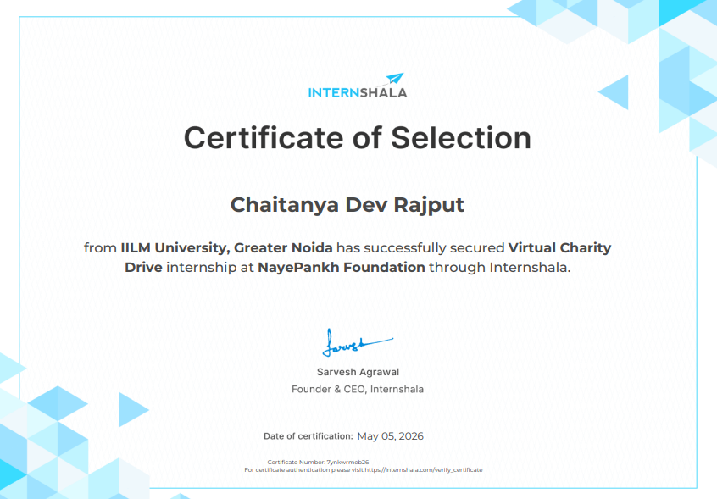
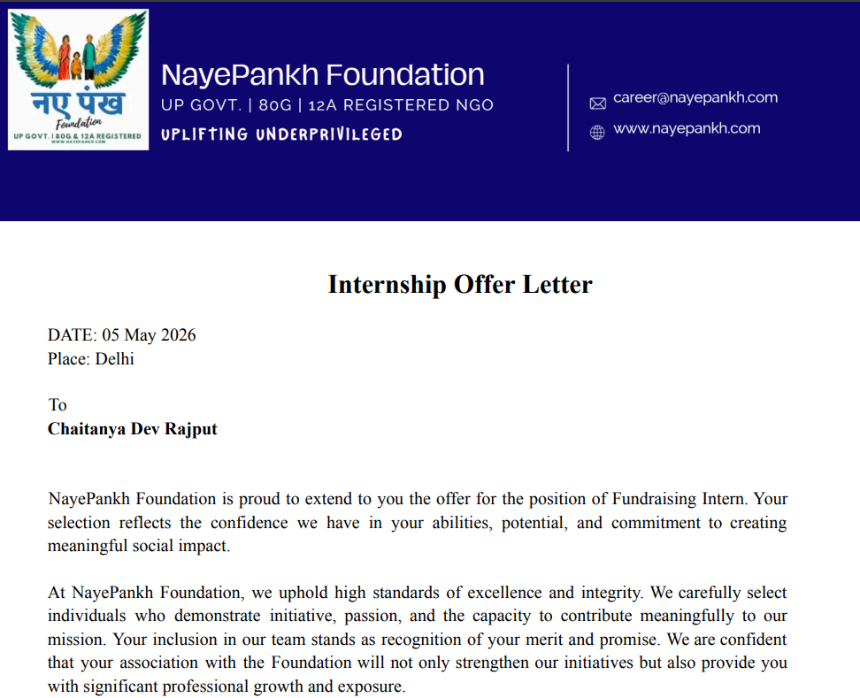
- Screenshot of Offer Letter of the Internship

Student Name | Chaitanya Dev Rajput
Roll Number | 25SCS1003002192
Program | B.Tech CSE (AIML)
Organization | NayePankh Foundation
Role | Fundraising Intern
Duration | 05th May 2026 – 06th June 2026 (One Month)
Mode | Online / Remote

5. Bibliography/References
[1] NayePankh Foundation, “Official Website,” [Online]. Available: https://www.nayepankh.com. [Accessed: Aug. 2026].

[2] NayePankh Foundation, Certificate of Internship – Fundraising Intern, issued to Chaitanya Dev Rajput, 05th May 2026 – 06th June 2026.

[3] IILM University, Greater Noida, Internship Report Format Guidelines, 2026-27.

[4] Income Tax Department, Government of India, “Section 80G – Deduction for Donations,” [Online]. Available: https://www.incometax.gov.in. [Accessed: Aug. 2026].

