DOCUMENTATION ON

**AMAZON CLONE**

By

M. CHAITANYA KRISHNA REDDY

IN PARTIAL FULFILLMENT OF THE FULL-STACK WEB DEVELOPMENT INTERNSHIP PROGRAM

UNDER GUIDANCE OF

MR. AAKASH HANDA

@ EDUREKA

(BATCH – 67, SEP - 2022)

**INDEX**

**S.NO. CHAPTER PAGE.NO.**

1. OVERVIEW 3
2. HOME PAGE 4
3. DETAILS PAGE 5
4. LOG IN / SIGNUP PAGE 6
5. PAYMENT PAGE 7
6. LOGOUT PAGE 8
7. TECHNOLOGIES USED 9

**OVERVIEW**

Amazon is an online retailer, manufacturer of electronic book readers, and Web services provider that became an iconic example of electronic commerce. Its headquarters are in Seattle, Washington. It is a vast Internet-based enterprise that sells books, music, movies, housewares, electronics, toys, and many other goods, either directly or as the middleman between other retailers and Amazon’s millions of customers.

In 1994 Jeff Bezos, a former Wall Street hedge fund executive, incorporated Amazon, choosing the name primarily because it began with the first letter of the alphabet and because of its association with the vast South American river. Based on research he conducted, Bezos concluded that books would be the most logical product initially to sell online. Amazon was not the first company to do so; Computer Literacy, a Silicon Valley bookstore, began selling books from its inventory to its technically astute customers in 1991. However, Amazon promised to deliver any book to any reader anywhere.

**HOME PAGE**

The home page is displayed whenever we enter any website URL on any browser. It contains all the navigations for further pages.

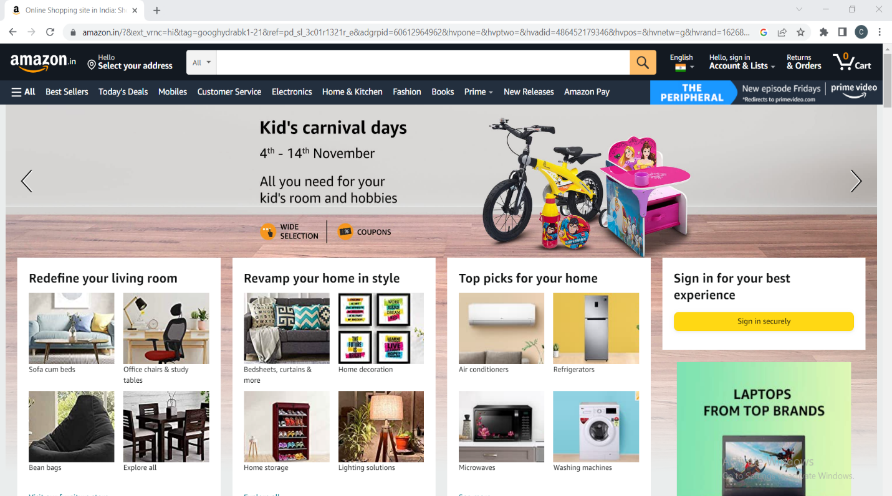

**DETAILS PAGE**

The details page is used to display all categories of items that are sold on this website.

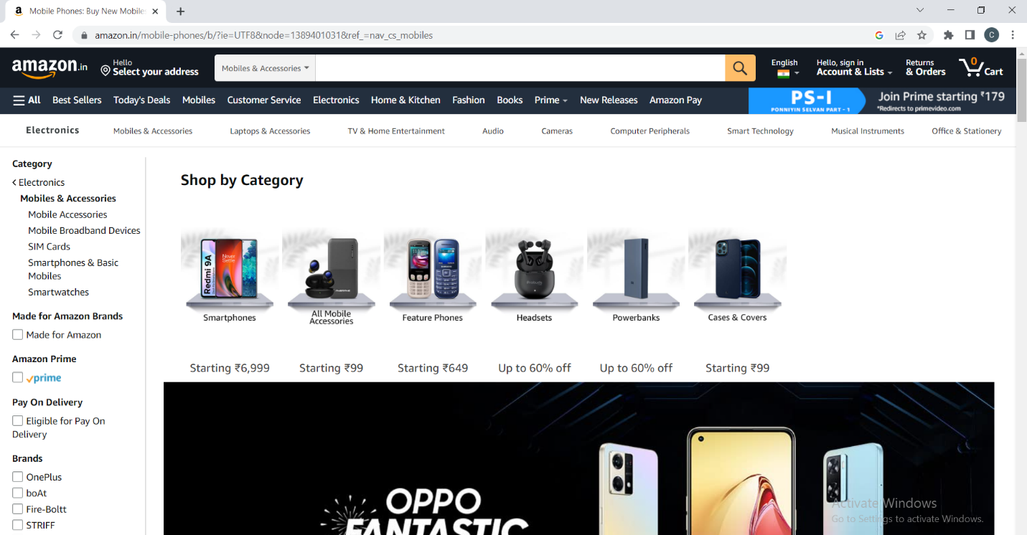

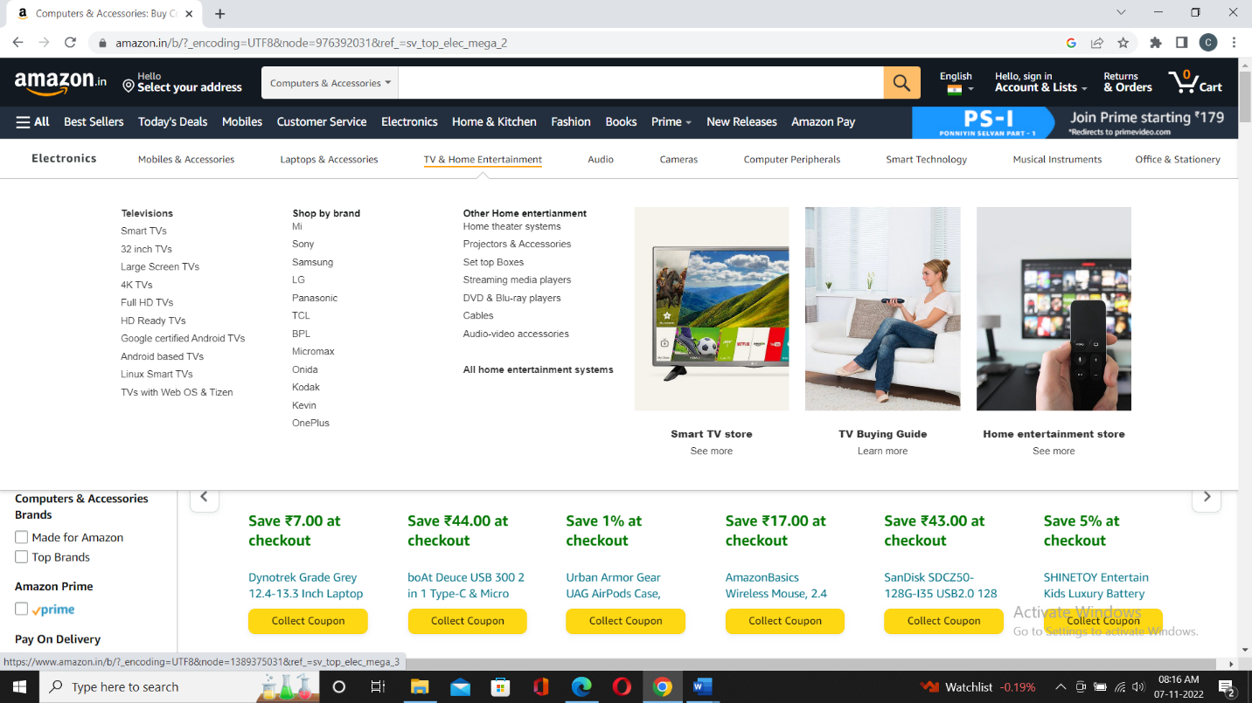

**LOG IN / SIGNUP PAGE**

It is nothing but authentication. Login is used for an existing customer whereas signup is for new customers.

**PAYMENT PAGE**

We can see different modes of payment. Users can select their mode of payment and can order items.

**LOGOUT PAGE**

It is used to close our account from the website. We can again sign in whenever we want to use the website.

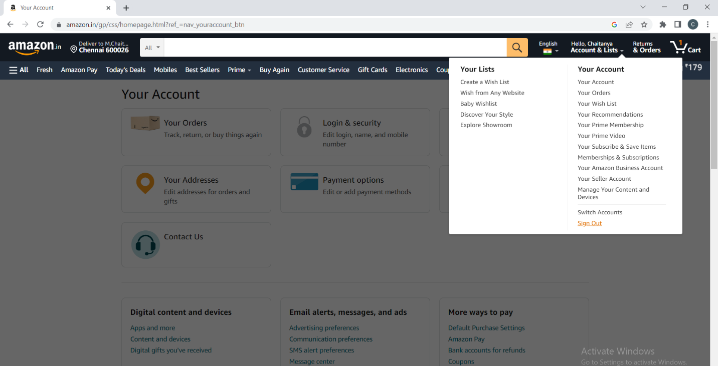

**TECHNOLOGIES USED**

**FRONT END**

* HTML
* CSS
* BOOTSTRAP

**BACK END**

* JAVASCRIPT
* REACT
* NODE JS

**DATABASE**

* MONGO DB

**HOSTING PLATFORM**

* GIT HUB

**CODE EDITOR**

* VISUAL STUDIO CODE