Speaking section overview:

* TOEFL has 4 sections. Reading, Listening, 10 min break, Speaking, Writing.
* Speaking is the **fastest and also the hardest section.**
* There will be 6 question.
* Q1 will be open ended question that will ask your opinion**. 15 seconds to prepare your answer and 45 seconds to speak.**
* Q2 will also ask opinion and the same timing as the first question to answer it.
* Q3 will present a 100 word passage followed by a conversation of students. There will be a question about the converation. 30 seconds to prepare the answer relating the converation and the passage. Finally, 60 seconds to deliver response.
* Q4 is similar to Q3. Instead of a passage, we get a scientific article followed by a lecture to it. 30 seconds to correlate the lecture and the article. 60 seconds to deliver speech.
* Q5 has a conversation. Need to listen to the conversation. 20 seconds to prepare the speech and 60 seconds to deliver.
* Q6 will be a lecture about a scientific topic. Question will be “what was the inference from the lecture”. 20 seconds to prepare the speech and 60 seconds to deliver the speech.

Speaking section Q1 and Q2:

* Question asks for opinion. This is an open question which means we can choose any answer for it.
* **Whenever you are using a word unfamiliar to the listener, always describe it in one sentence.**
* Break the scratch paper into 3 portions. “a” contains the key words/reason to use during the speech. “r1” is the first reason with example and “r2” is the second reason with example. **Do not miss conclusion.**

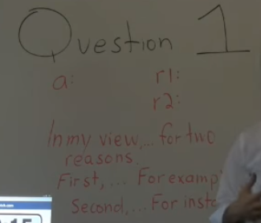

* Make sure a,r1,r2 will be short sentence. Also keep in mind that r1,r2 are connecting to the reason in a specific manner.
* If you only come up with one reason, give two examples.

Speaking Q3:

* Read, Listen, Question, Prepare(30s), Deliver(60s)
* Only 45 seconds to read the passage. Read the passage and look for the change “c” and the two reasons “r1 and r2” for that change. This should happen quickly.

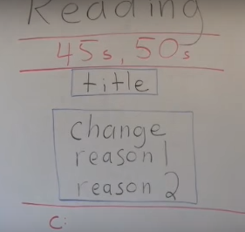

* In the listen, we will have two locutors, a man and a woman. One of them will SUPPORT/OPPOSE everything in the passage and have his opinion and two reasons. The other locutor will be supporting the conversation.
* Question will always be the same: describe the students’s opinion and reasons she/she gives for it.
* In the 30 seconds Draw circles around and run through the words
  1. Cause for the passage
  2. Opinion by the locutor
  3. Reasons 1 and 2 given by the locutor
* Delivery:
  1. The reading states that <cause>
  2. The man’s opinion is that <opinion>
  3. He provides 2 reasons(43s). First <r1> (22s)and second <r2>(3s). That’s why. (0s)

Speaking Q4:

* Read(45s), Listen(120s), Question, Prepare(30s), Deliver(60s)
* Read(45s)
  1. Split the scratch paper into 2 parts: T and D parts
  2. T must have the title of the passage. It will tell us what will be the focus of the topic.
  3. D section will have key words from the description of the topic. It will explain the T section in detail.
* Listening(120s):
  1. Lecture will elaborate the D section in detail.
  2. Note down only key words understand the idea and help remember.
* Questing: “Using the example provided, explain the title of the article”
* Prepare(30s)
  1. Draw circle around T,D,E words gathered. Bristle upon some of the words while circling.
  2. Aim is to establish relation between E and T. Cross out unimportant details that don’t establish the relation.
* Delivery(60s):
  1. The article is about <T> Which the passage defines as <D>.(60s)
  2. The professor defines example of <E> to illustrate this.(43s)
  3. Repeat the important details seen in E circle(3)
  4. And so, the <E> illustrates the <T>(0)

Speaking Q5:

* Conversation, question, prepare(20), speak(60)
* Conversation: there will be a man and a woman
  1. One of them will present a common problem.
  2. One solution will be brought up for the problem. It will be questioned and debated
  3. There will be a second solution. And solution two will also be questioned and rejoindered.
* Question: **“Whats the problem and which of the solution will you choose”**
* Preparation(20):
  1. First circle around problem keywords. P
  2. Second circle around solution 1 keywords(s1)
  3. Third circle around solution 2 keywords.(s2)
* Delivery(60):
  1. The man’s problems is <p>. the students discuss 2 solutions. First(s1) and second(s2)
  2. If I were the man I would choose the second soln. <Negate soln 1> and Propogate <S2>. That’s why.