* **Reversal algorithm for array rotation**

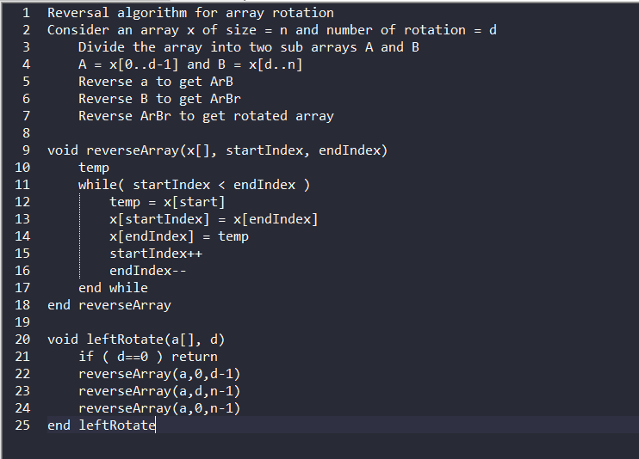

* **Finding rotation count in sorted rotated array**

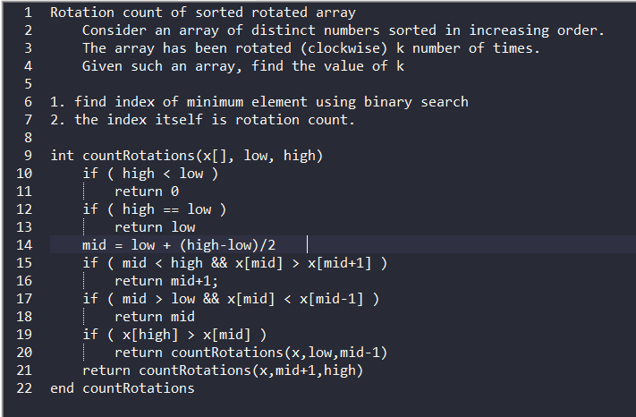

* **Searching element in sorted rotated array**

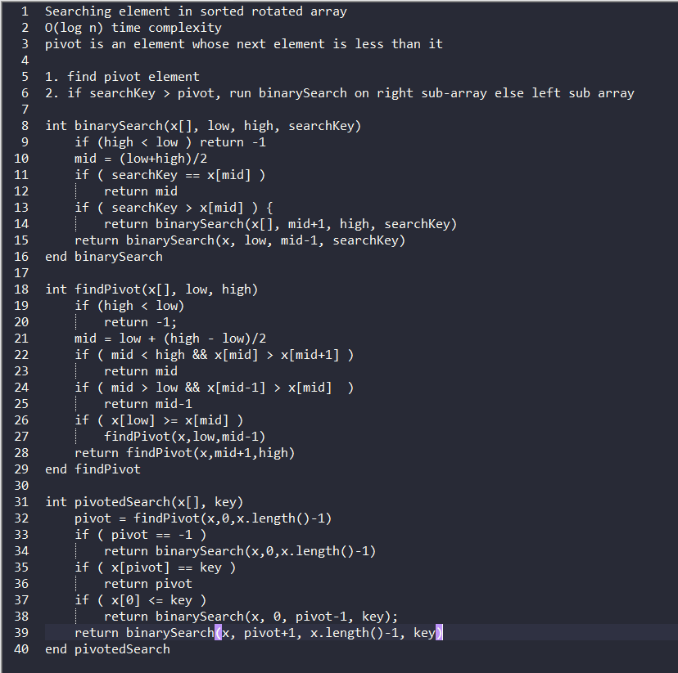

* **Reversal algorithm for right rotation**

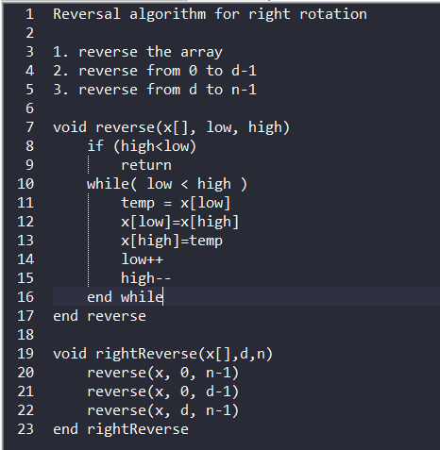

* **find minimum element in sorted rotated array**

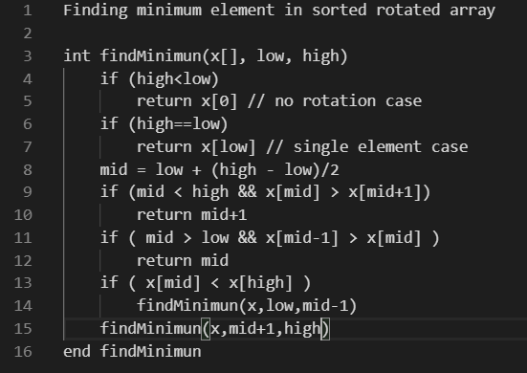

* **Reverse array using recursion**

