**INFO 6210**

**Data Management and Database Design**

**Chaitanya Joshi**

**NUID –** 0018600178

**Section 06**

**Problem Statement**

In this project, I have created a relational database for Schengen visa management. There are Schengen countries and they have their respective embassies where the applicant submits their visa applications for various purposes and embassies process approve/reject their applications.

There are many Schengen countries like Austria, Germany, Italy and each country has their respective embassies in non-Schengen country. Each embassy has a list of visa officers who process applications received by their respective embassy.

Applicants provide their personal details along with passport which is mandatory. Applicant can be of three types student applicant, tourist applicant, working applicant. However, their purpose could be for many cases like transiting, tourism, education and business. Each application must have one country as their main destination/first entry in Schengen area. Each application must have details of financial status, travel insurance and travel itinerary.

Visas are of three types Uniform Schengen Visa, Limited Territorial Validity Visa and National Visas. Based on their purpose and application they are granted one of visas above and visa entry type which can be single, double, multiple entry. For single entry once, applicant completes his travel the visa is deemed inactive. In case of double entry applicant can travel two times in and out of Schengen area and there is no restriction on multiple entry.

**Entities**

**Applicant** – A person providing passport and personal details. It could be a student, employee or need not be any of them.

**StudentApplicant** – A subtype of applicant whose plans to pursue his education in a Schengen country. He must have acceptance letter from university which he intends to study in.

**WorkingApplicant** – A subtype of applicant whose plans to work in a Schengen country. He must have contract from organization which he intends to work for.

**Traveltinerary** – It describes the flight booking details for applicant.

**Travelnsurance** – It describes the travel/medical insurance during stay in Schengen area.

**Embassy** – Each Schengen country has many embassies in non-Schengen area

**VisaOfficers** – Each embassy has a list of visa officers who process applications received by that embassy.

**VisaType** – It describes the types of visa which can be granted to the applicant.

**Application** – Each applicant makes an application to be submitted for visa approval. It contains details about applicant’s financial status, travel insurance, travel itinerary, accommodation details if any.

**FinancialStatus** – Each application must provide proof of funds to support their travel/work/education. This can also belong to a friend or relative if you will be staying there

**LogUserDetails –** This table is used for logging user details who have either approved or rejected visa applications.

**SchengenCountry** – This entity includes a list of Schengen countries to which a person living in a non-Schengen areaneeds to apply to.

**Organization** – This entity includes details of organization in Schengen area where the working applicant has received work permit from.

**University** – This entity stores details of university and linked to courses entity where study is pursuing his education.

**ER Diagram (3 NF)**

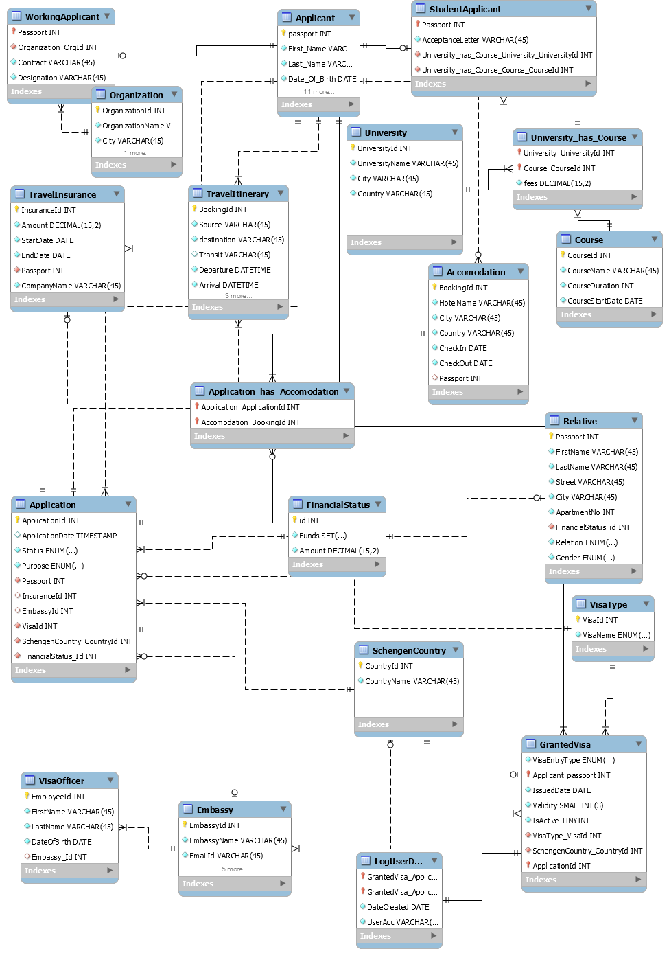

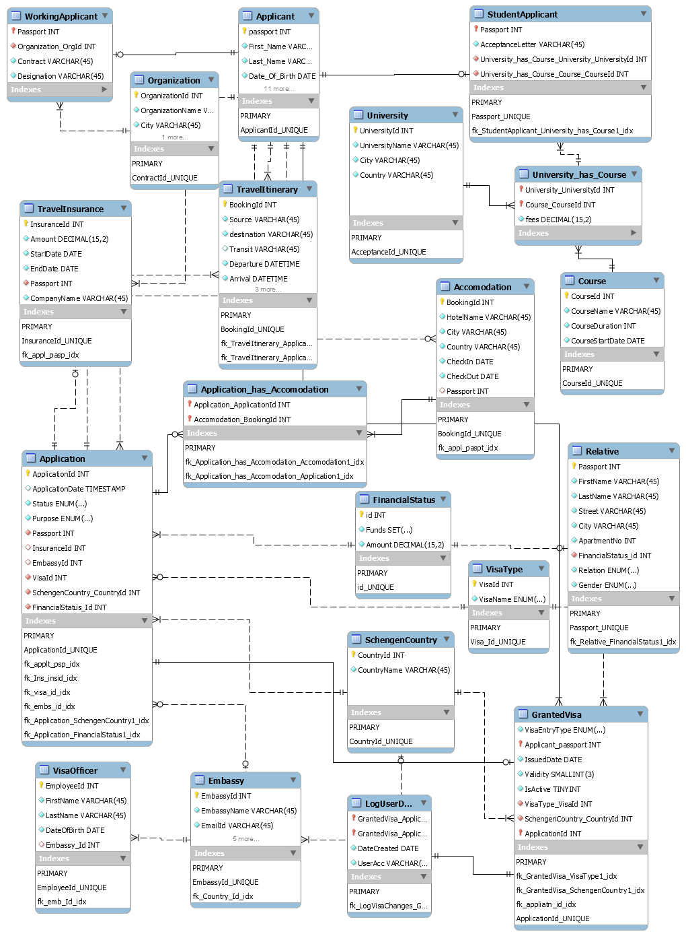

**Views**

1. **fetchOtherApplicantDetails**

This view is used to fetch applicant details other than student and applicant.

create view fetchOtherApplicantDetails

as

select applicant.passport,concat_ws(' ',First_Name,Last_Name) 'Applicant Name',Date_Of_Birth,Gender,ApartmentNo,Street,City,State,Country

from applicant

where applicant.passport not in

(select passport from studentapplicant

union select passport from workingapplicant);

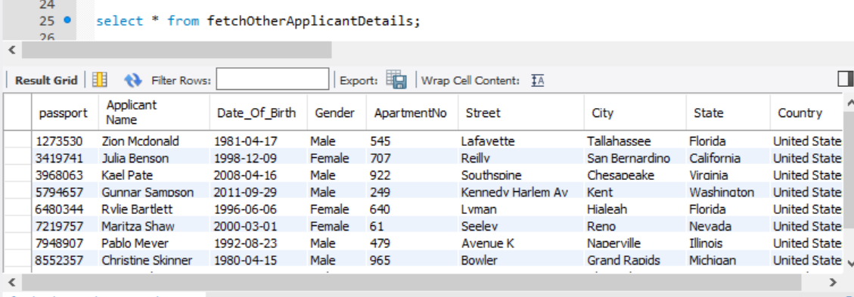

1. **fetchstudentapplicantdetails**

This view is used to fetch student applicant details.

create view fetchStudentApplicantDetails

as

select applicant.passport,concat_ws(' ',First_Name,Last_Name) 'Applicant Name',Date_Of_Birth 'DOB',Gender,UniversityName,CourseName,CourseDuration,Fees

from applicant

join studentapplicant

on applicant.passport=studentapplicant.Passport

join university_has_course

on studentapplicant.University_UnvId=university_has_course.University_UniversityId AND studentapplicant.CourseId=university_has_course.Course_CourseId

join university

on university_has_course.University_universityId=University.UniversityId

join course

on course.courseId=university_has_course.Course_courseId;

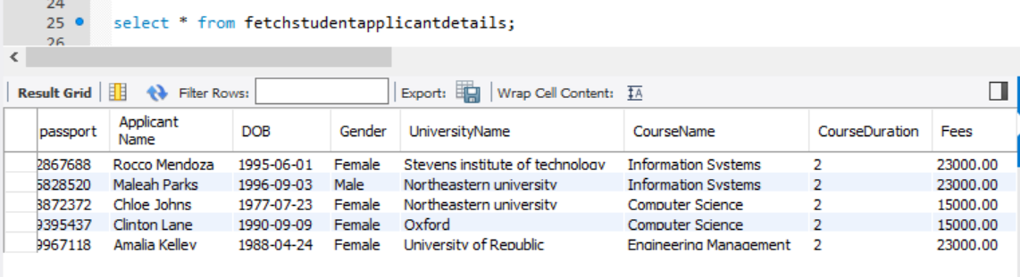

1. **fetchworkingapplcantdetails**

This view is used to fetch working applicant details.

create view fetchWorkingApplcantDetails

as

select applicant.passport,concat_ws(' ',First_Name,Last_Name) 'Applicant Name',Date_Of_Birth as 'DOB',Gender,OrganizationName 'Company',Designation,Contract

from applicant

join workingapplicant

on applicant.passport=workingapplicant.Passport

join Organization

on workingapplicant.Organization_OrgId=Organization.OrganizationId;

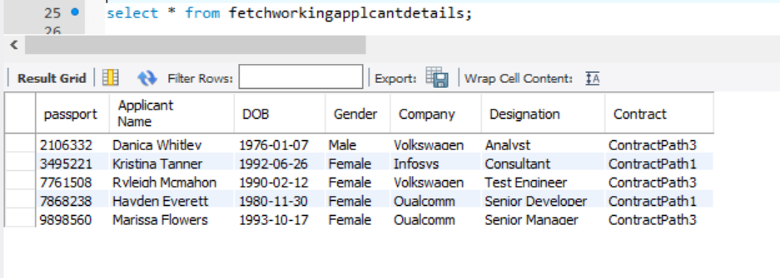

1. **fetchEmbassyEmployeeDetails**

This view is used to fetch number of employees in an embassy

Create view fetchEmbassyEmployeeDetails

as

select EmbassyId,EmbassyName,count(EmployeeId) as 'No Of Employees',PhoneNo,EmailId,CountryName 'SchengenCountry',Embassy.Street,Embassy.City,Embassy.Zipcode from

SchengenCountry

join Embassy

on Embassy.Country_Id=SchengenCountry.CountryId

join visaofficer

on visaofficer.Embassy_Id=Embassy.EmbassyId

group by EmbassyId

order by CountryName desc;

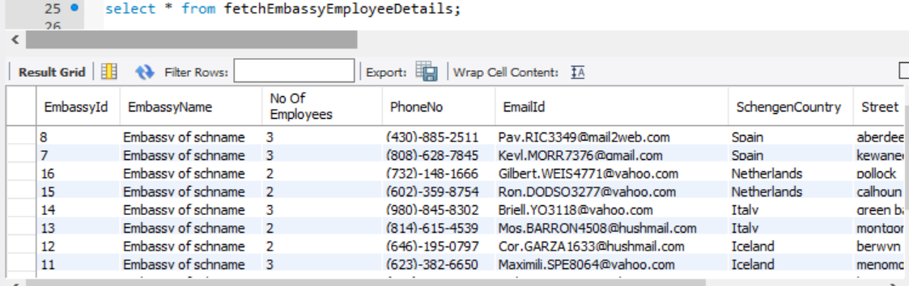

1. **getRejectedApplicationDetails**

This view is used to get rejected visa applicant and application details.

Create view getRejectedApplicationDetails

as

select Applicant.passport,concat_ws(' ',First_Name,Last_Name) 'ApplicantName',Date_Of_Birth 'DOB',Gender,EmailId,PhoneNo,ApplicationId,`Purpose`,EmbassyId,visatype.VisaName,SchengenCountry_CountryId 'MemberState',CompanyName from

applicant

join application

on applicant.passport=application.passport

join travelinsurance

on travelinsurance.InsuranceId=application.InsuranceId

join visatype

on visatype.VisaId =application.VisaId

where application.`Status`='Rejected';

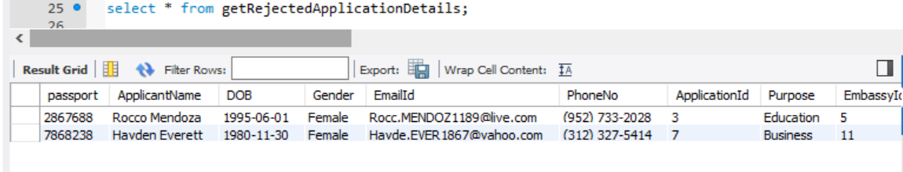

**Procedures**

1. **createApplicantDataDump**

This procedure is used to dump data to an out file

delimiter $

create definer=current_user() procedure createApplicantDataDump()

comment 'This procedure is used to dump data to a file'

deterministic

begin

select passport,Firstname,Lastname,Dateofbirth,City,Country,Gender,DateIssued,ExpiryDate,Street,Zipcode,ApartmentNo,EmailId,PhoneNo,State

into outfile 'C:\\ProgramData\\MySQL\\MySQL Server 5.7\\Uploads\\vmsdump.csv'

fields terminated by ','

optionally enclosed by '"'

lines terminated by '\n'

from Applicant;

end $

delimiter ;

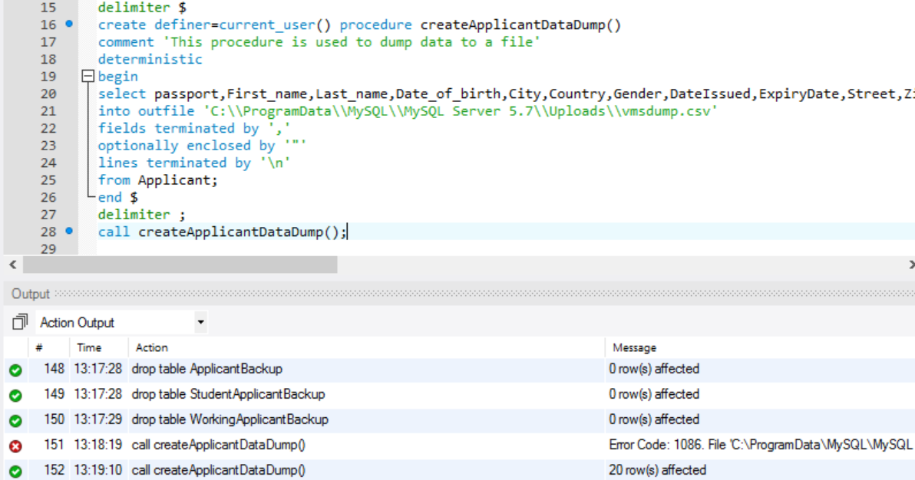

1. **applicant_Visa_Table_Backup**

This procedure is used to backup tables

delimiter $

create procedure applicant_Visa_Table_Backup()

comment 'This procedure is used to take backup of applicant and visagranted details'

begin

create table GrantedVisaBackup as select * from GrantedVisa;

create table ApplicantBackup as select * from applicant;

create table StudentApplicantBackup as select * from StudentApplicant;

create table WorkingApplicantBackup as select * from WorkingApplicant;

end $

delimiter ;

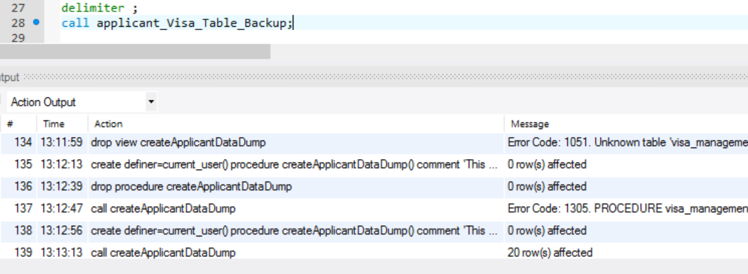

1. **getSumOfProcessingFee**

This procedure calculates sum of processing fee collected by each embassy.

delimiter %

create procedure getSumOfProcessingFee()

begin

--

select CountryName,embassy.EmbassyId,sum(calculateProcessingfee(ApplicationId)) as 'Revenue'

from application

join embassy

on application.EmbassyId=embassy.EmbassyId

join schengencountry

on schengencountry.CountryId=embassy.Country_Id

group by CountryName,embassy.EmbassyId with rollup;

--

end %

delimiter ;

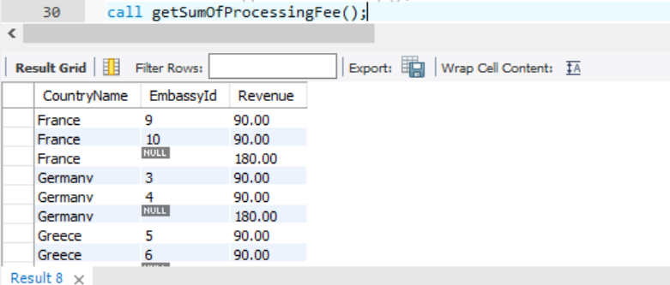

1. **getApplicationRelativeDetails**

This procedure is used to get application details who may or may not be sponsored by their relative or friend.

delimiter #

create definer=current_user() procedure getApplicationRelativeDetails()

comment 'This procedure is used to get details of applicants supported/not supported by relative'

begin

select concat_ws(' ',applicant.First_Name,applicant.Last_Name) 'ApplicantName',application.Purpose,visaName

,funds,concat_ws(' ',FirstName,LastName) 'RelativeName',relative.Gender,relative.ApartmentNo,relative.Street,relative.City

from application

join applicant

on applicant.passport=application.Passport

join visatype

on application.VisaId=visatype.VisaId

join financialstatus

on application.FinancialStatus_Id=financialStatus.id

left join relative

on financialstatus.id=relative.FinancialStatus_Id

order by applicationId;

end #

delimiter ;

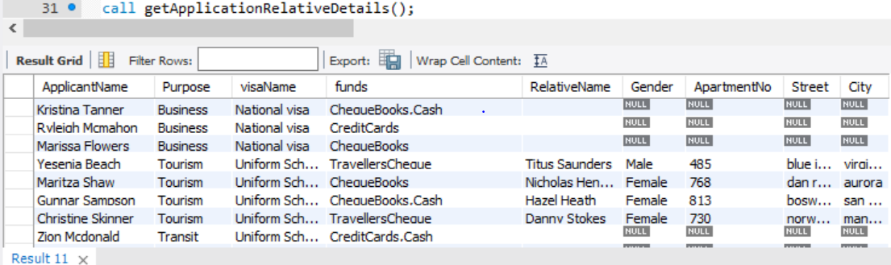

1. **getMaxApplicationCountEmbassy**

This procedure is used to get embassy details which have received max no of applications.

delimiter $

create definer=current_user() procedure getMaxApplicationCountEmbassy()

comment 'This procedure is used to fetch max student applcation received by embassy'

begin

select application.embassyId,CountryName,count(applicationId) `totalCount`

from Application

join SchengenCountry

on Application.SchengenCountry_CountryId=SchengenCountry.CountryId

group by application.embassyId,CountryName

order by totalCount desc

limit 1 ;

end $

delimiter ;

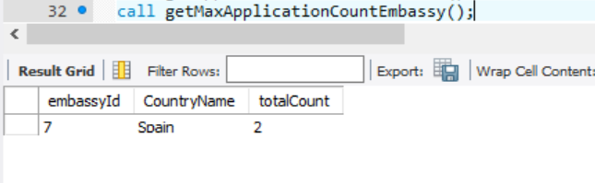

1. **getApplicantFlightBooking**

This procedure is used to fetch details of applicant who are tourist and do not have a return booking id

delimiter $

create definer=current_user() procedure getApplicantFlightBooking()

comment 'This procedure is used to fetch tourist applicant without returnBookingID'

begin

--

select ApplicationId,concat_ws(' ',applicant.First_Name,Last_Name) as 'Applicant Name',Gender,BookingId,`Source`,`Destination`,`arrival`,`departure`

from application

join travelitinerary

on application.applicationId=travelitinerary.Application_ApplicationId

join Applicant

on Application.passport=Applicant.passport

where ApplicationId

not in (select ti1.Application_ApplicationId from travelitinerary ti1 join travelitinerary ti2

on ti1.BookingId=ti2.Returnbooking) and Purpose='Tourism';

--

end $

delimiter ;

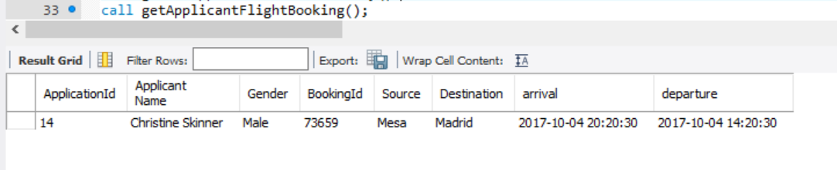

1. **getAccomodationDetails**

This procedure is used to get all applications with their accommodation details

delimiter #

create definer=current_user() procedure getAccomodationDetails()

comment 'This procedure is used to get accomodation details for applicant'

begin

select applicationId,concat_ws(' ',First_Name,Last_Name) as 'Applicant Name',Gender,bookingId,HotelName,accomodation.CheckIn,accomodation.CheckOut,accomodation.City,accomodation.Country

from accomodation

join application_has_accomodation

on accomodation.BookingId=application_has_accomodation.Accomodation_BookingId

right join application

on Application.ApplicationId=application_has_accomodation.Application_ApplicationId

join applicant

on application.Passport=applicant.passport;

end #

delimiter ;

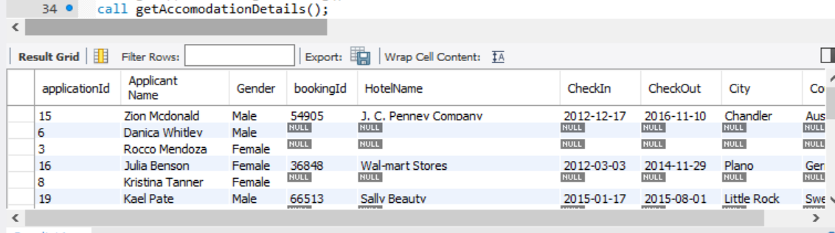

1. **getApprovedVisaDetails**

This procedure is used to get applicant along with granted visa details

delimiter %

create procedure getApprovedVisaDetails()

comment 'Gives details of approved visas'

begin

select Application.ApplicationId,Applicant_Passport,concat_ws(' ',First_name,Last_Name)'ApplicantName',CountryName,VisaEntryType,VisaName,IssuedDate,Validity,IsActive

from GrantedVisa

join visatype

on visatype.VisaId=GrantedVisa.VisaType_VisaId

join Application

on application.ApplicationId=GrantedVisa.ApplicationId

join Schengencountry

on application.SchengenCountry_CountryId=schengencountry.CountryId

join Applicant

on Applicant.Passport=Application.Passport;

end %

delimiter ;

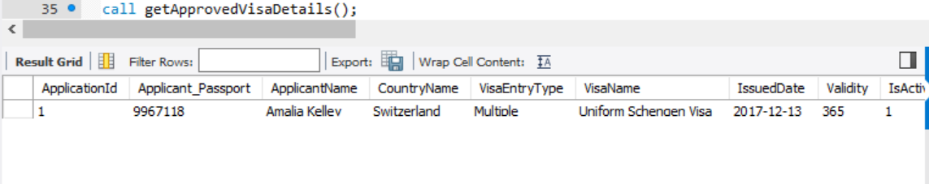

**Functions**

1. **CalculateProcessingFee**

delimiter %

create function calculateProcessingFee(appId int)

returns decimal(15,2)

deterministic

begin

declare fee decimal(15,2);

declare pur varchar(20);

declare age int;

declare flag boolean;

case when exists(select * from Application where ApplicationId=appId) then

set flag:=true;

select Purpose into pur from Application where ApplicationId=appId;

select truncate(datediff(curdate(),Date_Of_Birth)/365,0) into age

from Application

join applicant

on application.Passport=applicant.passport

where ApplicationId=appId;

else

set flag:=false;

end case;

if flag=true then

if pur = 'Transit' or pur ='Medical' then

if age>12 then

set fee:=60;

else

set fee:=35;

end if;

else

set fee:=90;

end if;

else

set fee:=0;

end if;

return fee;

end %

delimiter ;

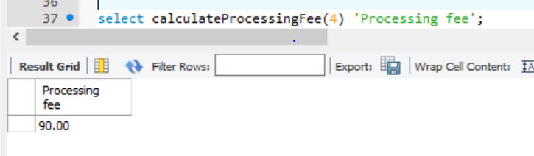

**Triggers**

1. **updateApplicationStatusApproved**

This trigger updates the application status for applicant who has been granted visa.

delimiter %

create trigger updateApplicationStatusApproved

after insert

on GrantedVisa

for each row

begin

Update Application

set `Status`='Approved'

where ApplicationId=New.ApplicationId;

end %

delimiter ;

1. **LogUserDetails**

This trigger logs the user who inserted an entry in grantedvisa table

delimiter %

create trigger LogUserDetails

after insert

on GrantedVisa

for each row

begin

declare iuser varchar(50);

select user() into iuser;

insert into loguserdetails(GrantedVisa_ApplicationId,GrantedVisa_Applicant_passport,DateCreated,UserAcc)

values(New.ApplicationId,New.Applicant_passport,current_timestamp,iuser);

end %

delimiter ;

**User Privileges**

1. CREATE USER 'vmsdesigner'@'localhost' IDENTIFIED BY 'design';

GRANT CREATE,DROP ON visa_management_system.* TO 'vmsdesigner'@'localhost';

SHOW GRANTS FOR 'vmsdesigner'@localhost;

1. CREATE USER 'chinmay'@'localhost' IDENTIFIED BY 'readRecord';

GRANT SELECT,EXECUTE ON visa_management_system.* TO 'chinmay'@'localhost';

SHOW GRANTS FOR 'chinmay'@localhost;

1. CREATE USER 'suyog'@'localhost' IDENTIFIED BY 'updateRecord';

GRANT SELECT,UPDATE ON visa_management_system.* TO 'suyog'@'localhost';

SHOW GRANTS FOR 'suyog'@localhost;

1. CREATE USER 'matt'@'localhost' IDENTIFIED BY 'brokenDelete';

GRANT SELECT,DELETE ON visa_management_system.* TO 'matt'@'localhost';

SHOW GRANTS FOR 'matt'@localhost;

1. CREATE USER 'applicantUser'@'localhost' IDENTIFIED BY 'applicant';

GRANT select,update,delete ON visa_management_system.Applicant TO 'applicantUser'@'localhost';

SHOW GRANTS FOR 'applicantUser'@localhost;

1. CREATE USER 'embassyAdmin'@'localhost' IDENTIFIED BY 'embassyAdmin';

GRANT select,update,delete ON visa_management_system.GrantedVisa TO 'embassyAdmin'@'localhost';

SHOW GRANTS FOR ' embassyAdmin'@localhost;

**MYSQL SCRIPT**

-- MySQL Workbench Forward Engineering

SET @OLD_UNIQUE_CHECKS=@@UNIQUE_CHECKS, UNIQUE_CHECKS=0;

SET @OLD_FOREIGN_KEY_CHECKS=@@FOREIGN_KEY_CHECKS, FOREIGN_KEY_CHECKS=0;

SET @OLD_SQL_MODE=@@SQL_MODE, SQL_MODE='TRADITIONAL,ALLOW_INVALID_DATES';

-- -----------------------------------------------------

-- Schema mydb

-- -----------------------------------------------------

-- -----------------------------------------------------

-- Schema Visa_Management_system

-- -----------------------------------------------------

-- NA

-- -----------------------------------------------------

-- Schema Visa_Management_system

--

-- NA

-- -----------------------------------------------------

CREATE SCHEMA IF NOT EXISTS `Visa_Management_system` ;

USE `Visa_Management_system` ;

-- -----------------------------------------------------

-- Table `Visa_Management_system`.`Applicant`

-- -----------------------------------------------------

CREATE TABLE IF NOT EXISTS `Visa_Management_system`.`Applicant` (

`passport` INT UNSIGNED NOT NULL,

`First_Name` VARCHAR(45) NOT NULL,

`Last_Name` VARCHAR(45) NOT NULL,

`Date_Of_Birth` DATE NOT NULL,

`City` VARCHAR(45) NOT NULL,

`Country` VARCHAR(45) NOT NULL,

`Gender` ENUM('Male', 'Female') NOT NULL,

`DateIssued` DATE NOT NULL,

`ExpiryDate` DATE NOT NULL,

`Street` VARCHAR(20) NOT NULL,

`Zipcode` INT NOT NULL,

`ApartmentNo` INT NOT NULL,

`EmailId` VARCHAR(50) NOT NULL,

`PhoneNo` VARCHAR(20) NOT NULL,

`State` VARCHAR(45) NOT NULL,

PRIMARY KEY (`passport`),

UNIQUE INDEX `ApplicantId_UNIQUE` (`passport` ASC))

ENGINE = InnoDB;

-- -----------------------------------------------------

-- Table `Visa_Management_system`.`University`

-- -----------------------------------------------------

CREATE TABLE IF NOT EXISTS `Visa_Management_system`.`University` (

`UniversityId` INT UNSIGNED NOT NULL AUTO_INCREMENT,

`UniversityName` VARCHAR(45) NOT NULL,

`City` VARCHAR(45) NOT NULL,

`Country` VARCHAR(45) NOT NULL,

PRIMARY KEY (`UniversityId`),

UNIQUE INDEX `AcceptanceId_UNIQUE` (`UniversityId` ASC))

ENGINE = InnoDB;

-- -----------------------------------------------------

-- Table `Visa_Management_system`.`StudentApplicant`

-- -----------------------------------------------------

CREATE TABLE IF NOT EXISTS `Visa_Management_system`.`StudentApplicant` (

`Passport` INT UNSIGNED NOT NULL,

`University_UnvId` INT UNSIGNED NOT NULL,

`AcceptanceLetter` VARCHAR(45) NOT NULL,

PRIMARY KEY (`Passport`),

UNIQUE INDEX `Passport_UNIQUE` (`Passport` ASC),

INDEX `fk_StudentApplicant_University1_idx` (`University_UnvId` ASC),

CONSTRAINT `fk_stAppl_Passp`

FOREIGN KEY (`Passport`)

REFERENCES `Visa_Management_system`.`Applicant` (`passport`)

ON DELETE NO ACTION

ON UPDATE NO ACTION,

CONSTRAINT `fk_StudentApplicant_University1`

FOREIGN KEY (`University_UnvId`)

REFERENCES `Visa_Management_system`.`University` (`UniversityId`)

ON DELETE NO ACTION

ON UPDATE NO ACTION)

ENGINE = InnoDB;

-- -----------------------------------------------------

-- Table `Visa_Management_system`.`Organization`

-- -----------------------------------------------------

CREATE TABLE IF NOT EXISTS `Visa_Management_system`.`Organization` (

`OrganizationId` INT UNSIGNED NOT NULL AUTO_INCREMENT,

`OrganizationName` VARCHAR(45) NOT NULL,

`City` VARCHAR(45) NOT NULL,

`Country` VARCHAR(45) NOT NULL,

PRIMARY KEY (`OrganizationId`),

UNIQUE INDEX `ContractId_UNIQUE` (`OrganizationId` ASC))

ENGINE = InnoDB;

-- -----------------------------------------------------

-- Table `Visa_Management_system`.`WorkingApplicant`

-- -----------------------------------------------------

CREATE TABLE IF NOT EXISTS `Visa_Management_system`.`WorkingApplicant` (

`Passport` INT UNSIGNED NOT NULL,

`Organization_OrgId` INT UNSIGNED NOT NULL,

`Contract` VARCHAR(45) NOT NULL,

`Designation` VARCHAR(45) NOT NULL,

PRIMARY KEY (`Passport`),

UNIQUE INDEX `Passport_UNIQUE` (`Passport` ASC),

INDEX `fk_WorkingApplicant_Organization1_idx` (`Organization_OrgId` ASC),

CONSTRAINT `fk_wkApp_passp`

FOREIGN KEY (`Passport`)

REFERENCES `Visa_Management_system`.`Applicant` (`passport`)

ON DELETE NO ACTION

ON UPDATE NO ACTION,

CONSTRAINT `fk_WorkingApplicant_Organization1`

FOREIGN KEY (`Organization_OrgId`)

REFERENCES `Visa_Management_system`.`Organization` (`OrganizationId`)

ON DELETE NO ACTION

ON UPDATE NO ACTION)

ENGINE = InnoDB;

-- -----------------------------------------------------

-- Table `Visa_Management_system`.`SchengenCountry`

-- -----------------------------------------------------

CREATE TABLE IF NOT EXISTS `Visa_Management_system`.`SchengenCountry` (

`CountryId` INT UNSIGNED NOT NULL AUTO_INCREMENT,

`CountryName` VARCHAR(45) NOT NULL,

PRIMARY KEY (`CountryId`),

UNIQUE INDEX `CountryId_UNIQUE` (`CountryId` ASC))

ENGINE = InnoDB;

-- -----------------------------------------------------

-- Table `Visa_Management_system`.`Embassy`

-- -----------------------------------------------------

CREATE TABLE IF NOT EXISTS `Visa_Management_system`.`Embassy` (

`EmbassyId` INT UNSIGNED NOT NULL AUTO_INCREMENT,

`EmbassyName` VARCHAR(45) NOT NULL,

`EmailId` VARCHAR(45) NOT NULL,

`PhoneNo` VARCHAR(20) NOT NULL,

`City` VARCHAR(45) NOT NULL,

`Zipcode` INT NOT NULL,

`Street` VARCHAR(45) NOT NULL,

`Country_Id` INT UNSIGNED NULL,

PRIMARY KEY (`EmbassyId`),

UNIQUE INDEX `EmbassyId_UNIQUE` (`EmbassyId` ASC),

INDEX `fk_Country_Id_idx` (`Country_Id` ASC),

CONSTRAINT `fk_Country_Id`

FOREIGN KEY (`Country_Id`)

REFERENCES `Visa_Management_system`.`SchengenCountry` (`CountryId`)

ON DELETE NO ACTION

ON UPDATE NO ACTION)

ENGINE = InnoDB;

-- -----------------------------------------------------

-- Table `Visa_Management_system`.`VisaOfficer`

-- -----------------------------------------------------

CREATE TABLE IF NOT EXISTS `Visa_Management_system`.`VisaOfficer` (

`EmployeeId` INT UNSIGNED NOT NULL AUTO_INCREMENT,

`FirstName` VARCHAR(45) NOT NULL,

`LastName` VARCHAR(45) NOT NULL,

`DateOfBirth` DATE NOT NULL,

`Embassy_Id` INT UNSIGNED NULL,

PRIMARY KEY (`EmployeeId`),

UNIQUE INDEX `EmployeeId_UNIQUE` (`EmployeeId` ASC),

INDEX `fk_emb_Id_idx` (`Embassy_Id` ASC),

CONSTRAINT `fk_emb_Id`

FOREIGN KEY (`Embassy_Id`)

REFERENCES `Visa_Management_system`.`Embassy` (`EmbassyId`)

ON DELETE NO ACTION

ON UPDATE NO ACTION)

ENGINE = InnoDB;

-- -----------------------------------------------------

-- Table `Visa_Management_system`.`VisaType`

-- -----------------------------------------------------

CREATE TABLE IF NOT EXISTS `Visa_Management_system`.`VisaType` (

`VisaId` INT UNSIGNED NOT NULL AUTO_INCREMENT,

`VisaName` ENUM('Uniform Schengen Visa', 'Limited Territorial Visa', 'National visa') NOT NULL,

PRIMARY KEY (`VisaId`),

UNIQUE INDEX `Visa_Id_UNIQUE` (`VisaId` ASC))

ENGINE = InnoDB;

-- -----------------------------------------------------

-- Table `Visa_Management_system`.`TravelInsurance`

-- -----------------------------------------------------

CREATE TABLE IF NOT EXISTS `Visa_Management_system`.`TravelInsurance` (

`InsuranceId` INT UNSIGNED NOT NULL AUTO_INCREMENT,

`Amount` DECIMAL(15,2) NOT NULL,

`StartDate` DATE NOT NULL,

`EndDate` DATE NOT NULL,

`Passport` INT UNSIGNED NOT NULL,

`CompanyName` VARCHAR(45) NOT NULL,

PRIMARY KEY (`InsuranceId`),

UNIQUE INDEX `InsuranceId_UNIQUE` (`InsuranceId` ASC),

INDEX `fk_appl_pasp_idx` (`Passport` ASC),

CONSTRAINT `fk_appl_pasp`

FOREIGN KEY (`Passport`)

REFERENCES `Visa_Management_system`.`Applicant` (`passport`)

ON DELETE NO ACTION

ON UPDATE NO ACTION)

ENGINE = InnoDB;

-- -----------------------------------------------------

-- Table `Visa_Management_system`.`FinancialStatus`

-- -----------------------------------------------------

CREATE TABLE IF NOT EXISTS `Visa_Management_system`.`FinancialStatus` (

`id` INT UNSIGNED NOT NULL AUTO_INCREMENT,

`Funds` SET('TravellersCheque', 'CreditCards', 'ChequeBooks', 'Cash') NOT NULL,

`Amount` DECIMAL(15,2) NOT NULL,

PRIMARY KEY (`id`),

UNIQUE INDEX `id_UNIQUE` (`id` ASC))

ENGINE = InnoDB;

-- -----------------------------------------------------

-- Table `Visa_Management_system`.`Application`

-- -----------------------------------------------------

CREATE TABLE IF NOT EXISTS `Visa_Management_system`.`Application` (

`ApplicationId` INT UNSIGNED NOT NULL AUTO_INCREMENT,

`ApplicationDate` TIMESTAMP NULL DEFAULT CURRENT_TIMESTAMP,

`Status` ENUM('Submitted', 'Processing', 'Approved', 'Rejected') NOT NULL,

`Purpose` ENUM('Tourism', 'Education', 'Business', 'Medical', 'Transit') NOT NULL DEFAULT 'Tourism',

`Passport` INT UNSIGNED NOT NULL,

`InsuranceId` INT UNSIGNED NULL,

`EmbassyId` INT UNSIGNED NULL,

`VisaId` INT UNSIGNED NOT NULL,

`SchengenCountry_CountryId` INT UNSIGNED NOT NULL,

`FinancialStatus_Id` INT UNSIGNED NOT NULL,

PRIMARY KEY (`ApplicationId`),

UNIQUE INDEX `ApplicationId_UNIQUE` (`ApplicationId` ASC),

INDEX `fk_applt_psp_idx` (`Passport` ASC),

INDEX `fk_Ins_insid_idx` (`InsuranceId` ASC),

INDEX `fk_visa_id_idx` (`VisaId` ASC),

INDEX `fk_embs_id_idx` (`EmbassyId` ASC),

INDEX `fk_Application_SchengenCountry1_idx` (`SchengenCountry_CountryId` ASC),

INDEX `fk_Application_FinancialStatus1_idx` (`FinancialStatus_Id` ASC),

CONSTRAINT `fk_applt_psp`

FOREIGN KEY (`Passport`)

REFERENCES `Visa_Management_system`.`Applicant` (`passport`)

ON DELETE NO ACTION

ON UPDATE NO ACTION,

CONSTRAINT `fk_Ins_insid`

FOREIGN KEY (`InsuranceId`)

REFERENCES `Visa_Management_system`.`TravelInsurance` (`InsuranceId`)

ON DELETE NO ACTION

ON UPDATE NO ACTION,

CONSTRAINT `fk_visa_id`

FOREIGN KEY (`VisaId`)

REFERENCES `Visa_Management_system`.`VisaType` (`VisaId`)

ON DELETE NO ACTION

ON UPDATE NO ACTION,

CONSTRAINT `fk_embs_id`

FOREIGN KEY (`EmbassyId`)

REFERENCES `Visa_Management_system`.`Embassy` (`EmbassyId`)

ON DELETE NO ACTION

ON UPDATE NO ACTION,

CONSTRAINT `fk_Application_SchengenCountry1`

FOREIGN KEY (`SchengenCountry_CountryId`)

REFERENCES `Visa_Management_system`.`SchengenCountry` (`CountryId`)

ON DELETE NO ACTION

ON UPDATE NO ACTION,

CONSTRAINT `fk_Application_FinancialStatus1`

FOREIGN KEY (`FinancialStatus_Id`)

REFERENCES `Visa_Management_system`.`FinancialStatus` (`id`)

ON DELETE NO ACTION

ON UPDATE NO ACTION)

ENGINE = InnoDB;

-- -----------------------------------------------------

-- Table `Visa_Management_system`.`TravelItinerary`

-- -----------------------------------------------------

CREATE TABLE IF NOT EXISTS `Visa_Management_system`.`TravelItinerary` (

`BookingId` INT NOT NULL,

`Source` VARCHAR(45) NOT NULL,

`destination` VARCHAR(45) NOT NULL,

`Transit` VARCHAR(45) NULL,

`Departure` DATETIME NOT NULL,

`Arrival` DATETIME NOT NULL,

`Returnbooking` INT NULL,

`Application_ApplicationId` INT UNSIGNED NULL,

`Applicant_passport` INT UNSIGNED NOT NULL,

PRIMARY KEY (`BookingId`),

UNIQUE INDEX `BookingId_UNIQUE` (`BookingId` ASC),

INDEX `fk_TravelItinerary_Application1_idx` (`Application_ApplicationId` ASC),

INDEX `fk_TravelItinerary_Applicant1_idx` (`Applicant_passport` ASC),

CONSTRAINT `fk_TravelItinerary_Application1`

FOREIGN KEY (`Application_ApplicationId`)

REFERENCES `Visa_Management_system`.`Application` (`ApplicationId`)

ON DELETE NO ACTION

ON UPDATE NO ACTION,

CONSTRAINT `fk_TravelItinerary_Applicant1`

FOREIGN KEY (`Applicant_passport`)

REFERENCES `Visa_Management_system`.`Applicant` (`passport`)

ON DELETE NO ACTION

ON UPDATE NO ACTION)

ENGINE = InnoDB;

-- -----------------------------------------------------

-- Table `Visa_Management_system`.`Accomodation`

-- -----------------------------------------------------

CREATE TABLE IF NOT EXISTS `Visa_Management_system`.`Accomodation` (

`BookingId` INT NOT NULL AUTO_INCREMENT,

`HotelName` VARCHAR(45) NOT NULL,

`City` VARCHAR(45) NOT NULL,

`Country` VARCHAR(45) NOT NULL,

`CheckIn` DATE NOT NULL,

`CheckOut` DATE NOT NULL,

`Passport` INT UNSIGNED NULL,

PRIMARY KEY (`BookingId`),

UNIQUE INDEX `BookingId_UNIQUE` (`BookingId` ASC),

INDEX `fk_appl_paspt_idx` (`Passport` ASC),

CONSTRAINT `fk_appl_paspt`

FOREIGN KEY (`Passport`)

REFERENCES `Visa_Management_system`.`Applicant` (`passport`)

ON DELETE NO ACTION

ON UPDATE NO ACTION)

ENGINE = InnoDB;

-- -----------------------------------------------------

-- Table `Visa_Management_system`.`GrantedVisa`

-- -----------------------------------------------------

CREATE TABLE IF NOT EXISTS `Visa_Management_system`.`GrantedVisa` (

`VisaEntryType` ENUM('Single', 'Double', 'Multiple') NOT NULL,

`Applicant_passport` INT UNSIGNED NOT NULL,

`IssuedDate` DATE NOT NULL,

`Validity` SMALLINT(3) NOT NULL,

`IsActive` TINYINT NOT NULL,

`VisaType_VisaId` INT UNSIGNED NOT NULL,

`SchengenCountry_CountryId` INT UNSIGNED NOT NULL,

`ApplicationId` INT UNSIGNED NOT NULL,

PRIMARY KEY (`Applicant_passport`, `ApplicationId`),

INDEX `fk_GrantedVisa_VisaType1_idx` (`VisaType_VisaId` ASC),

INDEX `fk_GrantedVisa_SchengenCountry1_idx` (`SchengenCountry_CountryId` ASC),

INDEX `fk_appliatn_id_idx` (`ApplicationId` ASC),

UNIQUE INDEX `ApplicationId_UNIQUE` (`ApplicationId` ASC),

CONSTRAINT `fk_GrantedVisa_VisaType1`

FOREIGN KEY (`VisaType_VisaId`)

REFERENCES `Visa_Management_system`.`VisaType` (`VisaId`)

ON DELETE NO ACTION

ON UPDATE NO ACTION,

CONSTRAINT `fk_GrantedVisa_SchengenCountry1`

FOREIGN KEY (`SchengenCountry_CountryId`)

REFERENCES `Visa_Management_system`.`SchengenCountry` (`CountryId`)

ON DELETE NO ACTION

ON UPDATE NO ACTION,

CONSTRAINT `fk_appliatn_id`

FOREIGN KEY (`ApplicationId`)

REFERENCES `Visa_Management_system`.`Application` (`ApplicationId`)

ON DELETE NO ACTION

ON UPDATE NO ACTION,

CONSTRAINT `fk_viza_pspt`

FOREIGN KEY (`Applicant_passport`)

REFERENCES `Visa_Management_system`.`Applicant` (`passport`)

ON DELETE NO ACTION

ON UPDATE NO ACTION)

ENGINE = InnoDB;

-- -----------------------------------------------------

-- Table `Visa_Management_system`.`Relative`

-- -----------------------------------------------------

CREATE TABLE IF NOT EXISTS `Visa_Management_system`.`Relative` (

`Passport` INT UNSIGNED NOT NULL,

`FirstName` VARCHAR(45) NOT NULL,

`LastName` VARCHAR(45) NOT NULL,

`Street` VARCHAR(45) NOT NULL,

`City` VARCHAR(45) NOT NULL,

`ApartmentNo` INT NOT NULL,

`FinancialStatus_id` INT UNSIGNED NOT NULL,

`Relation` ENUM('Spouse', 'Parent', 'Sibling', 'Friend') NOT NULL,

`Gender` ENUM('Male', 'Female') NOT NULL,

PRIMARY KEY (`Passport`),

UNIQUE INDEX `Passport_UNIQUE` (`Passport` ASC),

INDEX `fk_Relative_FinancialStatus1_idx` (`FinancialStatus_id` ASC),

CONSTRAINT `fk_Relative_FinancialStatus1`

FOREIGN KEY (`FinancialStatus_id`)

REFERENCES `Visa_Management_system`.`FinancialStatus` (`id`)

ON DELETE NO ACTION

ON UPDATE NO ACTION)

ENGINE = InnoDB;

-- -----------------------------------------------------

-- Table `Visa_Management_system`.`LogUserDetails`

-- -----------------------------------------------------

CREATE TABLE IF NOT EXISTS `Visa_Management_system`.`LogUserDetails` (

`GrantedVisa_ApplicationId` INT UNSIGNED NOT NULL,

`GrantedVisa_Applicant_passport` INT UNSIGNED NOT NULL,

`DateCreated` DATE NOT NULL,

`UserAcc` VARCHAR(45) NOT NULL,

PRIMARY KEY (`GrantedVisa_ApplicationId`, `GrantedVisa_Applicant_passport`),

INDEX `fk_LogVisaChanges_GrantedVisa1_idx` (`GrantedVisa_Applicant_passport` ASC, `GrantedVisa_ApplicationId` ASC),

CONSTRAINT `fk_LogVisaChanges_GrantedVisa1`

FOREIGN KEY (`GrantedVisa_Applicant_passport` , `GrantedVisa_ApplicationId`)

REFERENCES `Visa_Management_system`.`GrantedVisa` (`Applicant_passport` , `ApplicationId`)

ON DELETE NO ACTION

ON UPDATE NO ACTION)

ENGINE = InnoDB;

-- -----------------------------------------------------

-- Table `Visa_Management_system`.`Course`

-- -----------------------------------------------------

CREATE TABLE IF NOT EXISTS `Visa_Management_system`.`Course` (

`CourseId` INT UNSIGNED NOT NULL AUTO_INCREMENT,

`CourseName` VARCHAR(45) NOT NULL,

`CourseDuration` INT NOT NULL,

`Fees` DECIMAL(15,2) NOT NULL,

`CourseStartDate` DATE NOT NULL,

PRIMARY KEY (`CourseId`),

UNIQUE INDEX `CourseId_UNIQUE` (`CourseId` ASC))

ENGINE = InnoDB;

-- -----------------------------------------------------

-- Table `Visa_Management_system`.`University_has_Course`

-- -----------------------------------------------------

CREATE TABLE IF NOT EXISTS `Visa_Management_system`.`University_has_Course` (

`University_UniversityId` INT UNSIGNED NOT NULL,

`Course_CourseId` INT UNSIGNED NOT NULL,

PRIMARY KEY (`University_UniversityId`, `Course_CourseId`),

INDEX `fk_University_has_Course_Course1_idx` (`Course_CourseId` ASC),

INDEX `fk_University_has_Course_University1_idx` (`University_UniversityId` ASC),

CONSTRAINT `fk_University_has_Course_University1`

FOREIGN KEY (`University_UniversityId`)

REFERENCES `Visa_Management_system`.`University` (`UniversityId`)

ON DELETE NO ACTION

ON UPDATE NO ACTION,

CONSTRAINT `fk_University_has_Course_Course1`

FOREIGN KEY (`Course_CourseId`)

REFERENCES `Visa_Management_system`.`Course` (`CourseId`)

ON DELETE NO ACTION

ON UPDATE NO ACTION)

ENGINE = InnoDB;

-- -----------------------------------------------------

-- Table `Visa_Management_system`.`Application_has_Accomodation`

-- -----------------------------------------------------

CREATE TABLE IF NOT EXISTS `Visa_Management_system`.`Application_has_Accomodation` (

`Application_ApplicationId` INT UNSIGNED NOT NULL,

`Accomodation_BookingId` INT NOT NULL,

PRIMARY KEY (`Application_ApplicationId`, `Accomodation_BookingId`),

INDEX `fk_Application_has_Accomodation_Accomodation1_idx` (`Accomodation_BookingId` ASC),

INDEX `fk_Application_has_Accomodation_Application1_idx` (`Application_ApplicationId` ASC),

CONSTRAINT `fk_Application_has_Accomodation_Application1`

FOREIGN KEY (`Application_ApplicationId`)

REFERENCES `Visa_Management_system`.`Application` (`ApplicationId`)

ON DELETE NO ACTION

ON UPDATE NO ACTION,

CONSTRAINT `fk_Application_has_Accomodation_Accomodation1`

FOREIGN KEY (`Accomodation_BookingId`)

REFERENCES `Visa_Management_system`.`Accomodation` (`BookingId`)

ON DELETE NO ACTION

ON UPDATE NO ACTION)

ENGINE = InnoDB;

SET SQL_MODE=@OLD_SQL_MODE;

SET FOREIGN_KEY_CHECKS=@OLD_FOREIGN_KEY_CHECKS;

SET UNIQUE_CHECKS=@OLD_UNIQUE_CHECKS;

* INSERTION SCRIPT.

-- Insert script for schengen countries

insert into SchengenCountry(CountryName) values('Austria'),('Belgium'),('Switzerland'),('Cyprus'),('Czech Republic'),('Germany'),('Denmark'),('Estonia'),('Greece'),('Spain'),('Finland'),('France'),('Hungary'),('Ireland'),('Iceland'),('Italy'),('Liechtenstein'),('Lithuania'),('Luxembourg'),('Latvia'),('Malta'),('Netherlands'),('Norway'),('Poland'),('Portugal'),('Sweden'),('Slovenia'),('Slovakia');

-- Insert script for embassies.

INSERT INTO Embassy ('EmbassyId', 'EmbassyName', 'EmailId', 'PhoneNo', 'City', 'Zipcode', 'Street','CountryId') VALUES (1, 'Embassy of schname', 'Tho.SMI7515@gmail.com', '(606)-788-5029', 'Chula Vista', 369126, 'stevenson ib lsd sb',3);

INSERT INTO Embassy ('EmbassyId', 'EmbassyName', 'EmailId', 'PhoneNo', 'City', 'Zipcode', 'Street','CountryId') VALUES (2, 'Embassy of schname', 'Alfred.WILE2482@yahoo.com', '(409)-243-7554', 'Rochester', 890380, 'kilpatrick',3);

INSERT INTO Embassy ('EmbassyId', 'EmbassyName', 'EmailId', 'PhoneNo', 'City', 'Zipcode', 'Street','CountryId') VALUES (3, 'Embassy of schname', 'Col.BO2835@live.com', '(713)-276-3667', 'Moreno Valley', 594593, 'loring',6);

INSERT INTO Embassy ('EmbassyId', 'EmbassyName', 'EmailId', 'PhoneNo', 'City', 'Zipcode', 'Street','CountryId') VALUES (4, 'Embassy of schname', 'Celes.AGUIRRE5782@mail2web.com', '(907)-249-2836', 'Newark', 830775, 'gole',6);

INSERT INTO Embassy ('EmbassyId', 'EmbassyName', 'EmailId', 'PhoneNo', 'City', 'Zipcode', 'Street','CountryId') VALUES (5, 'Embassy of schname', 'Kourtney.HARM8823@hushmail.com', '(617)-874-4433', 'Henderson', 405126, 'solidarity',9);

INSERT INTO Embassy ('EmbassyId', 'EmbassyName', 'EmailId', 'PhoneNo', 'City', 'Zipcode', 'Street','CountryId') VALUES (6, 'Embassy of schname', 'Kailyn.STONE5511@live.com', '(608)-723-5380', 'Baton Rouge', 660662, 'kinzua',9);

INSERT INTO Embassy ('EmbassyId', 'EmbassyName', 'EmailId', 'PhoneNo', 'City', 'Zipcode', 'Street','CountryId') VALUES (7, 'Embassy of schname', 'Keyl.MORR7376@gmail.com', '(808)-628-7845', 'Allentown', 676252, 'kewanee',10);

INSERT INTO Embassy ('EmbassyId', 'EmbassyName', 'EmailId', 'PhoneNo', 'City', 'Zipcode', 'Street','CountryId') VALUES (8, 'Embassy of schname', 'Pay.RIC3349@mail2web.com', '(430)-885-2511', 'San Francisco', 416239, 'aberdeen',10);

INSERT INTO Embassy ('EmbassyId', 'EmbassyName', 'EmailId', 'PhoneNo', 'City', 'Zipcode', 'Street','CountryId') VALUES (9, 'Embassy of schname', 'Zo.GORD8635@mail2web.com', '(623)-118-5720', 'Chandler', 290638, 'eisenhower wacker dr',12);

INSERT INTO Embassy ('EmbassyId', 'EmbassyName', 'EmailId', 'PhoneNo', 'City', 'Zipcode', 'Street','CountryId') VALUES (10, 'Embassy of schname', 'Danielle.AUST5414@gmail.com', '(641)-863-4150', 'Spokane', 505691, 'bowen',12);

INSERT INTO Embassy ('EmbassyId', 'EmbassyName', 'EmailId', 'PhoneNo', 'City', 'Zipcode', 'Street','CountryId') VALUES (11, 'Embassy of schname', 'Maximili.SPE8064@yahoo.com', '(623)-382-6650', 'Chicago', 505155, 'menomonee',15);

INSERT INTO Embassy ('EmbassyId', 'EmbassyName', 'EmailId', 'PhoneNo', 'City', 'Zipcode', 'Street','CountryId') VALUES (12, 'Embassy of schname', 'Cor.GARZA1633@hushmail.com', '(646)-195-0797', 'St. Petersburg', 299292, 'berwyn',15);

INSERT INTO Embassy ('EmbassyId', 'EmbassyName', 'EmailId', 'PhoneNo', 'City', 'Zipcode', 'Street','CountryId') VALUES (13, 'Embassy of schname', 'Mos.BARRON4508@hushmail.com', '(814)-615-4539', 'North Las Vegas', 922853, 'montgomery',16);

INSERT INTO Embassy ('EmbassyId', 'EmbassyName', 'EmailId', 'PhoneNo', 'City', 'Zipcode', 'Street','CountryId') VALUES (14, 'Embassy of schname', 'Briell.YO3118@yahoo.com', '(980)-845-8302', 'Independence', 767512, 'green bay',16);

INSERT INTO Embassy ('EmbassyId', 'EmbassyName', 'EmailId', 'PhoneNo', 'City', 'Zipcode', 'Street','CountryId') VALUES (15, 'Embassy of schname', 'Ron.DODSO3277@yahoo.com', '(602)-359-8754', 'Warren', 109036, 'calhoun',22);

INSERT INTO Embassy ('EmbassyId', 'EmbassyName', 'EmailId', 'PhoneNo', 'City', 'Zipcode', 'Street','CountryId') VALUES (16, 'Embassy of schname', 'Gilbert.WEIS4771@yahoo.com', '(732)-148-1666', 'Fort Collins', 755152, 'pollock',22);

-- Insert script for Visa officers.

INSERT INTO VisaOfficer ('EmployeeId', 'FirstName', 'LastName', 'DateOfBirth', 'Embassy_Id') VALUES (13, 'Abril', 'Paul', '1973-01-03', 5);

INSERT INTO VisaOfficer ('EmployeeId', 'FirstName', 'LastName', 'DateOfBirth', 'Embassy_Id') VALUES (15, 'Braiden', 'Hobbs', '1986-03-17', 6);

INSERT INTO VisaOfficer ('EmployeeId', 'FirstName', 'LastName', 'DateOfBirth', 'Embassy_Id') VALUES (16, 'Paisley', 'Peck', '1971-10-05', 6);

INSERT INTO VisaOfficer ('EmployeeId', 'FirstName', 'LastName', 'DateOfBirth', 'Embassy_Id') VALUES (17, 'Nico', 'Peck', '1970-05-21', 7);

INSERT INTO VisaOfficer ('EmployeeId', 'FirstName', 'LastName', 'DateOfBirth', 'Embassy_Id') VALUES (18, 'Kyra', 'Rosales', '1990-02-23', 7);

INSERT INTO VisaOfficer ('EmployeeId', 'FirstName', 'LastName', 'DateOfBirth', 'Embassy_Id') VALUES (19, 'Van', 'Everett', '1976-02-18', 7);

INSERT INTO VisaOfficer ('EmployeeId', 'FirstName', 'LastName', 'DateOfBirth', 'Embassy_Id') VALUES (20, 'Leilani', 'Park', '1992-10-09', 8);

INSERT INTO VisaOfficer ('EmployeeId', 'FirstName', 'LastName', 'DateOfBirth', 'Embassy_Id') VALUES (21, 'Giada', 'Simpson', '1975-10-21', 8);

INSERT INTO VisaOfficer ('EmployeeId', 'FirstName', 'LastName', 'DateOfBirth', 'Embassy_Id') VALUES (22, 'Major', 'Johnson', '1990-02-22', 8);

INSERT INTO VisaOfficer ('EmployeeId', 'FirstName', 'LastName', 'DateOfBirth', 'Embassy_Id') VALUES (23, 'Keon', 'Goodman', '1988-06-05', 9);

INSERT INTO VisaOfficer ('EmployeeId', 'FirstName', 'LastName', 'DateOfBirth', 'Embassy_Id') VALUES (24, 'Marlon', 'Medina', '1979-02-25', 9);

INSERT INTO VisaOfficer ('EmployeeId', 'FirstName', 'LastName', 'DateOfBirth', 'Embassy_Id') VALUES (25, 'Wendy', 'Small', '1971-10-24', 9);

INSERT INTO VisaOfficer ('EmployeeId', 'FirstName', 'LastName', 'DateOfBirth', 'Embassy_Id') VALUES (26, 'Bentley', 'Guzman', '1980-09-05', 10);

INSERT INTO VisaOfficer ('EmployeeId', 'FirstName', 'LastName', 'DateOfBirth', 'Embassy_Id') VALUES (27, 'Macy', 'Palmer', '1970-04-19', 10);

INSERT INTO VisaOfficer ('EmployeeId', 'FirstName', 'LastName', 'DateOfBirth', 'Embassy_Id') VALUES (28, 'Cale', 'Mcgee', '1990-05-27', 11);

INSERT INTO VisaOfficer ('EmployeeId', 'FirstName', 'LastName', 'DateOfBirth', 'Embassy_Id') VALUES (29, 'Mattie', 'Gordon', '1988-02-01', 11);

INSERT INTO VisaOfficer ('EmployeeId', 'FirstName', 'LastName', 'DateOfBirth', 'Embassy_Id') VALUES (30, 'Giovanni', 'Church', '1994-02-11', 11);

INSERT INTO VisaOfficer ('EmployeeId', 'FirstName', 'LastName', 'DateOfBirth', 'Embassy_Id') VALUES (31, 'Nadia', 'Miller', '1991-03-01', 12);

INSERT INTO VisaOfficer ('EmployeeId', 'FirstName', 'LastName', 'DateOfBirth', 'Embassy_Id') VALUES (32, 'Emery', 'Noble', '1985-05-12', 12);

INSERT INTO VisaOfficer ('EmployeeId', 'FirstName', 'LastName', 'DateOfBirth', 'Embassy_Id') VALUES (33, 'Meadow', 'Stout', '1982-09-17', 13);

INSERT INTO VisaOfficer ('EmployeeId', 'FirstName', 'LastName', 'DateOfBirth', 'Embassy_Id') VALUES (34, 'Jaelyn', 'Evans', '1973-10-08', 13);

INSERT INTO VisaOfficer ('EmployeeId', 'FirstName', 'LastName', 'DateOfBirth', 'Embassy_Id') VALUES (35, 'Rayden', 'Mcbride', '1975-11-08', 14);

INSERT INTO VisaOfficer ('EmployeeId', 'FirstName', 'LastName', 'DateOfBirth', 'Embassy_Id') VALUES (36, 'Sariyah', 'Kent', '1986-12-03', 14);

INSERT INTO VisaOfficer ('EmployeeId', 'FirstName', 'LastName', 'DateOfBirth', 'Embassy_Id') VALUES (37, 'Beckett', 'Whitley', '1987-06-13', 14);

INSERT INTO VisaOfficer ('EmployeeId', 'FirstName', 'LastName', 'DateOfBirth', 'Embassy_Id') VALUES (38, 'Ali', 'Gaines', '1987-03-26', 15);

INSERT INTO VisaOfficer ('EmployeeId', 'FirstName', 'LastName', 'DateOfBirth', 'Embassy_Id') VALUES (39, 'Kaleb', 'Sharpe', '1971-08-04', 15);

INSERT INTO VisaOfficer ('EmployeeId', 'FirstName', 'LastName', 'DateOfBirth', 'Embassy_Id') VALUES (40, 'Romeo', 'Curry', '1994-05-31', 16);

INSERT INTO VisaOfficer ('EmployeeId', 'FirstName', 'LastName', 'DateOfBirth', 'Embassy_Id') VALUES (41, 'Kade', 'Larsen', '1975-09-29', 16);

-- Insert script for visatypes

Insert into VisaType(`VisaName`) values('Uniform Schengen Visa'),('Limited Territorial Visa'),('National Visa');

-- Insert script for organisation.

INSERT INTO Organization(`OrganizationName`,`City`,`Country`) VALUES ('Volkswagen','Paris','France'),('Qualcomm','Munich','Germany'),('Infosys','abc','Belgium');

-- Insert script for courses.

INSERT INTO Course(CourseName,CourseDuration,Fees,CourseStartDate) VALUES ('Information Systems',2,23000,'2016-10-09');

INSERT INTO Course(CourseName,CourseDuration,Fees,CourseStartDate) VALUES ('Computer Science',2,15000,'2016-05-09');

INSERT INTO Course(CourseName,CourseDuration,Fees,CourseStartDate) VALUES ('Cyber Security',2,30000,'2016-01-09');

INSERT INTO Course(CourseName,CourseDuration,Fees,CourseStartDate) VALUES ('Engineering Management',2,23000,'2016-04-09');

-- Insert script for university.

INSERT INTO University (`UniversityId`, `UniversityName`, `City`, `Country`) VALUES (1, 'Oxford', 'Orlando', 'Sweden');

INSERT INTO University (`UniversityId`, `UniversityName`, `City`, `Country`) VALUES (2, 'Northeastern university', 'Shreveport', 'Switzerland');

INSERT INTO University (`UniversityId`, `UniversityName`, `City`, `Country`) VALUES (3, 'Stevens institute of technology', 'Stutgart', 'Germany');

INSERT INTO University (`UniversityId`, `UniversityName`, `City`, `Country`) VALUES (4, 'University of Republic', 'Naples', 'Italy');

-- Insert script for university has courses.

INSERT INTO University_has_Course VALUES (1,1),(1,2),(1,3),(2,1),(2,2),(2,4),(3,2),(3,4),(3,1),(4,2),(4,1),(4,3),(4,4);

-- Insert script for student applicants

INSERT INTO Applicant (`passport`, `First_Name`, `Last_Name`, `Date_Of_Birth`, `City`, `Country`, `Gender`, `DateIssued`, `ExpiryDate`, `Street`, `Zipcode`, `ApartmentNo`, `EmailId`, `PhoneNo`, `State`) VALUES (9967118, 'Amalia', 'Kelley', '1988-04-24', 'Madison', 'United States', 'Female', '2005-05-20', '2028-04-16', 'Newgard', 21278, 174, 'Amal.KELL4129@gmail.com', '(862) 133-8662', 'Wisconsin');

INSERT INTO StudentApplicant (`Passport`, `University_UnvId`, `AcceptanceLetter`) VALUES (9967118, '1', 'Tesoro Corporation');

INSERT INTO Applicant (`passport`, `First_Name`, `Last_Name`, `Date_Of_Birth`, `City`, `Country`, `Gender`, `DateIssued`, `ExpiryDate`, `Street`, `Zipcode`, `ApartmentNo`, `EmailId`, `PhoneNo`, `State`) VALUES (5828520, 'Maleah', 'Parks', '1996-09-03', 'Stamford', 'United States', 'Male', '2009-12-02', '2011-05-07', 'Lowerlevelt3', 31549, 507, 'Male.PARKS1783@mail2web.com', '(909) 328-2161', 'Connecticut');

INSERT INTO StudentApplicant (`Passport`, `University_UnvId`, `AcceptanceLetter`) VALUES (5828520, '2', 'Alcoa');

INSERT INTO Applicant (`passport`, `First_Name`, `Last_Name`, `Date_Of_Birth`, `City`, `Country`, `Gender`, `DateIssued`, `ExpiryDate`, `Street`, `Zipcode`, `ApartmentNo`, `EmailId`, `PhoneNo`, `State`) VALUES (2867688, 'Rocco', 'Mendoza', '1995-06-01', 'Newark', 'United States', 'Female', '2003-08-16', '2033-11-03', 'Anchor', 89892, 757, 'Rocc.MENDOZ1189@live.com', '(952) 733-2028', 'New Jersey');

INSERT INTO StudentApplicant (`Passport`, `University_UnvId`, `AcceptanceLetter`) VALUES (2867688, '3', 'Mercury General Corporation');

INSERT INTO Applicant (`passport`, `First_Name`, `Last_Name`, `Date_Of_Birth`, `City`, `Country`, `Gender`, `DateIssued`, `ExpiryDate`, `Street`, `Zipcode`, `ApartmentNo`, `EmailId`, `PhoneNo`, `State`) VALUES (8872372, 'Chloe', 'Johns', '1977-07-23', 'Augusta', 'United States', 'Female', '1992-09-10', '2023-07-26', 'Kreiter', 54963, 431, 'Chlo.JO9751@live.com', '(503) 426-7194', 'Georgia');

INSERT INTO StudentApplicant (`Passport`, `University_UnvId`, `AcceptanceLetter`) VALUES (8872372, '2', 'Carlisle Companiesorporated');

INSERT INTO Applicant (`passport`, `First_Name`, `Last_Name`, `Date_Of_Birth`, `City`, `Country`, `Gender`, `DateIssued`, `ExpiryDate`, `Street`, `Zipcode`, `ApartmentNo`, `EmailId`, `PhoneNo`, `State`) VALUES (9395437, 'Clinton', 'Lane', '1990-09-09', 'Sterling Heights', 'United States', 'Female', '1998-08-15', '2021-08-15', 'Circle', 43654, 631, 'Clinton.LAN5645@hushmail.com', '(351) 910-7949', 'Michigan');

INSERT INTO StudentApplicant (`Passport`, `University_UnvId`, `AcceptanceLetter`) VALUES (9395437, '1', 'Exterran Holdings');

-- Insert script for Applicants and working applicants

INSERT INTO Applicant (`passport`, `First_Name`, `Last_Name`, `Date_Of_Birth`, `City`, `Country`, `Gender`, `DateIssued`, `ExpiryDate`, `Street`, `Zipcode`, `ApartmentNo`, `EmailId`, `PhoneNo`, `State`) VALUES (2106332, 'Danica', 'Whitley', '1976-01-07', 'Houston', 'United States', 'Male', '1990-03-13', '2025-07-17', 'Dan Ryan Ib Franklin Ext', 10398, 813, 'Dani.WHI2612@gmail.com', '(779) 750-5706', 'Texas');

INSERT INTO WorkingApplicant (`Passport`, `Organization_OrgId`, `Contract`,`Designation`) VALUES (2106332, '1','ContractPath3','Analyst' );

INSERT INTO Applicant (`passport`, `First_Name`, `Last_Name`, `Date_Of_Birth`, `City`, `Country`, `Gender`, `DateIssued`, `ExpiryDate`, `Street`, `Zipcode`, `ApartmentNo`, `EmailId`, `PhoneNo`, `State`) VALUES (7868238, 'Hayden', 'Everett', '1980-11-30', 'Lansing', 'United States', 'Female', '1991-03-29', '2023-05-07', 'Dan Ryan 63rd St', 22557, 112, 'Hayde.EVER1867@yahoo.com', '(312) 327-5414', 'Michigan');

INSERT INTO WorkingApplicant (`Passport`, `Organization_OrgId`, `Contract`,`Designation`) VALUES (7868238, '2','ContractPath1','Senior Developer' );

INSERT INTO Applicant (`passport`, `First_Name`, `Last_Name`, `Date_Of_Birth`, `City`, `Country`, `Gender`, `DateIssued`, `ExpiryDate`, `Street`, `Zipcode`, `ApartmentNo`, `EmailId`, `PhoneNo`, `State`) VALUES (3495221, 'Kristina', 'Tanner', '1992-06-26', 'Anaheim', 'United States', 'Female', '2007-11-04', '2021-02-18', 'Finsbury', 84087, 295, 'Kristina.TANNE1324@mail2web.com', '(985) 389-6353', 'California');

INSERT INTO WorkingApplicant (`Passport`, `Organization_OrgId`, `Contract`,`Designation`) VALUES (3495221, '3','ContractPath1','Consultant');

INSERT INTO Applicant (`passport`, `First_Name`, `Last_Name`, `Date_Of_Birth`, `City`, `Country`, `Gender`, `DateIssued`, `ExpiryDate`, `Street`, `Zipcode`, `ApartmentNo`, `EmailId`, `PhoneNo`, `State`) VALUES (7761508, 'Ryleigh', 'Mcmahon', '1990-02-12', 'Cincinnati', 'United States', 'Female', '2008-06-21', '2028-03-04', 'Waterside', 15717, 276, 'Ryle.MCMA5173@yahoo.com', '(979) 618-8936', 'Ohio');

INSERT INTO WorkingApplicant (`Passport`, `Organization_OrgId`, `Contract`,`Designation`) VALUES (7761508, '1','ContractPath3','Test Engineer');

INSERT INTO Applicant (`passport`, `First_Name`, `Last_Name`, `Date_Of_Birth`, `City`, `Country`, `Gender`, `DateIssued`, `ExpiryDate`, `Street`, `Zipcode`, `ApartmentNo`, `EmailId`, `PhoneNo`, `State`) VALUES (9898560, 'Marissa', 'Flowers', '1993-10-17', 'Joliet', 'United States', 'Female', '1994-07-02', '2019-07-31', 'Root', 29135, 797, 'Marissa.FLOWER3292@yahoo.com', '(940) 532-4797', 'Illinois');

INSERT INTO WorkingApplicant (`Passport`, `Organization_OrgId`, `Contract`,`Designation`) VALUES (9898560, '2','ContractPath3','Senior Manager' );

-- Insert script for Applicants and tourist applicants

INSERT INTO Applicant (`passport`, `First_Name`, `Last_Name`, `Date_Of_Birth`, `City`, `Country`, `Gender`, `DateIssued`, `ExpiryDate`, `Street`, `Zipcode`, `ApartmentNo`, `EmailId`, `PhoneNo`, `State`) VALUES (9719041, 'Yesenia', 'Beach', '1986-06-16', 'Atlanta', 'United States', 'Female', '2008-07-21', '2014-11-20', 'Court', 69044, 22, 'Yeseni.BEA8706@live.com', '(302) 755-1993', 'Georgia');

INSERT INTO Applicant (`passport`, `First_Name`, `Last_Name`, `Date_Of_Birth`, `City`, `Country`, `Gender`, `DateIssued`, `ExpiryDate`, `Street`, `Zipcode`, `ApartmentNo`, `EmailId`, `PhoneNo`, `State`) VALUES (7219757, 'Maritza', 'Shaw', '2000-03-01', 'Reno', 'United States', 'Female', '1997-12-07', '2013-08-18', 'Seeley', 30621, 61, 'Maritza.SHAW6650@live.com', '(262) 559-2652', 'Nevada');

INSERT INTO Applicant (`passport`, `First_Name`, `Last_Name`, `Date_Of_Birth`, `City`, `Country`, `Gender`, `DateIssued`, `ExpiryDate`, `Street`, `Zipcode`, `ApartmentNo`, `EmailId`, `PhoneNo`, `State`) VALUES (5794657, 'Gunnar', 'Sampson', '2011-09-29', 'Kent', 'United States', 'Male', '1997-08-17', '2021-10-22', 'Kennedy Harlem Av', 53665, 249, 'Gunn.SAM2582@live.com', '(351) 296-6875', 'Washington');

INSERT INTO Applicant (`passport`, `First_Name`, `Last_Name`, `Date_Of_Birth`, `City`, `Country`, `Gender`, `DateIssued`, `ExpiryDate`, `Street`, `Zipcode`, `ApartmentNo`, `EmailId`, `PhoneNo`, `State`) VALUES (8552357, 'Christine', 'Skinner', '1980-04-15', 'Grand Rapids', 'United States', 'Male', '1994-10-20', '2013-03-07', 'Bowler', 84069, 965, 'Chri.SKI6981@live.com', '(980) 653-1334', 'Michigan');

-- Insert script for Applicants and transit applicants

INSERT INTO Applicant (`passport`, `First_Name`, `Last_Name`, `Date_Of_Birth`, `City`, `Country`, `Gender`, `DateIssued`, `ExpiryDate`, `Street`, `Zipcode`, `ApartmentNo`, `EmailId`, `PhoneNo`, `State`) VALUES (1273530, 'Zion', 'Mcdonald', '1981-04-17', 'Tallahassee', 'United States', 'Male', '2003-05-17', '2025-04-14', 'Lafayette', 45943, 545, 'Zion.MCDO9211@yahoo.com', '(559) 338-6016', 'Florida');

INSERT INTO Applicant (`passport`, `First_Name`, `Last_Name`, `Date_Of_Birth`, `City`, `Country`, `Gender`, `DateIssued`, `ExpiryDate`, `Street`, `Zipcode`, `ApartmentNo`, `EmailId`, `PhoneNo`, `State`) VALUES (3419741, 'Julia', 'Benson', '1998-12-09', 'San Bernardino', 'United States', 'Female', '2006-05-06', '2014-10-07', 'Reilly', 37324, 707, 'Julia.BENSO9624@mail2web.com', '(310) 172-4165', 'California');

INSERT INTO Applicant (`passport`, `First_Name`, `Last_Name`, `Date_Of_Birth`, `City`, `Country`, `Gender`, `DateIssued`, `ExpiryDate`, `Street`, `Zipcode`, `ApartmentNo`, `EmailId`, `PhoneNo`, `State`) VALUES (6480344, 'Rylie', 'Bartlett', '1996-06-06', 'Hialeah', 'United States', 'Female', '2005-01-31', '2013-11-30', 'Lyman', 19503, 640, 'Ryli.BART7710@yahoo.com', '(443) 221-7630', 'Florida');

-- Insert script for Applicants and medical applicants

INSERT INTO Applicant (`passport`, `First_Name`, `Last_Name`, `Date_Of_Birth`, `City`, `Country`, `Gender`, `DateIssued`, `ExpiryDate`, `Street`, `Zipcode`, `ApartmentNo`, `EmailId`, `PhoneNo`, `State`) VALUES (7948907, 'Pablo', 'Meyer', '1992-08-23', 'Naperville', 'United States', 'Male', '2000-11-08', '2026-03-17', 'Avenue K', 38720, 479, 'Pa.MEYER2405@mail2web.com', '(351) 702-9667', 'Illinois');

INSERT INTO Applicant (`passport`, `First_Name`, `Last_Name`, `Date_Of_Birth`, `City`, `Country`, `Gender`, `DateIssued`, `ExpiryDate`, `Street`, `Zipcode`, `ApartmentNo`, `EmailId`, `PhoneNo`, `State`) VALUES (3968063, 'Kael', 'Pate', '2008-04-16', 'Chesapeake', 'United States', 'Male', '2005-03-27', '2012-03-11', 'Southspine', 92506, 922, 'Ka.PATE9396@live.com', '(812) 315-6169', 'Virginia');

INSERT INTO Applicant (`passport`, `First_Name`, `Last_Name`, `Date_Of_Birth`, `City`, `Country`, `Gender`, `DateIssued`, `ExpiryDate`, `Street`, `Zipcode`, `ApartmentNo`, `EmailId`, `PhoneNo`, `State`) VALUES (9630037, 'Levi', 'Burch', '1986-12-06', 'Alexandria', 'United States', 'Male', '2009-04-24', '2033-09-20', 'Kennicott', 39648, 616, 'Lev.BURCH1566@yahoo.com', '(903) 481-0633', 'Virginia');

-- Insert script for FinancialStatus

INSERT INTO FinancialStatus (`Id`, `Funds`, `Amount`) VALUES (1, ('TravellersCheque,Cash'), 52752);

INSERT INTO FinancialStatus (`Id`, `Funds`, `Amount`) VALUES (2, ('TravellersCheque'), 65340);

INSERT INTO FinancialStatus (`Id`, `Funds`, `Amount`) VALUES (3, ('CreditCards'), 61068);

INSERT INTO FinancialStatus (`Id`, `Funds`, `Amount`) VALUES (4, ('TravellersCheque'), 48014);

INSERT INTO FinancialStatus (`Id`, `Funds`, `Amount`) VALUES (5, ('CreditCards'), 53322);

INSERT INTO FinancialStatus (`Id`, `Funds`, `Amount`) VALUES (6, ('TravellersCheque,CreditCards'), 61958);

INSERT INTO FinancialStatus (`Id`, `Funds`, `Amount`) VALUES (7, ('Cash'), 49391);

INSERT INTO FinancialStatus (`Id`, `Funds`, `Amount`) VALUES (8, ('ChequeBooks,Cash'), 47421);

INSERT INTO FinancialStatus (`Id`, `Funds`, `Amount`) VALUES (9, ('CreditCards'), 59779);

INSERT INTO FinancialStatus (`Id`, `Funds`, `Amount`) VALUES (10, ('ChequeBooks'), 50357);

INSERT INTO FinancialStatus (`Id`, `Funds`, `Amount`) VALUES (11, ('Cash,CreditCards'), 51745);

INSERT INTO FinancialStatus (`Id`, `Funds`, `Amount`) VALUES (12, ('TravellersCheque'), 42423);

INSERT INTO FinancialStatus (`Id`, `Funds`, `Amount`) VALUES (13, ('ChequeBooks,CreditCards'), 58732);

INSERT INTO FinancialStatus (`Id`, `Funds`, `Amount`) VALUES (14, ('TravellersCheque,Cash'), 51267);

INSERT INTO FinancialStatus (`Id`, `Funds`, `Amount`) VALUES (15, ('ChequeBooks'), 44879);

INSERT INTO FinancialStatus (`Id`, `Funds`, `Amount`) VALUES (16, ('TravellersCheque'), 57185);

INSERT INTO FinancialStatus (`Id`, `Funds`, `Amount`) VALUES (17, ('TravellersCheque'), 42280);

INSERT INTO FinancialStatus (`Id`, `Funds`, `Amount`) VALUES (18, ('ChequeBooks'), 48724);

INSERT INTO FinancialStatus (`Id`, `Funds`, `Amount`) VALUES (19, ('ChequeBooks,Cash'), 64095);

INSERT INTO FinancialStatus (`Id`, `Funds`, `Amount`) VALUES (20, ('TravellersCheque'), 68669);

-- Insert script for Relative

-- INSERT INTO Relative (`Passport`, `FirstName`, `LastName`, `Street`, `City`, `ApartmentNo`, `FinancialStatus_id`, `Relation`, `Gender`) VALUES (490433, 'Messiah', 'Miller', 'columbia', 'hartford', 371, 15, 'Spouse', 'Female');

INSERT INTO Relative (`Passport`, `FirstName`, `LastName`, `Street`, `City`, `ApartmentNo`, `FinancialStatus_id`, `Relation`, `Gender`) VALUES (710157, 'Danny', 'Stokes', 'norwood', 'manchester', 730, 20, 'Sibling', 'Female');

-- INSERT INTO Relative (`Passport`, `FirstName`, `LastName`, `Street`, `City`, `ApartmentNo`, `FinancialStatus_id`, `Relation`, `Gender`) VALUES (480070, 'Pierre', 'Barrett', 'irving park', 'des moines', 646, 16, 'Sibling', 'Male');

INSERT INTO Relative (`Passport`, `FirstName`, `LastName`, `Street`, `City`, `ApartmentNo`, `FinancialStatus_id`, `Relation`, `Gender`) VALUES (435245, 'Titus', 'Saunders', 'blue island', 'virginia beach', 485, 17, 'Parent', 'Male');

INSERT INTO Relative (`Passport`, `FirstName`, `LastName`, `Street`, `City`, `ApartmentNo`, `FinancialStatus_id`, `Relation`, `Gender`) VALUES (942445, 'Nicholas', 'Henderson', 'dan ryan ob dan ryan', 'aurora', 768, 18, 'Friend', 'Female');

INSERT INTO Relative (`Passport`, `FirstName`, `LastName`, `Street`, `City`, `ApartmentNo`, `FinancialStatus_id`, `Relation`, `Gender`) VALUES (442225, 'Hazel', 'Heath', 'bosworth', 'san francisco', 813, 19, 'Parent', 'Female');

-- Insert script for TravelInsurance

INSERT INTO TravelInsurance (`InsuranceId`, `Amount`, `StartDate`, `EndDate`, `Passport`, `CompanyName`) VALUES (900745, 745221, '2012-07-04', '2014-12-10', 9967118, 'Cinemark Usa');

INSERT INTO TravelInsurance (`InsuranceId`, `Amount`, `StartDate`, `EndDate`, `Passport`, `CompanyName`) VALUES (560326, 921809, '2010-11-23', '2014-09-30', 5828520, 'Sungard');

INSERT INTO TravelInsurance (`InsuranceId`, `Amount`, `StartDate`, `EndDate`, `Passport`, `CompanyName`) VALUES (489762, 477236, '2012-08-28', '2015-04-08', 2867688, 'Meritor');

INSERT INTO TravelInsurance (`InsuranceId`, `Amount`, `StartDate`, `EndDate`, `Passport`, `CompanyName`) VALUES (747778, 373860, '2010-02-03', '2014-03-19', 8872372, 'Supermedia');

INSERT INTO TravelInsurance (`InsuranceId`, `Amount`, `StartDate`, `EndDate`, `Passport`, `CompanyName`) VALUES (247943, 327042, '2013-12-26', '2016-08-15', 9395437, 'Cytec Industries');

INSERT INTO TravelInsurance (`InsuranceId`, `Amount`, `StartDate`, `EndDate`, `Passport`, `CompanyName`) VALUES (751659, 846191, '2015-02-21', '2017-06-18', 2106332, 'Barnes & Noble');

INSERT INTO TravelInsurance (`InsuranceId`, `Amount`, `StartDate`, `EndDate`, `Passport`, `CompanyName`) VALUES (846482, 708812, '2015-12-15', '2017-01-27', 7868238, 'News Corporation');

INSERT INTO TravelInsurance (`InsuranceId`, `Amount`, `StartDate`, `EndDate`, `Passport`, `CompanyName`) VALUES (805672, 640280, '2015-10-18', '2016-12-26', 3495221, 'Seaboard Foods');

INSERT INTO TravelInsurance (`InsuranceId`, `Amount`, `StartDate`, `EndDate`, `Passport`, `CompanyName`) VALUES (439923, 577821, '2014-10-02', '2017-07-25', 7761508, 'News Corporation');

INSERT INTO TravelInsurance (`InsuranceId`, `Amount`, `StartDate`, `EndDate`, `Passport`, `CompanyName`) VALUES (264404, 706887, '2015-11-30', '2017-03-13', 9898560, 'Cinemark Usa');

INSERT INTO TravelInsurance (`InsuranceId`, `Amount`, `StartDate`, `EndDate`, `Passport`, `CompanyName`) VALUES (132543, 829364, '2015-10-29', '2016-03-01', 9719041, 'Lithia Motors');

INSERT INTO TravelInsurance (`InsuranceId`, `Amount`, `StartDate`, `EndDate`, `Passport`, `CompanyName`) VALUES (804717, 681766, '2014-07-14', '2017-06-30', 7219757, 'Sunoco');

INSERT INTO TravelInsurance (`InsuranceId`, `Amount`, `StartDate`, `EndDate`, `Passport`, `CompanyName`) VALUES (635563, 532530, '2015-04-04', '2016-10-04', 5794657, 'Cbs Corporation');

INSERT INTO TravelInsurance (`InsuranceId`, `Amount`, `StartDate`, `EndDate`, `Passport`, `CompanyName`) VALUES (503239, 610517, '2015-02-08', '2016-11-08', 8552357, 'Questar Corporation');

INSERT INTO TravelInsurance (`InsuranceId`, `Amount`, `StartDate`, `EndDate`, `Passport`, `CompanyName`) VALUES (151840, 660905, '2014-09-19', '2017-09-01', 1273530, 'News Corporation');

INSERT INTO TravelInsurance (`InsuranceId`, `Amount`, `StartDate`, `EndDate`, `Passport`, `CompanyName`) VALUES (430742, 893322, '2014-04-27', '2017-07-25', 3419741, 'Barnes & Noble');

INSERT INTO TravelInsurance (`InsuranceId`, `Amount`, `StartDate`, `EndDate`, `Passport`, `CompanyName`) VALUES (824740, 616847, '2014-07-11', '2016-03-03', 6480344, 'Meritor');

INSERT INTO TravelInsurance (`InsuranceId`, `Amount`, `StartDate`, `EndDate`, `Passport`, `CompanyName`) VALUES (211017, 541557, '2015-06-22', '2017-07-27', 7948907, 'Cbs Corporation');

INSERT INTO TravelInsurance (`InsuranceId`, `Amount`, `StartDate`, `EndDate`, `Passport`, `CompanyName`) VALUES (114174, 543709, '2014-08-21', '2017-12-02', 3968063, 'Sherwin-williams');

INSERT INTO TravelInsurance (`InsuranceId`, `Amount`, `StartDate`, `EndDate`, `Passport`, `CompanyName`) VALUES (571506, 626292, '2014-01-09', '2017-08-27', 9630037, 'Questar Corporation');

-- Insert script for Application

INSERT INTO Application(`ApplicationDate`,`Status`,`Purpose`,`Passport`,`InsuranceId`,`EmbassyId`,`VisaId`,`SchengenCountry_CountryId`,`FinancialStatus_Id`) VALUES (null,'Submitted','Education',9967118,900745,1,3,3,1);

INSERT INTO Application(`ApplicationDate`,`Status`,`Purpose`,`Passport`,`InsuranceId`,`EmbassyId`,`VisaId`,`SchengenCountry_CountryId`,`FinancialStatus_Id`) VALUES (null,'Submitted','Education',5828520,560326,3,3,6,2);

INSERT INTO Application(`ApplicationDate`,`Status`,`Purpose`,`Passport`,`InsuranceId`,`EmbassyId`,`VisaId`,`SchengenCountry_CountryId`,`FinancialStatus_Id`) VALUES (null,'Submitted','Education',2867688,489762,5,3,9,3);

INSERT INTO Application(`ApplicationDate`,`Status`,`Purpose`,`Passport`,`InsuranceId`,`EmbassyId`,`VisaId`,`SchengenCountry_CountryId`,`FinancialStatus_Id`) VALUES (null,'Submitted','Education',8872372,747778,7,3,10,4);

INSERT INTO Application(`ApplicationDate`,`Status`,`Purpose`,`Passport`,`InsuranceId`,`EmbassyId`,`VisaId`,`SchengenCountry_CountryId`,`FinancialStatus_Id`) VALUES (null,'Submitted','Education',9395437,247943,13,3,16,5);

INSERT INTO Application(`ApplicationDate`,`Status`,`Purpose`,`Passport`,`InsuranceId`,`EmbassyId`,`VisaId`,`SchengenCountry_CountryId`,`FinancialStatus_Id`) VALUES (null,'Submitted','Business',2106332,751659,9,3,12,6);

INSERT INTO Application(`ApplicationDate`,`Status`,`Purpose`,`Passport`,`InsuranceId`,`EmbassyId`,`VisaId`,`SchengenCountry_CountryId`,`FinancialStatus_Id`) VALUES (null,'Submitted','Business',7868238,846482,11,3,15,7);

INSERT INTO Application(`ApplicationDate`,`Status`,`Purpose`,`Passport`,`InsuranceId`,`EmbassyId`,`VisaId`,`SchengenCountry_CountryId`,`FinancialStatus_Id`) VALUES (null,'Submitted','Business',3495221,805672,13,3,16,8);

INSERT INTO Application(`ApplicationDate`,`Status`,`Purpose`,`Passport`,`InsuranceId`,`EmbassyId`,`VisaId`,`SchengenCountry_CountryId`,`FinancialStatus_Id`) VALUES (null,'Submitted','Business',7761508,439923,15,3,22,9);

INSERT INTO Application(`ApplicationDate`,`Status`,`Purpose`,`Passport`,`InsuranceId`,`EmbassyId`,`VisaId`,`SchengenCountry_CountryId`,`FinancialStatus_Id`) VALUES (null,'Submitted','Business',9898560,264404,2,3,3,10);

INSERT INTO Application(`ApplicationDate`,`Status`,`Purpose`,`Passport`,`InsuranceId`,`EmbassyId`,`VisaId`,`SchengenCountry_CountryId`,`FinancialStatus_Id`) VALUES (null,'Submitted','Tourism',9719041,132543,4,1,6,17);

INSERT INTO Application(`ApplicationDate`,`Status`,`Purpose`,`Passport`,`InsuranceId`,`EmbassyId`,`VisaId`,`SchengenCountry_CountryId`,`FinancialStatus_Id`) VALUES (null,'Submitted','Tourism',7219757,804717,6,1,9,18);

INSERT INTO Application(`ApplicationDate`,`Status`,`Purpose`,`Passport`,`InsuranceId`,`EmbassyId`,`VisaId`,`SchengenCountry_CountryId`,`FinancialStatus_Id`) VALUES (null,'Submitted','Tourism',5794657,635563,8,1,10,19);

INSERT INTO Application(`ApplicationDate`,`Status`,`Purpose`,`Passport`,`InsuranceId`,`EmbassyId`,`VisaId`,`SchengenCountry_CountryId`,`FinancialStatus_Id`) VALUES (null,'Submitted','Tourism',8552357,503239,10,1,12,20);

INSERT INTO Application(`ApplicationDate`,`Status`,`Purpose`,`Passport`,`InsuranceId`,`EmbassyId`,`VisaId`,`SchengenCountry_CountryId`,`FinancialStatus_Id`) VALUES (null,'Submitted','Transit',1273530,151840,12,1,15,11);

INSERT INTO Application(`ApplicationDate`,`Status`,`Purpose`,`Passport`,`InsuranceId`,`EmbassyId`,`VisaId`,`SchengenCountry_CountryId`,`FinancialStatus_Id`) VALUES (null,'Submitted','Transit',3419741,430742,14,1,16,12);

INSERT INTO Application(`ApplicationDate`,`Status`,`Purpose`,`Passport`,`InsuranceId`,`EmbassyId`,`VisaId`,`SchengenCountry_CountryId`,`FinancialStatus_Id`) VALUES (null,'Submitted','Transit',6480344,824740,16,1,22,13);

INSERT INTO Application(`ApplicationDate`,`Status`,`Purpose`,`Passport`,`InsuranceId`,`EmbassyId`,`VisaId`,`SchengenCountry_CountryId`,`FinancialStatus_Id`) VALUES (null,'Submitted','Medical',7948907,211017,1,2,3,14);

INSERT INTO Application(`ApplicationDate`,`Status`,`Purpose`,`Passport`,`InsuranceId`,`EmbassyId`,`VisaId`,`SchengenCountry_CountryId`,`FinancialStatus_Id`) VALUES (null,'Submitted','Medical',3968063,114174,7,2,10,15);

INSERT INTO Application(`ApplicationDate`,`Status`,`Purpose`,`Passport`,`InsuranceId`,`EmbassyId`,`VisaId`,`SchengenCountry_CountryId`,`FinancialStatus_Id`) VALUES (null,'Submitted','Medical',9630037,571506,8,2,10,16);

-- Insert script for Accomodation

INSERT INTO Accomodation (`BookingId`, `HotelName`, `City`, `Country`, `CheckIn`, `CheckOut`, `Passport`) VALUES (54905, 'J. C. Penney Company', 'Chandler', 'Austria', '2012-12-17', '2016-11-10', 1273530);

INSERT INTO Accomodation (`BookingId`, `HotelName`, `City`, `Country`, `CheckIn`, `CheckOut`, `Passport`) VALUES (36848, 'Wal-mart Stores', 'Plano', 'Germany', '2012-03-03', '2014-11-29', 3419741);

INSERT INTO Accomodation (`BookingId`, `HotelName`, `City`, `Country`, `CheckIn`, `CheckOut`, `Passport`) VALUES (72959, 'Kansas City Power & Light Company', 'Philadelphia', 'Italy', '2014-05-02', '2015-02-02', 6480344);

INSERT INTO Accomodation (`BookingId`, `HotelName`, `City`, `Country`, `CheckIn`, `CheckOut`, `Passport`) VALUES (40757, 'International Business Machines Corporation', 'Colorado Springs', 'Spain', '2010-08-17', '2015-05-02', 7948907);

INSERT INTO Accomodation (`BookingId`, `HotelName`, `City`, `Country`, `CheckIn`, `CheckOut`, `Passport`) VALUES (66513, 'Sally Beauty', 'Little Rock', 'Sweden', '2015-01-17', '2015-08-01', 3968063);

INSERT INTO Accomodation (`BookingId`, `HotelName`, `City`, `Country`, `CheckIn`, `CheckOut`, `Passport`) VALUES (92124, 'Realogy Corporation', 'Jersey City', 'Netherlands', '2011-08-18', '2015-03-27', 9630037);

-- Insert into accomodation application script

INSERT INTO Application_has_Accomodation(Application_ApplicationId,Accomodation_BookingId) VALUES(15,54905);

INSERT INTO Application_has_Accomodation(Application_ApplicationId,Accomodation_BookingId) VALUES(16,36848);

INSERT INTO Application_has_Accomodation(Application_ApplicationId,Accomodation_BookingId) VALUES(17,72959);

INSERT INTO Application_has_Accomodation(Application_ApplicationId,Accomodation_BookingId) VALUES(18,40757);

INSERT INTO Application_has_Accomodation(Application_ApplicationId,Accomodation_BookingId) VALUES(19,66513);

INSERT INTO Application_has_Accomodation(Application_ApplicationId,Accomodation_BookingId) VALUES(20,92124);

-- Insert script for TravelItinerary for student

INSERT INTO TravelItinerary (`BookingId`, `Source`, `Destination`, `Transit`, `Departure`, `Arrival`, `ReturnBooking`, `Application_ApplicationId`, `Applicant_passport`) VALUES (25987, 'Mumbai', 'Berlin', null, localtimestamp(), localtimestamp(), null, 1, 9967118);

INSERT INTO TravelItinerary (`BookingId`, `Source`, `Destination`, `Transit`, `Departure`, `Arrival`, `ReturnBooking`, `Application_ApplicationId`, `Applicant_passport`) VALUES (69083, 'Kolkata', 'Paris', null, localtimestamp(),localtimestamp(), null, 2, 5828520);

INSERT INTO TravelItinerary (`BookingId`, `Source`, `Destination`, `Transit`, `Departure`, `Arrival`, `ReturnBooking`, `Application_ApplicationId`, `Applicant_passport`) VALUES (83311, 'Chennai', 'bellevue', null, '2017-10-04 14:20:30', '2017-10-04 20:20:30', null, 3, 2867688);

INSERT INTO TravelItinerary (`BookingId`, `Source`, `Destination`, `Transit`, `Departure`, `Arrival`, `ReturnBooking`, `Application_ApplicationId`, `Applicant_passport`) VALUES (11276, 'Boston', 'Barcelona', null,'2017-10-04 14:20:30', '2017-10-04 20:20:30', null, 4, 8872372);

INSERT INTO TravelItinerary (`BookingId`, `Source`, `Destination`, `Transit`, `Departure`, `Arrival`, `ReturnBooking`, `Application_ApplicationId`, `Applicant_passport`) VALUES (37085, 'Gainesville', 'Gainesville',null,'2017-10-04 14:20:30', '2017-10-04 20:20:30', null, 5, 9395437);

-- Insert script for TravelItinerary for working

INSERT INTO TravelItinerary (`BookingId`, `Source`, `Destination`, `Transit`, `Departure`, `Arrival`, `ReturnBooking`, `Application_ApplicationId`, `Applicant_passport`) VALUES (86243, 'Orlando', 'Naples', null, '2017-10-04 14:20:30', '2017-10-04 20:20:30', null, 6, 2106332);

INSERT INTO TravelItinerary (`BookingId`, `Source`, `Destination`, `Transit`, `Departure`, `Arrival`, `ReturnBooking`, `Application_ApplicationId`, `Applicant_passport`) VALUES (70606, 'Tacoma', 'Amsterdam', null, '2017-10-04 14:20:30', '2017-10-04 20:20:30', null, 7, 7868238);

INSERT INTO TravelItinerary (`BookingId`, `Source`, `Destination`, `Transit`, `Departure`, `Arrival`, `ReturnBooking`, `Application_ApplicationId`, `Applicant_passport`) VALUES (21278, 'Mumbai', 'fort lauderdale', null, '2017-10-04 14:20:30', '2017-10-04 20:20:30', null, 8, 3495221);

INSERT INTO TravelItinerary (`BookingId`, `Source`, `Destination`, `Transit`, `Departure`, `Arrival`, `ReturnBooking`, `Application_ApplicationId`, `Applicant_passport`) VALUES (54537, 'Colorado Springs', 'Bruggels', null, '2017-10-04 14:20:30', '2017-10-04 20:20:30', null, 9, 7761508);

INSERT INTO TravelItinerary (`BookingId`, `Source`, `Destination`, `Transit`, `Departure`, `Arrival`, `ReturnBooking`, `Application_ApplicationId`, `Applicant_passport`) VALUES (19131, 'Delhi', 'oxnard', null, '2017-10-04 14:20:30', '2017-10-04 20:20:30', null, 10, 9898560);

-- Insert script for TravelItinerary for tourist

INSERT INTO TravelItinerary (`BookingId`, `Source`, `Destination`, `Transit`, `Departure`, `Arrival`, `ReturnBooking`, `Application_ApplicationId`, `Applicant_passport`) VALUES (55269, 'Mumbai', 'Nashville', 'abudhabi', '2017-10-04 14:20:30', '2017-10-04 20:20:30', 12345, 11, 9719041);

INSERT INTO TravelItinerary (`BookingId`, `Source`, `Destination`, `Transit`, `Departure`, `Arrival`, `ReturnBooking`, `Application_ApplicationId`, `Applicant_passport`) VALUES (12345, 'Nashville', 'mumbai', 'dubai', '2017-10-04 14:20:30', '2017-10-04 20:20:30', null, 11, 9719041);

INSERT INTO TravelItinerary (`BookingId`, `Source`, `Destination`, `Transit`, `Departure`, `Arrival`, `ReturnBooking`, `Application_ApplicationId`, `Applicant_passport`) VALUES (78711, 'Baton Rouge', 'Delhi', 'Baton Rouge', '2017-10-04 14:20:30', '2017-10-04 20:20:30', 54321, 12, 7219757);

INSERT INTO TravelItinerary (`BookingId`, `Source`, `Destination`, `Transit`, `Departure`, `Arrival`, `ReturnBooking`, `Application_ApplicationId`, `Applicant_passport`) VALUES (54321, 'Delhi', 'baton rouge', 'Baton Rouge', '2017-10-04 14:20:30', '2017-10-04 20:20:30', null, 12,7219757 );

INSERT INTO TravelItinerary (`BookingId`, `Source`, `Destination`, `Transit`, `Departure`, `Arrival`, `ReturnBooking`, `Application_ApplicationId`, `Applicant_passport`) VALUES (78689, 'Bangalore', 'aurora', 'Aurora', '2017-10-04 14:20:30', '2017-10-04 20:20:30', 56789, 13, 5794657);

INSERT INTO TravelItinerary (`BookingId`, `Source`, `Destination`, `Transit`, `Departure`, `Arrival`, `ReturnBooking`, `Application_ApplicationId`, `Applicant_passport`) VALUES (56789, 'Aurora', 'Bangalore', 'Aurora', '2017-10-04 14:20:30', '2017-10-04 20:20:30', null, 13, 5794657);

INSERT INTO TravelItinerary (`BookingId`, `Source`, `Destination`, `Transit`, `Departure`, `Arrival`, `ReturnBooking`, `Application_ApplicationId`, `Applicant_passport`) VALUES (73659, 'Mesa', 'Madrid', 'Mesa', '2017-10-04 14:20:30', '2017-10-04 20:20:30', null, 14, 8552357);

-- Insert script for TravelItinerary for transit

INSERT INTO TravelItinerary (`BookingId`, `Source`, `Destination`, `Transit`, `Departure`, `Arrival`, `ReturnBooking`, `Application_ApplicationId`, `Applicant_passport`) VALUES (80008, 'Elizabeth', 'Bangalore', 'Paris','2017-10-04 14:20:30', '2017-10-04 20:20:30', null, 15, 1273530);

INSERT INTO TravelItinerary (`BookingId`, `Source`, `Destination`, `Transit`, `Departure`, `Arrival`, `ReturnBooking`, `Application_ApplicationId`, `Applicant_passport`) VALUES (15019, 'Chennai', 'st. louis', 'Munich', '2017-10-04 14:20:30', '2017-10-04 20:20:30', null, 16, 3419741);

INSERT INTO TravelItinerary (`BookingId`, `Source`, `Destination`, `Transit`, `Departure`, `Arrival`, `ReturnBooking`, `Application_ApplicationId`, `Applicant_passport`) VALUES (69483, 'San Bernardino', 'Mumbai', 'Milan', '2017-10-04 14:20:30', '2017-10-04 20:20:30', null, 17, 6480344);

-- Insert script for TravelItinerary for medical

INSERT INTO TravelItinerary (`BookingId`, `Source`, `Destination`, `Transit`, `Departure`, `Arrival`, `ReturnBooking`, `Application_ApplicationId`, `Applicant_passport`) VALUES (36859, 'Eugene', 'Paris', 'Monaco', '2017-10-04 14:20:30', '2017-10-04 20:20:30', null, 18, 7948907);

INSERT INTO TravelItinerary (`BookingId`, `Source`, `Destination`, `Transit`, `Departure`, `Arrival`, `ReturnBooking`, `Application_ApplicationId`, `Applicant_passport`) VALUES (78596, 'Greece', 'Hialeadg', 'Lyon', '2017-10-04 14:20:30', '2017-10-04 20:20:30', null, 19, 3968063);

INSERT INTO TravelItinerary (`BookingId`, `Source`, `Destination`, `Transit`, `Departure`, `Arrival`, `ReturnBooking`, `Application_ApplicationId`, `Applicant_passport`) VALUES (75935, 'Atlanta', 'duthces', 'Paris','2017-10-04 14:20:30', '2017-10-04 20:20:30', null, 20, 9630037);