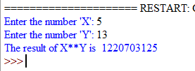

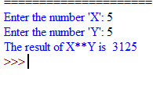

**EXPERIMENT : 1**

**AIM:** To calculate power of given number.

**PROGRAM:** Given two integers x and y and compute xy

**CODING:**

# User Input

x = int(input("Enter the number 'X': "))

y = int(input("Enter the number 'Y': "))

# Calculating and printing output

output = x**y

print("The result of X**Y is ", output)

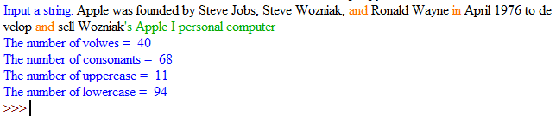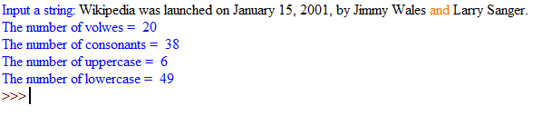

**EXPERIMENT : 2**

**AIM:** To find the number of vowels, consonants, uppercase and lowercase characters in a string

**PROGRAM:** Given a string find the number of vowels, consonants, lowercase and uppercase characters in the string and displaying the numbers of each respectively

**CODING:**

#User input

string = input("Input a string: ")

#Defining variables

vowels_no = 0

consonant_no = 0

uppercase_no = 0

lowercase_no = 0

#Defining vowels

vowels = ["a","e","i","o","u"]

#Looping through the string

for i in string:

    if  not i.isnumeric():

        if i.isupper():

            uppercase_no += 1

        elif i.islower():

            lowercase_no += 1

        #Switiching i to lower to check the consonant and vowels

        i = i.lower()

        if i in vowels:

            vowels_no += 1

        elif i not in vowels and i != " ":

            consonant_no += 1

#Printing the output

print("The number of volwes = ",vowels_no,"\nThe number of consonants = ",consonant_no)

print("The number of uppercase = ",uppercase_no,"\nThe number of lowercase = ",lowercase_no)

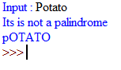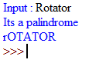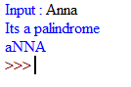

**EXPERIMENT : 3**

**AIM:** To find whether the given string is a palindrome and change its case

**PROGRAM:** Given a string find whether the string is palindrome and switch the case of each character and print the result

**CODING:**

#User Input

a = input("Input : ")

#Temporary string with lowercase for checking

Temp = a.lower()

n = 0

#Logic to check palindrome

for i in range(len(a)//2):

    if a[i] == a[(len(a) - 1 - i)]:

        n += 1

if n == len(a)//2:

    #printing the result

    print("Its a palindrome")

else:

    print("Its is not a palindrome")

a = a.swapcase()

#printing string with inverted case

print(a)

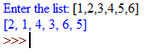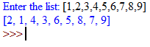

**EXPERIMENT : 4**

**AIM:** To swap the position of elements on even position with that of the odd position

**PROGRAM:** Given a list swap the position of the items on even position with that of items on odd position

**CODING:**

#User input

list_inp = eval(input("Enter the list: "))

for i in range(len(list_inp)):

    if i%2==0 and i + 1 < len(list_inp):

        #temp variable to store even values

        x = list_inp[i]

        list_inp[i] = list_inp[i+1]

    #Using elif instead of else to avoid error in case of odd no items in list

    elif i%2==1:

        list_inp[i] = x

#printing the value

print(list_inp)

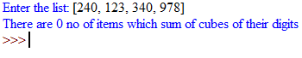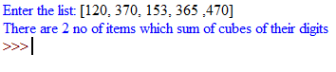

**EXPERIMENT : 5**

**AIM:** To check whether the in the given list of number how many are equal to the sum of the cubes of their digits

**PROGRAM:** Given a list of number find the number of items in list which are equal to the sum of cubes of their digits

**CODING:**

#User Input

list_inp = eval(input("Enter the list: "))

count = 0

#Checking if the number is sum of cubes of its digit

for i in list_inp:

    sum_digit = 0

    temp = i

    while temp >= 1:

        sum_digit += (temp%10)**3

        temp = temp//10

    if i == sum_digit:

        count += 1

#Printing the output

print("There are",count,"no of items which sum of cubes of their digits")



**EXPERIMENT : 6**

**AIM:** To find the sum of square of first 20 numbers

**PROGRAM:** calculating the sum of squares of first 20 numbers

**CODING:**

#variable for storing the sum

sum_square = 0

#for variable for iterating over first 20 nos

for i in range(1,21):

    sum_square += i**2

#Printing the result

print("Sum of the squares of first 20 numbers is",sum_square)

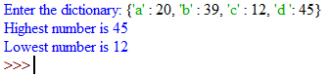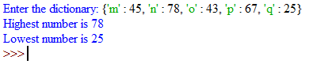

**EXPERIMENT : 7**

**AIM:** To print the highest and lowest values in a dictionary

**PROGRAM:** Given a dictionary find and print the highest and lowest value in the dictionary

**CODING:**

#User Input

dictionary = eval(input("Enter the dictionary: "))

#sorting Values

srt = sorted(dictionary.values())

#Printing values

print("Highest number is",srt[-1])

print("Lowest number is",srt[0])

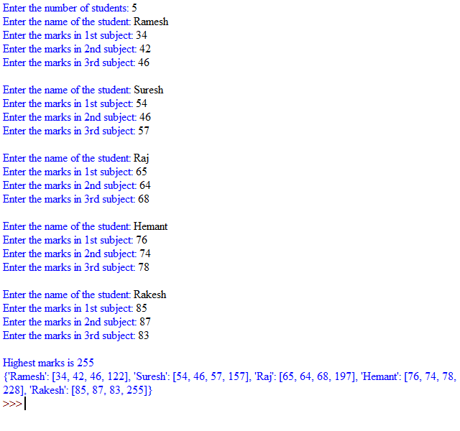

**EXPERIMENT : 8**

**AIM:** To create a dictionary to store names of students and marks of 3 subjects and their total marks and printing highest total marks

**PROGRAM:** Given input of names of students, marks of 3 subject create dictionary storing the information along with the total marks in the 3 subjects and printing the highest total marks achieved

**CODING:**

#User input

dictionary = {}

#variable to store no of students

no = int(input("Enter the number of students: "))

max_marks = 0

for i in range(no):

    name = input("Enter the name of the student: ")

    a = int(input("Enter the marks in 1st subject: "))

    b = int(input("Enter the marks in 2nd subject: "))

    c = int(input("Enter the marks in 3rd subject: "))

    dictionary.setdefault(name,[a,b,c,a+b+c])

    if a+b+c > max_marks:

        max_marks = a+b+c

    print()

#Printing the output

print("Highest marks is",max_marks)

print(dictionary)