
D.K.T.E Society’s Textile and Engineering Institute, Ichalkaranji
IoT and AI-Based Real-Time Water Quality Monitoring and Disease Prediction System
Synopsis of Proposed Work Submitted to

Department of
Electronics and Telecommunication Engineering

For the Degree of

Bachelor of Technology
In

Electronics and Telecommunication Engineering
By
23UCS047 | Varad Mahadev Kadam
23UCS101 | Sanika Arvind Patil
23UCS115 | Vishwadeep Vishwanath Sankpal
23UCS123 | Prafull Prataprao Shinde
23UCS124 | Swapnil Dipak Shinde

Under the Guidance of
Prof. R.R. SHRESHTHI
Academic Year

2026– 2027

DKTE Society's Textile and Engineering Institute, Ichalkaranji

(An Autonomous Institute)

Introduction:

Water is one of the most important natural resources required for human health, agriculture, industrial activities and environmental sustainability. The quality of water directly affects its suitability for drinking, domestic use, agriculture and industrial applications. Contamination of water can occur due to sewage discharge, industrial waste, agricultural runoff, excessive suspended particles, changes in chemical composition and environmental conditions. Therefore, regular monitoring of water quality is essential for identifying abnormal conditions at an early stage.
Traditional water-quality monitoring generally depends on collecting samples and sending them to laboratories for detailed analysis. Laboratory testing provides reliable results, but it is not always suitable for continuous monitoring because it can require significant time, cost, transportation and skilled personnel. A change in water quality occurring between two sampling intervals may therefore remain undetected. This creates a requirement for systems capable of continuously collecting important water-quality parameters and making the information available remotely.
The proposed project, “IoT and AI-Based Real-Time Water Quality Monitoring and Disease Prediction System” aims to develop an integrated system that combines Internet of Things (IoT) technology with Artificial Intelligence (AI). The proposed system uses an ESP32 microcontroller as the main processing and communication unit. Three sensors are used for the prototype: a pH sensor, a turbidity sensor and a DS18B20 temperature sensor.
The pH sensor measures the acidity or alkalinity of water. The turbidity sensor provides an indication of suspended particles and cloudiness in the water. The DS18B20 sensor measures water temperature. These parameters are collected by the ESP32 at regular intervals. The ESP32 processes the sensor readings and transmits them through Wi-Fi to the application server.
The proposed software architecture consists of a Node.js and Express.js backend, MongoDB database and React-based web dashboard. The backend receives sensor data from the ESP32 and stores timestamped measurements in MongoDB. The system evaluates the measured water-quality parameters using predefined water-quality rules and classifies the water condition as Safe, Moderate or Unsafe. The React dashboard retrieves the data through the backend and displays real-time readings, historical graphs, water-quality status, alerts and other relevant information.
For disease-risk prediction, the system uses Cloudflare Workers AI with the Llama 3.1 8B Instruct Large Language Model (@cf/meta/llama-3.1-8b-instruct). No separate machine-learning model is trained or developed as part of the proposed system. The water-quality information and relevant system context are provided to the LLM, which analyses the available information and generates an estimated waterborne disease risk. The AI component provides a risk classification such as Low, Moderate or High, along with possible waterborne diseases, prevention recommendations and an AI-generated health summary.
The proposed system is intended as an early-warning and decision-support prototype. The sensors do not directly detect microorganisms or diseases, and the AI-generated output should not be considered a clinical diagnosis.
The overall objective is to create an affordable, scalable and technically demonstrable community health monitoring and early warning system capable of monitoring selected water-quality parameters in real time, automatically classifying water quality, providing AI-based disease-risk analysis and generating timely alerts through an interactive web dashboard.
2. Motivation:

The motivation for the proposed project arises from the importance of continuous water-quality monitoring and the need for faster identification of abnormal water conditions. Periodic water testing may not provide sufficient information about sudden changes in water quality. An IoT-based system can continuously collect measurements and transmit them to a centralized database, making it possible to observe changes over time.
Another important motivation is the relationship between contaminated water and public health. Poor water quality can increase the risk of several water-related illnesses. The proposed system combines IoT-based water-quality monitoring with Artificial Intelligence (AI) to provide an early indication of possible waterborne disease risk and support timely preventive action.
The proposed system is also motivated by the increasing use of IoT and Large Language Models (LLMs) in environmental monitoring and intelligent decision-support applications. IoT provides the capability of collecting real-time data from the physical environment, while Cloudflare Workers AI with the Llama 3.1 8B Instruct LLM (@cf/meta/llama-3.1-8b-instruct) can analyse the available water-quality information and generate an indicative disease-risk assessment, possible diseases, prevention recommendations and a health summary. The system does not involve training or developing a separate machine-learning model.
The use of ESP32 makes the proposed prototype compact and economical because the microcontroller provides processing capability and built-in Wi-Fi communication. The selected pH, turbidity and temperature sensors provide important water-quality parameters without making the hardware unnecessarily complex.
MongoDB is selected as the database because the project requires storage of continuous sensor readings. Timestamped records can be used to generate historical graphs, monitor changes in water quality and provide information to the AI-based analysis component.
The project also provides practical exposure to several engineering areas including embedded programming, sensors, wireless communication, backend development, database management, frontend development, real-time data communication, Artificial Intelligence and Large Language Model integration.

3. Literature survey:

The literature survey was conducted to understand existing research related to IoT-based water-quality monitoring, AI-based water-quality analysis, and water-related disease-risk prediction. The reviewed studies provide a foundation for understanding sensor-based monitoring, automated water-quality assessment, and intelligent analysis of water-related health risks. Although several existing studies use traditional machine-learning techniques, the proposed system differs by using a Cloudflare Workers AI Large Language Model (LLM), @cf/meta/llama-3.1-8b-instruct, for disease-risk analysis without training or developing a separate machine-learning model.

Table 1 . Summary of literature review

Ref. No. | Paper Details | Findings
[1] | B. Nemade, K. K. Maharana, V. Kulkarni et al., “IoT-based automated system for water-related disease prediction,” Scientific Reports, Vol. 14, Article 29483, 2024. DOI: 10.1038/s41598-024-79989-6. | The study integrates IoT-based water-quality monitoring with machine learning for water-related disease prediction. It demonstrates the use of water-quality and time-series data for disease-risk analysis and forecasting.
[2] | S. Sharma, D. Mishra, A. Yadav, B. Gami and E. S. Madhan, “An Intelligent, low-cost water quality monitoring system with on-device machine learning and cloud integration,” Scientific Reports, Vol. 16, Article 11106, 2026. DOI: 10.1038/s41598-026-37287-3. | The system uses ESP32 with pH, turbidity, temperature and TDS sensors for real-time monitoring. Machine learning is used for intelligent classification of water impurity events, with cloud-based visualization.
[3] | I. A. Adeleke, N. I. Nwulu and O. A. Ogbolumani, “A hybrid machine learning and embedded IoT-based water quality monitoring system,” Internet of Things, Vol. 22, Article 100774, 2023. DOI: 10.1016/j.iot.2023.100774. | The research combines embedded IoT sensing and machine-learning techniques for water-quality monitoring. It demonstrates the application of ML for automated assessment of water pollution levels.
[4] | M. A. Islam, S. C. Roy, M. F. U. Utsho et al., “An IoT-enabled intelligent water quality monitoring system for tourist safety using machine learning,” Discover Electronics, Vol. 2, Article 28, 2025. DOI: 10.1007/s44291-025-00070-1. | The study integrates IoT-based water-quality sensing, centralized data processing and machine-learning classification to improve real-time water-safety monitoring and provide timely alerts.
[5] | F. R. A. Hasibuan, M. V. Zalukhu, D. A. Simamora and M. I. Fahmi, “IoT-Based Water Quality Monitoring System Using ESP32 and K-Nearest Neighbor Algorithm,” Journal of Artificial Intelligence and Software Engineering, 2026. | The study uses ESP32 with pH, turbidity and temperature sensors and applies the K-Nearest Neighbour algorithm for water-quality classification, demonstrating the feasibility of combining IoT-based sensing with machine-learning techniques.

3.1 Observations from Literature Review:

The following observations are drawn from the literature review:
Observation – 1
IoT-based water-quality monitoring can provide continuous or frequent measurements compared with periodic manual sampling. This allows abnormal changes in selected parameters to be identified more quickly.
Observation – 2
ESP32 is suitable for low-cost IoT prototypes because it provides microcontroller functionality together with integrated Wi-Fi communication. This reduces the requirement for an additional communication controller.
Observation – 3
pH, turbidity and temperature are commonly used parameters in water-quality monitoring systems. These parameters provide information about acidity/alkalinity, suspended particles and temperature conditions respectively.
Observation – 4
Intelligent AI techniques can be applied to water-quality information for classification, analysis and prediction. Recent developments in Large Language Models (LLMs) also provide an alternative approach for analysing contextual environmental information without developing and training a separate machine-learning model.
Observation – 5
Historical sensor data is important for identifying water-quality trends and changes over time. Therefore, continuous storage of timestamped sensor data is an important part of the proposed system. The stored data can also provide relevant context for AI-based analysis.
Observation – 6
Water-quality assessment and disease-risk prediction are not identical problems. Disease-risk estimation should be treated as an AI-assisted risk assessment rather than a clinical diagnosis. The proposed system therefore uses measured water-quality parameters as input to the Cloudflare Workers AI Llama 3.1 8B Instruct LLM (@cf/meta/llama-3.1-8b-instruct) to generate an indicative risk category and health-related recommendations.

3.2 Gap Analysis
The gap analysis derived from the literature review highlights the following:
Gap – 1
Several existing IoT water-monitoring systems concentrate mainly on sensor measurement and visualization. There is an opportunity to integrate sensing, database management, real-time web monitoring, water-quality assessment and AI-based disease-risk analysis into one student-scale architecture.
Gap – 2
Many advanced systems use a larger number of sensors such as TDS, dissolved oxygen, conductivity and other parameters. Such systems provide broader characterization but increase hardware cost and calibration complexity. The proposed project focuses on pH, turbidity and temperature as the core sensing parameters.

Gap – 3
Some systems classify water quality while others attempt to predict disease risk. The proposed project separates water-quality monitoring from AI-based disease-risk prediction so that the AI-generated output is not incorrectly interpreted as a medical diagnosis. Water quality is classified using predefined rules, while disease-risk analysis is performed using the Cloudflare Workers AI Llama 3.1 8B Instruct LLM.
Gap – 4
A complete application stack using ESP32, Node.js/Express, MongoDB, React and Cloudflare Workers AI can provide clear separation between sensing, communication, storage, visualization, water-quality assessment and AI-based prediction. Unlike conventional machine-learning approaches, the proposed system uses an existing Large Language Model (LLM) through Cloudflare Workers AI and does not require training or developing a separate machine-learning model.
Gap – 5
Real-time monitoring alone does not provide sufficient historical context. Storing timestamped data in MongoDB enables trend analysis and provides relevant historical information that can be used as context for AI-based analysis.

3.3 Proposed Contribution

The proposed project aims to develop an end-to-end IoT and AI-based prototype consisting of ESP32-based water-quality sensing with pH, turbidity and temperature measurement, along with wireless transmission through Wi-Fi. The system uses a Node.js and Express.js backend for data processing and a MongoDB database for storing historical sensor data. Water quality is assessed using predefined rules and classified as Safe, Moderate or Unsafe. A React-based real-time dashboard provides water-quality status, historical data visualization and alerts. For intelligent analysis, the system integrates Cloudflare Workers AI using the Llama 3.1 8B Instruct Large Language Model (LLM), @cf/meta/llama-3.1-8b-instruct, to perform AI-based disease-risk estimation with Low, Moderate or High risk classification and generate possible disease identification, prevention recommendations and a health summary. The system also displays live weather information, including temperature, humidity, wind speed and weather condition, as contextual information without affecting water-quality calculations. The main contribution is the integration of these components into one functional prototype suitable for real-time water-quality monitoring, AI-assisted disease-risk assessment, smart alerts and academic demonstration. The proposed system uses an existing Large Language Model through Cloudflare Workers AI rather than training or developing a separate machine-learning model.

4. Problem Statement:
Conventional water-quality monitoring generally depends on periodic sampling and laboratory analysis. Although laboratory testing is important for accurate water-quality assessment, periodic testing may not provide continuous information about sudden changes in water conditions.
Furthermore, water-quality information can be analysed using Artificial Intelligence (AI) to provide an indicative assessment of possible water-related health risks. The proposed approach uses a Large Language Model (LLM) for contextual analysis instead of training or developing a separate machine-learning model. The AI-generated output is treated as a risk-estimation and decision-support result rather than a clinical diagnosis.
The proposed project aims to develop a real-time IoT-based water-quality monitoring system using ESP32, pH, turbidity and temperature sensors. The collected data will be transmitted through Wi-Fi to a Node.js/Express backend and stored in MongoDB. A React-based dashboard will display real-time measurements, historical trends, water-quality status and alerts. The system will classify water quality using predefined rules and use Cloudflare Workers AI with the Llama 3.1 8B Instruct LLM (@cf/meta/llama-3.1-8b-instruct) to estimate waterborne disease risk and generate possible diseases, prevention recommendations and an AI-generated health summary.
The proposed system will act as an early-warning and decision-support system and will not replace laboratory testing, certified water-quality analysis or medical diagnosis.

5. Objectives:
The objectives of the proposed work are as mentioned below:
5.1 Real-Time Water Quality Monitoring
To design and implement an ESP32-based system for continuously acquiring pH, turbidity and water-temperature measurements, transmitting the readings through Wi-Fi, and storing timestamped data in MongoDB.
5.2 Water Quality Assessment and Dashboard
To classify water quality as Safe, Moderate or Unsafe using predefined rules and develop a React-based dashboard for displaying real-time readings, historical trends, water-quality status and alerts.
5.3 AI-Based Disease-Risk Prediction
To integrate Cloudflare Workers AI with the Llama 3.1 8B Instruct LLM (@cf/meta/llama-3.1-8b-instruct) to analyse water-quality information and provide an indicative Low, Moderate or High disease-risk assessment, possible diseases, prevention recommendations and an AI-generated health summary.
5.4 Real-Time Alerts and Weather Monitoring
To provide real-time alerts for unsafe water conditions and display live weather information including temperature, humidity, wind speed and weather condition, while keeping weather information separate from water-quality calculations.

6. Block Diagram :

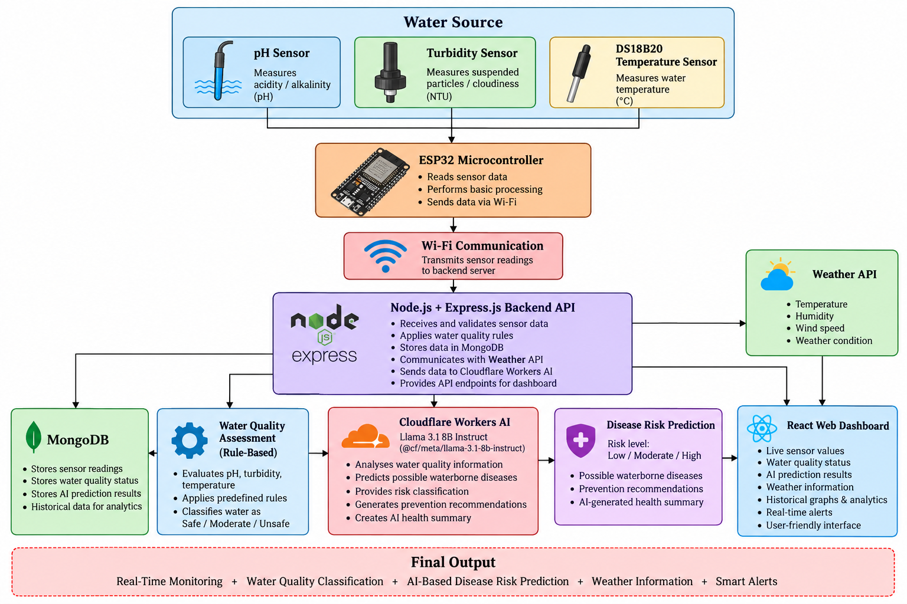

Figure 1. Block diagram of proposed work

6.1 Description of Block Diagram
1. pH Sensor
The pH sensor measures the acidity or alkalinity of the water. The sensor produces an electrical signal corresponding to the hydrogen-ion concentration of the water. The signal is processed by the ESP32 and converted into a pH value after suitable calibration.
2. Turbidity Sensor
The turbidity sensor measures the cloudiness of water caused by suspended particles. It generally operates using an optical sensing principle. The sensor output is acquired by the ESP32 and converted into a meaningful turbidity measurement after calibration.
3. DS18B20 Temperature Sensor
The DS18B20 is a digital temperature sensor. A waterproof probe version can be used for direct water-temperature measurement. The measured temperature is used as a water-quality parameter and is also stored for historical monitoring.
4. ESP32
The ESP32 is the main controller of the system. It reads the connected sensors, performs basic processing and sends the collected readings through Wi-Fi. The ESP32 reduces hardware complexity because Wi-Fi communication is integrated into the controller.

5. Wi-Fi Communication
The ESP32 uses Wi-Fi to transmit sensor readings to the backend server. Each data packet contains relevant information such as sensor values, device identifier, location/source information and timestamp.
6. Node.js and Express.js
Node.js with Express.js acts as the backend/API layer. It receives data from the ESP32, validates the readings and communicates with MongoDB. The backend also provides API endpoints for the React dashboard and handles communication with external services such as the weather API and Cloudflare Workers AI.
7. MongoDB
MongoDB is used to store the sensor readings and associated system information. Each record can contain parameters such as device ID, timestamp, pH, turbidity, temperature, location/source ID, water-quality status and AI prediction result. Historical records are used for displaying trends and analytics on the dashboard.
8. Water Quality Assessment
The backend evaluates the measured pH, turbidity and temperature values using predefined water-quality rules. Based on the configured threshold conditions, the water is automatically classified as Safe, Moderate or Unsafe. This classification is rule-based and does not involve machine-learning model training.
9. Cloudflare Workers AI
The system uses Cloudflare Workers AI with the Llama 3.1 8B Instruct Large Language Model (@cf/meta/llama-3.1-8b-instruct) for AI-based disease-risk analysis. The relevant water-quality information and system context are provided to the LLM. The LLM analyses the available information and generates an indicative waterborne disease-risk assessment.
10. Disease Risk Prediction
The AI component generates a disease-risk classification as Low, Moderate or High based on the available water-quality information and contextual input. It can also provide possible waterborne diseases, prevention recommendations and an AI-generated health summary. The output is intended for early warning and decision support and must not be considered a clinical medical diagnosis.
11. React Web Dashboard
The React dashboard provides the user interface for the monitoring system. It displays live sensor values, historical graphs, water-quality classification, AI disease-risk prediction, prevention recommendations, health summary and alerts. The dashboard communicates with the backend rather than directly exposing the database.
12. Weather Monitoring
The system retrieves live weather information through a weather API. The weather card displays temperature, humidity, wind speed and weather condition on the dashboard. Weather information is provided as contextual information and does not affect the water-quality calculation or classification.

6.2 Proposed Methodology

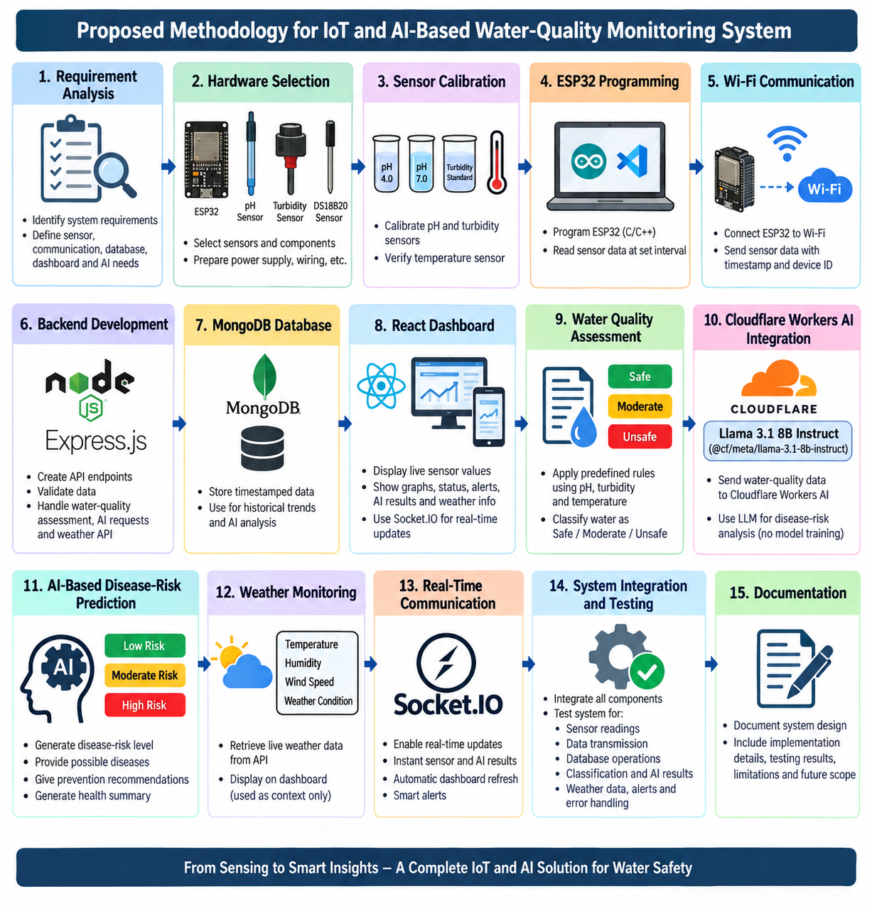
The proposed methodology starts with requirement analysis, hardware selection, sensor calibration and ESP32 programming, followed by Wi-Fi communication and backend/database development. The collected water-quality data is stored in MongoDB, assessed using predefined rules, and displayed on a React dashboard, while Cloudflare Workers AI provides disease-risk analysis and weather information is shown separately. Finally, Socket.IO enables real-time updates, followed by complete system integration, testing and documentation.

6.3 Software and Hardware Requirements

Category | Component / Technology | Purpose
Microcontroller | ESP32 | Sensor acquisition and Wi-Fi communication
pH Measurement | pH Sensor | Acidity/alkalinity measurement
Turbidity | Turbidity Sensor | Suspended particle/cloudiness measurement
Temperature | DS18B20 | Water-temperature measurement
Backend | Node.js + Express.js | API and server-side processing
Database | MongoDB | Real-time and historical data storage
Frontend | React.js | Interactive web dashboard
Programming | C/C++/python | ESP32 firmware development
Programming | JavaScript | React and backend development
AI | Cloudflare Workers AI | AI-based disease-risk analysis
AI Model | @cf/meta/llama-3.1-8b-instruct | LLM-based disease-risk prediction, possible disease identification, recommendations and health summary
Weather API | Weather API | Live temperature, humidity, wind speed and weather condition
Real-Time Communication | Socket.IO | Real-time sensor updates, AI prediction updates and alerts
HTTP Client | Axios | API communication between application components
Notifications | React Hot Toast | Dashboard alerts and user notifications
IDE | Arduino IDE / PlatformIO | ESP32 programming
IDE | Visual Studio Code | Backend and frontend development

7. Conclusive Discussion:
7.1 Real-Time Water Quality Monitoring
The proposed system provides a complete path from physical water sensing to remote monitoring. The ESP32 collects pH, turbidity and temperature measurements and transfers the readings through Wi-Fi. This enables frequent monitoring without requiring the user to manually record every measurement.
7.2 Centralized Data Storage
MongoDB provides a centralized database for storing timestamped sensor observations. Historical data can be used for generating graphs, analysing changes in water quality and maintaining a record of previous sensor readings for monitoring and analytics.
7.3 Web-Based Monitoring
The React dashboard provides a user-friendly interface through which users can observe real-time sensor readings and historical trends. The dashboard also displays water-quality status, AI prediction results, weather information and warning messages. Socket.IO enables automatic real-time updates without requiring continuous manual page refresh.
7.4 AI-Based Disease-Risk Prediction
Artificial Intelligence extends the proposed system beyond basic sensor monitoring. The system integrates Cloudflare Workers AI with the Llama 3.1 8B Instruct Large Language Model (@cf/meta/llama-3.1-8b-instruct) to analyse available water-quality information and provide an indicative assessment of possible waterborne disease risk.
The AI component generates a risk classification such as Low, Moderate or High, along with possible waterborne diseases, prevention recommendations and an AI-generated health summary. The system uses the existing pre-trained LLM and does not involve training or developing a separate machine-learning model.
The AI prediction is designed as an early-warning and decision-support feature because sensor readings alone cannot establish the presence of a particular disease. The generated result is therefore an indicative risk assessment and not a medical diagnosis.
7.5 Expected Outcomes
The project is expected to provide a functional ESP32-based water-quality monitoring system capable of measuring pH, turbidity and temperature, transmitting data through Wi-Fi, storing it in MongoDB and displaying it on a React-based dashboard with historical graphs. The system will classify water as Safe, Moderate or Unsafe, generate real-time alerts, and use Cloudflare Workers AI with Llama 3.1 8B Instruct to provide Low, Moderate or High disease-risk assessment, possible diseases, prevention recommendations and a health summary. It will also display live weather information and provide real-time sensor and AI updates using Socket.IO, with an architecture suitable for future expansion.

7.6 Limitations
- The selected sensors measure only physicochemical parameters and cannot directly detect bacteria, viruses or other pathogens.
- The system requires regular sensor calibration and maintenance, and readings may be affected by environmental conditions or electrical noise.
- AI-generated disease-risk assessment is indicative only, depends on the available information, and cannot replace laboratory testing or professional medical diagnosis.

7.7 Future Scope
The proposed system can be further enhanced by adding additional water-quality sensors, environmental data and advanced AI capabilities. These improvements can provide more comprehensive monitoring and strengthen the early-warning and decision-support features of the system.
- Additional Sensors: TDS, electrical conductivity, dissolved oxygen, ORP and free chlorine sensors.
- Environmental Monitoring: Rainfall and enhanced weather/environmental information.
- Advanced Applications: GIS-based visualization, geographic location support and mobile application.
- Communication & Alerts: SMS/e-mail notifications, MQTT communication and multi-location monitoring.
- AI Enhancement: Advanced AI/LLM analysis, predictive trend analysis and integration with additional environmental and health-related data sources.
- Automation: Automated water-treatment control based on monitored conditions.

8 . Workplan and Timeline:
Work Plan
Activity | W1 | W2 | W3 | W4 | W5 | W6 | W7 | W8
Literature Survey | ✓ | ✓
Requirement Analysis | ✓ | ✓
Component Selection |  | ✓ | ✓
Sensor Calibration |  |  | ✓ | ✓
ESP32 Programming |  |  | ✓ | ✓
Backend Development |  |  |  | ✓ | ✓
MongoDB Integration |  |  |  | ✓ | ✓
React Dashboard |  |  |  |  | ✓ | ✓
Water Quality Rule Implementation |  |  |  |  | ✓ | ✓
Cloudflare Workers AI Integration |  |  |  |  |  | ✓ | ✓
Weather API Integration |  |  |  |  |  | ✓ | ✓
Socket.IO / Real-Time Communication |  |  |  |  |  | ✓ | ✓
System Integration |  |  |  |  |  |  | ✓
Testing |  |  |  |  |  |  | ✓ | ✓
Documentation |  |  |  |  |  |  |  | ✓

The project will be completed systematically, starting with literature study, requirement analysis, hardware setup, sensor calibration and ESP32 programming.
This will be followed by Wi-Fi communication, backend/database development, React dashboard, AI and weather integration, and real-time communication.
Finally, system integration, testing and documentation will be carried out to ensure the complete system works effectively.

8.1 Project Deliverables
The major deliverables of the proposed project are:
- ESP32-based water-quality sensing unit with pH, turbidity and DS18B20 temperature sensors.
- ESP32 Wi-Fi communication program for transmitting sensor readings.
- Node.js/Express backend with MongoDB database for real-time and historical data storage.
- React-based web dashboard with historical data visualization and real-time monitoring.
- Rule-based water-quality classification module for Safe, Moderate and Unsafe conditions.
- Cloudflare Workers AI integration using Llama 3.1 8B Instruct (@cf/meta/llama-3.1-8b-instruct) for AI-based disease-risk prediction.
- AI-generated disease-risk results, including possible diseases, prevention recommendations and health summary.
- Weather monitoring, real-time alerts and Socket.IO communication for live system updates.
- System testing report and final project documentation.

8.2 Testing Plan
The system will be tested at multiple levels.
Hardware Testing
Each sensor will first be tested independently. Sensor readings will be compared with suitable reference measurements where available. The pH, turbidity and DS18B20 temperature sensors will be checked for proper operation and reliable data acquisition.
Communication Testing
The ESP32 will be tested for Wi-Fi connection, sensor-data transmission and recovery after temporary communication failure.
Backend Testing
The API will be tested for valid data insertion, invalid data rejection, retrieval of historical readings, water-quality classification and communication with external services.
Database Testing
MongoDB will be tested for correct storage and retrieval of timestamped sensor readings, water-quality status and AI prediction results.
Water Quality Classification Testing
The predefined water-quality rules will be tested using different pH, turbidity and temperature values to verify correct classification into Safe, Moderate or Unsafe categories and proper generation of unsafe-water alerts.
AI Testing
The Cloudflare Workers AI Llama 3.1 8B Instruct LLM integration will be tested for successful request processing and generation of:
- Disease-risk classification
- Possible waterborne diseases
- Prevention recommendations
- AI-generated health summary
The AI output will be checked for appropriate risk categories (Low, Moderate or High) and proper handling of invalid or incomplete input.
Weather API Testing
The weather service will be tested for successful retrieval and display of:
- Temperature
- Humidity
- Wind speed
- Weather condition
Weather information will be verified as a separate dashboard component and will not affect the water-quality calculation.

Dashboard Testing
The React dashboard will be tested for correct display of real-time sensor values, historical graphs, water-quality status, AI prediction results, weather information and warning messages.
Real-Time Communication Testing
Socket.IO communication will be tested to verify automatic updates of sensor readings, AI prediction results and alerts on the dashboard without requiring manual page refresh.
Integrated Testing
Finally, the complete system will be operated together to verify the complete data flow:
Sensor → ESP32 → Wi-Fi → Node.js/Express Backend → MongoDB → Water Quality Assessment → Cloudflare Workers AI → AI Risk/Recommendations → React Dashboard → Alerts
The Weather API → React Dashboard path will operate separately for live weather information.

References
Journal Articles
[1] B. Nemade, K. K. Maharana, V. Kulkarni, S. Mondal, G. S. P. Ghantasala, A. Al-Rasheed, M. Getahun, and B. O. Soufiene, “IoT-based automated system for water-related disease prediction,” Scientific Reports, vol. 14, Article 29483, 2024, doi: 10.1038/s41598-024-79989-6.
[2] S. Sharma, D. Mishra, A. Yadav, B. Gami, and E. S. Madhan, “An Intelligent, low-cost water quality monitoring system with on-device machine learning and cloud integration,” Scientific Reports, vol. 16, Article 11106, 2026, doi: 10.1038/s41598-026-37287-3.
[3] I. A. Adeleke, N. I. Nwulu, and O. A. Ogbolumani, “A hybrid machine learning and embedded IoT-based water quality monitoring system,” Internet of Things, vol. 22, Article 100774, 2023, doi: 10.1016/j.iot.2023.100774.
[4] M. A. Islam, S. C. Roy, M. F. U. Utsho, L. Naznin, R. Sarkar, and R. R. Sarkar, “An IoT-enabled intelligent water quality monitoring system for tourist safety using machine learning,” Discover Electronics, vol. 2, Article 28, 2025, doi: 10.1007/s44291-025-00070-1.
[5] F. R. A. Hasibuan, M. V. Zalukhu, D. A. Simamora, and M. I. Fahmi, “IoT-Based Water Quality Monitoring System Using ESP32 and K-Nearest Neighbor Algorithm,” Journal of Artificial Intelligence and Software Engineering, vol. 6, no. 2, 2026.
Standards / Technical References
[6] World Health Organization, Guidelines for Drinking-water Quality: Fourth Edition Incorporating the First Addendum, World Health Organization.
[7] World Health Organization, Guidelines for Drinking-water Quality: Small Water Supplies, World Health Organization.
[8] APHA, AWWA and WEF, Standard Methods for the Examination of Water and Wastewater, 23rd Edition.
AI and Technology References
[9] Cloudflare, Workers AI Documentation, Cloudflare.
[10] Meta, Llama 3.1: An Instruct-Tuned Large Language Model, Meta AI.
[11] MongoDB, MongoDB Documentation, MongoDB Inc.
[12] React, React Documentation, React.
[13] Socket.IO, Socket.IO Documentation, Socket.IO.
[14] OpenWeather, Weather API Documentation, OpenWeather.

Web Resources
[15] World Health Organization, Drinking-water Quality Guidelines.
[16] Cloudflare, Workers AI Documentation.
[17] Scientific Reports, “IoT-based automated system for water-related disease prediction.”
[18] Scientific Reports, “An Intelligent, low-cost water quality monitoring system with on-device machine learning and cloud integration.”

PRN | Name | Signature
23UCS047 | Varad Mahadev Kadam
23UCS101 | Sanika Arvind Patil
23UCS115 | Vishwadeep Vishwanath Sankpal
23UCS123 | Prafull Prataprao Shinde
23UCS124 | Swapnil Dipak Shinde

Prof.R.R.SHRESHTI Prof. (Dr.) J. P. KHARAT

Guide Head of ETC Department

