COMPUTER SYSTEM DESIGN (CSD)-Assignment 1
Pond Catchment Analysis — Phase 2 Report

Student Name: Ranga Chandra Naga Venkata Chaitanya Kumar
Roll Number: 12341740
GitHub Repository: https://github.com/chaitanyakumarAI/Pond_catchment_analysis
Working Live API URL: http://10.1.75.51:5237
Live API URL on browser:
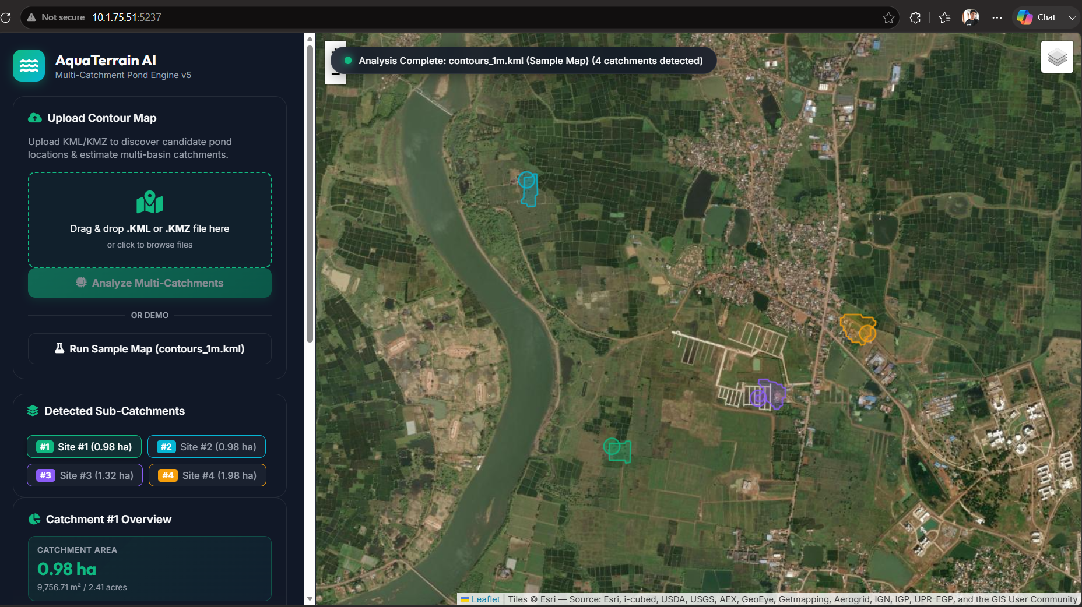

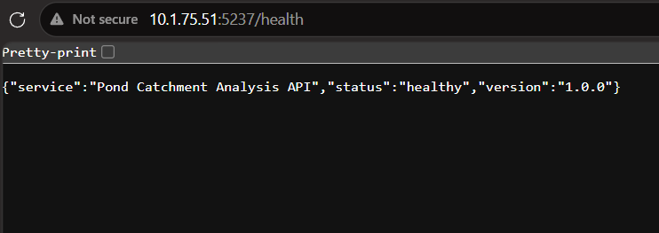
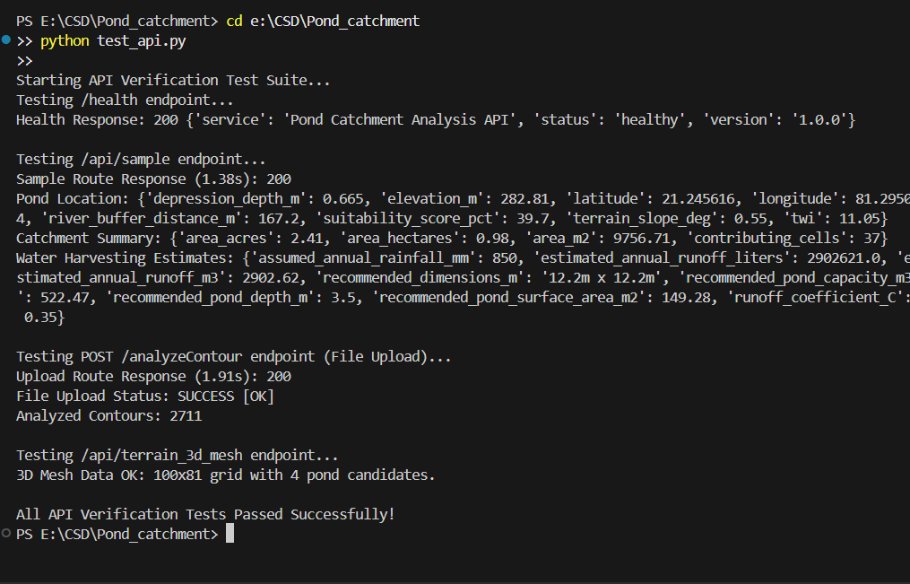
1. API Route — POST /analyzeContour
Accepts a KML or KMZ contour map file upload via multipart/form-data and returns full terrain analysis and catchment estimation in structured JSON.
Endpoint Details
Property | Value
Method | POST
Route | /analyzeContour (alias: /findCatchment)
Content-Type | multipart/form-data
File Parameter | 'file' or 'contour_file'
Live URL | http://10.1.75.51:5237/analyzeContour

Sample cURL Request
curl -X POST http://10.1.75.51:5237/analyzeContour \
-F "file=@contours_1m.kml"
Screenshot:
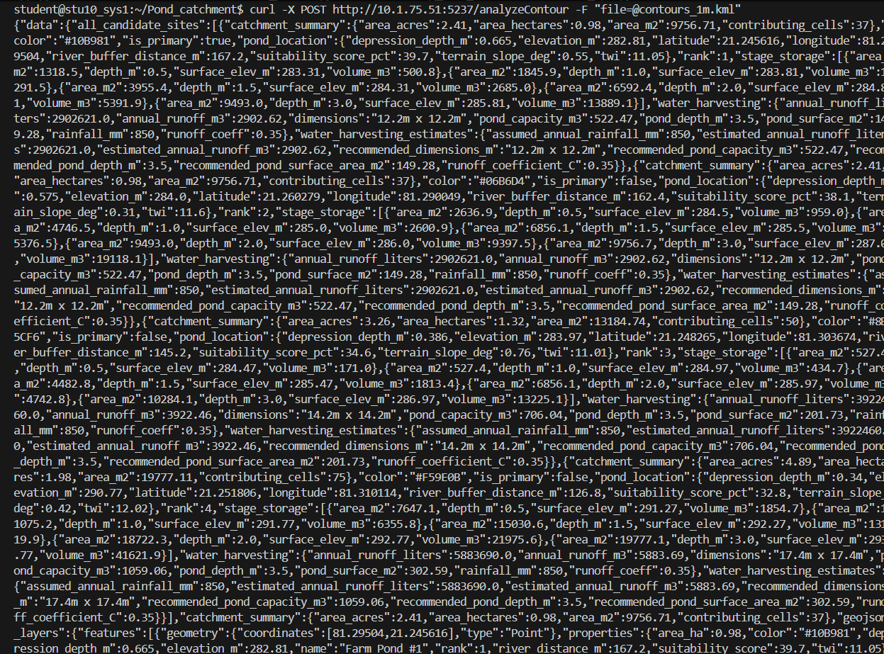

JSON Response Schema
{
"success": true,
"message": "Contour terrain analysis and catchment estimation completed successfully.",
"data": {
"pond_location": {
"latitude": 21.245616, "longitude": 81.29504,
"elevation_m": 282.81, "suitability_score_pct": 39.7,
"terrain_slope_deg": 0.55, "river_buffer_distance_m": 167.2,
"depression_depth_m": 0.665, "twi": 11.05
},
"catchment_summary": {
"area_m2": 9756.71, "area_hectares": 0.98,
"area_acres": 2.41, "contributing_cells": 37
},
"water_harvesting_estimates": {
"assumed_annual_rainfall_mm": 850,
"estimated_annual_runoff_m3": 2902.62,
"recommended_pond_capacity_m3": 522.47,
"recommended_pond_depth_m": 3.5,
"recommended_dimensions_m": "12.2m x 12.2m"
},
"terrain_statistics": {
"min_elevation_m": 260.0, "max_elevation_m": 300.0,
"avg_slope_deg": 1.2,
"map_width_meters": 1892.4, "map_height_meters": 1543.6
},
"geojson_layers": {
"type": "FeatureCollection", "features": [...]
}
}
}

Screenshot:
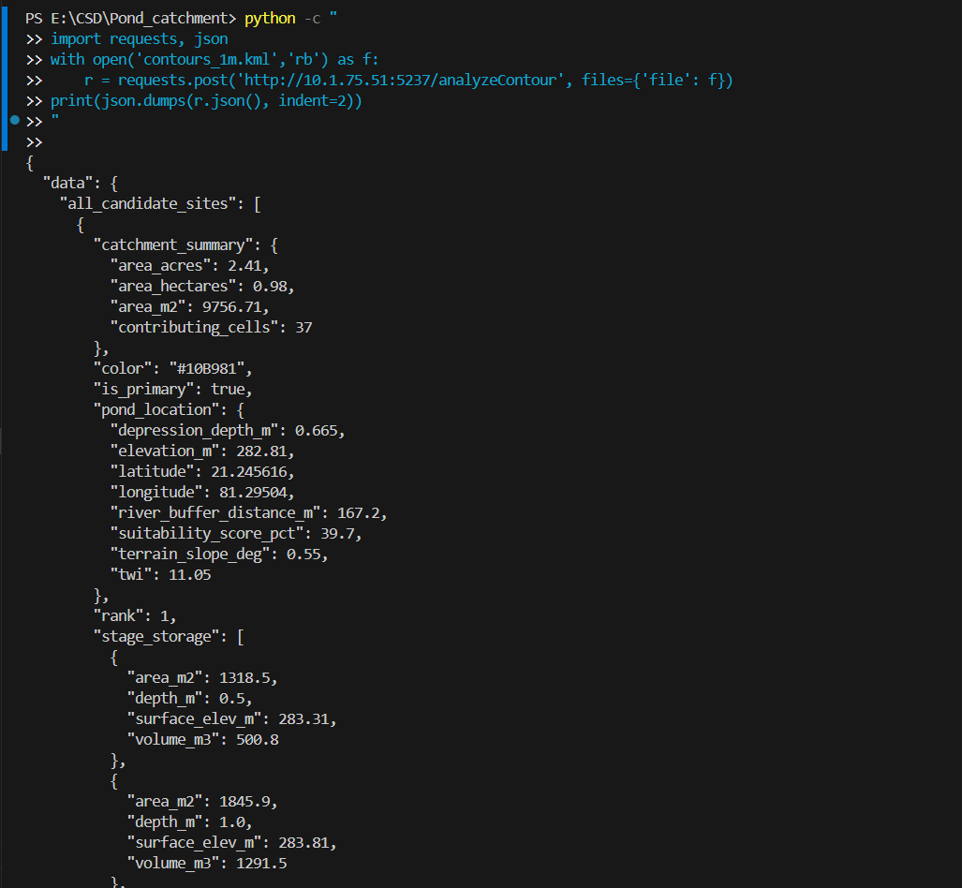
Additional Endpoints
Method | Route | Description
GET | /health | Health check — returns 200 OK with service status
GET | /api/sample | Runs analysis on bundled contours_1m.kml sample
GET | /api/terrain_3d_mesh | Returns 3D DEM grid for terrain visualization
2. Catchment Estimation Approach
The engine implements a fully generalized, multi-stage hydrological pipeline. No coordinates, elevations, or results are hardcoded — everything is derived dynamically from the uploaded contour file.
A. KML/KMZ Parsing: Extracts (longitude, latitude, elevation) from Placemark LineString / Polygon XML tags. Auto-unzips .kmz archives. Projects coordinates to local UTM meters using PyProj (auto-selects UTM zone for any global location).
B. DEM Grid Interpolation: Builds a regular 2D grid over the bounding box. Interpolates elevations using scipy.interpolate.griddata (linear + nearest fallback). Applies Gaussian smoothing (σ=1.0). Filters out boundary extrapolation noise (elevations < 250m rejected).
C. Hydrological Sink Filling: Priority-Flood algorithm fills terrain depressions to compute hydrologically correct flow paths. Depression depth = filled DEM − raw DEM — identifies natural water retention basins.
D. Slope & D8 Flow Direction: Horn's 8-neighbour method computes slope in degrees for each grid cell. D8 flow direction assigns each cell a single downslope direction (one of 8 neighbours).
E. Flow Accumulation: Cells sorted descending by elevation. Each cell accumulates upstream contributing cell count. High accumulation = natural stream channels.
F. River Corridor Masking: River channels flagged where flow accumulation ≥ 95th percentile. A strict 120m buffer is enforced — pond candidates must be ≥ 120m from any river corridor.
G. Pond Suitability Index (PSI): PSI = 0.35 × DepressionDepth_norm + 0.30 × FlowAcc_norm + 0.20 × TWI_norm + 0.15 × (1 − Elevation_norm). Top-4 ranked candidates outside the river buffer are selected.
H. Upstream Catchment Delineation: Reverse D8 traversal from pond site traces all contributing upstream cells. Catchment polygon = Convex Hull of contributing cells. Area computed in m², hectares, and acres.
I. Water Harvesting Estimation: Rational Method: Q = C × P × A (C=0.35, P=850mm/yr). Recommended pond dimensions derived from annual runoff volume.
3. Demonstration on Provided Sample Map (contours_1m.kml)
Parsed 2,711 contour lines (160,473 coordinate points) from the provided sample file. All values below are dynamically derived — not hardcoded.
Parameter | Derived Value | Hydrological Significance
Elevation Range | 260m — 300m (Δ 40m) | Rolling agricultural terrain
Optimal Pond Location | 21.2456° N, 81.2950° E | Natural micro-basin (167m from river)
Pond Elevation / Slope | 282.81m / 0.55° | Flat depression — ideal for excavation
Depression Sink Depth | 0.665 m | Natural water retention potential
Catchment Area | 0.98 Ha (9,756.7 m²) | Upstream drainage watershed
Est. Annual Runoff | 2,902.62 m³ (2.9 Million Liters) | Abundant for farm pond filling
Recommended Pond Size | 522.47 m³ (12.2m × 12.2m × 3.5m) | Optimal farm pond dimensions
River Buffer Distance | 167.2 m | Well clear of river corridor

4. Code Extensibility to Future Phases
Feature | How It Generalizes
File Format | Accepts any .kml or .kmz — auto-detects XML structure
Global Geography | PyProj auto-selects UTM zone — works anywhere on Earth
Elevation Scale | No fixed elevation constants — thresholds use percentiles
Map Resolution | Interpolation grid size adapts to input point density
Multiple Candidates | Returns top-4 ranked pond sites with full metrics each
River Detection | Flow accumulation 95th-percentile threshold — scale-adaptive
GeoJSON Output | Directly compatible with GIS tools, Leaflet, QGIS, etc.

5. Repository Structure
Pond_catchment_analysis/
├── app.py ← Flask API (POST /analyzeContour, GET /health, ...)
├── kml_parser.py ← Generalized KML/KMZ parser
├── terrain_analyzer.py ← Full terrain analysis & catchment engine
├── requirements.txt ← Python dependencies
├── contours_1m.kml ← Provided sample contour map
├── test_api.py ← Automated API test suite
└── Pond_Catchment_Report.md ← This report

GitHub: https://github.com/chaitanyakumarAI/Pond_catchment_analysis.git

