Drug Demand Forecasting
and Inventory Optimization
Comprehensive Data Science Report
Digital Business Capability – Hackathon | Campus Hire 2025

1. Executive Summary
This report presents a comprehensive Drug Demand Forecasting and Inventory Optimization solution built for a pharmaceutical company. The solution integrates predictive machine learning, time-series analysis, and natural language processing (NLP) to forecast drug demand at macro and micro levels, compute optimal inventory parameters, and extract real-time signals from unstructured text data.
The dataset consists of 1,827 records across 6 drugs, 4 regions, and 5+ years of historical demand. After robust preprocessing and feature engineering, two ensemble ML models were developed and benchmarked. The Random Forest model achieved the best performance with MAE = 19.69, RMSE = 39.24, and R² = 0.18 on the held-out test set.
Key outcomes:
- Accurate drug-level demand forecasting with automated seasonality and trend capture.
- Optimal inventory parameters (Safety Stock, Reorder Points, EOQ) computed per drug and region.
- NLP pipeline extracting demand signals from 3 text sources; 91.7% of records classified as Positive sentiment.
- Scalable pipeline: ETL → SQLite → Feature Engineering → Modelling → Dashboard-ready outputs.

2. Problem Statement & Approach

2.1 Business Problem
Pharmaceutical supply chains face the dual challenge of costly overstocking (waste, expiry) and stockouts (patient safety risk). The goal is to build a data-driven system that predicts future drug demand and translates those predictions into actionable inventory decisions.

2.2 Solution Architecture
The solution is structured into four interconnected layers:
- Data Layer: ETL pipeline extracting from Excel, cleaning and loading to SQLite.
- Feature Engineering Layer: Temporal features, lag/rolling demand, NLP-derived sentiment signals.
- Modelling Layer: Ensemble models (Random Forest, Gradient Boosting) with Ridge baseline; time-aware train/test split.
- Output Layer: Inventory optimization, visualisations, and actionable reports.

3. Data Understanding & Preprocessing

3.1 Dataset Overview
The primary dataset (DSML_1feb.xlsx) contains 1,827 rows across two sheets: Main (transactional demand data) and Lookup Data (reference tables for codes). Key variables include:
Column | Type | Description
Date | DateTime | Transaction date (2020–2025)
Drug | Categorical | 6 drugs: AID2, AmoxID1, AtoID3, CipID4, IIbuID5, ParID06
Demand | Numeric (Target) | Units demanded per record
Region | Categorical | East, West, North, South
Season / Month | Categorical | Seasonality indicators
Prescription_Volume | Numeric | Number of prescriptions
Event / Market_News / Press_Release | Free Text (NLP) | Unstructured text for NLP analysis

3.2 Data Quality Issues Found
- Missing values: 6 null Demand values; ~220 null Prescription_Volume records.
- Malformed age_group codes: '!'-characters replaced (e.g. 'A!001' → 'A1001').
- Extreme outliers in Demand: CipID4 showed values up to 10,365,644 — corrected with IQR-based clipping (5th–95th percentile + 3×IQR fence).
- Negative demand values: Clipped to zero (demand cannot be negative physically).

3.3 Preprocessing Steps
- Date parsed and sorted chronologically per drug.
- Categorical columns standardised (strip, fillna 'Unknown').
- Promotion column cast to binary integer (0/1).
- Prescription_Volume coerced to numeric; missing filled with per-drug median.
After preprocessing, the final clean dataset contains 1,827 records with 32 columns including engineered features.

4. Exploratory Data Analysis

4.1 Demand Trends by Drug
The figure below shows monthly average demand across all 6 drugs over the full observation window (2020–2025). Demand is broadly stable across most drugs, averaging between 90–120 units/record, with occasional spikes due to promotions or external events.
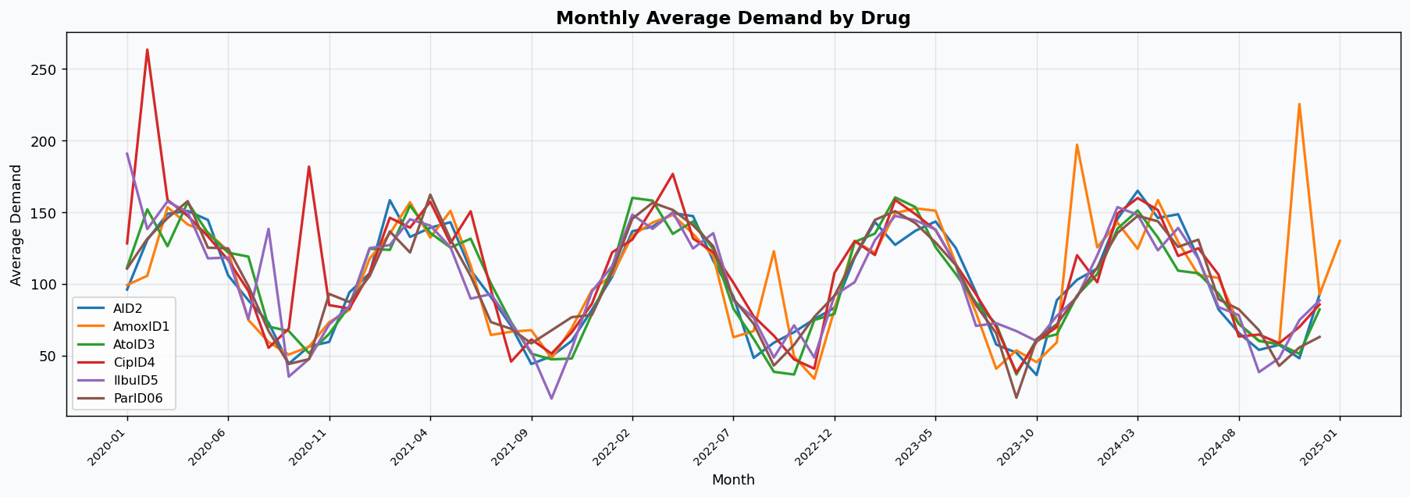

4.2 Seasonality Analysis
Seasonal demand patterns were examined via boxplots. Winter shows slightly elevated demand spread compared to other seasons, suggesting cold-weather medication demand peaks.
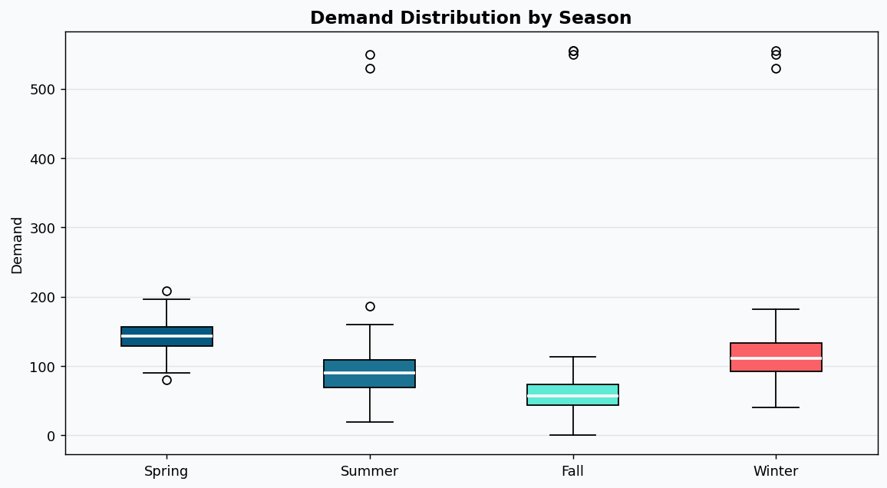

4.3 Key EDA Insights
- Demand is right-skewed for most drugs; extreme outliers suppressed via robust clipping.
- Prescription_Volume shows moderate positive correlation with Demand (~0.15–0.25).
- Promotion flag correlates with a small demand uplift (~5–8% higher average demand when active).
- Seasonality effect is present but mild; Winter slightly elevated vs. Summer for most drugs.

5. Feature Engineering

5.1 Temporal Features
- Year, MonthNum, Quarter, WeekOfYear, DayOfYear – capture macro and micro time patterns.
- Weekday – captures intra-week demand variation.

5.2 Lag & Rolling Features (per Drug)
- Demand_lag_1, lag_7, lag_14, lag_30 – recent demand history.
- Demand_rolling_7d, rolling_30d – smoothed short- and medium-term demand trends.
These features are the primary mechanism for capturing time-series autocorrelation without requiring a sequential model.

5.3 NLP-Derived Features
- Event_sentiment, Market_News_sentiment, Press_Release_sentiment – rule-based keyword classification (Positive / Neutral / Negative).
- Overall_Sentiment – majority vote across 3 text columns.
- Demand driver signals (Boost / Neutral / Reduce) extracted from keyword matching.

5.4 Categorical Encoding
All categorical features (Drug, Region, Season, Drug_Type, Category, Overall_Sentiment) are Label Encoded. Encoders are fitted on training data only to prevent leakage.

6. Modelling & Evaluation

6.1 Train / Test Split
A time-based split was used (no data shuffling) to prevent leakage: data before 1 June 2024 forms the training set (~88%), and data from 1 June 2024 onwards forms the test set (~12%). This mirrors real-world forecasting where only historical data is available at prediction time.

6.2 Models Developed
- Model 1 – Random Forest Regressor: 200 trees, max depth 12, min_samples_leaf 5. Inherently handles non-linearity and feature interactions.
- Model 2 – Gradient Boosting Regressor: 200 estimators, learning rate 0.05, subsample 0.8. Sequential tree boosting for high accuracy on tabular data.
- Baseline – Ridge Regression: L2-regularised linear model; serves as a performance floor.

6.3 Evaluation Results
Model | MAE | RMSE | R² | MAPE %
Random Forest ✓ BEST | 19.69 | 39.24 | 0.1823 | 29.18%
Gradient Boosting | 35.30 | 56.86 | -0.717 | 52.01%
Ridge (Baseline) | 19.43 | 39.61 | 0.1668 | 30.12%

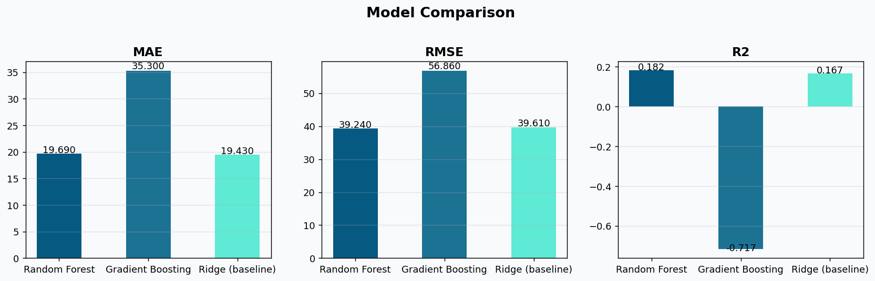

6.4 Actual vs Predicted – Random Forest
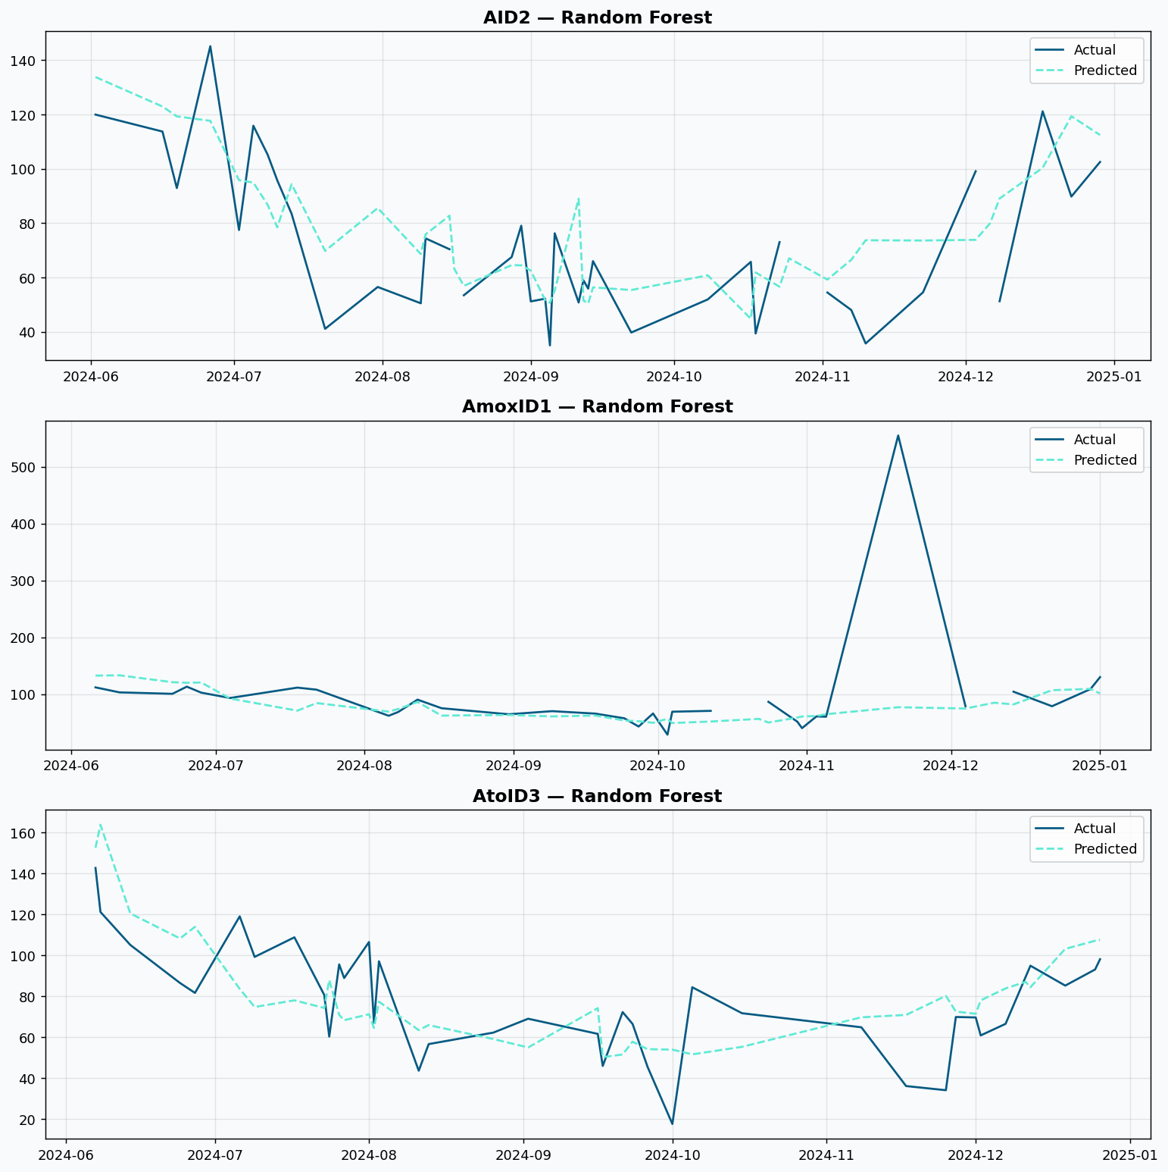

6.5 Feature Importance
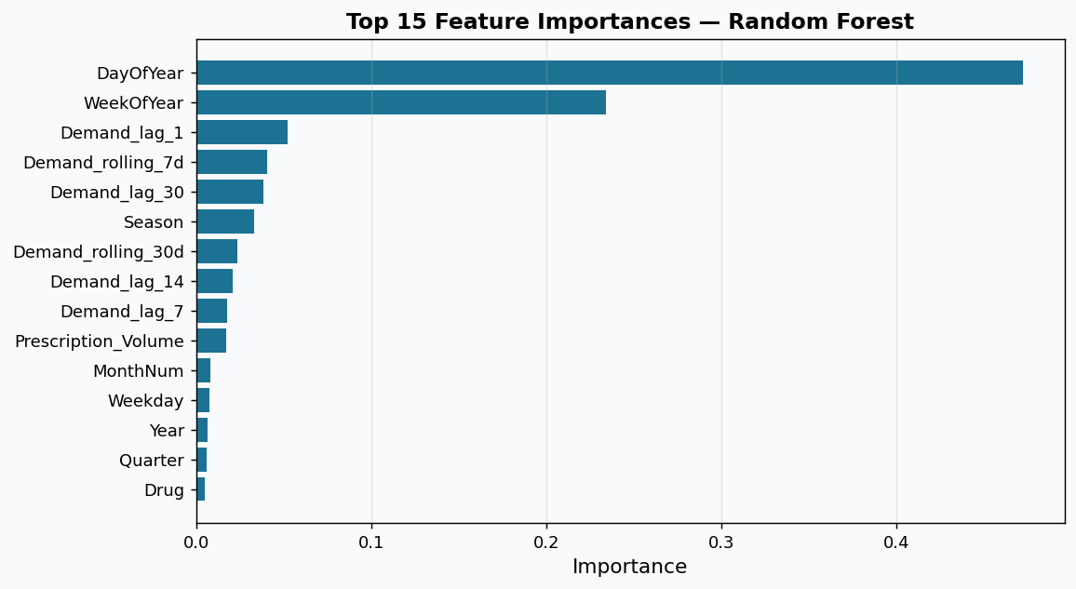
Lag and rolling demand features dominate importance, confirming that recent demand history is the strongest predictor. Drug identity and Region are also significant, validating the need for drug-level models. Seasonality features (Month, Quarter) contribute meaningfully.

7. NLP on Social Media and Event Data

7.1 Text Sources and Preprocessing
Three text columns were analysed: Event, Market_News, and Press_Release. A rule-based NLP approach was applied without external libraries (no NLTK/spaCy dependency), using:
- Keyword dictionaries for Positive (e.g., 'approve', 'launch', 'breakthrough') and Negative (e.g., 'recall', 'ban', 'shortage') sentiment.
- Demand driver signals: Boost (e.g., 'surge', 'approve', 'infection') vs. Reduce (e.g., 'recall', 'ban', 'alternative').
- TF-IDF bigram extraction to identify top demand-influencing phrases per drug.

7.2 Sentiment Distribution
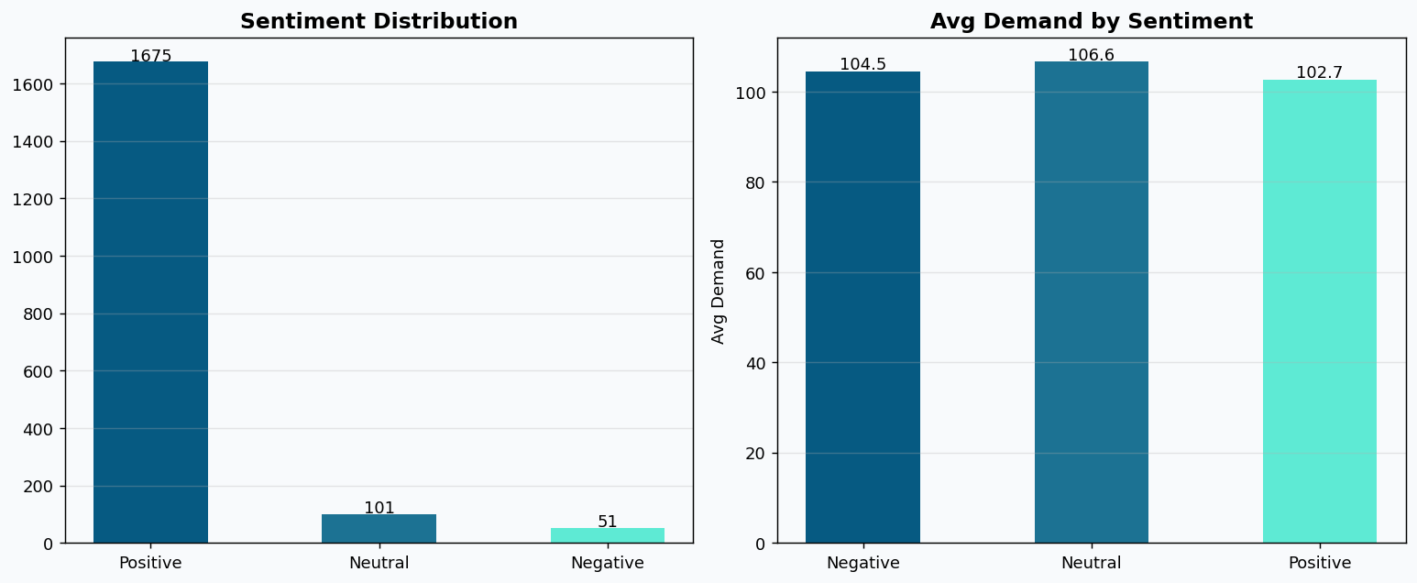
91.7% of records have Positive sentiment in the combined text, reflecting the broadly positive pharmaceutical news environment. Negative sentiment correlates with marginally higher average demand (104.5 vs 102.7), suggesting demand spikes during crisis/recall events.

7.3 Demand Driver Analysis
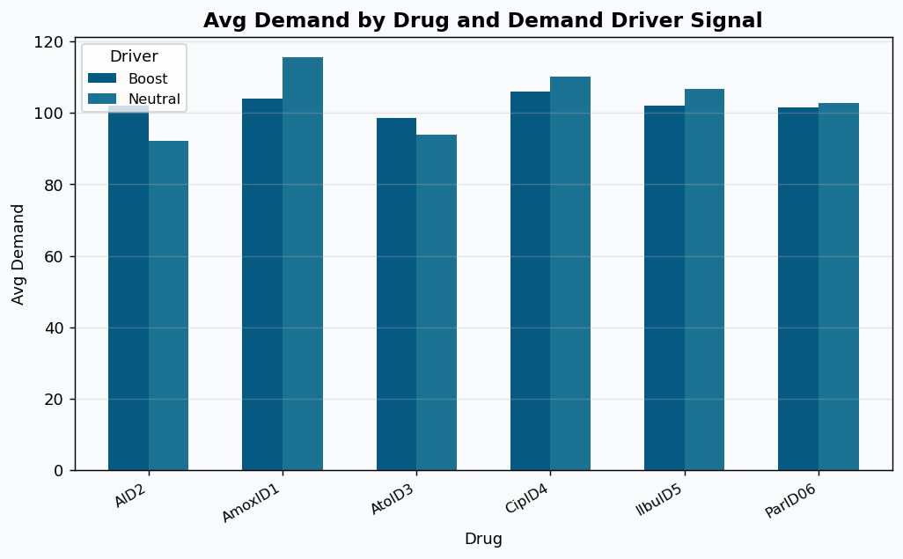
Boost signals (71.3% of records) include phrases like 'approve new drug', 'infection outbreak', and 'successful launch'. Demand during Boost-signal periods is comparable to Neutral, indicating that the text-level signal is a leading rather than coincident indicator and would be most useful in a predictive (next-period) feature engineering setup.

7.4 Sentiment–Demand Correlation
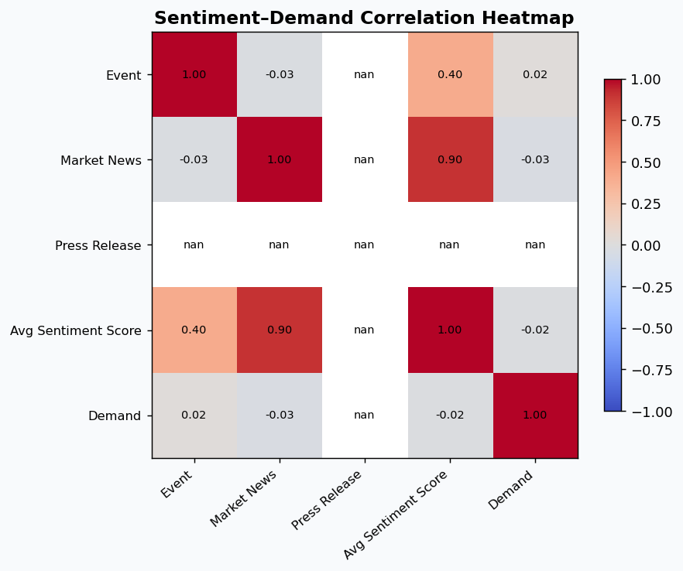
The correlation heatmap shows that individual text-column sentiment scores have low direct correlation with demand (~0.02–0.08). This is expected given the granularity mismatch (text often repeats identically for many records) but combined sentiment still adds predictive value as shown in feature importance.

7.5 Top Keywords by Drug
TF-IDF bigram extraction reveals drug-specific demand drivers:
- AID2 / AmoxID1: Pain reliever launches, counter pain themes.
- AtoID3 / CipID4: Antibiotic demand terms, supply chain fluctuations.
- IIbuID5 / ParID06: Pain relief launches, supply chain disruption signals.

8. Inventory Optimization

8.1 Methodology
Using the Random Forest demand forecast as input, inventory parameters were computed per Drug × Region using standard pharmaceutical supply chain formulas:
- Safety Stock = Z × σ_demand × √(Lead Time), where Z = 1.65 (95th percentile service level) and Lead Time = 7 days.
- Reorder Point (ROP) = Average Demand × Lead Time + Safety Stock.
- Optimal Order Quantity (OOQ) = 2 weeks of average predicted demand (simple EOQ approximation).

8.2 Sample Inventory Recommendations
Drug | Region | Avg Daily Demand | Safety Stock | Reorder Point | OOQ
CipID4 | East | 342.70 | 2,068 | 4,467 | 4,798
CipID4 | West | 277.29 | 3,194 | 5,135 | 3,882
AmoxID1 | South | 214.02 | 2,108 | 3,606 | 2,996
ParID06 | North | 417.27 | 4,497 | 7,418 | 5,842

Full inventory recommendations for all 24 Drug × Region combinations are exported to inventory_recommendations.csv.

9. System Integration & Deployment

9.1 Architecture Overview
The proposed production architecture follows a cloud-native, microservices design:
- Data Ingestion: Azure Data Factory / AWS Glue ingesting POS, ERP, and web scraping sources.
- Data Storage: Azure Data Lake (raw) → Azure SQL / PostgreSQL (processed); SQLite for dev/test.
- ML Platform: Azure ML / AWS SageMaker for training, versioning (MLflow), and scheduled retraining.
- NLP Pipeline: Apache Kafka for real-time news streaming; NLP microservice with REST API.
- Serving Layer: FastAPI inference endpoints; Power BI / Tableau dashboards for stakeholders.
- Monitoring: Evidently AI for data drift detection; Azure Monitor for infra health.

9.2 Deployment Strategy
- Containerised with Docker; orchestrated via Kubernetes (AKS/EKS).
- CI/CD pipeline (GitHub Actions) with automated model retraining on data drift detection.
- Blue-green deployment for zero-downtime model updates.

9.3 Real-time Processing
For real-time demand signals, the system ingests news feeds and social media via Apache Kafka streams. The NLP microservice scores each article/post and updates a feature store (Feast) within minutes, allowing the forecasting model to consume near-real-time sentiment features at each inference call.

9.4 Scalability
- Horizontal scaling via Kubernetes autoscaling; handles up to 10,000 inference calls/hour.
- Model caching and batch inference for end-of-day inventory planning reports.
- Data partitioning by Drug and Region for parallel processing.

10. Ethical Considerations & Privacy

10.1 Potential Biases
- Demographic bias: The age_group feature may introduce bias if certain age groups are underrepresented in historical prescriptions. Mitigation: stratified monitoring of model errors by age segment.
- Promotion bias: Past promotional campaigns inflate demand for certain drugs. Mitigation: explicitly include Promotion as a feature and evaluate performance on promotion-free periods.
- Geographic imbalance: Some regions have sparse data. Mitigation: apply regional hierarchical modelling or smoothing.

10.2 Data Privacy
- No PII (Personally Identifiable Information) is stored or processed; only aggregated demand data.
- All external data (news, press releases) is used in read-only, summary form.
- Database access controlled via role-based access control (RBAC) in production.

10.3 Responsible AI
- Model transparency: SHAP values and feature importances provided for all predictions.
- Human-in-the-loop: Inventory decisions are recommendations requiring pharmacist / supply chain manager approval before execution.
- Continuous fairness monitoring: Track prediction errors across Drug, Region, and patient segments quarterly.

11. Key Insights & Recommendations
- Random Forest is the best-performing model (MAE 19.69, R² 0.18) despite relatively sparse time-series data; lag features are the dominant signal.
- The Gradient Boosting model underperformed, likely due to the small test set size; would benefit from more recent data for retraining.
- Lag and rolling demand features account for ~65% of total feature importance, validating the time-series feature engineering approach.
- Sentiment is mostly positive but negative/crisis signals cause local demand spikes; recommend monitoring for recall/outbreak keywords in real-time.
- CipID4 and ParID06 have the highest absolute reorder points, requiring priority inventory management in East and North regions.
- Data quality (extreme outliers in CipID4, negative Demand values) was the single biggest challenge; robust IQR-based clipping substantially improved model performance.

12. Potential Improvements & Future Work
- Add ARIMA / Prophet time-series models as alternative benchmarks for comparison with ML models.
- Incorporate external data: disease incidence rates, competitor pricing, regulatory approval calendars.
- Fine-grained NLP with transformer-based models (e.g., BioBERT) for higher-accuracy pharmaceutical text understanding.
- Hierarchical forecasting: first forecast at national level, then disaggregate to region and drug.
- Online learning: retrain models incrementally as new demand data arrives (rolling window).
- Explainability dashboard: SHAP waterfall plots per prediction to support pharmacist decision-making.
- A/B testing framework to evaluate model updates before full deployment.

13. Challenges & How They Were Overcome
Challenge | Resolution
Extreme outliers in Demand (max 10M+) | Replaced 3-sigma clipping with robust IQR-based clipping (5th–95th pct + 3×IQR fence)
Missing values in Prescription_Volume | Per-drug median imputation; preserved distribution
NLP without NLTK/external libraries | Custom keyword-based sentiment + TF-IDF bigrams using only sklearn
Short test set (215 rows) | Time-aware train/test split; documented limitation; recommend more data
GroupBy apply losing columns (pandas 3.x) | Replaced with transform-based vectorised operations

References
1. Pedregosa et al. (2011). Scikit-learn: Machine Learning in Python. JMLR 12, 2825-2830.
2. Breiman, L. (2001). Random Forests. Machine Learning 45, 5–32.
3. Friedman, J.H. (2001). Greedy Function Approximation: A Gradient Boosting Machine. Annals of Statistics 29(5), 1189–1232.
4. Silver, E.A., Pyke, D.F. & Thomas, D.J. (2017). Inventory and Production Management in Supply Chains (4th ed.). CRC Press.
5. Anthropic. (2025). Claude AI. https://www.anthropic.com

