Convolve 3.0
Team: Chill guys

Code explanation:

Importing data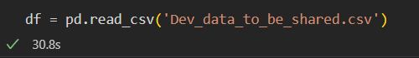

The shape of the dataset is (98,806, 1216) our dataset has around 1300 rows having bad_flag == 1 and rest 0

Topic 1) Feature Engineering
- Dropping the columns having % missing > 76%
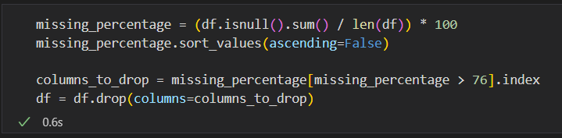
After dropping the columns, our shape become (96806, 1200)
- Now we drop the columns having more than 70% of 0 in each column expect bad_flag. We first separate the rows having bad_flag == 1 and bad_flag == 0 then we perform the above operation separately on both of them and drop the columns that were common in both of them. After it we concatenate the separated data and shuffled them
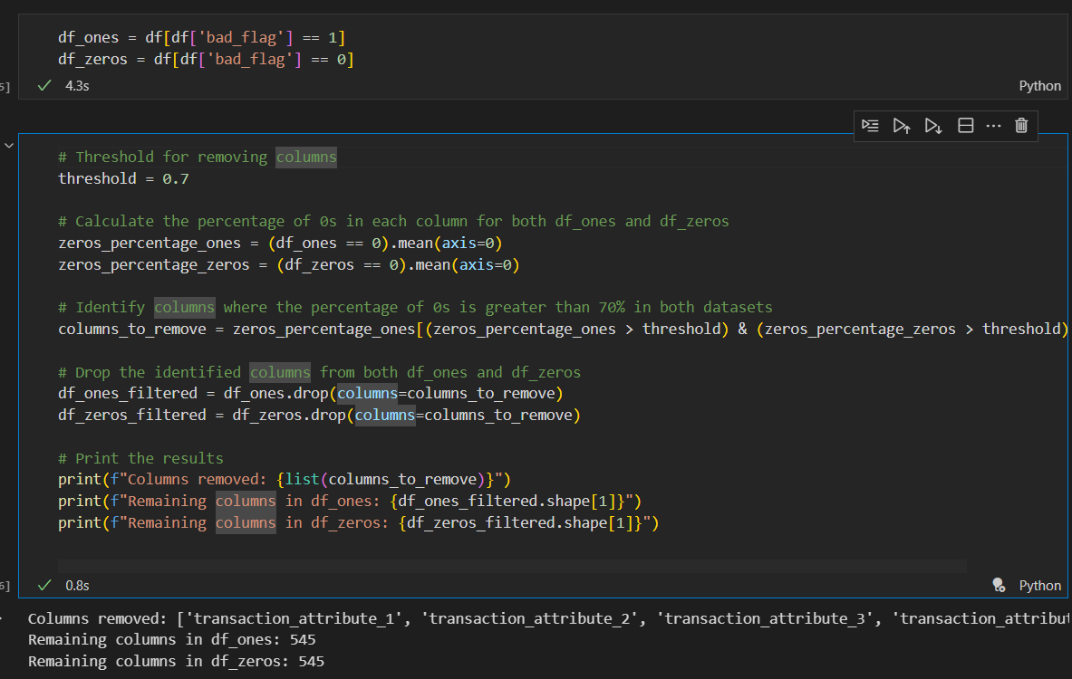

After the above operation our shape became (96806, 545)

- Now we remove the rows having NaN value > 50% as Rows with more than 50% missing values have insufficient information to contribute meaningfully to the analysis or predictive modeling.
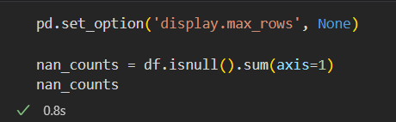
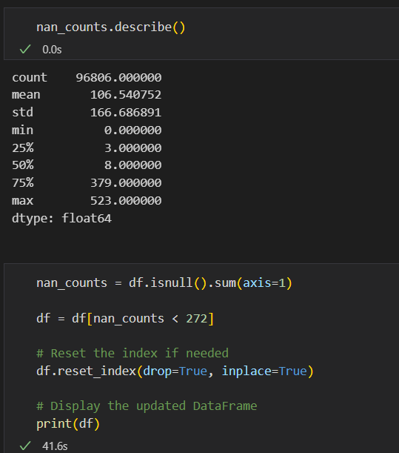
After the above operation our shape becomes (71575, 545)
ONE COUNT = 1050
ZERO COUNT = 70525
- We will the missing data (i.e NaN) with mean for rows having bad_flag == 1 and with median for rows having bad_flag == 0
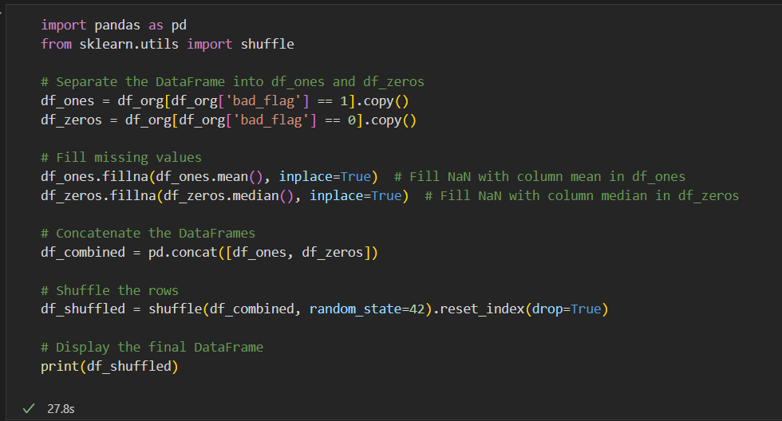

- After above operations, we did VIF(Variance Inflation Factor) and remove the columns whose VIF >= 5. Features with high multicollinearity (VIF ≥ 5) can distort the model's coefficients, making them unstable and difficult to interpret.
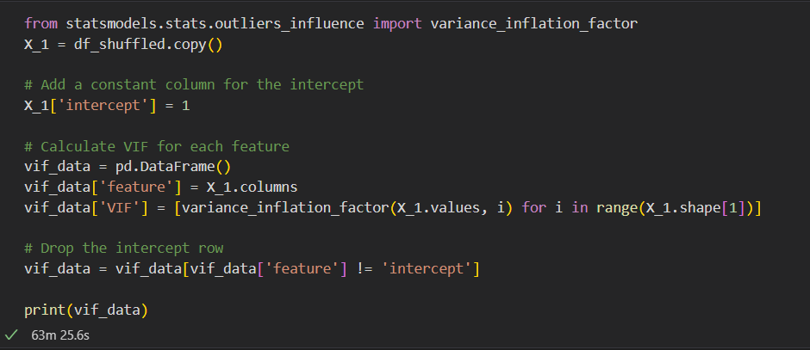

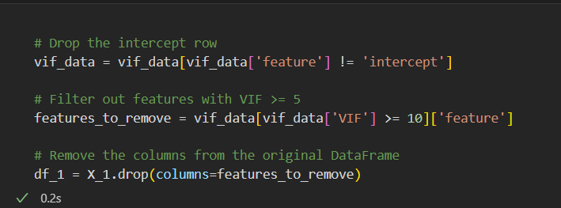
After the above operation our shape becomes (71575, 153)

- We decided to Generate the dataset using SMOTE, we generated around 3000 dataset of class 1 and we downsample the class 0(to 15000), so we have 16000 dataset for training and testing

Data interpretation
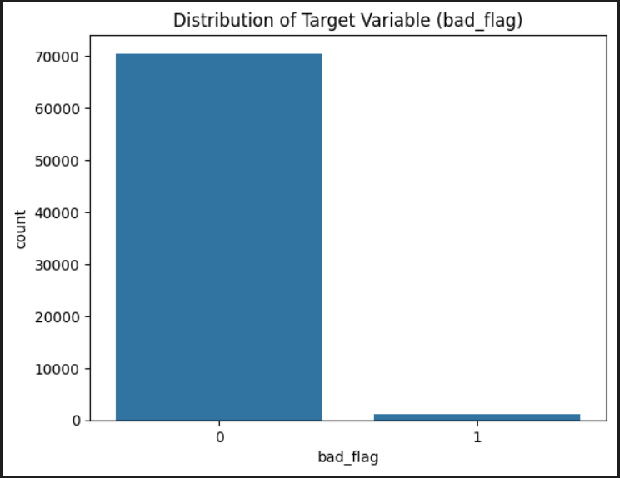
Our dataset is highly imbalanced (contains ~ 70,000 (0) and ~ 1000(1) )

